|  |
| --- |
| TS012 - Termination of Electric Service_Individual - Portal |

|  |
| --- |
| TC009_Termination of Service Application |

|  |
| --- |
| Step 1 - Login to Meralco Online |
| User should be logged in to Meralco Online |

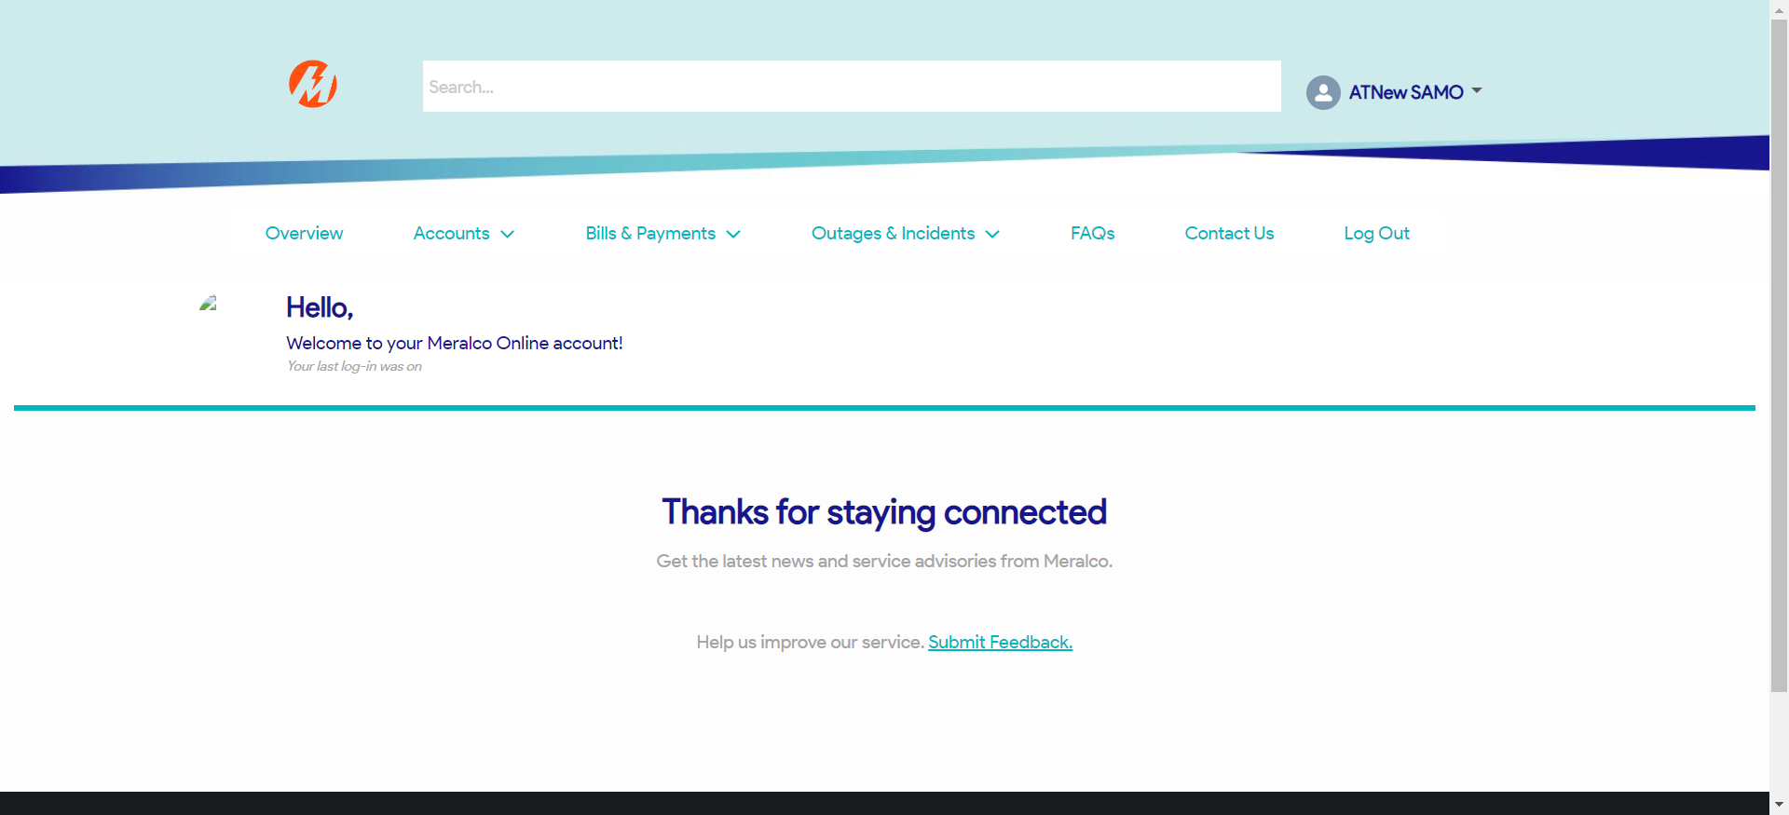

|  |
| --- |
| Step 2 - Go to Accounts> Manage Accounts |
| Accounts page should be displayed |

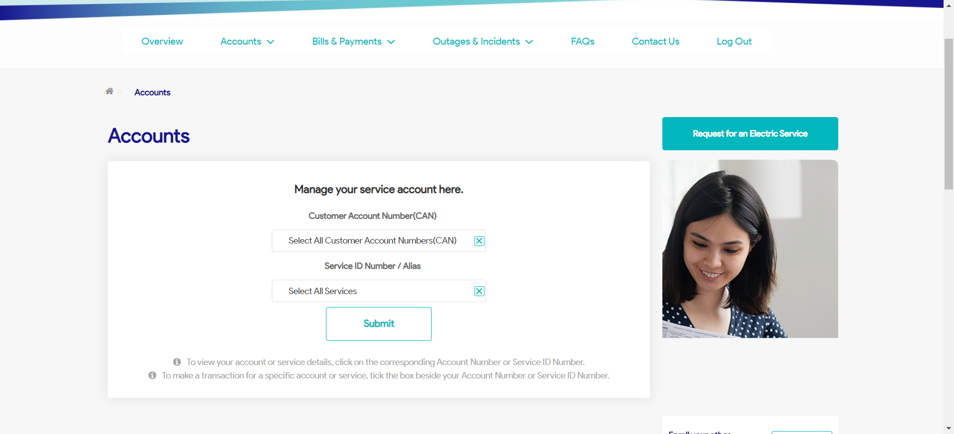

|  |
| --- |
| Step 3 - Search then Select Account > Click Stop Electric Service button |
| Request page for Stop Electric Service should be displayed |

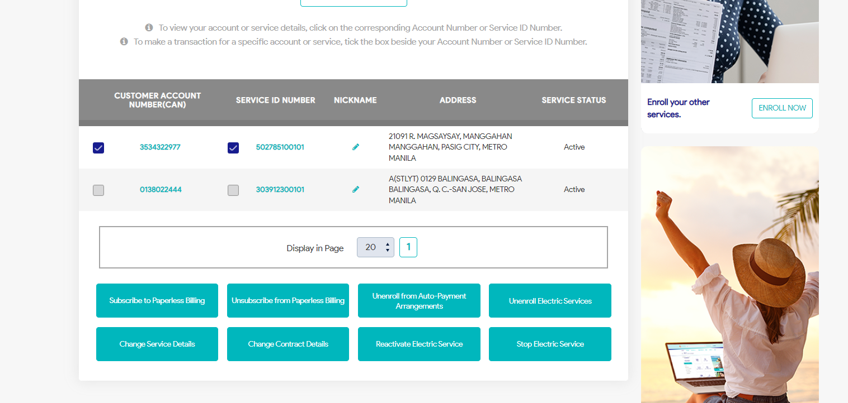

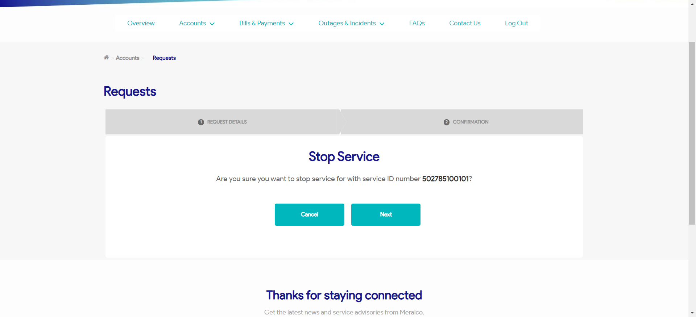

|  |
| --- |
| Step 4 - Click Next |
| Confirmation tab should be displayed. Case # should be generated. |



Passed