|  |
| --- |
| TS016 - Termination of Electric Service_Contractor - CXEApply |

|  |
| --- |
| TC016_Recontract of Business Service via CXE Apply |

|  |
| --- |
| Step 1 - Go to https://fuat-meralco.cs73.force.com/customers/s/cxe-apply |
| Service Application page should be displayed |

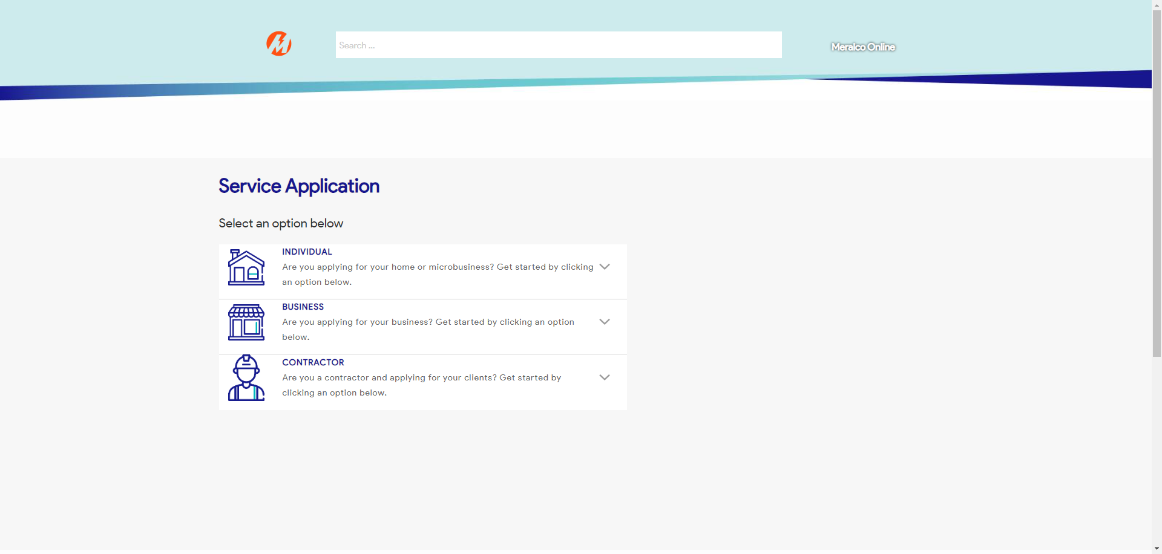

|  |
| --- |
| Step 2 - Click on Business |
| The following should be displayed under Business |

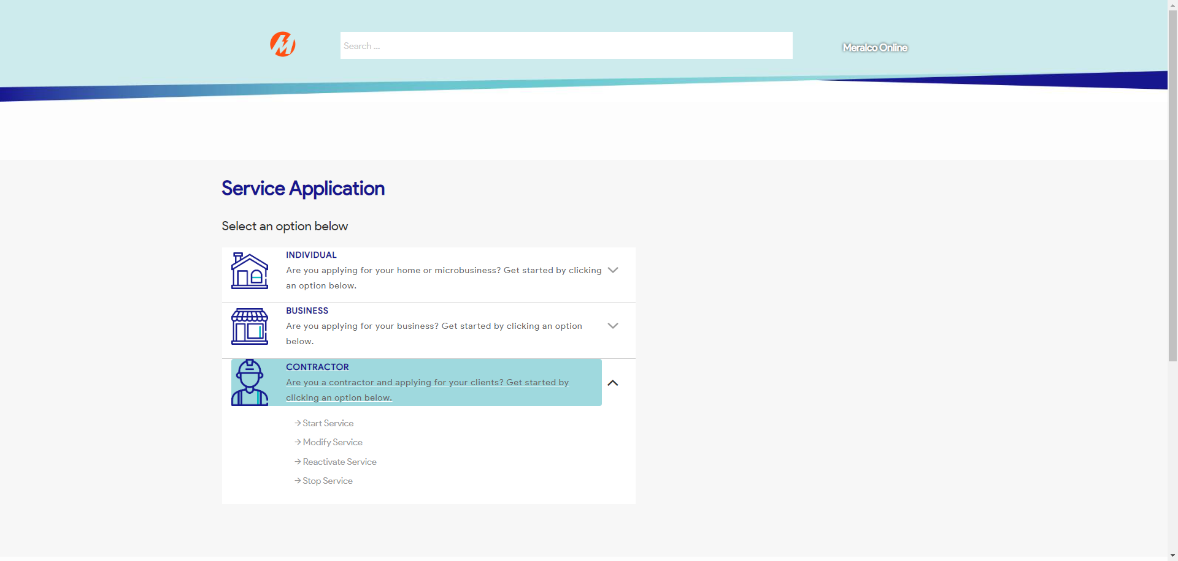

|  |
| --- |
| Step 3 - Click on Reactivate Service |
| Reactivate a Service page should be displayed |

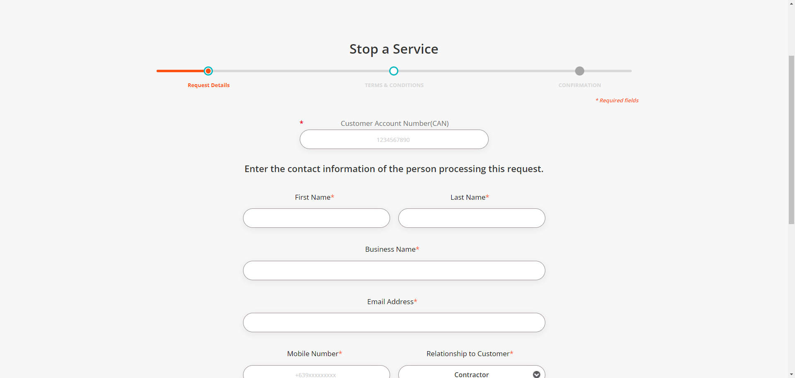

|  |
| --- |
| Step 4 - Validate if CAN field is visible and enabled |
| CAN field should be visible and enabled |

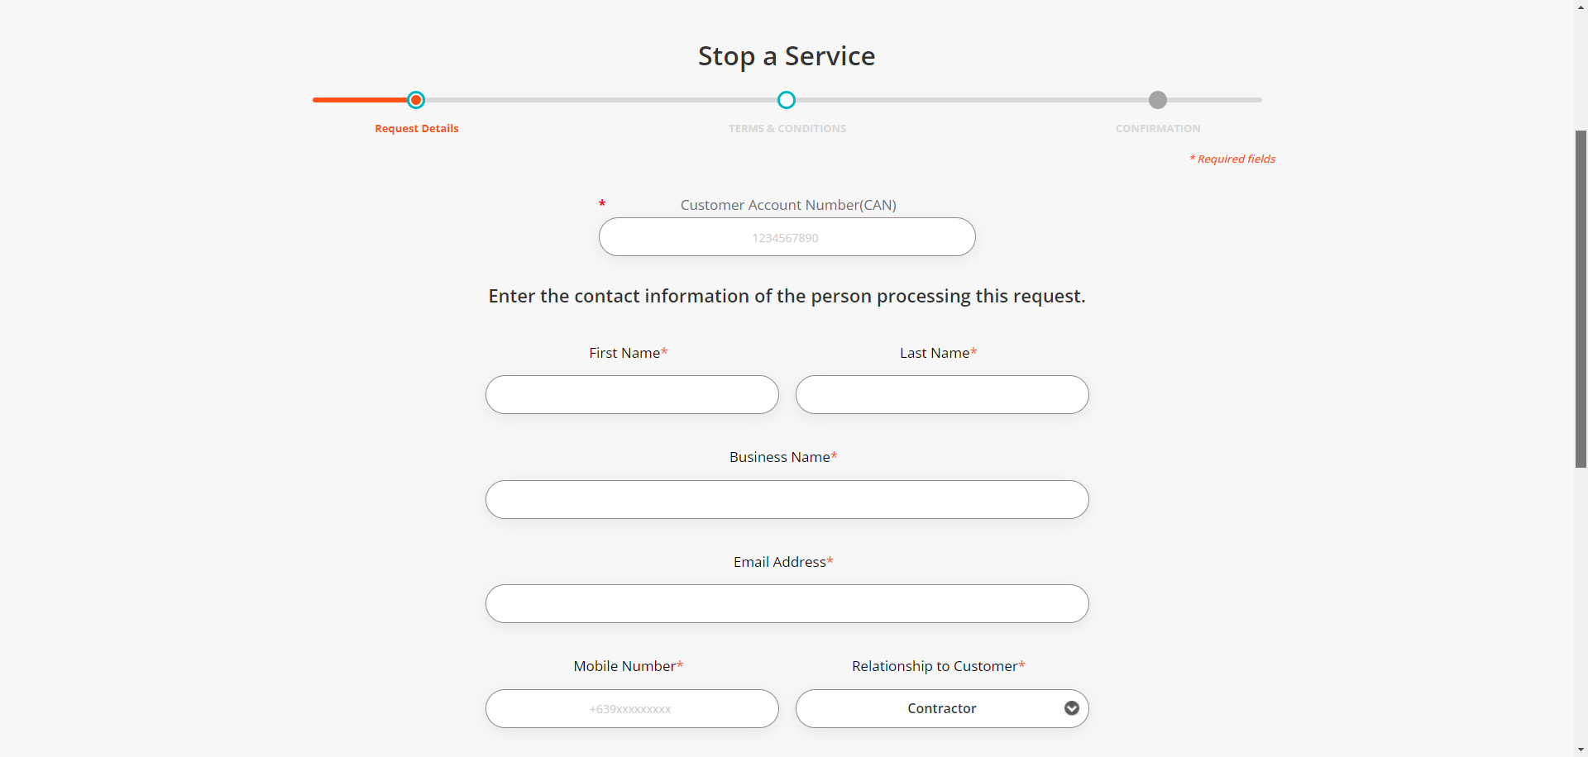

|  |
| --- |
| Step 5 - Populate CAN field |
| CAN field should be populated |

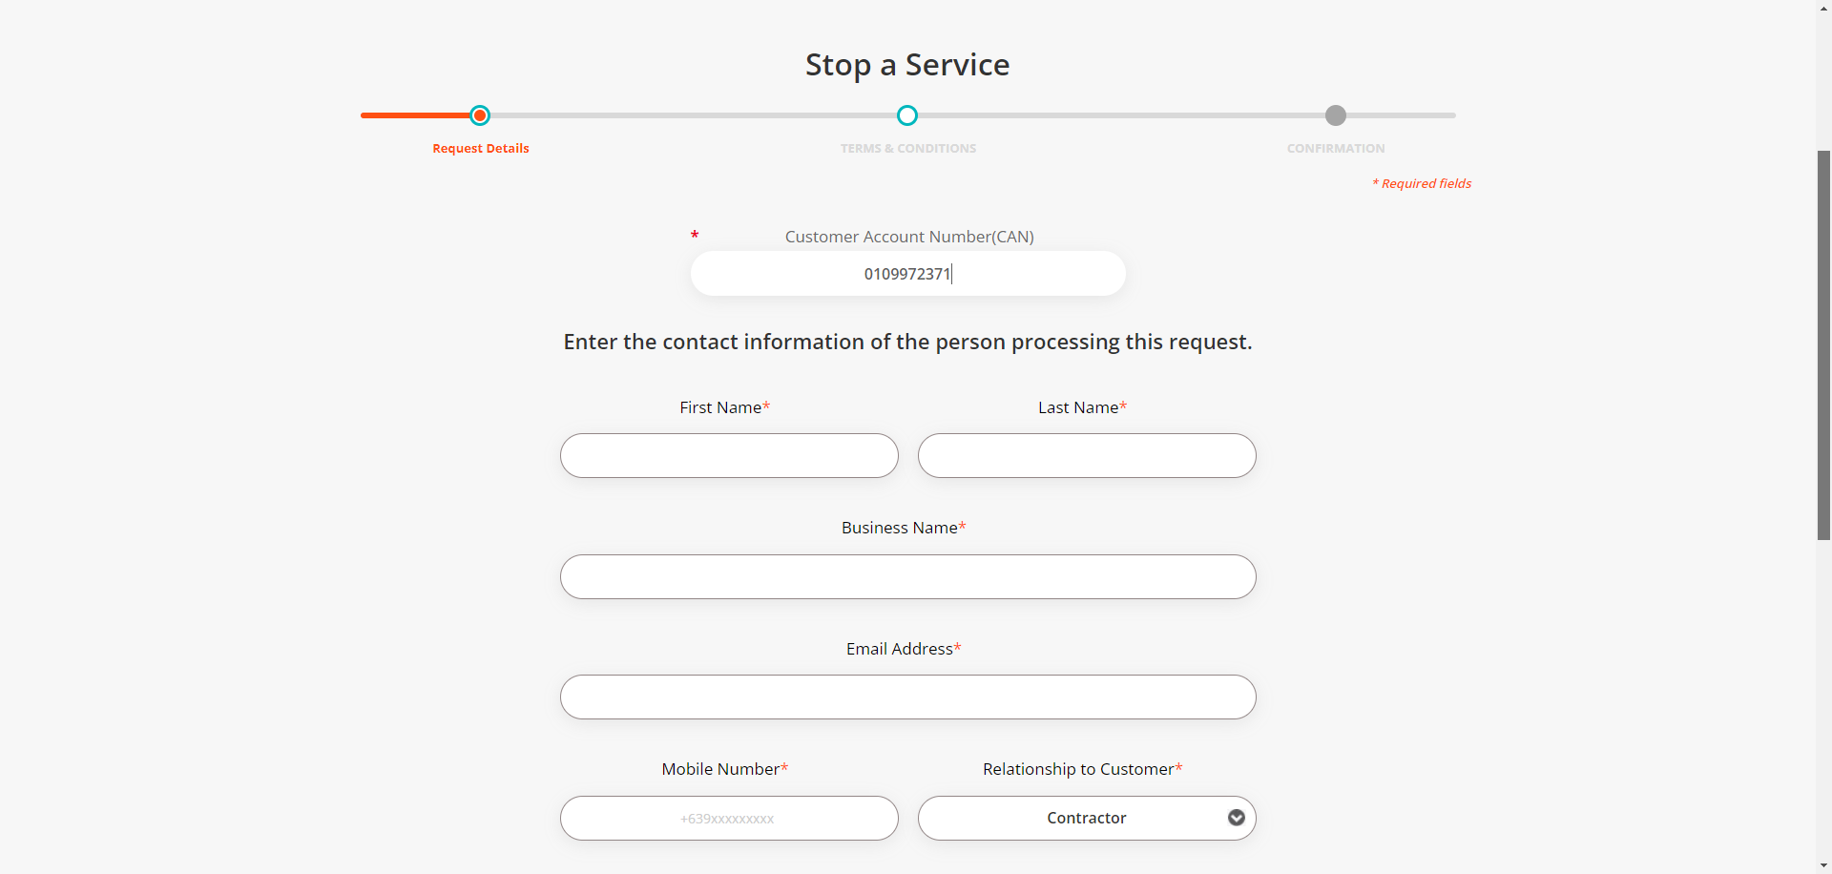

|  |
| --- |
| Step 6 - Populate the following:  First Name*  Last Name*  Business Name*  Email Address*  Mobile Number*  Relationship to Customer*  Notification indicator  > Click Next |
| Fields should be populated; Terms and Conditions tab should be displayed |

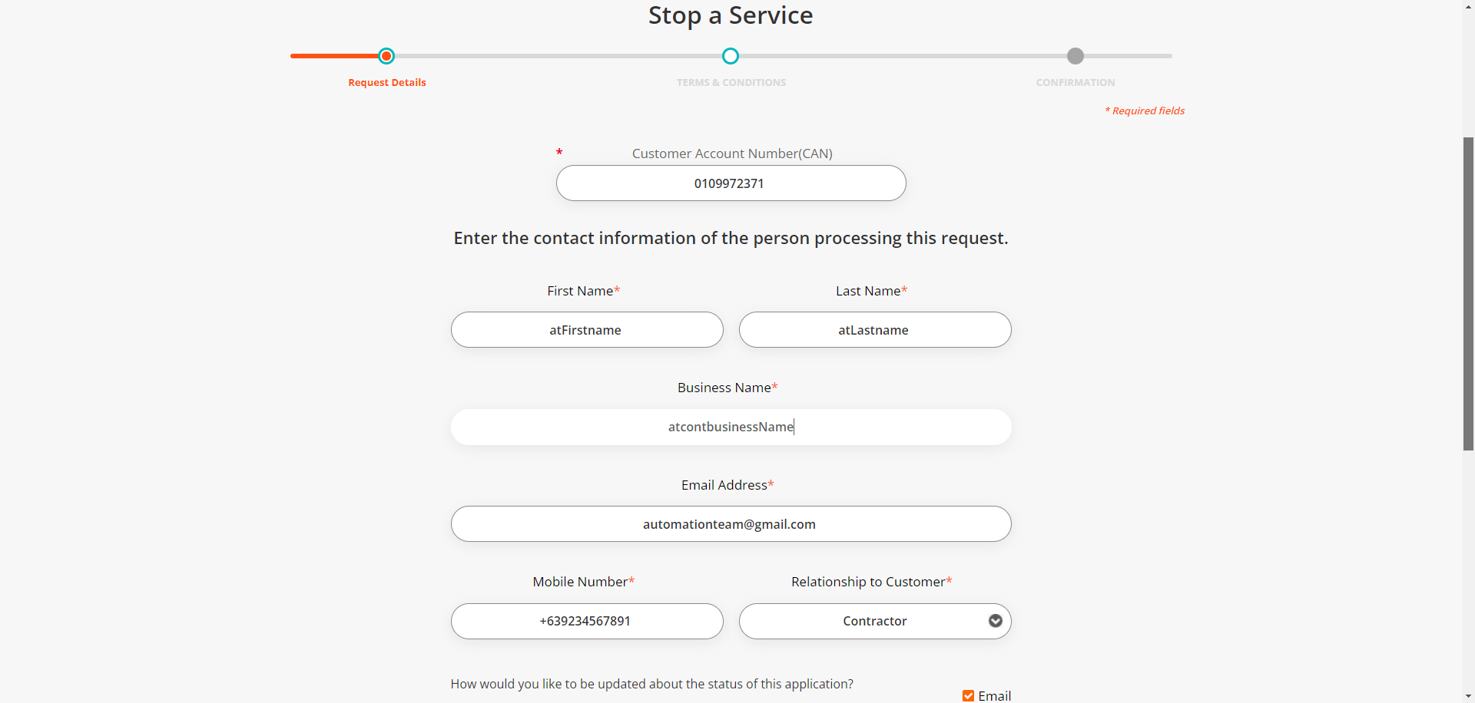

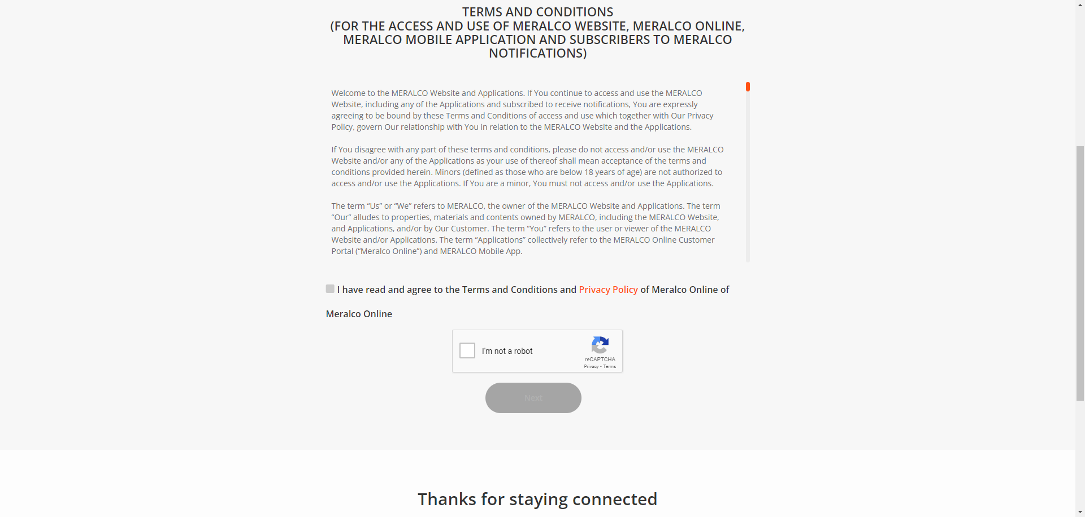

|  |
| --- |
| Step 7 - Tick on I have read and agree to the Meralco Online Terms & Conditions and consent to the processing of my personal data in accordance with the Privacy Policy |
| Submit button should be enabled |

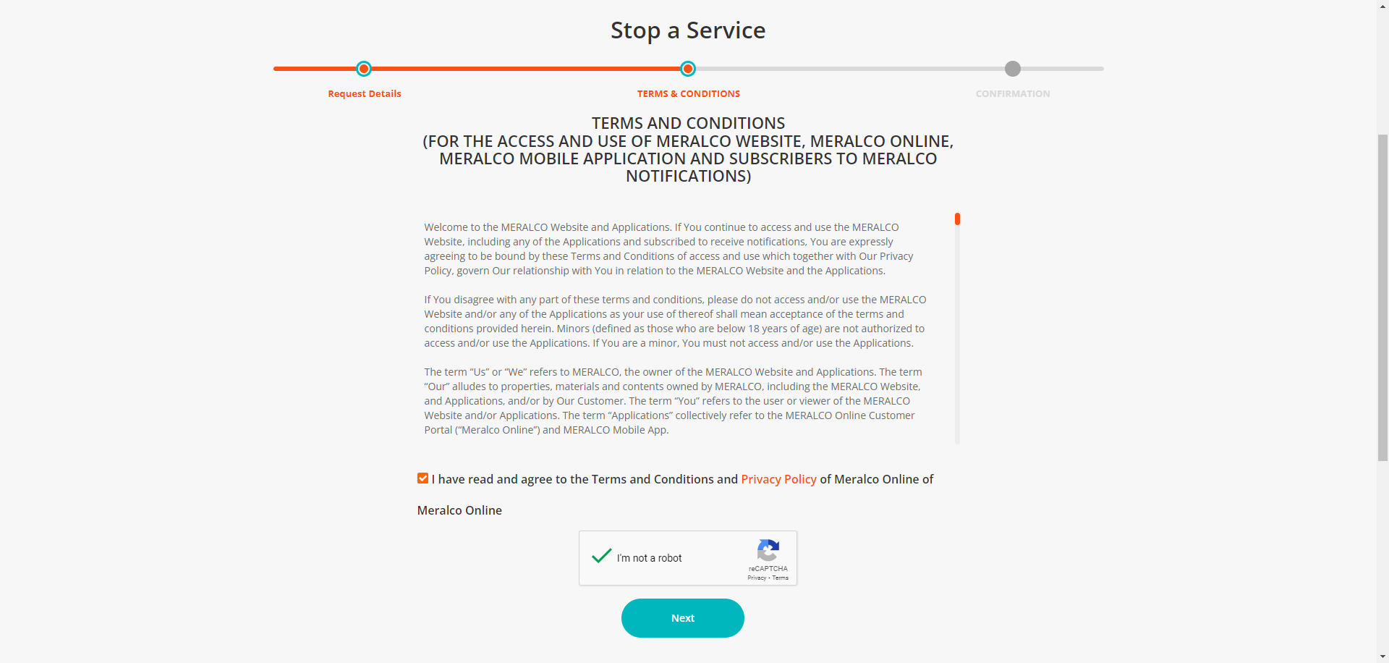

|  |
| --- |
| Step 8 – Click Submit |
| Confirmation tab should be displayed. Case # should be generated. |

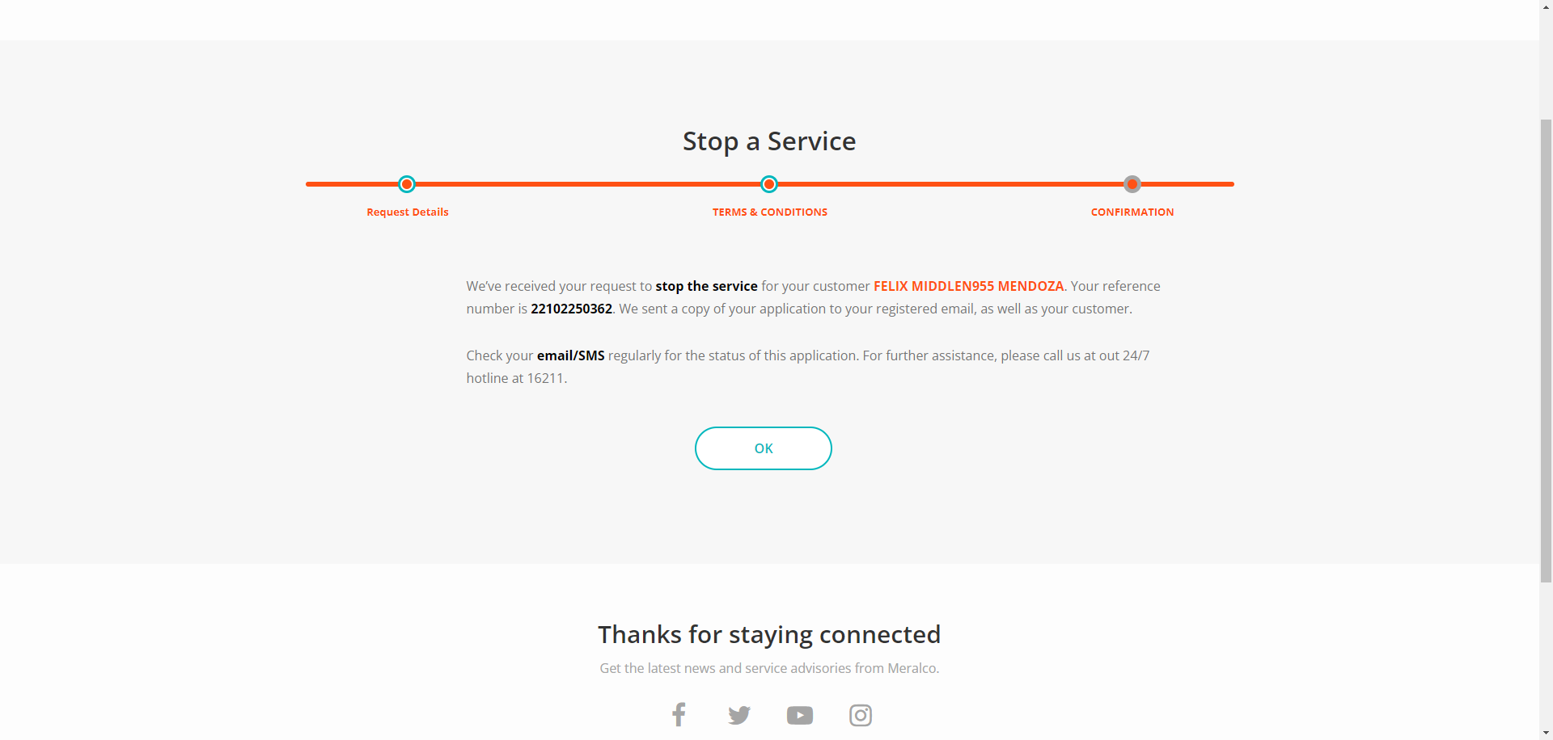



Passed