|  |
| --- |
| TS017 - Recontract of Electric Service_Individual - Portal |

|  |
| --- |
| TC010_Recontract of Service Application |

|  |
| --- |
| Step 1 - Login to Meralco Online |
| User should be logged in to Meralco Online |

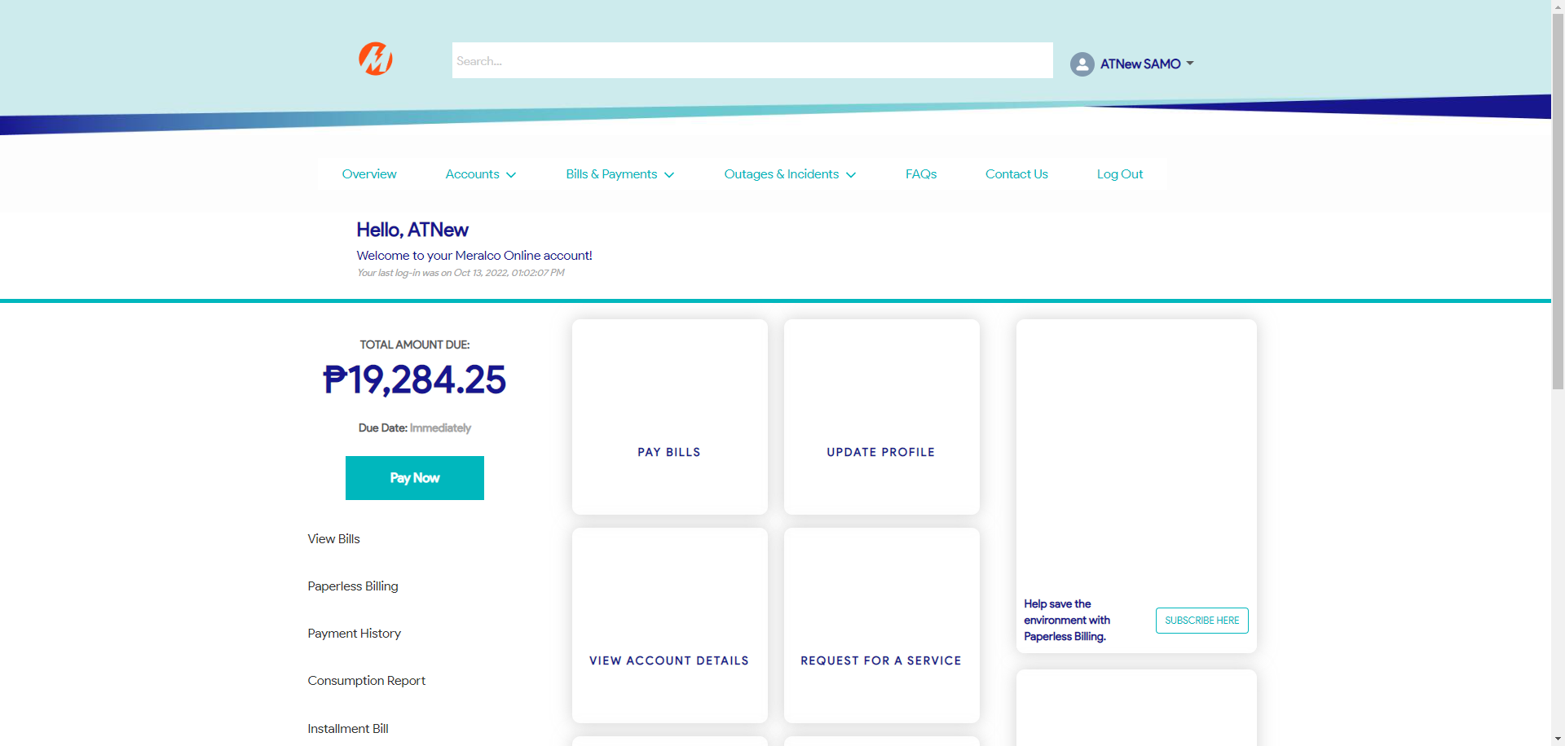

|  |
| --- |
| Step 2 - Go to Accounts> Manage Accounts |
| Accounts page should be displayed |

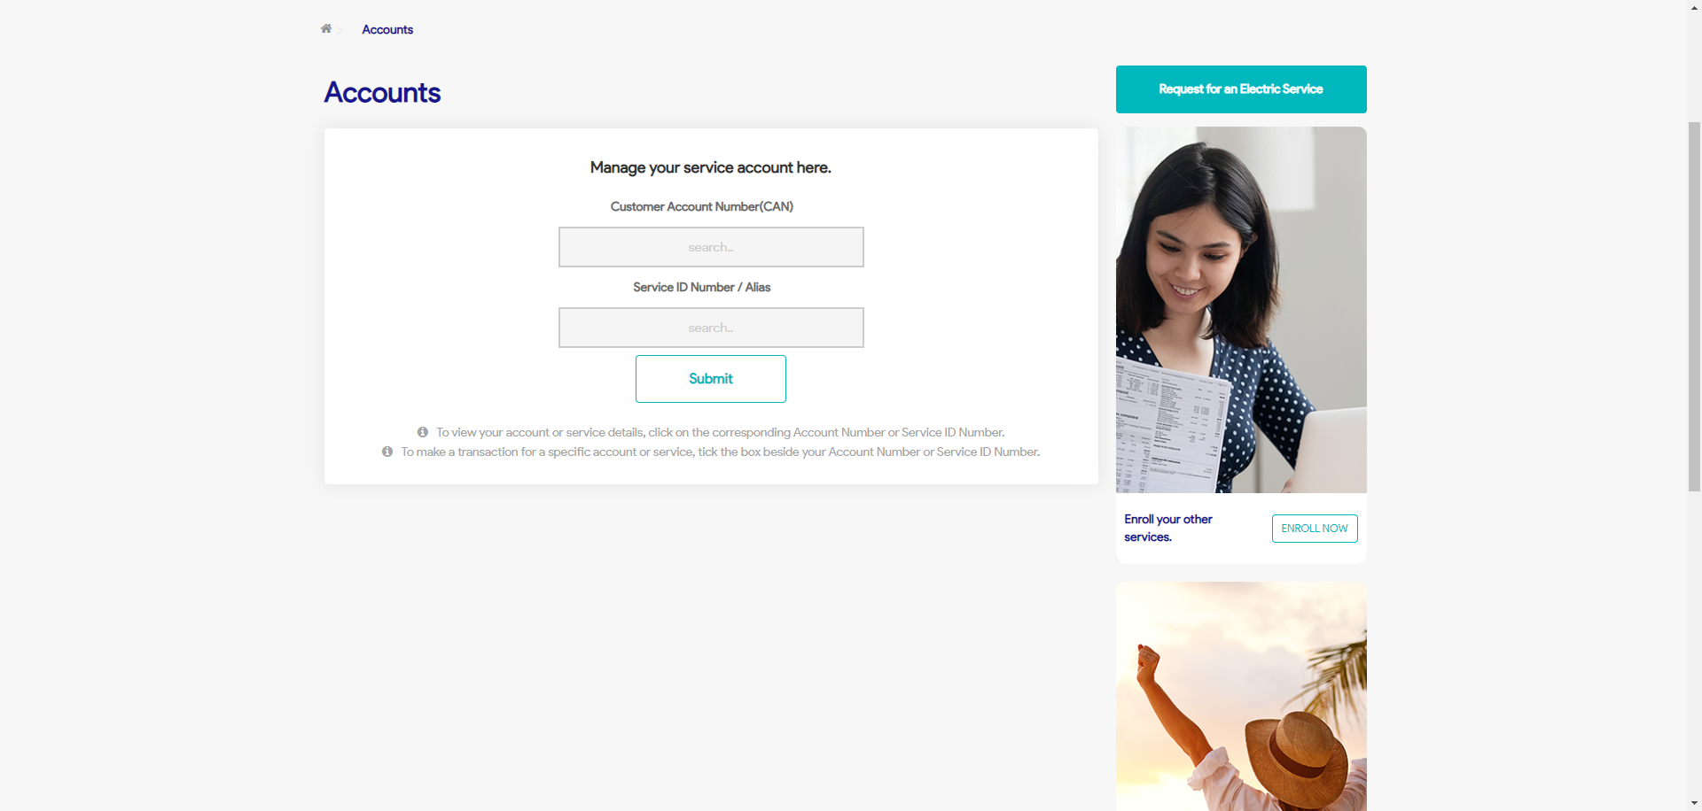

|  |
| --- |
| Step 3 - Search then Select Account > Click Reactivate Electric Service button |
| Request page for Reactivate Electric Service should be displayed |

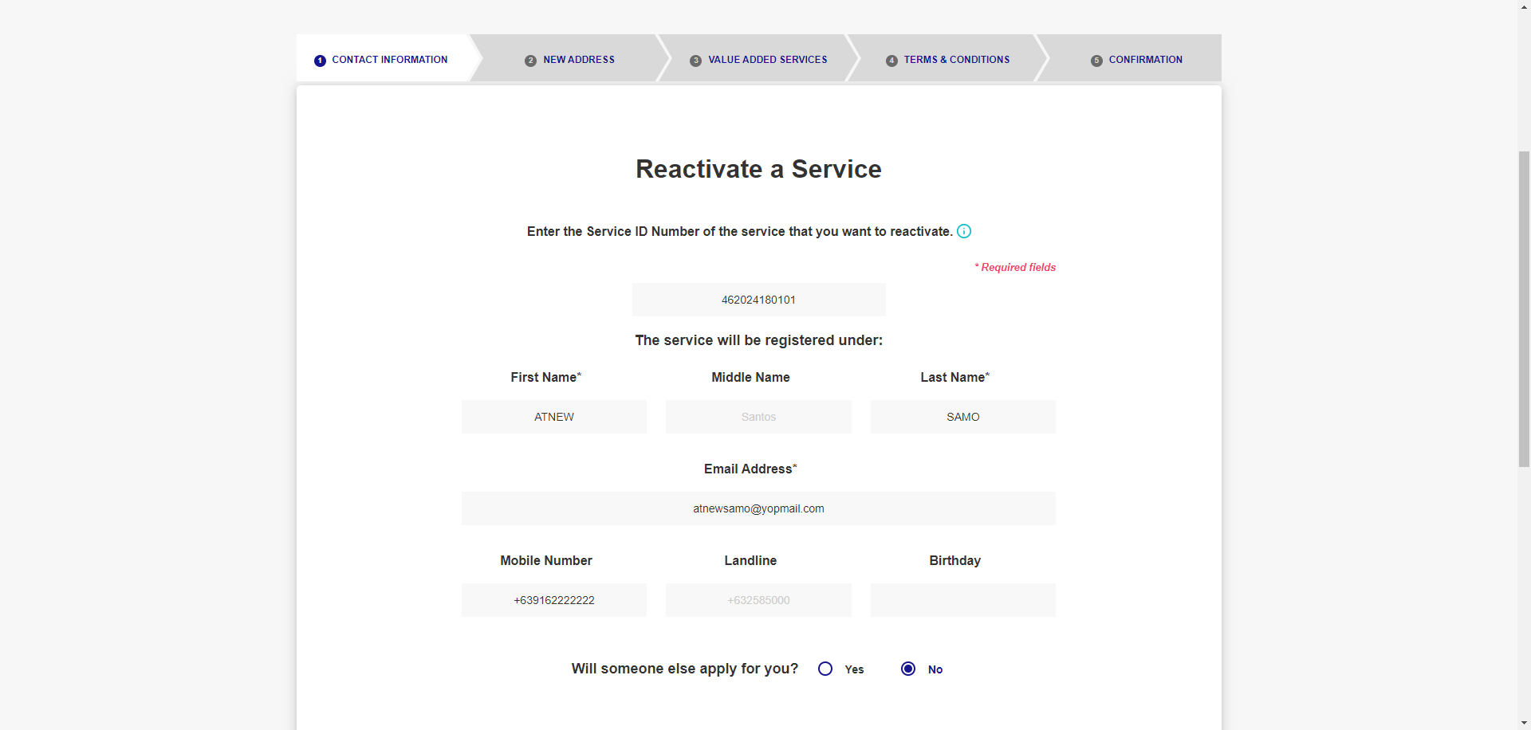



|  |
| --- |
| Step 4 - Populate the following: SIN First Name Middle Name (Optional) Last Name Email Address Mobile Number (optional) Landline (optional) Birthday (optional) Representative indicator Click Next |
| Fields should be populated; New Address tab should be displayed |



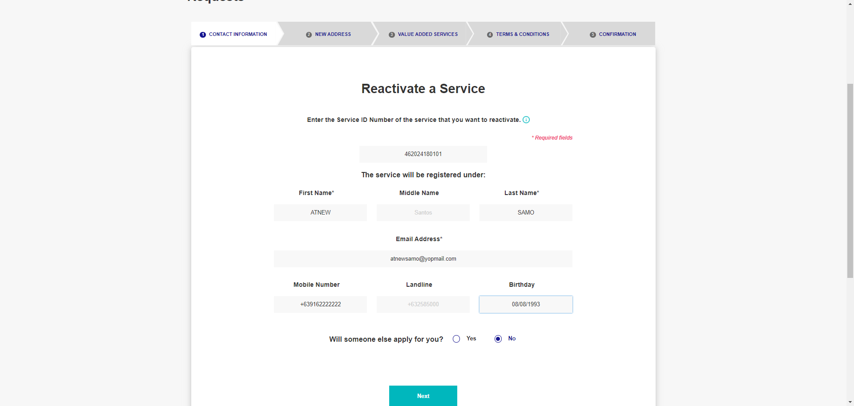

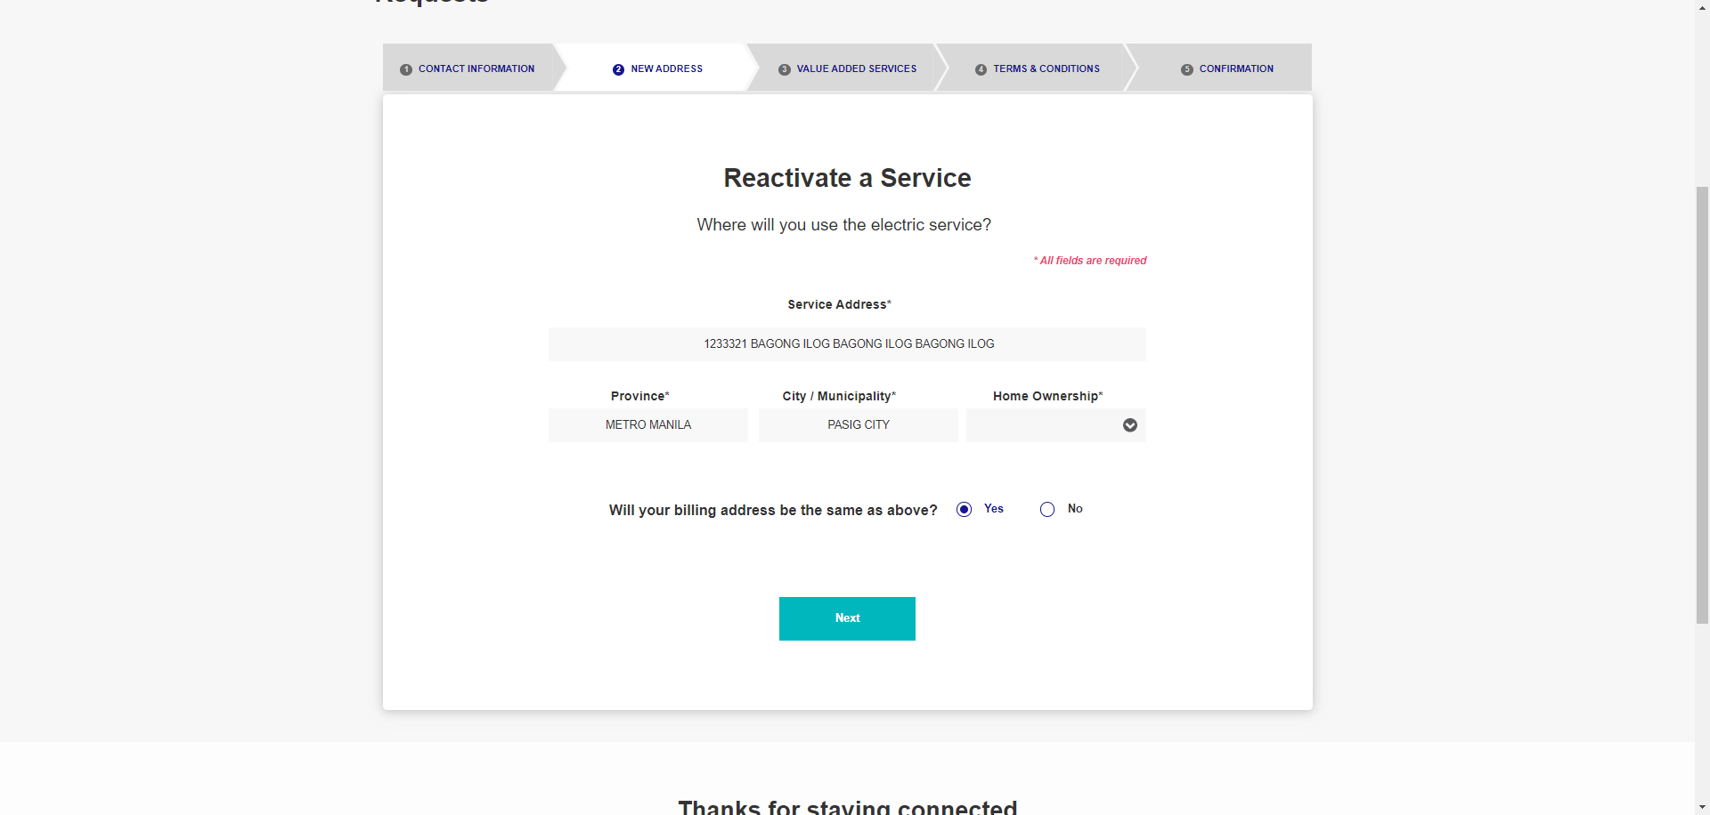

|  |
| --- |
| Step 5 - Populate the following: Service Address Province City / Municipality Home Ownership Billing Address Indicator |
| Fields should be populated; Value Added Service tab should be displayed |

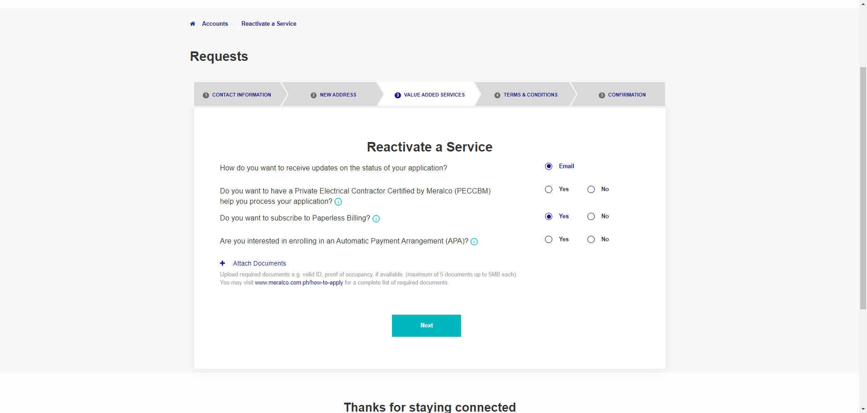



|  |
| --- |
| Step 6 - Populate the following: Notification indicator AMC indicator Paperless Billing indicator APA indicator > Attach documents > Click Next |
| Fields should be populated; Terms and Conditions tab should be displayed |



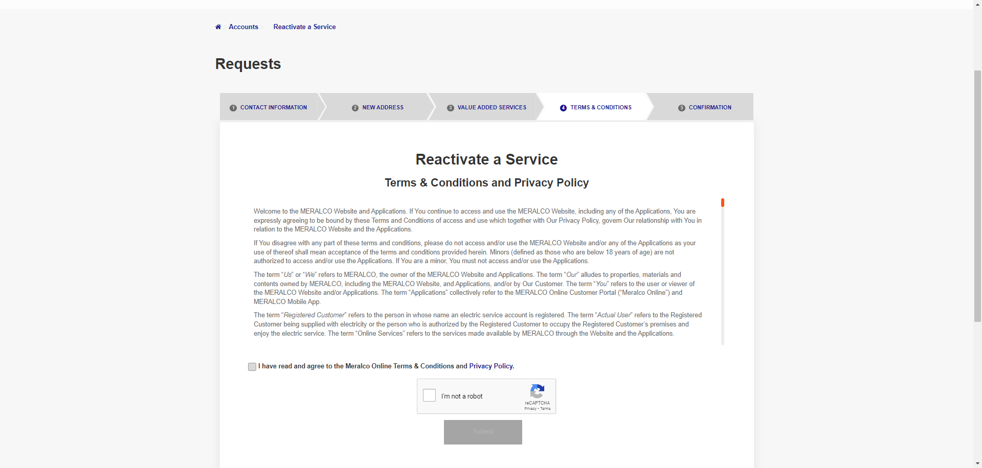

|  |
| --- |
| Step 7 - Tick on I have read and agree to the Meralco Online Terms & Conditions and consent to the processing of my personal data in accordance with the Privacy Policy |
| Submit button should be enabled |

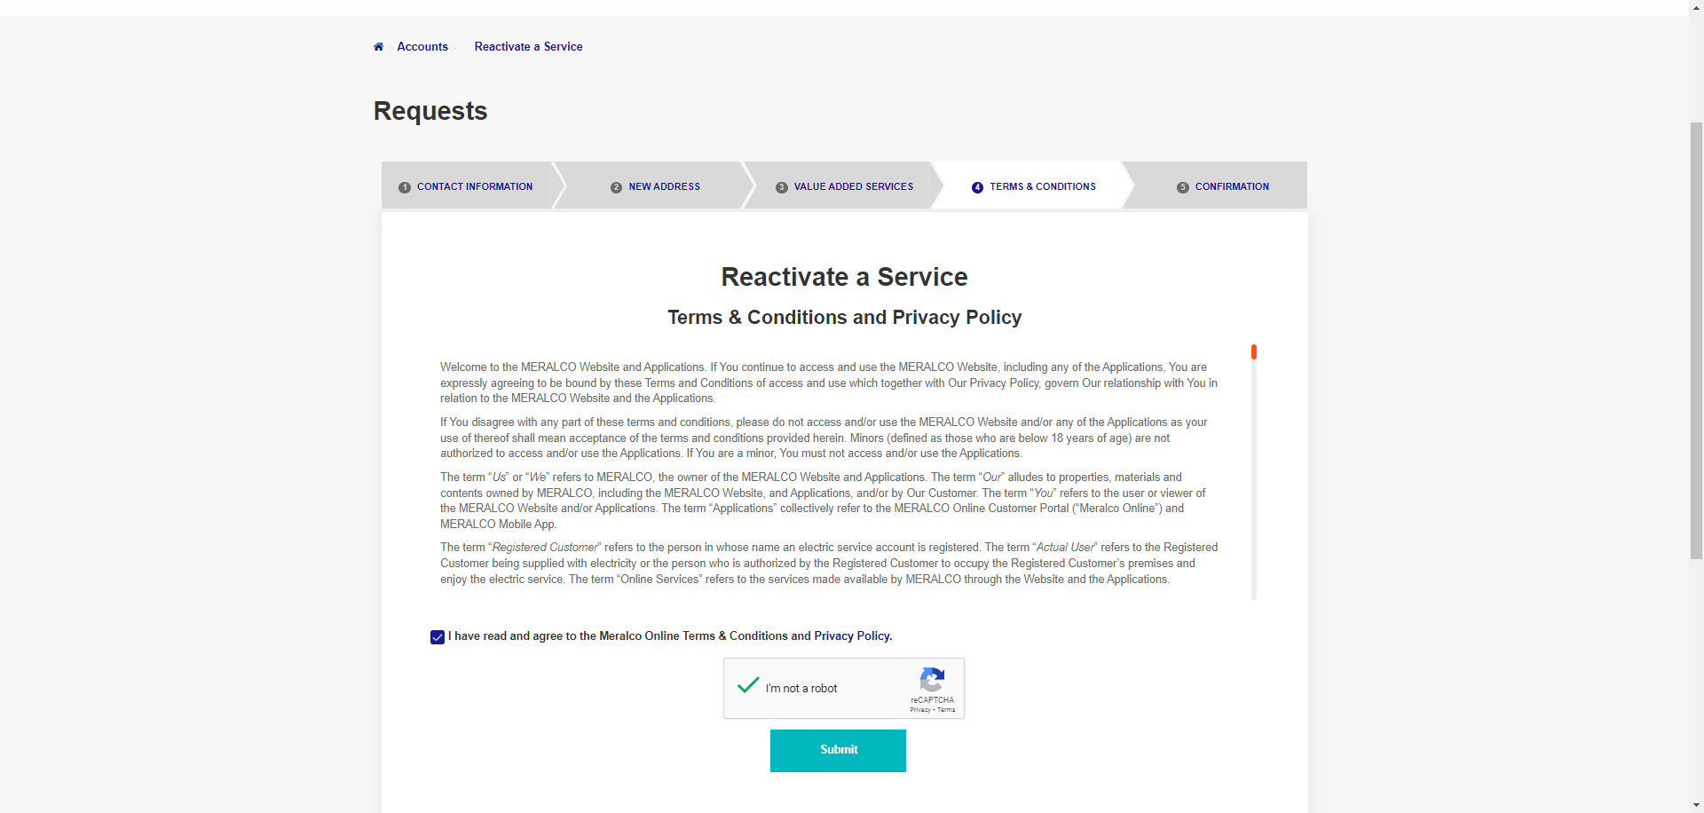

|  |
| --- |
| Step 8 - Click Submit |
| Confirmation tab should be displayed. Case # should be generated. |

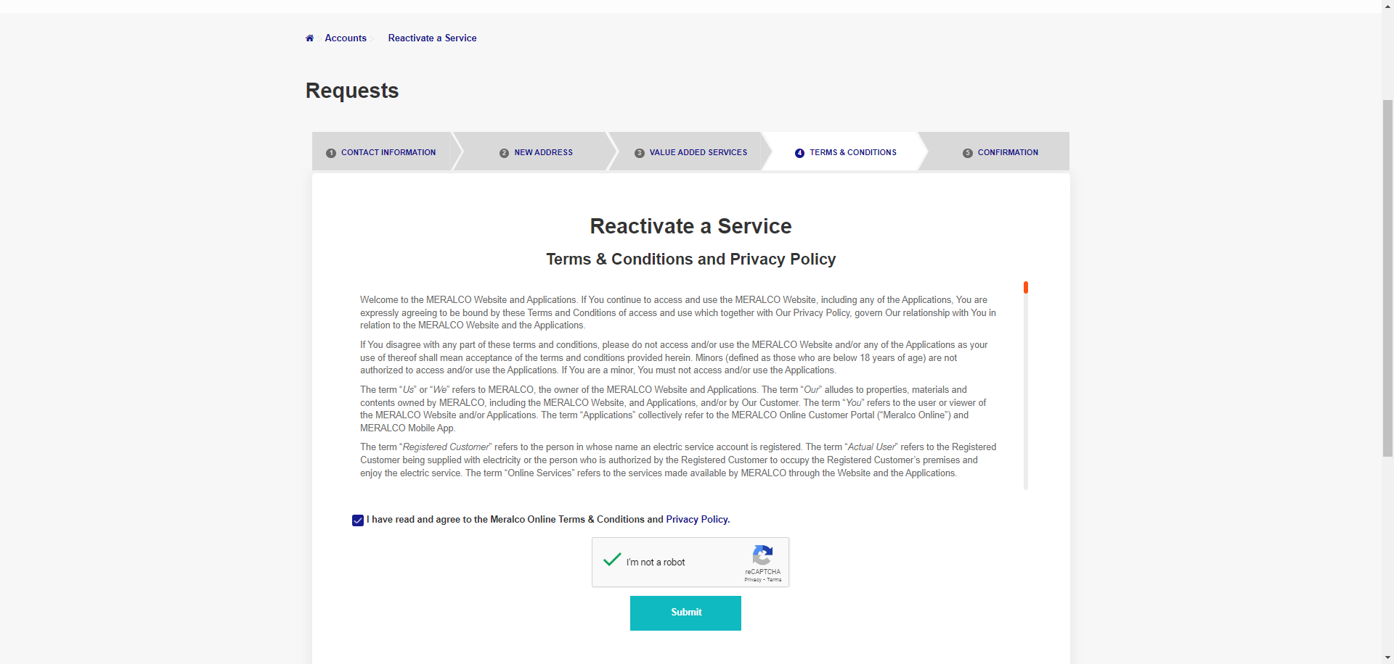

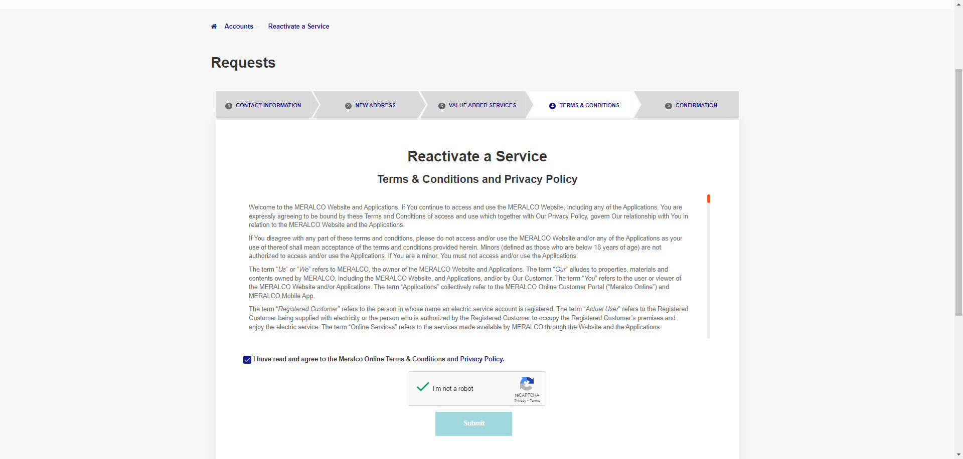

Passed