|  |
| --- |
| TS032 - |

|  |
| --- |
| TC012_Modification of Business Service via CXE Apply |

|  |
| --- |
| Step 1 - Go to https://fuat-meralco.cs73.force.com/customers/s/cxe-apply |
| Service Application page should be displayed |

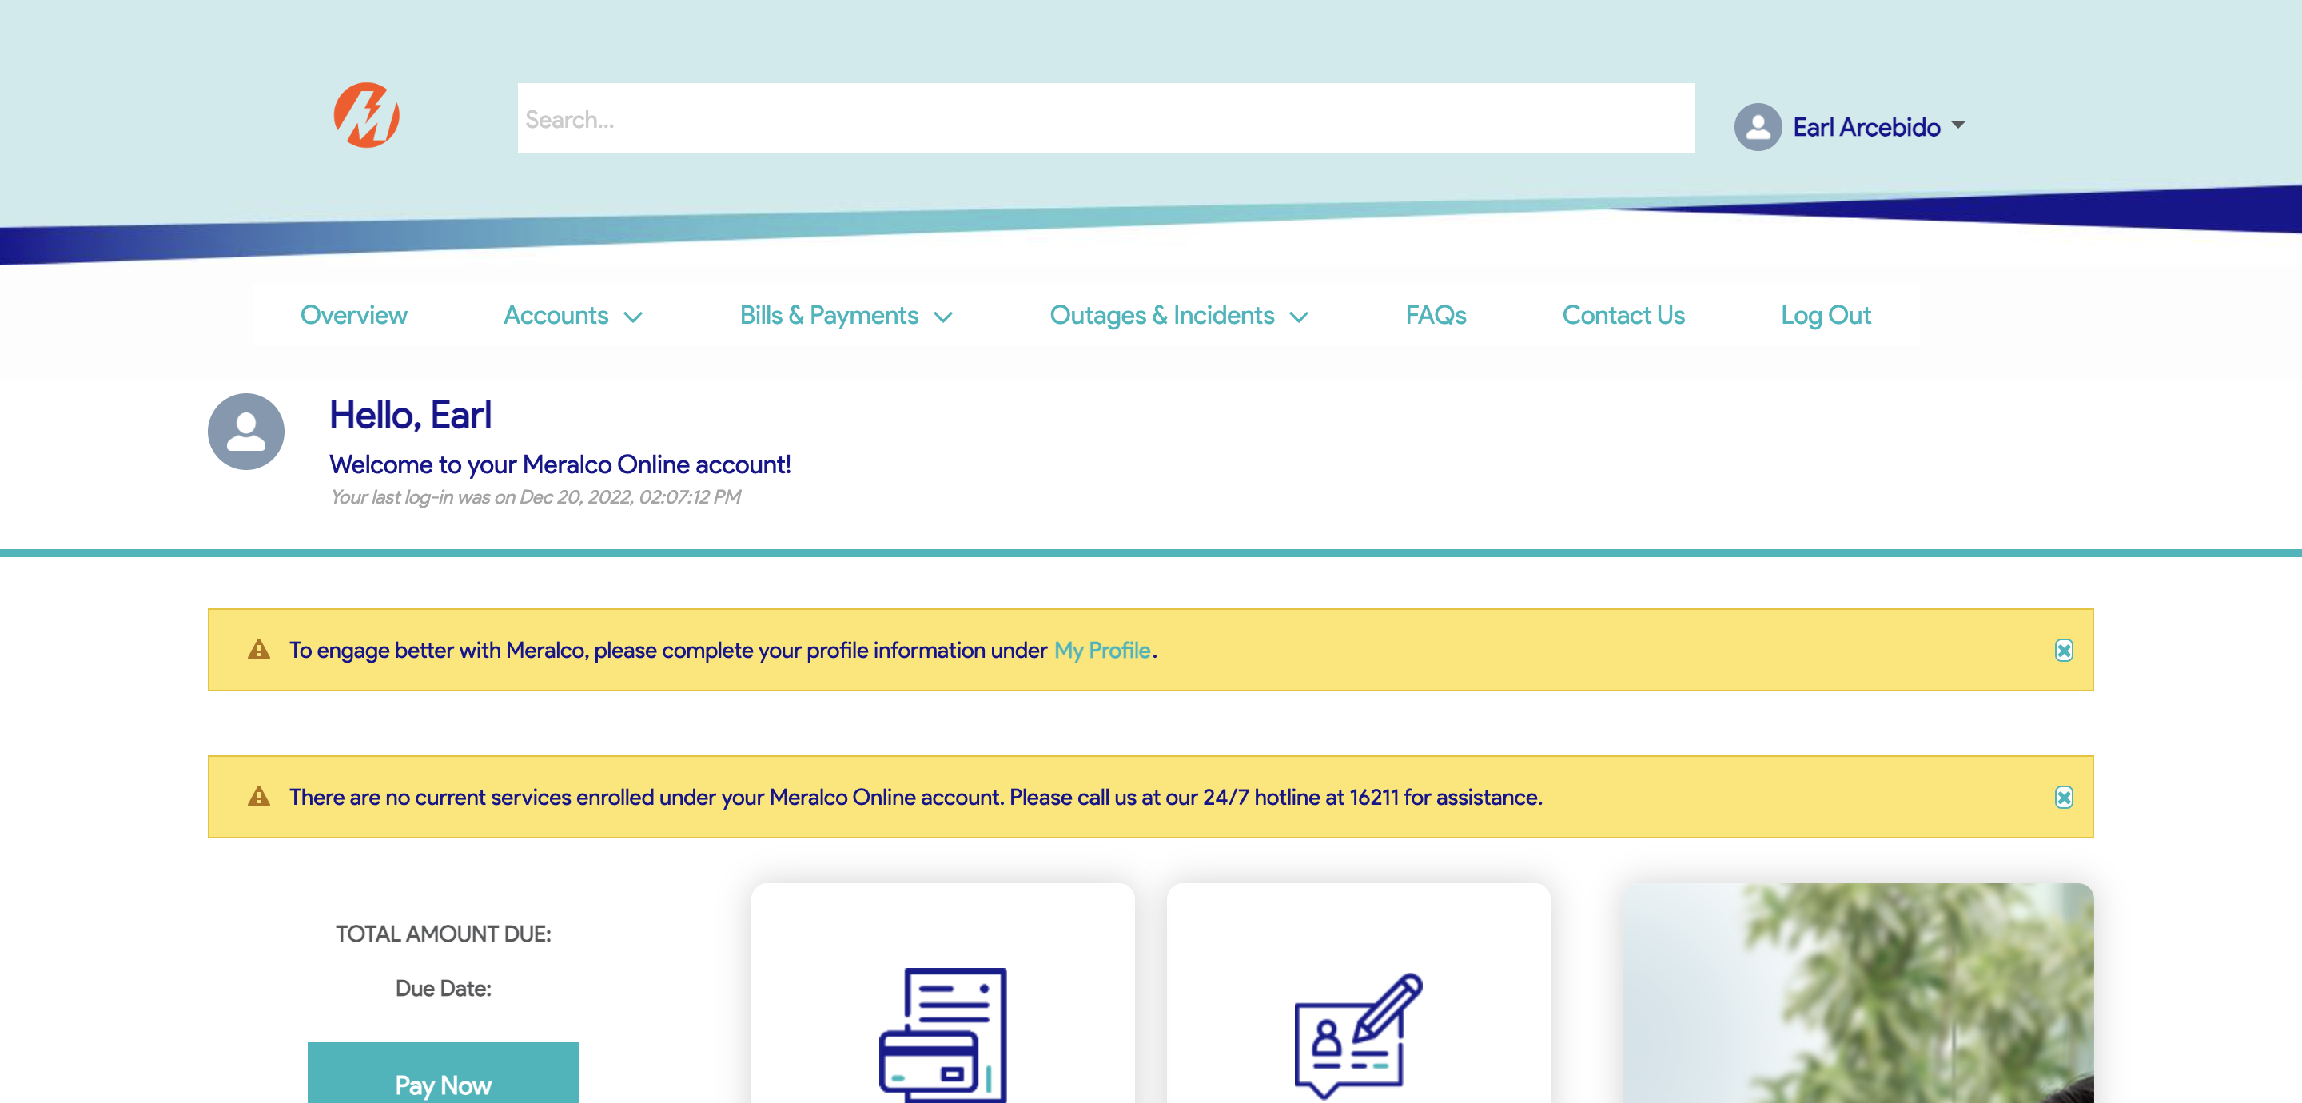

|  |
| --- |
| Step 2 - Click on Business |
| The following should be displayed under Business |

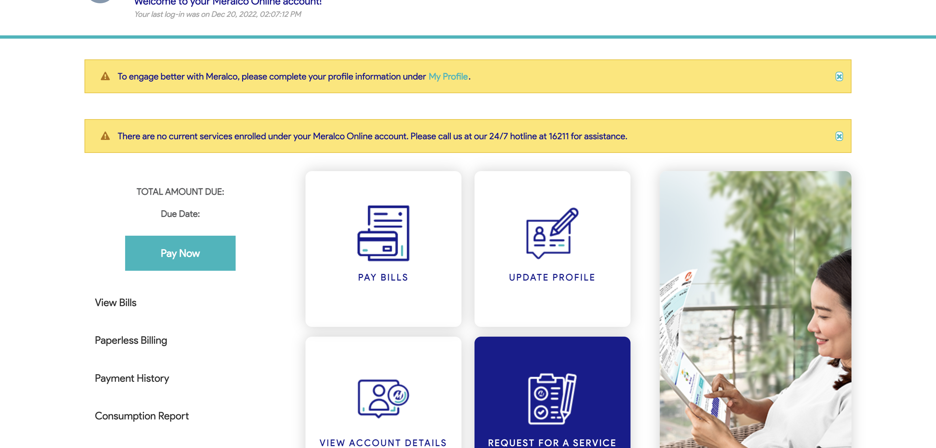

|  |
| --- |
| Step 3 - Click on Modify Service |
| Request page for Modify Service should be displayed |

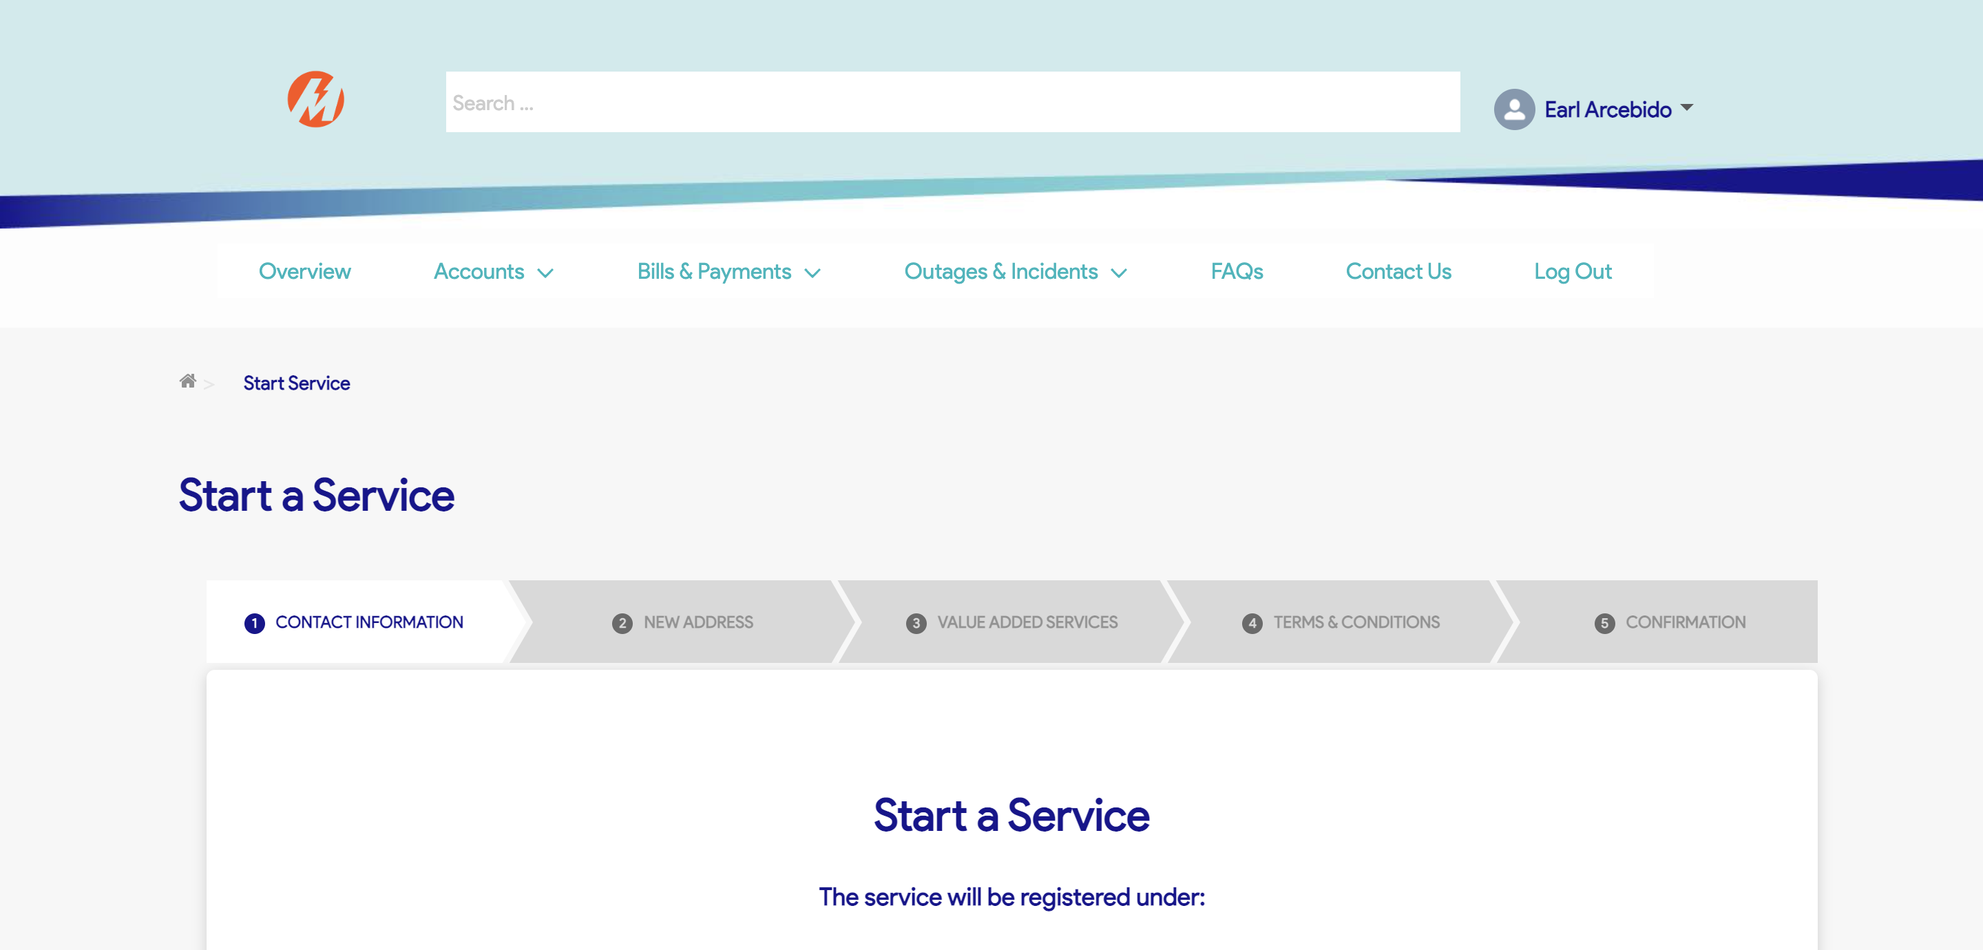

|  |
| --- |
| Step 4 - Validate if CAN field is visible and enabled |
| CAN field should be visible and enabled |

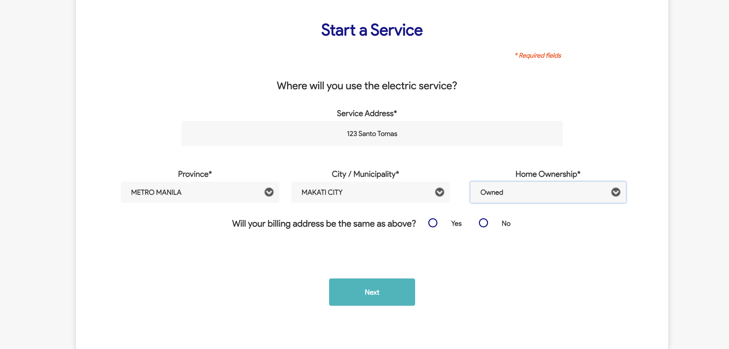

|  |
| --- |
| Step 5 - Populate CAN field |
| CAN field should be populated |

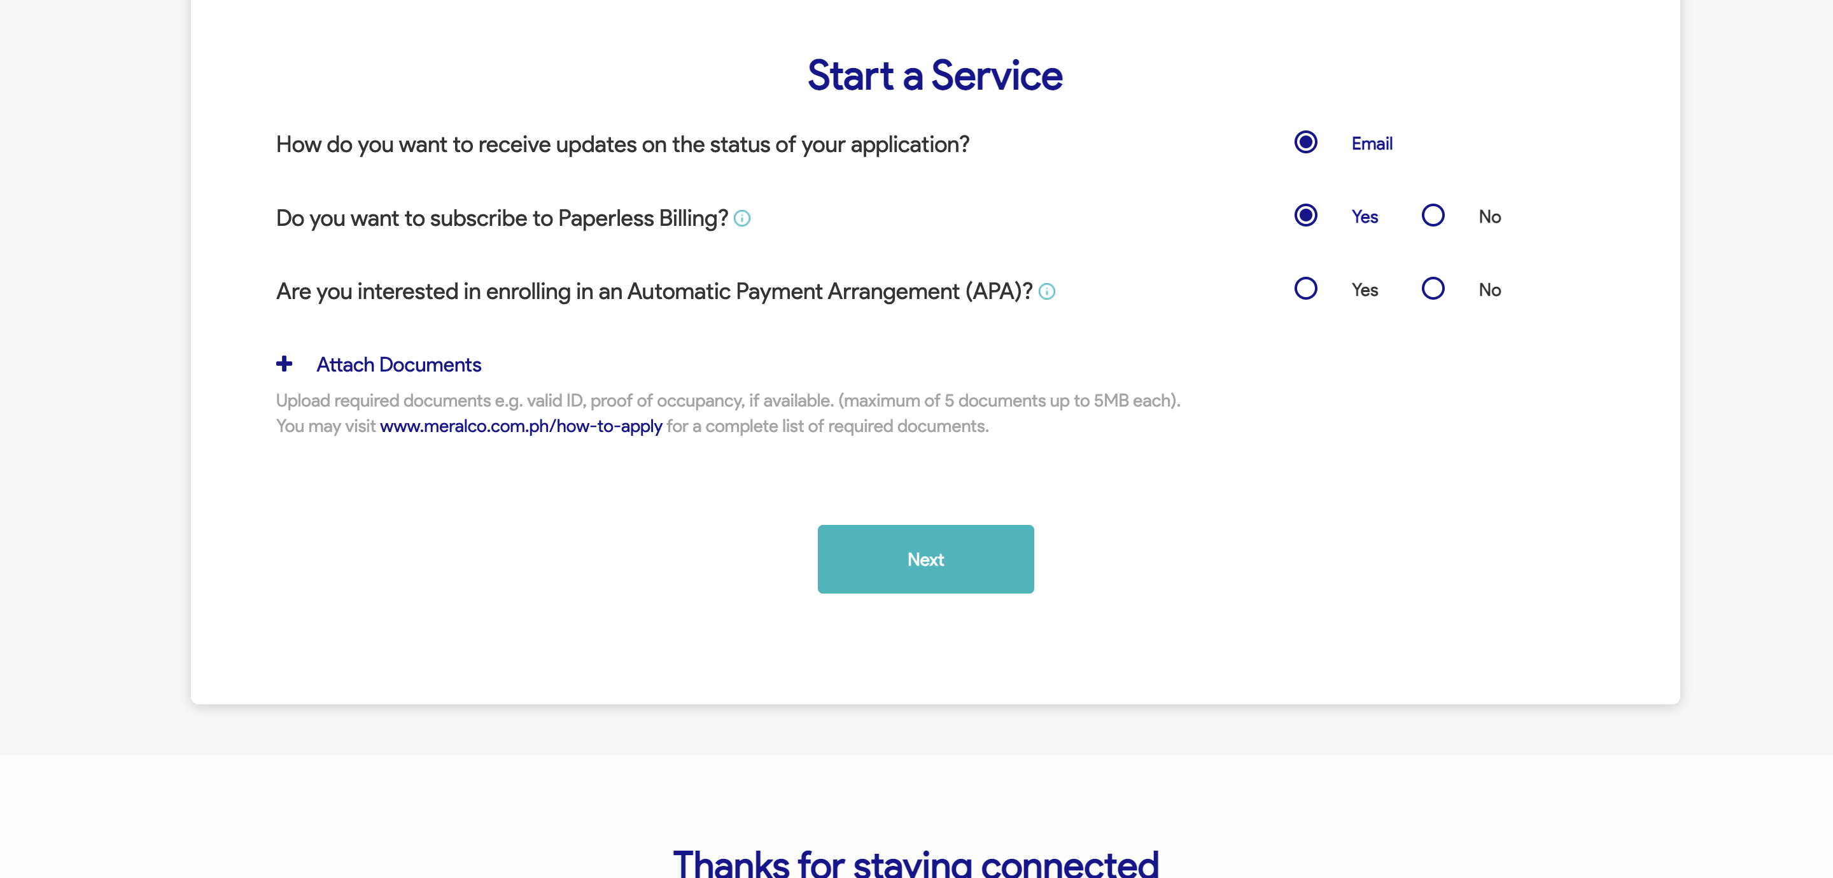

|  |
| --- |
| Step 6 - Tick Change my Contract Details then tick Transfer of Service |
| Transfer of Service should be selected |

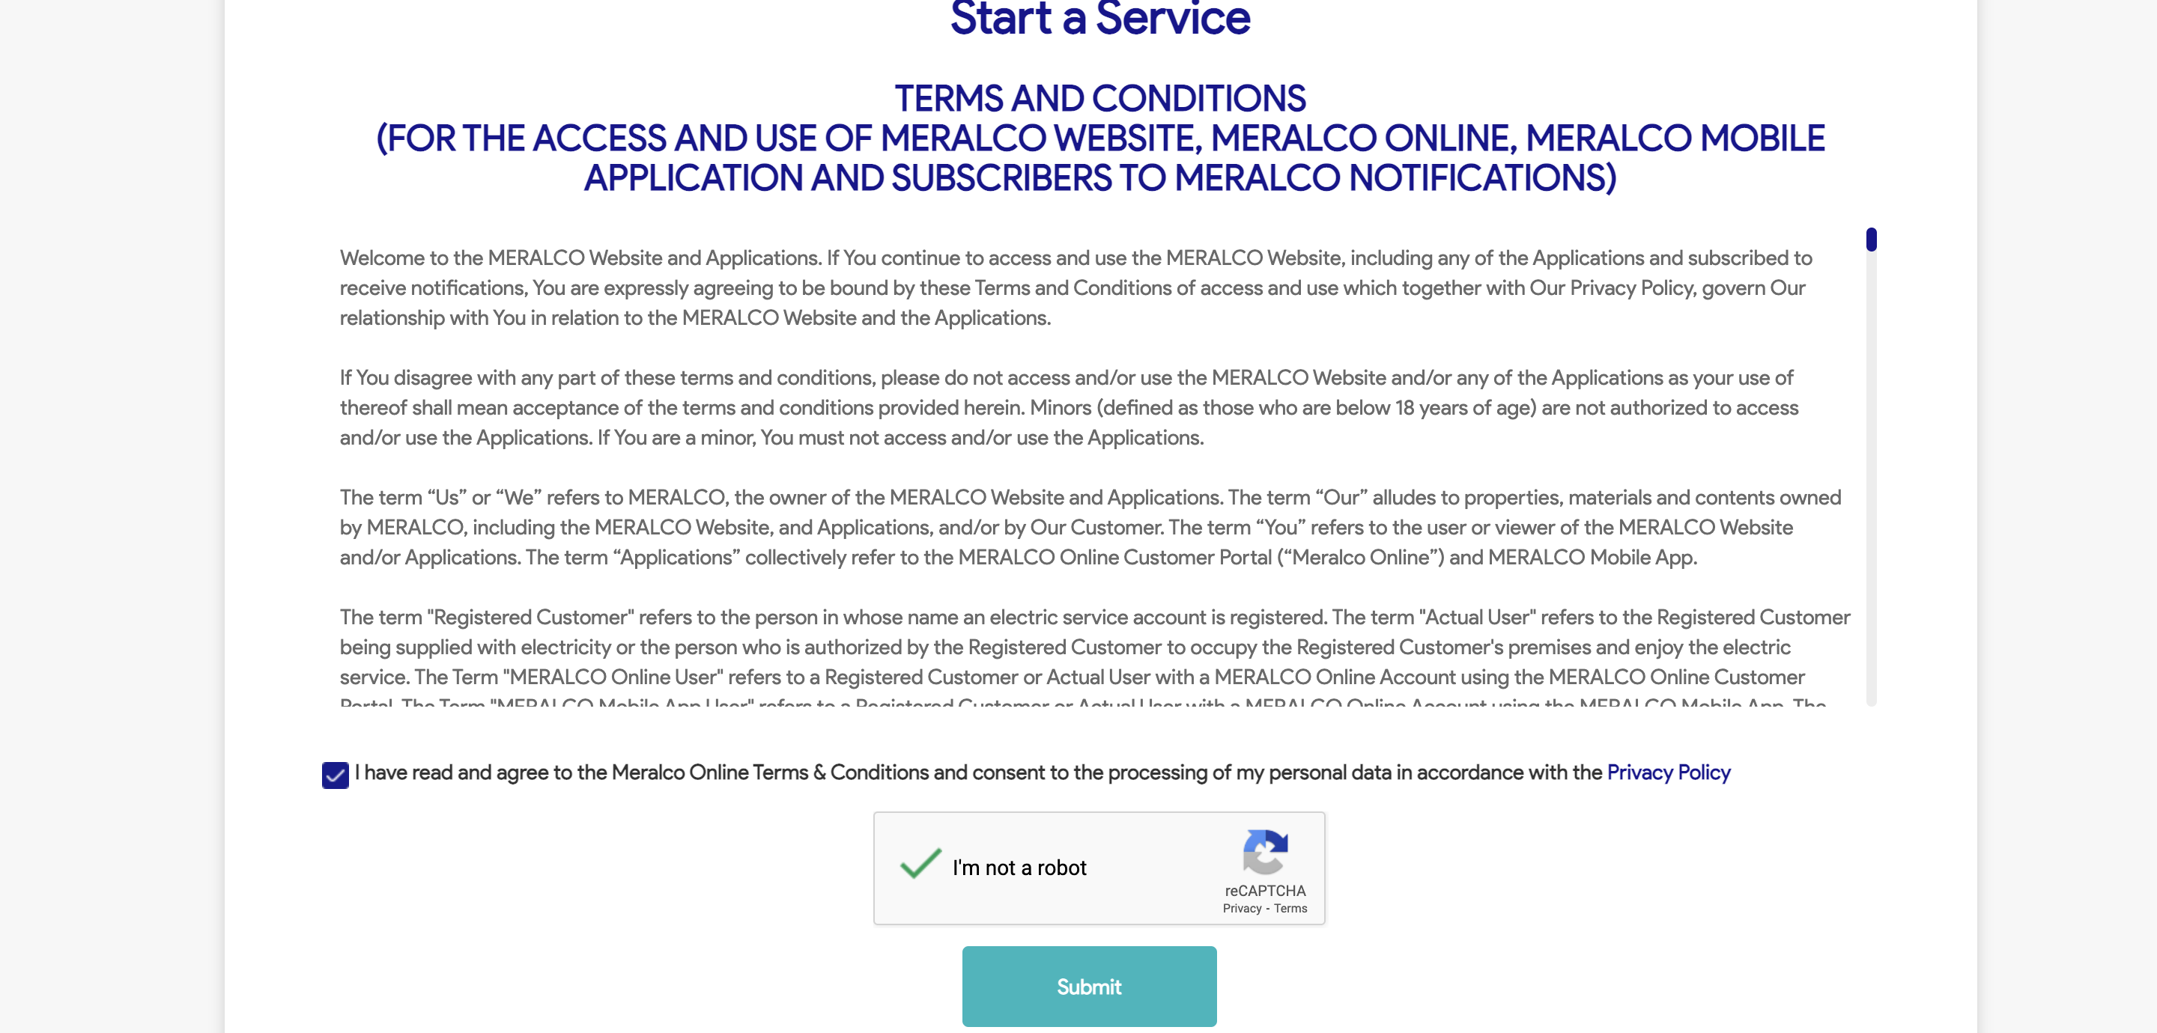

|  |
| --- |
| Step 7 - Populate the following |
| Fields should be populated; Contact Information tab should be displayed |



|  |
| --- |
|  |

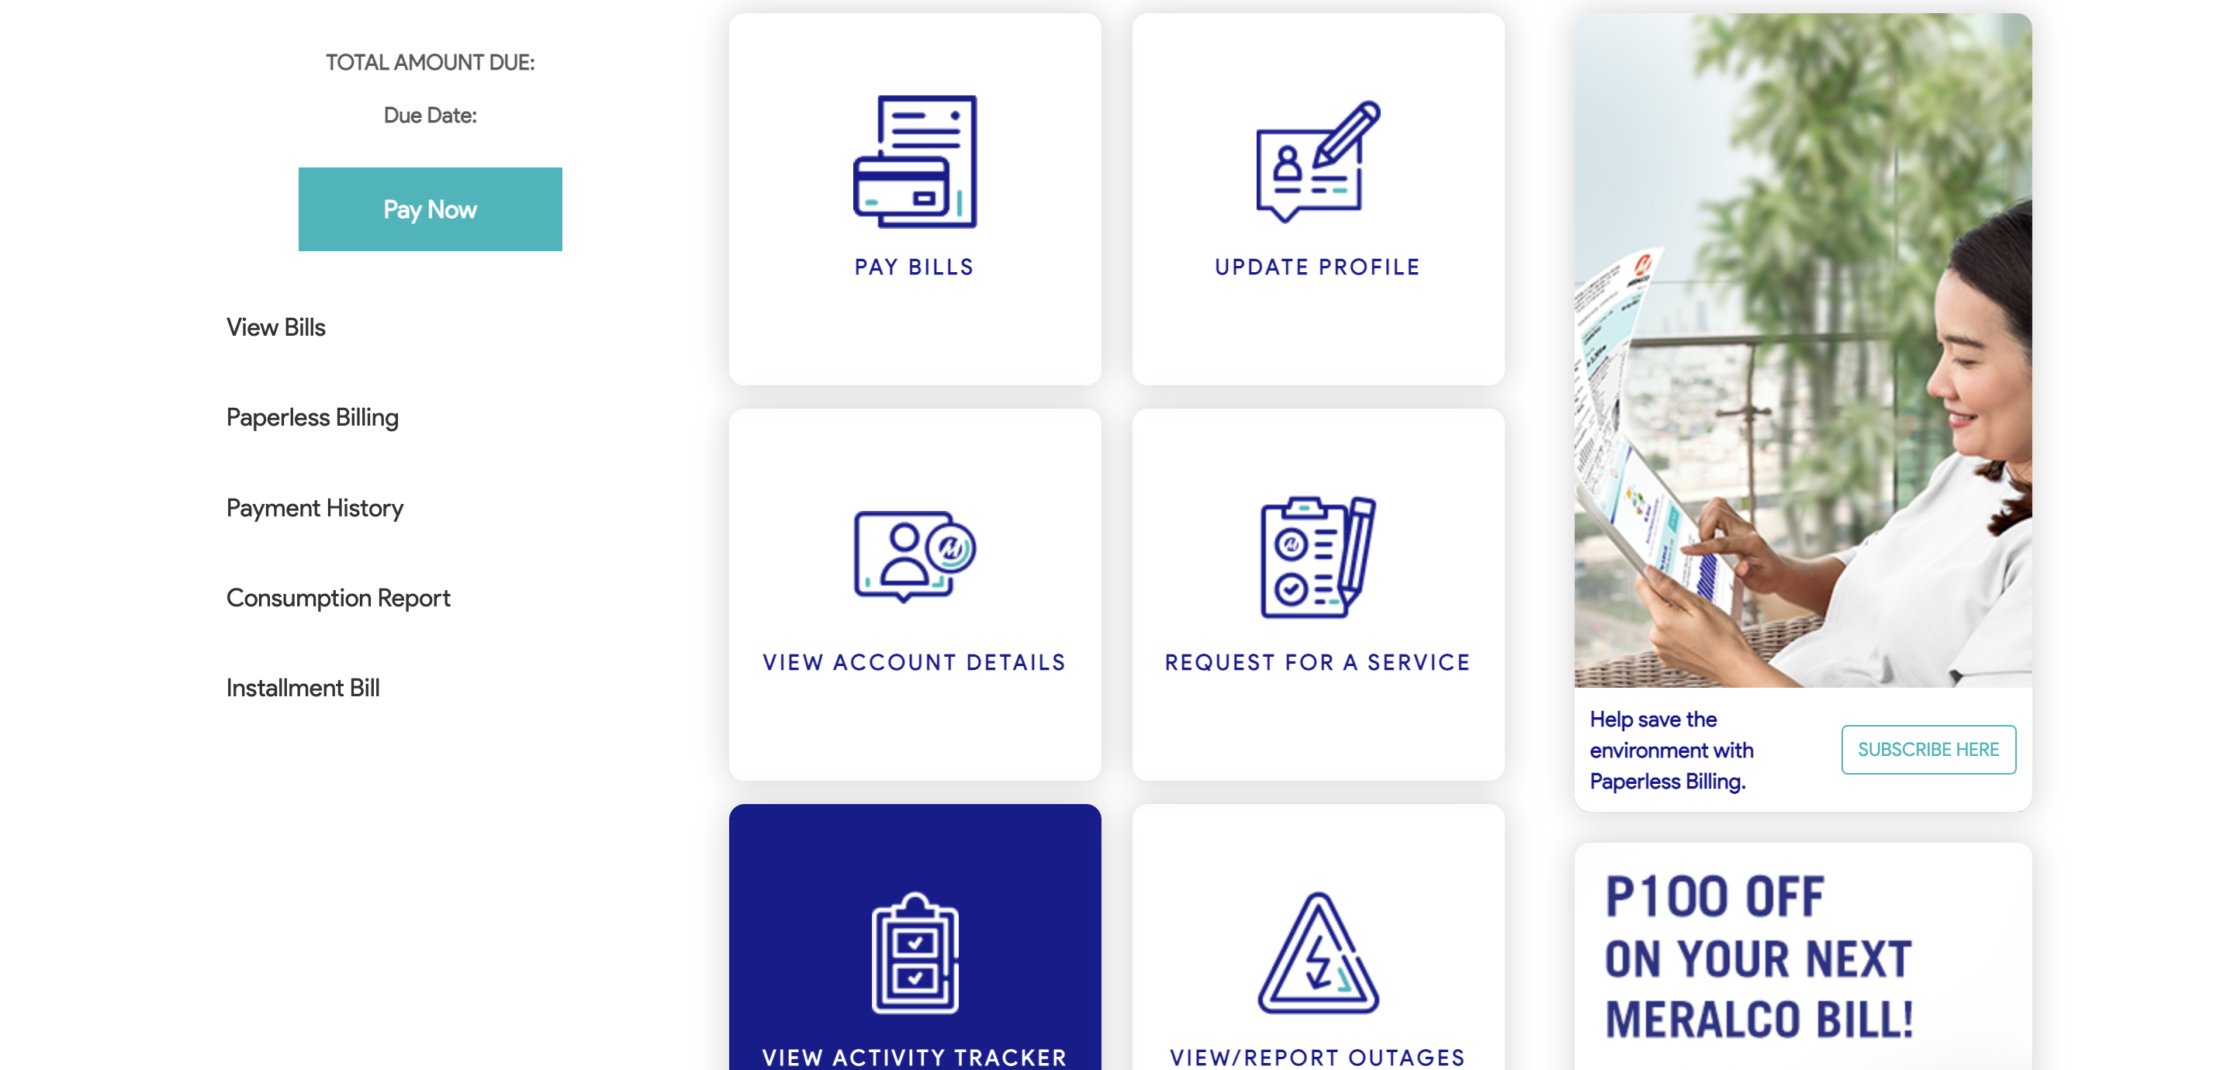

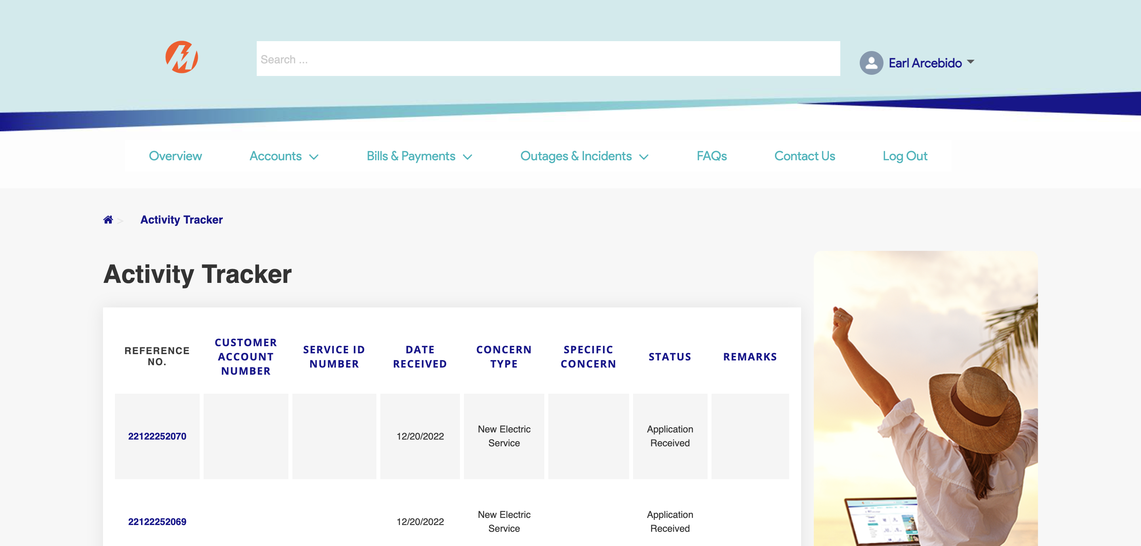

|  |
| --- |
| TC014_Termination of Individual Service via CXE Apply |

|  |
| --- |
| Step 1 - Go to https://fuat-meralco.cs73.force.com/customers/s/cxe-apply |
| Service Application page should be displayed |

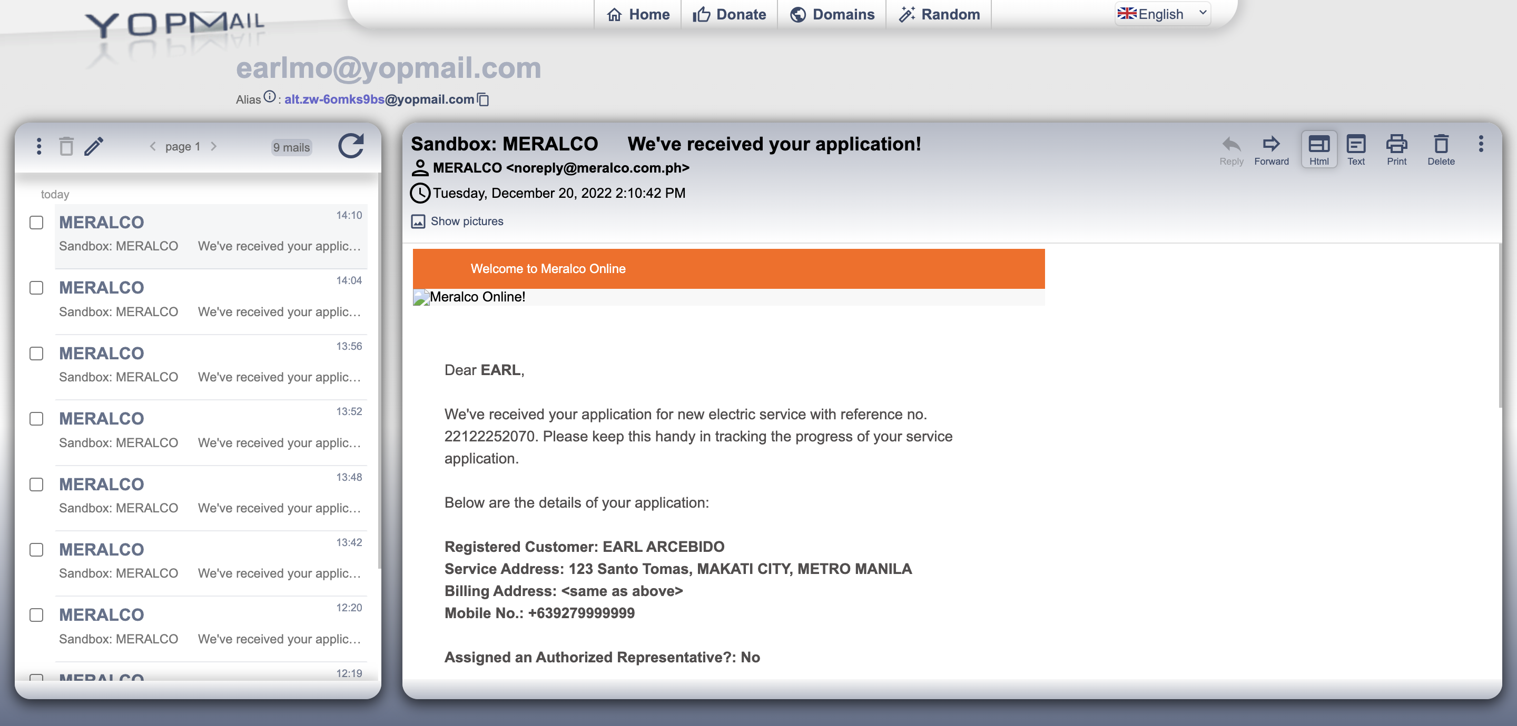

Passed