|  |
| --- |
| TS035 - |

|  |
| --- |
|  |

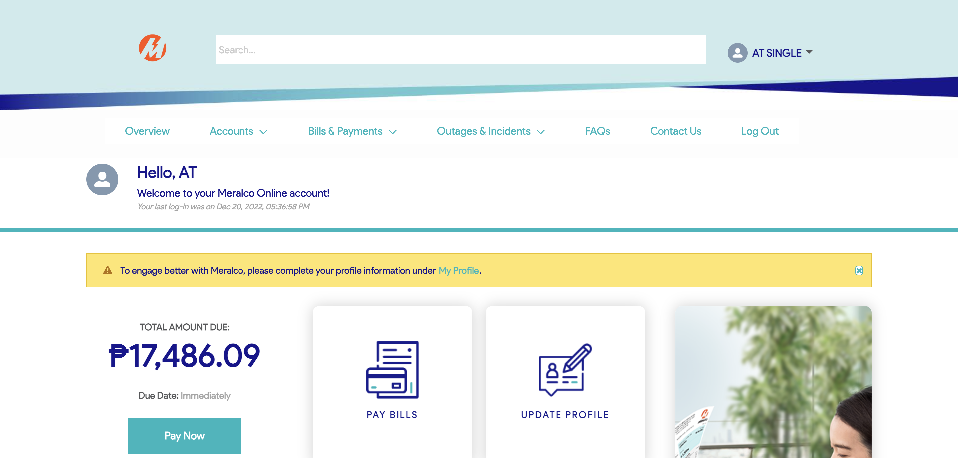

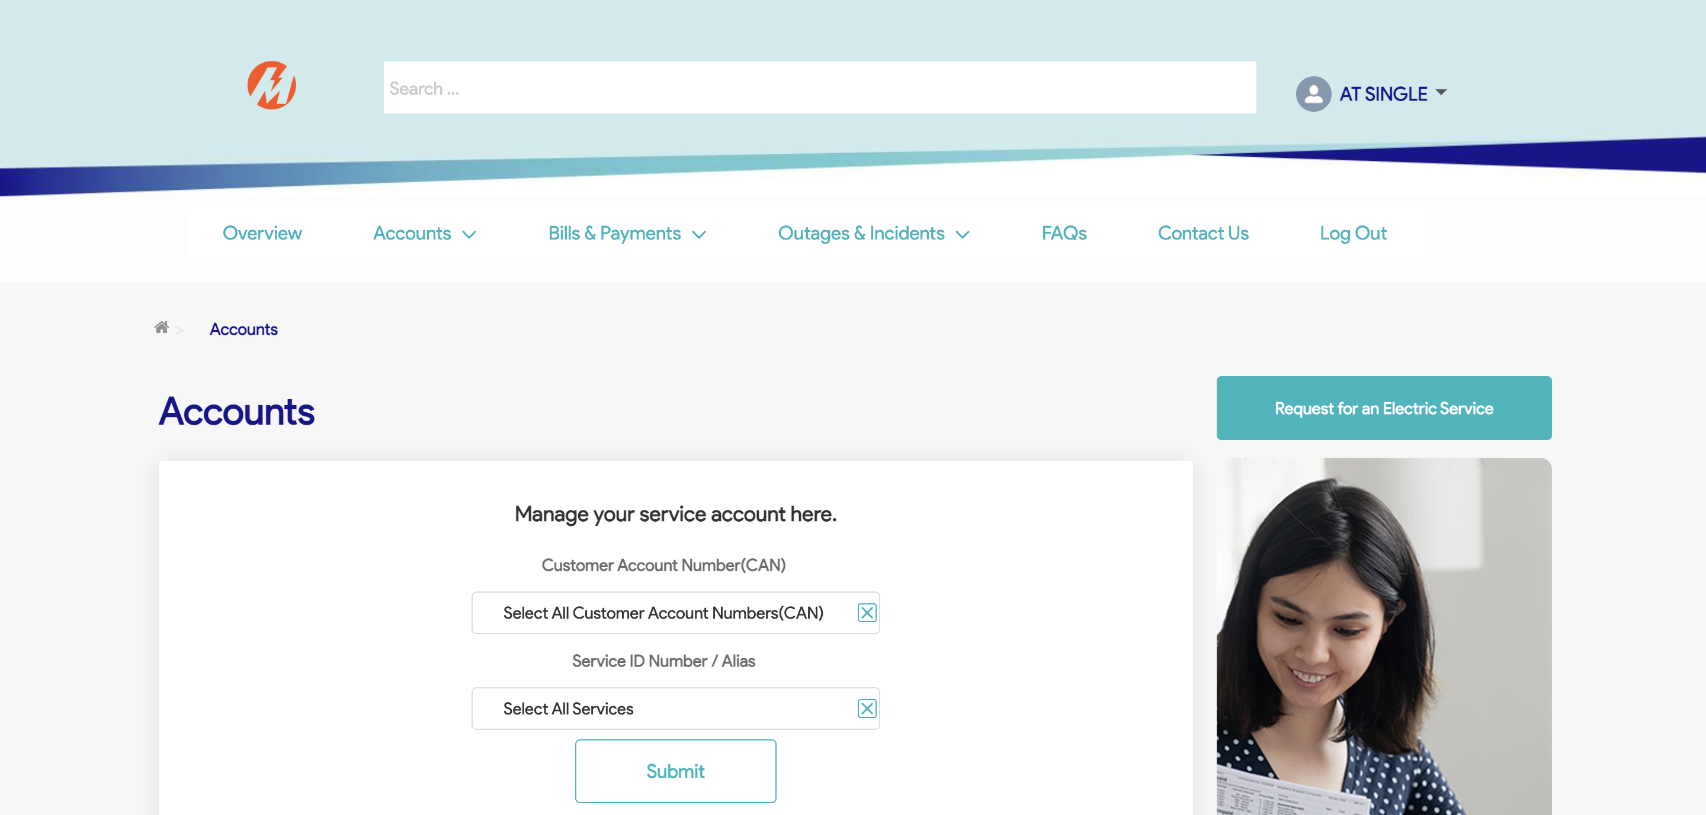

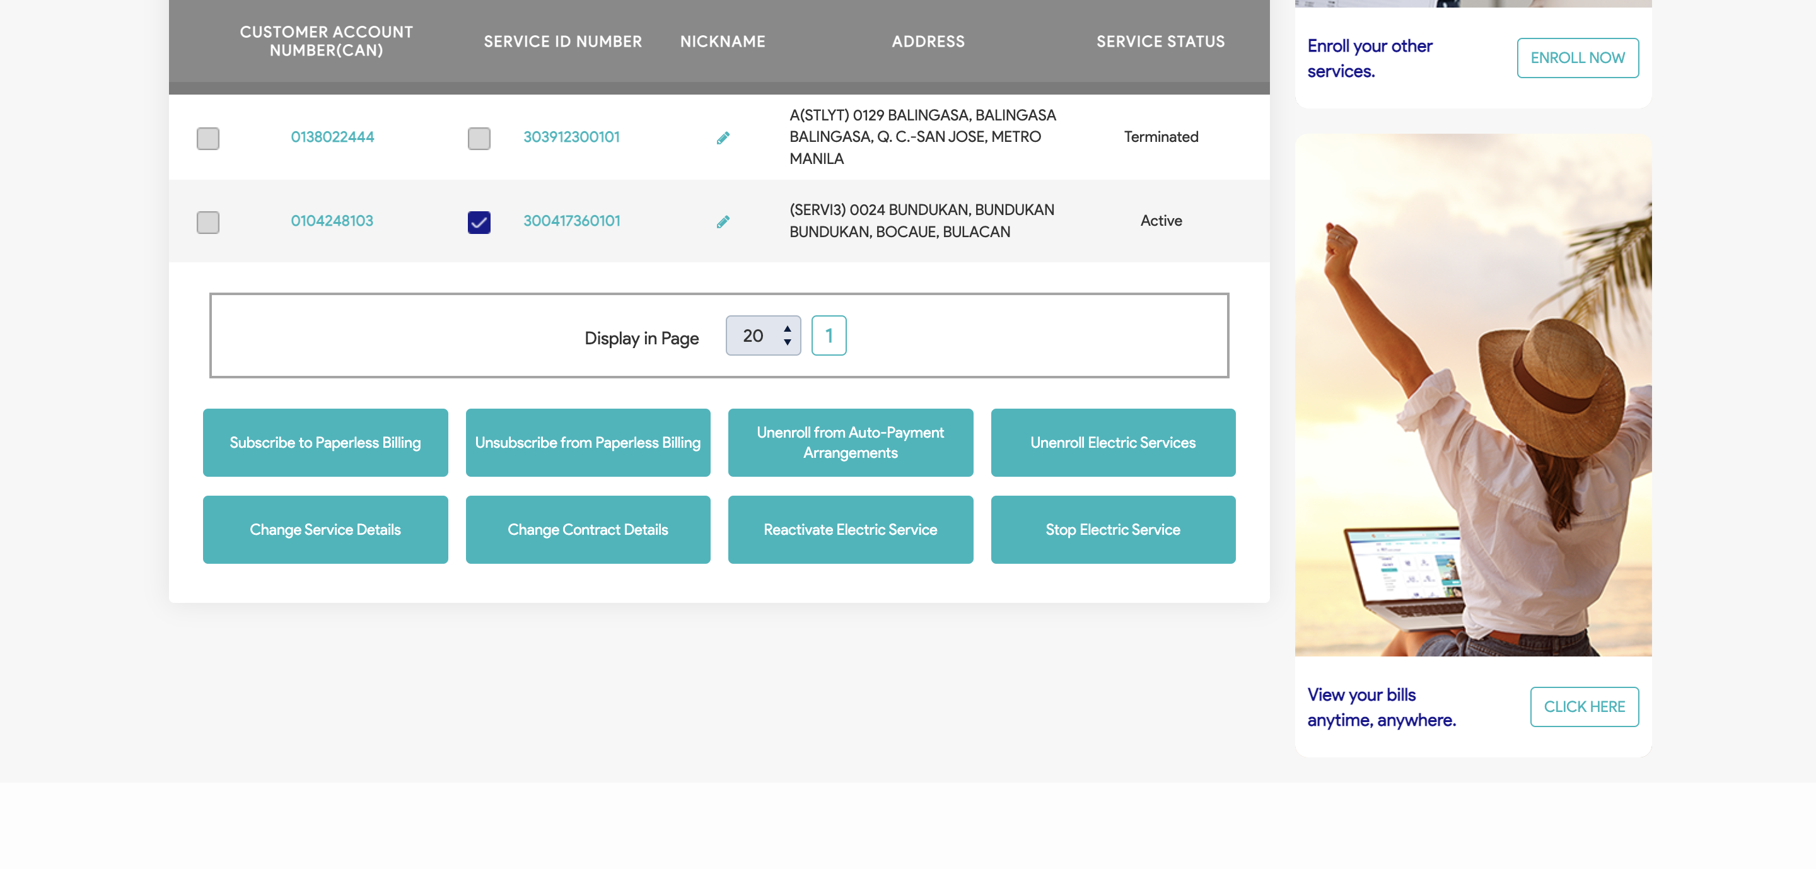

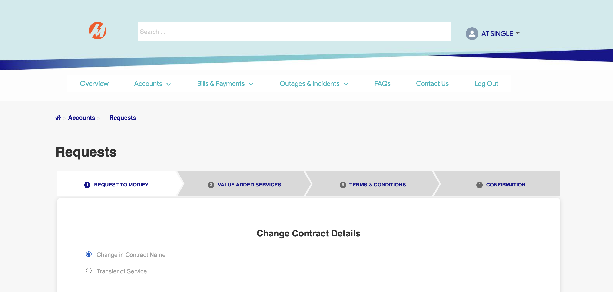

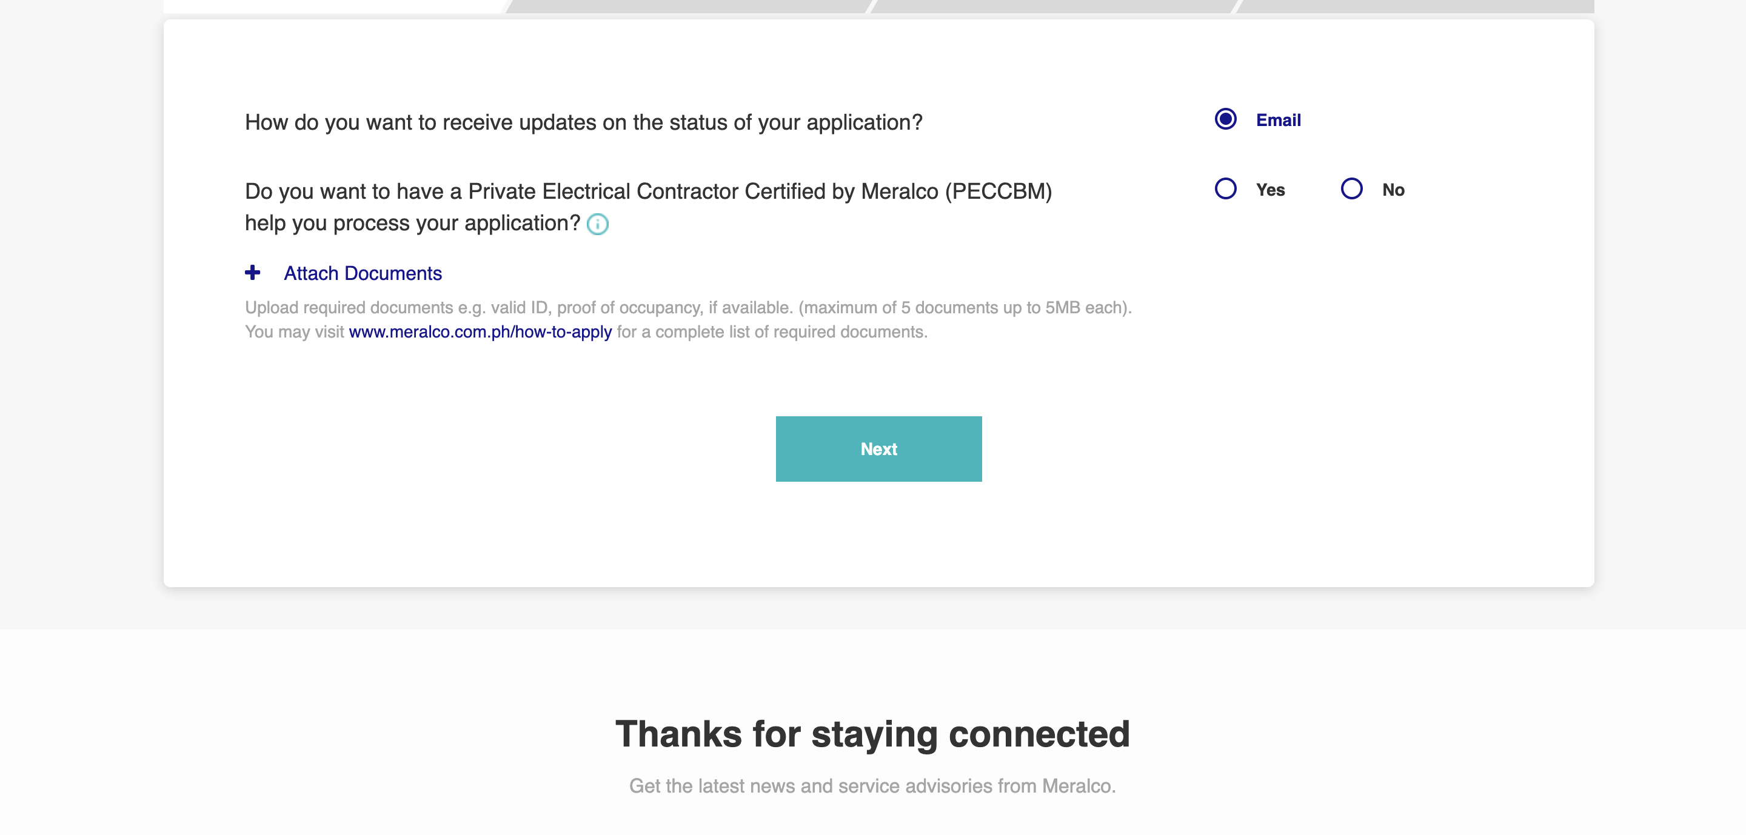

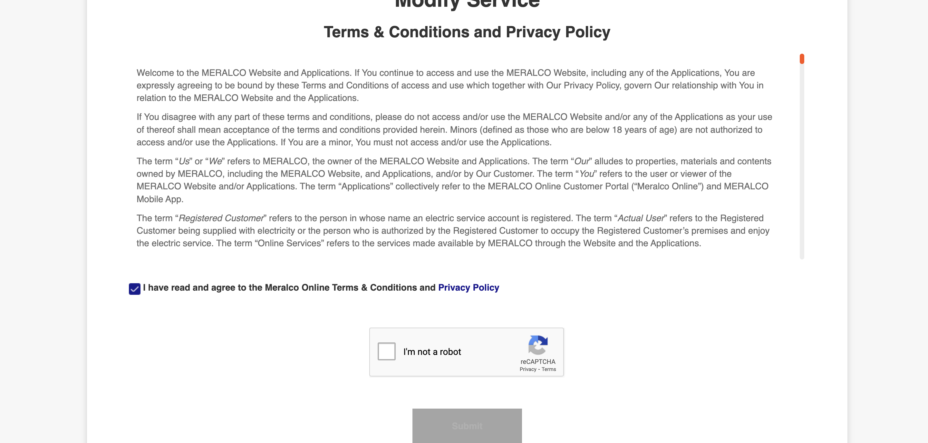



|  |
| --- |
| TC013_Modification of Service via CXE Apply_Contractor |

|  |
| --- |
| Step 1 - Go to https://fuat-meralco.cs73.force.com/customers/s/cxe-apply |
| Service Application page should be displayed |

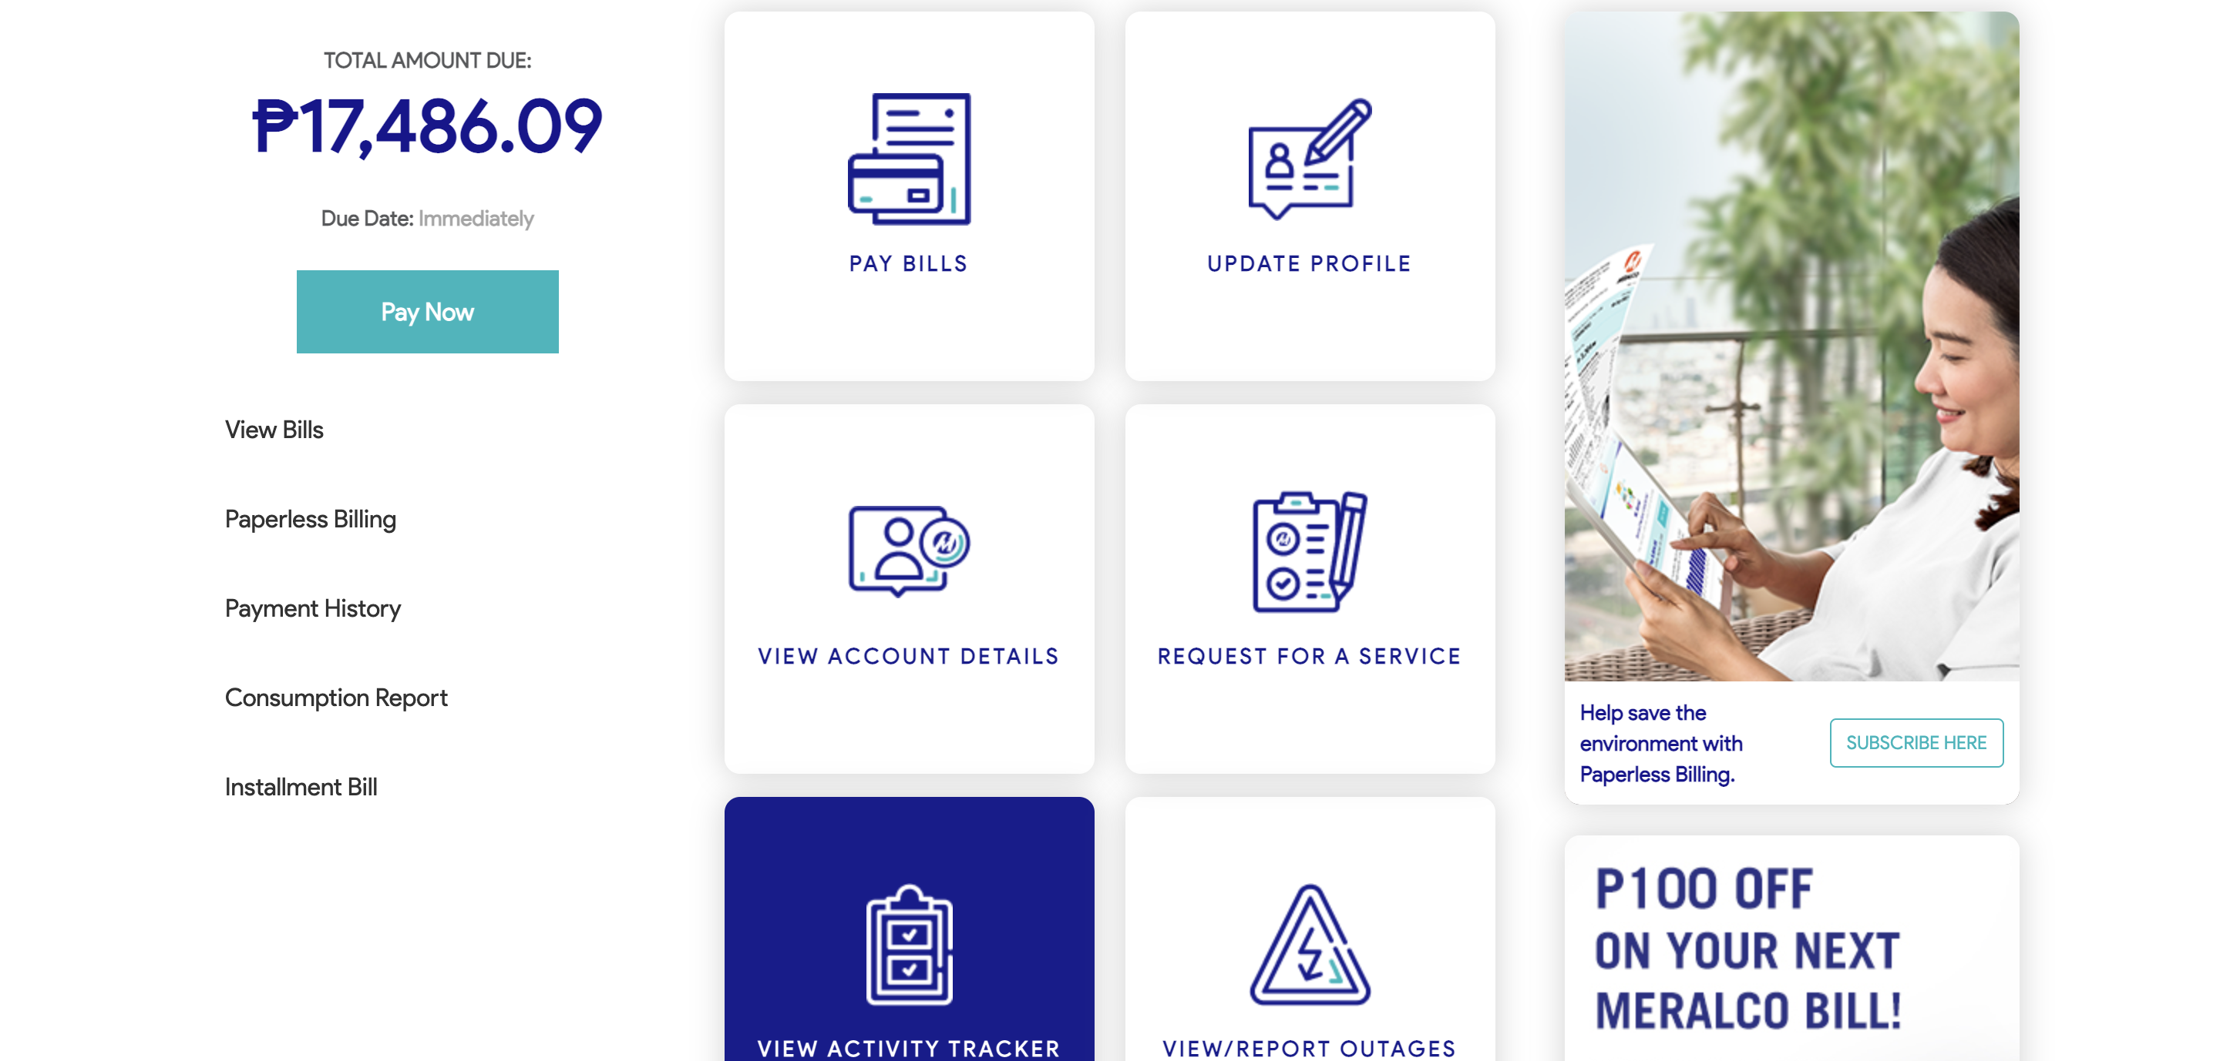

|  |
| --- |
| Step 2 - Click on Contractor |
| The following should be displayed under Contractor |

