|  |
| --- |
| TS004 - New Service Application_Business - CXEApply |

|  |
| --- |
| TC003_Application for New Service Application via CXE Apply_Business |

|  |
| --- |
| Step 1 - Go to https://fuat-meralco.cs73.force.com/customers/s/cxe-apply |
| Service Application page should be displayed |

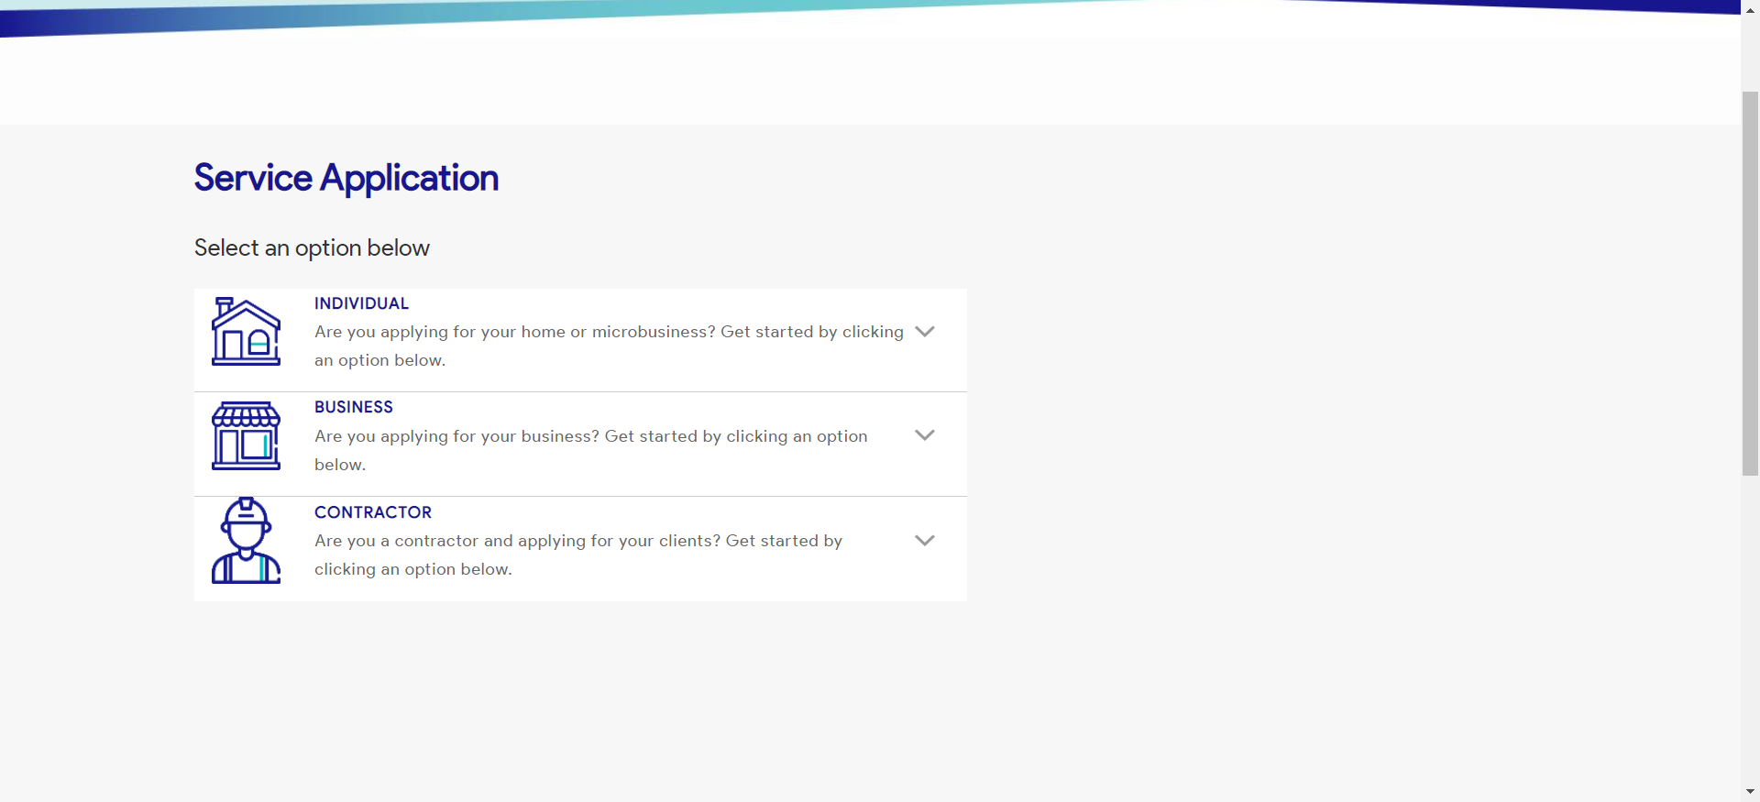

|  |
| --- |
| Step 2 - Click on Business |
| The following should be displayed under Business |

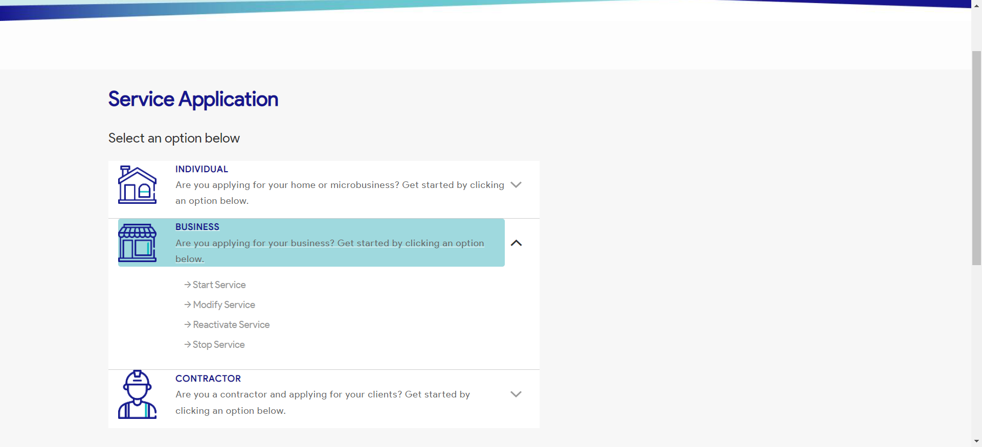

|  |
| --- |
| Step 3 - Click on Start a Service |
| Start a Service page should be displayed |

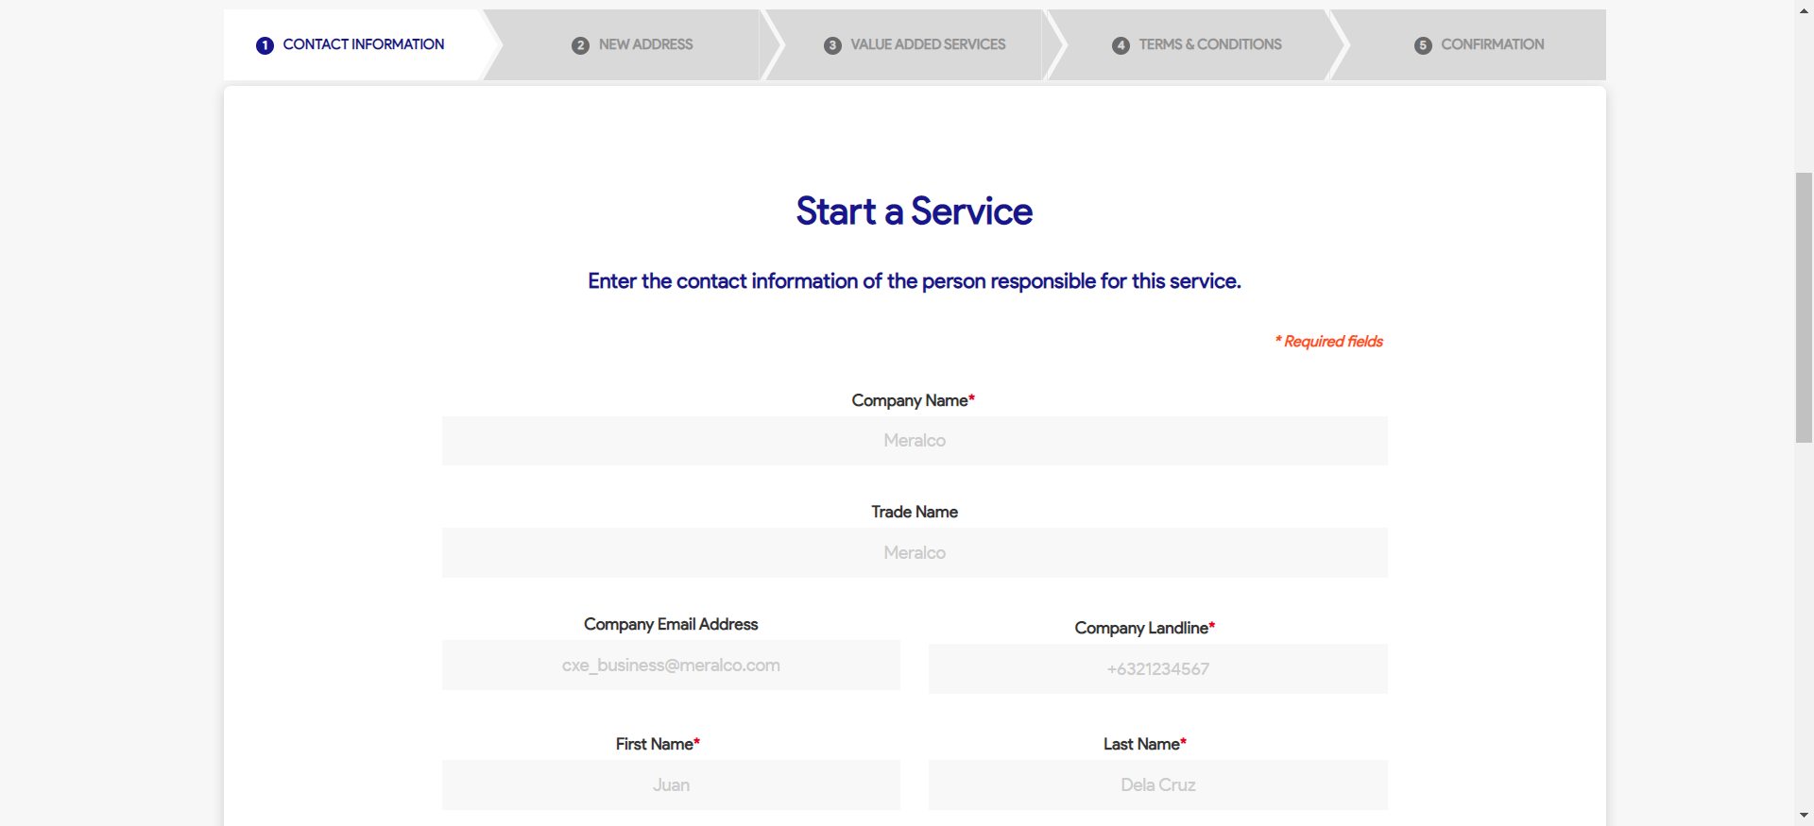

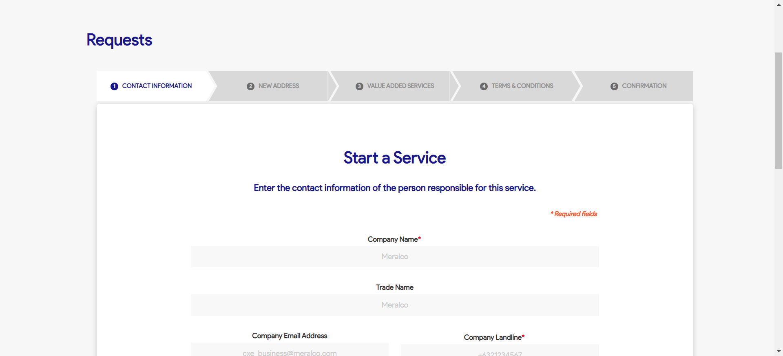

|  |
| --- |
| Step 4 - Populate the following fields: - Company Name - Trade Name (Optional) - Company Email Address (Optional) - Company Landline - First Name - Last Name - Email Address - Mobile Number - Designation Click Next |
| Fields shoud be populated; New Address tab should be displayed |

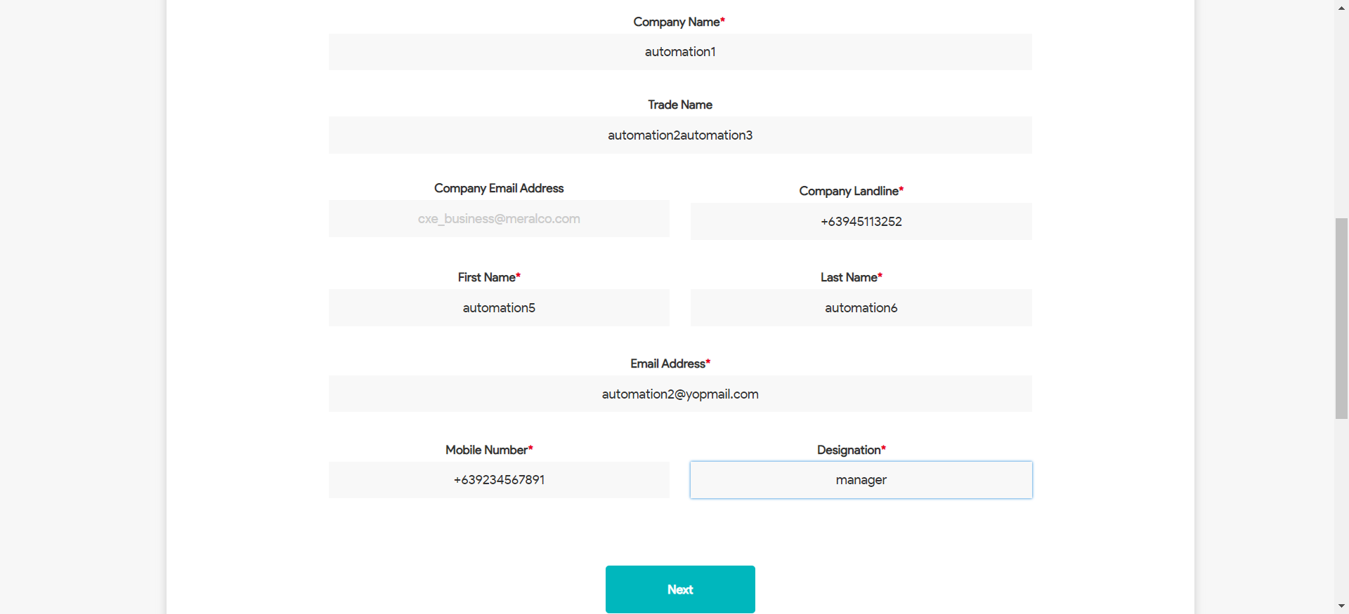

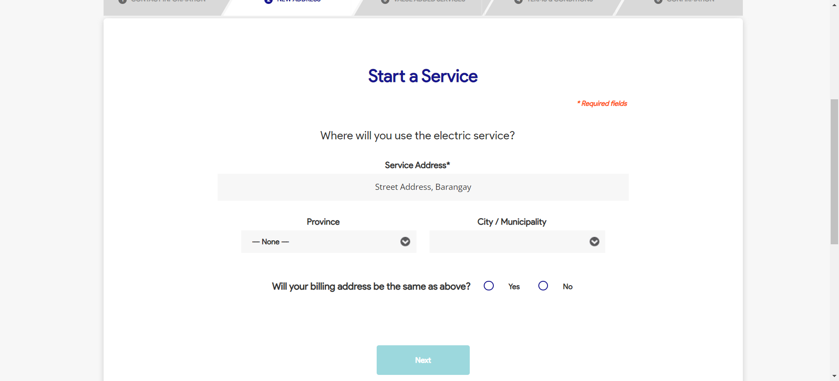

|  |
| --- |
| Step 5 - Populate the following: Service Address Province City / Municipality Home Ownership Billing Address Indicator |
| Fields should be populated; Value Added Service tab should be displayed |

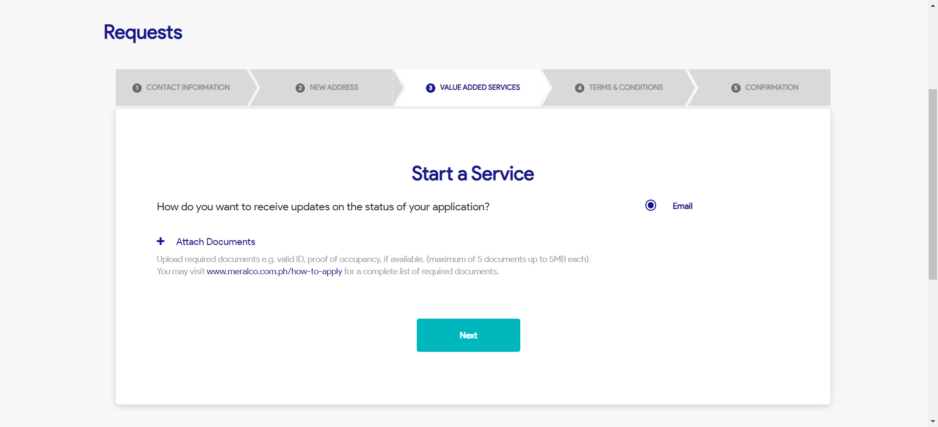

|  |
| --- |
| Step 6 - Populate the following: Notification indicator AMC indicator Paperless Billing indicator APA indicator > Attach documents > Click Next |
| Fields should be populated; Terms and Conditions tab should be displayed |

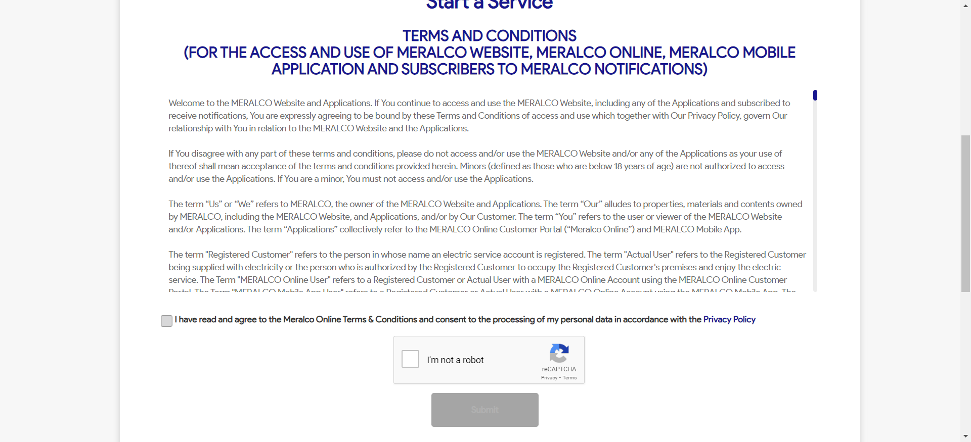

|  |
| --- |
| Step 7 - Tick on I have read and agree to the Meralco Online Terms & Conditions and consent to the processing of my personal data in accordance with the Privacy Policy |
| Submit button should be enabled |

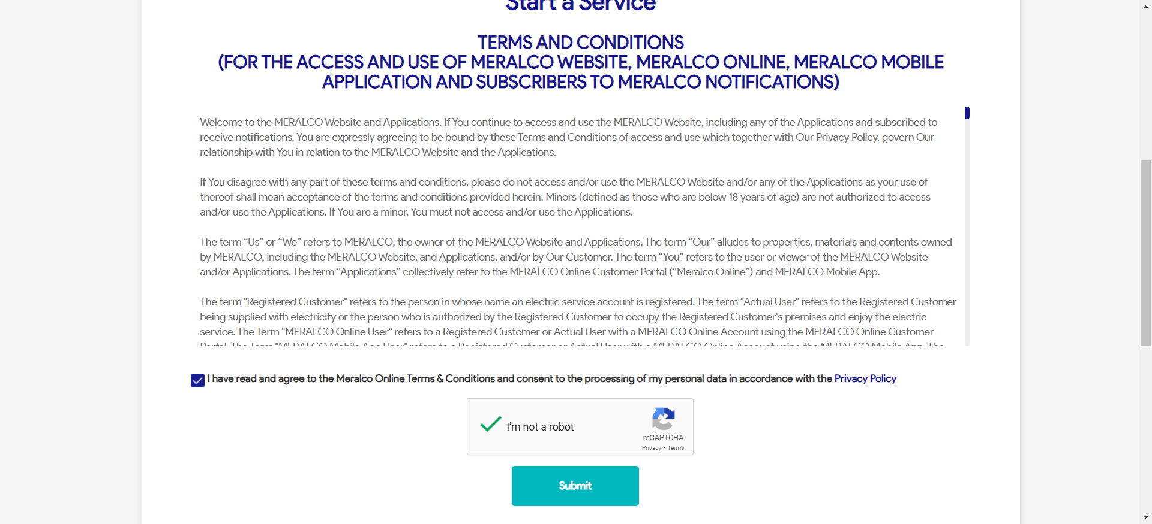

|  |
| --- |
| Step 8 - Click Submit |
| Confirmation tab should be displayed. Case # should be generated. |

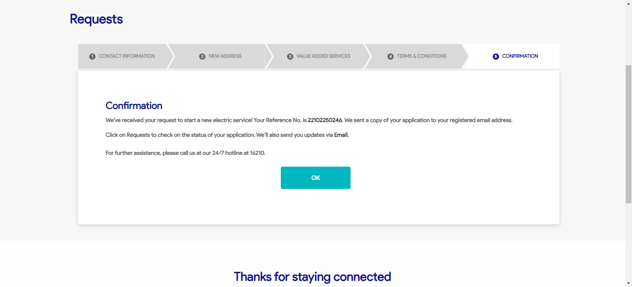

Passed