|  |
| --- |
| TS005 - New Service Application_Contractor - CXEApply |

|  |
| --- |
| TC004_Creation of New Service Application via CXE Apply_Contractor |

|  |
| --- |
| Step 1 - Go to https://fuat-meralco.cs73.force.com/customers/s/cxe-apply |
| Service Application page should be displayed |

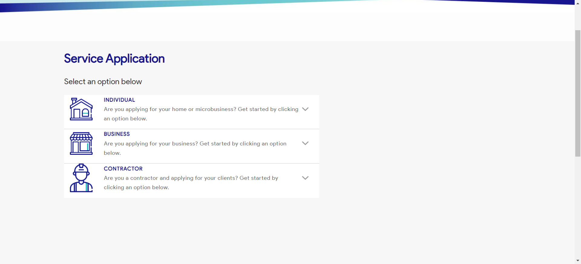

|  |
| --- |
| Step 2 - Click on Contractor |
| The following should be displayed under Contractor |

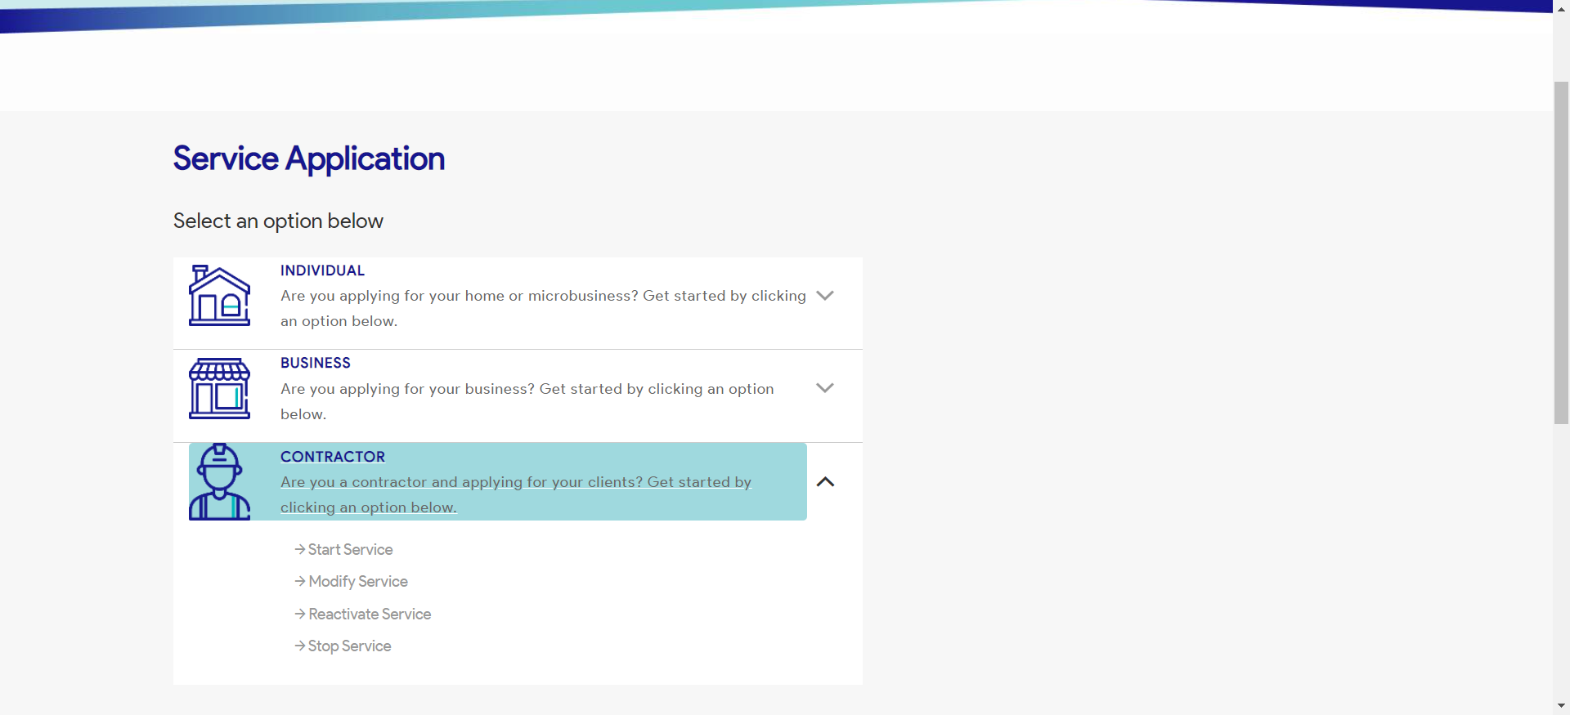

|  |
| --- |
| Step 3 - Click on Start a Service |
| Start a Service page should be displayed |

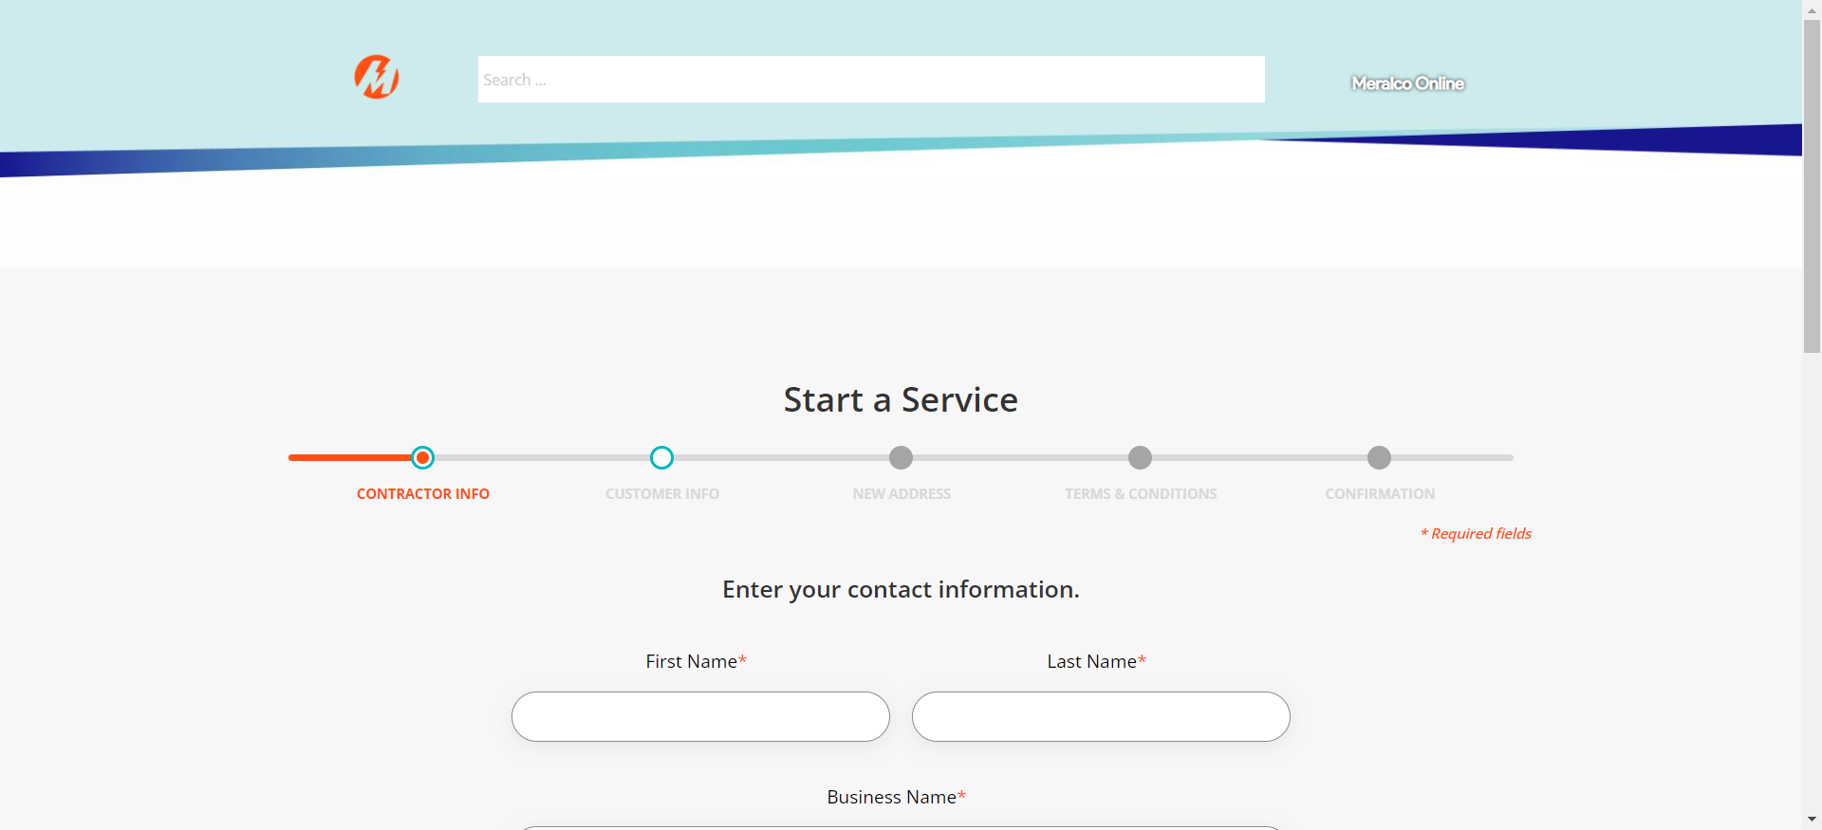

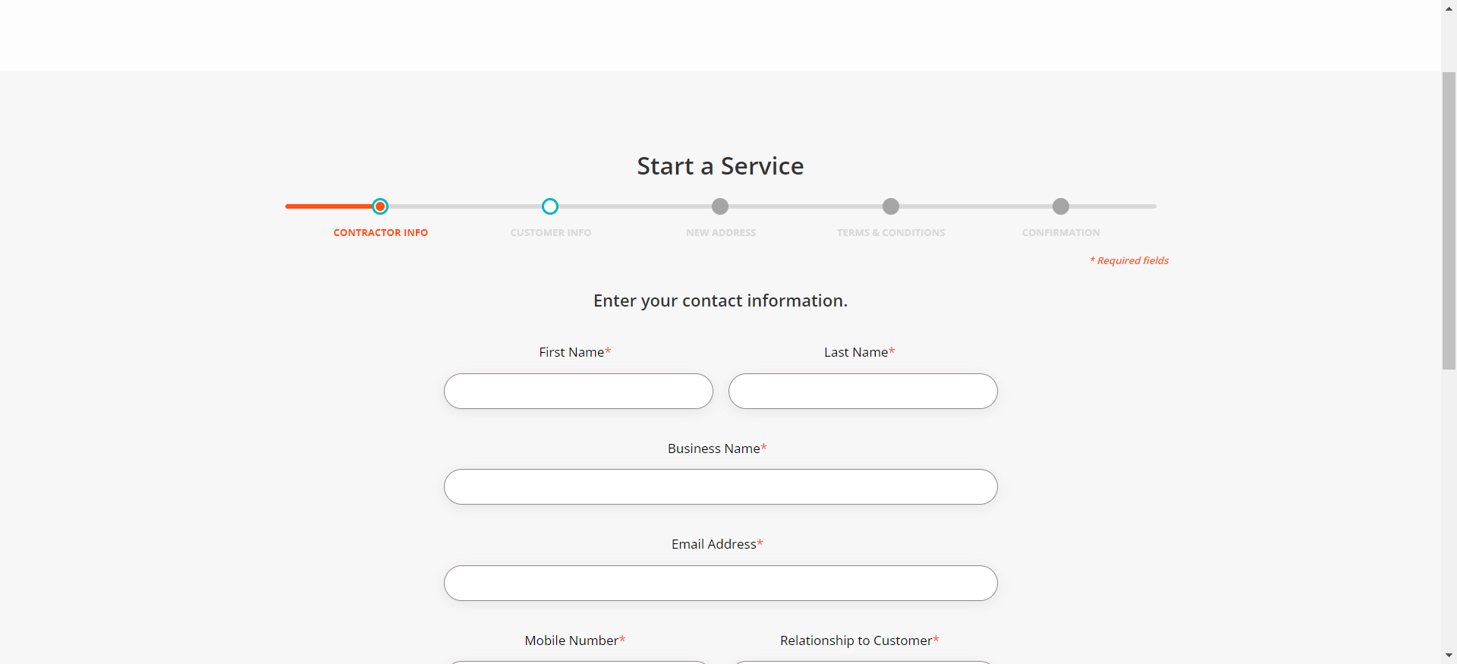

|  |
| --- |
| Step 4 - Populate the following fields: First Name* Last Name* Business Name* Email Address* Mobile Number* Relationship to Customer* Notification indicator |
| Fields shoud be populated; Customer Info tab should be displayed |

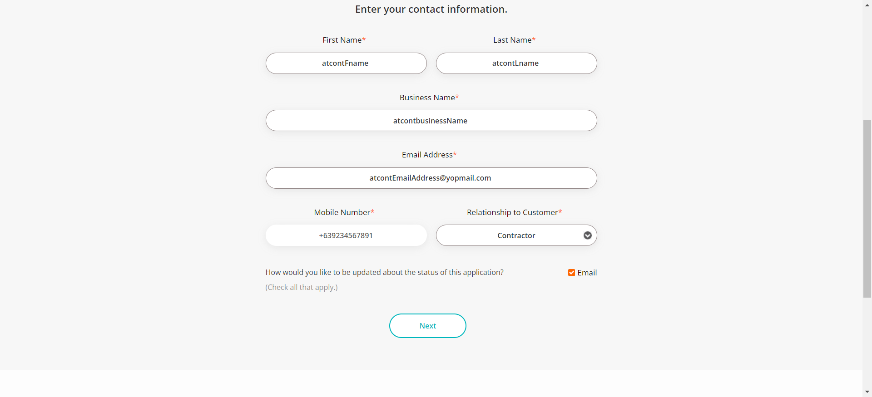

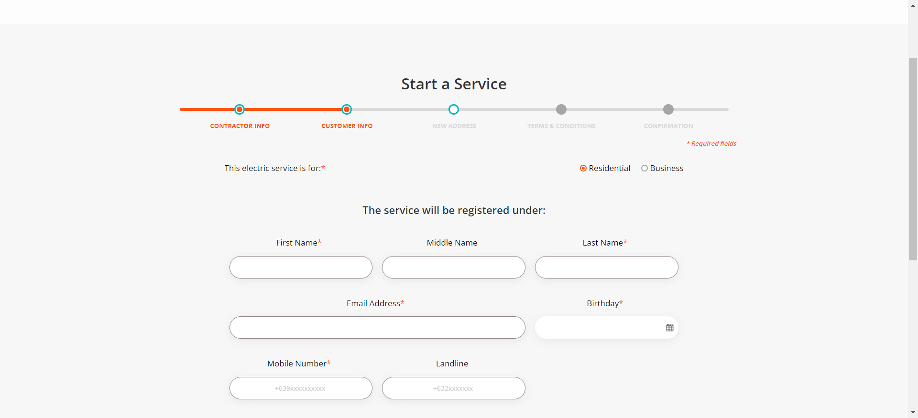

|  |
| --- |
| Step 5 - Populate the following: Electric Service indicator* First Name* Middle Name Last Name* Email Address* Birthday* Mobile Number* Landline > Click Next |
| Fields should be populated; New Address tab should be displayed |

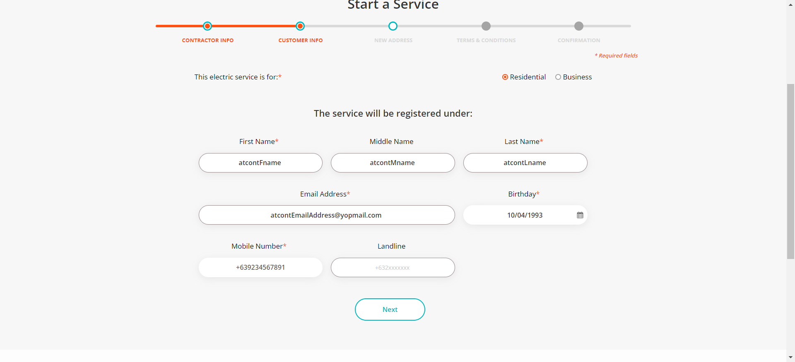

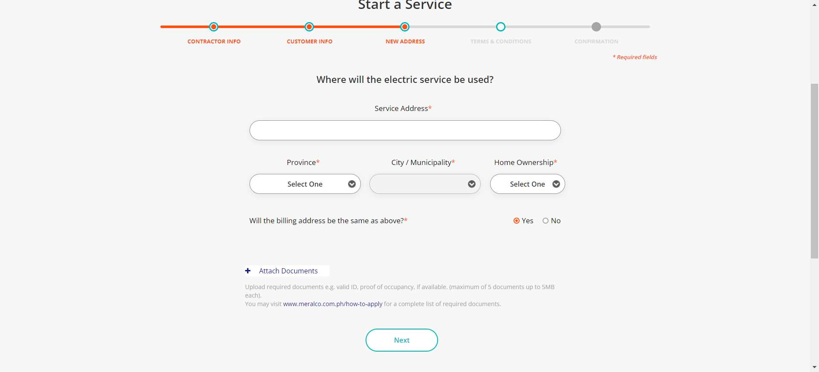

|  |
| --- |
| Step 6 - Populate the following: Service Address Province City / Municipality Home Ownership Billing Address Indicator > Attach Document > Click Next |
| Fields should be populated; Terms and Conditions tab should be displayed |

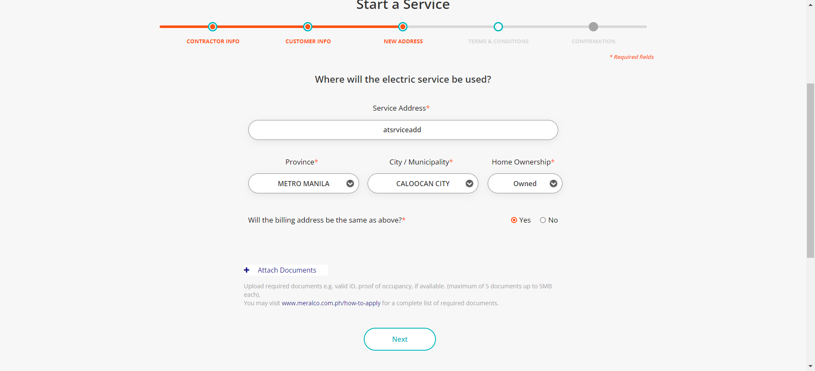

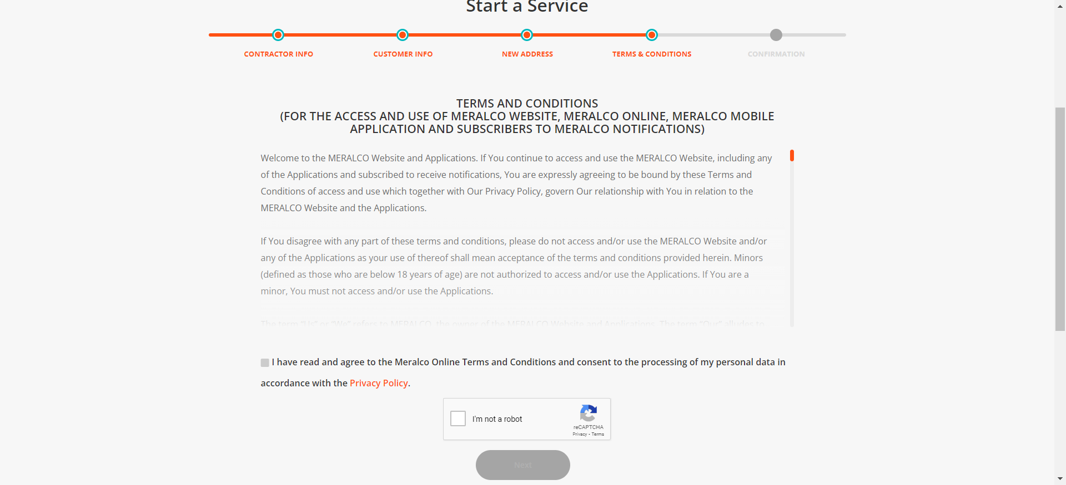

|  |
| --- |
| Step 7 - Tick on I have read and agree to the Meralco Online Terms & Conditions and consent to the processing of my personal data in accordance with the Privacy Policy |
| Submit button should be enabled |

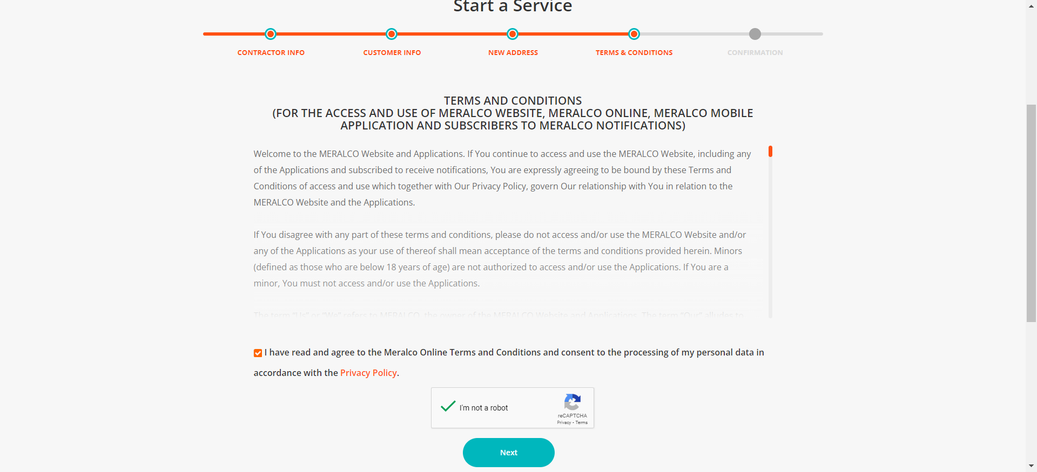

|  |
| --- |
| Step 8 - Click Submit |
| Confirmation tab should be displayed. Case # should be generated. |

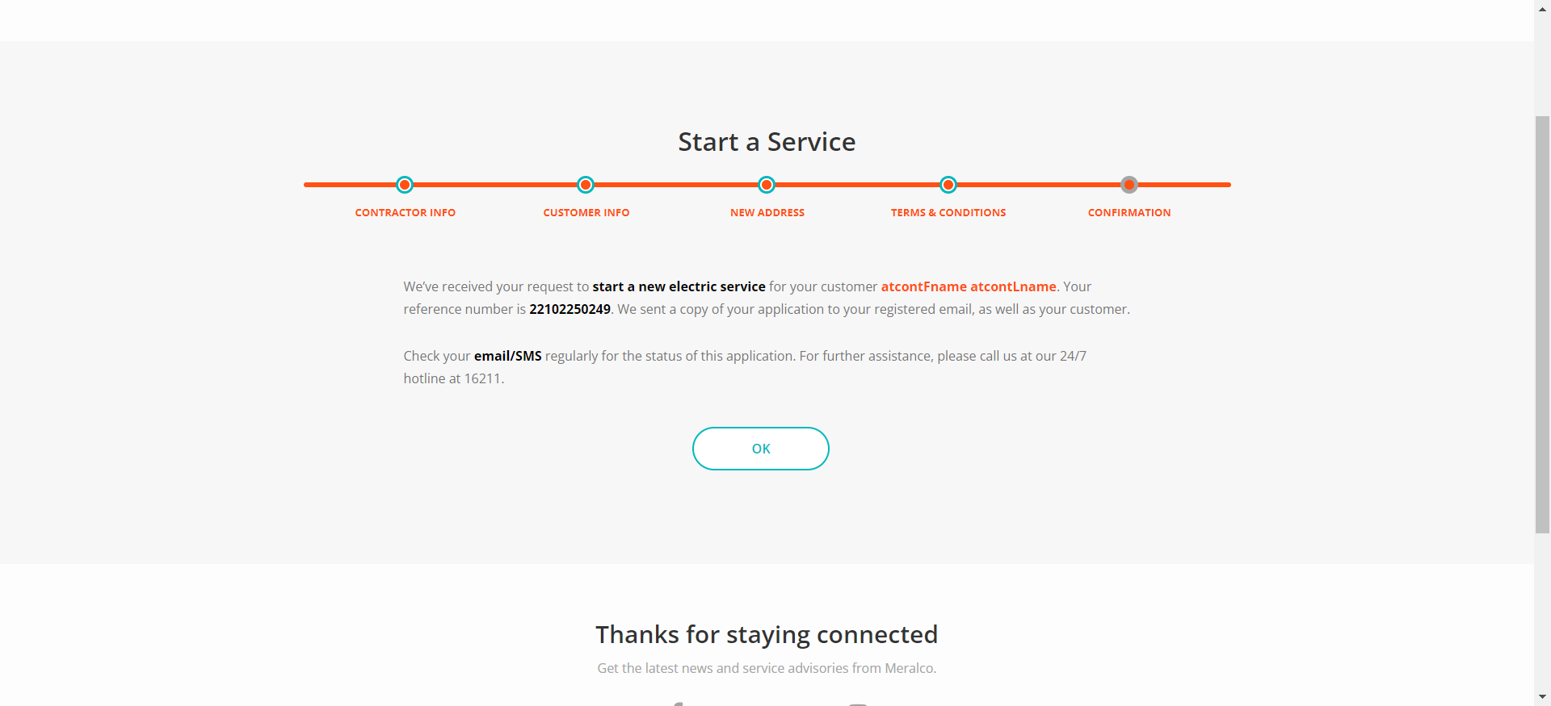

Passed