|  |
| --- |
| TS003 - Log in - Regular Account; Meralco Online |

|  |
| --- |
| TC007_Log in Regular account Email and Password Validation |

|  |
| --- |
| Step 1 - Input Regular account details in Email and Password field in the Log in page -> Click Log in button |
| User should be able to Log in |

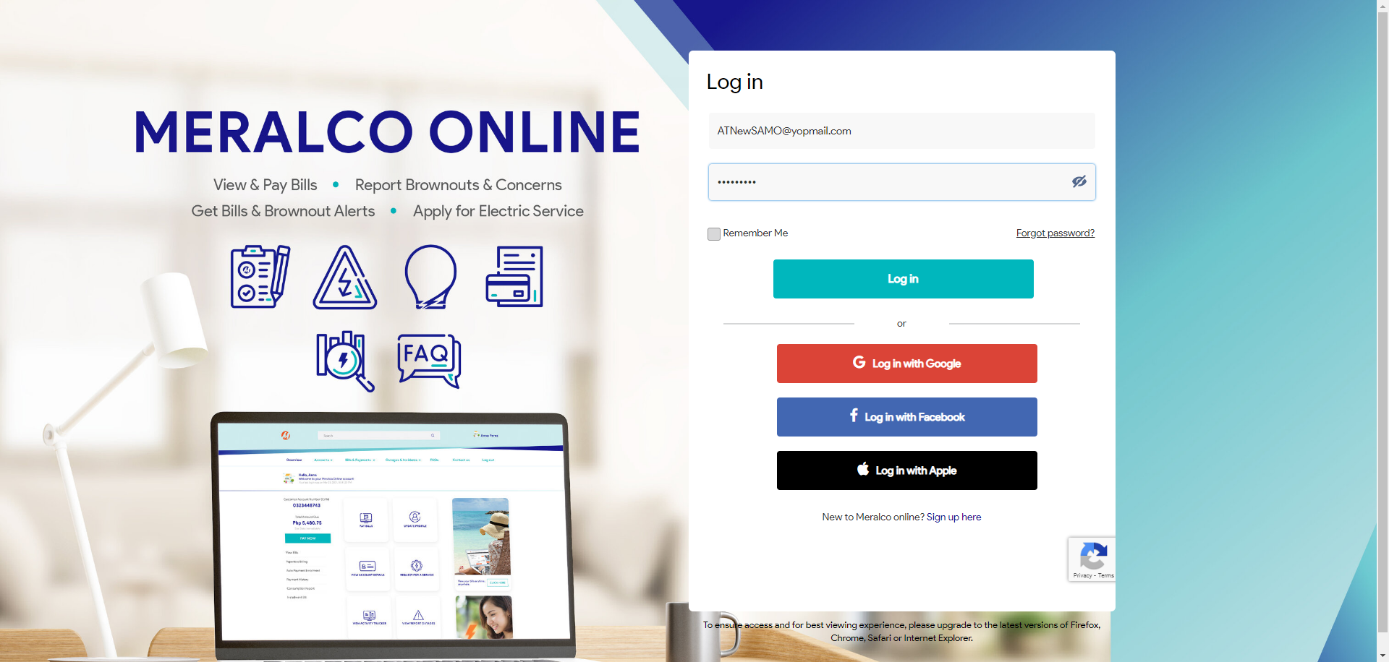

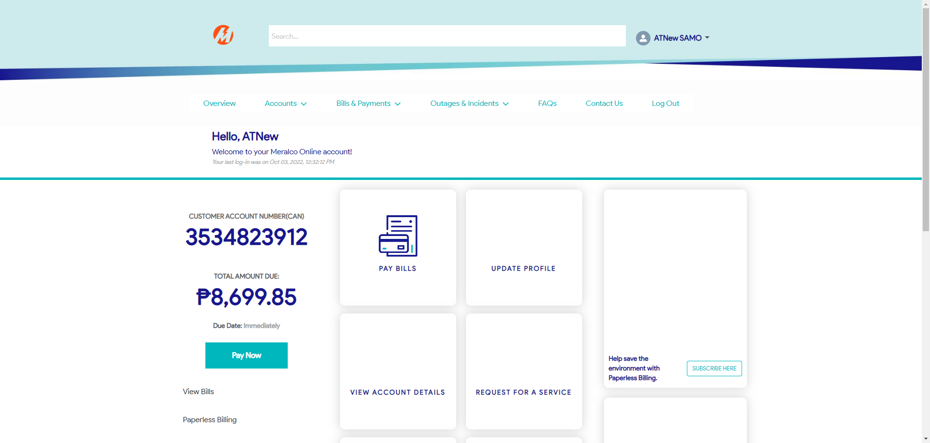

Passed