|  |
| --- |
| TS004 - Login field - Lockout - Regular Account; Meralco Online |

|  |
| --- |
| TC010_Regular account Lockout |

|  |
| --- |
| Step 1 - Input wrong password 5x |
| Account should be locked |

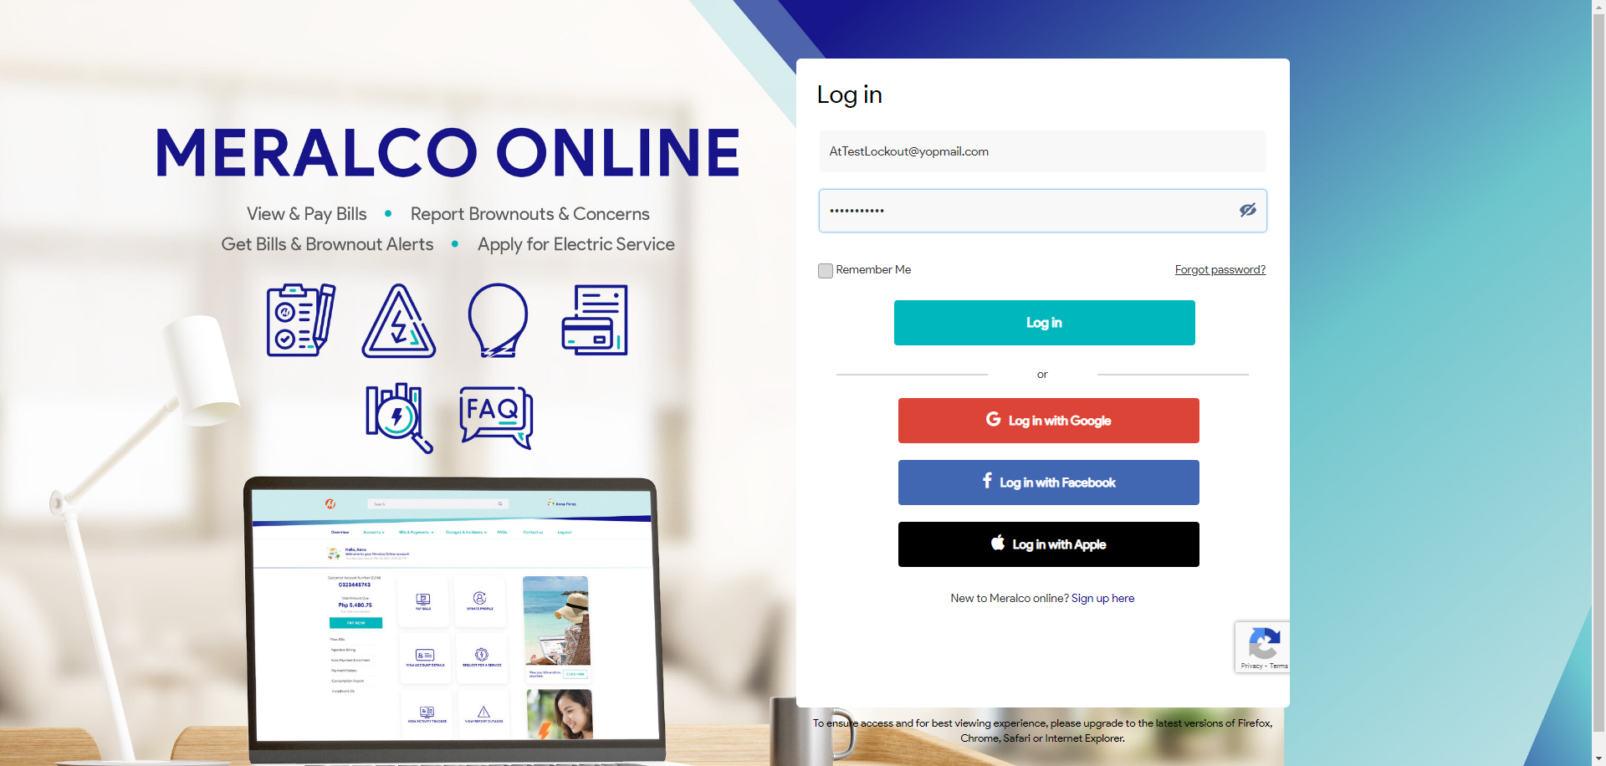

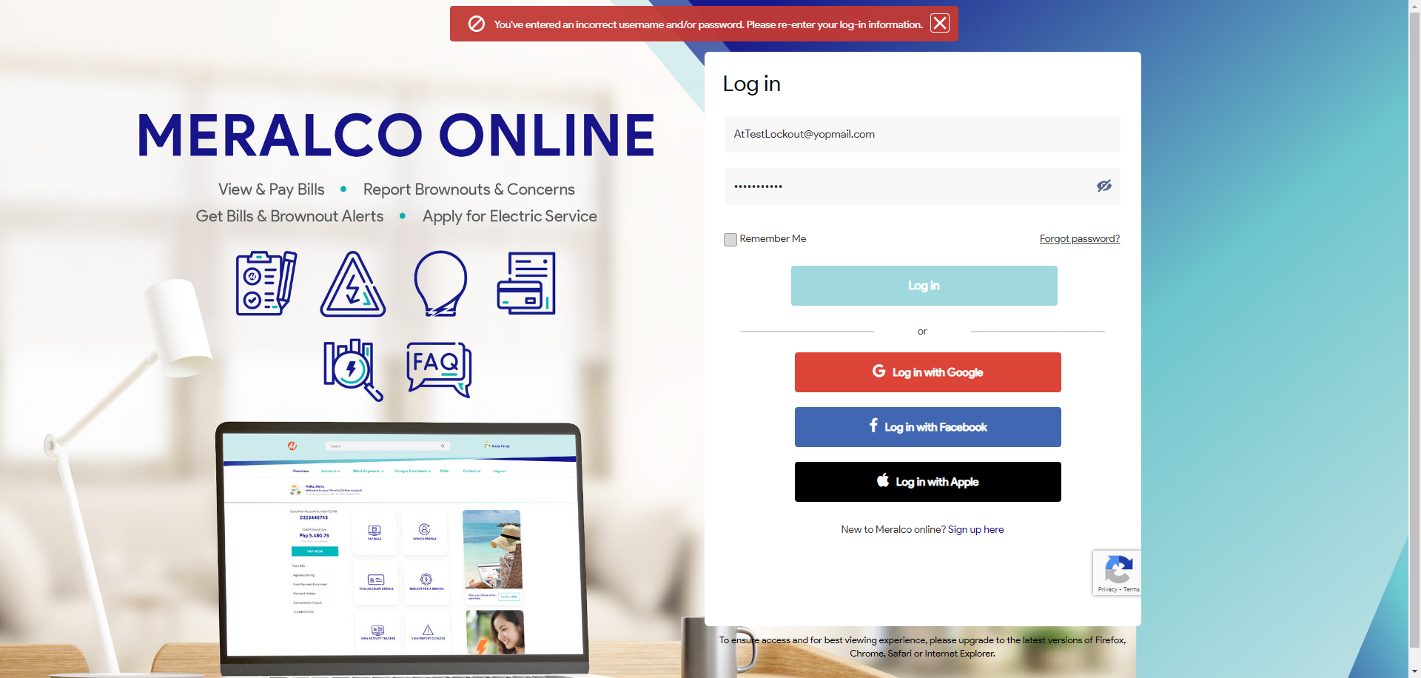

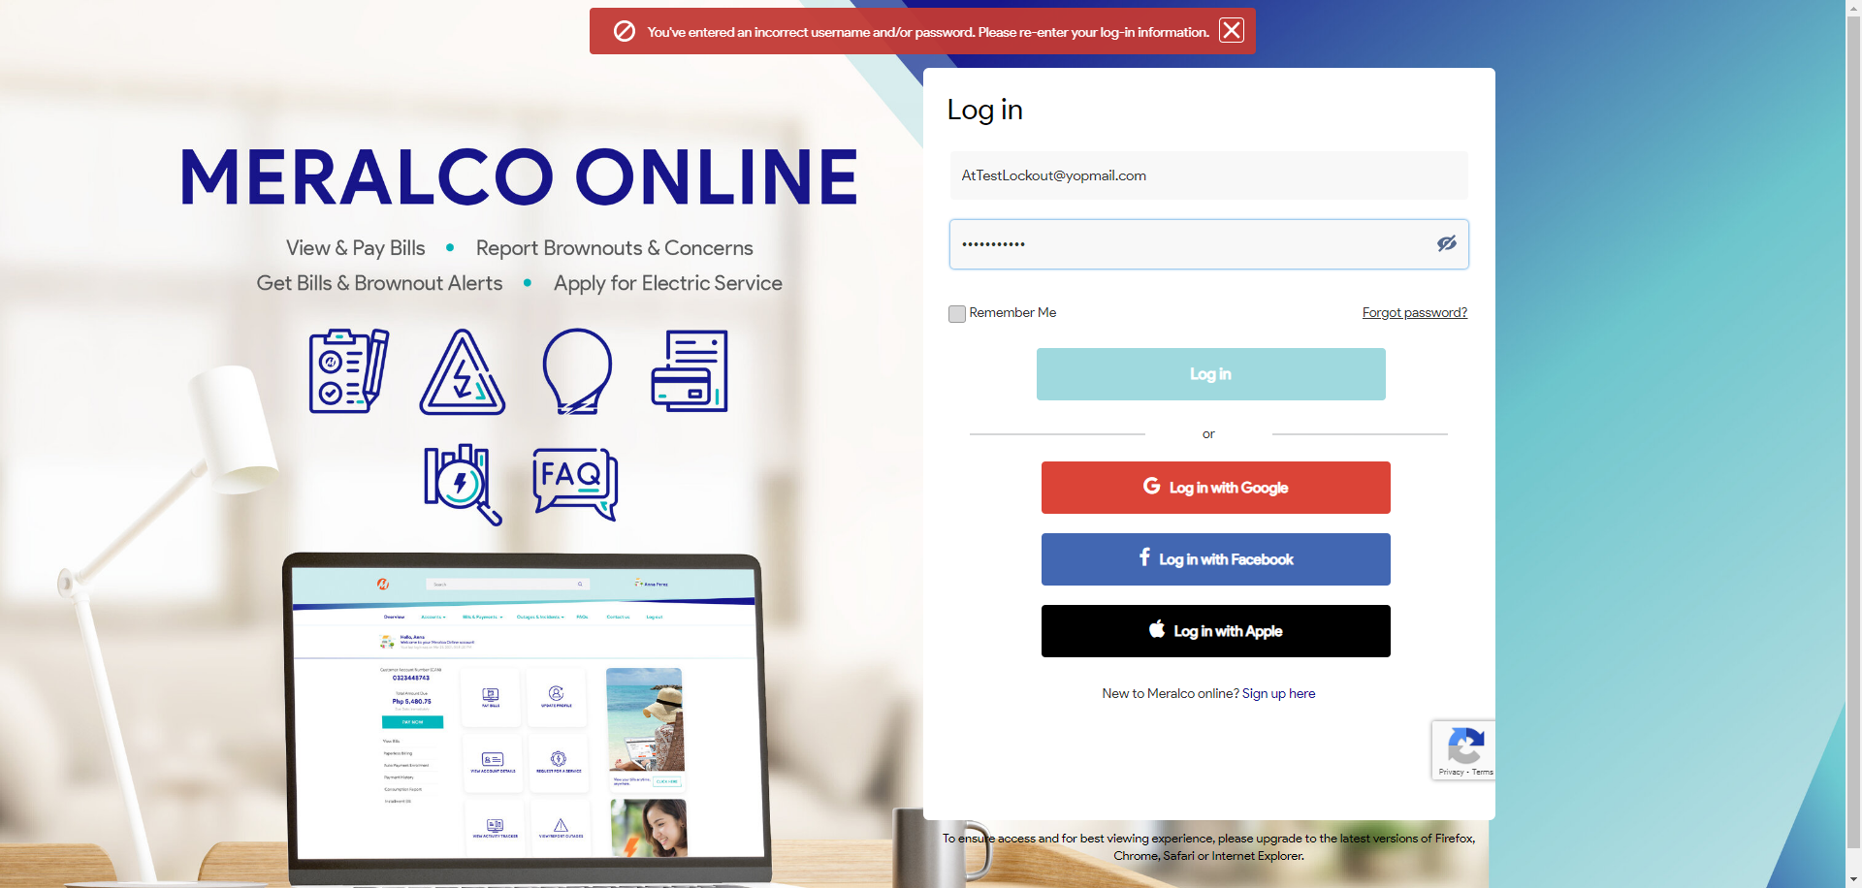





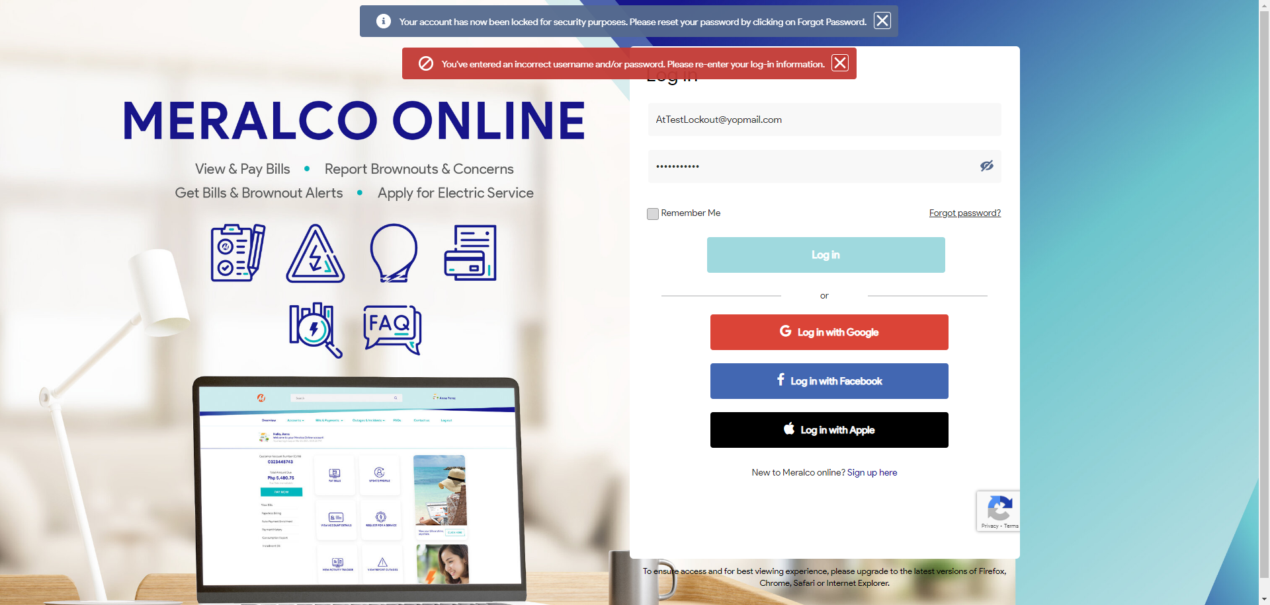

Passed