|  |
| --- |
| TS006 - Forgot Password - Google SSO - Meralco Online |

|  |
| --- |
| TC001_Forgot Password SSO |

|  |
| --- |
| Step 1 - Click Forgot Password? In login page |
| User should be redirected to Password reset page |

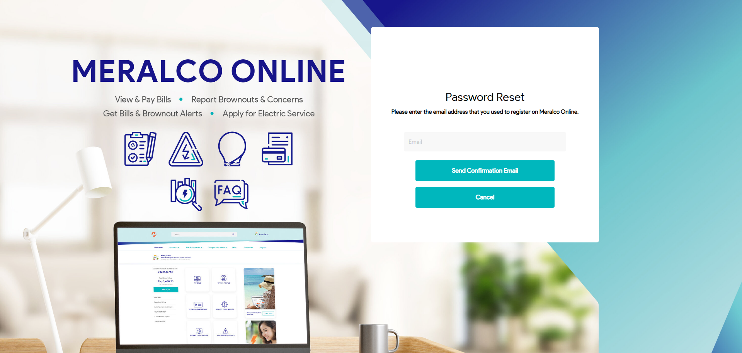

|  |
| --- |
| Step 2 - Input SSO email in Email field then click Send Confirmation Email button |
| Prompt should display: Please use your Facebook, Google, or Apple account to login. Your Meralco Online account is registered and/or previously accessed in using these options. |

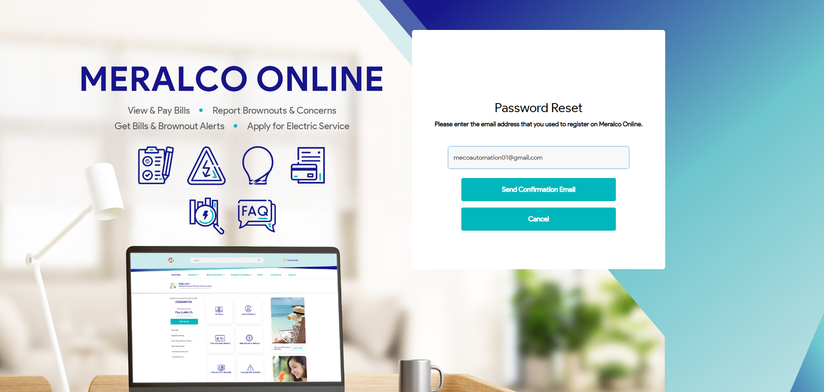

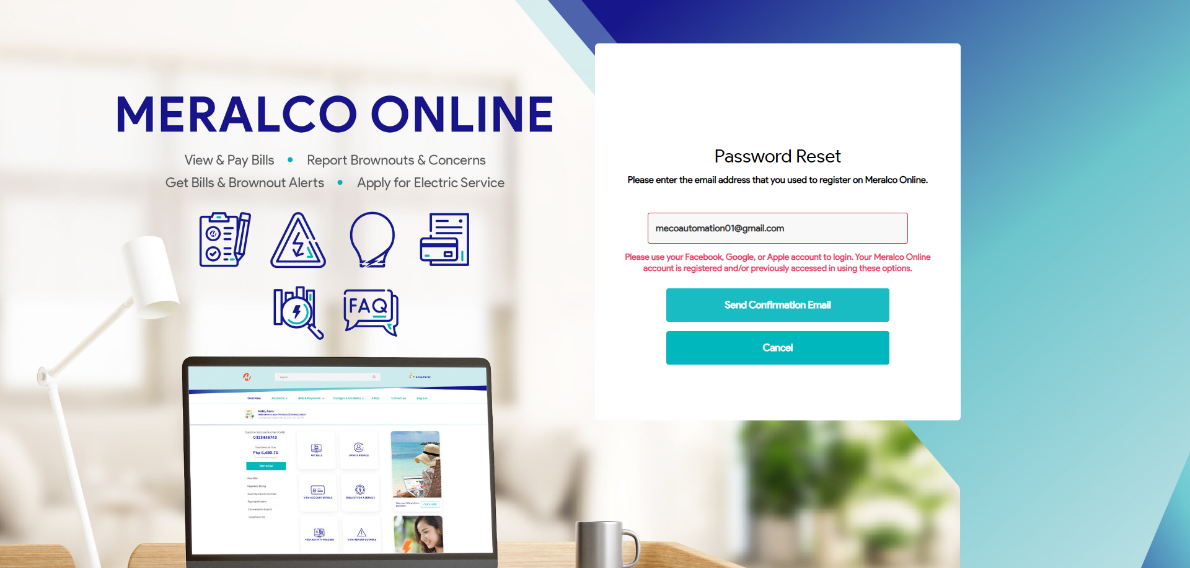

Passed