|  |
| --- |
| TS007 - Forgot Password - Regular Account - Meralco Online |

|  |
| --- |
| TC003_Forgot Password Regular Account |

|  |
| --- |
| Step 1 - Click Forgot Password? In Meralco Online login page |
| User should be redirected to Password reset page |

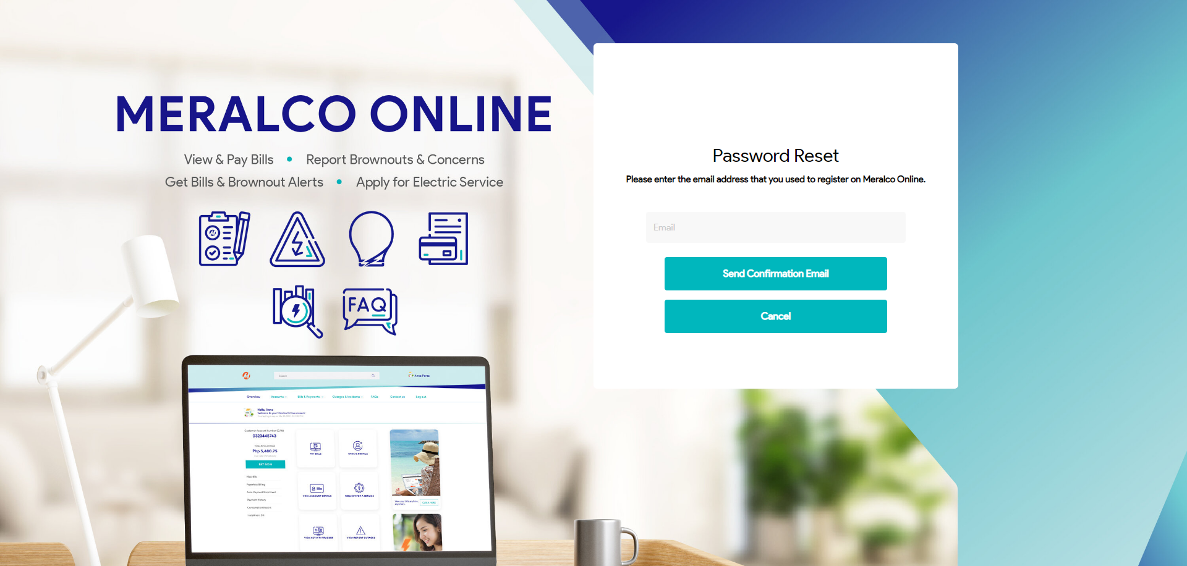

|  |
| --- |
| Step 2 - Input email in Email field then Click Send Confirmation Email button |
| Confirmation email should be sent |

