|  |
| --- |
| TS009 - Change Password - Google SSO - Meralco Online |

|  |
| --- |
| TC002_Change Password SSO - Meralco Online |

|  |
| --- |
| Step 1 - Login to Meralco Portal using SSO account |
| User should be logged in |

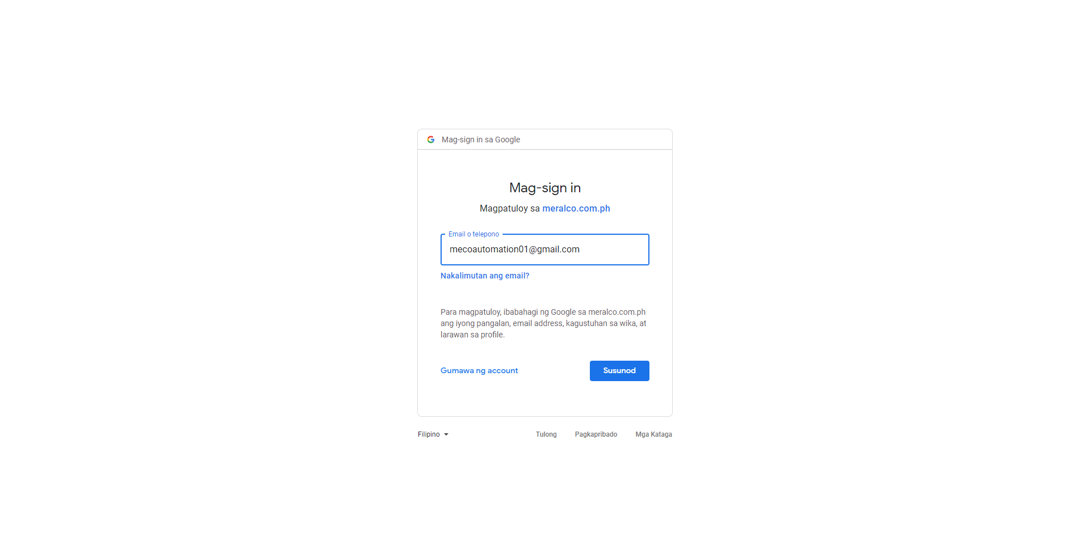

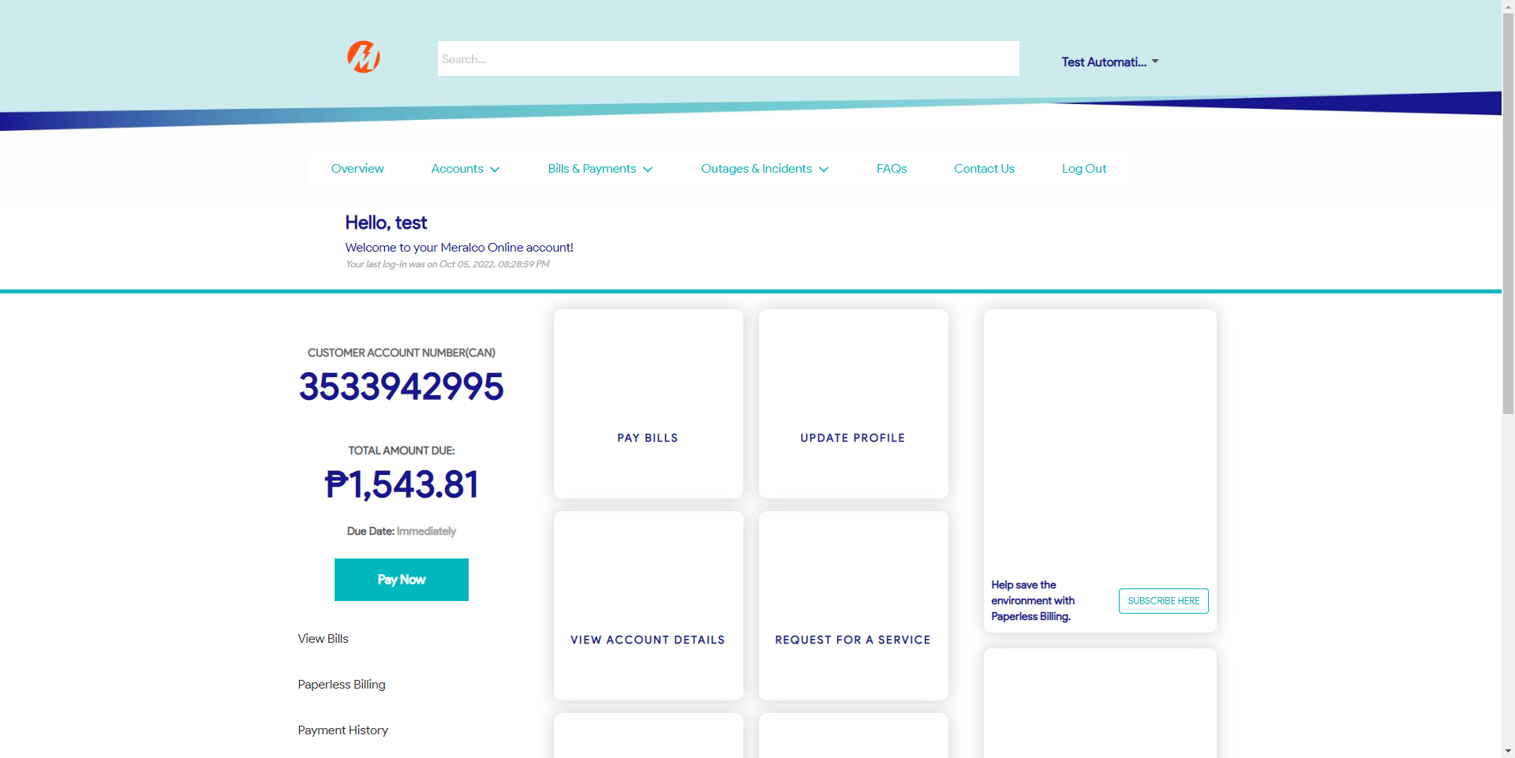

|  |
| --- |
| Step 2 - Go to Profile -> Change Password tab |
| Prompt should display:  Please login directly to your Facebook, Google, or Apple account to if you wish to change your password. Your Meralco Online account is registered and/or previously accessed using these options. |

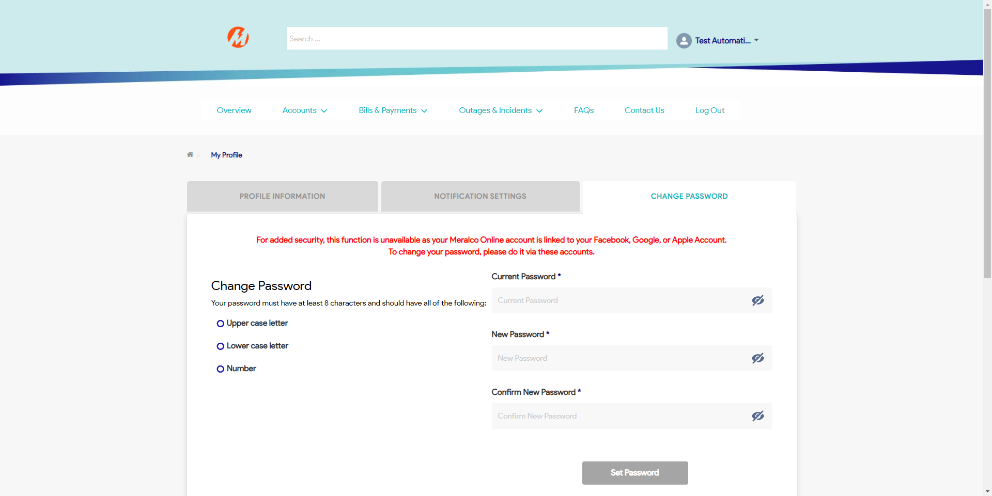

Passed