|  |
| --- |
| TS010 - Change Password - Regular Account - Meralco Online |

|  |
| --- |
| TC004_Change Password Regular Account |
| Step 1 - Log in using regular account |
| User should be logged in |
|  |

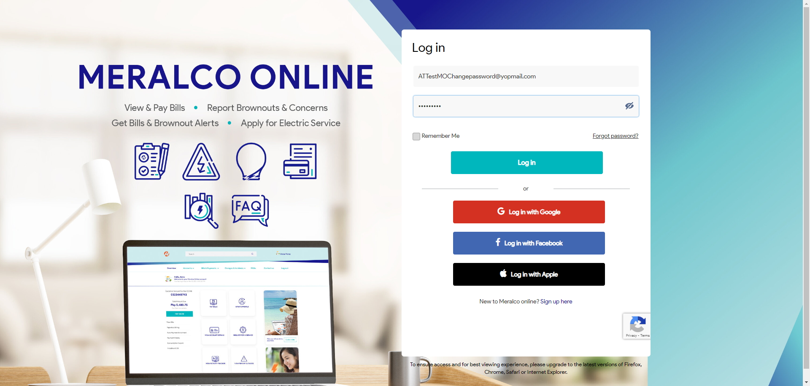

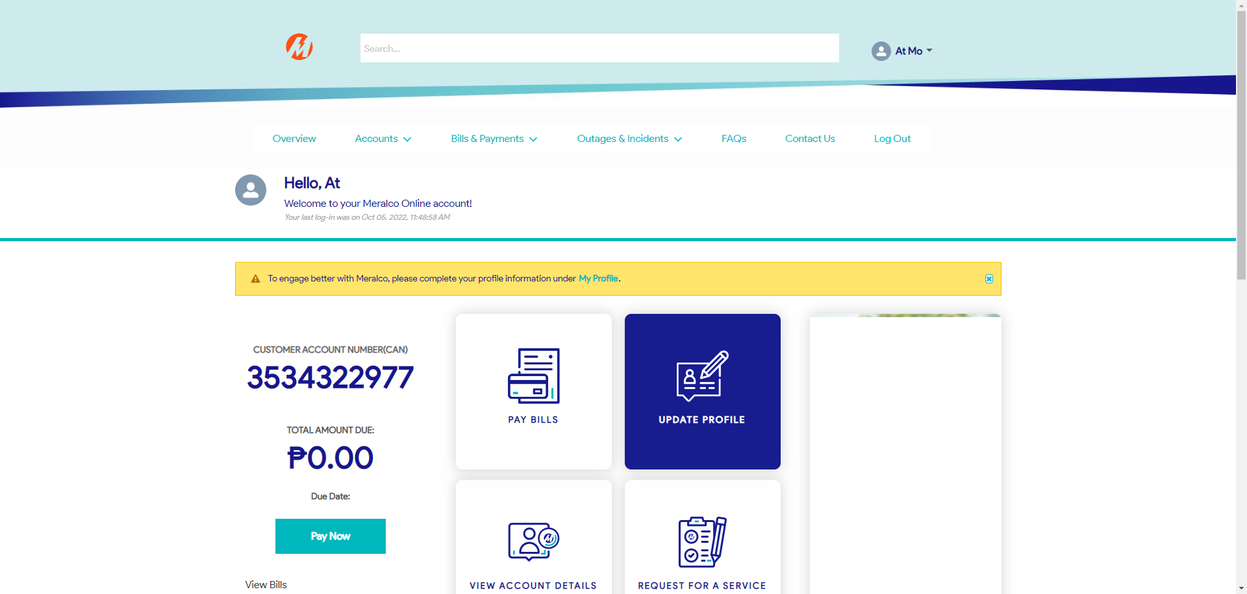

|  |
| --- |
| Step 2 - Change password |
| Password should be changed |

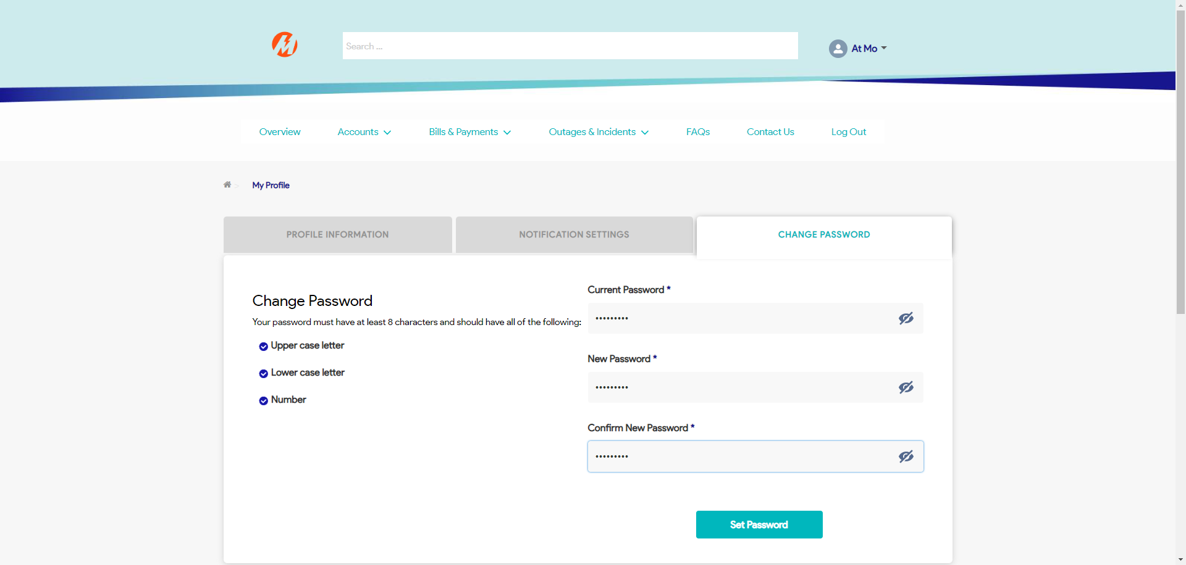

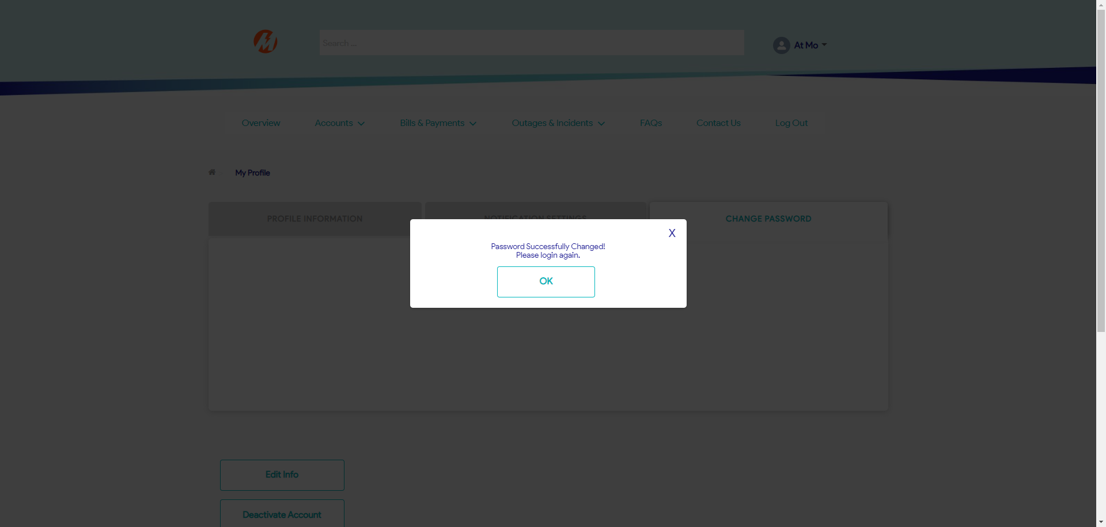

|  |
| --- |
| Step 3 - Log in using new password |
| User should be logged in |

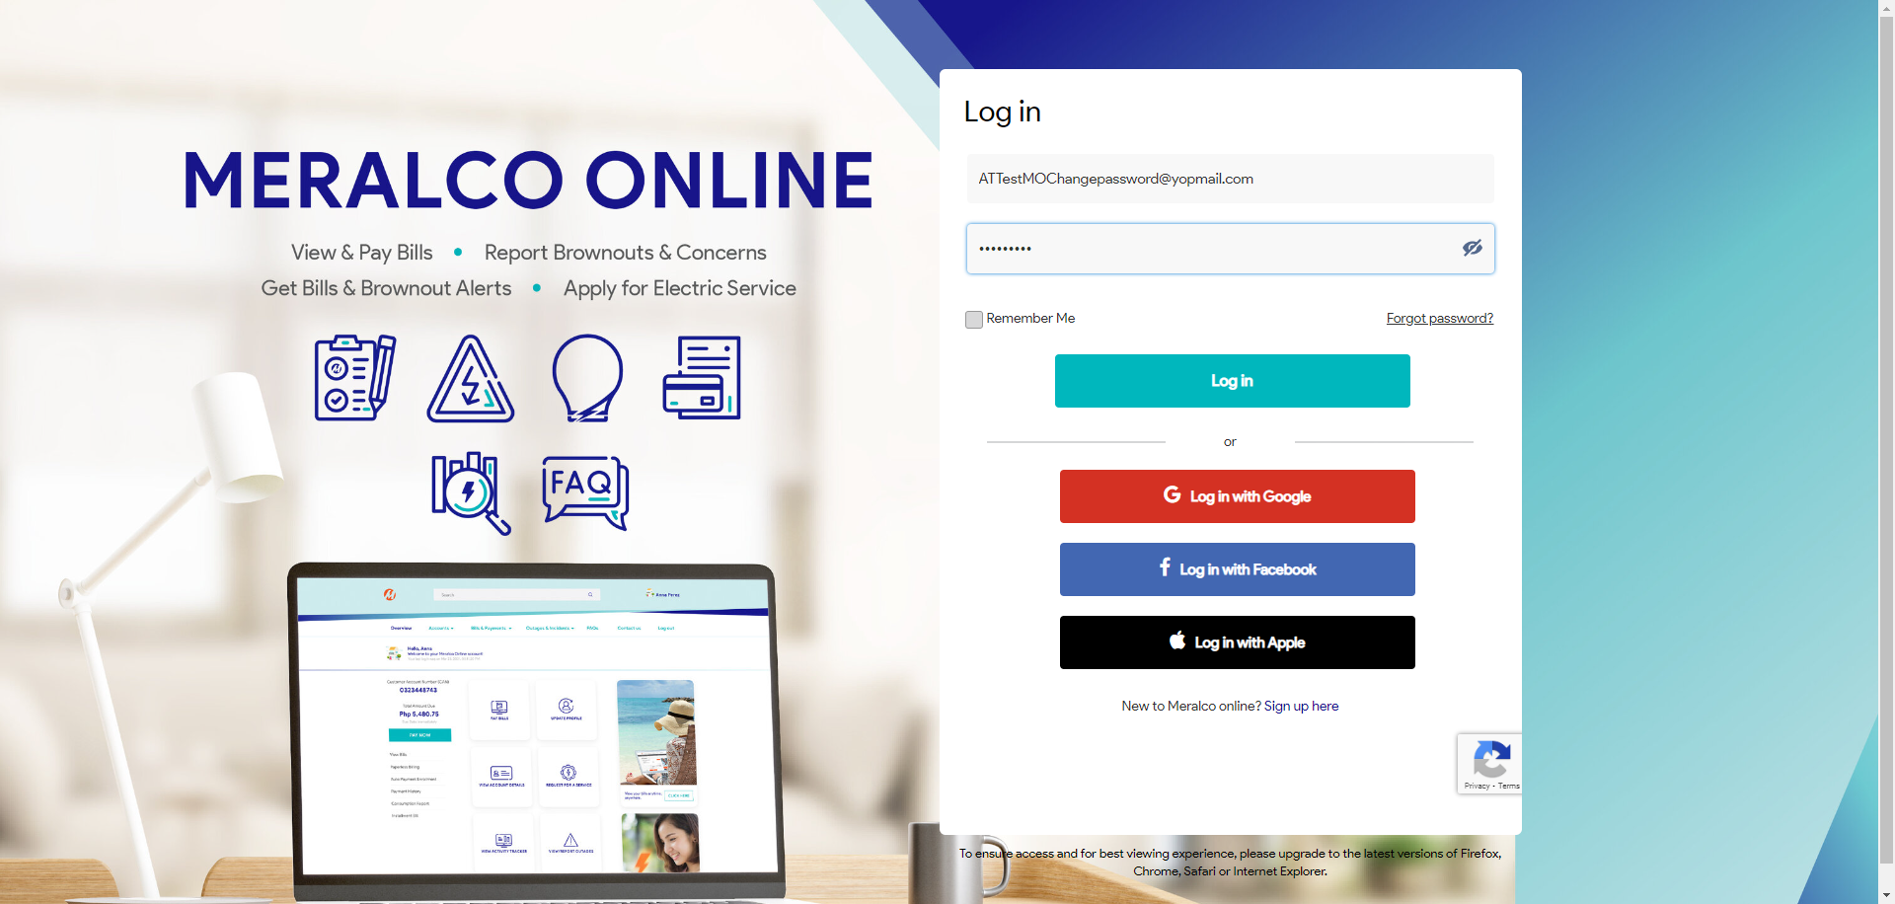

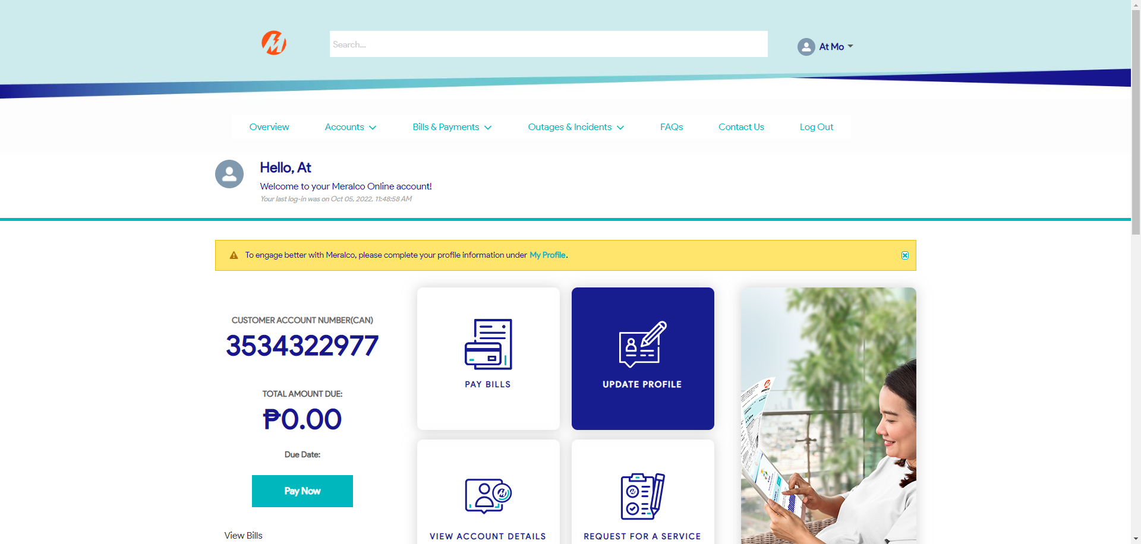

Passed