|  |
| --- |
| TS019a - |

|  |
| --- |
|  |

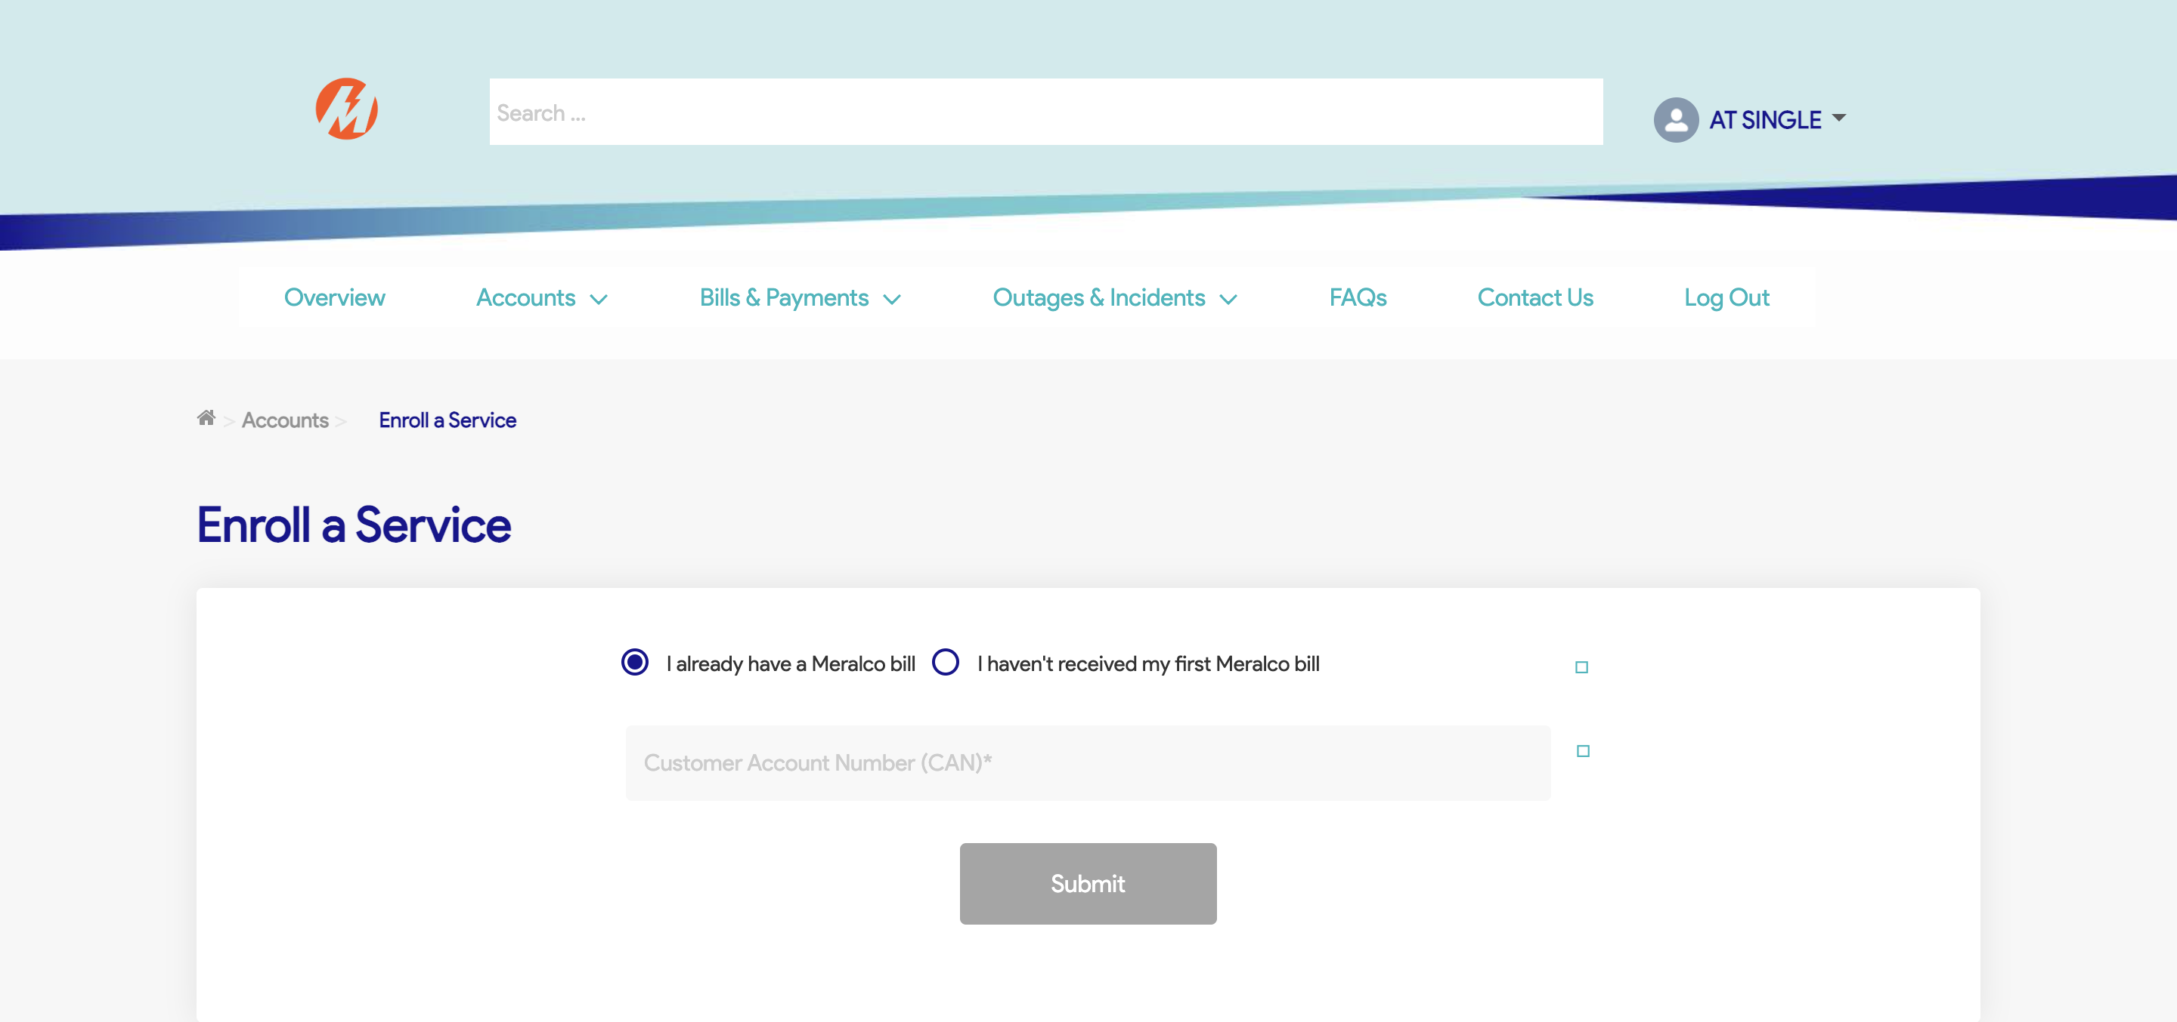

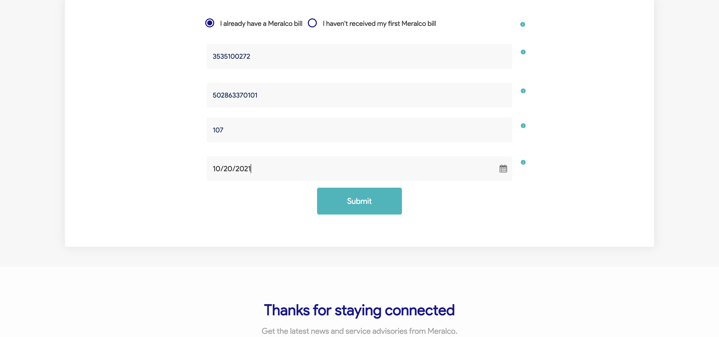

Passed