|  |
| --- |
| TS022 - Expired Password - Logged in Account_Regular; Meralco Online |

|  |
| --- |
| TC009_Validation of Expired Password_Meralco Online |

|  |
| --- |
| Step 1 - Go to Meralco Online |
| User should be redirected to Change Password for Expired password page |



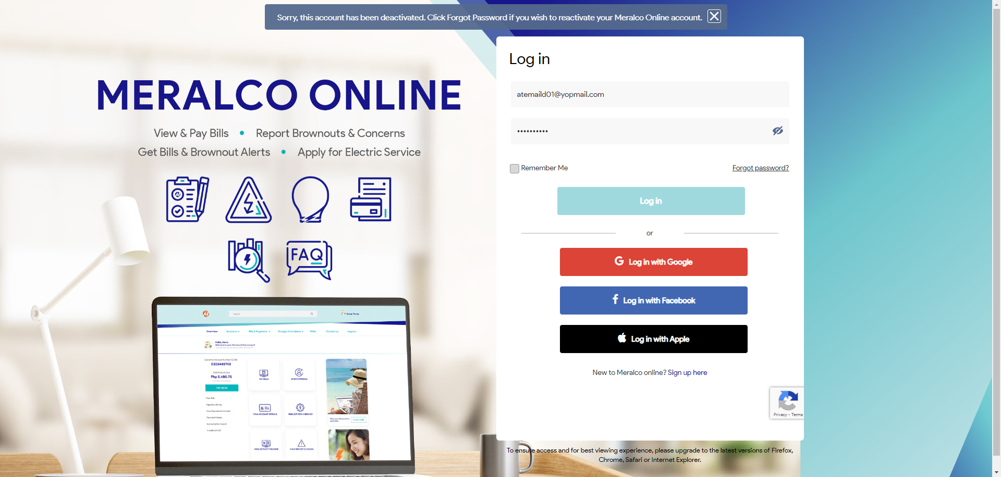

Passed