|  |
| --- |
| TS022a - |

|  |
| --- |
|  |

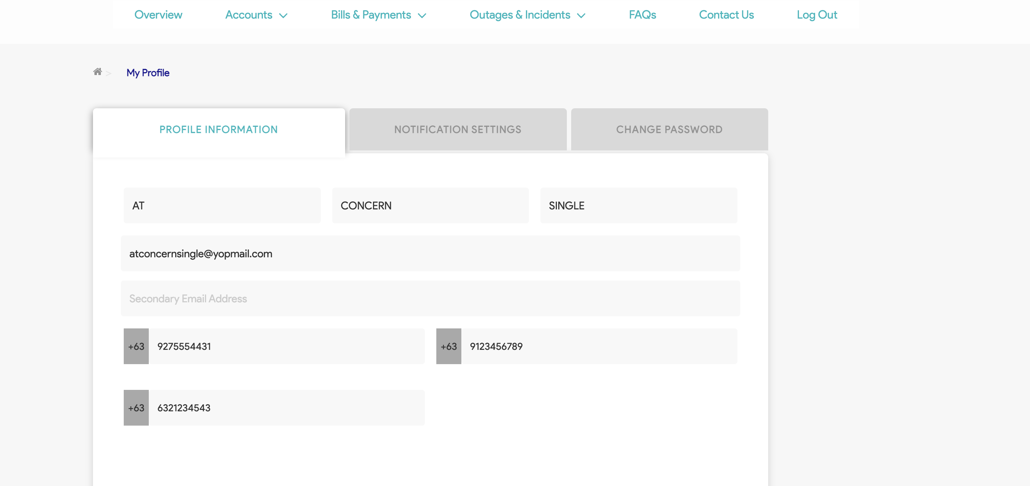

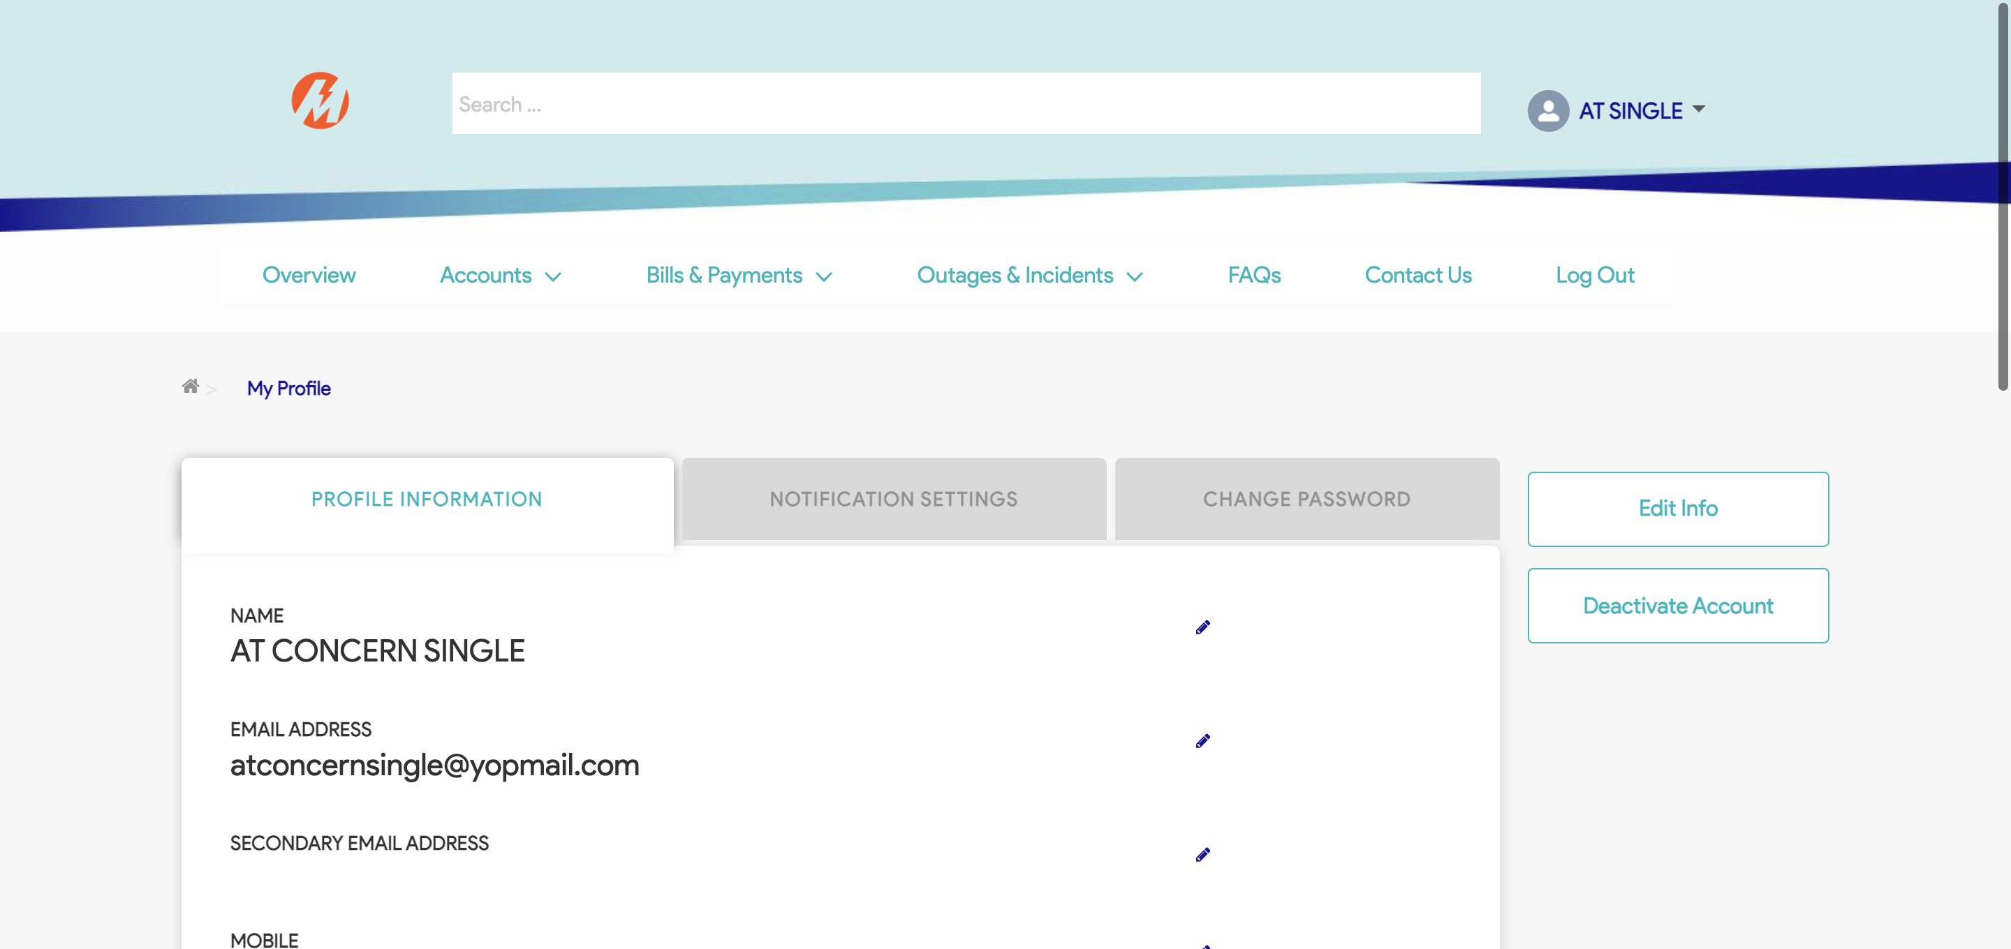

Passed