|  |
| --- |
| TS024 - Log in - Google SSO Account; Meralco Online |

|  |
| --- |
| TC008_Successful login_SSO |

|  |
| --- |
| Step 1 - Login via SSO indicated in scenario |
| User should be successfully logged in |

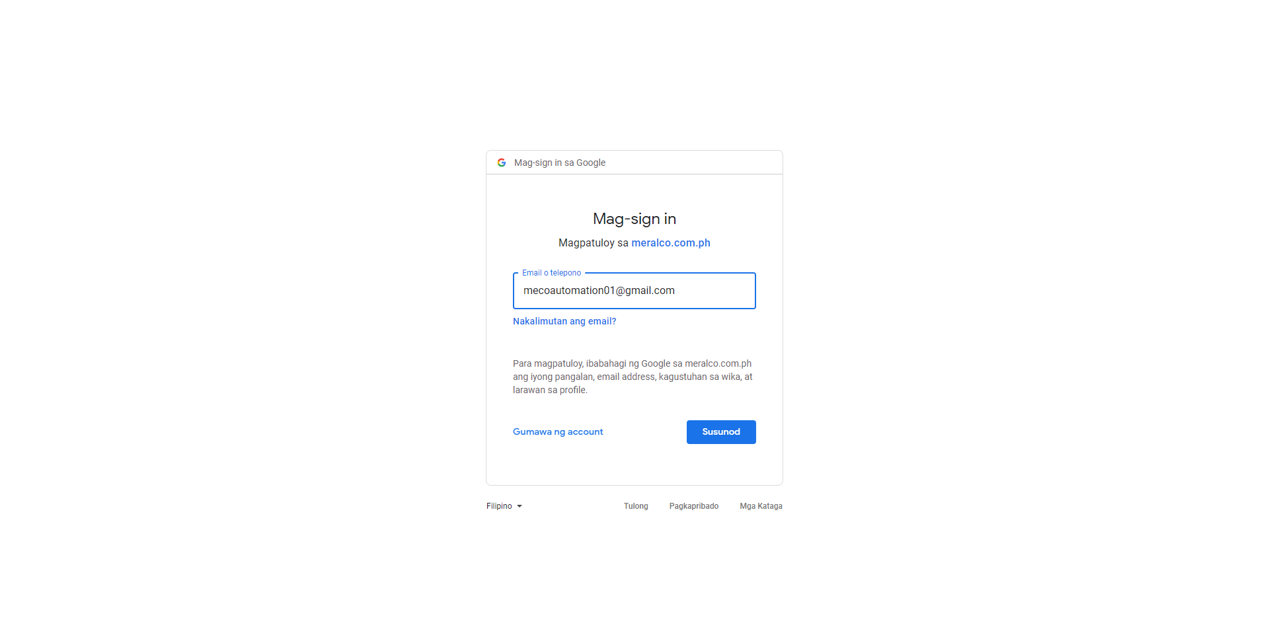

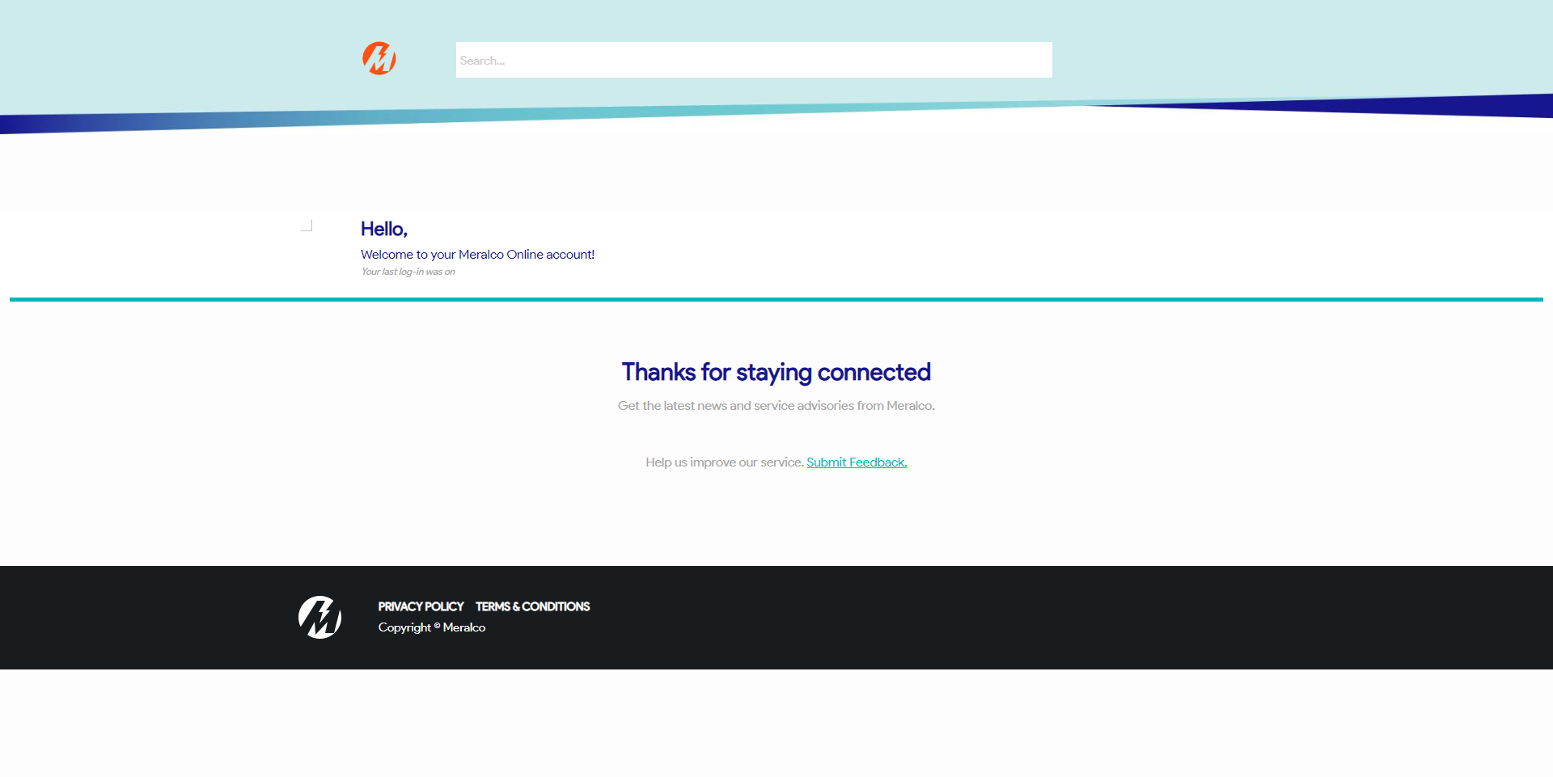

Passed