Nguyen Chi Cong

Computer Project

1. **Designing**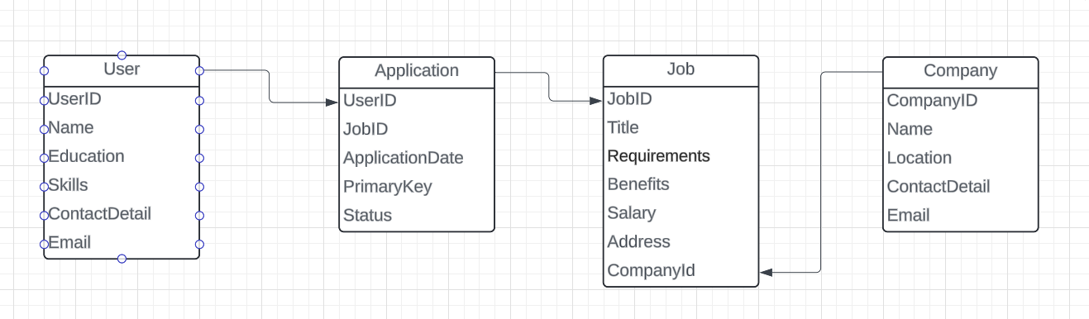

### 2 . Project Process

### Primary branches:

* **main (or master)**: the primary branch containing stable code that is ready for production.
* **develop**: the main development branch where all features and bug fixes are integrated before moving to the main branch.

**Auxiliary branches**:

* **feature**: a separate branch for each new feature or module. After the development is complete, this branch is merged into develop.
* **release**: a branch created for preparing a product release. It allows final testing and minor adjustments before being merged into the main branch.
* **hotfix**: a branch used for quickly addressing bugs or issues in the production version (e.g., in the main branch).

**If you are developing a new module, what steps should be taken from the start of development to the release of the module?**

1. **Requirement analysis**: Gather and understand the functional and non-functional requirements.
2. **Create a feature branch**: Set up a new branch for the specific module.
3. **Design phase**: Outline the architecture of the module and create necessary diagrams, such as an ERD.
4. **Development**: Implement the module while adhering to coding conventions.
5. **Testing**: Conduct unit tests followed by integration tests.
6. **Code review**: Have the code reviewed by other team members or a senior developer.
7. **Merge**: Merge the feature branch into the develop branch.
8. **Release**: Test the module within the release branch before merging into the main branch for deployment.

**3. Testing**

**What types of testing strategies are there?**

1. **Functional testing**: Ensures the system functions as intended.
2. **Non-functional testing**: Covers areas like performance, security, and usability.
3. **Regression testing**: Verifies that new changes haven’t negatively affected existing functionality.
4. **Acceptance testing**: Checks if the product fulfills the business requirements and is ready for delivery.

**What is the purpose of Unit Testing?**

* It is designed to test individual components of the code, such as functions or methods, in isolation to ensure they behave as expected.

**What is the goal of Integration Testing?**

* It ensures that different modules or components of the system work together correctly, helping to identify any issues in the way they interact.

**If a tester needs to test a new module, what steps should they follow from the start of testing to the release?**

1. **Understand the requirements**: Review the module documentation and requirements.
2. **Plan the tests**: Create test cases and scenarios based on the module's functionality.
3. **Set up the test environment**: Deploy the module to a testing environment.
4. **Execute tests**: Run unit tests, integration tests, and perform functional and acceptance testing.
5. **Perform regression testing**: Ensure that the new module does not break existing features.
6. **Retest**: Verify that any reported bugs or issues have been fixed.
7. **Finalize and document**: Record all test results and hand the module over for release.