Landmark-specific transcriptomic and proteomic associations with 60-day mortality in Day-1-defined sepsis-induced coagulopathy: a multicentre longitudinal cohort study
Hao Lyu¹, Lingwei Li², Jianxing Guo¹, Dong Zhang^{1*}

¹ Department of Critical Care Medicine, The First Hospital of Jilin University, No.1, Xinmin Street, Changchun, Jilin, 130021, China.
² Department of Cadre Ward, The First Hospital of Jilin University, No.1, Xinmin Street, Changchun, Jilin, 130021, China.
Email addresses:
Hao Lyu: haolv25@mails.jlu.edu.cn; Lingwei Li: lilw24@mails.jlu.edu.cn;
Jianxing Guo: guojianxing@jlu.edu.cn;
*Corresponding author: Dong Zhang; Emails: zhangdong@jlu.edu.cn

Abstract
Background
Sepsis-induced coagulopathy (SIC) develops within a thromboinflammatory network, but mortality-associated programmes may differ across sampling landmarks and molecular compartments.
Methods
We analysed 504 adults with Day-1 SIC from the multicentre Chinese Multi-omics Advances in Sepsis cohort. Whole-blood RNA-seq and plasma protein measurements on Days 1, 3 and 5 were analysed in separate centre-stratified Cox models for 60-day mortality, with delayed entry at later landmarks. Cox Wald statistics were used to rank features for Hallmark enrichment. Prespecified pathway scores were evaluated in adjusted contemporaneous, forward and reverse-order cross-omic models. Day-5 RNA-seq observation was examined using positivity-supported inverse-probability weighting.
Results
Risk-valid RNA-seq datasets included 504, 420 and 320 patients on Days 1, 3, 5, with 84, 67 and 53 subsequent deaths; plasma proteomic datasets included 168, 147 and 114 patients, with 27, 18 and 14 deaths. Early transcriptomic mortality rankings were enriched for heme, hypoxic and inflammatory programmes. At Day 5, these signals coexisted with negative enrichment of MYC targets, oxidative phosphorylation, unfolded-protein response, E2F targets and DNA repair. Later plasma proteomic rankings were dominated by extracellular-matrix/tissue-remodelling enrichment. Interferon pathways showed reproducible contemporaneous and forward associations; no reverse-order model met the FDR threshold. Weighted and unweighted Day-5 Hallmark profiles were concordant (Spearman ρ=0.980), although positivity and residual balance remained limited.
Conclusions
Mortality-associated programmes differed across landmark-specific survivor risk sets and molecular compartments. These findings require external validation and do not establish within-patient trajectories, causal cross-compartment transfer or incremental prognostic value beyond clinical severity.
Keywords
Sepsis-induced coagulopathy; longitudinal multi-omics; landmark analysis; transcriptomics; proteomics; interferon; extracellular matrix; mortality
Background
Sepsis-induced coagulopathy (SIC) is a clinically identifiable manifestation of dysregulated haemostasis in sepsis. It develops within a reciprocal network of innate immune activation, endothelial perturbation, platelet and coagulation activation, impaired endogenous anticoagulant pathways and suppressed fibrinolysis[1-4]. SIC should therefore not be regarded as an isolated abnormality of conventional coagulation tests, but as part of a heterogeneous thromboinflammatory spectrum linking immunothrombosis, vascular injury, coagulation consumption and organ dysfunction. Clinical SIC scores identify a high-risk population but do not define the molecular programmes associated with subsequent mortality after the initial SIC episode.
Blood transcriptomics and plasma proteomics have demonstrated substantial biological heterogeneity in sepsis. A consensus blood-transcriptomic framework identified inflammatory/endothelial, heme/coagulation and interferon/lymphoid programmes across large cohorts, including longitudinal follow-up samples[5]. High-throughput and serial plasma proteomic studies have identified mortality-associated signals involving inflammation, complement, coagulation, tissue injury and extracellular-matrix biology[6, 7]. These molecular layers are not interchangeable. Whole-blood RNA-seq profiles reflect circulating-cell abundance and transcriptional state, whereas plasma protein abundance integrates secretion, tissue release, vascular permeability, consumption and clearance. Discordance between the two compartments can consequently be biologically informative rather than evidence of analytical failure.
Previous analyses of the CMAISE resource focused on baseline molecular heterogeneity, subgroup discovery or prediction[8, 9]. They did not determine whether mortality-associated pathway rankings differ across Day-1, Day-3 and Day-5 landmark-specific survivor risk sets in a fixed Day-1 SIC population, or whether selected pathways show reproducible associations across whole-blood and plasma compartments. Analyses of later samples also require explicit attention to risk-set eligibility and sample observation: patients who die before a sampling landmark cannot contribute a post-mortem molecular state, and survivors may differ systematically in whether a sample is obtained.
We therefore applied risk-set-aware landmark analyses to serial whole-blood RNA-seq and plasma protein data from a fixed Day-1 SIC cohort. We aimed to characterise molecular programmes associated with subsequent 60-day mortality at each landmark, determine whether whole-blood and plasma compartments provided complementary prognostic information, evaluate selected cross-omic associations and assess the robustness of Day-5 RNA-seq findings to sampling selection.
Methods
Study design and data source
We performed a secondary longitudinal analysis of prospectively collected clinical, whole-blood transcriptomic and plasma proteomic data from the multicentre Chinese Multi-omics Advances in Sepsis (CMAISE) cohort[8, 10]. The CMAISE v1.5 release included patients recruited from 43 tertiary hospitals in China between November 2020 and November 2024.
Analytic framework and estimands
The analysis addressed three distinct estimands. First, centre-stratified molecular associations with subsequent 60-day mortality were estimated separately among patients eligible at the Day-1, Day-3 and Day-5 sampling landmarks. Second, contemporaneous and forward cross-compartment pathway associations were evaluated among patients with the required paired molecular measurements. Third, the robustness of the Day-5 RNA-seq mortality-ranking results to selective sample observation was assessed among landmark survivors from centres with empirical positivity support. This framework separated landmark-specific prognosis from within-patient molecular trajectory and distinguished structural non-availability caused by death from potentially modelled sample observation.
Participants, SIC definition and outcome
The analytic source cohort comprised 504 adults who fulfilled Sepsis-3 criteria and had an SIC score of at least 4 on Day 1[2, 11]. Day-3 and Day-5 samples were longitudinal follow-up samples from this fixed Day-1 SIC cohort; contemporaneous SIC status at the later time points was not assumed. The primary outcome was 60-day all-cause mortality, with death coded as the event and follow-up administratively censored at 60 days. Baseline demographic, physiological and laboratory variables were recorded on Day 1 and retained as baseline covariates when linked to later molecular samples.
This secondary analysis included all eligible patients and available molecular measurements; no prospective sample-size calculation was performed.
Clinical descriptive and exploratory survival analyses
Baseline variables were summarised as median [interquartile range] or number (percentage), with group separation described primarily using standardised mean differences. Clinical variable definitions, prespecified exclusions, transformations and infection-source harmonisation are provided in Supplementary Table S1. Exploratory univariable Cox models used the prespecified increments in Supplementary Table S2. Proportional-hazards diagnostics and prespecified nonlinearity tests were performed, and the Benjamini–Hochberg procedure was applied across displayed contrasts. Infection source was tested overall by likelihood ratio and then by category with lung/chest infection as the reference. These analyses provided clinical context and did not inform construction of the molecular models.
Longitudinal sample linkage and time-specific risk sets
Patient identifiers were derived by removing only the terminal sampling suffix from each sample name, thereby linking Day-1, Day-3 and Day-5 measurements without altering other portions of the identifier. Day 1 was treated as the nominal study-time origin. Prespecified entry times were 0 days for Day 1, 2 days for Day 3 and 4 days for Day 5, reflecting the cohort sampling windows. Patients contributed to a time-specific risk set only when their recorded survival time exceeded the corresponding entry landmark. This delayed-entry formulation prevented patients who had died before a later sampling window from contributing immortal person-time to that analysis[12].
Molecular data generation in the parent cohort
The deposited molecular matrices were generated within the CMAISE parent cohort. Whole-blood RNA-seq used ribosomal-RNA-depleted libraries sequenced on an Illumina NovaSeq 6000 platform and aligned to GRCh38; plasma proteins were quantified by data-independent acquisition mass spectrometry with peptide- and protein-level false-discovery rates below 1%. Detailed laboratory and primary processing procedures are provided in Supplementary Methods.
RNA-seq processing
We analysed the deposited integer RNA-seq count matrix for 1,246 longitudinal SIC samples. Genes with at least one count per million in at least 20% of samples were retained; Ensembl identifiers were mapped to gene symbols, duplicate symbols were summed, and trimmed-mean-of-M-values normalisation was estimated jointly across landmarks. Within each risk-valid dataset, gene expression was standardised so that hazard ratios represented a one-standard-deviation increase. Detailed annotation and normalisation procedures are provided in Supplementary Methods.
Plasma protein processing and quality control
The deposited log2 plasma protein matrix showed no material missingness, and no protein-value imputation was applied. Rows without gene symbols were removed, duplicated symbols were deterministically resolved, and replicate variability was summarised across ten quality-control batches. Proteins with a median replicate coefficient of variation below 20% were retained, yielding 3,875 proteins. Protein abundance was standardised within each risk-valid dataset. A prespecified sensitivity analysis additionally adjusted for sample median protein intensity. Detailed duplicate-resolution and quality-control procedures are provided in Supplementary Methods.
Time-specific molecular survival models
Day-1, Day-3 and Day-5 molecular measurements were analysed in separate prognostic models; they were not entered as time-dependent covariates in a single Cox model. For each gene or protein, we fitted a centre-stratified Cox proportional-hazards model of the form Surv(entry, stop, event) ~ feature_z + strata(centre), with Efron handling of tied event times. Cox Wald statistics were used as signed feature-level prognostic rankings. Proportional-hazards assumptions were assessed using scaled Schoenfeld residuals with the Kaplan–Meier time transformation. The primary analysis retained all successfully estimated features; a prespecified sensitivity analysis repeated gene-set enrichment after restricting to features with nominal proportional-hazards-test P values of at least 0.05. The primary molecular models were centre stratified but otherwise unadjusted for clinical severity; they estimated total prognostic associations and were not designed to quantify severity-independent or incremental prognostic value.
All tests were two sided. Feature-level hazard ratios, 95% confidence intervals (CI) and P values were retained for audit, but biological interpretation focused on prespecified pathway-level analyses rather than individual features selected by nominal significance.
Hallmark gene-set enrichment
Complete signed Cox Wald rankings were analysed using the Molecular Signatures Database Hallmark collection (release 2026.1). Gene-set enrichment was performed with a multilevel permutation algorithm, with minimum and maximum set sizes of 15 and 500, respectively, and eps=0[13, 14]. The Benjamini–Hochberg procedure controlled the FDR across the complete Hallmark family within each time point, molecular layer and prespecified analysis family. An FDR below 0.05 defined statistical significance. Normalised enrichment scores describe the position of pathway members along a mortality-associated feature ranking; they do not measure absolute pathway activity, within-person change or causal activation.
Patient-level pathway scores and cross-omic analysis
For each sample and molecular layer, detected features were converted to fractional within-sample ranks. For each pathway, the score was the mean fractional rank of its detected members minus 0.5; a score was calculated only when at least 10 pathway members were detected. Scores were standardised within each sampling landmark before cross-omic modelling. These rank-based scores were relative within-sample composite summaries rather than latent constructs. Rank transformation reduced dependence on absolute assay scale but did not remove centre, batch or cell-composition effects.
The 15-pathway core panel was predefined before patient-level cross-omic modelling and was not selected according to the observed cross-omic associations or P values. The panel was intended to reduce multiplicity and preserve a clinically interpretable cross-omic hypothesis space, not to provide an exhaustive catalogue of SIC biology.
The 15 pathways represented four SIC-relevant domains supported by the reference study and consensus pathobiology: inflammatory and interferon host response (TNF-α signalling via NF-κB, IL-6/JAK/STAT3 signalling, inflammatory response, IFN-α response and IFN-γ response); thromboinflammation and erythroid/heme biology (coagulation, complement and heme metabolism); barrier and tissue remodelling (epithelial–mesenchymal transition, TGF-β signalling and apical junction); and hypoxic, oxidative and bioenergetic stress (hypoxia, oxidative phosphorylation, reactive oxygen species pathway and glycolysis). All 15 pathways met the prespecified coverage requirement; after quality control, each pathway contained at least 20 measured proteins and 48 transcriptomic features.
Contemporaneous transcriptomic–proteomic associations were estimated as Spearman correlations after residualising both pathway scores for age, sex, baseline Sequential Organ Failure Assessment (SOFA) score, study centre and sample median protein intensity. Forward models examined Day-1 transcriptomic scores in relation to Day-3 protein scores and Day-3 transcriptomic scores in relation to Day-5 protein scores. These models adjusted for the previous protein score, age, sex, baseline SOFA score, centre and target-landmark sample median protein intensity, and used heteroscedasticity-consistent HC3 standard errors. Reverse-order protein-to-subsequent-transcriptomic models were prespecified temporal-association analyses. Mortality-adjusted sensitivity analyses were retained as secondary repository outputs and did not alter the primary interpretation. FDR correction was applied within each prespecified time-direction family. These models quantify adjusted temporal association and do not establish mediation, translation delay or causal molecular transfer.
Day-5 RNA-seq availability and inverse-observation-probability weighting
The primary Day-5 availability estimand comprised patients from the Day-1 SIC cohort who survived beyond the Day-4 landmark and came from centres with empirical support for Day-5 RNA-seq observation. Death at or before entry was classified as structural non-availability and reported separately; weighting was not used to reconstruct molecular states after death. Centres with no Day-5 RNA-seq observations were outside the positivity-supported estimand, centres with complete observation were assigned probability and weight equal to one, and observation probabilities were estimated only in partially observing centres.
The prespecified primary observation model included baseline age, sex, SOFA score, infection source, centre, prior Day-3 RNA-seq availability, and lactate, INR and D-dimer, each log₂-transformed before standardisation. In alternative severity-specification sensitivity models, baseline SOFA was replaced by the PaO₂/FiO₂ ratio and log₂-transformed platelet count. Inverse-observation weights were truncated at the 1st and 99th percentiles and normalised to mean one among observed patients. Weighted centre-stratified Cox models used robust sandwich standard errors. Detailed weight construction, variance verification and scenario definitions are provided in Supplementary Methods and Supplementary Table S8.
All 14,541 successfully estimated genes were ranked by the weighted robust Wald statistic for Hallmark enrichment. Weighted and unweighted pathway profiles were compared across the complete Hallmark family using NES Spearman correlation, pathway-direction agreement and Jaccard overlap of FDR-significant sets. The weighted model was a prespecified sensitivity analysis and was not intended to replace the unweighted centre-stratified primary result. Alternative observation models and entry-boundary scenarios were used only as prespecified sensitivity analyses[15]. The weighted analysis evaluated robustness only within the positivity-supported landmark-survivor population and was not interpreted as complete correction for centre-structured non-observation.
Missing data, multiplicity and interpretation hierarchy
The final RNA-seq and protein feature matrices entered the time-specific models after the processing steps described above. No protein-value imputation was used in the final pipeline. The covariates used in the primary positivity-supported Day-5 availability cohort had no missing values; prefit observation models were full rank and showed no complete separation. Analysis-family-specific FDR correction was used throughout. The evidential hierarchy was fixed before manuscript production: unweighted time-specific Cox/GSEA results were primary; proportional-hazards, global-intensity and Day-5 weighting results were sensitivity analyses; and cross-omic models were interpreted as adjusted associations. No pathway was promoted to a primary conclusion solely because of an uncorrected P value or visual concordance.
Software, reproducibility and generative-AI assistance
Analyses were performed in R version 4.4.2 using version-controlled scripts, fixed package versions and prespecified random seeds. The code and aggregate source-data snapshot corresponding to this manuscript are maintained in the project repository. Individual-level clinical and molecular data remain subject to controlled-access governance.
Under our direction and supervision, generative-AI tools provided assistive support for language editing, document organisation, code review and consistency checking. We determined the research questions, estimands, analysis plan and interpretation, verified all code and numerical outputs, approved the final manuscript and take full responsibility for the work.
Results
Cohort construction and longitudinal molecular availability
The Day-1 SIC cohort included 504 patients, of whom 84 died within 60 days (Figure 1a). All 504 patients contributed to the Day-1 RNA-seq analysis. The raw Day-3 RNA-seq dataset included 421 samples; 420 samples were risk-valid after delayed entry, with 67 subsequent deaths. The raw Day-5 RNA-seq dataset included 321 samples; 320 samples were risk-valid, with 53 subsequent deaths. Plasma protein measurements were available in a nested subset, yielding risk-valid datasets of 168 patients with 27 deaths at Day 1, 147 patients with 18 deaths at Day 3 and 114 patients with 14 deaths at Day 5 (Figure 1b). Baseline characteristics are summarised in Table 1; the clinical analyses were descriptive and were not used to select covariates for the molecular feature-wise Cox models.
Baseline differences were largest for SOFA score, blood urea nitrogen (BUN), lactate, PaO₂/FiO₂ ratio, infection source and sodium. In exploratory univariable Cox analyses, 10 of 41 displayed contrasts retained BH-FDR below 0.05, reflecting age, organ dysfunction, metabolic derangement and infection source; BUN showed evidence of nonlinearity. These analyses were descriptive and did not inform the molecular models (Table 1, Supplementary Table S2 and Supplementary Figure A9).
For the primary Day-5 availability analysis, 491 patients survived beyond the Day-4 landmark; 13 patients who died at or before entry were structurally unavailable (Figure 1c,d). Four patients from three zero-observation centres were excluded from the positivity-supported estimand, leaving 487 patients. Day-5 RNA-seq was observed in 320 patients and unobserved in 167 patients; the observed group included 53 subsequent deaths. Across centres, three centres had zero observation, 13 centres had complete observation and 14 centres had partial observation (Figure 1e).

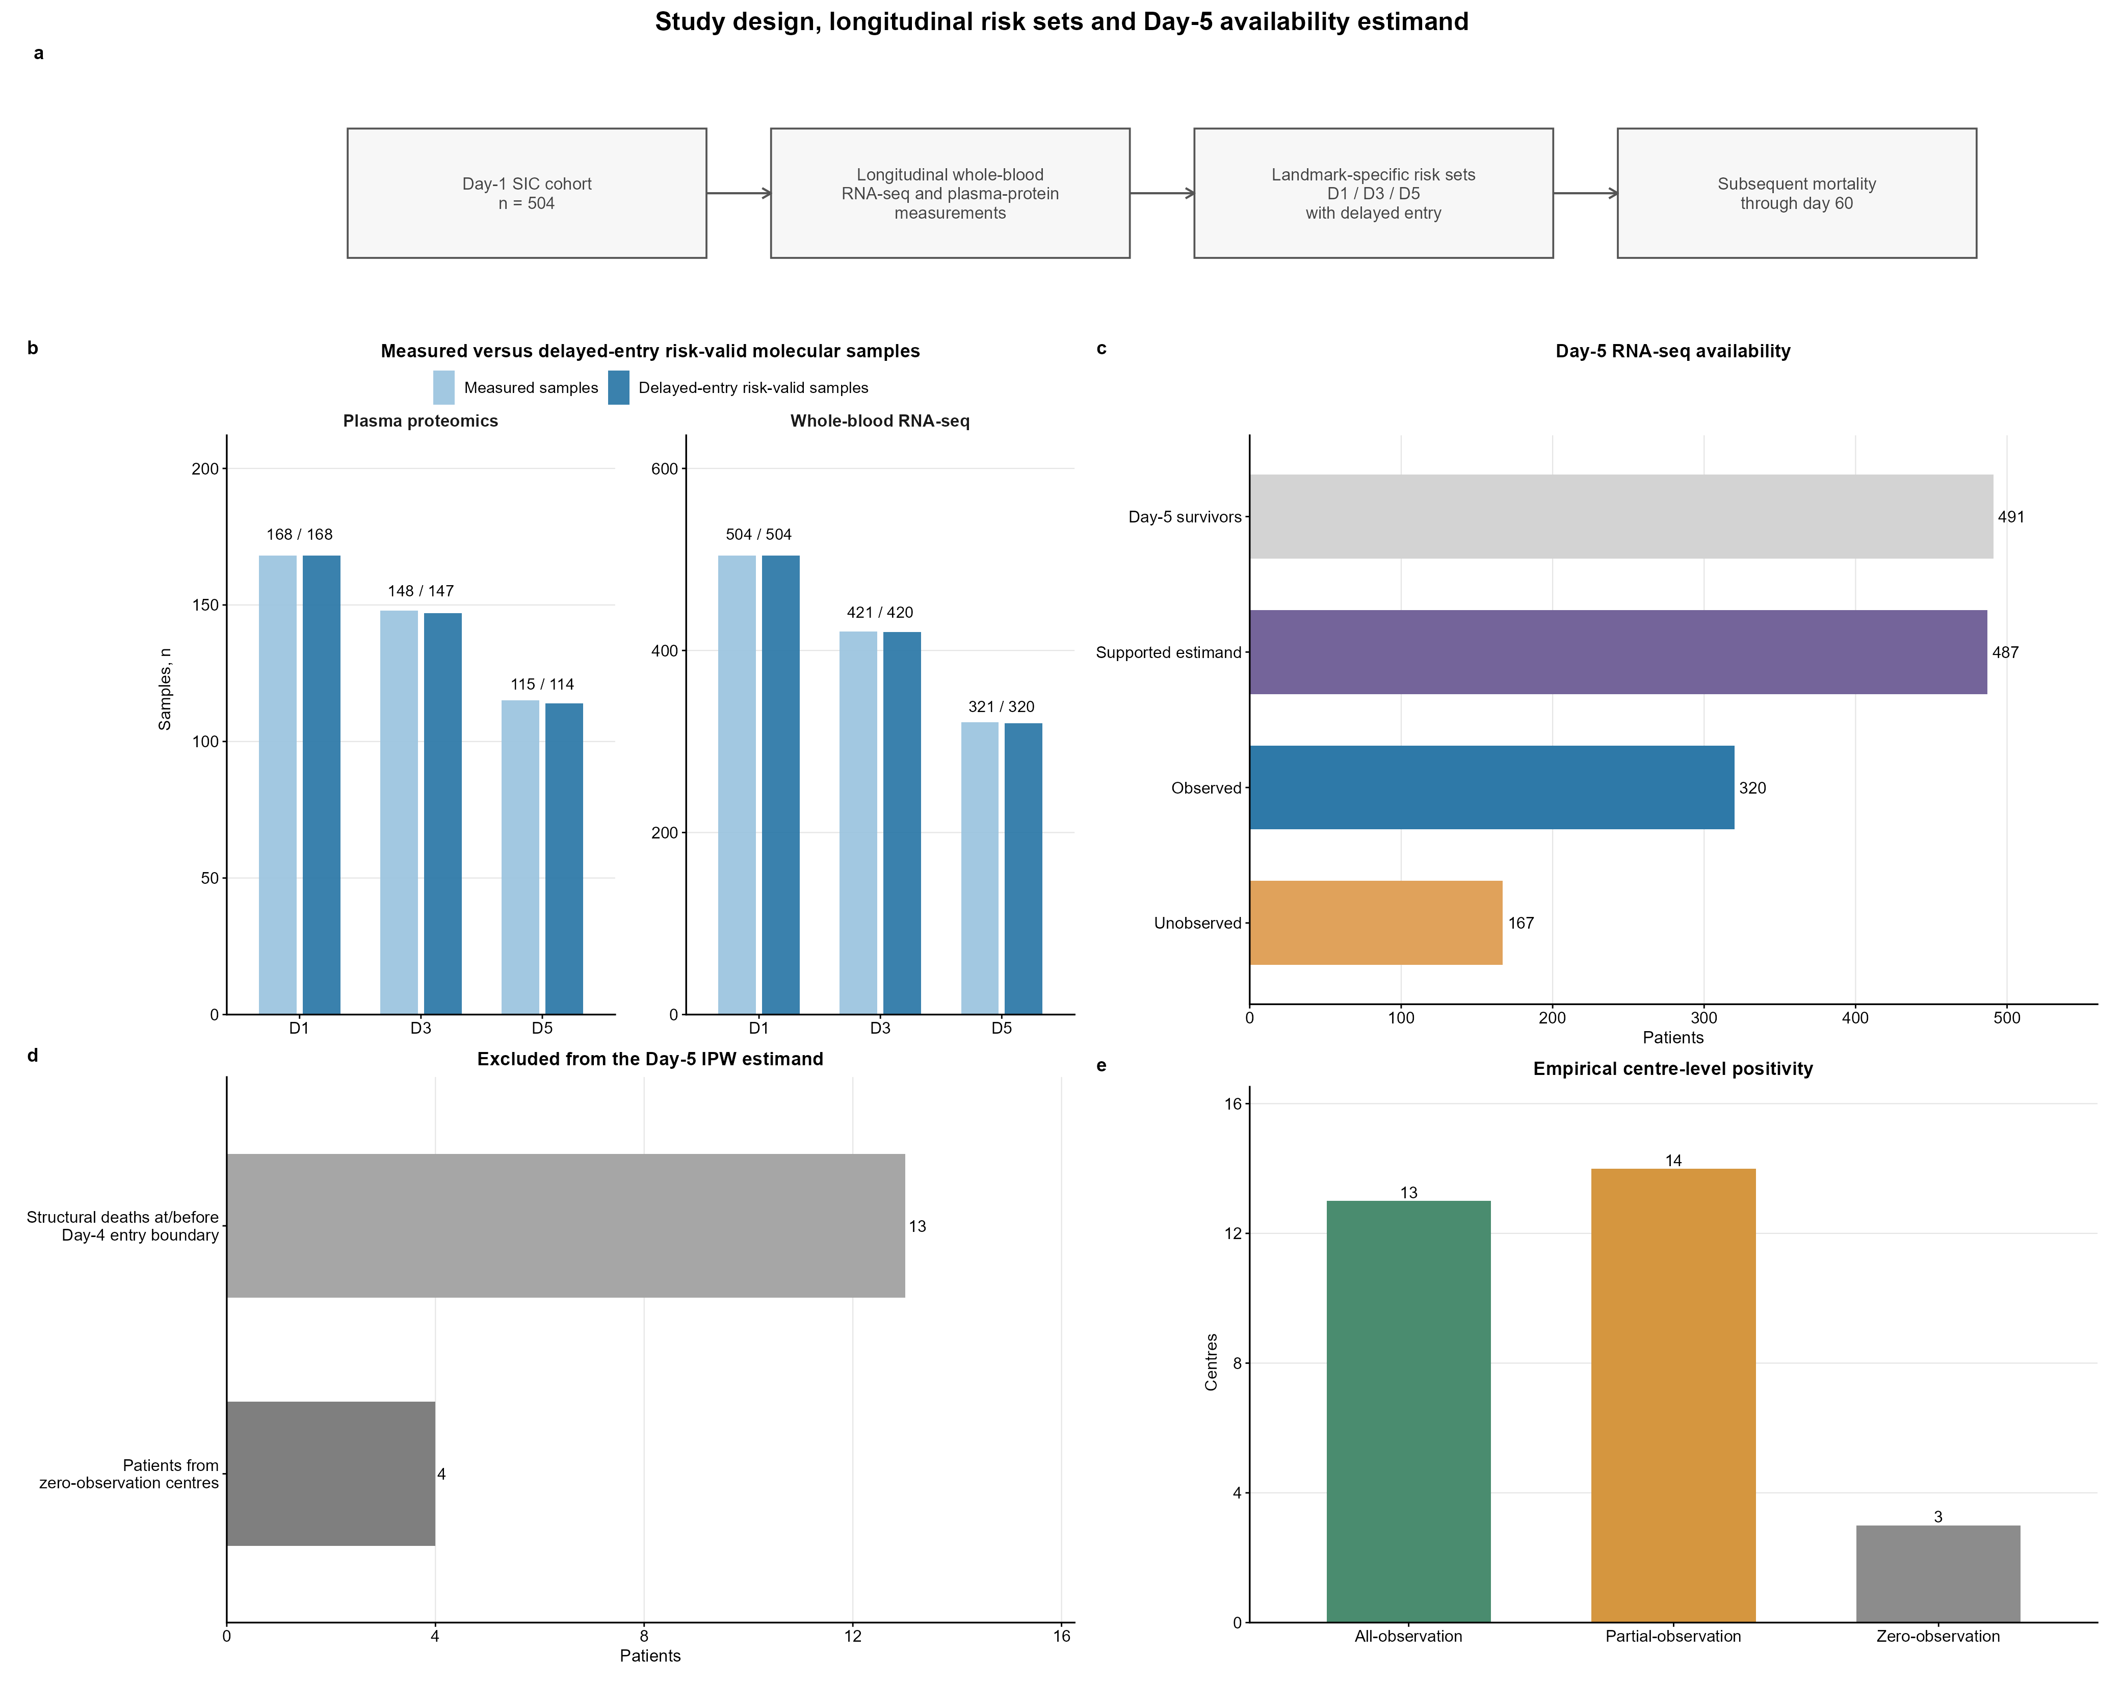
Figure 1 | Study design, longitudinal risk sets and Day-5 availability estimand. a, The Day-1 SIC cohort (N=504) was linked to longitudinal whole-blood RNA-seq and plasma protein measurements; each sampling landmark was analysed in a separate time-specific prognostic model. b, Raw measured and delayed-entry risk-valid sample counts for RNA-seq and plasma proteomics at Days 1, 3 and 5. c, Day-5 RNA-seq availability among 491 landmark survivors: 487 patients belonged to the positivity-supported estimand, of whom 320 had observed and 167 had unobserved Day-5 RNA-seq. d, Thirteen deaths at or before the prespecified Day-4 entry boundary for the Day-5 sampling landmark were structurally unavailable. Four patients from three zero-observation centres were excluded from the positivity-supported estimand. e, Empirical centre-level positivity classes.

Whole-blood mortality-associated rankings differed across landmark-specific risk sets
At Day 1, the strongest positive mortality-associated transcriptomic enrichment involved heme metabolism (NES 2.69, FDR 2.95×10⁻²⁰), hypoxia (NES 2.43, FDR 1.80×10⁻¹²) and TNF-α signalling via NF-κB (NES 2.06, FDR 1.40×10⁻⁷). Coagulation, reactive oxygen species, glycolysis, inflammatory response, the Hallmark epithelial–mesenchymal transition signature and apical junction were also positively enriched. In contrast, oxidative phosphorylation (NES −1.69, FDR 1.15×10⁻⁴) and MYC targets V1 (NES −1.65, FDR 2.93×10⁻⁴) were negatively enriched (Figure 2). The principal Day-1 directions and statistical support were retained in the proportional-hazards-pass sensitivity analysis.
At Day 3, heme metabolism remained the most prominent positive programme (NES 2.39, FDR 6.78×10⁻¹⁹), accompanied by TNF-α/NF-κB, hypoxia and IL-6/JAK/STAT3 signalling. Reactive oxygen species, complement, inflammatory response, coagulation, glycolysis, apical junction and the Hallmark epithelial–mesenchymal transition signature were also positively enriched. IFN-α and IFN-γ responses were FDR significant at this landmark (NES 1.62 and 1.45, respectively). These Day-3 pathway directions were consistent in the proportional-hazards-pass analysis.
By Day 5, the mortality-associated transcriptomic ranking combined recurrent positive enrichment of heme, hypoxic and inflammatory programmes with broader negative enrichment of bioenergetic, biosynthetic, proteostatic and repair programmes. The strongest negative signals involved MYC targets V1 (NES −3.13, FDR 6.19×10⁻²⁷), oxidative phosphorylation (NES −2.44, FDR 1.77×10⁻¹²), unfolded-protein response (NES −2.04, FDR 1.65×10⁻⁵), E2F targets (NES −1.89, FDR 1.38×10⁻⁵) and DNA repair (NES −1.62, FDR 0.0029). Conversely, heme metabolism, IL-6/JAK/STAT3 signalling, hypoxia, inflammatory response, TNF-α/NF-κB, complement, apical junction, reactive oxygen species and IFN-γ remained positively enriched. Principal Day-5 directions were preserved after proportional-hazards filtering and in the availability-weighted sensitivity analyses. These NES values represent enrichment along mortality-associated Cox rankings rather than longitudinal changes in absolute pathway activity. Complete gene-wise Cox/PH results and full Hallmark results are provided in Supplementary Tables S3 and S4.

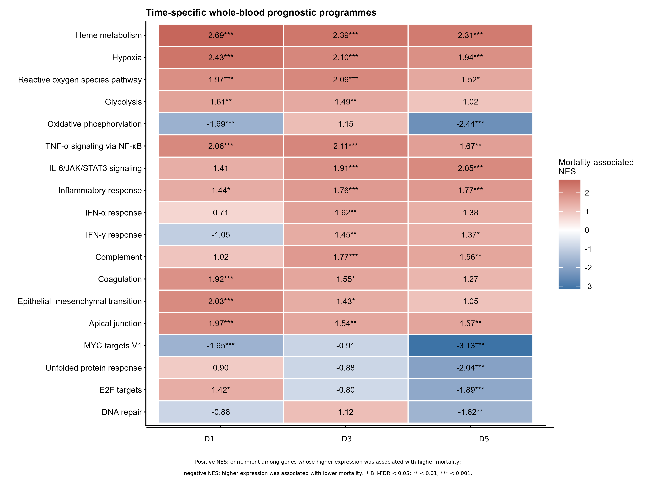
Figure 2 | Time-specific whole-blood transcriptomic prognostic programmes. Cells show normalised enrichment scores (NES) from the primary Hallmark analysis based on gene-wise Cox Wald-z rankings at Days 1, 3 and 5. Positive NES indicates enrichment among genes whose higher standardised expression was associated with higher subsequent 60-day mortality risk. Negative NES indicates enrichment among genes whose higher expression was associated with lower subsequent mortality—or equivalently, whose lower expression was associated with higher mortality. NES therefore represents the direction of the mortality association and not absolute pathway expression or activation. *BH-FDR<0.05, **BH-FDR<0.01 and ***BH-FDR<0.001 for the displayed primary analysis.

Plasma protein mortality-associated programmes concentrated on tissue remodelling
Among 3,875 retained proteins, the Day-1 mortality-associated landscape included positive enrichment of MYC targets V1 (NES 1.62, FDR 9.89×10⁻⁷), hypoxia (NES 1.56, FDR 7.81×10⁻⁴), glycolysis (NES 1.54, FDR 7.81×10⁻⁴), the Hallmark epithelial–mesenchymal transition signature (NES 1.36, FDR 0.024), DNA repair, fatty-acid metabolism, G2M checkpoint and mTORC1 signalling (Figure 3). The key Day-1 directions remained stable in the prespecified proportional-hazards and global-intensity sensitivity analyses, although the strength of individual pathways varied.
At Day 3, the Hallmark epithelial–mesenchymal transition signature was the dominant positive programme (NES 2.38, FDR 5.86×10⁻⁸), with positive myogenesis (NES 2.05, FDR 3.50×10⁻⁴), hypoxia and G2M-checkpoint enrichment. Oxidative phosphorylation (NES −1.57, FDR 0.0316), protein secretion (NES −1.61, FDR 0.0316) and complement (NES −1.65, FDR 0.0275) were negatively enriched. At Day 5, the same canonical Hallmark signature was the only displayed pathway meeting the full-family FDR threshold (NES 1.94, FDR 5.67×10⁻⁶). Its Day-5 leading edge was dominated by matrix and tissue-remodelling proteins, including collagens, lysyl oxidase, periostin, versican, tenascin C, thrombospondin 2, fibrillin 1 and elastin. We therefore describe this signal as extracellular-matrix/tissue-remodelling enrichment rather than evidence of a specific cellular transition. Given the 14 subsequent deaths in the Day-5 protein risk set, this later-landmark result was interpreted as pathway-level, hypothesis-generating evidence. Complete protein-wise and Hallmark sensitivity results, including leading edges, are provided in Supplementary Tables S5 and S6.
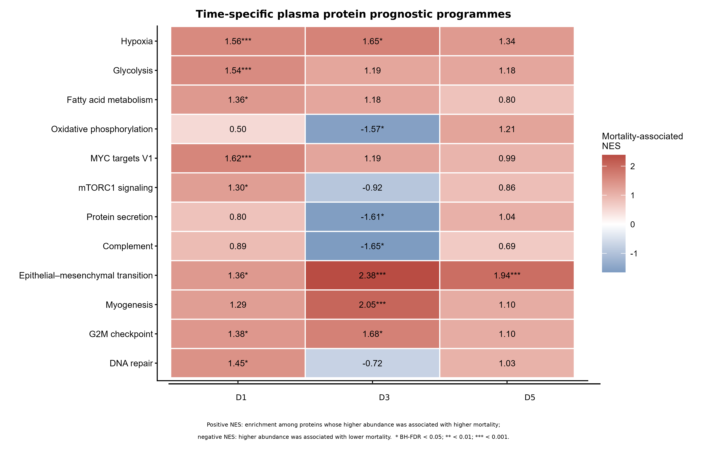
Figure 3 | Time-specific plasma protein prognostic programmes. Cells show normalised enrichment scores (NES) from the primary Hallmark analysis based on protein-wise centre-stratified Cox Wald-z rankings at Days 1, 3 and 5. Positive NES indicates enrichment among proteins whose higher standardised abundance was associated with higher subsequent 60-day mortality risk. Negative NES indicates enrichment among proteins whose higher abundance was associated with lower subsequent mortality—or equivalently, whose lower abundance was associated with higher mortality. NES does not denote absolute pathway expression or activation. The canonical Hallmark epithelial–mesenchymal transition label is retained; its later protein leading edge was dominated by extracellular-matrix proteins and was interpreted as tissue-remodelling enrichment rather than cellular epithelial-to-mesenchymal transition. The Day-5 protein result was based on 14 subsequent deaths and is hypothesis generating. *BH-FDR<0.05, **BH-FDR<0.01 and ***BH-FDR<0.001 for the displayed primary analysis.

Cross-omic concordance was pathway selective rather than global
After adjustment for age, sex, baseline SOFA score, centre and sample median protein intensity, contemporaneous transcriptomic–proteomic associations varied by pathway and sampling landmark (Figure 4a). IFN responses were the most consistent signals. At Day 1, partial Spearman correlations were 0.516 for IFN-α (FDR 1.15×10⁻¹¹) and 0.492 for IFN-γ (FDR 9.16×10⁻¹¹). Corresponding correlations were 0.326 and 0.332 at Day 3 (both FDR 5.06×10⁻⁴), and 0.394 (FDR 3.22×10⁻⁴) and 0.291 (FDR 0.0107) at Day 5. Day-1 hypoxia, inflammatory response, TNF-α/NF-κB and apical junction also showed positive contemporaneous associations, and Day-5 TNF-α/NF-κB was positively associated across compartments. The absence of broad, uniform concordance supported a compartment-specific molecular architecture rather than global synchrony between layers. Complete contemporaneous, forward and reverse-order model results are provided in Supplementary Table S7.
Interferon pathways showed selective forward cross-compartment associations
In forward models controlling for the previous protein score and prespecified clinical covariates, the Day-1 transcriptomic IFN-α score was associated with the Day-3 protein IFN-α score (standardised β 0.343, 95% CI 0.188–0.498; FDR 4.21×10⁻⁴; n=147) (Figure 4b,f). The Day-1 transcriptomic IFN-γ score had a nominal association with the Day-3 protein IFN-γ score (β 0.197, 95% CI 0.0067–0.388; P=0.044) but did not survive interval-wide FDR correction (FDR 0.333).
Across the later interval, the Day-3 transcriptomic IFN-α score was associated with the Day-5 protein IFN-α score (β 0.310, 95% CI 0.141–0.478; FDR 0.0074; n=111), and the Day-3 transcriptomic IFN-γ score was associated with the Day-5 protein IFN-γ score (β 0.280, 95% CI 0.099–0.461; FDR 0.0235) (Figure 4c,f). No reverse-order protein-to-subsequent-transcriptomic pathway model met its corresponding FDR threshold (Figure 4d). Significant associations were detected in the prespecified earlier-transcriptomic-to-subsequent-protein models but not in the reverse-order models; this pattern does not establish directional biological transfer, mediation or causality.
Apparent oxidative-phosphorylation associations were not robust to centre adjustment. The Day-1 transcriptomic-to-Day-3 protein coefficient attenuated from −0.207 (FDR 0.0116) before centre adjustment to −0.074 (FDR 0.684) afterwards, and the Day-3-to-Day-5 coefficient attenuated from −0.280 (FDR 0.0223) to −0.114 (FDR 0.581). Contemporaneous oxidative-phosphorylation correlations likewise approached zero after centre adjustment at all three sampling landmarks (Figure 4e). The attenuation indicates sensitivity to centre-level case mix, sampling context or technical heterogeneity; the available data could not identify the specific source. Oxidative-phosphorylation cross-omic associations were therefore not retained as a primary conclusion.
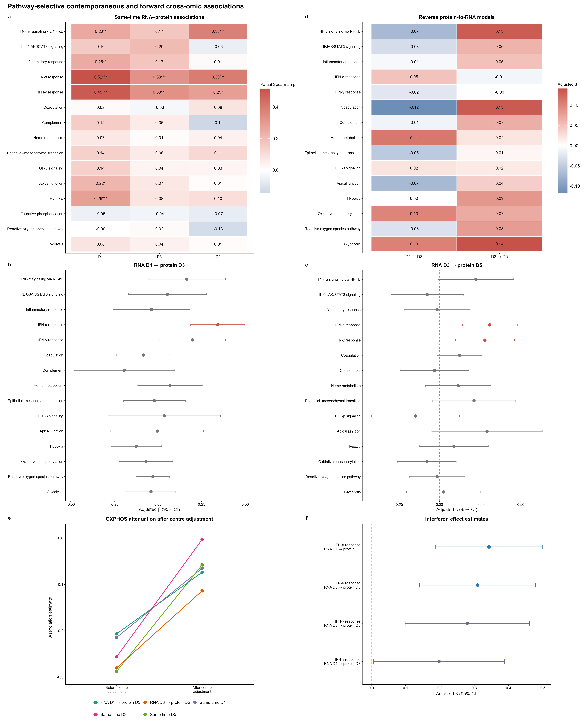
Figure 4 | Pathway-selective contemporaneous and forward cross-omic associations. a, Contemporaneous transcriptomic–proteomic associations quantified by adjusted partial Spearman correlations. b, c, Forward association models for Day-1 transcriptomic scores to Day-3 protein scores and Day-3 transcriptomic scores to Day-5 protein scores; points and bars show adjusted beta coefficients and 95% CI. d, Reverse-order protein-to-subsequent-transcriptomic association models. e, Attenuation of apparent OXPHOS associations after study-centre adjustment. f, Adjusted interferon forward-association estimates and 95% CI. Positive rho indicates concordant patient-level transcriptomic and protein pathway scores; positive beta indicates that a higher earlier score was associated with a higher later score conditional on the prespecified covariates. Neither quantity is an NES or a direct mortality-risk estimate. In a and d, *BH-FDR<0.05, **BH-FDR<0.01 and ***BH-FDR<0.001. In b and c, red denotes BH-FDR<0.05 and grey denotes non-significance.

Day-5 transcriptomic pathway patterns were largely preserved after availability weighting
In the prespecified primary observation model, the minimum estimated probability of Day-5 RNA-seq observation was 0.00505 and the maximum raw inverse-observation weight was 20.85. After truncation and mean normalisation, the effective sample size was 91.3% of the observed sample, but the maximum weighted absolute standardised mean difference remained 0.450, predominantly because of residual imbalance in prior Day-3 RNA-seq availability. The weighting diagnostics were therefore interpreted as cautionary rather than evidence of adequate balance.
All 14,541 Day-5 gene models converged and entered weighted gene-set enrichment. Across the complete Hallmark family, weighted and unweighted NES values were highly correlated (Spearman ρ=0.980), pathway directions agreed for 95.9%, and the Jaccard overlap of FDR-significant pathway sets was 0.88. Core MYC, oxidative-phosphorylation, unfolded-protein-response, heme, hypoxia and inflammatory directions were retained across prespecified observation-model and entry-boundary scenarios. The weighted analysis therefore supported the stability of the overall Day-5 pathway pattern but did not eliminate sampling-selection bias. Weight diagnostics, covariate balance, complete weighted-versus-unweighted Hallmark comparisons and scenario robustness are provided in Supplementary Table S8 and Supplementary Figures A1–A7. Descriptive Day-5 plasma protein availability is shown in Supplementary Figure A8.

Discussion
Principal findings
This study provides an outcome-oriented, risk-set-aware view of molecular heterogeneity in a fixed cohort of 504 patients who met SIC criteria on Day 1. Three findings are central. First, whole-blood mortality-associated rankings differed substantially across the Day-1, Day-3 and Day-5 risk sets: early thromboinflammatory, hypoxic, oxidative and erythroid/heme-associated programmes remained represented, whereas the Day-5 adverse ranking additionally showed coordinated negative enrichment of oxidative phosphorylation, MYC, E2F, unfolded-protein-response and DNA-repair programmes. Second, the plasma protein layer did not globally reproduce the transcriptomic architecture; at later landmarks, the strongest reproducible feature was extracellular-matrix/tissue-remodelling enrichment. Third, cross-compartment concordance was selective, with interferon programmes showing the most consistent contemporaneous and forward associations. The Day-5 weighting analysis supported the overall pathway pattern but also showed that limited positivity and residual imbalance precluded complete correction for sample-observation bias.
The distinctive contribution is therefore not serial sampling alone, but the integration of serial whole-blood RNA-seq and plasma protein measurements with sampling-landmark-specific survival risk sets, forward and reverse-order cross-omic models and an explicit audit of later-sample availability. These results describe how molecular features were ordered along subsequent-mortality rankings in different risk-valid populations. They do not demonstrate within-patient pathway trajectories, persistence or recovery of SIC, a uniform biological state in every cell, or causal transfer from transcriptomic state to circulating protein.
Recurrent thromboinflammatory enrichment across landmarks with broader late negative enrichment of cellular-maintenance programmes
The Day-1 and Day-3 transcriptomic findings place adverse prognosis in SIC within a reciprocal thromboinflammatory network rather than a purely haemostatic disorder. Positive TNF-α/NF-κB, IL-6/JAK/STAT3, complement, coagulation, hypoxia and reactive-oxygen-species enrichment is compatible with concurrent innate immune activation, endothelial perturbation, fibrinolytic suppression and microvascular stress described in contemporary SIC frameworks[2-4]. Recent work emphasises that endotheliopathy is an integrative node that develops in parallel with monocyte tissue-factor expression, platelet activation and neutrophil-extracellular-trap formation, rather than a single upstream cause[4, 16]. This network is consistent with the classical concept of immunothrombosis, in which platelets, leukocytes, endothelial cells and coagulation cooperate to contain pathogens within the microvasculature; loss of spatial and temporal containment can convert the same host-defence programme into diffuse microvascular thrombosis and organ injury[17, 18]. The present data are consistent with this network model, but they do not identify which component initiated or sustained the response.
The heme-metabolism signal warrants particular restraint. The 2025 consensus blood-transcriptomic framework identified a reproducible subtype characterised by heme-metabolism genes, platelet and eosinophil features and fibrinolytic disturbance, alongside separate inflammatory/endothelial and interferon/lymphoid subtypes[5]. The prior baseline CMAISE SIC study likewise reported heme-, hypoxia- and metabolism-related mortality associations[9]. Our landmark-specific mortality rankings complement these subtype and baseline observations, but do not assign individual patients to those subtypes. Experimental severe-sepsis work supports the biological plausibility that extracellular free heme can amplify oxidative injury and lethality[19]. However, in whole blood, heme Hallmark enrichment may reflect reticulocyte or nucleated erythroid-cell abundance, red-cell injury, hypoxic erythropoietic responses, leukocyte-composition shifts or a combination of these processes. Without serial reticulocytes, cell-free haemoglobin, haptoglobin, bilirubin and lactate dehydrogenase, the study cannot establish haemolysis or free-heme toxicity[19, 20].
The Day-5 mortality-associated ranking was distinguished by strong negative enrichment of oxidative phosphorylation, MYC targets, E2F targets, the unfolded-protein response and DNA repair. Because higher expression of pathway members tended to be associated with lower subsequent mortality, this pattern is consistent with relative under-representation of cellular bioenergetic, biosynthetic, proliferative, proteostatic and repair programmes among higher-risk survivors; it does not demonstrate absolute pathway suppression or mitochondrial failure. Human leukocyte studies have described impaired glycolytic and oxidative metabolism during sepsis-associated immune dysfunction, while precision-immunology and single-cell studies indicate that inflammatory activation, immune tolerance, cellular redistribution and metabolic impairment may coexist within the same syndrome[5, 21-25]. Mitochondrial injury could also amplify thromboinflammation through mitochondrial DNA and reactive oxygen species that engage innate-immune and NET-forming pathways. The concurrent positive enrichment of heme, hypoxia and inflammatory programmes argues against labelling the Day-5 state simply as “immunosuppression”. Instead, the Day-5 ranking is consistent with coexisting inflammatory/hypoxic stress and relative under-representation of cellular-maintenance programmes within the sampled circulating-cell compartment.
This interpretation remains hypothesis generating. The analysis did not directly measure mitochondrial respiration, substrate use, endoplasmic-reticulum stress, cell-cycle activity or DNA damage. Moreover, because SIC was defined on Day 1 only, the Day-3 and Day-5 findings represent prognostic states among survivors of an initial SIC episode; they cannot be interpreted as molecular signatures of persistent SIC, SIC recovery or progression to overt DIC without contemporaneous coagulation phenotyping.
Bulk whole-blood transcriptomic signals represent a composite of cellular abundance and within-cell transcriptional state. During sepsis, rapid changes in neutrophil, monocyte and lymphocyte proportions, expansion of immature myeloid populations, and variation in reticulocyte or nucleated erythroid-cell abundance can alter pathway-level rankings even when transcription within an individual cell type is unchanged[5, 25]. Consequently, the heme/erythroid, interferon, MYC, E2F and oxidative-phosphorylation signals observed here cannot be attributed uniquely to cell-intrinsic pathway activation or suppression. The dataset lacked synchronised differential-cell counts, flow-cytometric phenotyping and single-cell profiles sufficient to separate compositional redistribution from per-cell transcriptional change. Cell composition should not be treated solely as technical noise, because redistribution of circulating immune and erythroid populations may itself be part of sepsis pathobiology. Future validation should therefore combine bulk molecular associations with contemporaneous blood-cell differentials, reference-based deconvolution and targeted single-cell or sorted-cell assays.
Later plasma extracellular-matrix signals provide a compartment-specific view of injury and repair
The plasma proteome provided complementary rather than confirmatory information. Recent large human plasma proteomic studies identified mortality-associated networks spanning coagulation, complement, immune activation, tissue injury and extracellular-matrix organisation, while also showing that circulating abundance integrates secretion, tissue release, vascular permeability, proteolysis, consumption and clearance[6, 7]. This biology makes broad transcriptomic–proteomic concordance unlikely. The opposing Day-3 complement directions in the present study illustrate the point: positive whole-blood transcriptomic enrichment and negative plasma protein enrichment can coexist because transcriptional activation is not equivalent to circulating protein abundance, which is additionally shaped by activation, consumption, leakage, hepatic synthesis and clearance. These data cannot distinguish among those explanations.
At Days 3 and 5, the plasma epithelial–mesenchymal-transition Hallmark signal was driven by collagens and matrix-associated proteins including lysyl oxidase, periostin, versican, tenascin C, thrombospondin 2, fibrillin 1 and elastin. The pathway label should therefore be read as later-landmark extracellular-matrix turnover and tissue-remodelling enrichment associated with subsequent mortality, not as histological epithelial–mesenchymal transition. Its recurrence at both later risk sets is biologically coherent with continuing tissue injury and repair, but the time-specific design does not establish within-patient persistence or irreversible matrix deposition.
Endotheliopathy is a plausible contributor but not a specific source of this signal. Glycocalyx degradation, shedding of thrombomodulin and endothelial protein C receptor, Tie2 deactivation, vascular leakage and leukocyte–platelet–endothelial interactions can release barrier- and matrix-associated proteins and amplify SIC[3, 4, 26, 27]. In a prospective clinical SIC cohort, plasma N-GSDMD and MPO–DNA were elevated alongside syndecan-1 and matrix metalloproteinase-9, and MPO–DNA correlated strongly with syndecan-1, supporting—but not proving—an interaction between NET-associated inflammation and glycocalyx injury[28]. Authoritative vascular reviews similarly frame the endothelium as a dynamic organ integrating permeability, leukocyte adhesion, microcirculatory regulation and anticoagulant surface function, rather than as a single linear upstream cause[4, 26, 29]. Plasma matrix proteins may also derive from lung, liver, muscle and other injured tissues. Accordingly, the current data do not demonstrate endothelial-to-mesenchymal transition, organ fibrosis or a selectively endothelial origin. Serial matrix neo-epitopes combined with syndecan-1, soluble thrombomodulin, angiopoietin-2/angiopoietin-1 or Tie2, von Willebrand factor and organ-specific injury markers will be needed to resolve source and kinetics.
Interferon programmes mark selective cross-compartment coherence, not causal transfer
Interferon responses were the clearest reproducible link between whole-blood and plasma compartments. IFN-α and IFN-γ pathway scores were positively associated at all three contemporaneous sampling landmarks; the Day-1 transcriptomic IFN-α score was associated with the Day-3 protein IFN-α score after adjustment for the prior protein score; and both interferon programmes showed significant Day-3 transcriptomic-to-Day-5 protein associations. No reverse protein-to-subsequent-transcriptomic model met the corresponding FDR threshold. These findings document reproducible contemporaneous and forward associations of a systemic host-response programme, but the scores are composite pathway summaries rather than direct measurements of circulating IFN-α or IFN-γ concentrations.
The biological meaning of interferon activity in sepsis is strongly context dependent. In the consensus transcriptomic framework, interferon signalling clustered with lymphocyte, nonclassical-monocyte, anticoagulation and DNA-repair features rather than with the heme/coagulation subtype[5]. Pathogen class, timing from infection, immune-cell composition, viral reactivation, secondary infection and immunomodulatory treatment may all alter whether type-I or type-II interferon activity is protective, maladaptive or primarily a marker of host-response state[21, 23, 24]. Cross-omic coherence must therefore be distinguished from prognostic direction: a pathway may be measurable in both compartments without being uniformly harmful or beneficial.
The forward models do not establish mediation, translation delay or a one-way biological mechanism. Common upstream stimuli and time-varying clinical exposures could generate the observed ordering, and the absence of FDR-significant reverse associations is not proof of directionality. The oxidative-phosphorylation results provide a useful internal caution: apparently coherent same-time and forward associations were markedly attenuated by centre adjustment and were therefore not promoted to a primary conclusion. By contrast, the interferon estimates retained prespecified support across both forward intervals, making interferon the highest-priority candidate among the examined pathways for external measurement rather than a validated therapeutic target.
Methodological and translational implications
Two design features materially strengthen interpretation. Delayed entry ensured that a Day-3 or Day-5 molecular value was related only to mortality occurring after the corresponding sampling landmark, avoiding immortal person-time and the attribution of a molecular state to patients who had already died. The availability analysis then separated structural non-availability caused by death from potentially modelled sample observation among landmark survivors. This distinction is especially important in critical-care omics, where later sampling is jointly determined by survival, centre practice, clinical stability and logistical factors.
The weighting results should remain a sensitivity analysis. The weighted–unweighted concordance supports the stability of the overall Day-5 pathway pattern under the prespecified model, but residual imbalance after weighting is clinically plausible and should not be interpreted as computational failure. In multicentre critical-care studies, later biospecimen collection can depend on centre-specific workflow, staffing and laboratory schedules, protocol adherence, patient instability, procedures, transport or transfer restrictions, isolation requirements, treatment escalation and clinician judgement; many of these determinants are incompletely recorded. Prior Day-3 RNA-seq availability therefore acts as a proxy for a complex latent sampling process and can remain difficult to balance when observation is nearly deterministic within particular centre or clinical-trajectory strata.
Very low predicted probabilities and zero-observation centres indicate limited empirical overlap. Weight truncation reduces variance inflation but cannot create overlap where none exists and can deliberately leave some residual imbalance[15]. Weighting also cannot recover molecular states after death or represent patients from zero-observation centres. The analysis should therefore be interpreted as a robustness assessment within the positivity-supported landmark-survivor population, rather than as complete correction for selection bias or reconstruction of the original Day-1 SIC cohort. Retaining the prespecified caution classification is more defensible than selecting a post hoc model with more favourable balance.
Clinical translation should proceed in staged validation rather than immediate construction of a static prognostic panel. First, a prospective multicentre cohort should use prespecified sampling windows around Days 1, 3 and 5, record exact specimen times, protocol eligibility and reasons for missed collection, and pair each molecular measurement with contemporaneous SIC and overt-DIC scores, platelet count, PT/INR, activated partial-thromboplastin time, fibrinogen, D-dimer, lactate, organ-support intensity, transfusion, anticoagulation, corticosteroid exposure, infection source and source-control status.
Second, biological triangulation should combine a reduced targeted RNA/protein panel with blood-cell composition and direct measurements of endothelial and haemostatic injury, including syndecan-1, soluble thrombomodulin, angiopoietin-2/angiopoietin-1, von Willebrand factor, NET-related markers such as myeloperoxidase–DNA complexes or citrullinated histone H3, thrombin-generation measures including lag time, peak thrombin and endogenous thrombin potential, and fibrinolysis measurements[4, 16, 26, 27]. Third, prognostic validation should assess calibration, discrimination and clinical utility beyond contemporaneous SOFA and coagulation variables in an independent cohort before any biomarker-by-treatment interaction or enrichment-trial hypothesis is tested.
Mechanistic follow-up could then test whether plasma from the identified molecular states alters endothelial barrier integrity, thrombomodulin expression, NET formation or cellular mitochondrial respiration. Such experiments would evaluate biological plausibility but would not retroactively convert the present observational associations into causal effects.
The present findings do not support treatment selection. They should not be used to infer benefit from anticoagulation, thrombomodulin, antithrombin, endothelial-directed therapy, interferon modulation, corticosteroids, metabolic stimulation or matrix-targeted treatment. The 2025 consensus transcriptomic study reported subtype-dependent treatment signals only in post hoc analyses, illustrating the distinction between prognostic enrichment and prediction of treatment response[5]. Any therapeutic hypothesis arising from the current pathways requires independently specified biomarker-by-treatment analyses or prospective enrichment trials.
Strengths and limitations
Strengths include the fixed Day-1 SIC cohort, multicentre serial sampling, parallel whole-blood RNA-seq and plasma proteomic analyses, delayed-entry landmark risk sets, complete feature-level Cox rankings with FDR control across the complete Hallmark family, prespecified proportional-hazards and protein-intensity sensitivity analyses, forward and reverse-order cross-omic models, and an explicit assessment of Day-5 sample availability. Version-controlled scripts, locked analysis outputs and aggregate figure source data further reduced the risks of selective reporting and transcription error.
Several limitations should be considered. First, the findings have not been independently validated in a cohort with comparable serial RNA-seq, plasma proteomic and outcome data. Second, the later plasma proteomic risk sets were small, particularly at Day 5, where only 14 subsequent deaths limited precision; these results should therefore be interpreted as pathway-level, hypothesis-generating evidence. Third, contemporaneous Day-3 and Day-5 SIC or overt-DIC status, exact specimen timing and comprehensive coagulation trajectories were unavailable, preventing distinction among persistence, resolution and progression of coagulopathy. Fourth, no functional experiments or direct measurements of endothelial injury, NET formation, thrombin generation, fibrinolysis, heme injury or mitochondrial function were available. Fifth, bulk whole-blood RNA-seq could not separate changes in cellular composition from within-cell transcription, whereas circulating protein abundance could not be assigned to specific tissues or cell types and may be influenced by vascular leakage, consumption and organ clearance. Sixth, later sampling depended on both survival and sample observation. The IPW analysis remained constrained by zero-observation centres, limited empirical positivity, residual measured imbalance and unmeasured determinants of sample collection. Seventh, treatments and intercurrent clinical events between landmarks were not modelled as time-varying confounders. Finally, as a secondary observational analysis, the study cannot establish causal mechanisms, within-patient molecular trajectories, incremental prognostic value beyond clinical severity or treatment responsiveness. The Hallmark enrichments and patient-level pathway scores should therefore be regarded as composite, hypothesis-generating summaries requiring independent, cell-resolved and functional validation.
Conclusions
Mortality-associated molecular rankings in patients with Day-1-defined SIC differed across Day-1, Day-3 and Day-5 landmark risk sets and between whole-blood and plasma compartments. Whole-blood rankings showed recurrent enrichment of heme metabolism, hypoxia and inflammatory pathways, together with prominent negative enrichment of cellular-maintenance programmes at Day 5. Later plasma protein rankings were dominated by extracellular-matrix and tissue-remodelling signals. Interferon pathways exhibited reproducible contemporaneous and forward cross-compartment associations, but these observational models did not establish causal intercompartmental signalling. Cell-type-resolved longitudinal validation with synchronised assessment of SIC/DIC status, endothelial function, coagulation phenotypes and treatment exposures is required before inferring incremental prognostic value, specific cellular mechanisms or therapeutic relevance.

List of abbreviations
BH, Benjamini–Hochberg; CI, confidence interval; CMAISE, Chinese Multi-omics Advances in Sepsis; DIC, disseminated intravascular coagulation; ECM, extracellular matrix; FDR, false-discovery rate; HC3, heteroscedasticity-consistent type 3; IFN, interferon; IPW, inverse-probability weighting; NES, normalised enrichment score; NET, neutrophil extracellular trap; OXPHOS, oxidative phosphorylation; PH, proportional hazards; RNA-seq, RNA sequencing; SIC, sepsis-induced coagulopathy; SMD, standardised mean difference; SOFA, Sequential Organ Failure Assessment.
Declarations
Ethics approval and consent to participate
This study was conducted in accordance with the Declaration of Helsinki. The parent study was approved by the Ethics Committee of Sir Run Run Shaw Hospital (Approval No.: 20201014-39), with additional local ethics approvals obtained at participating centres as required. Written informed consent was obtained from all participants or their legally authorised representatives.
Consent for publication
Not applicable.
Availability of data and materials
Individual-level clinical and molecular data are controlled-access data available through the formal CMAISE/OMIX application process under accession OMIX011182; the authors are not authorised to redistribute them. Aggregate result tables, figure source data, quality-assurance outputs and analysis code supporting this study are archived in GitHub release jic-submission-v1.0 at https://github.com/lvhao1123/SIC-longitudinal-multiomics/releases/tag/jic-submission-v1.0.
Competing interests
The authors declare that they have no competing interests.
Funding
This research was supported by the National Key R&D Program of China, Ministry of Science and Technology of the People’s Republic of China (Grant Nos. 2022YFC2304605 and 2022YFC2304604). The funders had no role in the design of the present secondary analysis, data analysis, interpretation of the results, manuscript preparation or the decision to submit.
Authors’ contributions
HL contributed to methodology, software and drafting the manuscript. LL contributed to visualisation, validation, formal analysis and data curation. JG contributed to visualisation, supervision and data curation. DZ contributed to conceptualisation, supervision, validation, funding acquisition, and manuscript review and editing. All authors read and approved the final manuscript.
Acknowledgements
This study used data from the Chinese Multi-omics Advances in Sepsis cohort. We thank the investigators, study teams and participants at all participating centres.

Additional files
Additional file 1 contains Supplementary Methods and Supplementary Figures A1–A9. Additional file 2 contains Supplementary Tables S1–S8, including clinical definitions and exploratory Cox results, complete gene- and protein-wise Cox/PH outputs, Hallmark enrichment and leading-edge results, cross-omic models, and Day-5 RNA-seq availability/IPW diagnostics.
Table 1. Baseline characteristics of the Day-1 SIC cohort according to 60-day outcome
Characteristic | Overall  (n=504) | Survivor/censored  (n=420) | Death  (n=84) | SMD | P value
Age | 68.00 [58.00, 78.00] | 67.00 [56.00, 77.00] | 72.00 [63.75, 81.00] | 0.311 | 0.005
Height | 166.00 [159.00, 170.00] | 165.50 [159.00, 170.00] | 167.50 [158.75, 171.00] | 0.040 | 0.655
Weight | 63.00 [55.00, 70.00] | 63.00 [55.00, 70.00] | 64.50 [55.00, 70.00] | -0.087 | 0.751
BMI | 23.24 [20.81, 25.02] | 23.28 [20.94, 25.08] | 23.08 [20.76, 24.76] | -0.102 | 0.408
HRmax | 119.00 [103.00, 135.00] | 118.00 [102.00, 134.00] | 121.00 [108.00, 139.25] | 0.267 | 0.049
MAPmax | 94.85 [84.00, 106.00] | 95.00 [85.00, 107.00] | 92.00 [82.00, 102.25] | -0.283 | 0.045
SBPmax | 141.00 [126.00, 156.25] | 141.00 [126.00, 156.00] | 138.00 [125.25, 159.00] | -0.033 | 0.887
RRmax | 26.00 [22.00, 32.00] | 26.00 [23.00, 32.00] | 26.00 [22.00, 32.00] | -0.103 | 0.347
Tmax | 37.70 [37.00, 38.50] | 37.70 [37.00, 38.50] | 37.60 [36.77, 38.42] | -0.084 | 0.366
Lactate | 2.80 [1.70, 5.20] | 2.67 [1.61, 4.90] | 3.88 [1.90, 6.90] | 0.411 | 0.004
K | 3.80 [3.35, 4.21] | 3.80 [3.32, 4.20] | 3.92 [3.43, 4.44] | 0.303 | 0.044
Na | 137.05 [133.50, 142.00] | 137.00 [133.00, 141.10] | 138.45 [135.00, 145.10] | 0.364 | 0.032
Cl | 107.00 [102.00, 112.00] | 107.20 [102.00, 112.00] | 106.05 [100.75, 112.70] | 0.057 | 0.589
BUN | 11.89 [8.10, 18.20] | 11.26 [7.88, 16.52] | 18.20 [9.80, 25.36] | 0.530 | <0.001
Albumin | 28.25 [24.80, 31.63] | 28.40 [25.00, 31.90] | 27.25 [24.15, 29.75] | -0.238 | 0.038
Creatinine | 134.55 [93.00, 223.37] | 130.30 [91.75, 217.50] | 163.75 [112.82, 247.43] | 0.154 | 0.006
Bilirubin | 23.00 [13.30, 42.70] | 23.00 [13.67, 43.71] | 21.40 [12.17, 37.08] | -0.099 | 0.422
CRP | 153.95 [79.64, 219.64] | 154.61 [77.35, 226.05] | 147.84 [83.68, 206.16] | 0.001 | 0.897
PCT | 23.05 [5.22, 86.87] | 24.40 [5.74, 91.32] | 12.25 [2.20, 57.23] | -0.221 | 0.026
WBC | 11.60 [7.11, 17.68] | 11.59 [7.19, 17.18] | 12.00 [5.83, 19.92] | -0.003 | 0.892
Platelet | 89.00 [57.00, 132.25] | 86.50 [55.00, 131.00] | 96.50 [68.00, 143.25] | 0.168 | 0.064
INR | 1.38 [1.23, 1.61] | 1.37 [1.22, 1.57] | 1.49 [1.31, 1.65] | 0.119 | 0.007
aPTT | 37.60 [32.10, 45.00] | 37.25 [31.75, 44.75] | 39.35 [34.08, 45.85] | 0.107 | 0.133
D-dimer | 6.06 [2.73, 14.95] | 5.98 [2.73, 14.59] | 7.07 [2.75, 18.14] | 0.187 | 0.584
SOFA score | 10.00 [7.00, 12.00] | 9.00 [7.00, 12.00] | 12.00 [10.00, 14.00] | 0.636 | <0.001
PF | 243.82 [168.06, 327.52] | 249.70 [178.38, 330.45] | 205.30 [122.64, 280.95] | -0.404 | 0.001
Sex(male,n) | 298 (59.1%) | 242 (57.6%) | 56 (66.7%) | 0.187 | 0.145
Diabetes mellitus | 137 (27.2%) | 108 (25.7%) | 29 (34.5%) | 0.193 | 0.107
Hypertension | 200 (39.7%) | 161 (38.3%) | 39 (46.4%) | 0.164 | 0.180
Myocardial infarction | 20 (4.0%) | 14 (3.3%) | 6 (7.1%) | 0.172 | 0.122
Heart failure | 53 (10.5%) | 39 (9.3%) | 14 (16.7%) | 0.221 | 0.052
Cerebrovascular disease | 88 (17.5%) | 66 (15.7%) | 22 (26.2%) | 0.260 | 0.027
Dementia | 23 (4.6%) | 13 (3.1%) | 10 (11.9%) | 0.339 | 0.002
COPD | 35 (6.9%) | 25 (6.0%) | 10 (11.9%) | 0.210 | 0.060
Paralysis | 16 (3.2%) | 11 (2.6%) | 5 (6.0%) | 0.165 | 0.161
Renal failure | 42 (8.3%) | 34 (8.1%) | 8 (9.5%) | 0.050 | 0.666
Infection source,n
Abdomen | 90 (17.9%) | 83 (19.8%) | 7 (8.3%) | -0.333 | 0.003
Biliary/liver | 66 (13.1%) | 57 (13.6%) | 9 (10.7%) | -0.088
Lung/chest | 194 (38.5%) | 148 (35.2%) | 46 (54.8%) | 0.400
Others/unknown | 36 (7.1%) | 31 (7.4%) | 5 (6.0%) | -0.057
Soft tissue | 25 (5.0%) | 18 (4.3%) | 7 (8.3%) | 0.167
Urinary | 93 (18.5%) | 83 (19.8%) | 10 (11.9%) | -0.216
Data are median [interquartile range] or n (%).aPTT, activated partial thromboplastin time; BMI, body mass index; BUN, blood urea nitrogen; Cl, chloride; COPD, chronic obstructive pulmonary disease; CRP, C-reactive protein; HRmax, maximum heart rate; INR, international normalised ratio; K, potassium; MAPmax, maximum mean arterial pressure; Na, sodium; PCT, procalcitonin; PF, PaO₂/FiO₂ ratio; RRmax, maximum respiratory rate; SBPmax, maximum systolic arterial pressure; SIC, sepsis-induced coagulopathy; SMD, standardised mean difference; SOFA, Sequential Organ Failure Assessment; Tmax, maximum temperature; WBC, white blood cell.

References
1. Singer M, Deutschman CS, Seymour CW, et al. The Third International Consensus Definitions for Sepsis and Septic Shock (Sepsis-3). Jama 2016, 315(8):801-810.doi: 10.1001/jama.2016.0287
2. Iba T, Nisio MD, Levy JH, et al. New criteria for sepsis-induced coagulopathy (SIC) following the revised sepsis definition: a retrospective analysis of a nationwide survey. BMJ Open 2017, 7(9):e017046.doi: 10.1136/bmjopen-2017-017046
3. Iba T, Levi M, Thachil J, et al. Communication from the Scientific and Standardization Committee of the International Society on Thrombosis and Haemostasis on sepsis-induced coagulopathy in the management of sepsis. Journal of Thrombosis and Haemostasis 2023, 21(1):145-153.doi: 10.1016/j.jtha.2022.10.022
4. Iba T, Maier CL, Ferrer R, et al. Endotheliopathy within the thromboinflammatory network of sepsis-induced coagulopathy. Inflammation Research 2026, 75(1):59.doi: 10.1007/s00011-026-02204-x
5. Scicluna BP, Cano-Gamez K, Burnham KL, et al. A consensus blood transcriptomic framework for sepsis. Nature Medicine 2025, 31(12):4119-4130.doi: 10.1038/s41591-025-03964-5
6. Mi Y, Burnham KL, Charles PD, et al. High-throughput mass spectrometry maps the sepsis plasma proteome and differences in patient response. Science Translational Medicine 2024, 16(750):eadh0185.doi: 10.1126/scitranslmed.adh0185
7. Palmowski L, Weber M, Bayer M, et al. Mortality-associated plasma proteome dynamics in a prospective multicentre sepsis cohort. eBioMedicine 2025, 111:105508.doi: 10.1016/j.ebiom.2024.105508
8. Zhang Z, Chen L, Shen H, et al. Deriving consensus sepsis clusters via goal-directed subgroup identification in multi-omics study. Nature Communications 2025, 16(1):10328.doi: 10.1038/s41467-025-65271-4
9. Qian S, Zheng R, Shi Y, et al. Multi-omics integration reveals molecular heterogeneity and constructs a machine learning survival model for sepsis-induced coagulopathy. Thrombosis Research 2026, 259:109618.doi: 10.1016/j.thromres.2026.109618
10. Yang J, Yang S, Cai J, et al. CMAISE: Establishing the Longitudinal Multi-Omics Cohort for Sepsis Precision Medicine. Med Research 2026, 2(2):397-404.doi: 10.1002/mdr2.70057
11. Seymour CW, Liu VX, Iwashyna TJ, et al. Assessment of Clinical Criteria for Sepsis: For the Third International Consensus Definitions for Sepsis and Septic Shock (Sepsis-3). JAMA 2016, 315(8):762-774.doi: 10.1001/jama.2016.0288
12. VAN HOUWELINGEN HC. Dynamic Prediction by Landmarking in Event History Analysis. Scandinavian Journal of Statistics 2007, 34(1):70-85.doi: 10.1111/j.1467-9469.2006.00529.x
13. Subramanian A, Tamayo P, Mootha VK, et al. Gene set enrichment analysis: A knowledge-based approach for interpreting genome-wide expression profiles. Proceedings of the National Academy of Sciences 2005, 102(43):15545-15550.doi: 10.1073/pnas.0506580102
14. Liberzon A, Birger C, Thorvaldsdóttir H, et al. The Molecular Signatures Database Hallmark Gene Set Collection. Cell Systems 2015, 1(6):417-425.doi: 10.1016/j.cels.2015.12.004
15. White I, Seaman S. Review of inverse probability weighting for dealing with missing data. Statistical Methods in Medical Research 2013, 22(3):278-295.doi: 10.1177/0962280210395740
16. Czaikoski PG, Mota JMSC, Nascimento DC, et al. Neutrophil Extracellular Traps Induce Organ Damage during Experimental and Clinical Sepsis. PLOS ONE 2016, 11(2):e0148142.doi: 10.1371/journal.pone.0148142
17. Engelmann B, Massberg S. Thrombosis as an intravascular effector of innate immunity. Nature Reviews Immunology 2013, 13(1):34-45.doi: 10.1038/nri3345
18. Iba T, Levi M, Levy JH. Intracellular communication and immunothrombosis in sepsis. Journal of Thrombosis and Haemostasis 2022, 20(11):2475-2484.doi: 10.1111/jth.15852
19. Larsen R, Gozzelino R, Jeney V, et al. A Central Role for Free Heme in the Pathogenesis of Severe Sepsis. Science Translational Medicine 2010, 2(51):51ra71-51ra71.doi: 10.1126/scitranslmed.3001118
20. Dimitrov JD, Roumenina LT, Perrella G, et al. Basic Mechanisms of Hemolysis-Associated Thrombo-Inflammation and Immune Dysregulation. Arteriosclerosis, Thrombosis, and Vascular Biology 2023, 43(8):1349-1361.doi: 10.1161/ATVBAHA.123.318780
21. Wiersinga WJ, van der Poll T. Immunopathophysiology of human sepsis. eBioMedicine 2022, 86:104363.doi: 10.1016/j.ebiom.2022.104363
22. Cheng S-C, Scicluna BP, Arts RJW, et al. Broad defects in the energy metabolism of leukocytes underlie immunoparalysis in sepsis. Nature Immunology 2016, 17(4):406-413.doi: 10.1038/ni.3398
23. Giamarellos-Bourboulis EJ, Aschenbrenner AC, Bauer M, et al. The pathophysiology of sepsis and precision-medicine-based immunotherapy. Nature Immunology 2024, 25(1):19-28.doi: 10.1038/s41590-023-01660-5
24. Shankar-Hari M, Calandra T, Soares MP, et al. Reframing sepsis immunobiology for translation: towards informative subtyping and targeted immunomodulatory therapies. The Lancet Respiratory Medicine 2024, 12(4):323-336.doi: 10.1016/S2213-2600(23)00468-X
25. Reyes M, Filbin MR, Bhattacharyya RP, et al. An immune-cell signature of bacterial sepsis. Nature Medicine 2020, 26(3):333-340.doi: 10.1038/s41591-020-0752-4
26. Iba T, Maier CL, Helms J, et al. Managing sepsis and septic shock in an endothelial glycocalyx-friendly way: from the viewpoint of surviving sepsis campaign guidelines. Annals of Intensive Care 2024, 14(1):64.doi: 10.1186/s13613-024-01301-6
27. Lin JJ, Hsiao HJ, Chan OW, et al. Increased serum thrombomodulin level is associated with disease severity and mortality in pediatric sepsis. PLoS One 2017, 12(8):e0182324.doi: 10.1371/journal.pone.0182324
28. Shan X, Yu S, Tang Z, et al. GSDMD-NETs in patients with sepsis-induced coagulopathy and their interaction with glycocalyx damage. Frontiers in Immunology 2025, 16:1624128.doi: 10.3389/fimmu.2025.1624128
29. Joffre J, Hellman J, Ince C, et al. Endothelial Responses in Sepsis. Am J Respir Crit Care Med 2020, 202(3):361-370.doi: 10.1164/rccm.201910-1911TR

