Supplementary Information
Landmark-specific transcriptomic and proteomic associations with 60-day mortality in Day-1-defined sepsis-induced coagulopathy: a multicentre longitudinal cohort study
Hao Lyu¹, Lingwei Li², Jianxing Guo¹, Dong Zhang¹*

Supplementary Methods

Molecular data generation in the parent cohort
The deposited molecular matrices were generated under the CMAISE laboratory workflow. Whole-blood samples were collected in PAXgene tubes and processed after ribosomal-RNA depletion using a strand-specific dUTP/UDG library protocol; libraries were sequenced on an Illumina NovaSeq 6000 platform with 2×150-bp paired-end reads. Reads were adapter- and quality-filtered with cutadapt v1.9, assessed with FastQC v0.10.1, aligned to Ensembl GRCh38 v96 with HISAT2 v2.0.4, and assembled and quantified with StringTie v1.3.4, with GffCompare used to reconcile annotations. Plasma underwent magnetic-nanobead enrichment of low-abundance proteins, tryptic digestion, C18 desalting and 13-minute liquid-chromatography separation before positive-ion data-independent acquisition on an Orbitrap Astral mass spectrometer. DIA-NN v1.9.2 was used in DirectDIA mode with target-decoy control and peptide-spectrum-match and protein false-discovery rates below 1%. These procedures generated the deposited matrices; the present study then applied the longitudinal downstream processing described below.

RNA-seq processing
For the present longitudinal reanalysis, we started from the deposited integer RNA-seq count matrix rather than the variance-stabilised or TPM-derived matrices used for the parent baseline analyses. Counts were restricted to the 1,246 longitudinal SIC RNA-seq samples. Features were retained when they reached at least one count per million in at least 20% of longitudinal samples. Ensembl identifiers were harmonised to gene symbols using the frozen annotation map, and records mapping to the same symbol were combined by summing counts. Library sizes and log counts per million were estimated jointly across all three sampling landmarks using trimmed-mean-of-M-values normalisation rather than normalising each landmark independently. For each time-specific Cox analysis, expression of every retained gene was standardised within the corresponding risk-valid dataset; hazard ratios therefore represented a one-standard-deviation increase in expression.

Plasma protein processing and quality control
For the present reanalysis, the supplied quantitative plasma protein matrix was evaluated on its deposited log2 scale and showed no material missingness; no K-nearest-neighbour or left-censoring imputation was applied. Seven rows without a gene symbol were removed. Before feature filtering, the three duplicated symbols (CUX1, RABGAP1L and TMPO) were resolved by retaining the UniProt entry with the highest median abundance across the 431 matched clinical proteomic samples, with original row order used only as a deterministic tie-breaker. Replicate variability was assessed across ten QC batches with three replicates per batch. Within-batch standard deviations on the deposited log2 scale were converted to the corresponding linear-scale coefficients of variation, and the median coefficient of variation across batches was used for filtering. All 5,614 unique symbols passed the clinical-sample missingness criterion; 3,875 proteins with a median replicate coefficient of variation below 20% entered the final time-specific prognostic analyses. Protein abundance was standardised within each risk-valid dataset. A prespecified sensitivity analysis additionally adjusted for sample median protein intensity to evaluate global-intensity effects.

Day-5 availability weighting implementation
The prespecified primary observation model included baseline age, sex, SOFA score, infection source, centre, prior Day-3 RNA-seq availability, and lactate, INR and D-dimer, each log₂-transformed before standardisation. Non-stabilised inverse observation probabilities were calculated as the reciprocal of the estimated probability, truncated at the 1st and 99th percentiles and normalised to mean one among observed patients. Weighted Day-5 delayed-entry Cox coefficients were estimated from the same centre-stratified partial likelihood. Observation-level Lin–Wei sandwich variances were calculated from weighted dfbeta residuals and independently verified against a model assigning a unique cluster to every row. All 14,541 successfully estimated genes were ranked by the weighted robust Wald statistic for Hallmark enrichment. Weighted and unweighted pathway profiles were compared across the complete Hallmark family using NES Spearman correlation, pathway-direction agreement and Jaccard overlap of FDR-significant sets. The primary weighted analysis was prespecified as a sensitivity analysis and was not intended to replace the unweighted centre-stratified result. Alternative observation models and entry-boundary scenarios were used only as prespecified sensitivity analyses. The weighted analysis evaluated robustness only within the positivity-supported landmark-survivor population and was not interpreted as complete correction for centre-structured non-observation.

Supplementary Figures
Supplementary Figs. S1–S9 are presented in numerical order. Supplementary Figs. S1–S8 provide prespecified Day-5 RNA-seq availability and weighting diagnostics, Hallmark robustness analyses, entry-boundary sensitivity and the descriptive Day-5 plasma protein availability audit. Supplementary Fig. S9 presents the complete displayed clinical univariable Cox contrasts.
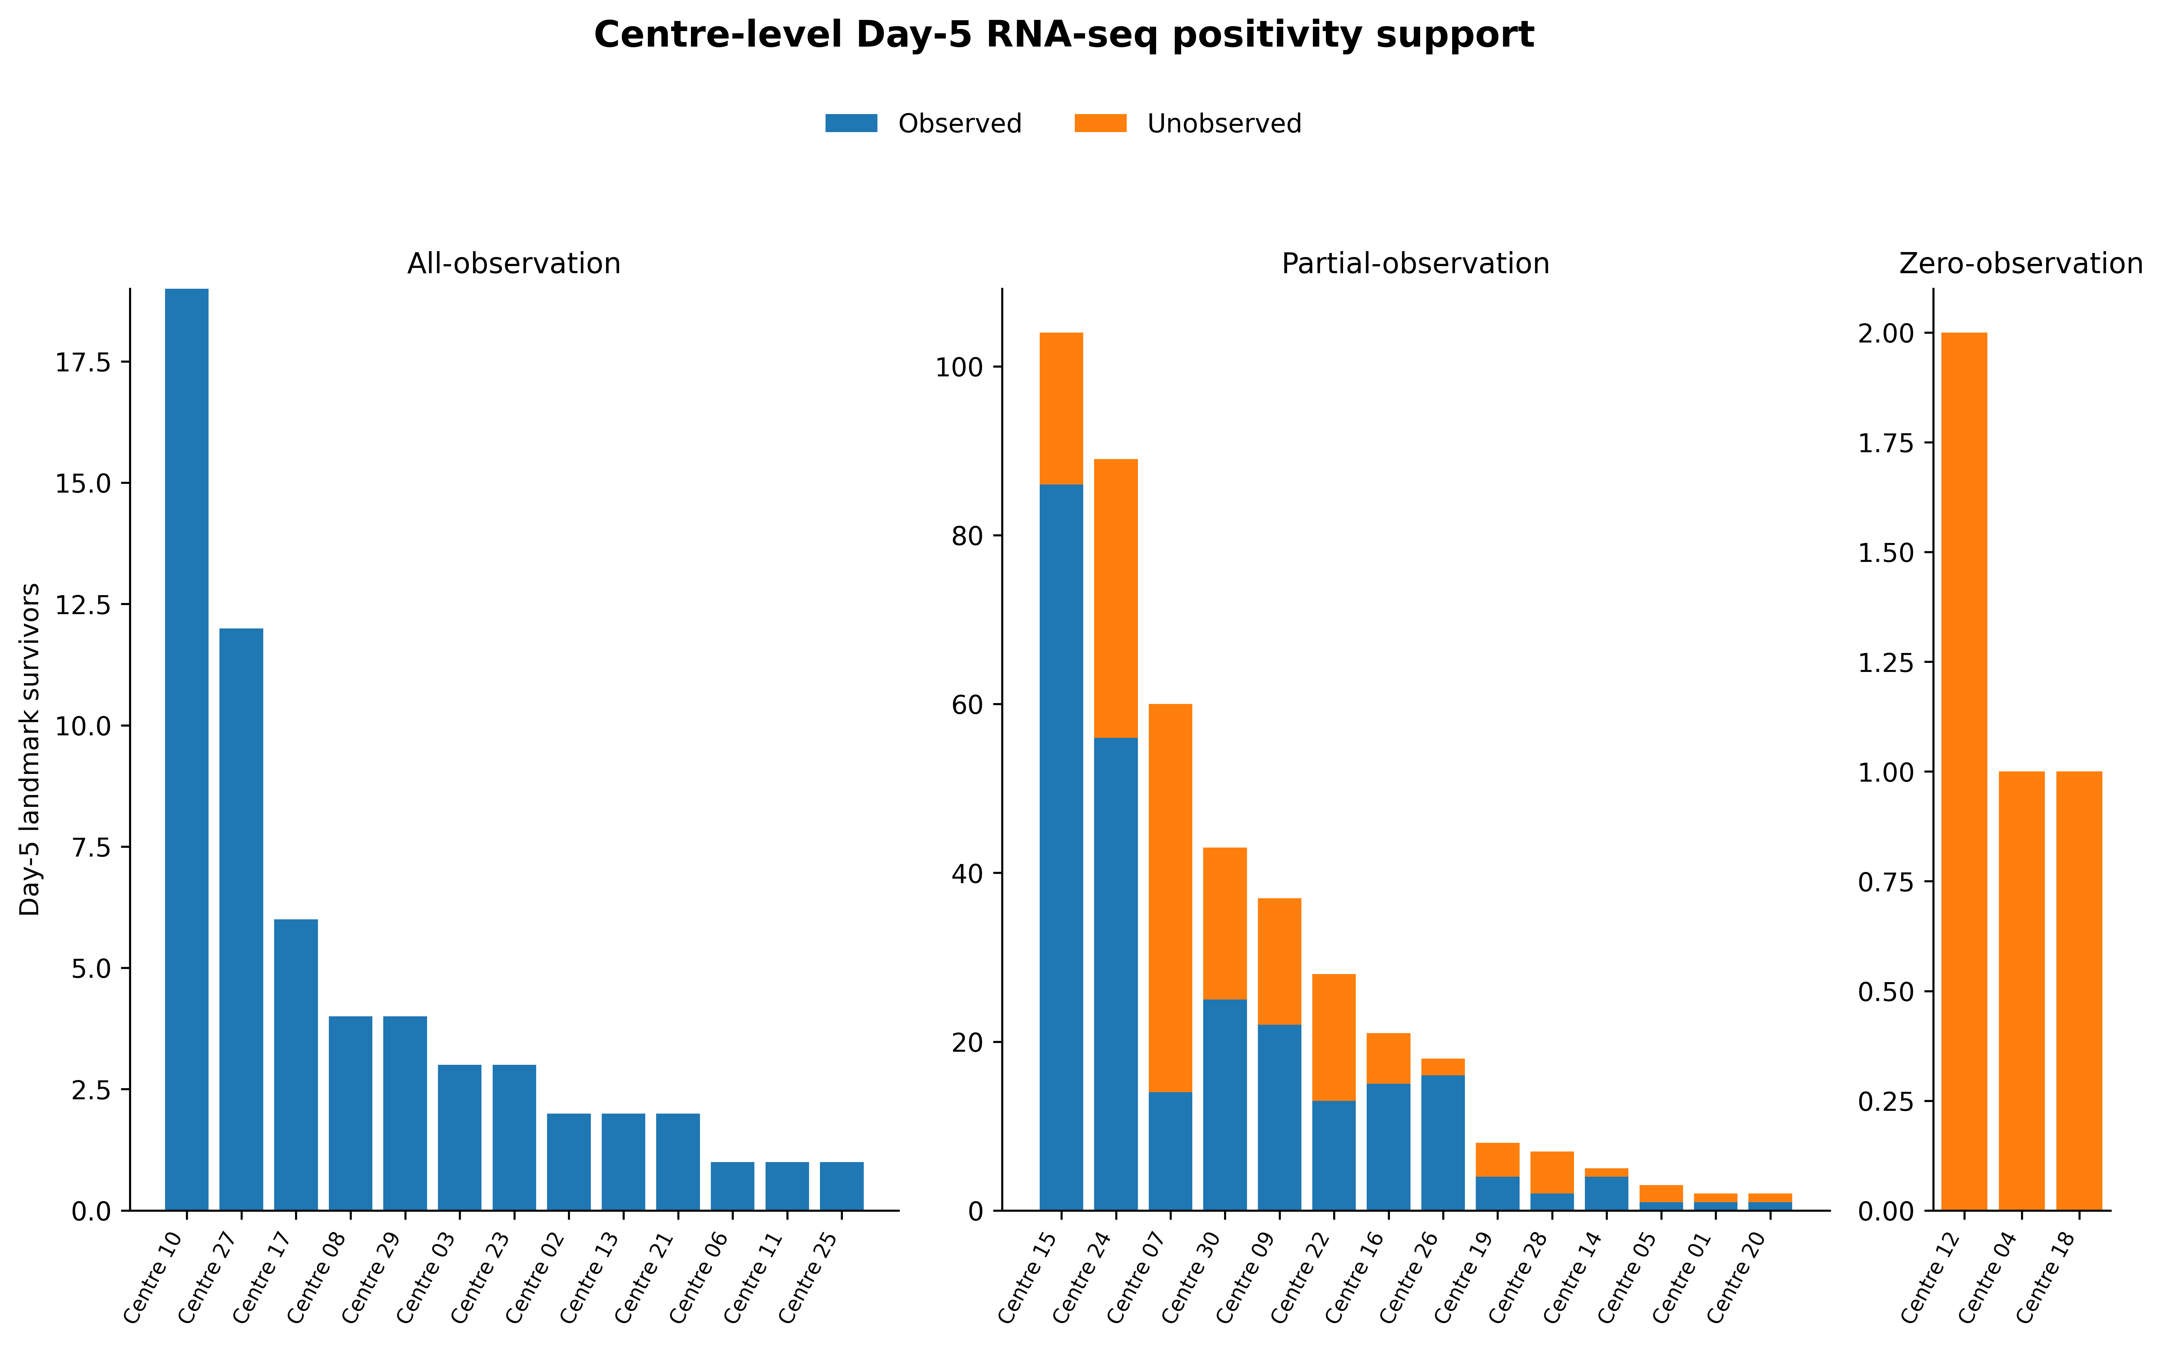
Supplementary Fig. S1 | Centre-level positivity support for Day-5 RNA-seq availability. Centre-level numbers of observed and unobserved Day-5 RNA-seq samples are shown for the prespecified primary entry definition. Centres were classified as zero-, partial- or all-observation centres before weighting. Patients from zero-observation centres were excluded from the positivity-supported estimand.
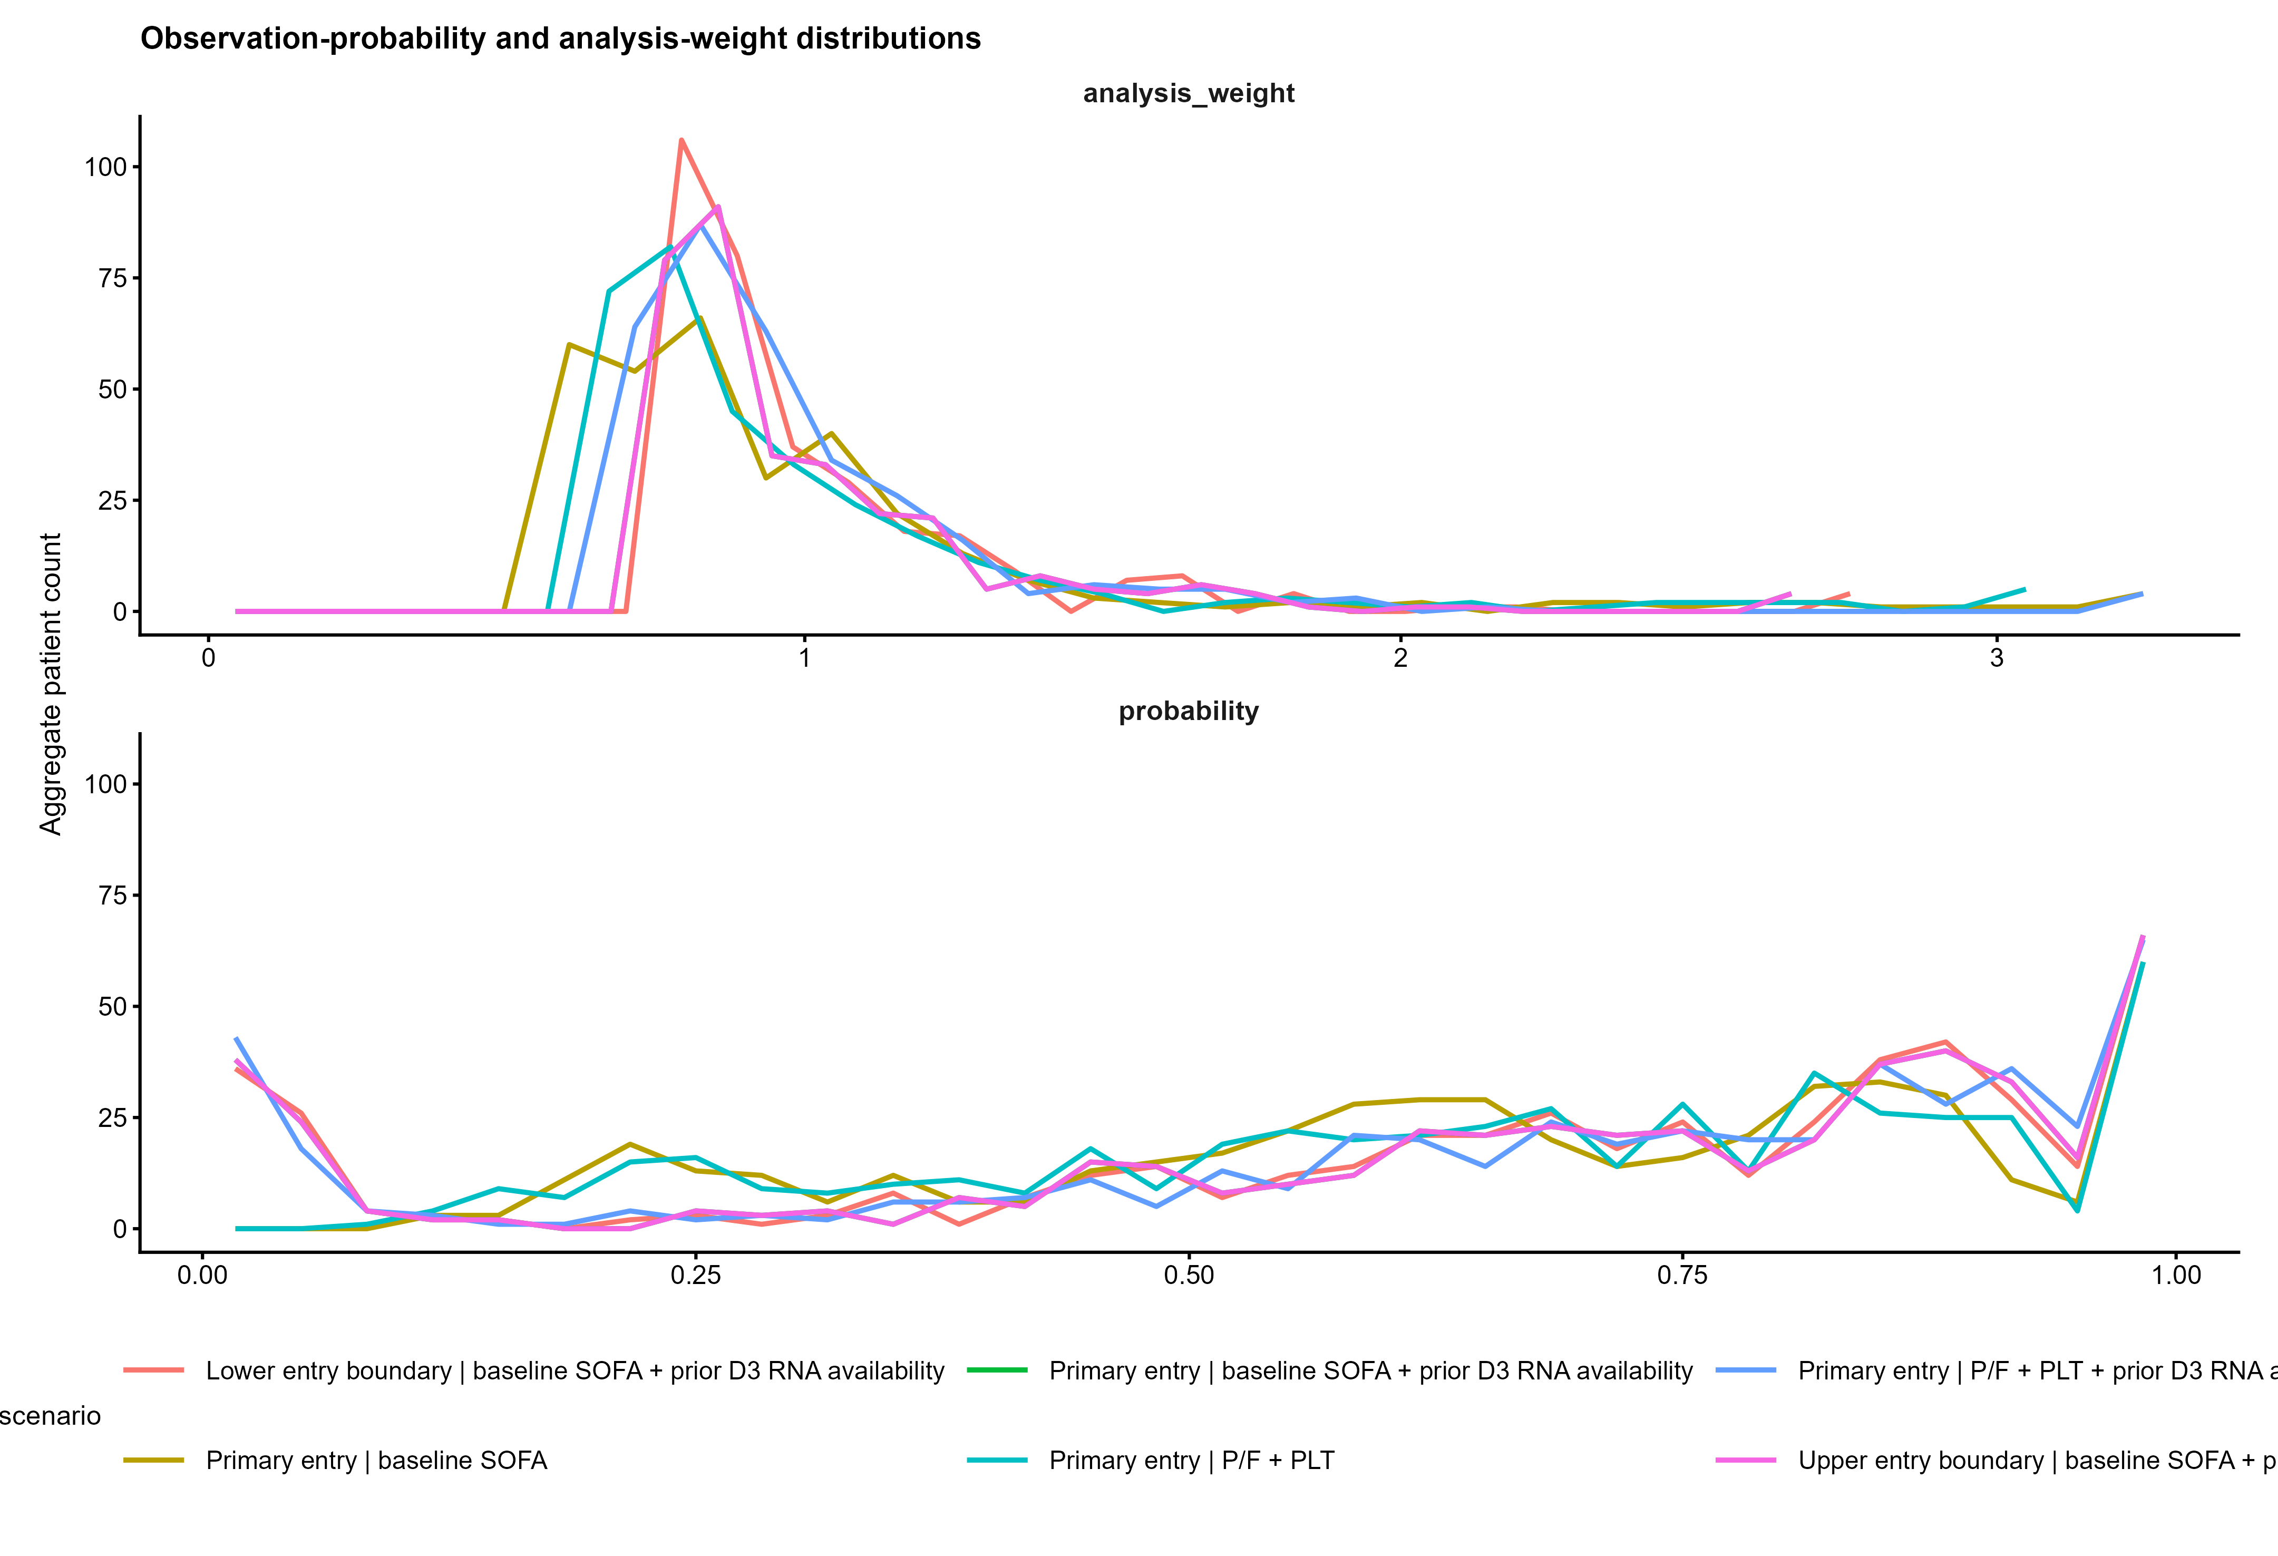
Supplementary Fig. S2 | Availability probabilities and inverse-probability weights. Aggregate binned distributions of model-estimated Day-5 RNA-seq observation probabilities and the corresponding non-stabilised inverse-observation-probability weights are shown for all six prespecified scenarios. Weights were truncated according to the prespecified scenario rules and normalised to mean one among observed patients.

Supplementary Fig. S3 | Covariate balance before and after weighting. Signed standardised mean differences compare observed and unobserved Day-5 RNA-seq groups before weighting and after application of the prespecified primary inverse-probability weights. The vertical reference lines mark an absolute standardised mean difference of 0.10. Residual imbalance, particularly in prior Day-3 RNA-seq availability, remained after weighting.
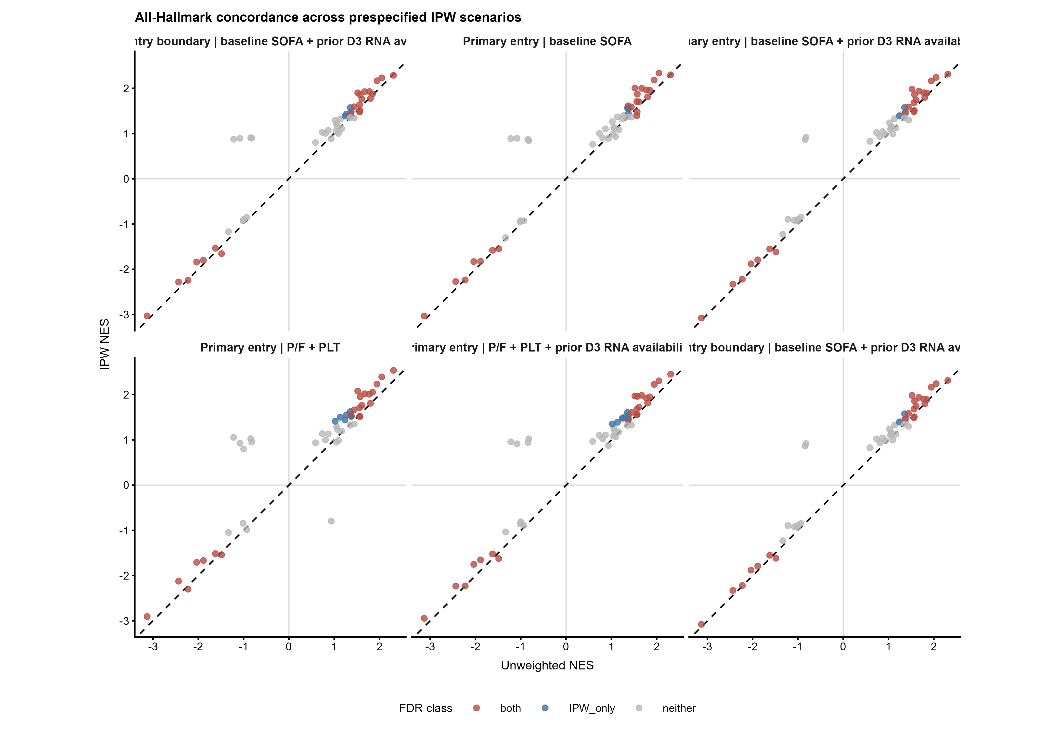
Supplementary Fig. S4 | Comparison of unweighted and IPW Hallmark enrichment. Each point compares Day-5 mortality-association NES from the unweighted centre-stratified primary analysis with NES from a prespecified weighted scenario across the complete Hallmark family. Colour denotes the joint FDR classification based on BH-FDR <0.05. The primary weighted scenario showed an NES Spearman correlation of 0.980, direction agreement of 95.9% and significant-set Jaccard index of 0.88 relative to the unweighted analysis. Concordance supports robustness of the overall pathway pattern but does not remove availability bias.
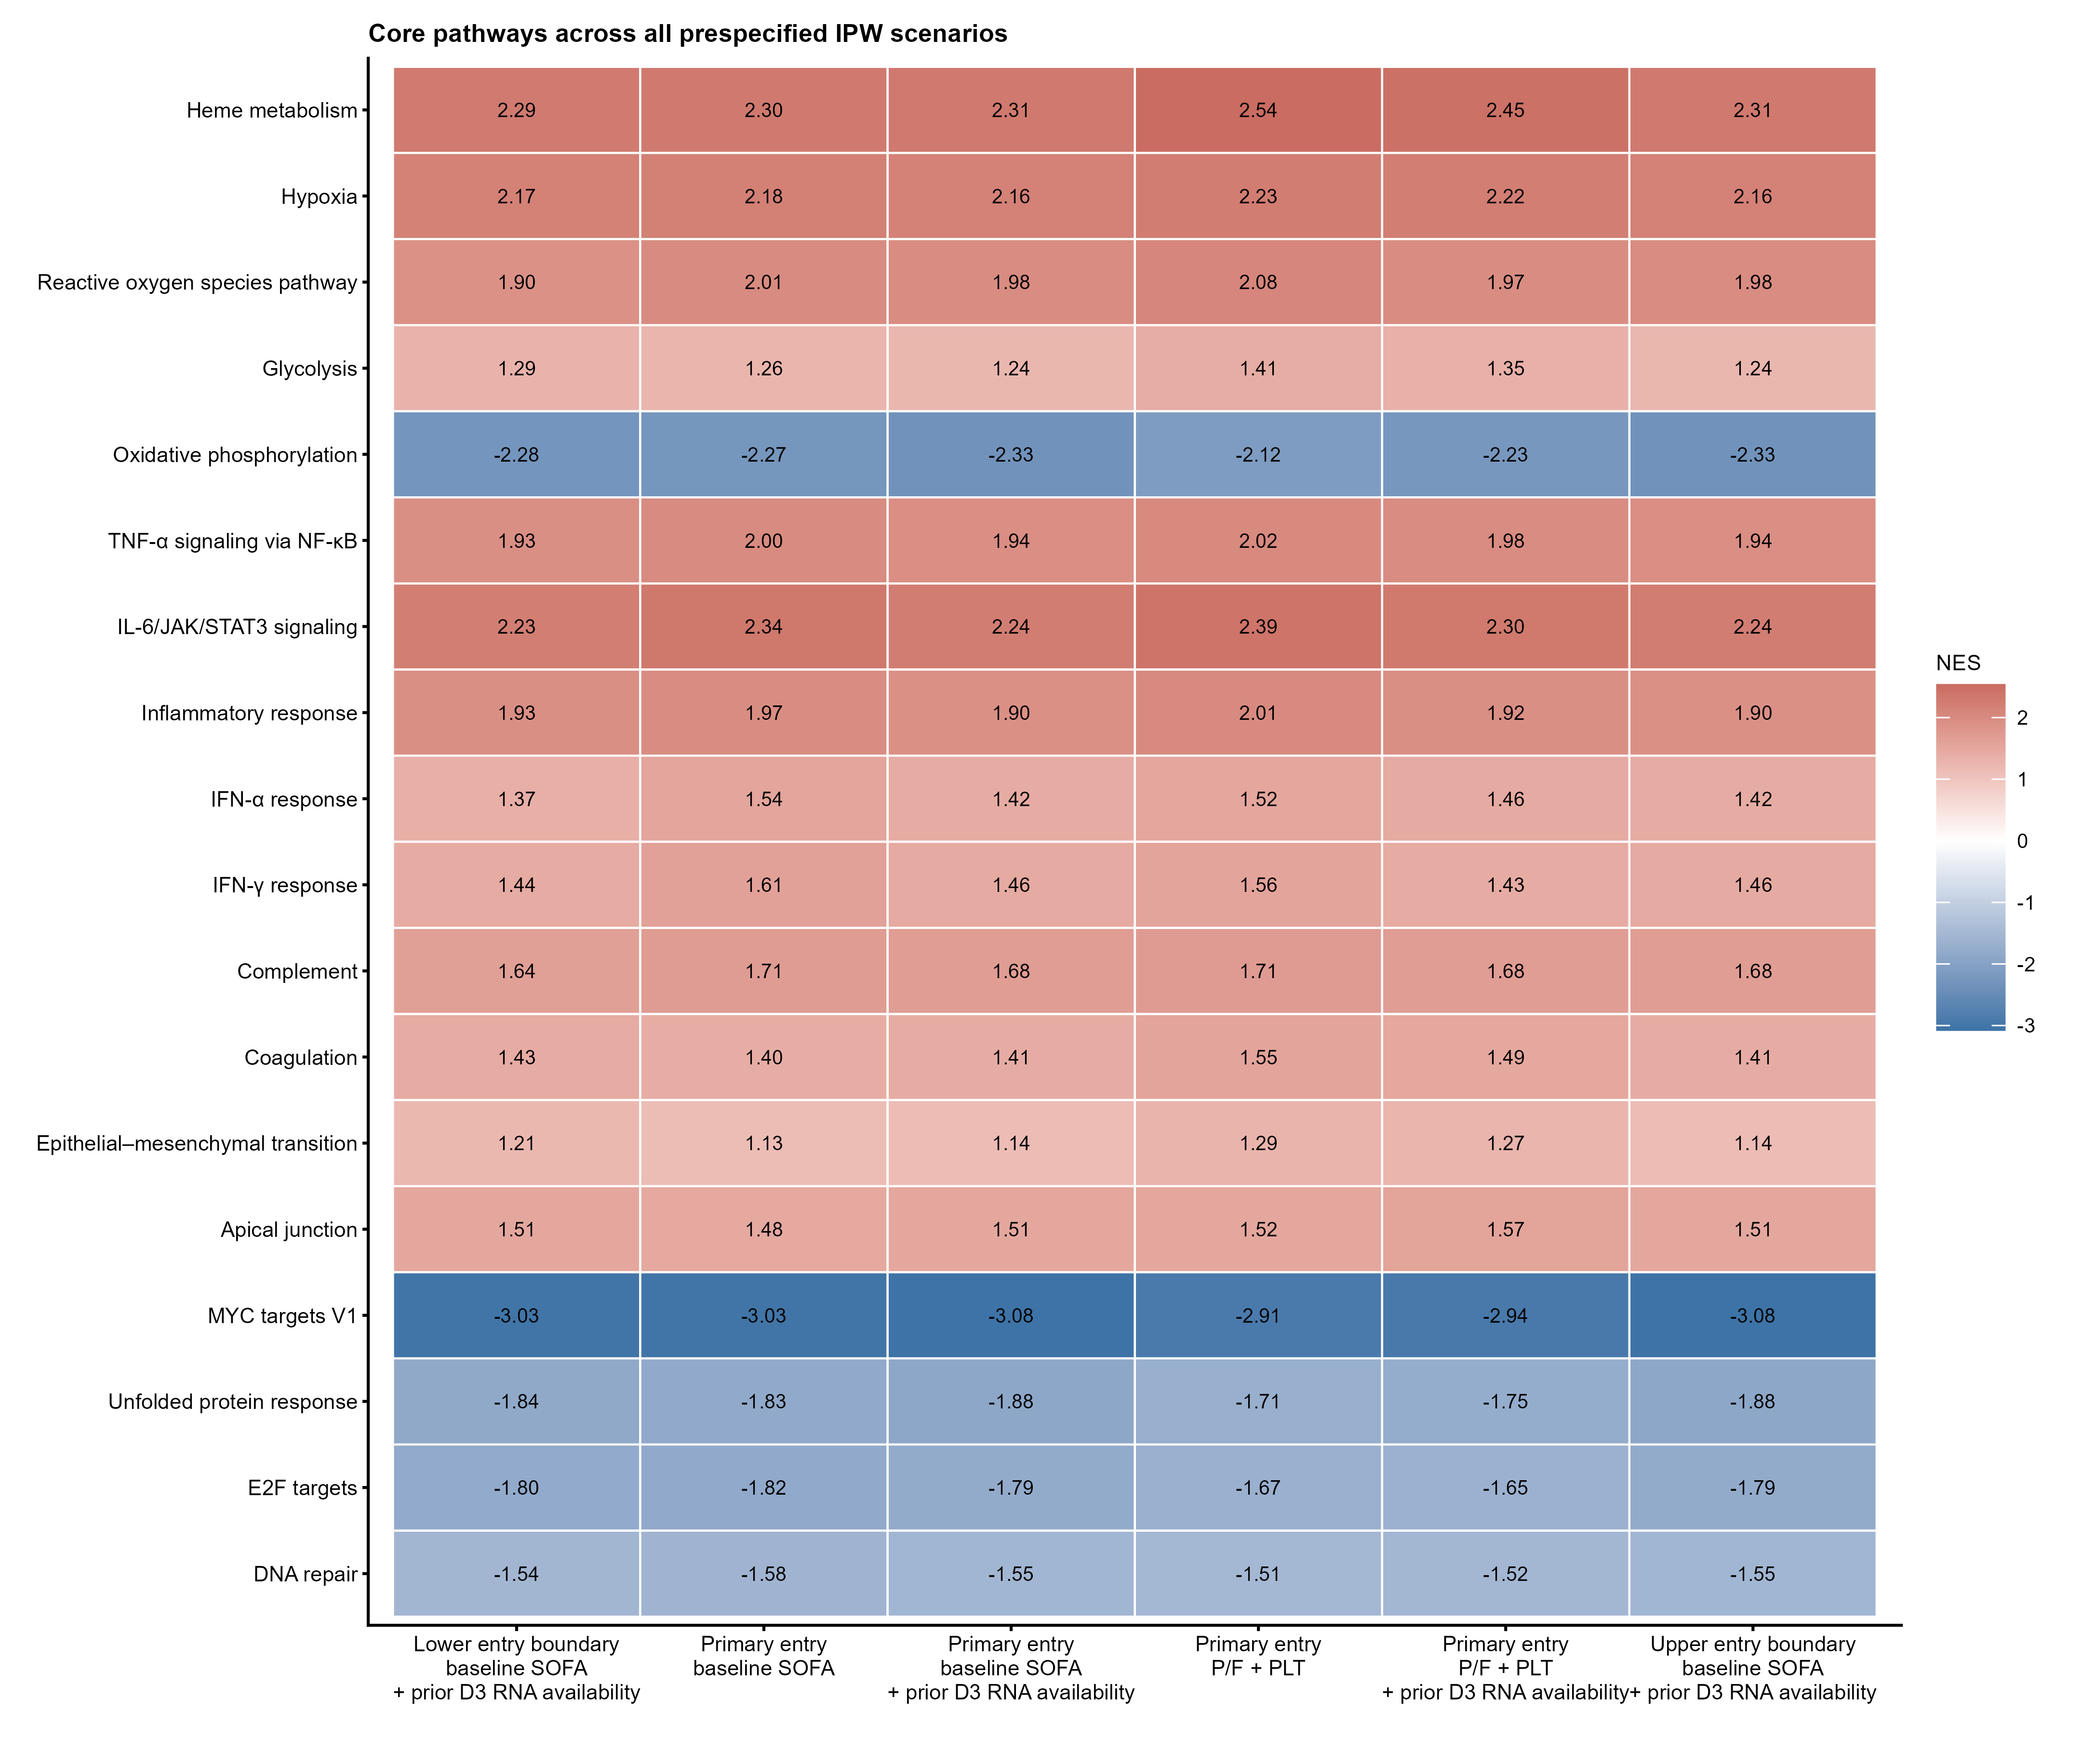
Supplementary Fig. S5 | Core pathways across prespecified IPW scenarios. Heat-map cells show weighted Day-5 mortality-association NES for the prespecified core Hallmark pathways across all six availability scenarios. Positive NES indicates enrichment among genes whose higher expression was associated with higher subsequent 60-day mortality risk. Negative NES indicates enrichment among genes whose higher expression was associated with lower subsequent mortality or, equivalently, whose lower expression was associated with higher mortality. NES does not denote absolute pathway expression. *BH-FDR<0.05, **BH-FDR<0.01 and ***BH-FDR<0.001 for the displayed scenario.
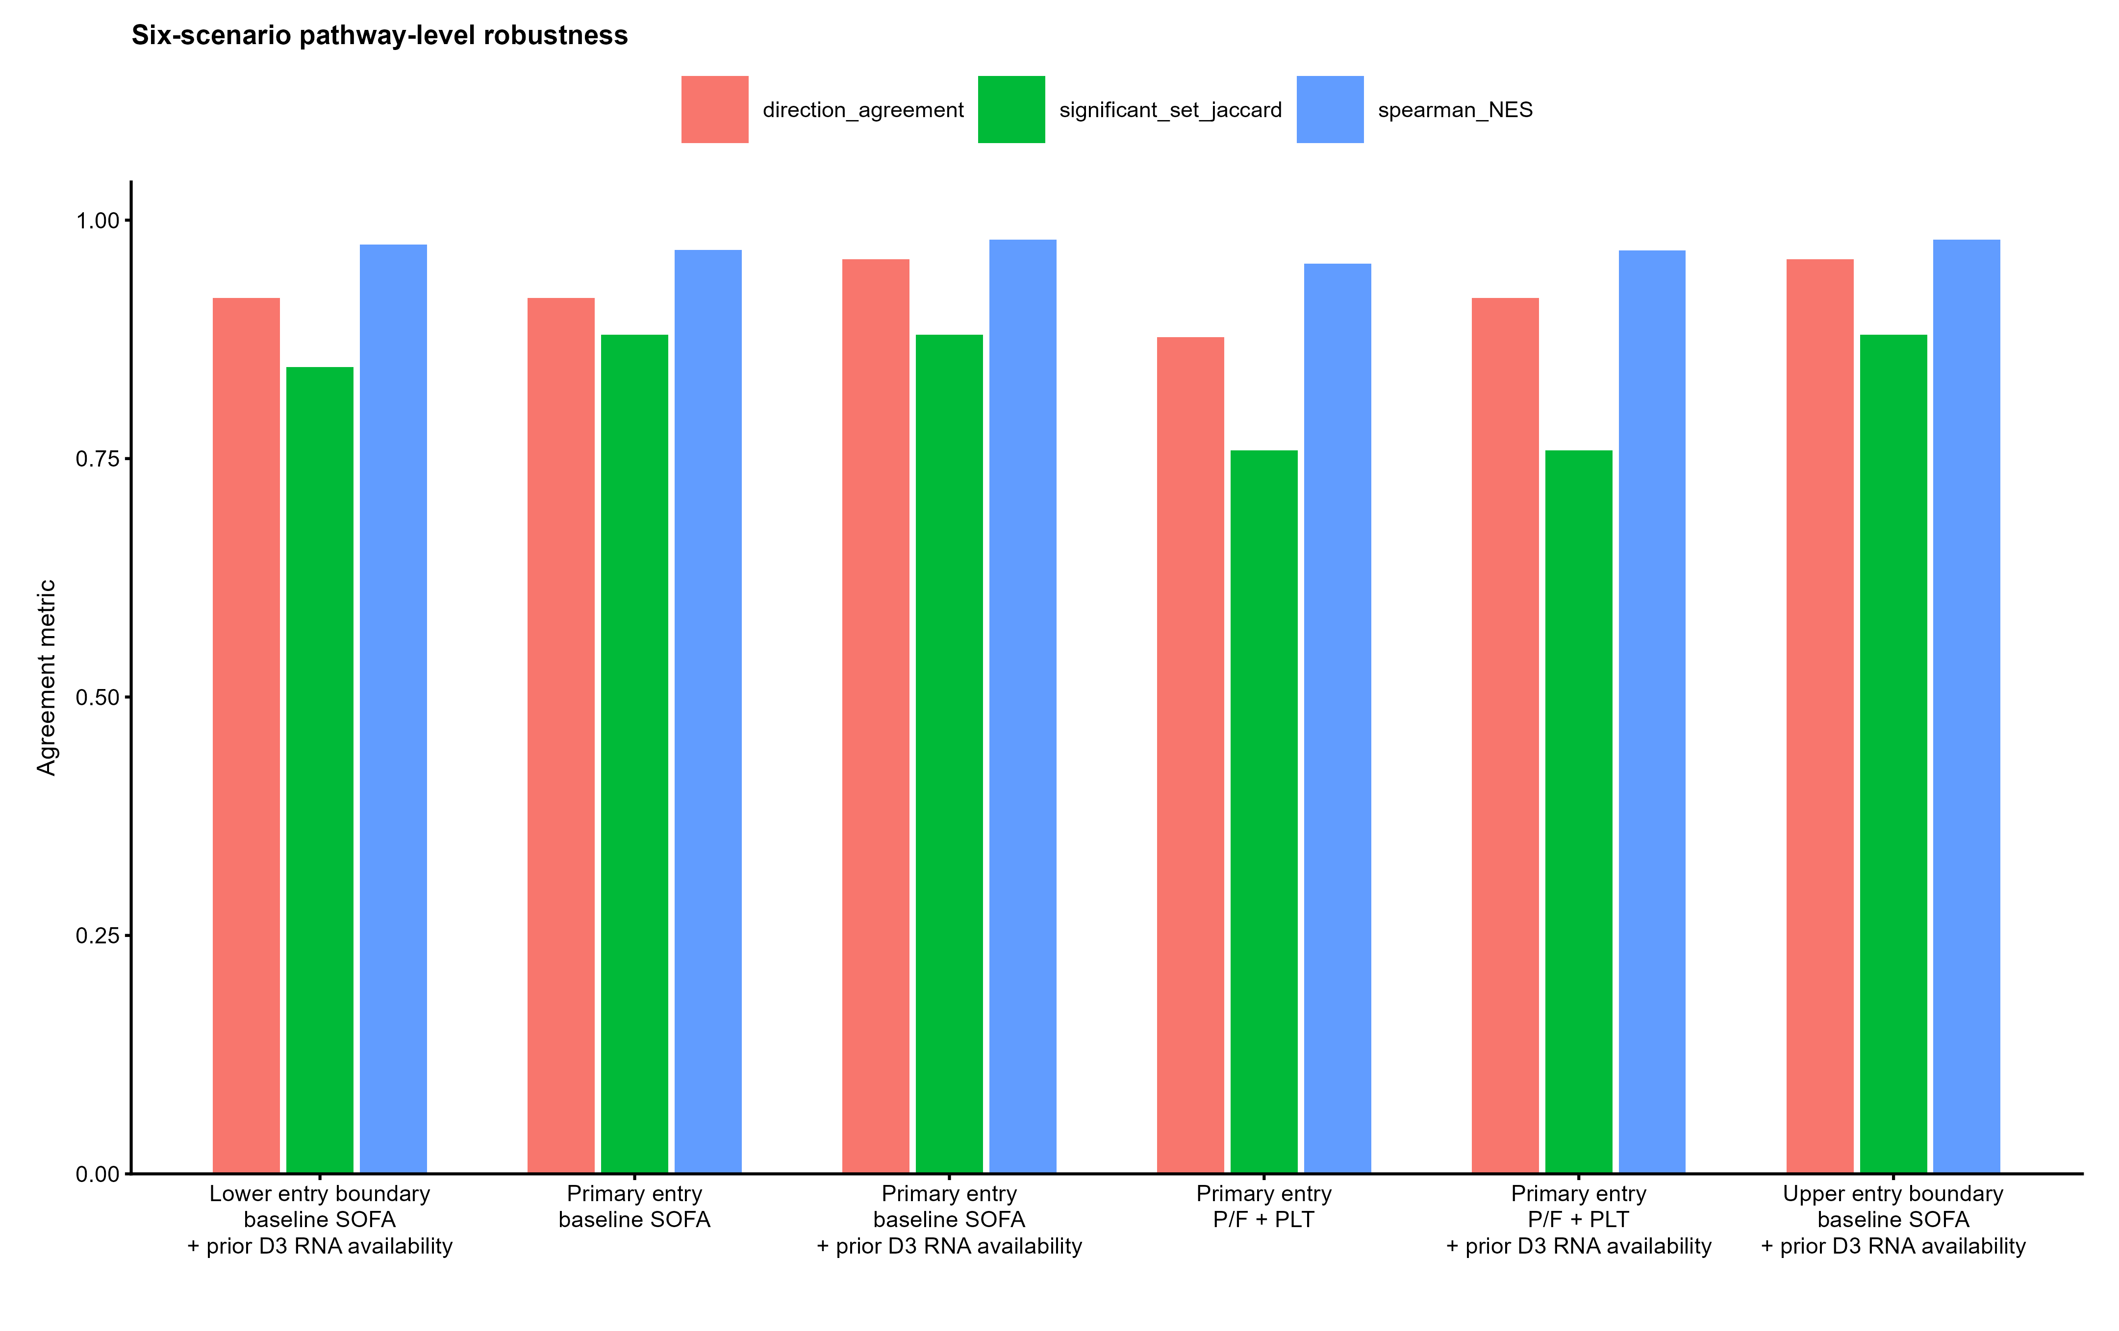
Supplementary Fig. S6 | Scenario-level Hallmark robustness metrics. Spearman correlation of NES, pathway-direction agreement and significant-set Jaccard overlap compare each weighted scenario with the unweighted Day-5 primary analysis across the complete Hallmark family.
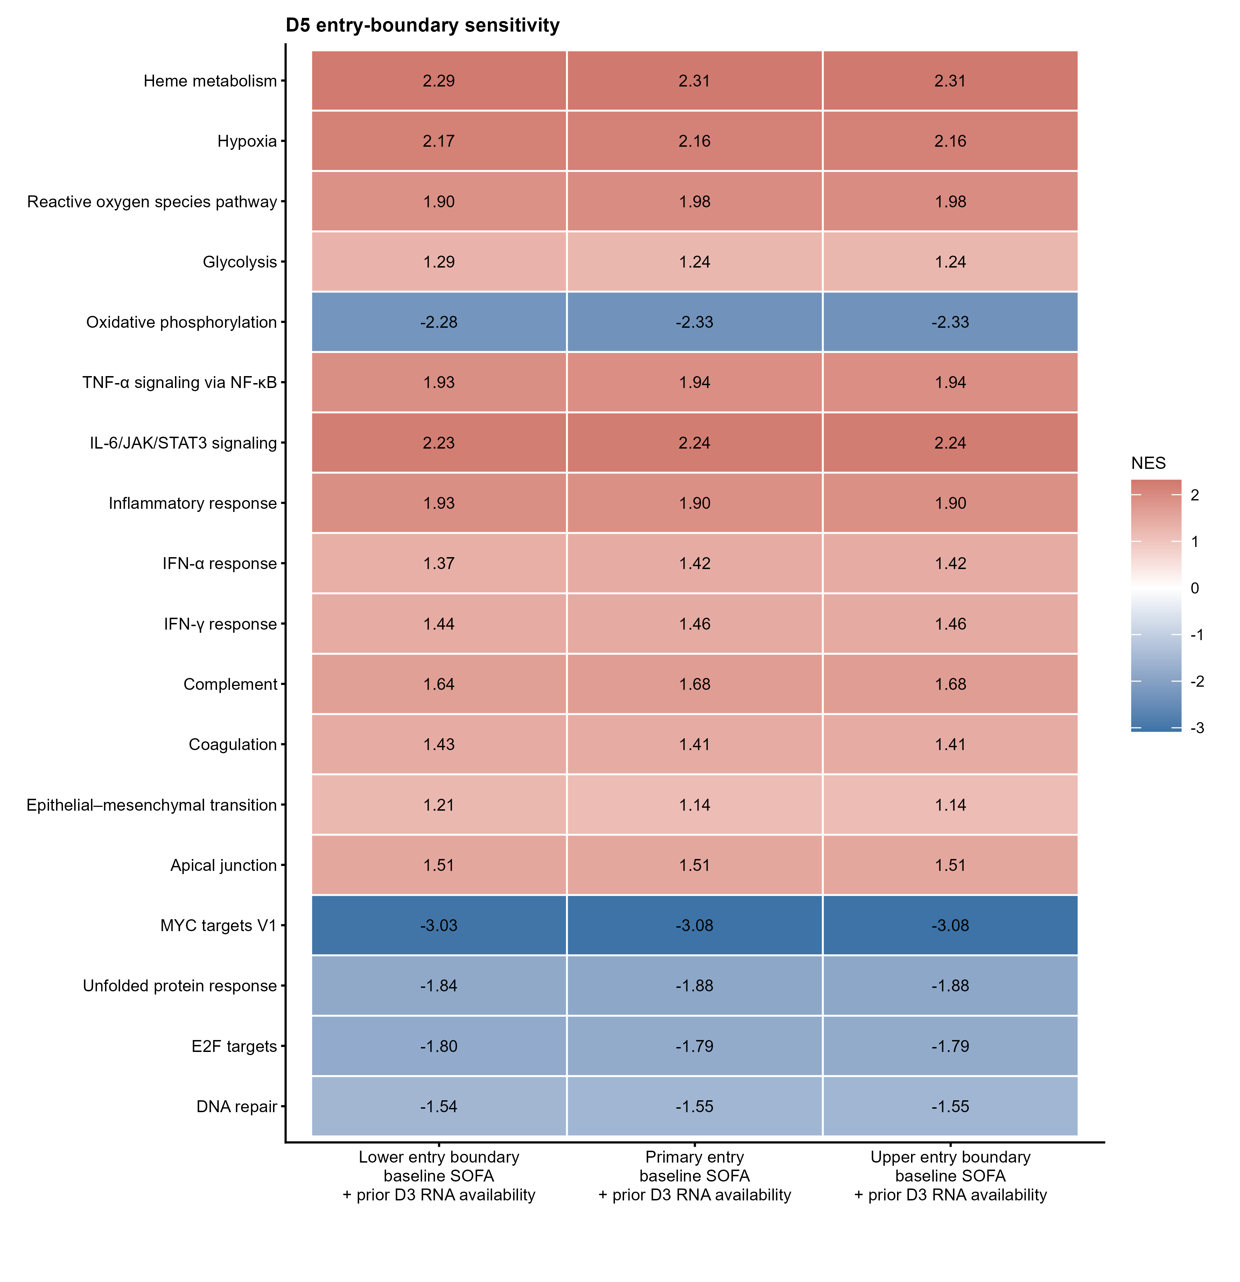
Supplementary Fig. S7 | Day-5 entry-boundary sensitivity. Core-pathway mortality-association NES values are compared across the prespecified lower, primary and upper Day-5 entry boundaries. Positive NES indicates enrichment among genes whose higher expression was associated with higher subsequent 60-day mortality risk. Negative NES indicates enrichment among genes whose higher expression was associated with lower subsequent mortality or, equivalently, whose lower expression was associated with higher mortality. *BH-FDR<0.05, **BH-FDR<0.01 and ***BH-FDR<0.001 for the displayed scenario.
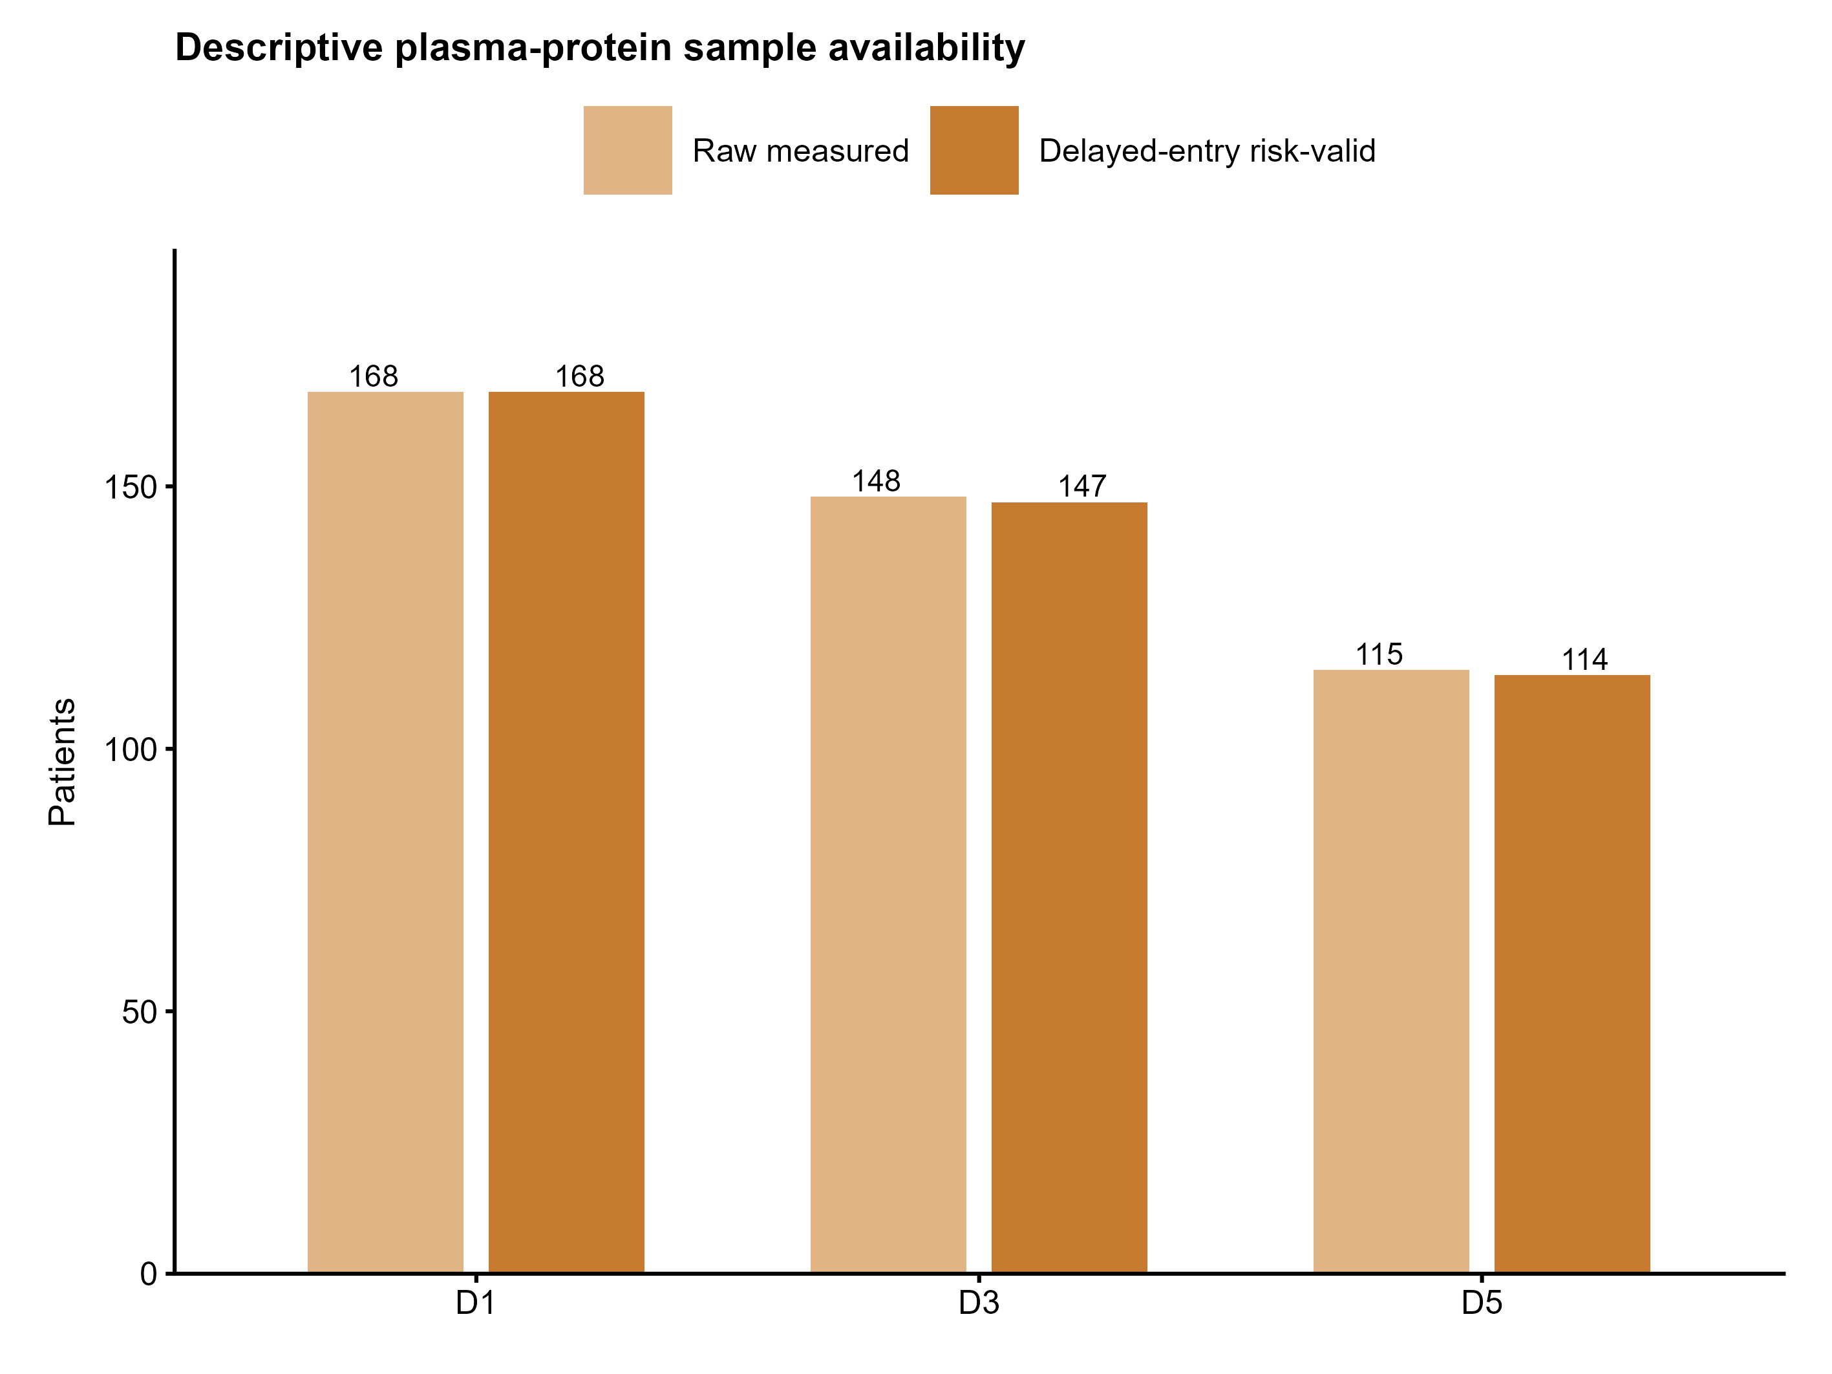
Supplementary Fig. S8 | Descriptive availability of plasma proteomic samples across landmarks. Raw measured and delayed-entry risk-valid plasma protein sample counts are shown across Days 1, 3 and 5. This analysis is descriptive; no protein availability weights were estimated.
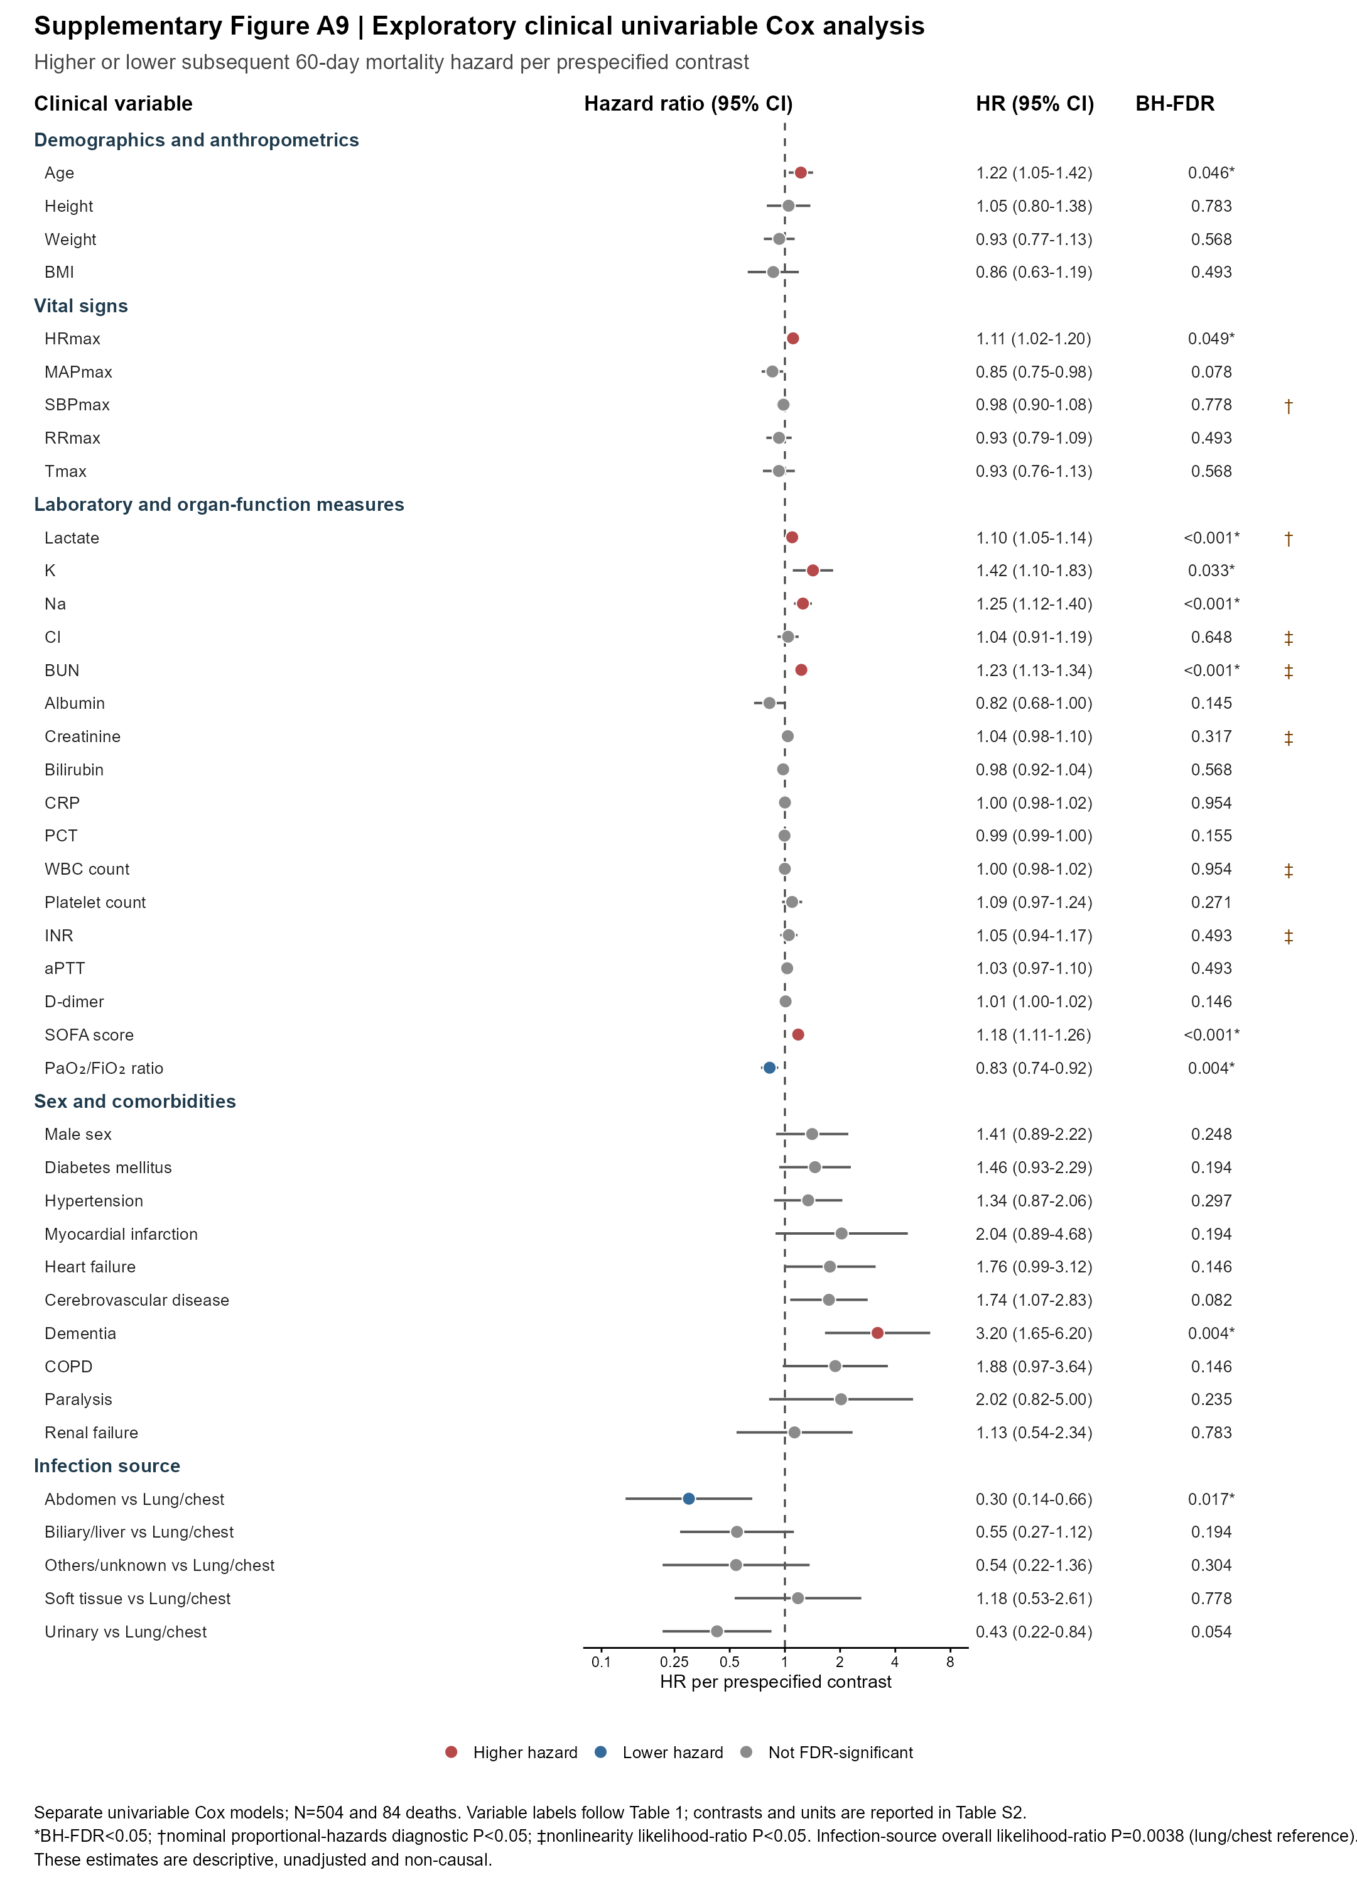
Supplementary Fig. S9 | Exploratory clinical univariable Cox associations with 60-day mortality. Points and horizontal bars show hazard ratios and 95% confidence intervals from separate univariable Cox models in 504 patients with 84 deaths. Variable names and abbreviations follow Table 1; prespecified contrasts and units are reported in Supplementary Table S2. The Benjamini–Hochberg procedure was applied across all 41 displayed contrasts; * indicates BH-FDR<0.05. † denotes nominal evidence against the proportional-hazards assumption and ‡ denotes nominal evidence of nonlinearity. Infection source was additionally associated with outcome in an overall likelihood-ratio test (P=0.0038). These univariable estimates are descriptive and are not mutually adjusted or causal.

Supplementary Tables
Supplementary Tables S1–S8 are supplied as separate machine-readable Excel workbooks. Supplementary Table S9 is included below and supplied as a separate Excel workbook.
Item | Title | Contents
Supplementary Table S1 | Clinical variable definitions | Variable definitions, prespecified increments, transformations, infection-source harmonisation and missing-variable exclusions.
Supplementary Table S2 | Clinical univariable Cox models | Complete exploratory univariable Cox contrasts, proportional-hazards diagnostics and nonlinearity tests.
Supplementary Table S3 | RNA-seq gene-wise Cox and PH outputs | Complete gene-level Day-1, Day-3 and Day-5 centre-stratified Cox results and PH diagnostics.
Supplementary Table S4 | RNA-seq Hallmark enrichment | Complete Hallmark enrichment and leading-edge results for transcriptomic analyses.
Supplementary Table S5 | Protein-wise Cox and PH outputs | Complete protein-level Day-1, Day-3 and Day-5 centre-stratified Cox results and PH diagnostics.
Supplementary Table S6 | Protein Hallmark enrichment | Complete Hallmark enrichment and leading-edge results for proteomic analyses.
Supplementary Table S7 | Cross-omic models | Contemporaneous, forward, reverse-order and sensitivity cross-omic pathway models.
Supplementary Table S8 | Day-5 availability and IPW | Positivity, observation-model, weight, balance and weighted-enrichment diagnostics.
Supplementary Table S9 | Complete baseline characteristics | Complete Day-1 baseline characteristics according to 60-day outcome; this is the full source table from which main-text Table 1 was selected.

Supplementary Table S9. Complete baseline characteristics of the Day-1 SIC cohort according to 60-day outcome
Characteristic | Overall  (n=504) | Survivor/censored  (n=420) | Death  (n=84) | SMD | P value
Age | 68.00 [58.00, 78.00] | 67.00 [56.00, 77.00] | 72.00 [63.75, 81.00] | 0.311 | 0.005
Height | 166.00 [159.00, 170.00] | 165.50 [159.00, 170.00] | 167.50 [158.75, 171.00] | 0.040 | 0.655
Weight | 63.00 [55.00, 70.00] | 63.00 [55.00, 70.00] | 64.50 [55.00, 70.00] | -0.087 | 0.751
BMI | 23.24 [20.81, 25.02] | 23.28 [20.94, 25.08] | 23.08 [20.76, 24.76] | -0.102 | 0.408
HRmax | 119.00 [103.00, 135.00] | 118.00 [102.00, 134.00] | 121.00 [108.00, 139.25] | 0.267 | 0.049
MAPmax | 94.85 [84.00, 106.00] | 95.00 [85.00, 107.00] | 92.00 [82.00, 102.25] | -0.283 | 0.045
SBPmax | 141.00 [126.00, 156.25] | 141.00 [126.00, 156.00] | 138.00 [125.25, 159.00] | -0.033 | 0.887
RRmax | 26.00 [22.00, 32.00] | 26.00 [23.00, 32.00] | 26.00 [22.00, 32.00] | -0.103 | 0.347
Tmax | 37.70 [37.00, 38.50] | 37.70 [37.00, 38.50] | 37.60 [36.77, 38.42] | -0.084 | 0.366
Lactate | 2.80 [1.70, 5.20] | 2.67 [1.61, 4.90] | 3.88 [1.90, 6.90] | 0.411 | 0.004
K | 3.80 [3.35, 4.21] | 3.80 [3.32, 4.20] | 3.92 [3.43, 4.44] | 0.303 | 0.044
Na | 137.05 [133.50, 142.00] | 137.00 [133.00, 141.10] | 138.45 [135.00, 145.10] | 0.364 | 0.032
Cl | 107.00 [102.00, 112.00] | 107.20 [102.00, 112.00] | 106.05 [100.75, 112.70] | 0.057 | 0.589
BUN | 11.89 [8.10, 18.20] | 11.26 [7.88, 16.52] | 18.20 [9.80, 25.36] | 0.530 | <0.001
Albumin | 28.25 [24.80, 31.63] | 28.40 [25.00, 31.90] | 27.25 [24.15, 29.75] | -0.238 | 0.038
Creatinine | 134.55 [93.00, 223.37] | 130.30 [91.75, 217.50] | 163.75 [112.82, 247.43] | 0.154 | 0.006
Bilirubin | 23.00 [13.30, 42.70] | 23.00 [13.67, 43.71] | 21.40 [12.17, 37.08] | -0.099 | 0.422
CRP | 153.95 [79.64, 219.64] | 154.61 [77.35, 226.05] | 147.84 [83.68, 206.16] | 0.001 | 0.897
PCT | 23.05 [5.22, 86.87] | 24.40 [5.74, 91.32] | 12.25 [2.20, 57.23] | -0.221 | 0.026
WBC | 11.60 [7.11, 17.68] | 11.59 [7.19, 17.18] | 12.00 [5.83, 19.92] | -0.003 | 0.892
Platelet | 89.00 [57.00, 132.25] | 86.50 [55.00, 131.00] | 96.50 [68.00, 143.25] | 0.168 | 0.064
INR | 1.38 [1.23, 1.61] | 1.37 [1.22, 1.57] | 1.49 [1.31, 1.65] | 0.119 | 0.007
aPTT | 37.60 [32.10, 45.00] | 37.25 [31.75, 44.75] | 39.35 [34.08, 45.85] | 0.107 | 0.133
D-dimer | 6.06 [2.73, 14.95] | 5.98 [2.73, 14.59] | 7.07 [2.75, 18.14] | 0.187 | 0.584
SOFA score | 10.00 [7.00, 12.00] | 9.00 [7.00, 12.00] | 12.00 [10.00, 14.00] | 0.636 | <0.001
PF | 243.82 [168.06, 327.52] | 249.70 [178.38, 330.45] | 205.30 [122.64, 280.95] | -0.404 | 0.001
Sex, male, n (%) | 298 (59.1%) | 242 (57.6%) | 56 (66.7%) | 0.187 | 0.145
Diabetes mellitus | 137 (27.2%) | 108 (25.7%) | 29 (34.5%) | 0.193 | 0.107
Hypertension | 200 (39.7%) | 161 (38.3%) | 39 (46.4%) | 0.164 | 0.180
Myocardial infarction | 20 (4.0%) | 14 (3.3%) | 6 (7.1%) | 0.172 | 0.122
Heart failure | 53 (10.5%) | 39 (9.3%) | 14 (16.7%) | 0.221 | 0.052
Cerebrovascular disease | 88 (17.5%) | 66 (15.7%) | 22 (26.2%) | 0.260 | 0.027
Dementia | 23 (4.6%) | 13 (3.1%) | 10 (11.9%) | 0.339 | 0.002
COPD | 35 (6.9%) | 25 (6.0%) | 10 (11.9%) | 0.210 | 0.060
Paralysis | 16 (3.2%) | 11 (2.6%) | 5 (6.0%) | 0.165 | 0.161
Renal failure | 42 (8.3%) | 34 (8.1%) | 8 (9.5%) | 0.050 | 0.666
Infection source, n (%)
Abdomen | 90 (17.9%) | 83 (19.8%) | 7 (8.3%) | -0.333 | 0.003
Biliary/liver | 66 (13.1%) | 57 (13.6%) | 9 (10.7%) | -0.088
Lung/chest | 194 (38.5%) | 148 (35.2%) | 46 (54.8%) | 0.400
Others/unknown | 36 (7.1%) | 31 (7.4%) | 5 (6.0%) | -0.057
Soft tissue | 25 (5.0%) | 18 (4.3%) | 7 (8.3%) | 0.167
Urinary | 93 (18.5%) | 83 (19.8%) | 10 (11.9%) | -0.216
Data are median [interquartile range] or n (%). P values are two-sided comparisons between survivors/censored patients and patients who died within 60 days. Continuous variables were compared using Wilcoxon rank-sum tests and categorical variables using Fisher’s exact tests. For infection source, the P value shown in the first category row is the global P value for the six-level variable. P values were descriptive and were not used for covariate selection. aPTT, activated partial thromboplastin time; BMI, body mass index; BUN, blood urea nitrogen; Cl, chloride; COPD, chronic obstructive pulmonary disease; CRP, C-reactive protein; HRmax, maximum heart rate; INR, international normalised ratio; K, potassium; MAPmax, maximum mean arterial pressure; Na, sodium; PCT, procalcitonin; PF, PaO₂/FiO₂ ratio; RRmax, maximum respiratory rate; SBPmax, maximum systolic arterial pressure; SIC, sepsis-induced coagulopathy; SMD, standardised mean difference; SOFA, Sequential Organ Failure Assessment; Tmax, maximum temperature; WBC, white blood cell.

