Overral: - How many stage

- Sống ở 3 môi trường sống khác nhau

- 1 cá hồi cần 10 năm để become adults, become mature, reach maturity



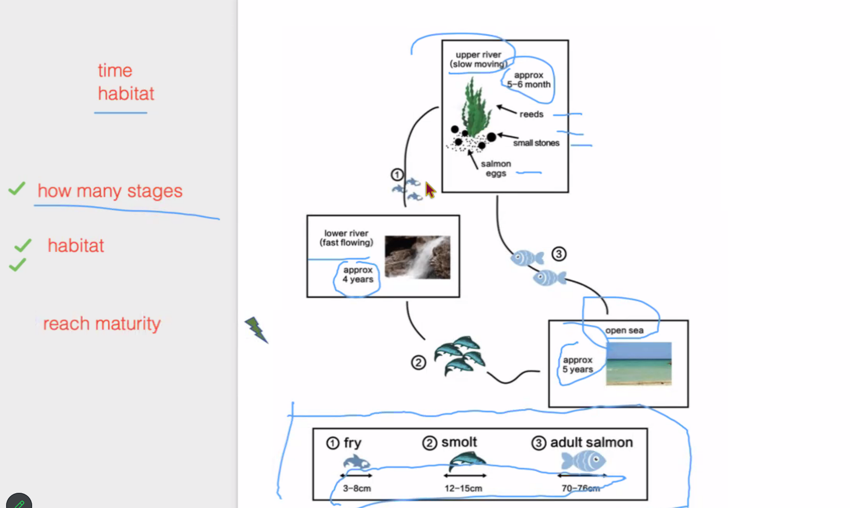

The diagram illustrates how salmon grows from eggs to maturity. There are three stages in those life cycle, a salmon need approximately 10 years to become adults.

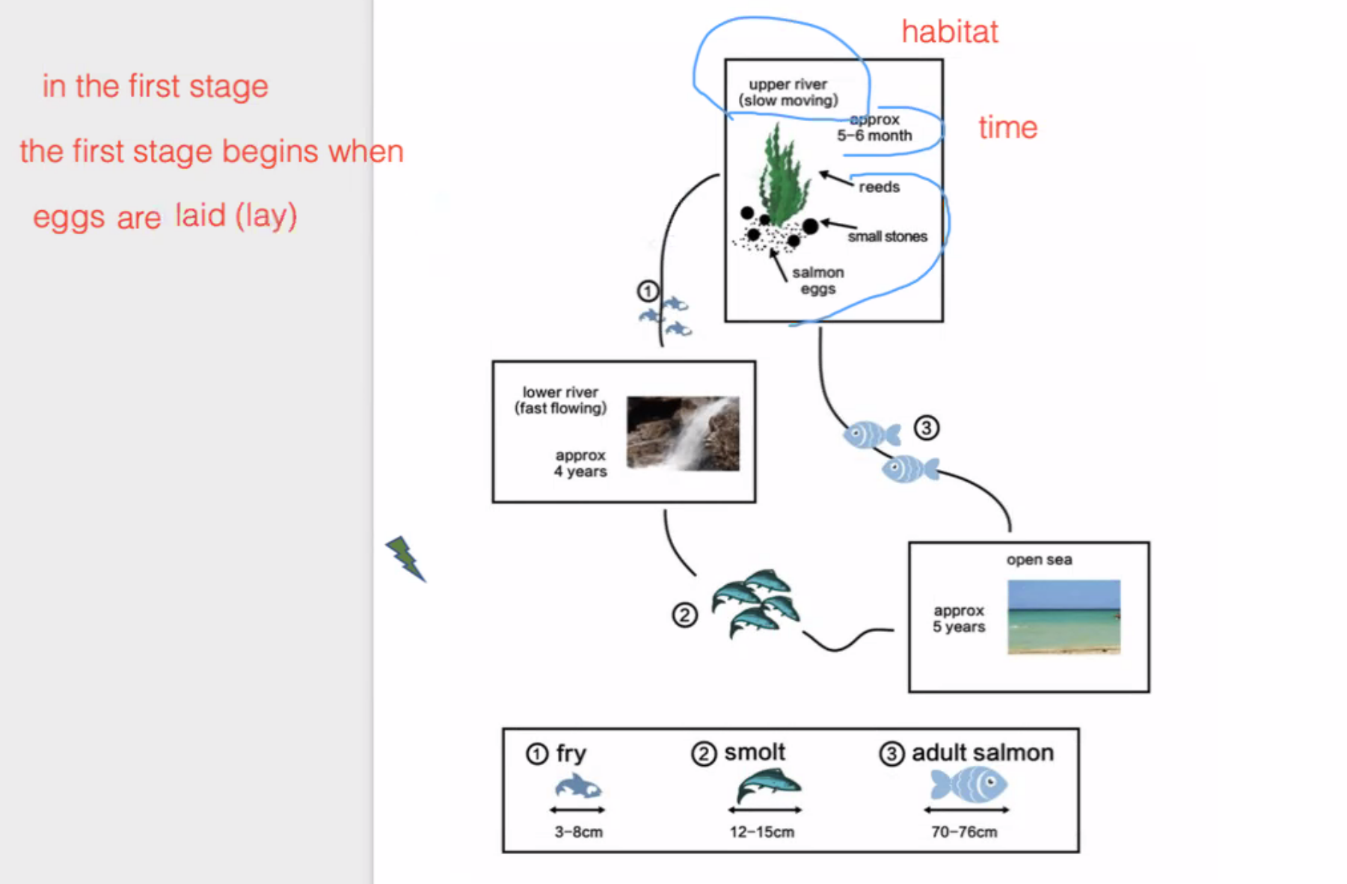

Lay: đặt cái gì đó nằm xuống

Lie: nằm xuống

Eggs are laid under reed and surrounded by small stones

After 5 to 6 months -> hatch into fry/ emerge from the eggs

They are 3-8cm long/ they have a length of

They stay here for 4 years, develop into 🡪 độ dài

They can reach 70-76 cm

Then go to breeding sites at upper river and begin a new cycle by đẻ trứng

