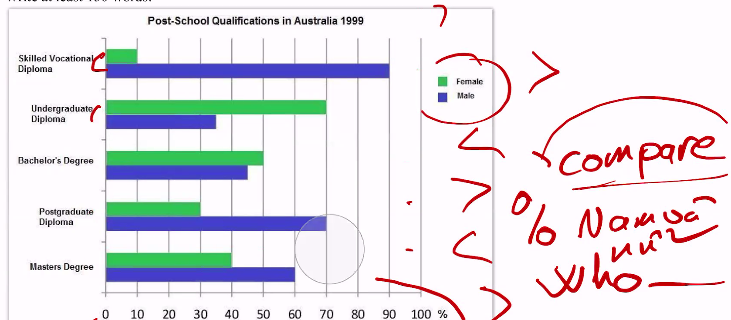

overall:

Nam cao hơn 3 loại bằng 🡪 nữ cao hơn 2 loại bằng

Sự khác biệt lớn nhất giữa 2 giới trong 1 loại bằng

The chart compares the proportion of men and women who held post-school qualifications in 1999 and the different levels of them. Overall, men are higher than at three post-school qualifications and women are higher than two, furthermore, women are worse off than men in terms of skilled vocational diploma.

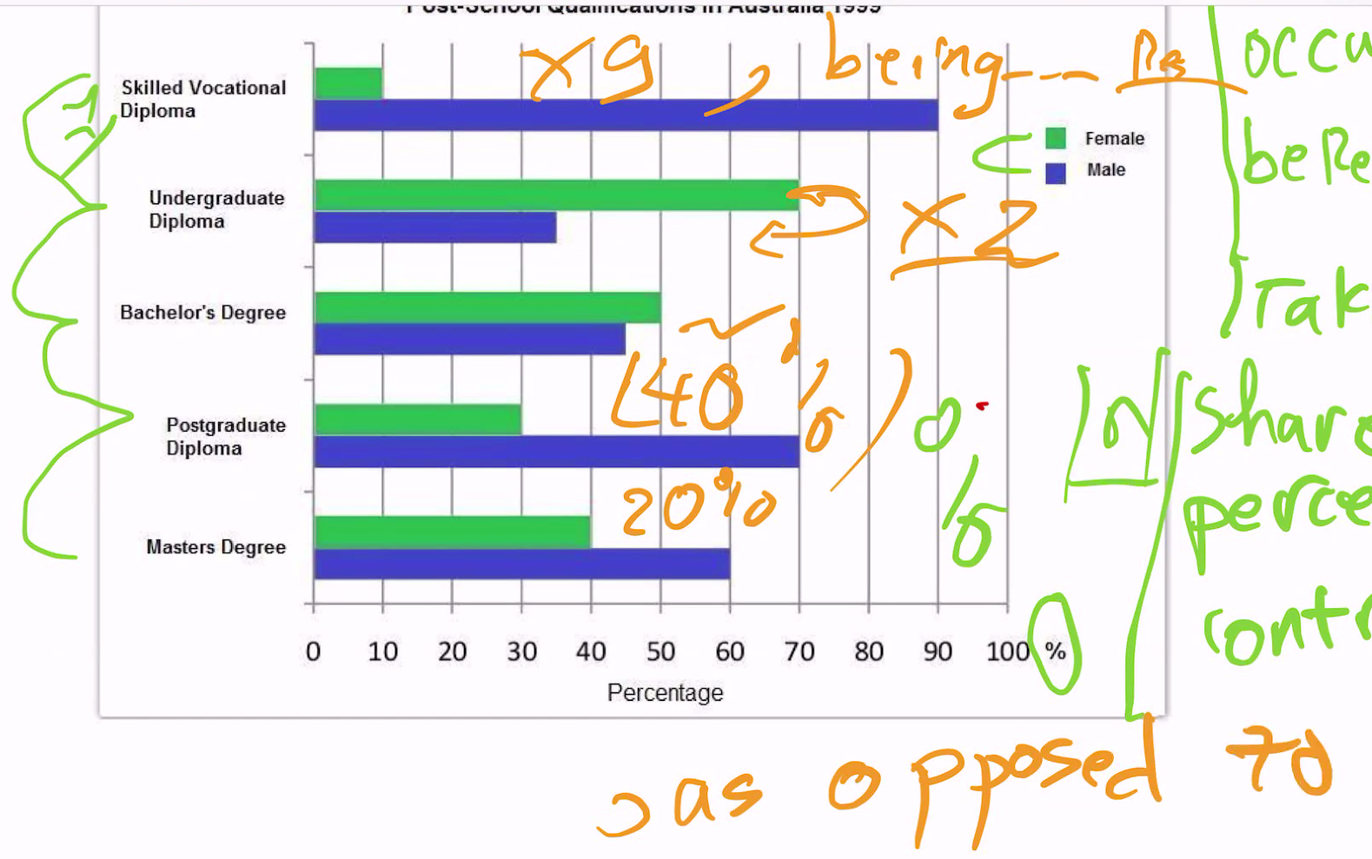

VD 🡪 Nam accounted for …., as opposed to …. for women

In the Undergraduate Diploma, there is a remarkable proportion of women and men. Women’s share accounts for 70%, which is approximate as twice much as men’s share. The same trend appears in Bachelors Degree, men occupied fewer than women about 5%.

Regarded to skilled vocational diploma, man accounted for 90%, nine fold higher than of women. Men are responsible for 70%, as opposed to 30% for women in term of postgraduate diploma whereas women are lower than men in Masters Degree, being 40% and 60% correspondingly.

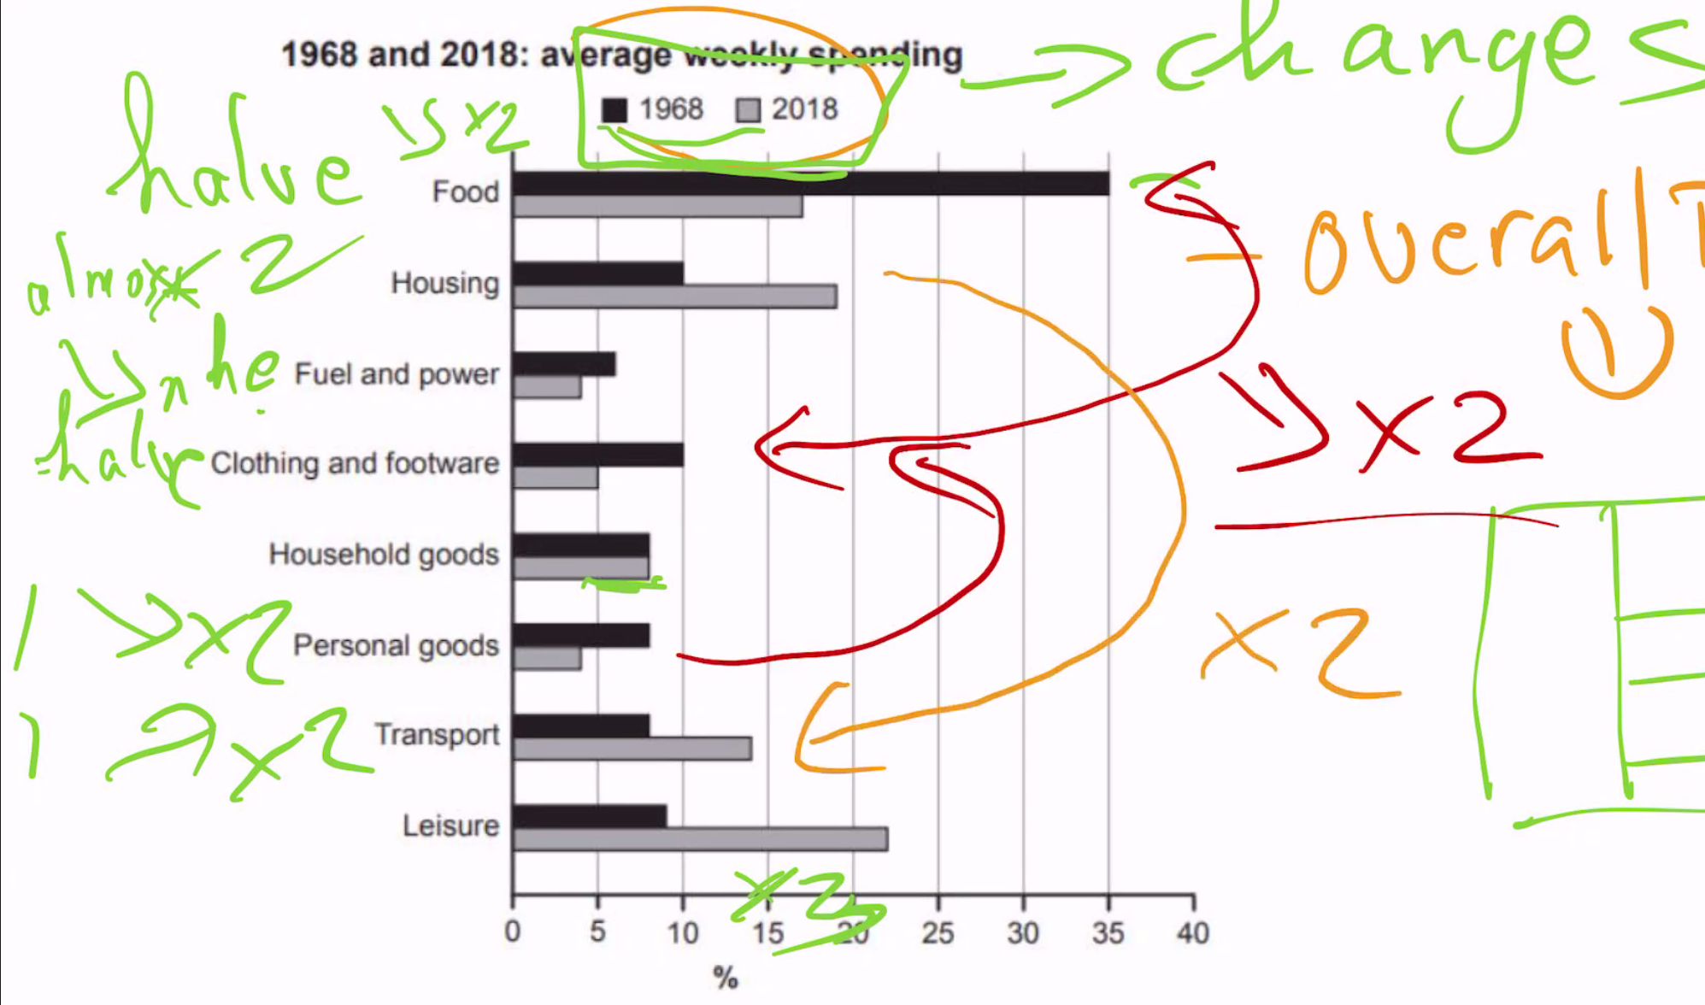

Overall:

* So sánh các số liệu giữa các chủ thể với nhau 🡪 ko phải gữa năm đầu và năm cuói
* Ở mốc đầu food (1968)cao nhất 🡪 cuối cùng leisure (2018) cao nhất 🡪 nói qua

Đưa ra sự thay đổi 🡪 bắt cặp

Những thằng còn lại 🡪 cho nằm riêng