Mở bài cho đề có 2 ý 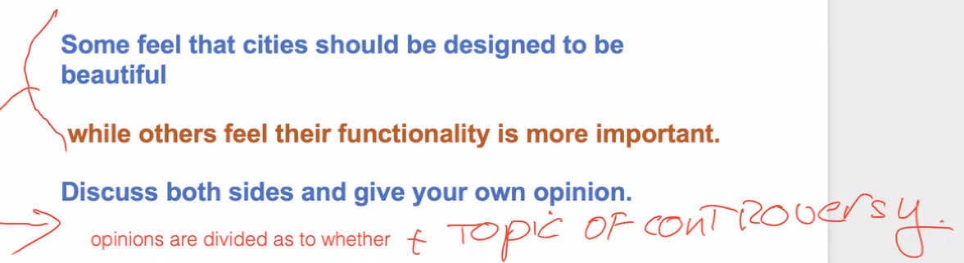

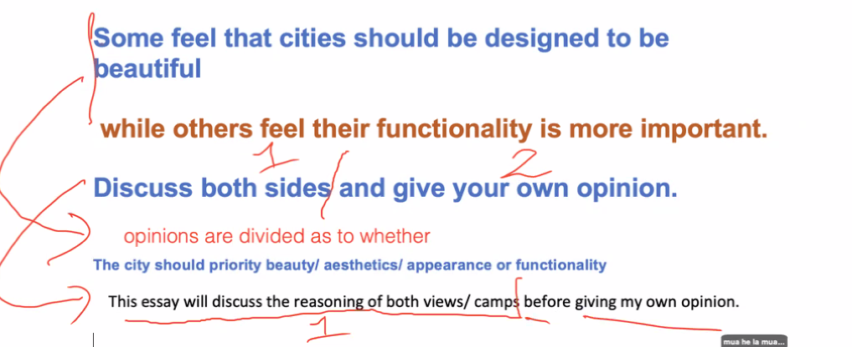

The city should prioritize beauty/ aesthetics/ appearance or functionality

**Counter argument: phản biện**

Not to mention, ……

Compelling: thuyết phục

Decided against something: định không làm nữa

Unsettling: không ổn, hơi đáng quan ngại

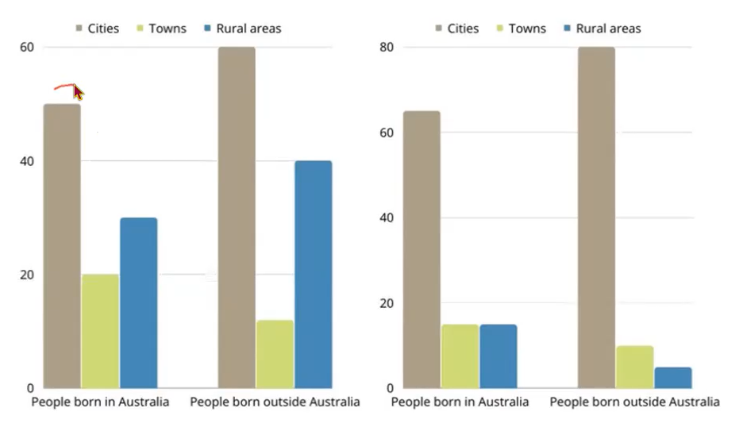

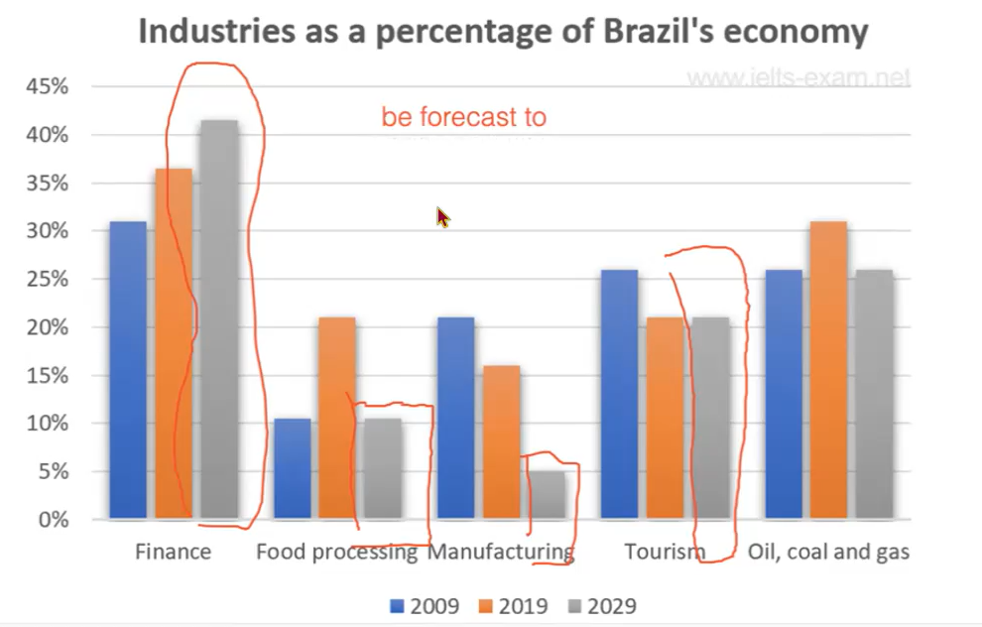

Be forecast to

Be predicted to

Be expected to

Be projected to

The chart compare some different industries’ percentage share of Brazil’s economy in 2009, 2019 and a forecast for 2029. Finance accounted for highest percentage share of Brazil economy in 2009, 2019 and It’s expect to upward trend in 2029.

In the period from 2009 to 2019, Finance and Oil, coal and gas field increased to 5%, being 36% and 31% correspondingly, whereas Manufacturing and Tourism have a fall of 5%, with 15% and 21& respectively. Food processing has increased dramatically, reaching 20% in 2019.

Over the period 2019 to 2029, Food processing and Manufacturing are forecast to plummet by approximately 10%. Finance is expected to increase to over 40%. In contrast, Oil, coal and gas is predicted to drop to 21%. Tourism is projected to be stable.

The chart illustrates the percentage of people who were born in Australia and who was born outside Australia living in urban, town and rural between 1995 and 2010. People living in Cities is sharply increased in both 1995 and 2010. By contrast, People living in Towns and Rural areas is plummet.

Regarded People born in Australia, the percentage of cities, towns and rural areas is 50%, 20% and 30% correspondingly in 1995, however, the percentage of towns is equal to rural areas at 17% and Cities accounted for 64% in 2010.

Moving on to people born outside Australia, the percentage of cities significantly rise from 60% in 1995 to 80% in 2010. In contrast, Rural areas hit the lowest percentage of 3% in 2010, lower than the percentage in 1995 at 40%. The percentage of Towns is slightly decrease from 10% to 7% in the period 1995 to 2010.