Overall 1:

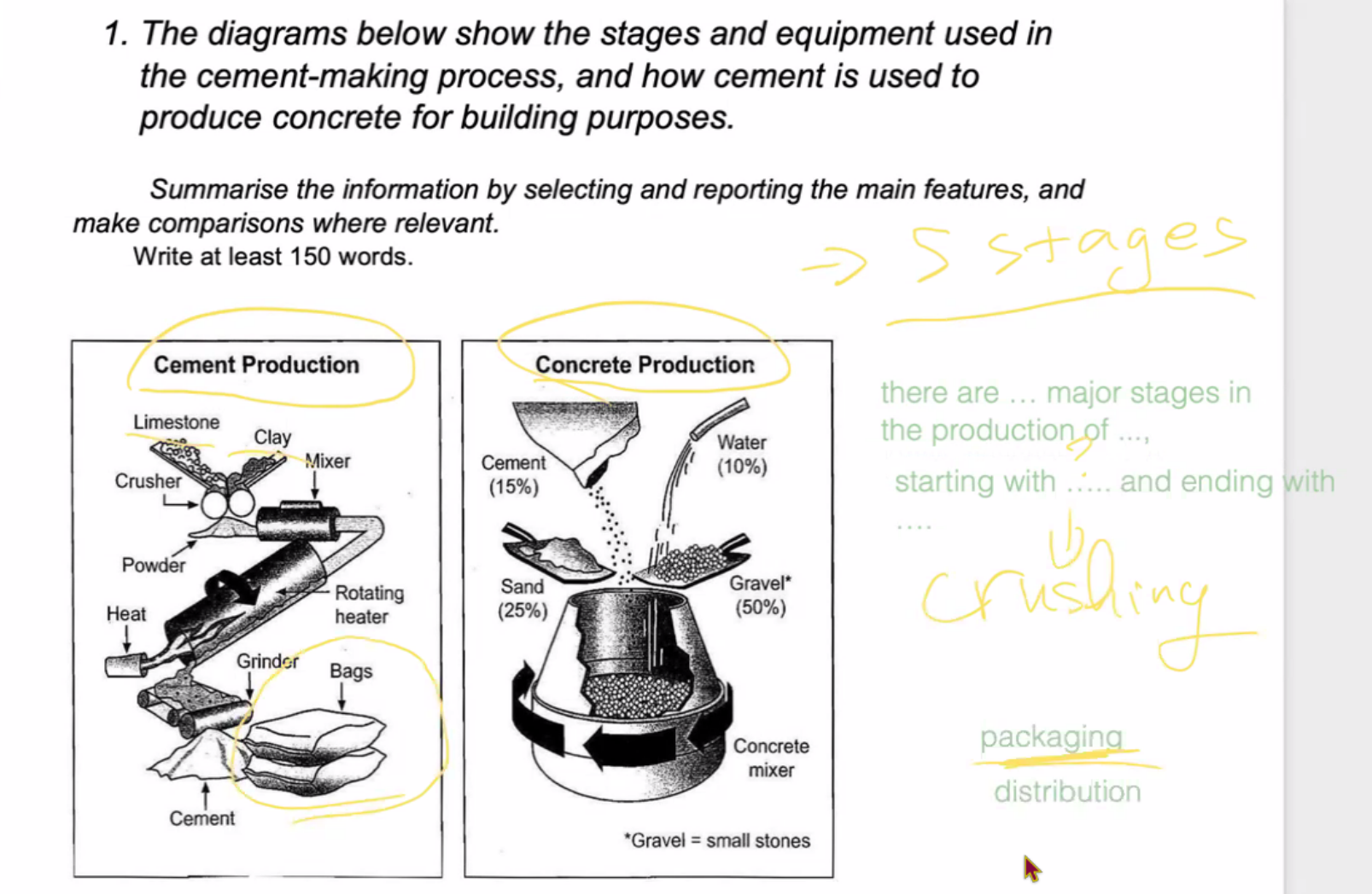

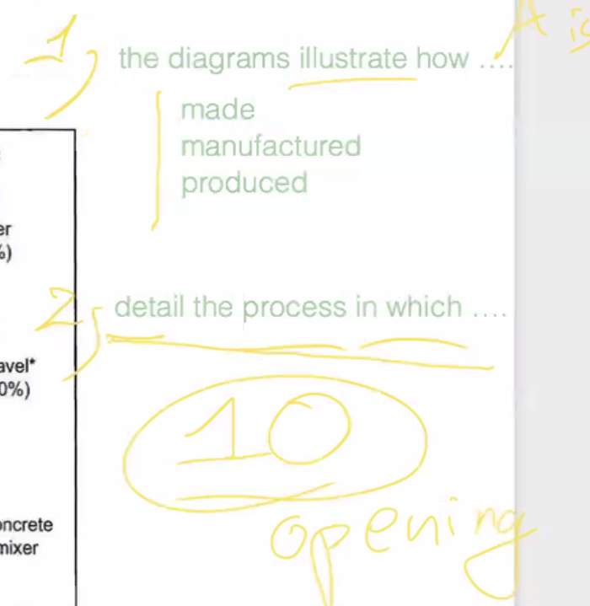

Overall 2: quy trình này là quy trình fully-automated hay semi-automated

This diagram illustrate how cement and concrete is made. There are five major stages in the production of cement-making, stating with crushing and ending with packaging, whereas concrete have only one stage which is concrete mixer. There are different between cement production and concrete, being semi-automated and fully-automated correspondingly.

Mở bài: 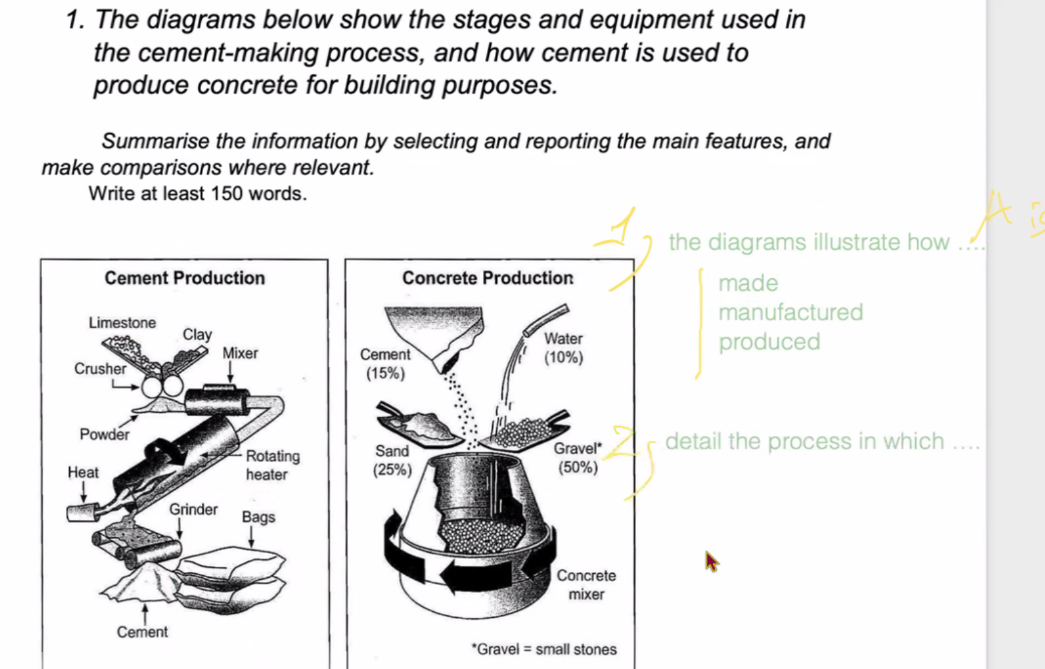

- Limestone and clay được nghiền

- các động từ được dùng ở bị động

- in the second stage

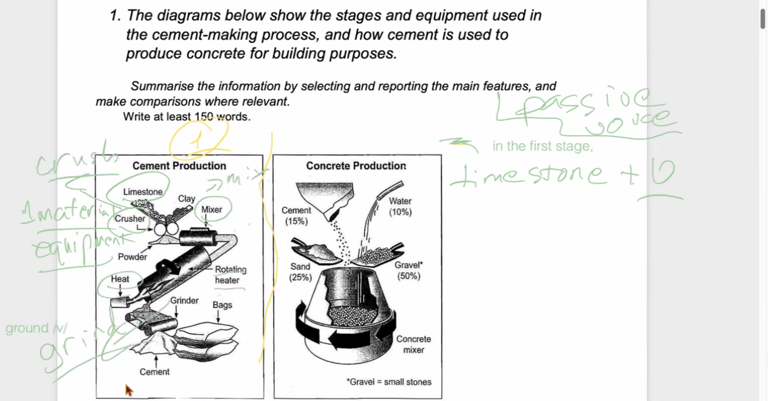

Grind: nghiền

Crush: nghiền



Nó được mixed trước khi được heated

