|  |  |
| --- | --- |
| **THE UNIVERSITY OF DANANG**  **UNIVERSITY OF SCIENCE AND TECHNOLOGY**  **FACULTY OF MECHANICAL ENGINEERING** | **Socialist Republic of Vietnam**  Independent – Freedom - Happiness |

**THESIS PROJECT**

|  |  |  |  |  |
| --- | --- | --- | --- | --- |
| TT | Student's name | Student code | Class | Major |
| 1 | Tran Truong Minh Chanh | 101180296 | 18CDTCLC | Mechatronics Engineering |
| 2 | Le Viet Hung | 101180288 | 18CDTCLC | Mechatronics Engineering |

1. *Topic:*

Equipment for lining up food bags.

1. *Initial figures and data:*

* Name: food bag (pouch), refer to the picture below.
* Product size (example): (sizes below are easy to find on the market).
* Approximately 90～100W x 145～160L x 10H.
* Weight: about 60～70 g/bag.

1. *Contents of explanations and calculations:*
2. *General part:*

|  |  |  |
| --- | --- | --- |
| TT | Student's name | Contents |
| 1 | Tran Truong Minh Chanh | * Analysis and selection of design options * Explanation * System design * Install the machine |
| 2 | Le Viet Hung |

1. *Private part:*

|  |  |  |
| --- | --- | --- |
| TT | Student's name | Contents |
| 1 | Tran Truong Minh Chanh |  |
| 2 | Le Viet Hung | * Design and solve problems |

# Abstract

This paper describes the concept and operation of a machine used to organize food bags in rows along the longitudinal direction of the bag, which is inserted after the emptying process. The mechanism can separate overlapping bags and accept two different product sizes. SUN FIELD VIETNAM Co., Ltd. entrusted the assignment to students in order to increase the speed and quality of the company's production line.

Dr. Dang Phuoc Vinh is the project's advisor, and we completed the project titled " Equipment for lining up food bags." We attempted to implement the needed topic with the information we had and the help of our professors and friends, but there were unavoidable errors and certain restrictions, therefore we are eager to hear your comments. Thoughts and suggestions for enhancing the subject.

We are grateful that Dr. Dang Phuoc Vinh helped to direct the project's execution, offered support, provided necessary paperwork and equipment, set up the necessary framework, and showed a great deal of concern.

We also want to express our gratitude to the professors at the University of Technology-University of Danang as well as the professors in the Department of Mechatronics who helped us with this project by sharing their knowledge, expertise, and skills.

# Assure

We therefore declare that the project titled "Equipment for lining up food bags" is the group's research effort. The areas of the project that use references and citations are noted, and their sources are fully acknowledged. The generated data are accurate, and the findings are the collaborative work of the study team led by Dr. Dang Phuoc Vinh, lecturer at the Faculty of Mechanical Engineering, University of Science and Technology - University of Danang.

If I am incorrect, I will accept full responsibility and endure the discipline of both the topic and the institution.

Danang, July 3rd, 2022.

Student Student

Nguyen Dinh Khang Nguyen Quoc Dat

Table of contents

# CHAPTER 1. INTRODUCTION

1. **About the topic**

* Factories are progressively investing in development teams that may help enhance production, thereby improving productivity, profitability, and reducing human labor in this age where everything is driven by the advancement of science and technology. To address these issues, functioning robots have now been created.
* About the topic, freely pour 20 food bags into the appliance from the luggage bin. With the aid of the gadget, these items may be arranged in a row along their length rather than atop one another.

1. **Requirements**

* Equipment positioned once the container has been emptied.
* The equipment must be capable of separating overlapping bags.
* The equipment lines up the bags in a row according to bag length.
* The bag doesn't need to be oriented or its surface aligned.
* Equipment ideal for two different sorts of items.

1. **Product object**

* Name: food bag (pouch), refer to the picture below.
* Product size (example): (sizes below are easy to find on the market).
* Approximately 90～100W x 145～160L x 10H.
* Weight: about 60～70 g/bag.

Figure 1.1 Product pictures reference

1. **Processing capacity**

* Food bags (pouches): 20 bags/carton.
* 120 bags/minute (10 sec/carton) or more.
* Target 200 bags/minute (6 sec/carton)

1. **General drawing**

Figure 1.2 General drawing

## Scope and subject of research

## Main content

# CHAPTER 2. IDEAS OF THE PROJECT

1. **Solution is based conveyor belt:**
2. **Conveyor belt:**

* Definition: Objects are simply moved from one position to another, from site A to location B, using a conveyor belt, which is only a mechanical device. It takes a lot of time and money to ship goods without using employees. Conveyor belts can help with the dirty work environment that labour causes.

It decreases the number of workers needed, shortens the workday, and boosts output.

Conveyor belts are therefore one of the crucial components in the manufacturing and assembly lines of factories and businesses. helping to create a contemporary, scientific manufacturing environment, freeing up workers, and delivering the firm excellent economic efficiency.

* Structure:
* Conveyor frame: Usually made of aluminum profile, powder coated steel or stainless steel.
* Conveyor belt by belt or roller: Usually 2mm and 3mm thick PVC tape or 1.5mm thick PU belt
* Conveyor controller: PLC, Inverter, Speed controller, Sensor, Relay, Contactor…
* Traction roller/active roller in galvanized steel or aluminum with Ø50, Ø60, Ø76, Ø89, Ø102…
* Supporting rollers/passive rollers in galvanized steel or stainless steel with Ø25, Ø32, Ø38.
* Chain or belt drive conveyors.
* Motor reducer capacity from 25W to 2.2KW.

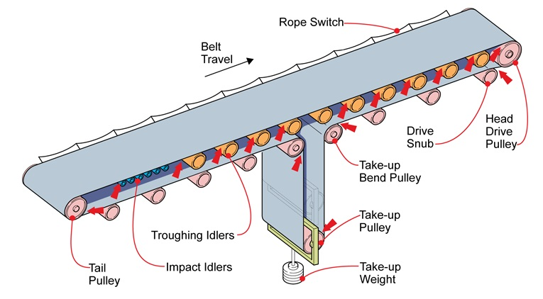

Figure 2.1 Conveyor belt

* Classification of conveyors:

There are many types of conveyors:

* Rubber conveyor belt: Is a transportation system with higher economic efficiency than other types, good heat resistance, large capacity. Used to install on all terrains, different distances, transporting many products of different sizes.

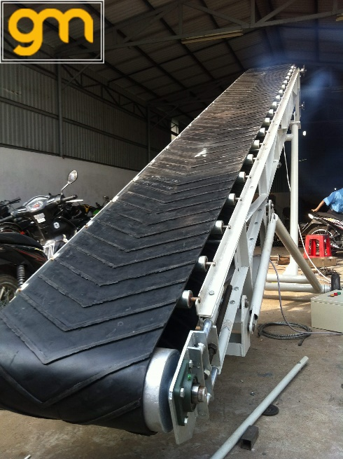

Figure 2.2 Rubber conveyor belt

* Chain Conveyor: Mainly used for transporting heavy products, suitable for bottle loading products that need stability. They are also widely used in the distribution industry, auto parts, ... are designed with one or two wires in the structure.

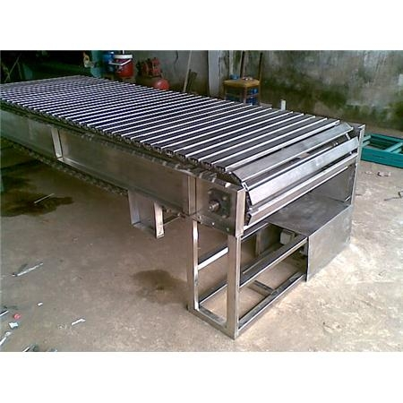

**Figure 2.3 Chain conveyor**

* Roller Conveyor: This is a conveyor system consisting of rollers arranged on a vertical frame to transport products. Widely used in harsh environments, environments with corrosive chemicals and dust. The rollers can be made from plastic, stainless steel, PVC, galvanized steel, motor, etc.

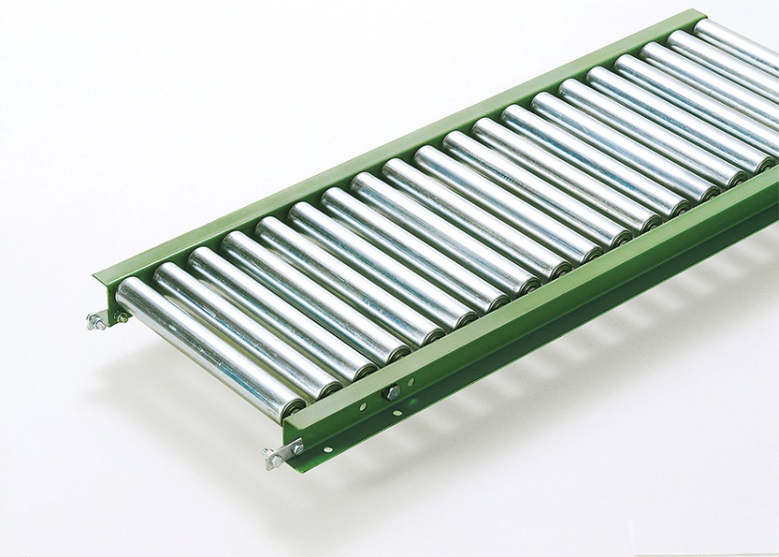

Figure 2.4 Roller conveyor

* Vertical Conveyor: also known as a transport elevator operating in a vertical mode of transporting materials and products up and down with different heights. Their advantage is that they do not take up space, and can be performed in a small environment.

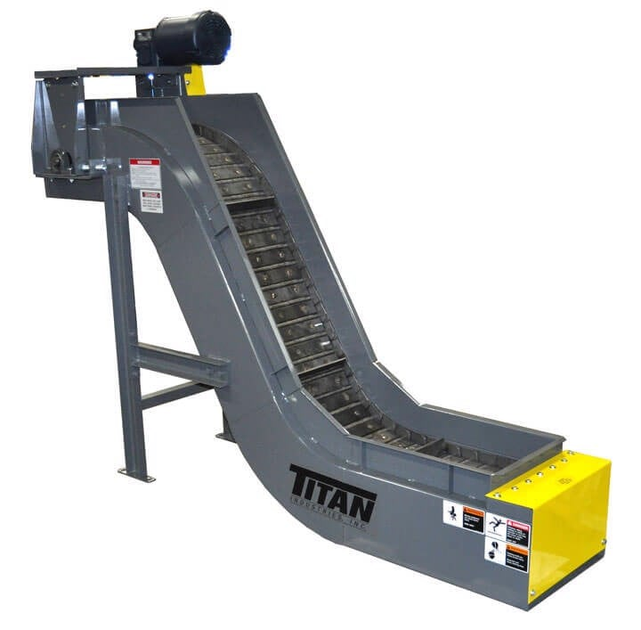

Figure 2.5 Vertical conveyor

* Flexible Conveyor: Designed from aluminum or stainless steel, the slide rail has low friction. Thanks to the ability to stretch well, neat, flexible, easy to adjust length and short according to the operating terrain. Suitable for the production of food packaging, warehouse, textile, printing, ...

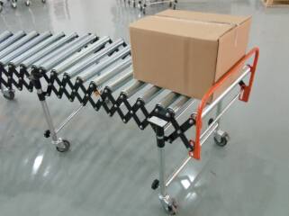

Figure 2.6 Flexible conveyor

* Curved angle conveyor: this type of conveyor can be flexible with a curvature from 30 to 180 degrees, depending on the arrangement and purpose of the business.

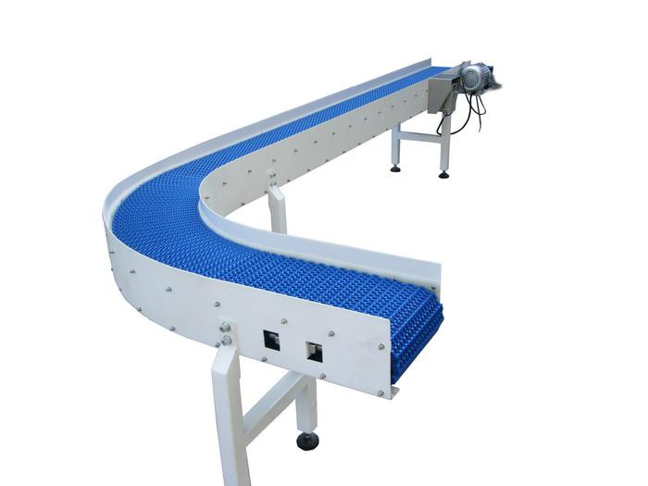

Figure 2.7 Curved angle conveyor

* Spiral Conveyor: Often used in the transportation of plastic bottle products, products that are easily thrown off the conveyor belt... This is the creation of a smart product that is most convenient in the production process. technology. The spiral conveyor is designed with an inclination of 11 degrees or less, so it is very suitable for transporting products that are prone to slip off the conveyor. Easily transport the product up and down the most gentle and effective way to ensure product safety.

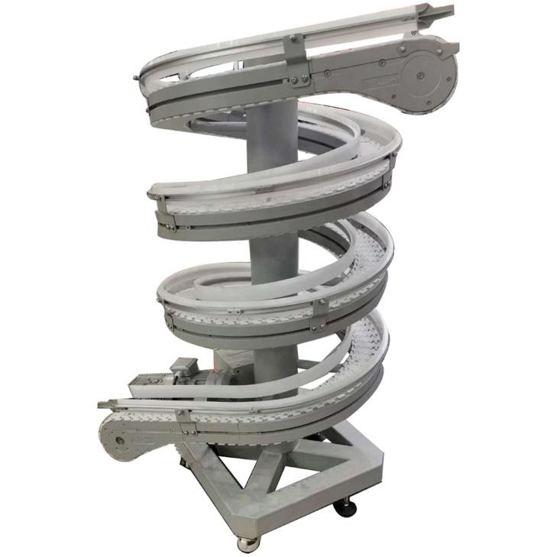

Figure 2.8 Spiral conveyor

* Vibrating conveyor: this is a large conveyor system including conveyor frame, conveyor belt, roller system, inverter control system, etc. Vibrating conveyor has a solid surface that, when operating, forms a trough. Commonly used for frozen foods, food industries, consumer industries, etc.

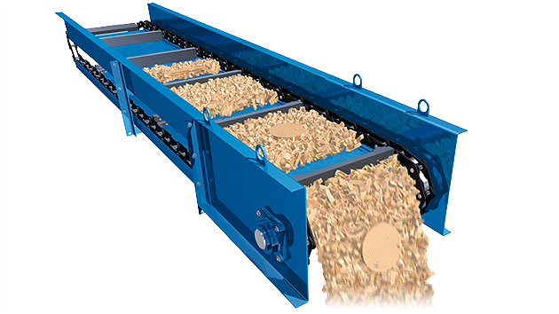

Figure 2.9 Vibrating conveyor

* Lifting Conveyor: This type of conveyor can flexibly change the height to easily bring goods to many different positions. Used for loading and unloading containers, trucks, etc. or up and down at high positions.

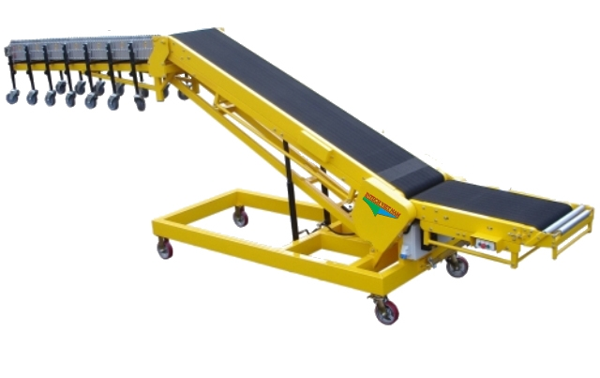

Figure 2.10 Lifting conveyor

* Thermal conveyor belt: has high heat resistance, used to dry products. Used for soldering circuits of electronic components, processing agricultural products, food

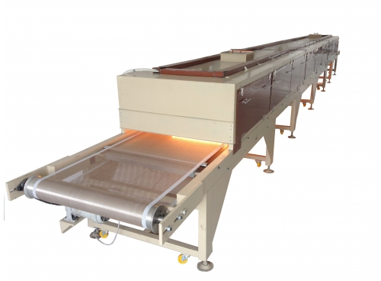

Figure 2.11 Thermal conveyor

* Stainless steel mesh conveyor belt: is a conveyor belt with stainless steel mesh belt, belonging to increased heat load because of its ability to withstand high temperatures, retain heat and transfer heat well.

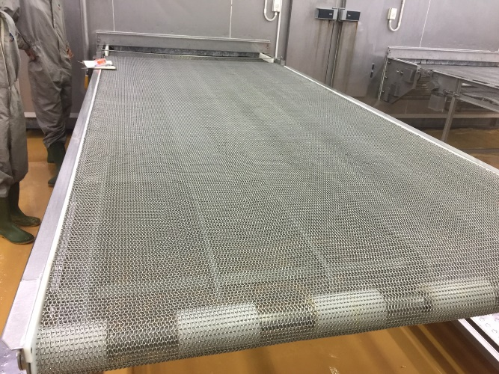

Figure 2.12 Stainless steel mesh conveyor belt

* Mini conveyor belt: is a type of conveyor with small size, used for machine manufacturing.

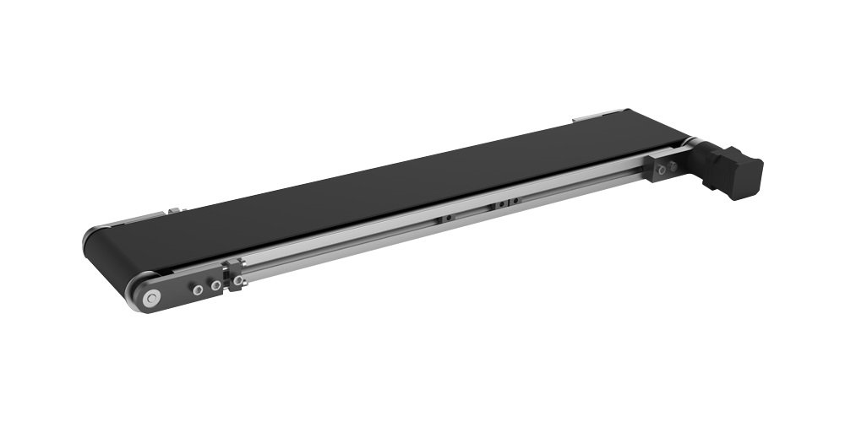

Figure 2.13 Mini conveyor belt

* Application:
* Applications in the food industry, packaging, transporting bottles, processing seafood, vegetables, fruits, ...
* In the field of assembling electronic components, manufacturing components, assembling motorcycles, ....
* Packing, transporting goods in warehouses, containers, trucks,…
* Clean room system, hospital, airport, ...
* In the production of food, medical, pharmaceutical, garment, footwear, ...
* Used to transport goods, pack products, etc.
* Advantages and disadvantages of conveyors:
* Advantages:
  + The transportation process is expedited and made more practical via conveyor systems. can resist heavy weights and challenging operational conditions.
  + Lower manufacturing hazards while lowering labor expenses. Workers are not required to do physically demanding tasks that might result in damage to their legs, shoulders, knees, or back.
  + Many benefits of automation are provided by conveyor belts to workers who produce and move items. Can arrange items on shelves, can move items automatically, and works well.
  + Capable of transporting materials in horizontal, inclined or a combination of both with large distances.
  + No noise to the surrounding, low power consumption
  + Transporting bulk goods such as sand, crushed stone, coal, coal from one place to another.
* Disadvantages:
  + The motor does not work, especially at low speed (full step control).
  + Current consumption is independent of the load.
  + Working noise.
  + There is no feedback so errors may occur.
  + Large initial investment.
  + Some systems are difficult to move, unable to transport oversized products.
  + When transporting long distances and uneven terrain requires many systems to combine together.
  + For granular products, crumbs, etc. may be lost or dropped during transportation.

1. **Explain idea:**

In this idea, we aim for a device that can meet the requirements of the project with tasks such as arranging products and avoiding overlapping products by running the target products on conveyor with the arrangement of the mechanism. After going through the conveyor belt, a row of products as required will be created. In general, with this idea we can meet the requirements in a simple and understandable way.

Here we use 2 types of conveyors: roller conveyors and pvc conveyors.

Figure 2.14 Preliminary design idea 1

* **Advantages:**
* Meet the requirements of the project
* Simple structure, easy to process
* Components that are easy to find in the market
* **Disadvantages:**
* Can't push processing speed
* The product goes through many processing mechanisms which take a lot of time
* Costs a lot of conveyor costs
* Large, heavy equipment takes up a large area
* Loud noise

1. **Solution is based on centrifugal force and barriers:**
2. **Centrifugal force:**

* **Definition**: Centrifugal force is an outward fictitious force that is experienced by an object moving in a circular path directed away from the center of rotation.
* The direction of this force is away from the axis of rotation and is parallel to the axis of rotation.
* Centrifugal force is equal in magnitude and dimensions with another force (centripetal) that acts towards the center of a circular path.
* It is termed a fictitious force because it only comes to play when there is a centripetal force. This force results due to the inertial property of the body moving in a circular path.
* The force does, however, depend on the mass of the object, the distance of the object from the center, and the speed of the rotation.
* The concept of centrifugal force has been used in various rotating devices like centrifuge rotors, banked roads, and centrifugal pumps.
* The unit of centrifugal force is Newton, and the dimensional formula is
* **Centrifugal Force Examples in Daily Life:**

Figure 2.15 Example for Centrifugal

* When spinning a ball on a string or twirling a lasso, the force of tension on the rope pulls the object towards the center.
* The centripetal force is provided by the frictional force between the ground and the wheels when turning a car.
* When going through a loop on a roller coaster, the force is provided by the normal force as the seat or wall pushes you towards the centre.
* For the planets orbiting around the Sun, the centripetal force is provided by Gravity.
* **Centrifugal force formula:**
* If the velocity of the moving object is known, the centrifugal force can be calculated by the formula:

where **v** is the velocity of the moving body, **r** is the distance of the moving body from the center and **m** is the mass of the moving body.

* If the angular velocity of the moving object is known, the centrifugal force can be calculated by the formula:

where **ω** is the angular velocity, **r** is the distance of the moving body from the center and **m** is the mass of the moving body.

1. **Barriers:**

* **Introduction:** Barrier is a traffic barrier used to ensure and control security, order in/out and traffic flow in high-traffic areas such as commercial centers, apartment buildings, and parking lots. parking, office buildings, airports, …

Barriers have been used in Vietnam for a long time, used to replace barricades with trees, wood, etc., using manual traction by humans. Initially, Barie had a very simple design and structure, a long crane with a fixed weight at one end.

Based on the structural characteristics of the barrier, automatic barie is divided into 3 types:

* Barrier straight rod;
* Barrier need urgent;
* Barrier automatic barrier.

In particular, in Vietnam, the automatic straight-line barrier is the most commonly used type of barrier today, accounting for 80% of the total number of bars being used. The automatic folding barrier is suitable for tight areas with small areas such as parking tunnels, toll booths, etc. As for automatic barricades, the popularity is not as high as the other two types, they are mainly used in areas requiring high security and control such as military barracks and special economic zones.

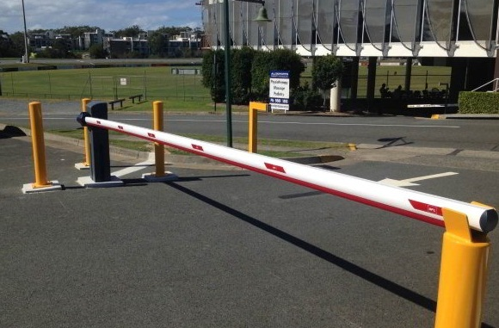

Figure 2.16 A real-life barrier

* The topic requires the device to avoid overlapping products, so we take the idea of ​​traffic barriers to perform this function.
* After the target product is lined up by centrifugal force, it will be passed through a conveyor belt with a barrier nearly equal to the height of a product, then the overlapping products will be pushed and only products single unit is passed.
* That was our idea, but implementing it encountered some problems during brainstorming, for example:
* The product packages are in liquid form so it is likely that they will be overlapped in the front part, they will also get into the barrier, but in the middle they are higher than the barrier leading to broken product packages and damaged.
* The barriers have to work too much because of the product pouring process, the products are easy to overlap. Due to the large number of overlapping product packages, the amount of scraping is also high, so it is very difficult to process or stream the product.
* The choice of height for the barrier is also a problem we have to face. If hard materials such as iron or steel are selected, the products may be damaged. If we choose materials such as fabric or plastic, we will reduce the chance of damage, but overlapped products will be more difficult to remove.

1. **Explain ideas:**

With this second approach, our team thinks that in order to arrange the products in a row in a faster time, it is necessary to use the action of centrifugal force to be able to push the products to the edge of the surface.

Additionally, the barriers will be in charge of eliminating any passing items whose height is greater than the barrier height in order to prevent the target products from being stacked on top of one another.

Figure 2.17 Preliminary design idea 2

* **Advantages:**
* Meet all requirements
* High processing speed
* Can adjust processing speed
* **Disadvantages:**
* Difficulty in processing
* Calculating centrifugal forces and speeds requires trial and error
* Loud noise

1. Choose option:

According to all the advantages and disadvantages of the ideas, our team decided to choose the 2nd idea "Solution is based on centrifugal force and barriers" to solve the problem. Because it can meet all the requirements of the project and meet the processing time. In addition, handling is also easier than solution 1.

# CHAPTER 3. MECHANICAL CALCULATION & DESIGN

* Based on the idea of using centrifugal force combined with barriers. We have designed a system consisting of 5 structures:
  + The first: automatic product dropping mechanism with the function of storing food pouches and putting them into the second mechanism for centrifugal processing.

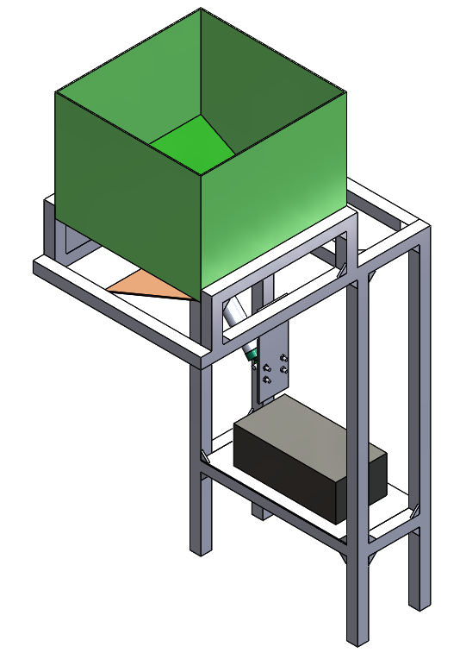

Figure 3.1. Containing Mechanism

* + The Second: the conical centrifugal rotating mechanism with the function of applying centrifugal force on the food bags so that they go away from the center of the cone in the radial direction and close to the wall of the cover.

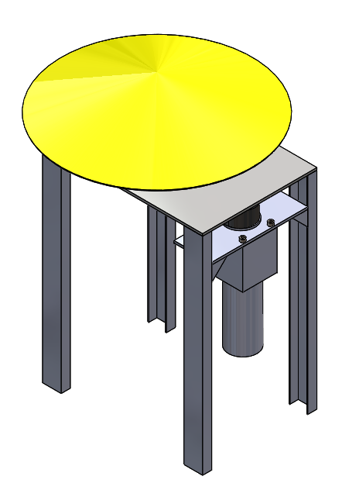

Figure 3.2. Cone-Shaped Centrifugal rotary mechanism

* + The Third: Smooth conveyor with the function of transporting those bags from the first cone mechanism to the second cone mechanism.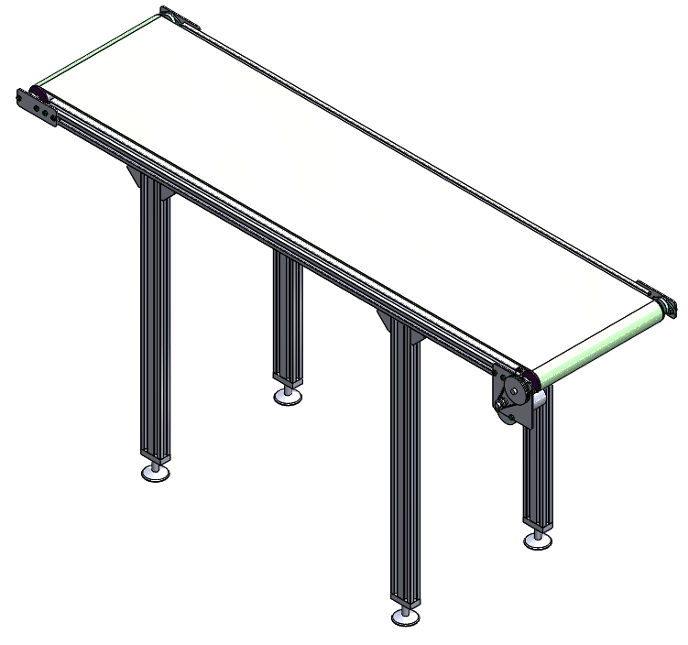

Figure 3.3. Conveyor system between cone-shaped mechanism

* + The Fourth: Conical centrifugal rotary mechanism with the same function as the previous rotary mechanism. This mechanism will once again make the food pouches close to the wall creating a uniform flow of motion.

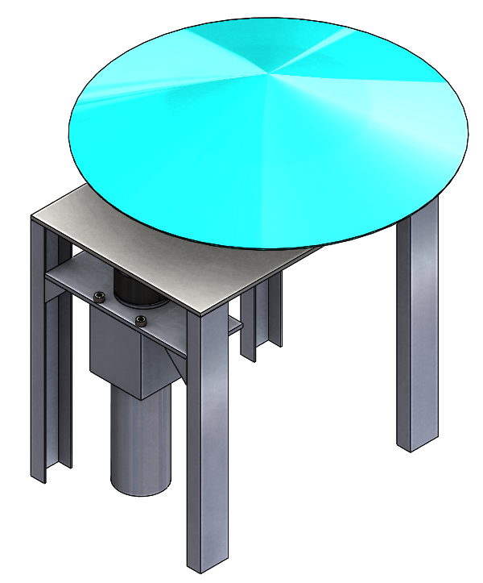

Figure 3.4. Cone-Shaped Centrifugal rotary mechanism

* + The Fifth: Smooth conveyor with two sides with the function of guiding the movement of food pouches in a straight line at the outlet of the system.

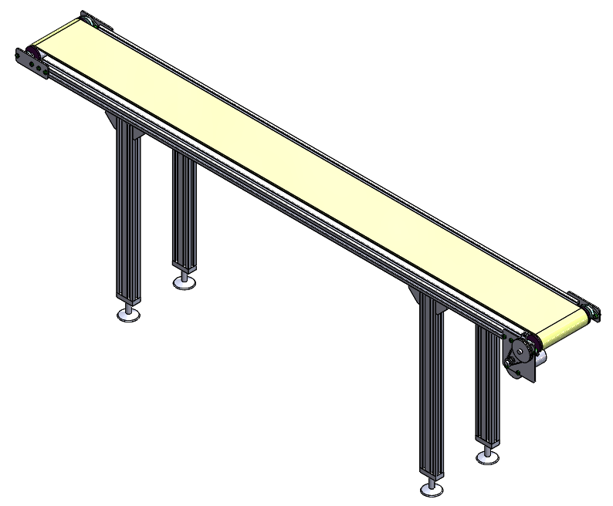

Figure 3.5. Conveyor system between cone-shaped mechanism

* + There is also a border with two functions. One is to prevent food bags from falling out of the system. The second is to act as a guide bar combined with centrifugal force to guide the food bags. There are also guide bars on the border to increase the ability to separate overlapping bags.

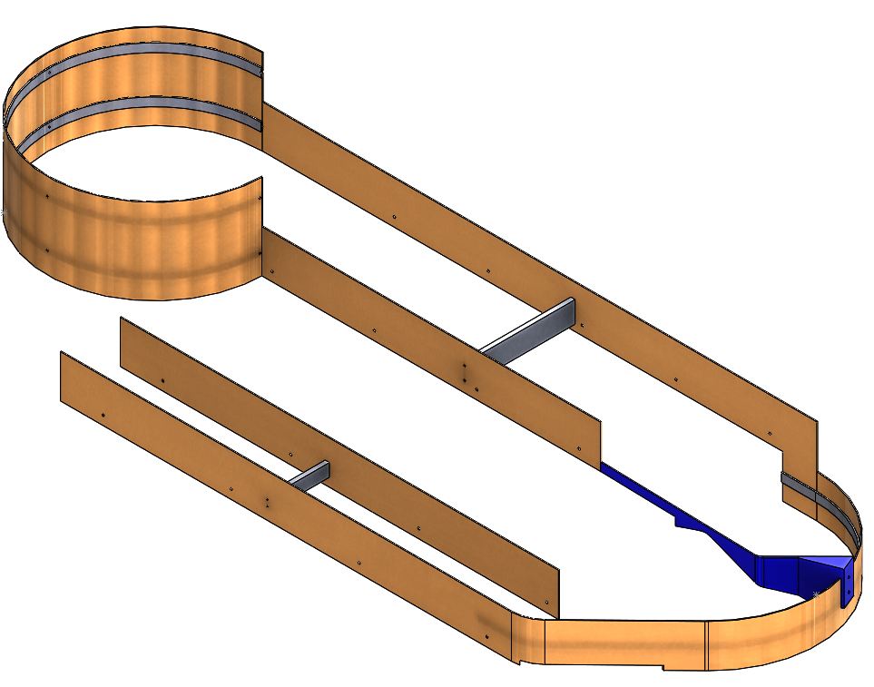

Figure 3.6. Cover

* Based on the required capacity of 20 products / 10 seconds.
* Assuming that all food pouches take the same amount of time to travel from the beginning to the end of the system.
* So, we can calculate the time a product moves through the system is 5 seconds.
* From that total time, we choose the product time periods on each mechanism:
  + The input centrifugal cone mechanism: 1 second..
  + The conveyor mechanism between two cone mechanisms: 2 seconds..
  + The second centrifugal cone mechanism: 1 second.
  + The output conveyor mechanism: 1 second.
* Calculation of choosing a conveyor system between two cone mechanisms:

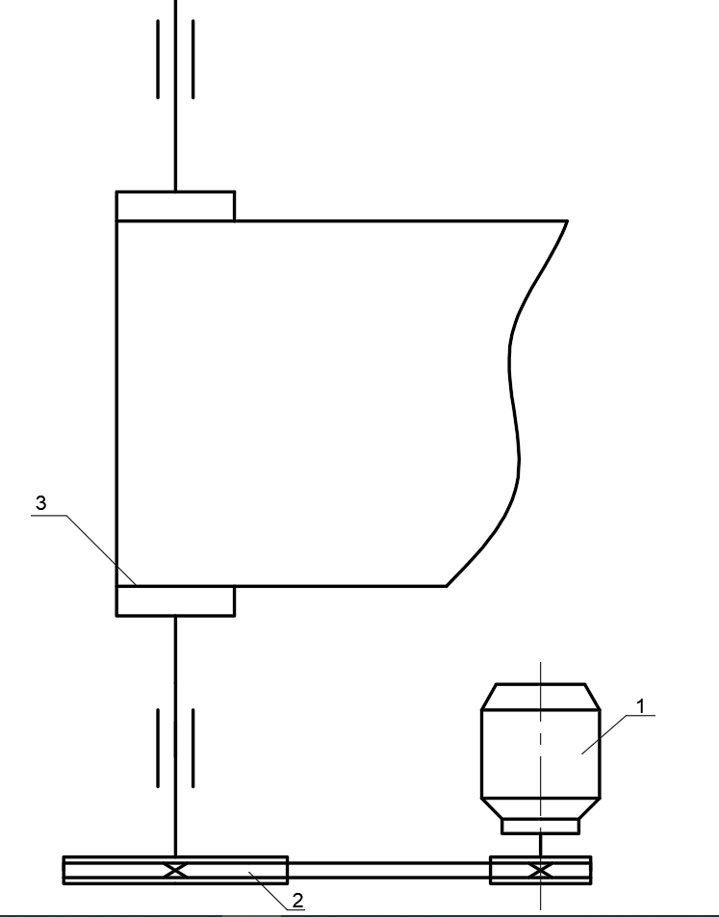

Figure 3.7 Diagram of the conveyor systems

1-Motor 2-Gear belt drive 3-roller&belt face

1. Initial specifications:

* Product processing time: t1= 2 sec.
* Product weight to be handled (10 bags of food weighing 240g): m1'=2.4 Kg
* Weight of 3mm thick PVC conveyor belt

Where D1 is the density of the PVC conveyor belt (KG/m2) ; L1, W1 are conveyor length and width.

* Total weight needed to create traction:
* Speed needed to meet delivery time::

1. Calculation parameters::

* The force value required to move the conveyor belt while loading 10 pouches:
* Useful power:
* Roller circumference:
* Roller speed:
* Actual Power:
* Choosing JGB37-550 DC Geared Motor with power up to 72W..
* Selecting 120 RPM motor speed..
* Belt transmission ratio:
* Output Conveyor: Similar calculation.

1. Mechanical calculation for conical centrifugal rotating mechanism:

1. Structure overview:

* 1. **Kinetic Diagram:**

Figure 4.8 Diagram of the conical-cylindrical rotating mechanism's motion

1-Motor 2-Gear belt drive 3-Empty cone

* 1. **Operation principle :**

The rotary motor sends force to the cone through the belt drive, which provides centrifugal force, causing the cone to operate on the target goods and align them along the contour.

* 1. **Transmission ratio: u = 2**
     + - 1. Electric motor selection and transmission ratio distribution calculation:

1. **Equipment system data:**

* Large cone base radius:
* The length of the cone's generant:
* Cone spindle rotational speed:
* Cone spindle rotational speed:
* Products put on the cone weighed:
* Density of steel:
* Steel thickness for the cone face:
* Steel thickness for machining mayer and mayer disc:
* The cone's weight:
* Friction coefficient:
* Preliminary selection:
  + Shaft diameter:
  + Mayer disc weight:
  + Mayer’s weight:
  + Shaft’s weight:
  + Two SKF 51105 bearings' total weight:
  + Weight of two aluminum belt wheels: .

1. **Select electric motors:**
2. **Engine selection conditions:**

* No engine overheat occurs.
* Short-term overload is a possibility.
* The initial torque is sufficient to overcome the load's beginning resistance.

1. **Select system performance:**

* Using the formula 2.9-document [7], we can determine how well the motor transmits power to the hollow cone as follows:
* Where: : toothed belt transmission effectiveness

: a single pair of bearings' effectiveness

1. **Calculate centrifugal force and friction force:**

* Centrifugal force:
* Friction force:
* demonstrates that the mechanism can centrifugal force.

1. **Calculate equivalent power (calculated power):**

* Mass of spinning component linked to main shaft:
* The equivalent power formula:

1. **Calculate the motor shaft's power:**

* According to the formula 2.9-document [7]:

1. **Calculate the shafts' total number of rotations:**

* Motor shaft rotational speed:
* Flat-belt transmission's transmission ratio:
* Spindle speed:

1. **Calculate the torque on the shafts:**
2. **Design of transmitters:**
3. **Select belt type:**

* Select the rubber webbing belt type.

1. **Calculate the small belt wheel’s diameter:**

* According to the formula 5-6 – [10], we have:
* According to table 5-1 – [10] take
* The lap speed according to the test formula 5-7 – [10]:

So v is within the allowed range.

1. **Calculate the big belt diameter:**

* Rubber fabric belt with slip coefficient:
* Large belt wheels diameter:
* According to table 5-1 – [10] take
* The actual number of revolutions per minute of the driven gear follows the formula 5-8 – [10]:
* Drive wheel speed difference:
* So there is no need to reselect the diameter .

1. **Minimum length of belt:**

* Choose a limited number of laps:
* Minimum belt length according to the formula 5-9 – [10]:

⇒ Choose

* Calculate the distance A axis according to the formula 5-2 – [10]:

⇒ Choose

* Recalculate L according to A according to the formula 5-1 – [10]:

* Depending on how the belt is connected, add to the length found above by about

1. **Calculate the angle according to the formula 5-3 – [10]:**

⇒ So the angle satisfies the condition 5-11 – [10].

1. **Belt cross-section calculation:**

* Belt thickness δ is selected according to the ratio (taken from table 5-2 – [10], for rubber cloth belt). So
* According to table 5-3 – [10], choose B grade rubber webbing belt without lining with thickness
* Choose initial tension stress , according to the value look up in table 5-5 – [10], find
* The coefficients look up according to the tables 5-6, 5-7, 5-8, 5-9 [10], respectively:
* Calculate the width b of the belt according to the formula 5-13 – [10]:
* According to table 5-4 – [10] choose the width of the belt:

1. **Determine the width B of belt wheel according to formula 5-14 and table 5-10 – [10]**

⇒ Choose

1. **Calculate the initial tension and the force acting on the shaft R:**

* Initial tension according to the formula 5-16 –[10]:
* The force acting on the R axis according to the formula 5-17 – [10]:

1. **Shaft design:**
2. **Choose shaft material:**

* Select normalized 45 steel with:
* Tensile strength:
* Yield strength:

1. **Preliminary calculation of shaft diameter:**

* The shaft diameter is roughly calculated according to the formula 10.9 - [7]:

Where:

* T – shaft torque.
* - The allowable torsional stress of the shaft, for the selected material, is .
* Select for axes:
* Axis I:
* Torque of shafts:
* Axis I:

⇒ Therefore:

so choose

* Width of bearing selected according to table 10.2 – [7]:

1. **Approximate axis:**

* Approximate I axis:
* Diagram, engineering drawing

  Description automatically generatedOutline the shaft size:

Figure 3.9 Outline the sharf size

* The distance between the side face of the drive to the inner wall of the bearing housing according to table 10.3 – [7] is
* The distance from the face of the rotating part to the bearing cover according to table 10.3 – [7] is
* Height of bearing cover and bolt head according to table 10.3 – [7] is
* The length of the mayer according to the formula 10.10 - [7] is
* Choose ; .
* Distance from bearing A to cone mounting position:
* Distance from drive A and drive B according to table 10.4 – [7]:
* Choose
* Distance from bearing B to belt wheel:
* Distance from bearing A to belt wheel:
* Force acting on the belt drive:
* Torque:
* Calculate the reaction at the bearings:
* Force balance equation in the Ozy plane:
* From (2) infer:
* Calculating bending moment values at sections under risky loads:
* Chart

  Description automatically generatedUsing the cross-sectional method in "Strength of materials", we can make the following moment diagram:

Figure 3.10 Moment diagram and force distribution diagram

* Bending moment at section 2-2 (bearing A):
* Bending moment at section 3-3 (bearing B):
* Bending moment at section 4-4 (bevel gear):
* Calculation of equivalent bending moment values and shaft diameters in dangerously loaded sections:
* Look up table 7-2 – [10], we have chosen preliminary, so we can choose the allowable stress .
* At the bearing cross-section at position B (section 3-3)

Equivalent torque:

Shaft diameter at the location where bearing position B is installed:

* Caculation the shaft sizes according to the standard number series:
* At mounting section (1-1), select .
* At the bearing section A (2-2), choose to ensure the rigidity of the system.
* At the bearing section B (3-3), choose to ensure the rigidity of the system.
* At the section where the bevel gear is installed, select .

1. **Axis accuracy:**

* The shaft's safety factor is determined using the formula 7-5 - [10]:

For according to pages 124 – [10].

* Because the axis rotates in both directions, the normal (bending) stress varies with the symmetry period (see page 120):
* Since the shear stress (torque) varies with the dynamic circuit period (one-way rotation axis) according to page 120 – [10]:
* Flexural and torsional fatigue limits for the symmetry period, according to pages 120 - [10]:
* The factor for medium carbon steel that considers the impact of the average stress value on the fatigue strength determined by the material may be found on page 122 - [10]:
* Axis I:
* Consider the section (3-3): and
* We have:
* Normal stress changes with symmetry period (two-way rotating axis):
* The shear stress (torque) varies with the dynamic circuit period (one-way rotation axis):
* According to table 7-4, we have the size coefficients:
* Stress concentration due to keyway and supply according to table 7-6, 7-7 – [10]: take the maximum value

⇒

* Coefficient of increasing durability: look up according to table 7-4.
* Stress concentration due to tension mounting with mounting type we choose T3 according to table 7-12 – [10], pressure generated on the joint surface:
* According to table 7-10 – [10], we have:
* Factor of safety for normal stress:
* Factor of safety for forward stress alone:
* Factor of safety:

We see that n is larger than without being too large, the axis is strong enough, keeping the selected dimensions.

1. **Test shaft for sudden overload:**

* According to the formula 7-8 – [10]:
* With

1. **Axis I:**

* Section 3-3:

⇒ Satisfy the overload condition.

1. **Caculate key:**

* Choose steel 45 and have a flat key (table 7.20 and 7.21- [10]):
* Allowable stamping stress:
* Allowable shear stress:
* Axis I:
* In section 1-1, there is
* Look up table 7-23- [10]:
* Key length:
* Test for impact resistance:
* Test of shear strength of the key:

⇒ Satisfy 2 conditions.

* + - * 1. Calculation of choosing a conveyor system between two cone mechanisms:

1. **Initial specifications:**

* Product processing time: t1= 2 sec.
* Product weight to be handled (10 bags of food weighing 240g): m1'=2.4 Kg
* Weight of 3mm thick PVC conveyor belt

Where D1 is the density of the PVC conveyor belt (KG/m2) ; L1, W1 are conveyor length and width.

* Total weight needed to create traction:
* Speed needed to meet delivery time::

1. **Calculation parameters::**

* The force value required to move the conveyor belt while loading 10 pouches:
* Useful power:
* Roller circumference:
* Roller speed:
* Actual Power:
* Choosing JGB37-550 DC Geared Motor with power up to 72W..
* Selecting 120 RPM motor speed..
* Belt transmission ratio: