MultiLeagues Android App

Installation & Customization

# Documentation History

|  |  |  |
| --- | --- | --- |
| Revision No. | Revision Date | Summary of Changes |
| 1 | 22/08/2015 | First created |
| 2 | 23/01/2016 | Edit Config |
| 3 | 05/09/2016 | Update season 2016-2017 |

Table of Contents

Documentation History 2

1. Android 4

1.1. Project Information: 4

1.2. Installation 4

1.3. Customization 4

# Android

* 1. Project Information:
* This app supports android 3.0 or higher.
* This app usesAndroid Studio IDE.
  1. Installation
* Import the Android source code to Android Studio IDE.
  1. Customization
* **How to edit app name?**

Go to “res/values/main_config.xml”file then change value of “app_name” key.

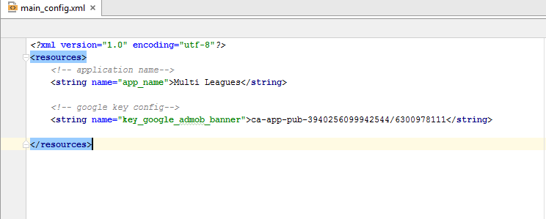

* **How to edit app Icon?**

You need to search “ic_launcher.png” files in “app/res/mipmap-xxxx” folders and replace them by your app icon.

* **How to edit images?**

You can find and edit any imageS in all “app/res/drawable-xxxx” folders.

* **How to edit layouts?**

You can find and edit any layoutS in “app/res/layouts” folder.

* **How to edit current language by your language?**

You can open “app/res/values/string.xml” file, then edit all texts by your language.

* **How to edit the current Backenlink by your Backen link?**

Change API link: Go to

Go to “app/java/com.hcpt.multileagues/configs/WebservicesConfigs.java”file then change value of “APP_DOMAIN”.

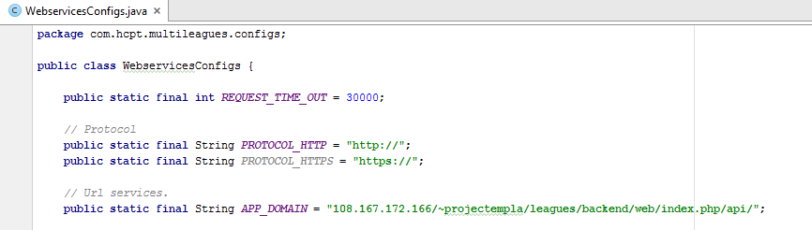

* **How to edit Admob ID**
* Find “main_config.xml” in app/res/values you will see a key name: “key_google_admob_bnner”

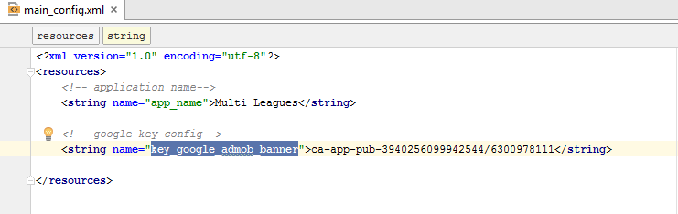

* **How to config chat room database and Push notification.**
  + Note: if you also bought the android version, make sure iOS and Android version implement the same Firebase account & app. So that when Android chats, the iOS will receive the message also.
  + Go to https://console.firebase.google.com/ then login and create project.
* Config Chat Room Database
  + Choose “Database ” in Menu Left in your project.

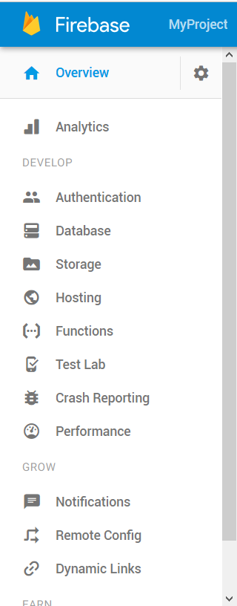

* + Save your urllink for Android and iOS app. For example :



* + Click on Rules Tab and change .read and .write like this screenshoot :   
    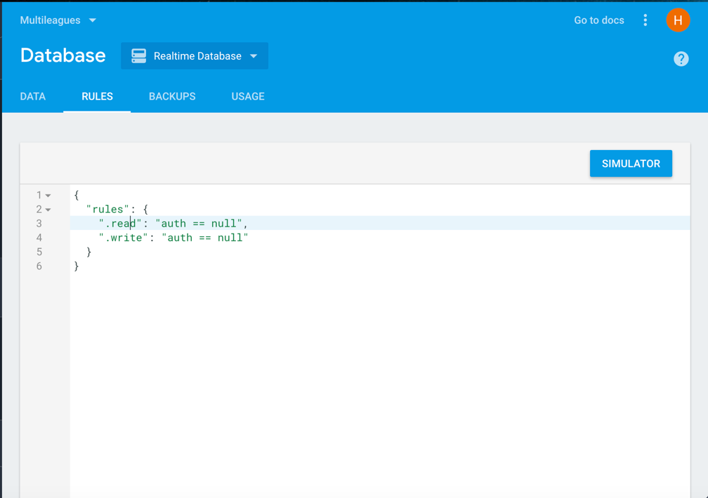
  + Go to “app\src\main\java\com\hcpt\multileagues\configs\Constants.java” file then change value of “FIREBASE_URL” to your firebase database url.

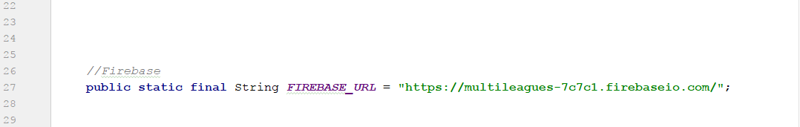

* **Config Push notification.**
* Choose Project Settings

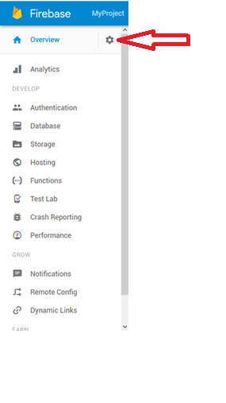

* **At General Tab:** Download **google-services.json then** Copy **google-services.json**file, go to your Android Project and paste it in **app**folder.
* 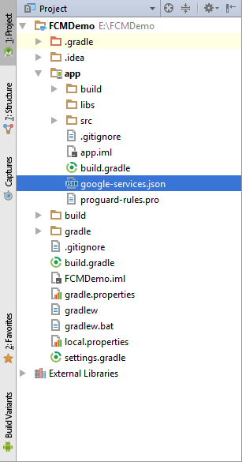
  + - **At Cloud Messaging Tab**: You will get Server Key**,** Server Key will be inserted at the backend (Settings > Google API key)

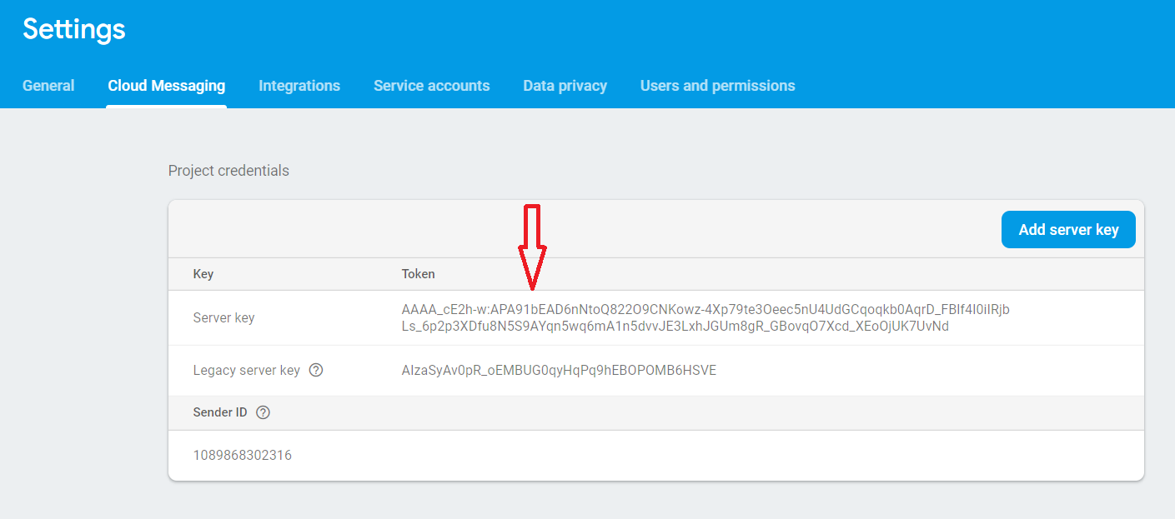

* **How to enable chat room**
  + Go to“app\src\main\java\com\hcpt\multileagues\configs\Constants.java”file then change value of “chatRoom” to true (to enable) or false (to disable);

