## 1 Usb与各个模块之间的调用关系

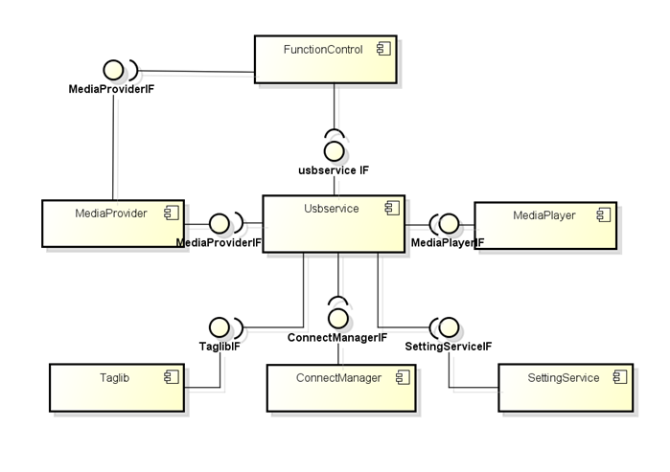

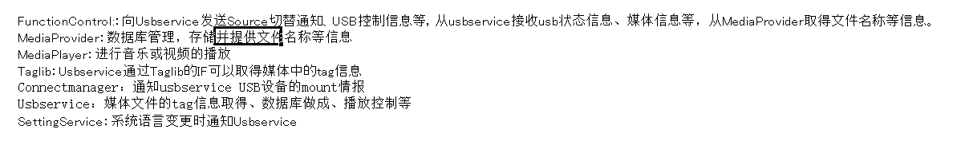

在usbservice中，上层与functionManager交互，下层与MediaService服务、DevicePlayerService服务、ConnectService服务交互。

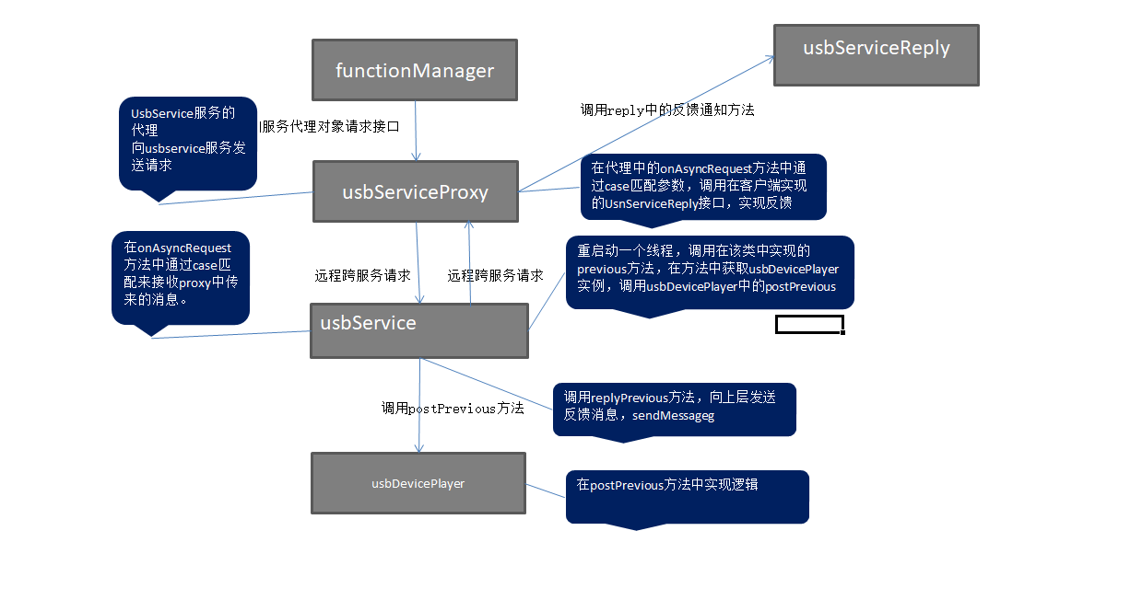

## 2 Usbservice与各个模块交互的方式

### Usbservice与functionManager模块交互

向usbservice发送数据，和接受数据

在usbservice中，通过proxy与functionManager交互。

Proxy作为usbservice的代理接口，在proxy中的方法中sendMessage，该message会被GMUsbserviceBase中的onAsyncResponse方法中的case 接收。

而在UsbserviceBase中从serviceBasea中继承过来的sendAsyncRequest方法发送的消息，会被proxy中的onAsyncResponse方法中的case接收。

在usbService调用底层的逻辑处理请求前会将replyer应答反馈给上层。具体是，在Usbservice中发送sendMessage请求，在代理的onAsyncResponse方法中，以case匹配形式对应方法，实现将结果反馈给functionManager层。

### UsbService与DevicePlayer模块的交互

在USbService中实现了plantform层的DevicePlayer的服务代理类NMMPClassicPlayerDelegation。在usbService中接受到message请求在方法onAsyncResponse中被case匹配处理。处理时，调用DevicePlayer中的方法，实现usbService服务与DevicePlayer服务的交互。

## 3 核心方法实现

### Play

#### 时序

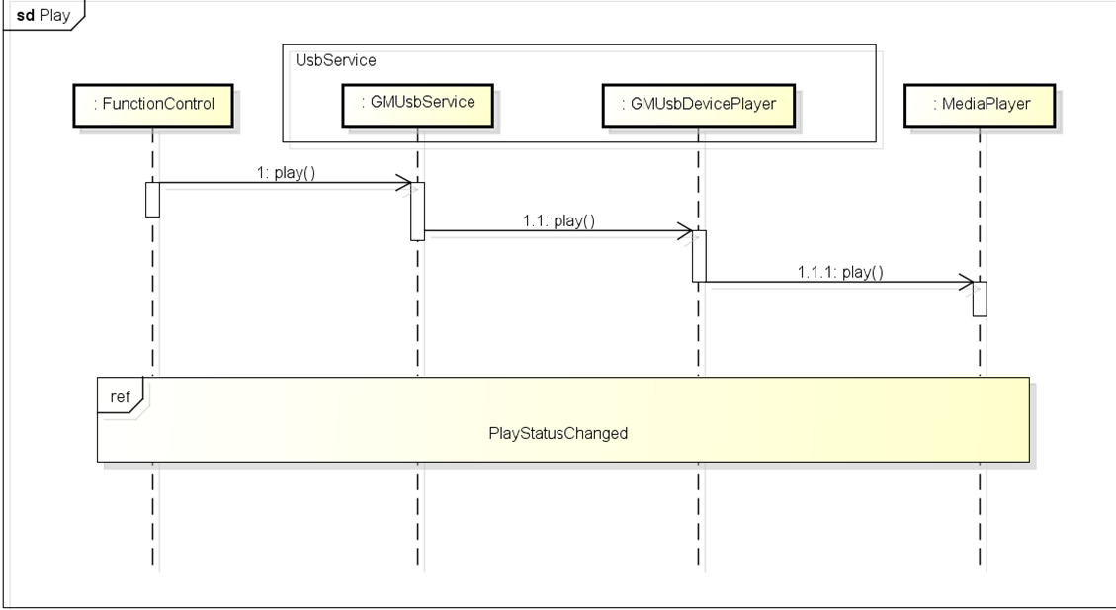

#### 涉及的模块

FunctionManager

GMUsbService

DevicePlayer

#### 实现

functionManager 调用proxy代理中play方法

|  |
| --- |
| uint64_t GMUsbProxy::play()  {  USBLOGD_FUNCALL; //打log  //定义调用id，静态，unsigned long 型  static uint64_t call_id = 1;  unsigned int code = USBMethod_Play; //方法id,通过枚举类型定义  //准备要发送的数据包  android::Parcel data;  prepareAsyncData(data);  // request service  //向usbservice发送异步请求,通过返回值判断请求是否成功。  if (BS_NO_CONNECTION == sendAsyncRequest(code, data)) {  return 0; // invalid call id '0' to indicate error  }  //调用完该方法后，返回call_id+1  return call_id++;  } |

proxy代理服务中发出的play请求，在usbService的onAsyncRequest方法中被接收，通过case匹配请求，选择对应的case进行处理。

|  |
| --- |
| int GMUsbServiceBase::onAsyncRequest(SenderId &id, unsigned int code, const android::Parcel &data) {  case USBMethod_Play:  {  //定义一个task  GMTaskDes des(Runnable_Pri_N, 0, "USBMethod_Play");  //启动主线程的looper方法，将task作为参数传入，调用该类中的play方法  (m_pMainThread->looper()).postRunnable(GMTaskBind(des,this, &GMUsbServiceBase::play, id));  break;  } |

在UsbService类中play方法被调用

|  |
| --- |
| void GMUsbServiceBase::play(SenderId sid) /* __0xB02013_DTFUNCID__ */  {  //通过该类中的replyPlay方法，向上层以消息的形式发送一个反馈  replyPlay(sid);  //判断usb的状态  if (GMUsbSourceState_SourceOn != m_sourceState) {  USBLOGD("the source is not on, %d", m_sourceState);  DTLOG_INFO(0xB02013, "tthe source is not on, %d", m_sourceState);  return ;  }  //调用该类中的getDPlayer方法，获取DevicePlayer对象，并调用其postPlay方法  if (NULL != getDPlayer(sid)) {  getDPlayer(sid)->postPlay();  }  } |

在DevicePlayer类中，postPlay方法被调用

|  |
| --- |
| void GMUsbDevicePlayer::postPlay() /* __0x500017_DTFUNCID__ */  {  //打log  USBLOGD_FUNCALL;  //判断线程类指针是否为空  if (m_pMPCbThread) {  //不为空时启动新的线程，并调用本类中的play方法  m_pMPCbThread->looper().postRunnable(MRunnableTask(this, &GMUsbDevicePlayer::play));  }  //为空时，直接通过函数调用的方式调用play方法  else {  play();  }  } |

DevicePlayer类中的play方法

在该方法中实现了上层发出的play指令的具体逻辑，分析代码结构发现，最终还是调用的DevicePlayer的父类，也就是在plantform层中NMMpClassciPlayer中的定义的play方法

|  |
| --- |
| void GMUsbDevicePlayer::play()  {  USBLOGD_FUNCALL;  if (NULL == m_pMediaPlayer) {  USBLOGD("player not exist");  DTLOG_INFO(0x500039, "player not exist");  return;  }  //宏  #ifdef GMUSB_PROPERTY_FAKESEEK  if (GIUsbItemType_APE == m_mediaStatus.itemInfo.eItemType) {  m_ForwardRewind = PlaySpeed_NormalPlay;  m_isSeeking = true;  NMMP_PropertyMap muteProperty;  NMMPPropSetAudioMute(NMMP_DEVICE_ID_AUDIO_FRONT, true, muteProperty);  m_pMediaPlayer->setProperty(muteProperty);  if (GIUsbPlayStatus_Playing != m_mediaStatus.ePlayStatus) {  m_pMediaPlayer->play();  }  MediaBackup::instance()->updatePlayTime(m_deviceId, m_mediaStatus.itemInfo.position, m_mediaStatus.ePlayMode);  if (NULL != m_pTimerHolder) {  m_pTimerHolder->stopTimer();  }  m_pMediaPlayer->seekTo(m_mediaStatus.itemInfo.position, m_ForwardRewind, false);  NMMP_PropertyMap soundProperty;  NMMPPropSetAudioMute(NMMP_DEVICE_ID_AUDIO_FRONT, false, soundProperty);  m_pMediaPlayer->setProperty(soundProperty);  }  #ifdef GMUSB_PROPERTY_FAKEOTHERSEEK  else if (PlaySpeed_NormalPlay != m_ForwardRewind) {  m_ForwardRewind = PlaySpeed_NormalPlay;  m_isSeeking = true;  MediaBackup::instance()->updatePlayTime(m_deviceId, m_mediaStatus.itemInfo.position, m_mediaStatus.ePlayMode);  if (NULL != m_pTimerHolder) {  m_pTimerHolder->stopTimer();  }  m_pMediaPlayer->seekTo(m_mediaStatus.itemInfo.position, m_ForwardRewind, false);  }  #endif  else {  m_ForwardRewind = PlaySpeed_NormalPlay;  m_pMediaPlayer->play();  }  #else  m_ForwardRewind = PlaySpeed_NormalPlay;  m_pMediaPlayer->play();  #endif  } |

### Pause

#### 时序

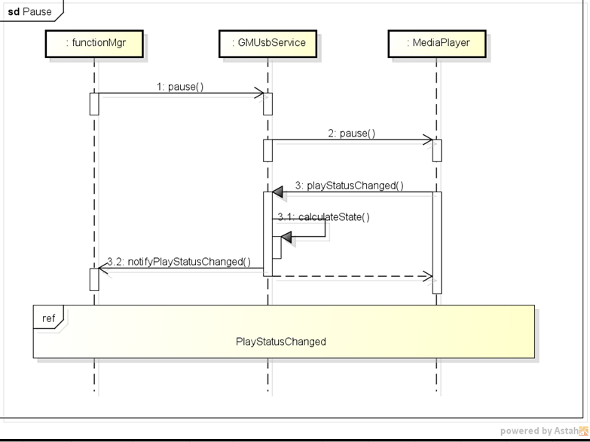

#### 涉及模块

FunctionManager

GMUsbService

DevicePlayer

#### 实现

代码的实现逻辑和play一致，都是从functionManager发出请求的message,在service中做中转同时给上层发反馈，最终在GMUSbDevicePlayer（MediaPlayService代理）中实现逻辑。

这里列举在GMUsbDevicePlayer中的pause方法，在该类中的pause中，又调用了plantform层的NMMpClassicPlayer中的pause方法。

|  |
| --- |
| void GMUsbDevicePlayer::pause() /* __0x50003A_DTFUNCID__ */  {  USBLOGD_FUNCALL;  if (NULL == m_pMediaPlayer) {  USBLOGD("player not exist");  DTLOG_INFO(0x50003A, "player not exist");  return;  }  m_pMediaPlayer->pause();  } |

### Stop

#### 时序

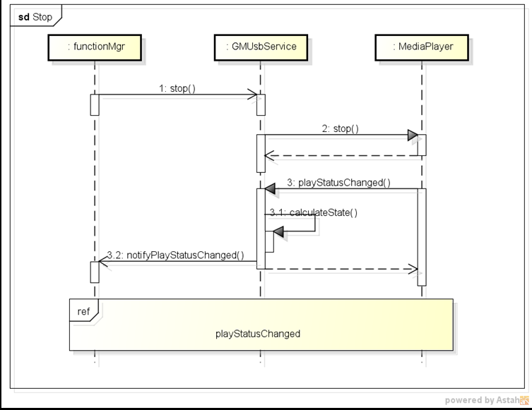

#### 涉及模块

FunctionManager

GMUsbService

DevicePlayer

#### 实现

代码的实现逻辑和play一致，都是从functionManager发出请求的message,在service中做中转同时给上层发反馈，最终在GMUSbDevicePlayer（MediaPlayService代理）中实现逻辑。

这里列举在GMUsbDevicePlayer中的stop方法，在该类中的stop中，又调用了plantform层的NMMpClassicPlayer中的stop方法。

|  |
| --- |
| void GMUsbDevicePlayer::stop() /* __0x50003B_DTFUNCID__ */  {  USBLOGD_FUNCALL;  //判断mediaPlayer对象是否为空。  if (NULL == m_pMediaPlayer) {  USBLOGD("player not exist");  DTLOG_INFO(0x50003B, "player not exist");  return;  }  //判断曲目的id是否为无穷大，不为则设置为无穷大。再调用下层的stop方法，同时设置playStatus为stoped状态。  if (m_mediaStatus.itemInfo.uid != INFINITE) {  m_mediaStatus.itemInfo.uid = INFINITE;  m_pMediaPlayer->stop();  m_mediaStatus.ePlayStatus = GIUsbPlayStatus_Stopped;  }  } |

### Next

#### 时序

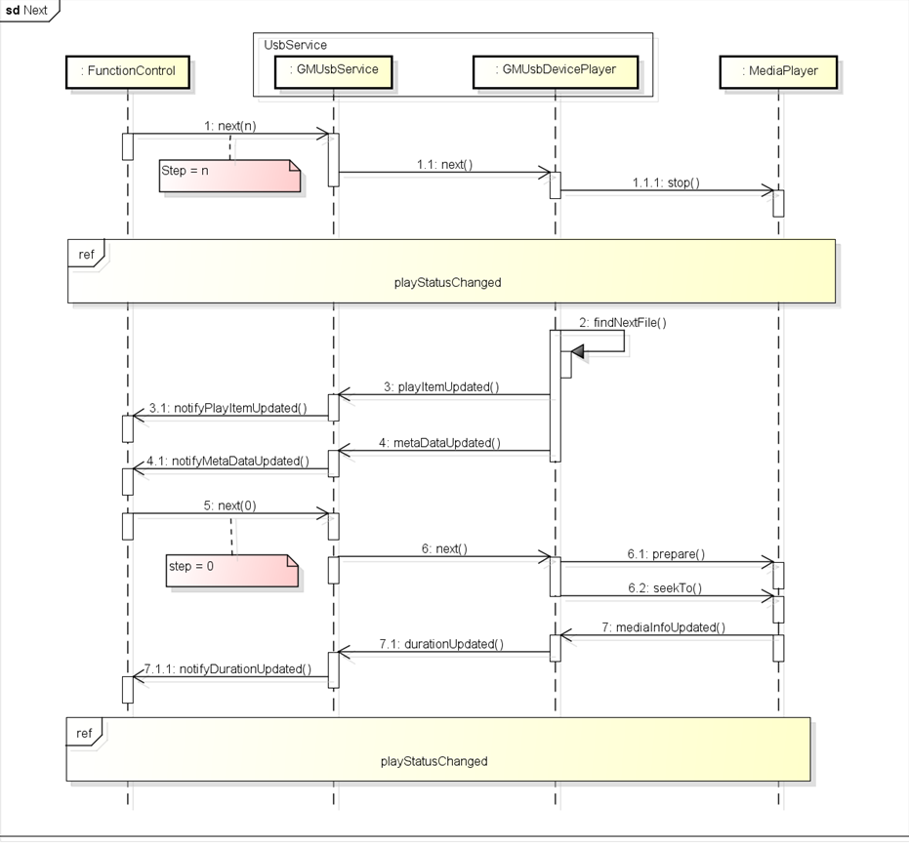

#### 涉及模块

FunctionManager

GMUsbService

MediaPlayer

#### 实现

在functionMaanger中调用usbService代理proxy中的next方法，向usbService发送异步请求。

|  |
| --- |
| uint64_t GMUsbProxy::next(const uint32_t step)  {  USBLOGD_FUNCALL;  static uint64_t call_id = 1;  unsigned int code = USBMethod_Next;  android::Parcel data;  prepareAsyncData(data);  data.writeInt32(step);  // request service  if (BS_NO_CONNECTION == sendAsyncRequest(code, data)) {  return 0; // invalid call id '0' to indicate error  }  return call_id++;  } |

在usbService中通过case匹配的方式接受处理请求，并通过新启线程的方式，调用usbservice中的next方法。

|  |
| --- |
| 代码和以上模块类似。。。 |

在next方法中，向上层通知通知，同时调用GMUsbDevicePlayer类中的postNext方法。

|  |
| --- |
| 代码和以上模块类似。。。 |

在postNext方法中调用GMUsbDevicePlayer中next方法。通过主线程是否存在判断是通过线程调用还是函数调用。

|  |
| --- |
| 代码和以上模块类似。。。 |

在next方法中实现了具体的逻辑。在next中又调用了playingList中的next.。其实真正的next的逻辑实在playingList中实现的

|  |
| --- |
| void GMUsbDevicePlayer::next(int step, bool forceSequence, bool autoPlay) /* __0x500028_DTFUNCID__ */  {  USBLOGD_FUNCALL;  //判断播放列表是否为空。m_pNowPlayingList在initialize方法中被初始化。  if (NULL == m_pNowPlayingList) {  USBLOGD("m_pNowPlayingList not exist");  DTLOG_INFO(0x500028, "m_pNowPlayingList not exist");  return;  }  //判断是否连接了mediaplayer  if (m_isMpBlinkReset) {  USBLOGD("ignor this command, wait for mediaplayer connect");  DTLOG_INFO(0x500028, "ignor this command, wait for mediaplayer connect");  return;  }  //当步数大于0时  if (0 < step) {  USBLOGD("continue to next");  m_readyToPlay = false;  //调用stop先停止当前播放  stop();  //调用playingList中的next  m_pNowPlayingList->next(step, forceSequence);  }  //当步数为0时且自动播放时  if (0 == step || true == autoPlay) {  USBLOGD("stop next and start to play, autoPlay = %d", autoPlay);  m_readyToPlay = true;  //当前播放item的id不等于INFINITE（无限大）  if (INFINITE != m_mediaStatus.itemInfo.uid) {  //设置播放准备，在setPrepare中，又调用了prepare方法，而在prepare中又调用了  //底层的prepare方法，真正的prepare逻辑是在plantform中实现。  setPrepare();  //设置播放，调用该类中的setPlay f方法。  setPlay();  }  else {  USBLOGE("ItemInfo uid is not available, trigger failed!!");  DTLOG_INFO(0x500028, "ItemInfo uid is not available, trigger failed!!");  }  }  else {  USBLOGD("the step is invalid");  DTLOG_INFO(0x500028, "the step is invalid");  }  } |

在GMUsbDevicePlayer中又调用了GMMediaPlayList类中的next方法。

|  |
| --- |
| bool GMMediaPlaylist::next(unsigned int step, bool forceSequence)  {  PLLOG_FUNCALL;  if (NULL == m_cb || DeviceType_None >= m_deviceInfo.type() || DeviceType_Count <= m_deviceInfo.type()) {  PLLOGW("next : param error, m_cb = [%p], type = [%d]", m_cb, m_deviceInfo.type());  return false;  }  PLLOGD("next step = [%d], forceSequence = [%d]", step, forceSequence);  if (m_totalError) {  PLLOGD("all error >> m_errorCount = [%d]", m_errorCount);  PLLOGD("[debug] : all error!!!,please choose another playlist");  m_cb->onPlaylistEnded(EndedType_AllError);  return false;  }  if (!forceSequence && (RandomMode_All == m_randomMode || RandomMode_List == m_randomMode)) {  if (m_randomIndex >= m_random.size()) {  PLLOGD("randomIndex error = [%d]", m_randomIndex);  return false;  }  for (unsigned int i = 0, startIndex = 0; i < step; ++i) {  startIndex = m_randomIndex;  do {  ++m_randomIndex;  if (m_randomIndex >= m_random.size()) {  m_randomIndex = 0;  }  if (startIndex == m_randomIndex) {  // all file in this list has been played once,reset the list  random_shuffle(m_random.begin(), m_random.end());  for (unsigned int j = 0; j < m_random.size(); ++j) {  if (NULL != m_random[j].get()) {  m_random[j]->setPlayed(false);  }  }  m_errorCountInList = 0;  }  } while (itemFilter());  m_errorCountInList = 0;  m_random[m_randomIndex]->setPlayed(true);  }  // keep normal index point to the currentItem  m_originIndex = m_random[m_randomIndex]->index();  if (RandomMode_All == m_randomMode) {  if (1 == amendListInfoIndex()) {  amendIndexAndCount();  }  }  updatePlaylistInfo();  if (m_listError) {  PLLOGD("[debug] : list error!!!,please choose another playlist");  m_listError = false;  m_cb->onPlaylistEnded(EndedType_ListError);  }  else {  m_cb->onPlayItemChanged(m_random[m_randomIndex]);  }  }  else { // randomMode_Off or forceSequence  if (m_originIndex >= m_origin.size()) {  PLLOGD("originIndex error = [%d]", m_originIndex);  return false;  }  for (unsigned int i = 0; i < step; ++i) {  do {  ++m_originIndex;  if (m_originIndex >= m_origin.size()) {  m_originIndex = 0;  m_errorCountInList = 0;  }  } while (itemFilter(forceSequence));  }  // keep the randomIndex point to the current item  if (forceSequence) {  for (unsigned int i = 0; i < m_random.size(); ++i) {  if (m_random[i]->index() == m_originIndex) {  m_randomIndex = i;  break;  }  }  }  if (RepeatMode_All == m_repeatMode || RepeatMode_One == m_repeatMode) {  if (1 == amendListInfoIndex()) {  amendIndexAndCount();  }  }  updatePlaylistInfo();  if (m_listError) {  PLLOGD("[debug] : list error!!!,please choose another playlist");  m_listError = false;  m_cb->onPlaylistEnded(EndedType_ListError);  }  else {  m_cb->onPlayItemChanged(m_origin[m_originIndex]);  }  }  PLLOGD("operation next succeed");  return true;  } |

### Previous

#### 时序

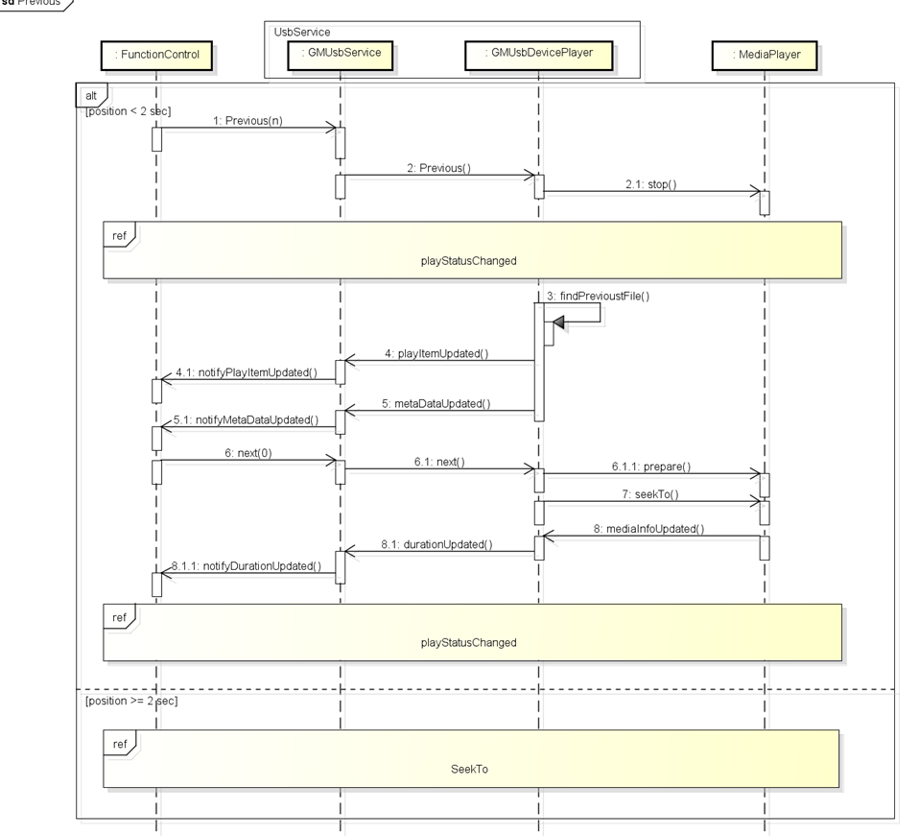

#### 涉及模块

FunctionManager

GMUsbService

MediaPlayer

#### 实现

这里只列举在DMUsbDevicePlayer中的被调用的previous方法。Previous的逻辑和next的逻辑一致。

|  |
| --- |
| //在devicePlayer中，往线程队列中发送调用该方法的请求  void GMUsbDevicePlayer::previous(int step, bool autoPlay)  {  USBLOGD_FUNCALL;  if (NULL == m_pNowPlayingList) {  USBLOGD("m_pNowPlayingList not exist");  DTLOG_INFO(0x500029, "m_pNowPlayingList not exist");  return;  }  if (m_isMpBlinkReset) {  USBLOGD("ignor this command, wait for mediaplayer connect");  DTLOG_INFO(0x500029, "ignor this command, wait for mediaplayer connect");  return;  }  if (0 < step) {  USBLOGD("continue to previous");  m_readyToPlay = false;  //调用该类中的stop方法，停止播放  stop();  //调用下一曲方法，传入step  m_pNowPlayingList->previous(step);  }  if (0 == step || true == autoPlay) {  USBLOGD("stop previous and start to play, autoPlay = %d", autoPlay);  m_readyToPlay = true;  if (INFINITE != m_mediaStatus.itemInfo.uid) {  setPrepare();  setPlay();  }  else {  USBLOGE("ItemInfo uid is not available, trigger failed!!");  DTLOG_INFO(0x500029, "ItemInfo uid is not available, trigger failed!!");  }  }  else {  USBLOGD("the step is invalid");  DTLOG_INFO(0x500029, "the step is invalid");  }  } |

在GMUsbDevicePlayer中调用了GMMediaPlayList的previous方法，实现真正的逻辑

|  |
| --- |
| bool GMMediaPlaylist::previous(unsigned int step)  {  PLLOG_FUNCALL;  if (NULL == m_cb || DeviceType_None >= m_deviceInfo.type() || DeviceType_Count <= m_deviceInfo.type()) {  PLLOGW("previous : param error, m_cb = [%p], type = [%d]", m_cb, m_deviceInfo.type());  return false;  }  if (m_totalError) {  PLLOGD("all error >> m_errorCount = [%d]", m_errorCount);  PLLOGD("[debug] : all error!!!,please choose another playlist");  m_cb->onPlaylistEnded(EndedType_AllError);  return false;  }  m_errorCountInList = 0;  if (RandomMode_All == m_randomMode || RandomMode_List == m_randomMode) {  if (m_randomIndex >= m_random.size()) {  PLLOGD("randomIndex error = [%d]", m_randomIndex);  return false;  }  m_originIndex = m_random[m_randomIndex]->index();  for (unsigned int i = 0; i < step; ++i) {  do {  if (m_originIndex == 0 && 0 != m_origin.size()) {  m_originIndex = m_origin.size() - 1;  m_errorCountInList = 0;  }  else {  --m_originIndex;  }  } while (itemFilter(true));  m_origin[m_originIndex]->setPlayed(true);  }  // keep the randomIndex point to the current item  for (unsigned int i = 0; i < m_random.size(); ++i) {  if (m_random[i]->index() == m_originIndex) {  m_randomIndex = i;  break;  }  }  // mark played in randomArray  m_random[m_randomIndex]->setPlayed(true);  if (RandomMode_All == m_randomMode) {  if (1 == amendListInfoIndex()) {  amendIndexAndCount();  }  }  updatePlaylistInfo();  if (m_listError) {  PLLOGD("[debug] : list error!!!,please choose another playlist");  m_listError = false;  m_cb->onPlaylistEnded(EndedType_ListError);  }  else {  m_cb->onPlayItemChanged(m_random[m_randomIndex]);  }  }  else { // randomMode_Off  if (m_originIndex >= m_origin.size()) {  PLLOGD("originIndex error = [%d]", m_originIndex);  return false;  }  for (unsigned int i = 0; i < step; ++i) {  do {  if (m_originIndex == 0 && 0 != m_origin.size()) {  m_originIndex = m_origin.size() - 1;  m_errorCountInList = 0;  }  else {  --m_originIndex;  }  } while (itemFilter());  }  if (RepeatMode_All == m_repeatMode || RepeatMode_One == m_repeatMode) {  if (1 == amendListInfoIndex()) {  amendIndexAndCount();  }  }  updatePlaylistInfo();  if (m_listError) {  PLLOGD("[debug] : all error!!!,please choose another playlist");  m_listError = false;  m_cb->onPlaylistEnded(EndedType_ListError);  }  else {  m_cb->onPlayItemChanged(m_origin[m_originIndex]);  }  }  PLLOGD("operation previous succeed");  return true;  } |

### PlayAll

#### 时序

#### 涉及模块

FunctionManager

GMUsbService

DevicePlayer

#### 涉及文件

#### 实现

在GMUsbDevicePlayer中的playAll方法。

|  |
| --- |
| void GMUsbDevicePlayer::playAll(GMUsbAvMode mode, unsigned int itemid) /* __0x500022_DTFUNCID__ */  {  USBLOGD_FUNCALL;  //判断playingList是否为空。  if (NULL == m_pNowPlayingList) {  USBLOGD("m_pNowPlayingList not exist");  DTLOG_INFO(0x500022, "m_pNowPlayingList not exis");  return;  }  //设置当前速度。  m_ForwardRewind = PlaySpeed_NormalPlay;  //调用暂停方法stop  stop();  //设置播放模式  GIUsbPlayMode playMode = static_cast<GIUsbPlayMode>(mode);  //更新播放模式。  playModeUpdated(playMode);  //调用GMMediaPlaylist中的playAll方法  m_pNowPlayingList->playAll(static_cast<GMMediaPlaylist::AvMode>(mode), static_cast<int>(itemid));  //调用GMMediaPlayList中save方法保存  m_pNowPlayingList->save();  } |

在GMMediaDevicePlayer中调用了GMMediaPlayList类中的playAll方法，在其中实现 了真正的playAll逻辑

|  |
| --- |
| //AVMode mode参数：  bool GMMediaPlaylist::playAll(AvMode mode, int index)  {  PLLOG_FUNCALL;  PLLOGD("playall mode = [%d], index = [%d]", mode, index);  int fileType = 0;  m_playMode = mode;  if (AvMode_Audio == mode) {  m_playlistInfo.filePlayMode = FilePlayMode_Audio_All;  fileType = 2;  }  else if (AvMode_Video == mode) {  m_playlistInfo.filePlayMode = FilePlayMode_Video_All;  fileType = 4;  }  else {  return false;  }  m_playlistInfo.folderId = USB_INVALID_ID;  m_playlistInfo.genreId = USB_INVALID_ID;  m_playlistInfo.artistId = USB_INVALID_ID;  m_playlistInfo.composerId = USB_INVALID_ID;  m_playlistInfo.albumId = USB_INVALID_ID;  MediaSrcType type = srcType();  if (MediaSrcType_Any == type) {  PLLOGW("srcType error");  return false;  }  NCUri uri;  NCList<NCString> select;  NCString where("");  NCString mkey("");  NCList<NCString> whereArgs;  NCString order("SORTKEY");  int dbStatus = deviceDbInfo(DeviceDbInfo_Status);  if (AvMode_Video == mode) {  uri = GIMediaProviderUri::FileBase::getContentUri(type);  select<< new NCString("ID")<< new NCString("FOLDER_ID")<< new NCString("NAME")<< new NCString("PATH");  where = "TYPE=?";  mkey.format("%d", fileType); // 2 refs audio , 4 refs video  whereArgs.append(&mkey);  }  else if (4 <= dbStatus) {  uri = GIMediaProviderUri::AudioBase::Songs::getContentUri(type);  select<< new NCString("FID")<< new NCString("FOLDER_ID")<< new NCString("FILE_NAME")<< new NCString("FILE_PATH")  << new NCString("COMPOSER_ID")<< new NCString("GENRE_ID")<< new NCString("ARTIST_ID")<< new NCString("ALBUM_ID");  }  else {  uri = GIMediaProviderUri::FileBase::getContentUri(type);  select<< new NCString("ID")<< new NCString("FOLDER_ID")<< new NCString("NAME")<< new NCString("PATH");  where = "TYPE=?";  mkey.format("%d", fileType); // 2 refs audio , 4 refs video  whereArgs.append(&mkey);  }  #ifndef __LOCAL  NCCursor* cursor = NULL;  cursor = m_pProviderResolver->query(uri, select, where, whereArgs, order);  if (NULL == cursor) {  PLLOGD("query failed, no data received");  select.clearData();  return false;  }  int listCountTmp = cursor->getCount();  PLLOGD("list Count = [%d]", listCountTmp);  cursor->moveToFirst();  ncsp<NMDataTable>::sp listSp = new NMDataTable(listCountTmp, PlayItem::Column_Count);  if (NULL != listSp.get()) {  INIT_TBL(listSp);  for (int i = 0; i < listCountTmp; ++i) {  listSp->putLong(i, PlayItem::Column_Fid, cursor->getInt64(PlayItem::Column_Fid));  listSp->putLong(i, PlayItem::Column_FolderId, cursor->getInt64(PlayItem::Column_FolderId));  listSp->putString(i, PlayItem::Column_Name, cursor->getString(PlayItem::Column_Name).getString(),  cursor->getString(PlayItem::Column_Name).getLength());  listSp->putString(i, PlayItem::Column_Path, cursor->getString(PlayItem::Column_Path).getString(),  cursor->getString(PlayItem::Column_Path).getLength());  if (AvMode_Video == mode) {  listSp->putLong(i, PlayItem::Column_ComposerId, USB_INVALID_ID);  listSp->putLong(i, PlayItem::Column_GenreId, USB_INVALID_ID);  listSp->putLong(i, PlayItem::Column_ArtistId, USB_INVALID_ID);  listSp->putLong(i, PlayItem::Column_AlbumId, USB_INVALID_ID);  }  else {  listSp->putLong(i, PlayItem::Column_ComposerId, cursor->getInt64(PlayItem::Column_ComposerId));  listSp->putLong(i, PlayItem::Column_GenreId, cursor->getInt64(PlayItem::Column_GenreId));  listSp->putLong(i, PlayItem::Column_ArtistId, cursor->getInt64(PlayItem::Column_ArtistId));  listSp->putLong(i, PlayItem::Column_AlbumId, cursor->getInt64(PlayItem::Column_AlbumId));  }  listSp->putLong(i, PlayItem::Column_FileType, fileType);  cursor->moveToNext();  }  loadInfoList(listSp);  selectPlaylist(listSp, index);  // saveLastList();  }  FREEIF(cursor);  #else  NMDataTable* tmp = GMUsbProvider::instance()->query(uri, select, where, whereArgs, order);  if (NULL != tmp) {  int listCountTmp = tmp->getRowCount();  ncsp<NMDataTable>::sp listSp = new NMDataTable(listCountTmp, PlayItem::Column_Count);  INIT_TBL(listSp);  for (int i = 0; i < listCountTmp; ++i) {  listSp->putLong(i, PlayItem::Column_Fid, tmp->getLong(i, PlayItem::Column_Fid));  listSp->putLong(i, PlayItem::Column_FolderId, tmp->getLong(i, PlayItem::Column_FolderId));  size_t len;  listSp->putString(i, PlayItem::Column_Name, tmp->getString(i, PlayItem::Column_Name, len),  256);  listSp->putString(i, PlayItem::Column_Path, tmp->getString(i, PlayItem::Column_Path, len),  256);  if (AvMode_Video == mode) {  listSp->putLong(i, PlayItem::Column_ComposerId, USB_INVALID_ID);  listSp->putLong(i, PlayItem::Column_GenreId, USB_INVALID_ID);  listSp->putLong(i, PlayItem::Column_ArtistId, USB_INVALID_ID);  listSp->putLong(i, PlayItem::Column_AlbumId, USB_INVALID_ID);  }  else {  listSp->putLong(i, PlayItem::Column_ComposerId, tmp->getLong(i, PlayItem::Column_ComposerId));  listSp->putLong(i, PlayItem::Column_GenreId, tmp->getLong(i, PlayItem::Column_GenreId));  listSp->putLong(i, PlayItem::Column_ArtistId, tmp->getLong(i, PlayItem::Column_ArtistId));  listSp->putLong(i, PlayItem::Column_AlbumId, tmp->getLong(i, PlayItem::Column_AlbumId));  }  listSp->putLong(i, PlayItem::Column_FileType, fileType);  }  loadInfoList(listSp);  selectPlaylist(listSp, index);  }  FREEIF(tmp);  #endif  select.clearData();  return true;  } |

### SeekTo

#### 时序

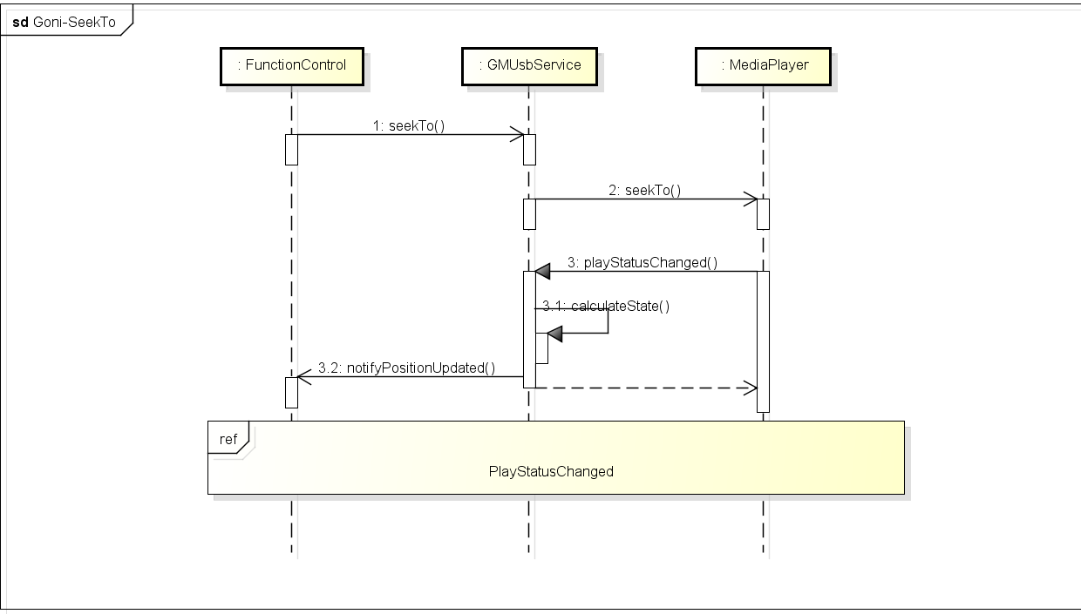

#### 涉及模块

FunctionManager

GMUsbService

DevicePlayer

#### 实现

在GMUsbDevicePlayer中seekTo被调用。在seekTo中又调用了NMMPClasssicPlayer中的seekTo方法和PlaylistManager中的autoNext方法。

|  |
| --- |
| void GMUsbDevicePlayer::seekTo(uint32_t secTimeIn) /* __0x50003C_DTFUNCID__ */  {  USBLOGD_FUNCALL;  if (NULL == m_pMediaPlayer) {  USBLOGD("player not exist");  DTLOG_INFO(0x50003C, "player not exist");  return;  }  USBLOGD("the position need to seekto is %d", secTimeIn);  USBLOGD("the duration is %d", m_mediaStatus.itemInfo.duration);  // because the operation of seekto is not finish,so the data is not be saved.  MediaBackup::instance()->updatePlayTime(m_deviceId, secTimeIn, m_mediaStatus.ePlayMode);  m_mediaStatus.itemInfo.position = secTimeIn;  uint32_t totalTime = m_mediaStatus.itemInfo.duration;  if (-1 == static_cast<int>(secTimeIn)) {  USBLOGD("play from tail of the item %d", secTimeIn);  m_pMediaPlayer->seekTo(0, PlaySpeed_NormalPlay, true);  }  else if ((totalTime > 0) && (((totalTime - secTimeIn) / 1000) < 1)) {  USBLOGD("stop seekto and next");  playCompletedNotify(0);  stop();  if (NULL != m_pNowPlayingList) {  m_pNowPlayingList->autoNext();  }  }  else {  if (!m_isSeeking) {  #ifdef GMUSB_PROPERTY_FAKESEEK  if (GIUsbItemType_APE == m_mediaStatus.itemInfo.eItemType) {  m_mediaStatus.itemInfo.position = secTimeIn;  play();  }  else {  m_isSeeking = true;  m_pMediaPlayer->seekTo(secTimeIn, PlaySpeed_NormalPlay, false);  }  #else  m_isSeeking = true;  m_pMediaPlayer->seekTo(secTimeIn, PlaySpeed_NormalPlay, false);  #endif  }  else {  USBLOGD("seekto is not completed ignore the command");  m_ignorePosition = secTimeIn;  }  }  } |

PlaylistManager中的autoNext方法

|  |
| --- |
| bool GMMediaPlaylist::autoNext()  {  PLLOGD("autoNext");  if (NULL == m_cb || DeviceType_None >= m_deviceInfo.type() || DeviceType_Count <= m_deviceInfo.type()) {  PLLOGW("autoNext : param error, m_cb = [%p], type = [%d]", m_cb, m_deviceInfo.type());  return false;  }  if (m_totalError) {  PLLOGW("warning : autoNext !!totalError!!");  m_cb->onPlaylistEnded(EndedType_AllError);  return true;  }  NCAutoSync autoSync(m_syncObj);  if (RepeatMode_One == m_repeatMode) {  // need not switch to next playitem, play this again  if (NULL != currentPlayItem().get()  && currentPlayItem()->playable()) {  m_cb->onNeedPlayAgain(currentPlayItem());  return true;  }  else {  return next(1);  }  }  else if (RepeatMode_List == m_repeatMode || RandomMode_List == m_randomMode) {  if (m_infoList[m_listIndex].isListError) {  return listUp(m_playlistInfo.filePlayMode);  }  else {  return next(1);  }  }  else {  return next(1);  }  } |

### BindSource

#### 时序

无

#### 涉及模块

FunctionManager

GMUsbService

DevicePlayer

#### 实现

该方法主要是将usb与设备绑定

Proxy代理

|  |
| --- |
| // binding source usb1/usb2  uint64_t GMUsbProxy::bindSource(const GIUsbSource& eSourceId)  {  USBLOGD_FUNCALL;  static uint64_t call_id = 1;  unsigned int code = USBMethod_BindSource;  android::Parcel data;  prepareAsyncData(data);  data.writeInt32(eSourceId);  data.setDataPosition(0);  // request service  if (BS_NO_CONNECTION == sendAsyncRequest(code, data)) {  return 0; // invalid call id '0' to indicate error  }  return call_id++;  } |

UsbService中接收消息，启动线程，传入sourceId和senderId，调用该类中的bindSource方法

|  |
| --- |
| case USBMethod_BindSource:  {  // define request param  GIUsbSource eSourceId;  // unpack request param  //从parse中获取sourceID  eSourceId = static_cast<GIUsbSource>(data.readInt32());  // call request function  // bindSource(id, eSourceId);  GMTaskDes des(Runnable_Pri_N, 0, "USBMethod_BindSource");  (m_pMainThread->looper()).postRunnable(GMTaskBind(des, this, &GMUsbServiceBase::bindSource  , id, eSourceId));  break;  } |

UsbService 中的BindSource方法，在这个方法中，又调用了DevicePlayer中的initialize方法，在初始化时进行绑定操作。这也说明了Usbservice只是功能的中转站，最终的处理逻辑还是放在了各个其他服务的代理类中。

|  |
| --- |
| void GMUsbServiceBase::bindSource(SenderId sid, const GIUsbSource& eSourceId) /* __0xB0200B_DTFUNCID__ */  {  //往上层反馈信息  replyBindSource(sid, eSourceId);  //将source纳入到clientManager的管理中。  m_spClientMgr->setLink(sid, static_cast<int>(eSourceId));  if (NULL != getDPlayer(sid)) {  getDPlayer(sid)->initialize();  }  // TODO sync service status with proxy  // GIUsbServiceStatus statusInfo;  // if (NULL != getDPlayer(sid)) {  // statusInfo = getDPlayer(sid)->mediaStatus();  // }  // int deviceId = m_spClientMgr->getDeviceId(sid);  // m_usbExtInfo[deviceId].infoMask = mask;  // notifyUsbExtInfo(sid, m_usbExtInfo[deviceId]);  } |

DevicePlayer中的initialize方法。

|  |
| --- |
| bool GMUsbDevicePlayer::initialize() /* __0x500007_DTFUNCID__ */  {  USBLOGD_FUNCALL;  //创建新的线程类  if (NULL == m_pMPCbThread) {  m_pMPCbThread = new GMUsbRunnableThread();  if (NULL == m_pMPCbThread) {  return false;  }  }  //创建mediaPlayer对象  //启动线程  if (NULL == m_pMediaPlayer) {  m_pMPCbThread->startThread(GONI_USBSERVICE_THREAD_PLAYER_CALLBACK);  NCRunnableLooper workLooper(m_pMPCbThread->looper());  //创建mediaPlayer对象  m_pMediaPlayer = new NMMPClassicPlayer(workLooper, this);  if (NULL == m_pMediaPlayer) {  return false;  }  // initialize classic player // move to onConnected  // m_pMediaPlayer->initialize();  // m_pMediaPlayer->registerNotify(GM_USB_MP_STATUS_MASK, GM_USB_MP_INFO_MASK);  // Do not need to connect in this PF Framework  // m_pMediaPlayer->connectToService();  }  //初始化playlistCallback  if (NULL == m_pPlaylistCallback) {  m_pPlaylistCallback = new GMUsbDevicePlayer::PlaylistCallback(*this);  }  //初始化playlist  if (NULL == m_pNowPlayingList && NULL != m_pPlaylistCallback) {  m_pNowPlayingList = new GMMediaPlaylist(m_pPlaylistCallback);  //设备信息  GMMediaPlaylist::DeviceInfo devInfo;  devInfo.setRootPath(m_rootPath);  if (GMUsbDeviceId_USB1 == m_deviceId) {  devInfo.setType(GMMediaPlaylist::DeviceType_Usb1);  }  else if (GMUsbDeviceId_USB2 == m_deviceId) {  devInfo.setType(GMMediaPlaylist::DeviceType_Usb2);  }  else {  devInfo.setType(GMMediaPlaylist::DeviceType_None);  }  //初始化一系列相关对象后，调用playList中的bindDevice方法  //将devInfo来实例化DeviceInfo  m_pNowPlayingList->bindDevice(devInfo);  }  #ifdef GMUSB_PROPERTY_FAKESEEK  m_spTimer = new LocalTimer(this, 100);  m_pTimerHolder = new GMUsbTimerHolder(m_spTimer.get(), "deviceplayer timer");  #endif  return true;  } |

### SwitchPlayMode

这个方法的主要功能就是Audio和Vedio之间的切换。

#### 时序

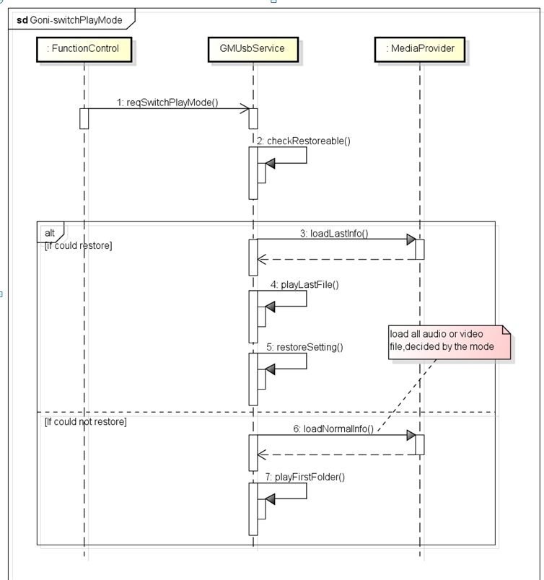

#### 涉及模块

FunctionManager

GMUsbService

DevicePlayer

#### 涉及文件

GMUsbProxy.h/cpp

SwitchPlayMode（）

GMUsbServiceBase.h/cpp

case USBMethod_SwitchPlayMode

SwitchPlayMode（）

GMUSbDevicePlayer.h/cpp

PostSwitchPlayMode()

SwitchPlayMode()

RestorePlay()

seekTo()

playFirstFolder()

playFolder

#### 实现

Proxy中SwitchPlayMode方法

|  |
| --- |
| /// switch play mode  uint64_t GMUsbProxy::switchPlayMode(const GIUsbPlayMode& ePlayMode)  {  USBLOGD_FUNCALL;  static uint64_t call_id = 1;  unsigned int code = USBMethod_SwitchPlayMode;  android::Parcel data;  prepareAsyncData(data);  data.writeInt32(ePlayMode);  data.setDataPosition(0);  // request service  if (BS_NO_CONNECTION == sendAsyncRequest(code, data)) {  return 0; // invalid call id '0' to indicate error  }  return call_id++;  } |

UsbService中接收并响应proxy中的请求的case

|  |
| --- |
| case USBMethod_SwitchPlayMode:  {  // define request param  GIUsbPlayMode ePlayMode;  // unpack request param  ePlayMode = static_cast<GIUsbPlayMode>(data.readInt32());  // call request function  // switchPlayMode(id, ePlayMode);  GMTaskDes des(Runnable_Pri_N, 0, "USBMethod_SwitchPlayMode");  (m_pMainThread->looper()).postRunnable(GMTaskBind(des, this, &GMUsbServiceBase::switchPlayMode  , id, ePlayMode));  break;  } |

UsbService中在case中调用的该类中的SwitchPlayMode方法

|  |
| --- |
| void GMUsbServiceBase::switchPlayMode(SenderId sid, const GIUsbPlayMode& ePlayMode)  {  // reserved  replySwitchPlayMode(sid, ePlayMode);  //判断资源状态是否可用。  if (GMUsbSourceState_SourceOn != m_sourceState) {  USBLOGD("the source is not on, %d", m_sourceState);  if (NULL != getDPlayer(sid)) {  USBLOGD("MARK DOWN THE PLAYMODE FOR MP BLINKRESET AND STUBBORN UI");  MediaBackup::instance()->updateLastAvMode(pathToDeviceId(getDPlayer(sid)->getRootPath()), static_cast<int>(ePlayMode));  }  return ;  }  //调用DevicePlayer中的postSwitchPlayMode方法。  if (NULL != getDPlayer(sid)) {  getDPlayer(sid)->postSwitchPlayMode(static_cast<GMUsbAvMode>(ePlayMode));  }  } |

调DevicePlayer中的postSwitchPlayMode方法。

|  |
| --- |
| void GMUsbDevicePlayer::postSwitchPlayMode(GMUsbAvMode mode)  {  USBLOGD_FUNCALL;  if (m_pMPCbThread) {  m_pMPCbThread->looper().postRunnable(MRunnableTask(this, &GMUsbDevicePlayer::switchPlayMode, mode));  }  else {  switchPlayMode(mode);  }  } |

在devicePlayer类中，postSwitchPlayMode调用该类中的switchPlayMode方法

在该方法的逻辑实现过程中，调用了restorePlay方法，在切换播放模式后恢复播放，恢复失败，则再调用playFirstFolder方法，播放第一个文件夹中的文件

|  |
| --- |
| void GMUsbDevicePlayer::switchPlayMode(GMUsbAvMode mode)  {  USBLOGD_FUNCALL;  USBLOGD("mode = [%d]", mode);  //调用恢复方法恢复播放。  if (!restorePlay(mode)) {  USBLOGD("restore failed, play first file if exist");  DTLOG_INFO(0x50002D, "restore failed, play first file if exist");  // playAll(mode, 0);  //恢复播放失败，调用playFirstFolder播放第一个文件夹  playFirstFolder(mode);  }  } |

在switchPlayMode中调用该类中的的恢复播放的方法。目的是在切换模式后还可以恢复切换前的播放状态。

思路：

停止播放，从ＤＢ中取出存储的uid,pos等信息，重新赋给新的模式，然后调用seekTo方法，跳转到指定的位置。

|  |
| --- |
| bool GMUsbDevicePlayer::restorePlay(GMUsbAvMode mode) /* __0x500051_DTFUNCID__ */  {  USBLOGD_FUNCALL;  m_isSeeking = false;  m_readyToPlay = true;  //判断playinglist是否为空  if (NULL == m_pNowPlayingList) {  USBLOGD("now play list is null, return");  DTLOG_INFO(0x500051, "now play list is null, return");  return false;  }  // Gypsophila  //打印DB中存储的备份数据  MediaBackup::instance()->printBackupData();  //设置播放速度为常规速度  m_ForwardRewind = PlaySpeed_NormalPlay;  //调用stop方法，停止播放  stop();  //mode为Audio  if (GMUsbAvMode_Audio == mode) {  m_mediaStatus.ePlayMode = static_cast<GIUsbPlayMode>(mode);  //从DB中getPlayUid和播放时间  int *uid* = MediaBackup::instance()->getPlayUid(m_deviceId, static_cast<int>(GMUsbAvMode_Audio));  int pos = MediaBackup::instance()->getPlayTime(m_deviceId, static_cast<int>(GMUsbAvMode_Audio));  USBLOGD("get last audio uid [%d]", uid);  if (m_pNowPlayingList->load(GMMediaPlaylist::AvMode_Audio, true)) {  m_restorePlayFlag = true;  GIUsbPlayMode playMode = static_cast<GIUsbPlayMode>(mode);  //调用播放模式更新方法，一是在数据库中更新数据，二是通知上层播放模式的改变  playModeUpdated(playMode);  // int repeatMode = MediaBackup::instance()->getRepeatMode(m_deviceId, static_cast<int>(mode));  // int randomMode = MediaBackup::instance()->getRandomMode(m_deviceId, static_cast<int>(mode));  // m_pNowPlayingList->setRepeatMode(static_cast<GMMediaPlaylist::RepeatMode>(repeatMode));  // m_pNowPlayingList->setRandomMode(static_cast<GMMediaPlaylist::RandomMode>(randomMode));  从数据库中获取原来的播放模式。  int trickplayMode = MediaBackup::instance()->getTrickPlayMode(m_deviceId, static_cast<int>(mode));  //恢复设置  restoreSetting(static_cast<TrickPlayMode>(trickplayMode));  m_mediaStatus.itemInfo.position = pos;  m_pNowPlayingList->selectUid(uid);  #ifdef GMUSB_PROPERTY_FAKESEEK  if (GIUsbItemType_APE == m_mediaStatus.itemInfo.eItemType) {  play();  }  else {  seekTo(pos);  }  #else  seekTo(pos);  #endif  }  else {  USBLOGW("load audio last info failed");  DTLOG_INFO(0x500051, "load audio last info failed");  return false;  }  }  else if (GMUsbAvMode_Video == mode) {  m_mediaStatus.ePlayMode = static_cast<GIUsbPlayMode>(mode);  int uid = MediaBackup::instance()->getPlayUid(m_deviceId, static_cast<int>(GMUsbAvMode_Video));  int pos = MediaBackup::instance()->getPlayTime(m_deviceId, static_cast<int>(GMUsbAvMode_Video));  USBLOGD("get last video uid [%d]", uid);  if (m_pNowPlayingList->load(GMMediaPlaylist::AvMode_Video, true)) {  m_restorePlayFlag = true;  GIUsbPlayMode playMode = static_cast<GIUsbPlayMode>(mode);  playModeUpdated(playMode);  // video do not have repeat&random mode  // int repeatMode = MediaBackup::instance()->getRepeatMode(m_deviceId, static_cast<int>(mode));  // int randomMode = MediaBackup::instance()->getRandomMode(m_deviceId, static_cast<int>(mode));  // m_pNowPlayingList->setRepeatMode(static_cast<GMMediaPlaylist::RepeatMode>(repeatMode));  // m_pNowPlayingList->setRandomMode(static_cast<GMMediaPlaylist::RandomMode>(randomMode));  int trickplayMode = MediaBackup::instance()->getTrickPlayMode(m_deviceId, static_cast<int>(mode));  restoreSetting(static_cast<TrickPlayMode>(trickplayMode));  m_mediaStatus.itemInfo.position = pos;  m_pNowPlayingList->selectUid(uid);  seekTo(pos);  }  else {  USBLOGW("load video last info failed");  DTLOG_INFO(0x500051, "load video last info failed");  return false;  }  }  else {  USBLOGD("restore mode error");  DTLOG_INFO(0x500051, "restore mode error");  return false;  }  return true;  } |

playFirstFolder，先通过getFirstFolderId方法获取第一个folder的id,再通过这个ID调用该类中的playFolder方法，从第一个文件夹开始播放

|  |
| --- |
| void GMUsbDevicePlayer::playFirstFolder(GMUsbAvMode mode)  {  USBLOGD_FUNCALL;  //得到第一个文件夹的id  unsigned int folderId = getFirstFolderId(mode);  if (0 != folderId) {  //调用该类中的playFolder方法,将第一个folder的ID作为参数传入即可  playFolder(mode, folderId, 0);  }  else {  USBLOGW("get first folder id failed");  DTLOG_INFO(0x500023, "get first folder id failed");  }  } |

DevicePlayer 中的playFolder方法，在这里调用了PlayingList中的playFolder和save方法。

|  |
| --- |
| void GMUsbDevicePlayer::playFolder(GMUsbAvMode mode, unsigned int folderId,  unsigned int fileIndex) /* __0x500024_DTFUNCID__ */  {  USBLOGD_FUNCALL;  //判断m_pNowPlayingList对象是否创建成功  if (NULL == m_pNowPlayingList) {  USBLOGD("m_pNowPlayingList not exist");  DTLOG_INFO(0x500024, "m_pNowPlayingList not exis");  return;  }  //设置播放速度为正常。  m_ForwardRewind = PlaySpeed_NormalPlay;  //停止  stop();  GIUsbPlayMode playMode = static_cast<GIUsbPlayMode>(mode);  playModeUpdated(playMode);  //调用m_pNowPlayingList中的playFoleder方法，实现逻辑  m_pNowPlayingList->playFolder(static_cast<GMMediaPlaylist::AvMode>(mode), static_cast<int>(folderId), static_cast<int>(fileIndex));  //恢复设置  restoreSetting(TrickPlayMode_RepAll_RanOff); // restore default setting  //调用m_pNowPlayingList保存save  m_pNowPlayingList->save();  } |

### playFolder

#### 时序

#### 涉及模块

FunctionManager

GMUsbService

DevicePlayer

PlayingList

#### 实现

Proxy

folderId 文件夹编号（数据库中folderID）

fileIndex 起始文件编号（数据库中fileID）

|  |
| --- |
| /// play audio/video of a folder  uint64_t GMUsbProxy::playFolder(const GIUsbPlayMode& eMode  , const uint32_t folderId, const uint32_t fileIndex)  {  USBLOGD_FUNCALL;  static uint64_t call_id = 1;  unsigned int code = USBMethod_PlayFolder;  android::Parcel data;  prepareAsyncData(data);  data.writeInt32(eMode);  data.writeInt32(folderId);  data.writeInt32(fileIndex);  data.setDataPosition(0);  // request service  if (BS_NO_CONNECTION == sendAsyncRequest(code, data)) {  return 0; // invalid call id '0' to indicate error  }  return call_id++;  } |

UsbServiceBase中case

|  |
| --- |
| case USBMethod_PlayFolder:  {  // define request param  GIUsbPlayMode eMode;  uint32_t folderId;  uint32_t fileIndex;  // unpack request param  eMode = static_cast<GIUsbPlayMode>(data.readInt32());  folderId = data.readInt32();  fileIndex = data.readInt32();  // call request function  // playFolder(id, eMode, folderId, fileIndex);  GMTaskDes des(Runnable_Pri_N, 0, "USBMethod_PlayFolder");  (m_pMainThread->looper()).postRunnable(GMTaskBind(des, this, &GMUsbServiceBase::playFolder  , id, eMode, folderId, fileIndex));  break;  } |

UsbServiceBase中playFolder

|  |
| --- |
| void GMUsbServiceBase::playFolder(SenderId sid, const GIUsbPlayMode& eMode, const uint32_t folderId , const uint32_t fileIndex)  {  //通知上层  replyPlayFolder(sid, eMode, folderId, fileIndex);  //判断资源是否打开  if (GMUsbSourceState_SourceOn != m_sourceState) {  USBLOGD("the source is not on, %d", m_sourceState);  DTLOG_INFO(0xB02010, "tthe source is not on, %d", m_sourceState);  return ;  }  if (NULL != getDPlayer(sid)) {  getDPlayer(sid)->postPlayFolder(static_cast<GMUsbAvMode>(eMode), folderId, fileIndex);  }  } |

在DevicePlayer中的postPlayFolder

|  |
| --- |
| void GMUsbDevicePlayer::postPlayFolder(GMUsbAvMode mode, unsigned int folderId, unsigned int fileIndex)  {  USBLOGD_FUNCALL;  if (m_pMPCbThread) {  m_pMPCbThread->looper().postRunnable(MRunnableTask(this, &GMUsbDevicePlayer::playFolder, mode, folderId, fileIndex));  }  else {  playFolder(mode, folderId, fileIndex);  }  } |

在DevicePlayer中的PlayFolder

|  |
| --- |
| void GMUsbDevicePlayer::playFolder(GMUsbAvMode mode, unsigned int folderId, unsigned int fileIndex)  {  USBLOGD_FUNCALL;  //判断m_pNowPlayingList对象是否创建成功  if (NULL == m_pNowPlayingList) {  USBLOGD("m_pNowPlayingList not exist");  DTLOG_INFO(0x500024, "m_pNowPlayingList not exis");  return;  }  //设置播放速度为正常。  m_ForwardRewind = PlaySpeed_NormalPlay;  //停止  stop();  GIUsbPlayMode playMode = static_cast<GIUsbPlayMode>(mode);  playModeUpdated(playMode);  //调用m_pNowPlayingList中的playFoleder方法，实现逻辑  m_pNowPlayingList->playFolder(static_cast<GMMediaPlaylist::AvMode>(mode), static_cast<int>(folderId), static_cast<int>(fileIndex));  //恢复设置  restoreSetting(TrickPlayMode_RepAll_RanOff); // restore default setting  //调用m_pNowPlayingList保存save  m_pNowPlayingList->save();  } |

PlayingList中的playFolder，在这里通过DB查询处结果，再将结果存在list中，从list的第一个文件开始播放。

|  |
| --- |
| bool GMMediaPlaylist::playFolder(AvMode mode, int folderId, int index, bool load)  {  PLLOG_FUNCALL;  PLLOGD("GMMediaPlaylist::playFolder mode = [%d], folderId = [%d], index = [%d], load [%d]"  , mode, folderId, index, load);  int fileType = 0;  m_playMode = mode;  if (AvMode_Audio == mode) {  m_playlistInfo.filePlayMode = FilePlayMode_Audio_Folder;  fileType = 2;  }  else if (AvMode_Video == mode) {  m_playlistInfo.filePlayMode = FilePlayMode_Video_Folder;  fileType = 4;  }  else {  return false;  }  m_playlistInfo.folderId = folderId;  m_playlistInfo.genreId = USB_INVALID_ID;  m_playlistInfo.artistId = USB_INVALID_ID;  m_playlistInfo.composerId = USB_INVALID_ID;  m_playlistInfo.albumId = USB_INVALID_ID;  //媒体资源类型，通过srcType方法，获取媒体资源类型  MediaSrcType type = srcType();  if (MediaSrcType_Any == type) {  PLLOGW("serType error");  return false;  }  //构造查询的参数  NCUri uri;  NCList<NCString> select;  NCString where("");  NCString mkey("");  NCList<NCString> whereArgs;  NCString order("");  int dbStatus = deviceDbInfo(DeviceDbInfo_Status);  if (AvMode_Video == mode) {  uri = GIMediaProviderUri::FileBase::getContentUri(type);  select<< new NCString("ID")<< new NCString("FOLDER_ID")<< new NCString("NAME")<< new NCString("PATH");  where = "TYPE=?";  mkey.format("%d", fileType); // 2 refs audio , 4 refs video  whereArgs.append(&mkey);  order = "FOLDER_SORTKEY, SORTKEY";  }  else if (4 <= dbStatus) {  PLLOGD("play folder, get file from song table");  uri = GIMediaProviderUri::AudioBase::Songs::getContentUri(type);  select<< new NCString("FID")<< new NCString("FOLDER_ID")<< new NCString("FILE_NAME")<< new NCString("FILE_PATH")  << new NCString("COMPOSER_ID")<< new NCString("GENRE_ID")<< new NCString("ARTIST_ID")<< new NCString("ALBUM_ID");  order = "FOLDER_SORTKEY, FILE_SORTKEY";  }  else {  PLLOGD("play folder, get file from file table");  uri = GIMediaProviderUri::FileBase::getContentUri(type);  select<< new NCString("ID")<< new NCString("FOLDER_ID")<< new NCString("NAME")<< new NCString("PATH");  where = "TYPE=?";  mkey.format("%d", fileType); // 2 refs audio , 4 refs video  whereArgs.append(&mkey);  order = "FOLDER_SORTKEY, SORTKEY";  }  #ifndef __LOCAL  //定义结果指针  NCCursor* cursor = NULL;  cursor = m_pProviderResolver->query(uri, select, where, whereArgs, order);  if (NULL == cursor) {  PLLOGD("query failed, no data received");  select.clearData();  return false;  }  //获取查询数量  int listCountTmp = cursor->getCount();  PLLOGD("list Count = [%d]", listCountTmp);  //将指针移动到第一个位置  cursor->moveToFirst();  ncsp<NMDataTable>::sp listSp = new NMDataTable(listCountTmp, PlayItem::Column_Count);  if (NULL != listSp.get()) {  INIT_TBL(listSp);  for (int i = 0; i < listCountTmp; ++i) {  listSp->putLong(i, PlayItem::Column_Fid, cursor->getInt64(PlayItem::Column_Fid));  listSp->putLong(i, PlayItem::Column_FolderId, cursor->getInt64(PlayItem::Column_FolderId));  listSp->putString(i, PlayItem::Column_Name, cursor->getString(PlayItem::Column_Name).getString(),  cursor->getString(PlayItem::Column_Name).getLength());  listSp->putString(i, PlayItem::Column_Path, cursor->getString(PlayItem::Column_Path).getString(),  cursor->getString(PlayItem::Column_Path).getLength());  if (AvMode_Video == mode || (4 > dbStatus)) {  listSp->putLong(i, PlayItem::Column_ComposerId, USB_INVALID_ID);  listSp->putLong(i, PlayItem::Column_GenreId, USB_INVALID_ID);  listSp->putLong(i, PlayItem::Column_ArtistId, USB_INVALID_ID);  listSp->putLong(i, PlayItem::Column_AlbumId, USB_INVALID_ID);  }  else {  listSp->putLong(i, PlayItem::Column_ComposerId, cursor->getInt64(PlayItem::Column_ComposerId));  listSp->putLong(i, PlayItem::Column_GenreId, cursor->getInt64(PlayItem::Column_GenreId));  listSp->putLong(i, PlayItem::Column_ArtistId, cursor->getInt64(PlayItem::Column_ArtistId));  listSp->putLong(i, PlayItem::Column_AlbumId, cursor->getInt64(PlayItem::Column_AlbumId));  }  listSp->putLong(i, PlayItem::Column_FileType, fileType);  cursor->moveToNext();  }  if (load) {  loadInfoList(listSp);  }  selectPlaylist(listSp, index);  // saveLastList();  }  FREEIF(cursor);  #else  NMDataTable* tmp = GMUsbProvider::instance()->query(uri, select, where, whereArgs, order);  if (NULL != tmp) {  int listCountTmp = tmp->getRowCount();  ncsp<NMDataTable>::sp listSp = new NMDataTable(listCountTmp, PlayItem::Column_Count);  INIT_TBL(listSp);  for (int i = 0; i < listCountTmp; ++i) {  listSp->putLong(i, PlayItem::Column_Fid, tmp->getLong(i, PlayItem::Column_Fid));  listSp->putLong(i, PlayItem::Column_FolderId, tmp->getLong(i, PlayItem::Column_FolderId));  size_t len;  listSp->putString(i, PlayItem::Column_Name, tmp->getString(i, PlayItem::Column_Name, len),  256);  listSp->putString(i, PlayItem::Column_Path, tmp->getString(i, PlayItem::Column_Path, len),  256);  if (AvMode_Video == mode) {  listSp->putLong(i, PlayItem::Column_ComposerId, USB_INVALID_ID);  listSp->putLong(i, PlayItem::Column_GenreId, USB_INVALID_ID);  listSp->putLong(i, PlayItem::Column_ArtistId, USB_INVALID_ID);  listSp->putLong(i, PlayItem::Column_AlbumId, USB_INVALID_ID);  }  else {  listSp->putLong(i, PlayItem::Column_ComposerId, tmp->getLong(i, PlayItem::Column_ComposerId));  listSp->putLong(i, PlayItem::Column_GenreId, tmp->getLong(i, PlayItem::Column_GenreId));  listSp->putLong(i, PlayItem::Column_ArtistId, tmp->getLong(i, PlayItem::Column_ArtistId));  listSp->putLong(i, PlayItem::Column_AlbumId, tmp->getLong(i, PlayItem::Column_AlbumId));  }  listSp->putLong(i, PlayItem::Column_FileType, fileType);  }  if (load) {  loadInfoList(listSp);  }  selectPlaylist(listSp, index);  }  FREEIF(tmp);  #endif  select.clearData();  return true;  } |

#### 常用方法总结

##### 获取指定文件的uri

在usbService中获取指定文件的uri

|  |
| --- |
| uri = GIMediaProviderUri::FileBase::getContentUri(type);  type：MediaSrcType 媒体资源类型 |

在UseService的GIMediaProviderUri接口中的内部类FileBase中定义的方法getContentUri方法，将媒体资源类型类型作为参数传入，就可以得到该资源的uri

##### 查询Query

根据指定的条件查询

|  |
| --- |
| NCCursor* cursor = NULL;  cursor = m_pProviderResolver->query(uri, select, where, whereArgs, order); |

|  |
| --- |
| //查询参数定义  NCUri uri;  NCList<NCString> select;  NCString where("");  NCString mkey("");  NCList<NCString> whereArgs;  NCString order("");  //为查询参数赋值  //通过在GIMediaProviderUri::FileBase中封装的getContentUri方法，传入资源类型。返回这个资源的uri  uri = GIMediaProviderUri::FileBase::getContentUri(type);  select<< new NCString("ID")<< new NCString("FOLDER_ID")<< new NCString("NAME")<< new NCString("PATH");  where = "TYPE=?";  mkey.format("%d", fileType); // 2 refs audio , 4 refs video  whereArgs.append(&mkey);  order = "FOLDER_SORTKEY, SORTKEY"; |

参数：

Uri：资源的uri，NCUri类型

Select： NCList类型。List，存放查询哪些字段。

Where：NCString类型 。查询条件

whereArgs：NCString类型。查询条件的参数

order：NCString类型。结果的顺序

返回值：

NCCursor:query返回的是一个指向结果的指针cursor，指向查询结果的第一个对象。

### setPlaySpeed

#### 时序

无

#### 涉及模块

FunctionManager

GMUsbService

DevicePlayer

PlayingList

#### 实现

Proxy

|  |
| --- |
| /// set play speed  uint64_t GMUsbProxy::setPlaySpeed(const int32_t speed)  {  USBLOGD_FUNCALL;  static uint64_t call_id = 1;  unsigned int code = USBMethod_SetPlaySpeed;  android::Parcel data;  prepareAsyncData(data);  data.writeInt32(speed);  // request service  if (BS_NO_CONNECTION == sendAsyncRequest(code, data)) {  return 0; // invalid call id '0' to indicate error  }  return call_id++;  } |

UsbService中的case USBMethod_SetPlaySpeed

|  |
| --- |
| case USBMethod_SetPlaySpeed:  {  // define request param  int32_t speed;  // unpack request param  speed = data.readInt32();  // call request function  // stopSlowForward(id);  GMTaskDes des(Runnable_Pri_N, 0, "USBMethod_SetPlaySpeed");  (m_pMainThread->looper()).postRunnable(GMTaskBind(des, this, &GMUsbServiceBase::setPlaySpeed  , id, speed));  break;  } |

在usbservice中调用setPlaySpeed方法。

|  |
| --- |
| void GMUsbServiceBase::setPlaySpeed(SenderId sid, const int32_t speed)  {  replySetPlaySpeed(sid);  if (GMUsbSourceState_SourceOn != m_sourceState) {  USBLOGD("the source is not on, %d", m_sourceState);  DTLOG_INFO(0xB0201B, "tthe source is not on, %d", m_sourceState);  return ;  }  if (NULL != getDPlayer(sid)) {  getDPlayer(sid)->postSetPlaySpeed(speed);  }  } |

调用DevicePlayer中的postSetPlaySpeed方法。

|  |
| --- |
| void GMUsbDevicePlayer::postSetPlaySpeed(int speed) /* __0x50001D_DTFUNCID__ */  {  USBLOGD_FUNCALL;  if (m_pMPCbThread) {  m_pMPCbThread->looper().postRunnable(MRunnableTask(this, &GMUsbDevicePlayer::setPlaySpeed, speed));  }  else {  setPlaySpeed(speed);  }  } |

在postsetPlaySpeed中，又启动了一个线程，调用了给类中的setPlaySpedd方法。

|  |
| --- |
| void GMUsbDevicePlayer::setPlaySpeed(int speed) /* __0x50003D_DTFUNCID__ */  {  USBLOGD_FUNCALL;  USBLOGD("setPlaySpeed: current speed is %d", speed);  if (NULL == m_pMediaPlayer) {  USBLOGD("player not exist");  DTLOG_INFO(0x50003D, "player not exist");  return;  }  //将从上层传过来的speed赋给全局变量m_ForwardRewind    m_ForwardRewind = speed;  #ifdef GMUSB_PROPERTY_FAKEOTHERSEEK  pause();  if (PlaySpeed_NormalPlay != m_ForwardRewind) {  playStatusUpdated(NMMP_PlaybackState_Playing, speed);  }  if (NULL != m_pTimerHolder) {  if (GIUsbPlayMode_Video == m_mediaStatus.ePlayMode) {  m_pTimerHolder->restartTimer(125);  }  else {  m_pTimerHolder->restartTimer(100);  }  }  #else  m_pMediaPlayer->setSpeed(speed);  #endif  } |

在devicePlayer中setPlaySpeed,在这个方法中，调用了plantform层中的setPlaySpeed方法

|  |
| --- |
| void GMUsbDevicePlayer::setPlaySpeed(int speed) /* __0x50003D_DTFUNCID__ */  {  USBLOGD_FUNCALL;  USBLOGD("setPlaySpeed: current speed is %d", speed);  if (NULL == m_pMediaPlayer) {  USBLOGD("player not exist");  DTLOG_INFO(0x50003D, "player not exist");  return;  }  //将从上层传过来的speed赋给全局变量m_ForwardRewind    m_ForwardRewind = speed;  #ifdef GMUSB_PROPERTY_FAKEOTHERSEEK  pause();  if (PlaySpeed_NormalPlay != m_ForwardRewind) {  playStatusUpdated(NMMP_PlaybackState_Playing, speed);  }  if (NULL != m_pTimerHolder) {  if (GIUsbPlayMode_Video == m_mediaStatus.ePlayMode) {  m_pTimerHolder->restartTimer(125);  }  else {  m_pTimerHolder->restartTimer(100);  }  }  #else  m_pMediaPlayer->setSpeed(speed);  #endif  } |

#### 常用方法总结

无

### SetRandomMode/SetRandomMode

SetRandomMode和SetRandomMode实现流程一致。

#### 时序

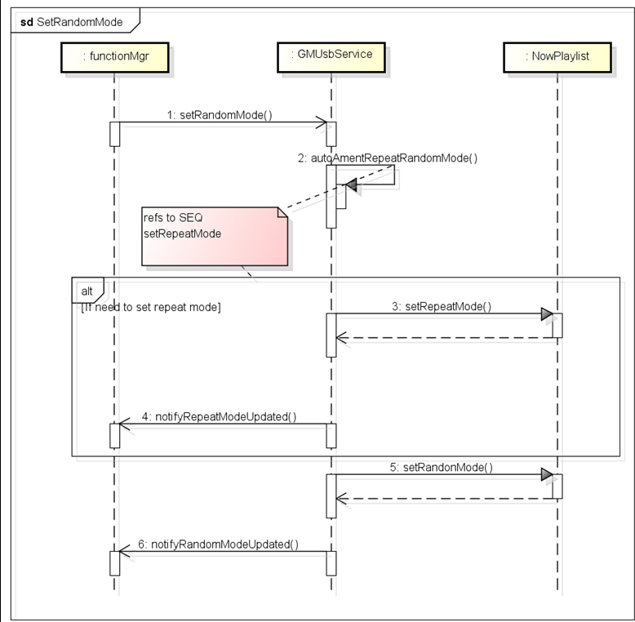

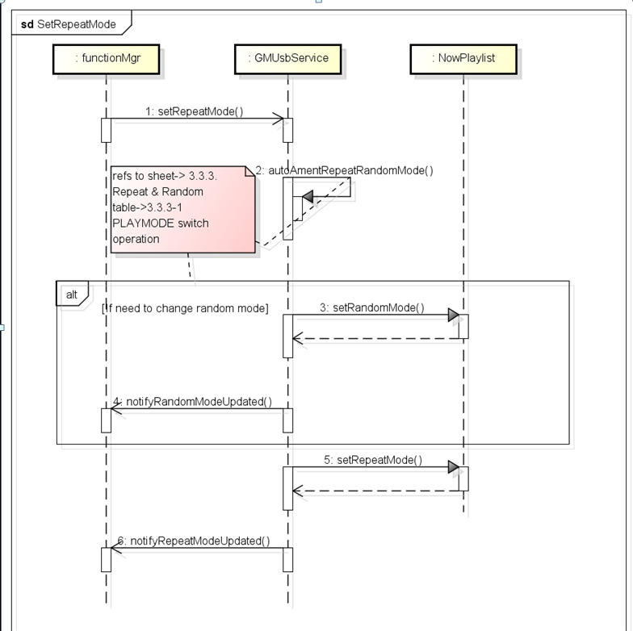

#### 涉及模块

functionManager

UsbService

DevicePlayer

#### 实现

Proxy

|  |
| --- |
| /// set random mode  uint64_t GMUsbProxy::setRandomMode(const GIUsbRandomMode& eRdmMode)  {  USBLOGD_FUNCALL;  static uint64_t call_id = 1;  unsigned int code = USBMethod_SetRandomMode;  android::Parcel data;  prepareAsyncData(data);  data.writeInt32(eRdmMode);  data.setDataPosition(0);  // request service  if (BS_NO_CONNECTION == sendAsyncRequest(code, data)) {  return 0; // invalid call id '0' to indicate error  }  return call_id++;  } |

UsbService中的case USBMethod_SetRandomMode:

在case中启动新的线程，执行setRandomMode方法

|  |
| --- |
| case USBMethod_SetRandomMode:  {  // define request param  GIUsbRandomMode eRdmMode;  // unpack request param  eRdmMode = static_cast<GIUsbRandomMode>(data.readInt32());  // call request function  // setRandomMode(id, eRdmMode);  GMTaskDes des(Runnable_Pri_N, 0, "USBMethod_SetRandomMode");  (m_pMainThread->looper()).postRunnable(GMTaskBind(des, this, &GMUsbServiceBase::setRandomMode  , id, eRdmMode));  break;  } |

SetRandomMode方法

在该方法中，往上层反馈结果，同时调用DevicePlayer中的postSetRandomMode方法

|  |
| --- |
| void GMUsbServiceBase::setRandomMode(SenderId sid, const GIUsbRandomMode& eRdmMode)  {  replySetRandomMode(sid, eRdmMode);  if (GMUsbSourceState_SourceOn != m_sourceState) {  USBLOGD("the source is not on, %d", m_sourceState);  DTLOG_INFO(0xB0201D, "tthe source is not on, %d", m_sourceState);  return ;  }  if (NULL != getDPlayer(sid)) {  getDPlayer(sid)->postSetRandomMode(eRdmMode);  }  } |

postSetRandomMod方法

|  |
| --- |
| void GMUsbDevicePlayer::postSetRandomMode(const GIUsbRandomMode &modeIn) /* __0x500014_DTFUNCID__ */  {  USBLOGD_FUNCALL;  if (m_pMPCbThread) {  m_pMPCbThread->looper().postRunnable(MRunnableTask(this, &GMUsbDevicePlayer::setRandomMode, modeIn));  }  else {  setRandomMode(modeIn);  }  } |

DevicePlayer中的setRandomMode方法

|  |
| --- |
| void GMUsbDevicePlayer::setRandomMode(const GIUsbRandomMode &modeIn) /* __0x50002B_DTFUNCID__ */  {  USBLOGD_FUNCALL;  USBLOGD("setRandomMode: modeIn is %d", modeIn);  // if (NULL == m_pNowPlayingList) {  // USBLOGD("m_pNowPlayingList not exist");  // return;  // }  m_pNowPlayingList->setRandomMode(static_cast<GMMediaPlaylist::RandomMode>(modeIn));  // randomModeUpdated(modeIn);  autoAmentRepeatRandomMode(RepRanToggle_Ran);  } |

在DevicePlayer的setRandowMode方法中，调用了autoAmentRandomMode方法。

|  |
| --- |
| // m_trickPlayMode默认是TrickPlayMode_RepAll_RanOff，重复，但不循环  switch (m_trickPlayMode) {  //默认的播放模式，repeatall，不循环  case TrickPlayMode_RepAll_RanOff: // state 1  {  if (RepRanToggle_Rep == repOrRan) {  m_trickPlayMode = TrickPlayMode_RepFld_RanOff; // state 2  m_pNowPlayingList->setRepeatMode(GMMediaPlaylist::RepeatMode_List);  repeatModeUpdated(GIUsbRepeatMode_List);  }  else if (RepRanToggle_Ran == repOrRan){  m_trickPlayMode = TrickPlayMode_RepAll_RanAll; // state 4  m_pNowPlayingList->setRandomMode(GMMediaPlaylist::RandomMode_All);  randomModeUpdated(GIUsbRandomMode_All);  }  else {  }  break;  } |

在上面的方法中，调用了PlayingList中的setRandomMode方法

|  |
| --- |
| void GMMediaPlaylist::setRandomMode(RandomMode randomMode)  {  PLLOGD("setRandomMode = [%d]", randomMode);  m_randomMode = randomMode;  m_errorCountInList = 0;  m_listError = false;  //真正的逻辑  if (RandomMode_All == randomMode || RandomMode_List == randomMode) {  //随机打乱播放顺序  random_shuffle(m_random.begin(), m_random.end());  //循环list  for (unsigned int i = 0; i < m_random.size(); ++i) {  if (NULL != m_random[i].get()) {  if (m_originIndex == m_random[i]->index()) { // index in all list  m_randomIndex = i;  m_random[i]->setPlayed(true);  }  else {  m_random[i]->setPlayed(false);  }  }  }  }  amendIndexAndCount();  updatePlaylistInfo();  } |

PlayList 中的setRepeatMode方法

|  |
| --- |
| void GMMediaPlaylist::setRepeatMode(RepeatMode repeatMode)  {  PLLOGD("setRepeatMode = [%d]", repeatMode);  m_repeatMode = repeatMode;  m_errorCountInList = 0;  m_listError = false;  amendIndexAndCount();  updatePlaylistInfo();  } |

#### 常用方法总结

### setWideMode

设置全屏显示

#### 时序

无

#### 涉及模块

FunctionManager

UsbService

#### 实现

Proxy

|  |
| --- |
| /// set wide mode  uint64_t GMUsbProxy::setWideMode(const GIUsbWideMode& eWideMode)  {  USBLOGD_FUNCALL;  static uint64_t call_id = 1;  unsigned int code = USBMethod_SetWideMode;  android::Parcel data;  prepareAsyncData(data);  data.writeInt32(eWideMode);  data.setDataPosition(0);  // request service  if (BS_NO_CONNECTION == sendAsyncRequest(code, data)) {  return 0; // invalid call id '0' to indicate error  }  return call_id++;  } |

UsbService中case中接收请求

|  |
| --- |
| case USBMethod_SetWideMode:  {  // define request param  GIUsbWideMode eWideMode;  // unpack request param  eWideMode = static_cast<GIUsbWideMode>(data.readInt32());  // call request function  // setWideMode(id, eWideMode);  GMTaskDes des(Runnable_Pri_N, 0, "USBMethod_SetWideMode");  (m_pMainThread->looper()).postRunnable(GMTaskBind(des, this, &GMUsbServiceBase::setWideMode  , id, eWideMode));  break;  } |

起一个新的线程，调用本类中的setWideMode方法。

在这个方法中，只是往上层反馈消息，并没有继续往下层调用处理

|  |
| --- |
| void GMUsbServiceBase::setWideMode(SenderId sid, const GIUsbWideMode& eWideMode) /* __0xB0201E_DTFUNCID__ */  {  // reserved  replySetWideMode(sid, eWideMode);  } |

replySetWideMode方法

往上层发送请求，反馈service端的处理结果

|  |
| --- |
| void GMUsbServiceBase::replySetWideMode(SenderId sid, const GIUsbWideMode& eWideMode)  {  USBLOGD_FUNCALL;  android::Parcel data;  unsigned int code = USBMethod_SetWideMode;  data.writeInt32(eWideMode);  data.setDataPosition(0);  sendAsyncResponse(sid, code, data);  } |

在proxy的onAsyncResponse方法的case中接受请求

调用functionManager中的反馈接口中的replySetWideMode方法。

|  |
| --- |
| case USBMethod_SetWideMode:  {  // define reply param  uint64_t call_id = 0;  GIUsbWideMode eWideMode = static_cast<GIUsbWideMode>(reply.readInt32());  m_spReply->replySetWideMode(eWideMode, call_id);  }  break |

#### 常用方法总结

无

### RequestStatus

#### 时序

#### 涉及模块

FunctionManager

UsbService

DevicePlayer

#### 实现

Proxy

|  |
| --- |
| /// request binded source status  uint64_t GMUsbProxy::requestStatus(const uint32_t notificationMask)  {  USBLOGD_FUNCALL;  static uint64_t call_id = 1;  unsigned int code = USBMethod_RequestStatus;  android::Parcel data;  prepareAsyncData(data);  data.writeInt32(notificationMask);  data.setDataPosition(0);  // request service  if (BS_NO_CONNECTION == sendAsyncRequest(code, data)) {  return 0; // invalid call id '0' to indicate error  }  return call_id++;  } |

在USBservice中的接受请求

在这里调用给类中的RequestStatus方法，处理逻辑

|  |
| --- |
| }  case USBMethod_RequestStatus:  {  // define request param  uint32_t notificationMask;  // unpack request param  notificationMask = data.readInt32();  // call request function  // requestStatus(id, notificationMask);  //通过传过来的notificationMask参数和0x702、0x703参数比较。确定是否销毁或者清空线程。  if (0x702 == notificationMask) {  m_pMainThread->looper().dumpRunnable();  break;  }  else if (0x703 == notificationMask) {  m_pMainThread->looper().clearRunnable();  break;  }  GMTaskDes des(Runnable_Pri_N, 0, "USBMethod_RequestStatus");  (m_pMainThread->looper()).postRunnable(GMTaskBind(des, this, &GMUsbServiceBase::requestStatus  , id, notificationMask));  break;  } |

RequestStatus方法

|  |
| --- |
| void GMUsbServiceBase::requestStatus(SenderId sid, const uint32_t notificationMask)  {  UNUSED(notificationMask);  //定义GIUsbServiceStatus,usbservice的所有相关状态  GIUsbServiceStatus statusInfo;  //调用getDPlayer方法，获得DevicePlayer对象，再调用其中的mediaStatus方法。  if (NULL != getDPlayer(sid)) {  statusInfo = getDPlayer(sid)->mediaStatus();  }  //往上层反馈，将GIUsbServiceStatus 这个包含了usbService中所有状态的结构体返回给调用方  replyRequestStatus(sid, statusInfo);  } |

DevicePlayer对象中的mediaStatus方法

|  |
| --- |
| //将 GIUsbServiceStatus返回给调用方。  const GIUsbServiceStatus& mediaStatus()  {  return m_mediaStatus;  } |

在functionManager中接收到service端返回给他的GIUsbServiceStatus数据，根据需求进行解析。并将解析出的结果封装在message中发送给上层。

#### 常用方法总结

### SelectUID

方法说明

selectUid，通过播放想要播放的曲目的id。选择 播放的音屏

#### 时序

#### 涉及模块

functionManager

UsbService

DevicePlayer

PlayingList

MediaProvider

#### 实现

Proxy

|  |
| --- |
| /// select file play by UID  //选择UId选择需要播放的文件  uint64_t GMUsbProxy::selectUID(const uint32_t uid, const bool isFastFileChange)  {  USBLOGD_FUNCALL;  static uint64_t call_id = 1;  unsigned int code = USBMethod_SelectUID;  android::Parcel data;  prepareAsyncData(data);  data.writeInt32(uid);  data.writeInt32(isFastFileChange);  data.setDataPosition(0);  // request service  if (BS_NO_CONNECTION == sendAsyncRequest(code, data)) {  return 0; // invalid call id '0' to indicate error  }  return call_id++;  } |

Usb Service中的Case

|  |
| --- |
| case USBMethod_SelectUID:  {  // define request param  uint32_t uid;  bool isFastFileChange;  // unpack request param  uid = data.readInt32();  isFastFileChange = data.readInt32();  // call request function  // selectUID(id, uid);  GMTaskDes des(Runnable_Pri_N, 0, "USBMethod_SelectUID");  (m_pMainThread->looper()).postRunnable(GMTaskBind(des, this, &GMUsbServiceBase::selectUID  , id, uid, isFastFileChange));  break;  } |

经过层层调用，先是调用了DevicePalyer中的selectUID方法

|  |
| --- |
| void GMUsbDevicePlayer::selectUID(uint32_t uid, bool isFastFileChange) /* __0x500021_DTFUNCID__ */  {  USBLOGD_FUNCALL;  m_readyToPlay = true;  if (NULL == m_pNowPlayingList) {  DTLOG_INFO(0x500021, "m_pNowPlayingList not exis");  return;  }  //通过传入的参数判断。为false使，调用autoAmentRepeatRandomMode方法。  if(!isFastFileChange) {  autoAmentRepeatRandomMode(RepRanToggle_Clear);  }  stop();  m_pNowPlayingList->selectUid(uid);  } |

最终调用到了PlayingList中的selectUID方法

|  |
| --- |
| bool GMMediaPlaylist::selectUid(unsigned int uid)  {  PLLOGD("selectUid : uid = [%d]", uid);  //判断原始文件list是否为空，为空返回false  if (m_origin.empty()) {  PLLOGW("list is empty, return false");  return false;  }  if (NULL == m_cb || DeviceType_None >= m_deviceInfo.type() || DeviceType_Count <= m_deviceInfo.type()) {  PLLOGW("selectUid : param error, m_cb = [%p], type = [%d]", m_cb, m_deviceInfo.type());  return false;  }  if (m_totalError) {  PLLOGW("warning : selectUid !!totalError!!");  m_cb->onPlaylistEnded(EndedType_AllError);  return true;  }  //通过循环的方式，设置originIndex和传过来的uid相同。同时设置index文件为可播放状态。  unsigned int count = m_origin.size();  for (m_originIndex = 0; m_originIndex < count; ++m_originIndex) {  if (NULL != m_origin[m_originIndex].get() && m_origin[m_originIndex]->fid() == static_cast<int>(uid)) {  setPlayable(m_origin[m_originIndex]->index(), true);  break;  }  }  PLLOGD("debug : m_listIndex = [%d], m_originIndex = [%d]", m_listIndex, m_originIndex);  if (m_originIndex >= count) {  PLLOGD("song not found , play the first one");  m_originIndex = 0;  }  // keep the m_randomIndex point to the current item  //设置循环的索引指针和当前Item相同。目的是维持两个表指针同步  count = m_random.size();  for (unsigned int i = 0; i < count; ++i) {  if (NULL != m_random[i].get() && m_random[i]->index() == m_originIndex) {  m_randomIndex = i;  break;  }  }  //将随机表中的现在的index对应的item设置为可播放  if (NULL != m_random[m_randomIndex].get()) {  m_random[m_randomIndex]->setPlayed(true);  }  if (NULL != m_origin[m_originIndex].get()) {  amendListInfoIndex();  updatePlaylistInfo();  m_cb->onPlayItemChanged(m_origin[m_originIndex]);  }  m_errorCountInList = 0;  return true;  } |

在PlayingList中的selectUID方法中，最终将通过UID查询出的结果，通过callBack返回给调用方DevicePlayer。在DevicePlayer中，根据返回的结果对一系列的值进行处理。

#### 常用方法总结

### ReqSourceChange

#### 方法说明

ReqSourceChange方法，请求改变资源。资源的状态有

GIUsbSourceChangeMode_On----打开播放器

GIUsbSourceChangeMod_Off----关闭播放器

GIUsbSourceChangeMode_DKStop-----暂停播放

GIUsbSourceChangeMode_DKStopOff----结束暂停，继续播放

GIUsbSourceChangeMode_OnWithMiracast----通过Miracast的方式打开播放器

等多种方式。根据上层传过来的请求改变的状态，进行对应的逻辑处理。

该方法的主要作用是，当播放音视频时，打开、关闭播放器，点击暂停按钮，播放按钮等改变状态的情景时，会调用该方法。

#### 时序

暂无

#### 涉及模块

functionManger

UsbService

DevicePlayer

#### 实现

在proxy中的reqSourceChange

|  |
| --- |
| uint64_t GMUsbProxy::reqSourceChange(const GIUsbSourceChangeInfo& info)  {  USBLOGD_FUNCALL;  static uint64_t call_id = 1;  unsigned int code = USBMethod_ReqSourceChange;  android::Parcel data;  prepareAsyncData(data);  info.writeToParcel(data);  data.setDataPosition(0);  // request service  if (BS_NO_CONNECTION == sendAsyncRequest(code, data)) {  return 0; // invalid call id '0' to indicate error  }  return call_id++;  } |

在service中接收请求

|  |
| --- |
| case USBMethod_ReqSourceChange:  {  // define request param  GIUsbSourceChangeInfo info;  // unpack request param  info.readFromParcel(data);  // call request function  // selectUID(id, uid);  GMTaskDes des(Runnable_Pri_N, 0, "USBMethod_ReqSourceChange");  (m_pMainThread->looper()).postRunnable(GMTaskBind(des, this, &GMUsbServiceBase::reqSourceChange  , id, info));  break;  } |

调用该类中的reqSourceChange方法.。在这个方法中，通过if else的方式，对所有的可能改变的资源进行了判断。

|  |
| --- |
| void GMUsbServiceBase::reqSourceChange(SenderId sid, const GIUsbSourceChangeInfo& info)  {  //通过ClientMgr获取设备的ID  int deviceId = m_spClientMgr->getDeviceId(sid);  if (GIUsbSourceChangeMode_On == info.eMode) {  USBLOGD("the value of info.isLastSource is %d",info.isLastSource);  //尝试打开资源 。在baseService中 没有实现，在service中做了具体实现。  trySourceOn(deviceId, info.isLastSource, info.screen);  }  else if (GIUsbSourceChangeMode_Off == info.eMode) {  trySourceOff(deviceId, info.screen);  }  //暂停  else if (GIUsbSourceChangeMode_DKStop == info.eMode) {  USBLOGD("TODO:");  if (NULL != getDPlayer(sid)) {  当状态为DKStop，先调用DevicePlayer中的方法暂停播放。  getDPlayer(sid)->pause();  }  GIUsbSourceChangeInfo result;  result.isLastSource = false;  result.eMode = GIUsbSourceChangeMode_DKStop;  result.eResult = GIUsbSourceChangeRlt_Succeed;  result.screen = 0;  notifySourceChanged(sid, result);  }  //暂停结束。开始播放  else if (GIUsbSourceChangeMode_DKStopOff == info.eMode) {  USBLOGD("TODO : maybe need to record last player state");  GMUsbDevicePlayer* DKdevicePlayer = getDPlayer(sid);  if (NULL != DKdevicePlayer) {  GIUsbServiceStatus status = DKdevicePlayer->mediaStatus();  DKdevicePlayer->play();  DKdevicePlayer->playItemUpdated(status.itemInfo);  DKdevicePlayer->metaDataUpdated(status.metaInfo);  }  GIUsbSourceChangeInfo result;  result.isLastSource = false;  result.eMode = GIUsbSourceChangeMode_DKStopOff;  result.eResult = GIUsbSourceChangeRlt_Succeed;  result.screen = 0;  //往上层发送通知  notifySourceChanged(sid, result);  }  //the follow case is designed for the miracast source change to usb  else if (GIUsbSourceChangeMode_OnWithMiracast == info.eMode) {  USBLOGD("TODO : the source from miracast to usb");  if (NULL != getDPlayer(sid)) {  getDPlayer(sid)->setMiracastSourceValue(true);  }  trySourceOn(deviceId, info.isLastSource, info.screen);  }  } |

========================================

### 模版

#### 时序

#### 涉及模块

#### 实现

#### 常用方法总结