  - LV Marlowe

Project Documentation
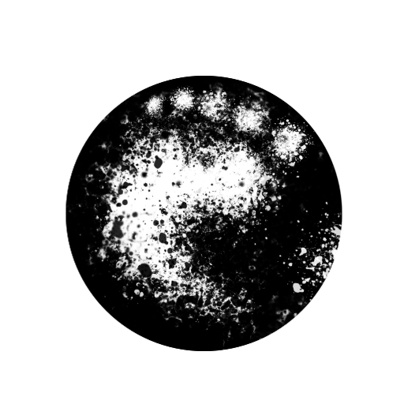

Executive Summary
Inkstride is a narrative-driven Android step-tracking application that converts real-world walking into structured story progression. The app reads cumulative step totals through Android Health Connect and maps distance to milestones along a fixed journey route. When milestones are reached, story segments unlock and are stored in a Storybook view for later reading. Progress is based on total distance rather than speed, scoring, or competition.
The application is implemented for Android using Kotlin and Jetpack Compose for the user interface, with Room (SQLite) used for local data persistence. The delivered scope covers Act 1, a complete 168-mile (approximately 336,000-step) narrative across six biomes. The project includes two primary screens: Journey for progress tracking and Storybook for unlocked narrative segments. Competitive mechanics such as leaderboards and rankings are intentionally excluded to keep the experience low-pressure and narrative-focused.

Scenario 1 | First Launch + Permission Grant
The user opens Inkstride for the first time and lands on the Permissions screen. The screen displays a Grant Permissions button along with a prompt explaining that Health Connect step access is required to calculate journey distance and unlock story milestones. The user taps the button, which triggers the Health Connect permission request. If permissions are granted, the app separately requests background read access. Once both permission steps are resolved, the router determines the first destination.

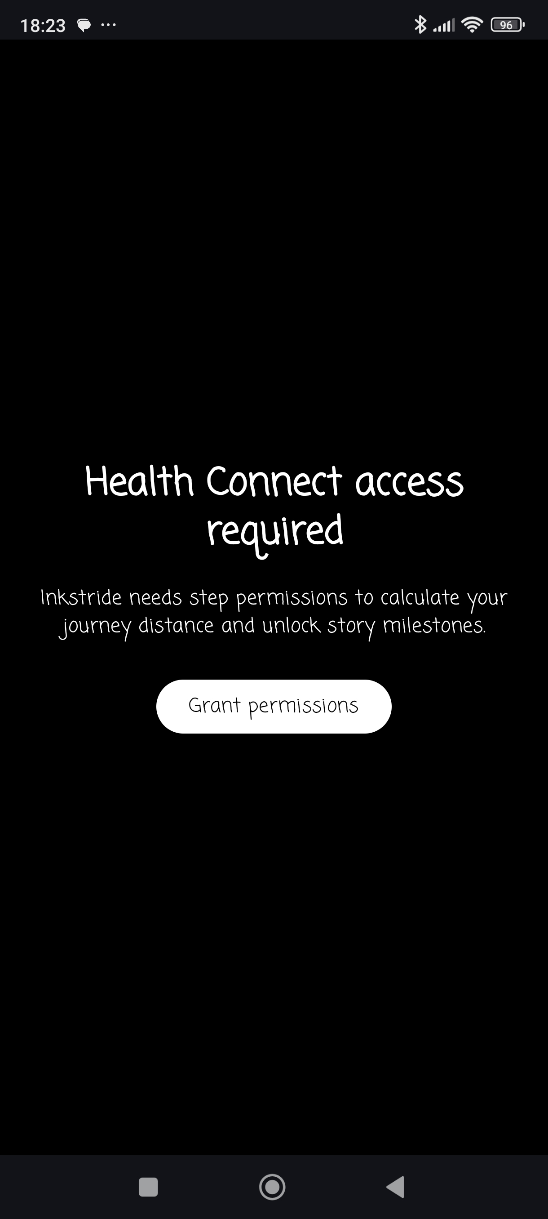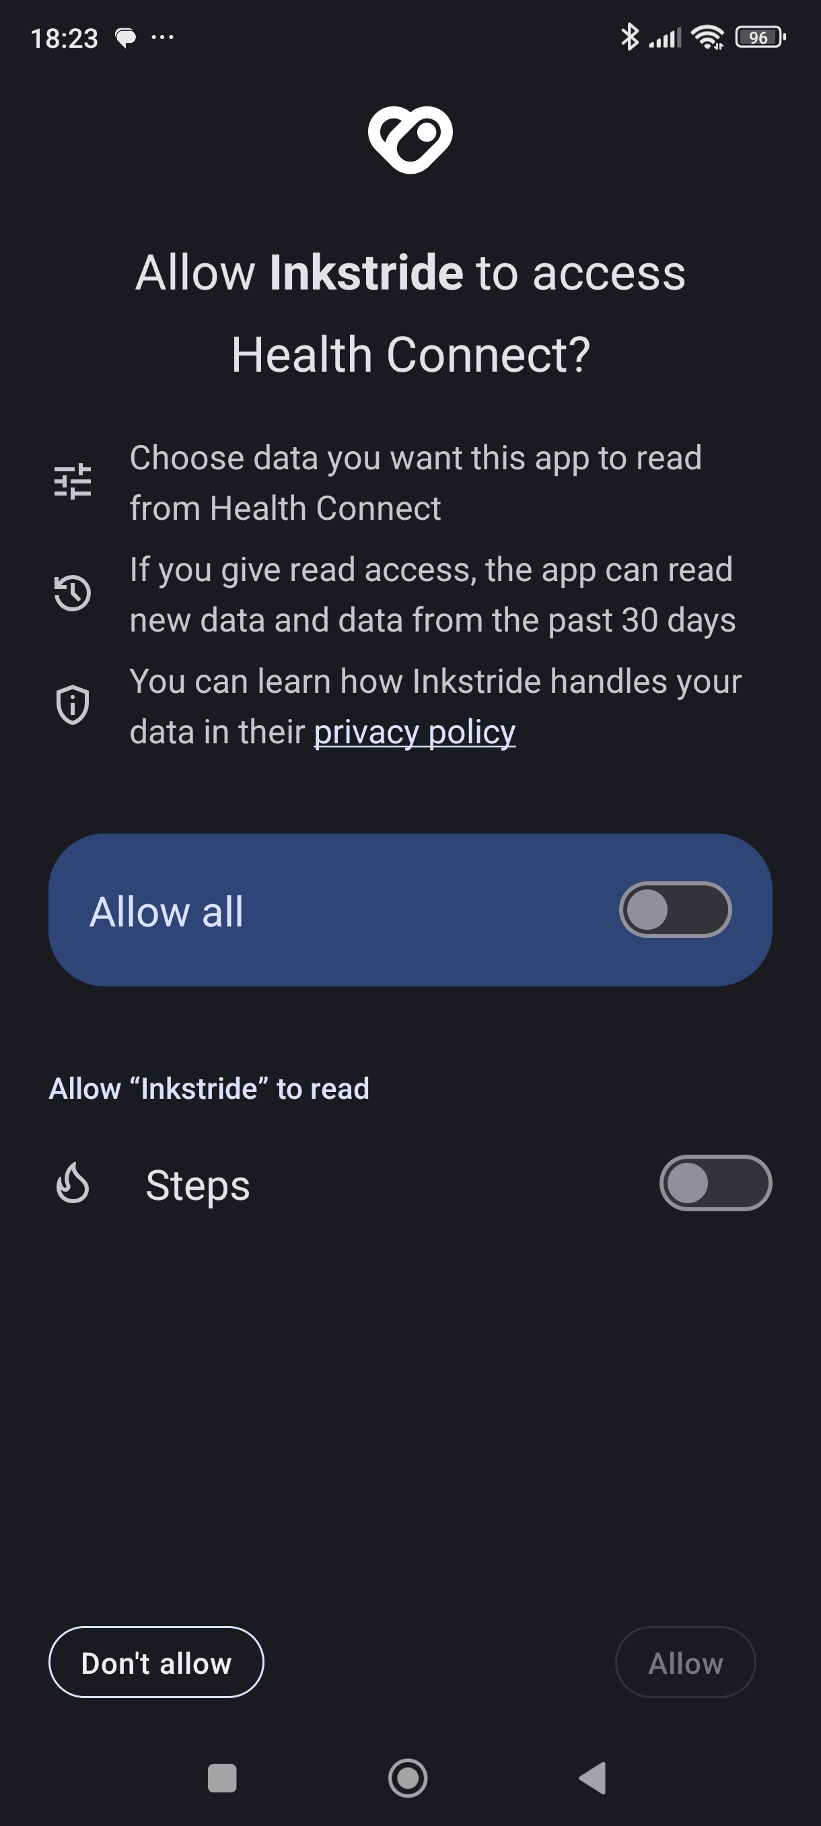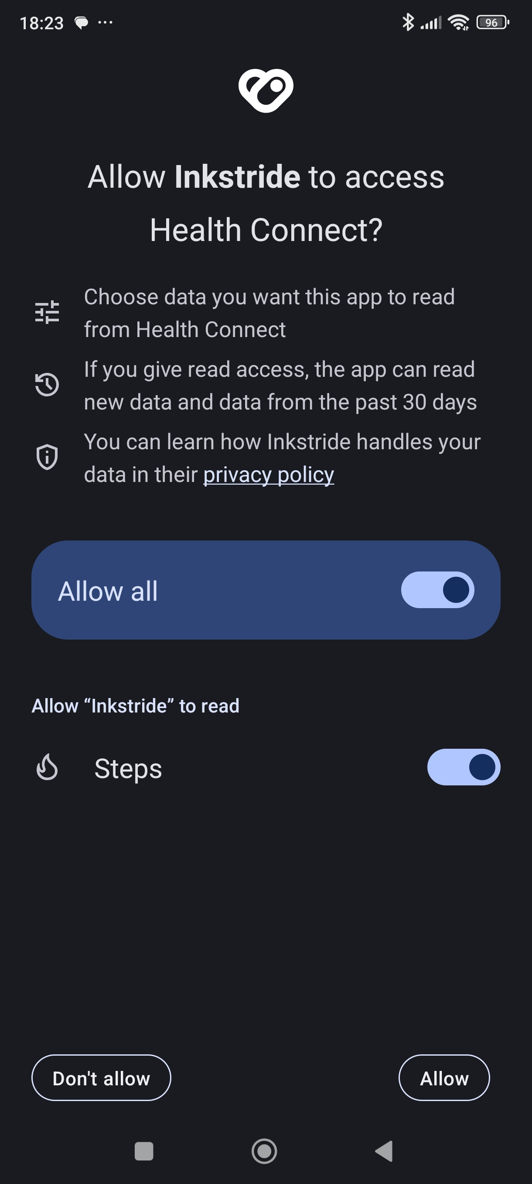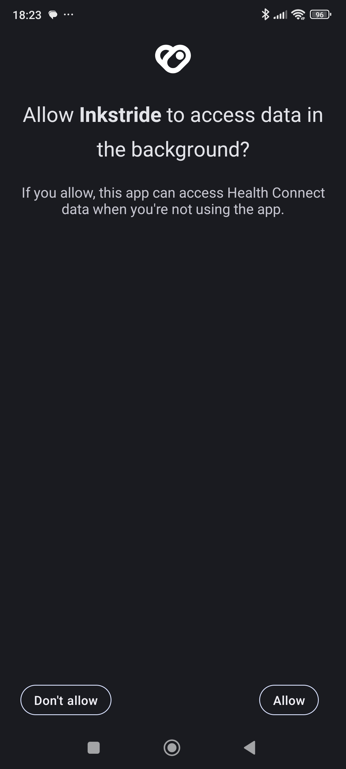

Scenario 2 | Intro Story
After the user has granted permissions, the router detects that the intro story segment is unlocked and unread and sends the user to the Intro Story Unlock screen. The screen displays the intro story segment text in a horizontal pager with a Continue button. The intro segment is associated with a distance marker of 0.0 and is unlocked by default, so it is available immediately without any walking required. The user taps Continue, which marks the intro story segment as read and routes them to the Journey screen. The Intro Story routing is only triggered once, as the router bypasses it on subsequent launches.

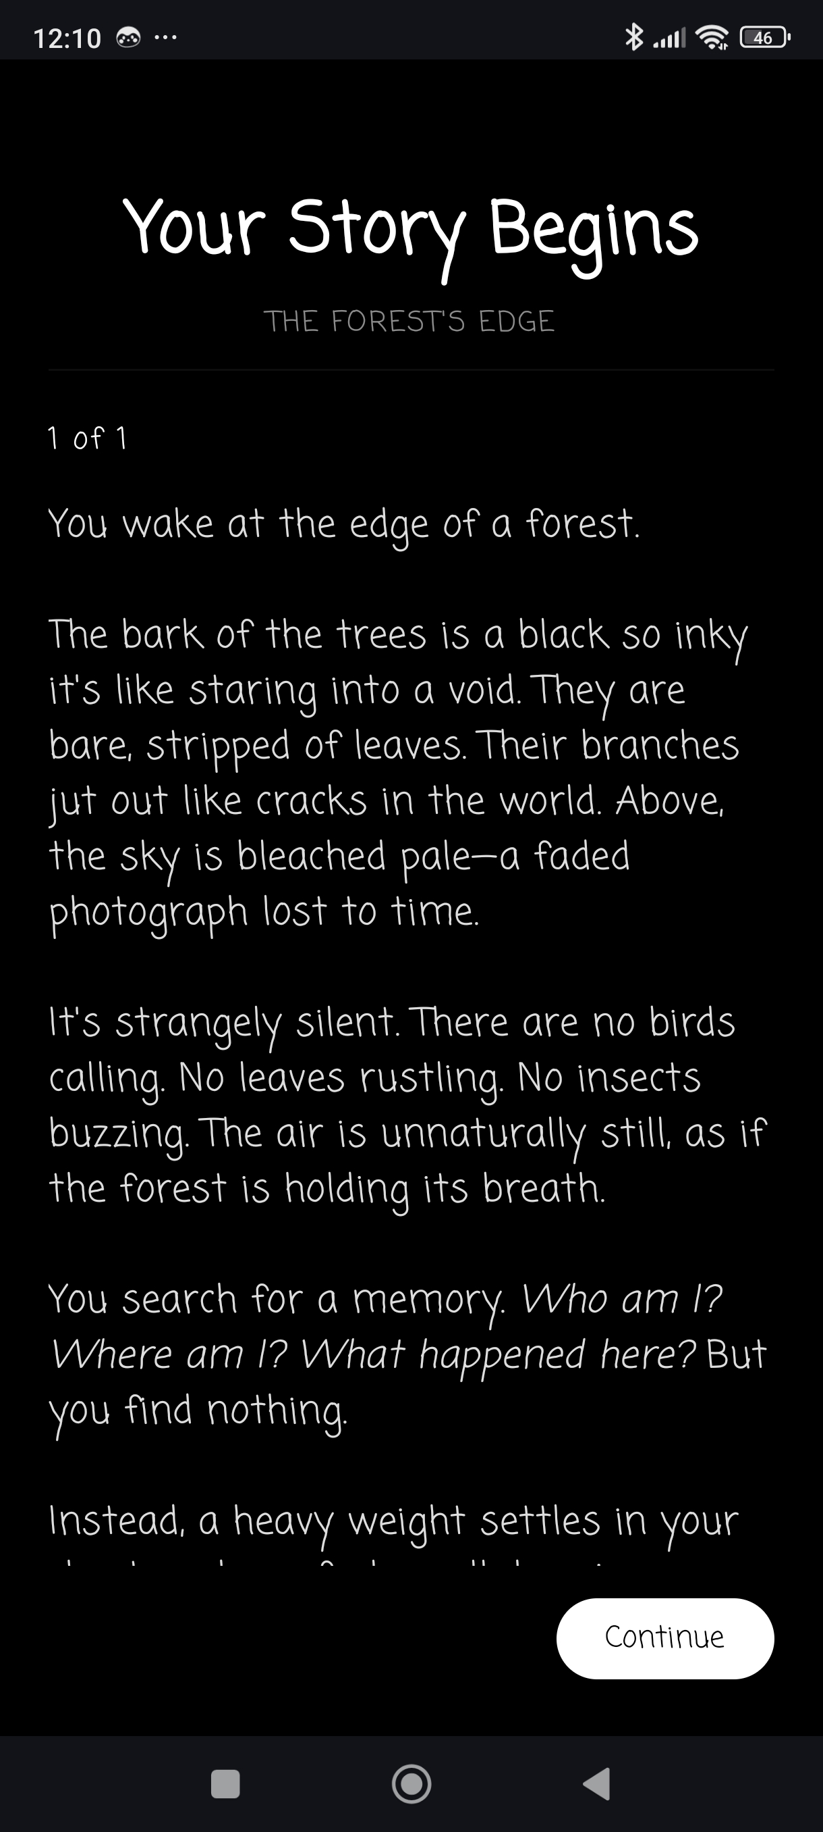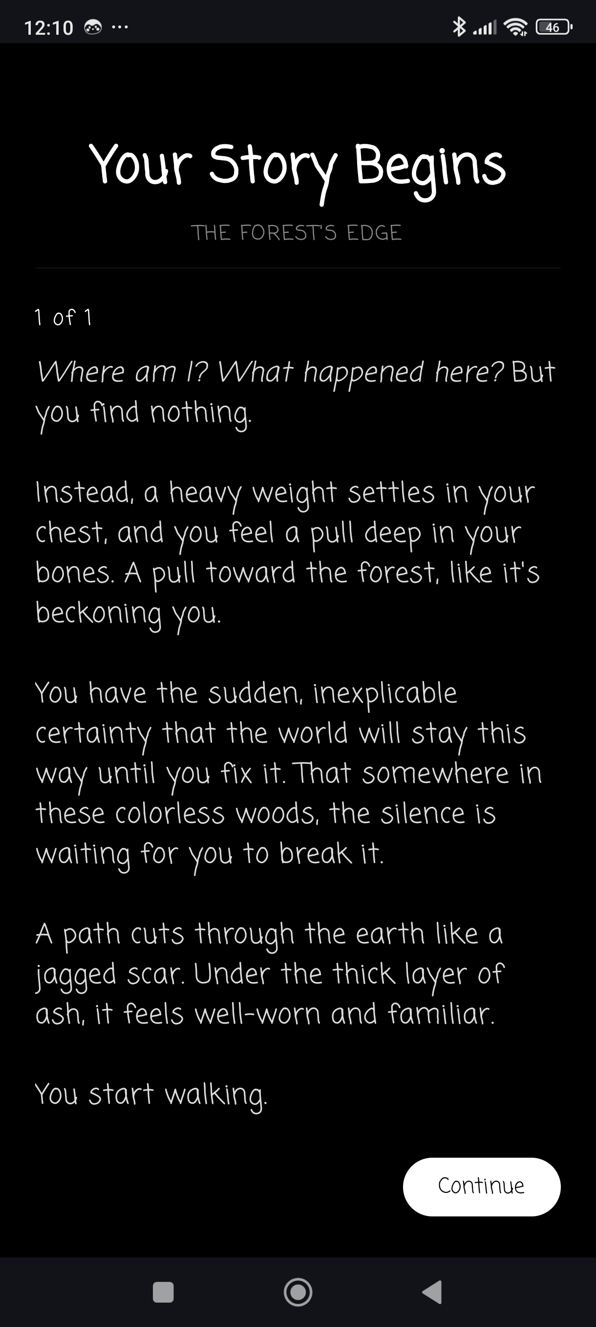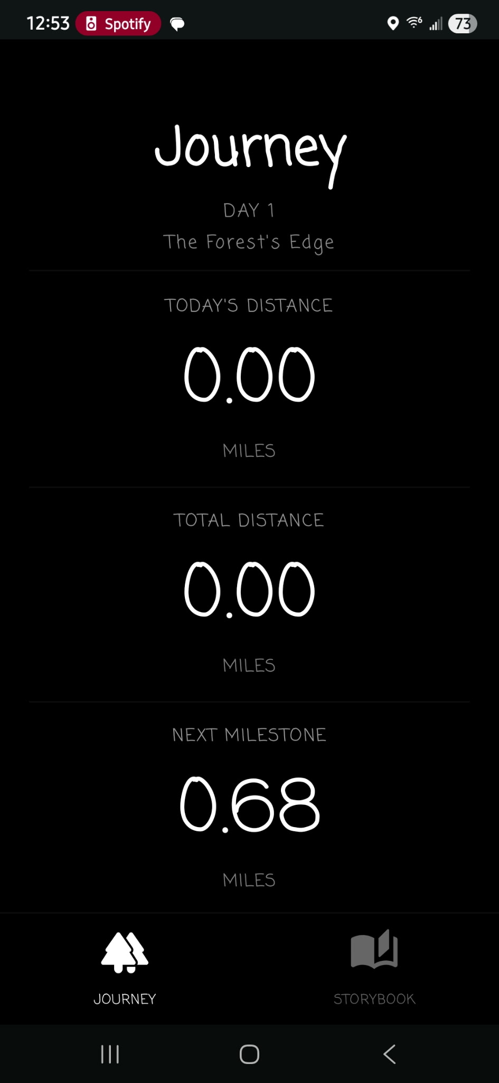

Scenario 3 | Journey Progress Check
The user taps the Journey icon to open the Journey screen and check their progress. The screen displays the current day number, forest area name, today's distance, total cumulative distance, and the remaining distance to the next milestone. The user pulls to refresh, triggering a manual sync that fetches the latest step totals from Health Connect and runs a milestone unlock check. A brief "Synced" status message flashes at the top of the screen, and the distance totals are updated.

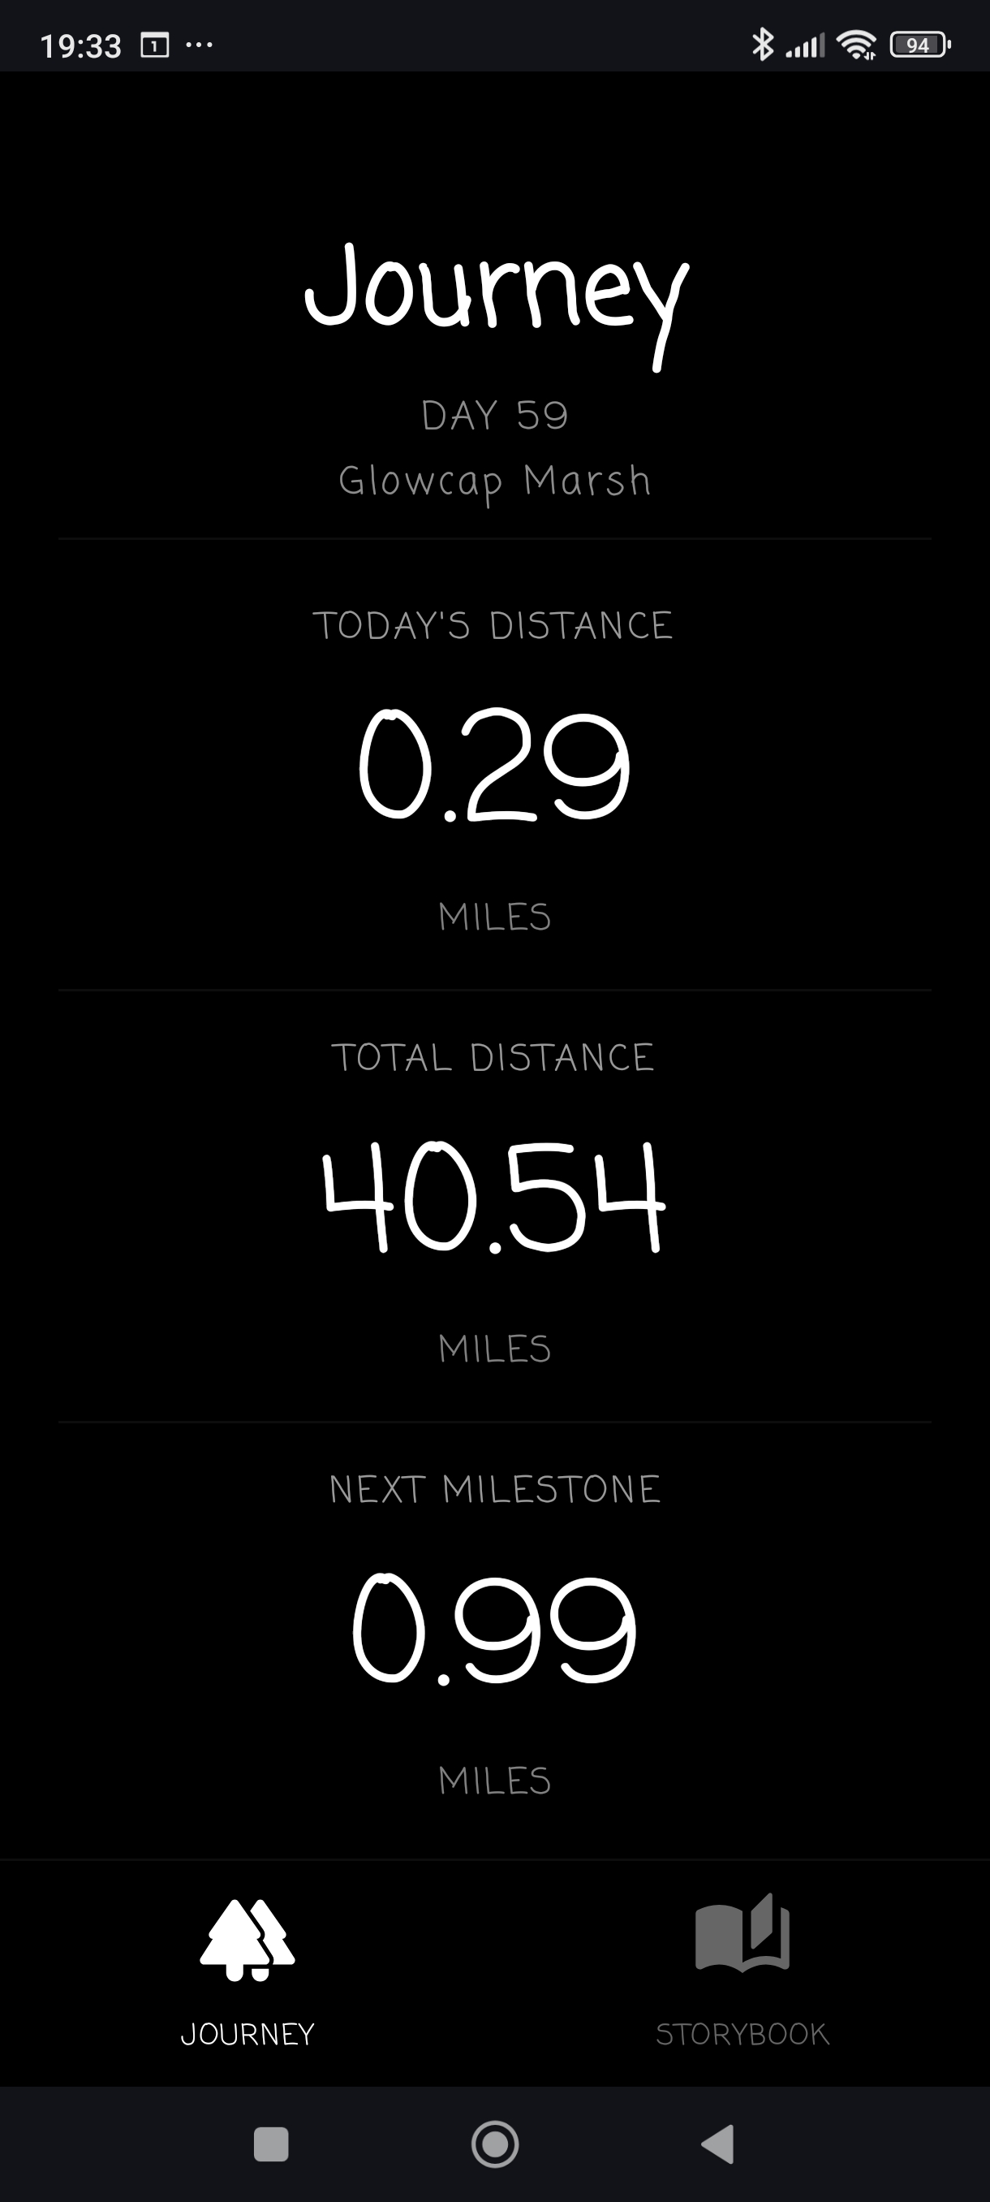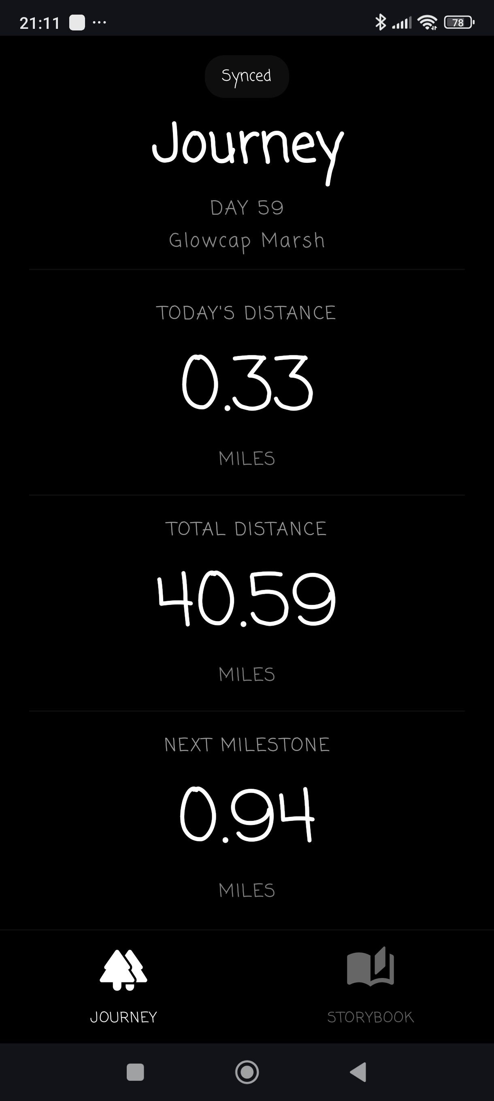

Scenario 4 | New Story Segments Unlocked
After the user has walked enough to reach new milestones, the app detects the newly unlocked story segments and displays a notification badge on the Storybook icon in the bottom navigation bar. The user taps the Storybook icon and is routed to the Story Unlock screen. The screen displays the title of the currently displayed unlocked segment and a count of how many unlocked and unread segments there are. Each segment is displayed in a horizontal pager and marked read when paged to. A forward arrow appears between pages when more than one segment is present and the user is not on the last page.
The user reads the first segment and taps the arrow to scroll to the next. They read the second segment and tap the Continue button at the bottom of the screen to be routed back to the Journey or Storybook screen, depending on where they came from. The notification badge remains on the Storybook icon until all unlocked story segments are read. Read story segments are added to the Storybook.

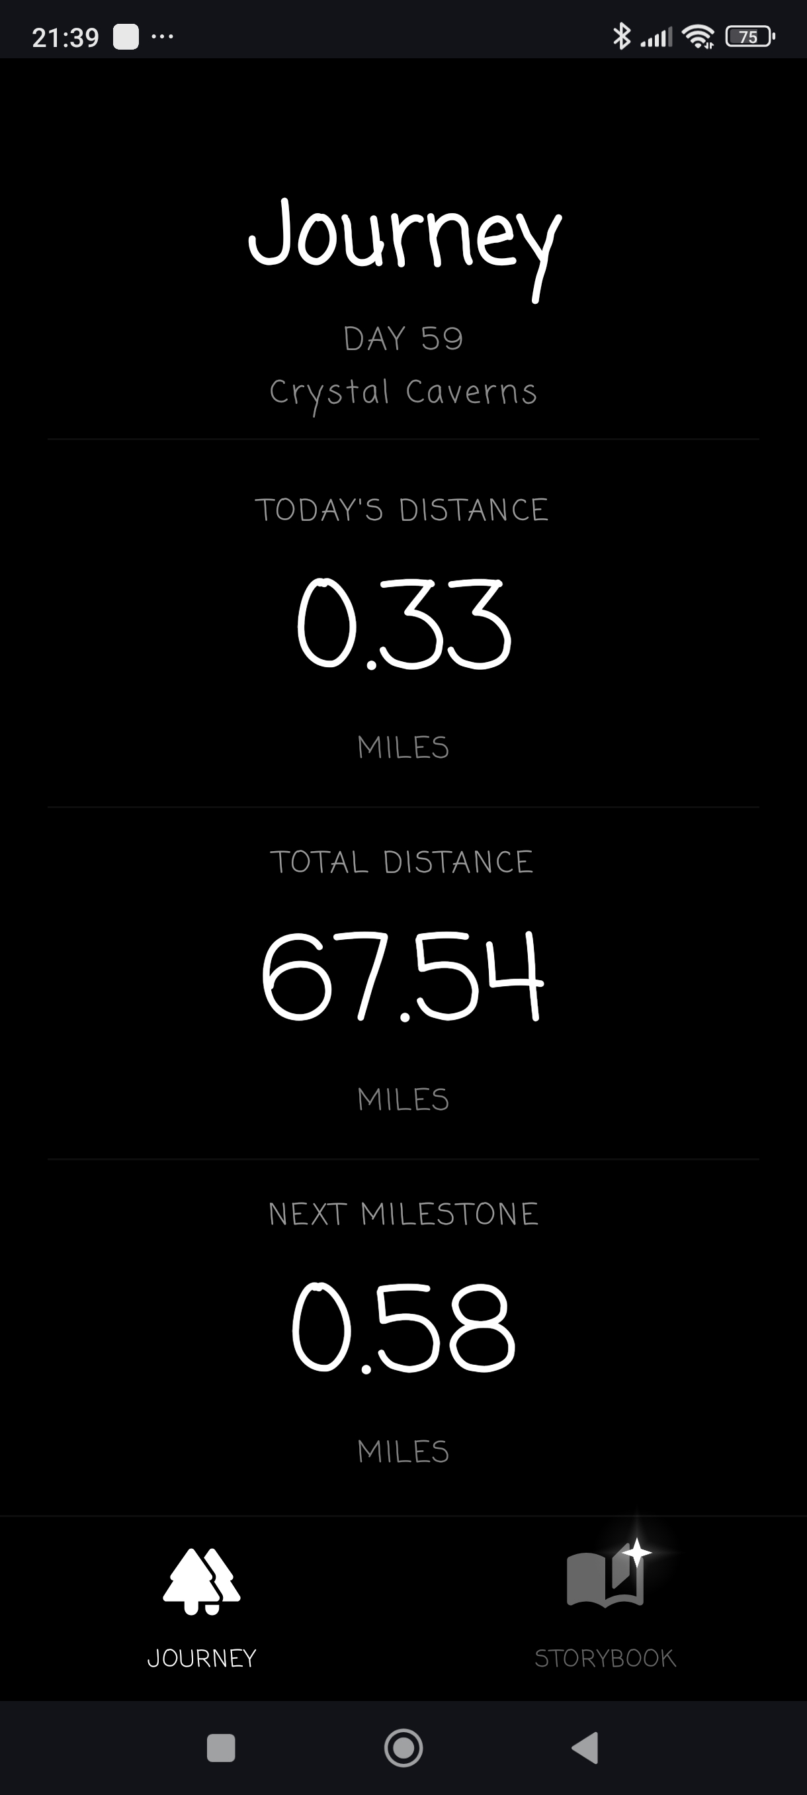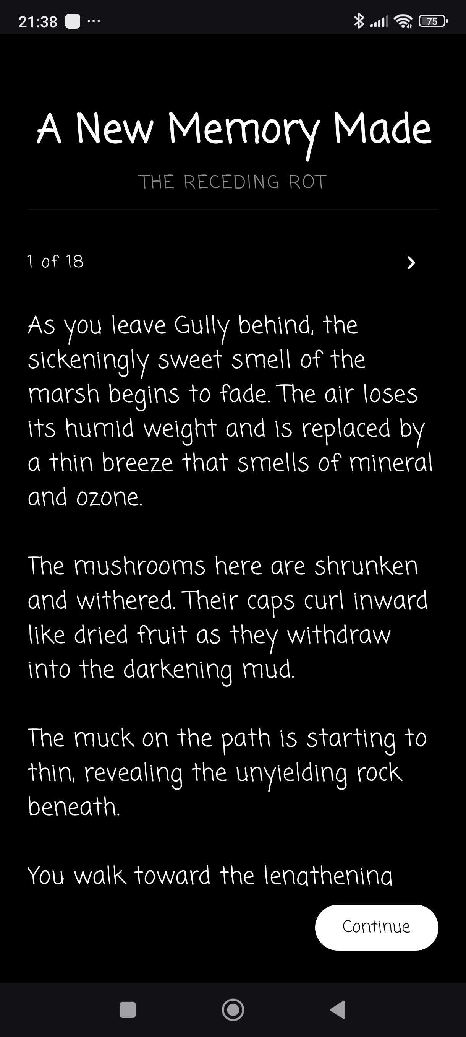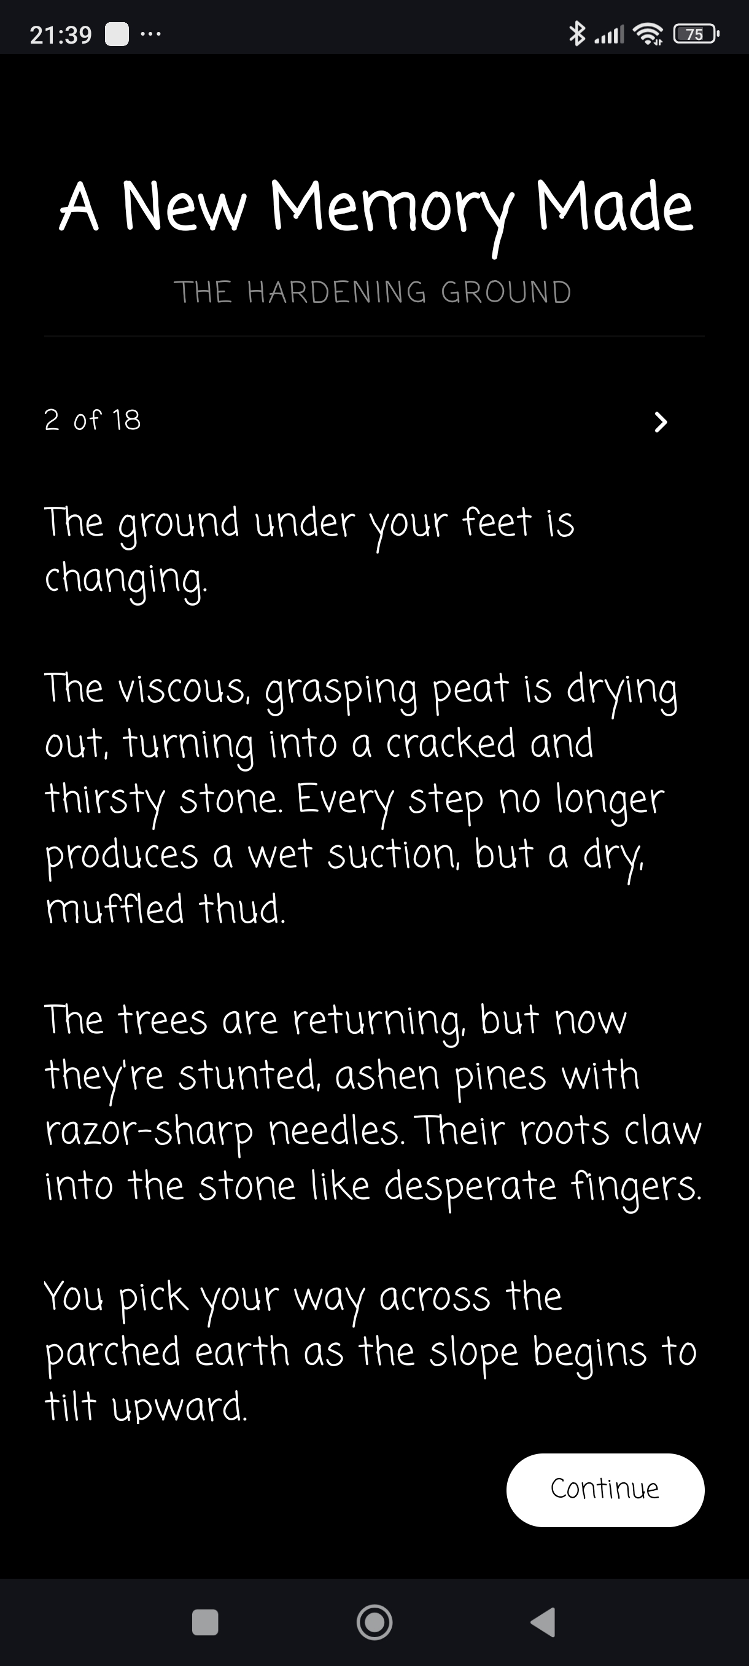

Scenario 5 | Storybook Review
The user has been away from the app for several days and cannot remember where the story left off. They tap the Storybook icon to open the Storybook screen and scroll through their previously unlocked and read story segments to refresh their memory. Segments are displayed in milestone order as continuous scrollable text, with each area of the forest displayed above the events occurring in that area. As the user scrolls, they notice that a segment they recently unlocked recontextualizes something that happened much earlier in the story. They scroll back to the earlier segment to reread it with this new understanding, then continue forward through the rest of the story to piece together the full picture. When they are done, the user taps the Journey icon to return to the Journey screen.

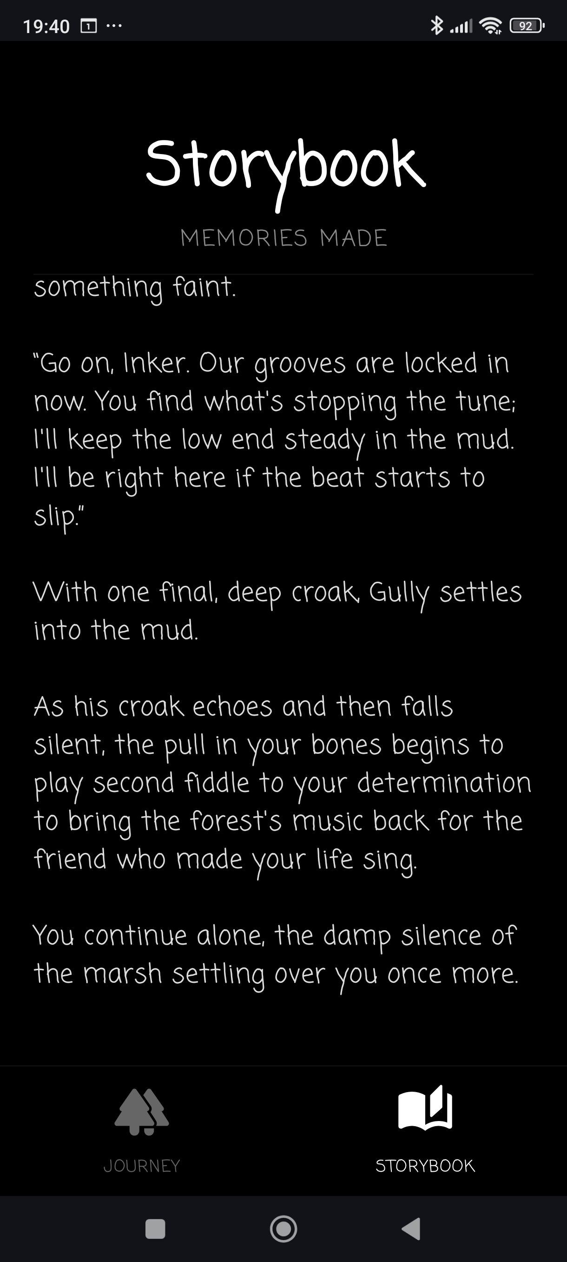

Reports
Inkstride does not generate printable or exported reports in the traditional sense, but it does provide three report-like in-app readouts that communicate user progress and story state. These screens function as live reports for user progress throughout the app.
- Journey screen: Displays the current day of the journey, today’s distance, total cumulative distance, and remaining distance to the next milestone


- Storybook screen: Lists all read and unlocked segments in journey order, with persistent area labels tied to milestone progression


- Story Unlock screen: Presents newly unlocked segment pages and tracks read-state as the user navigates

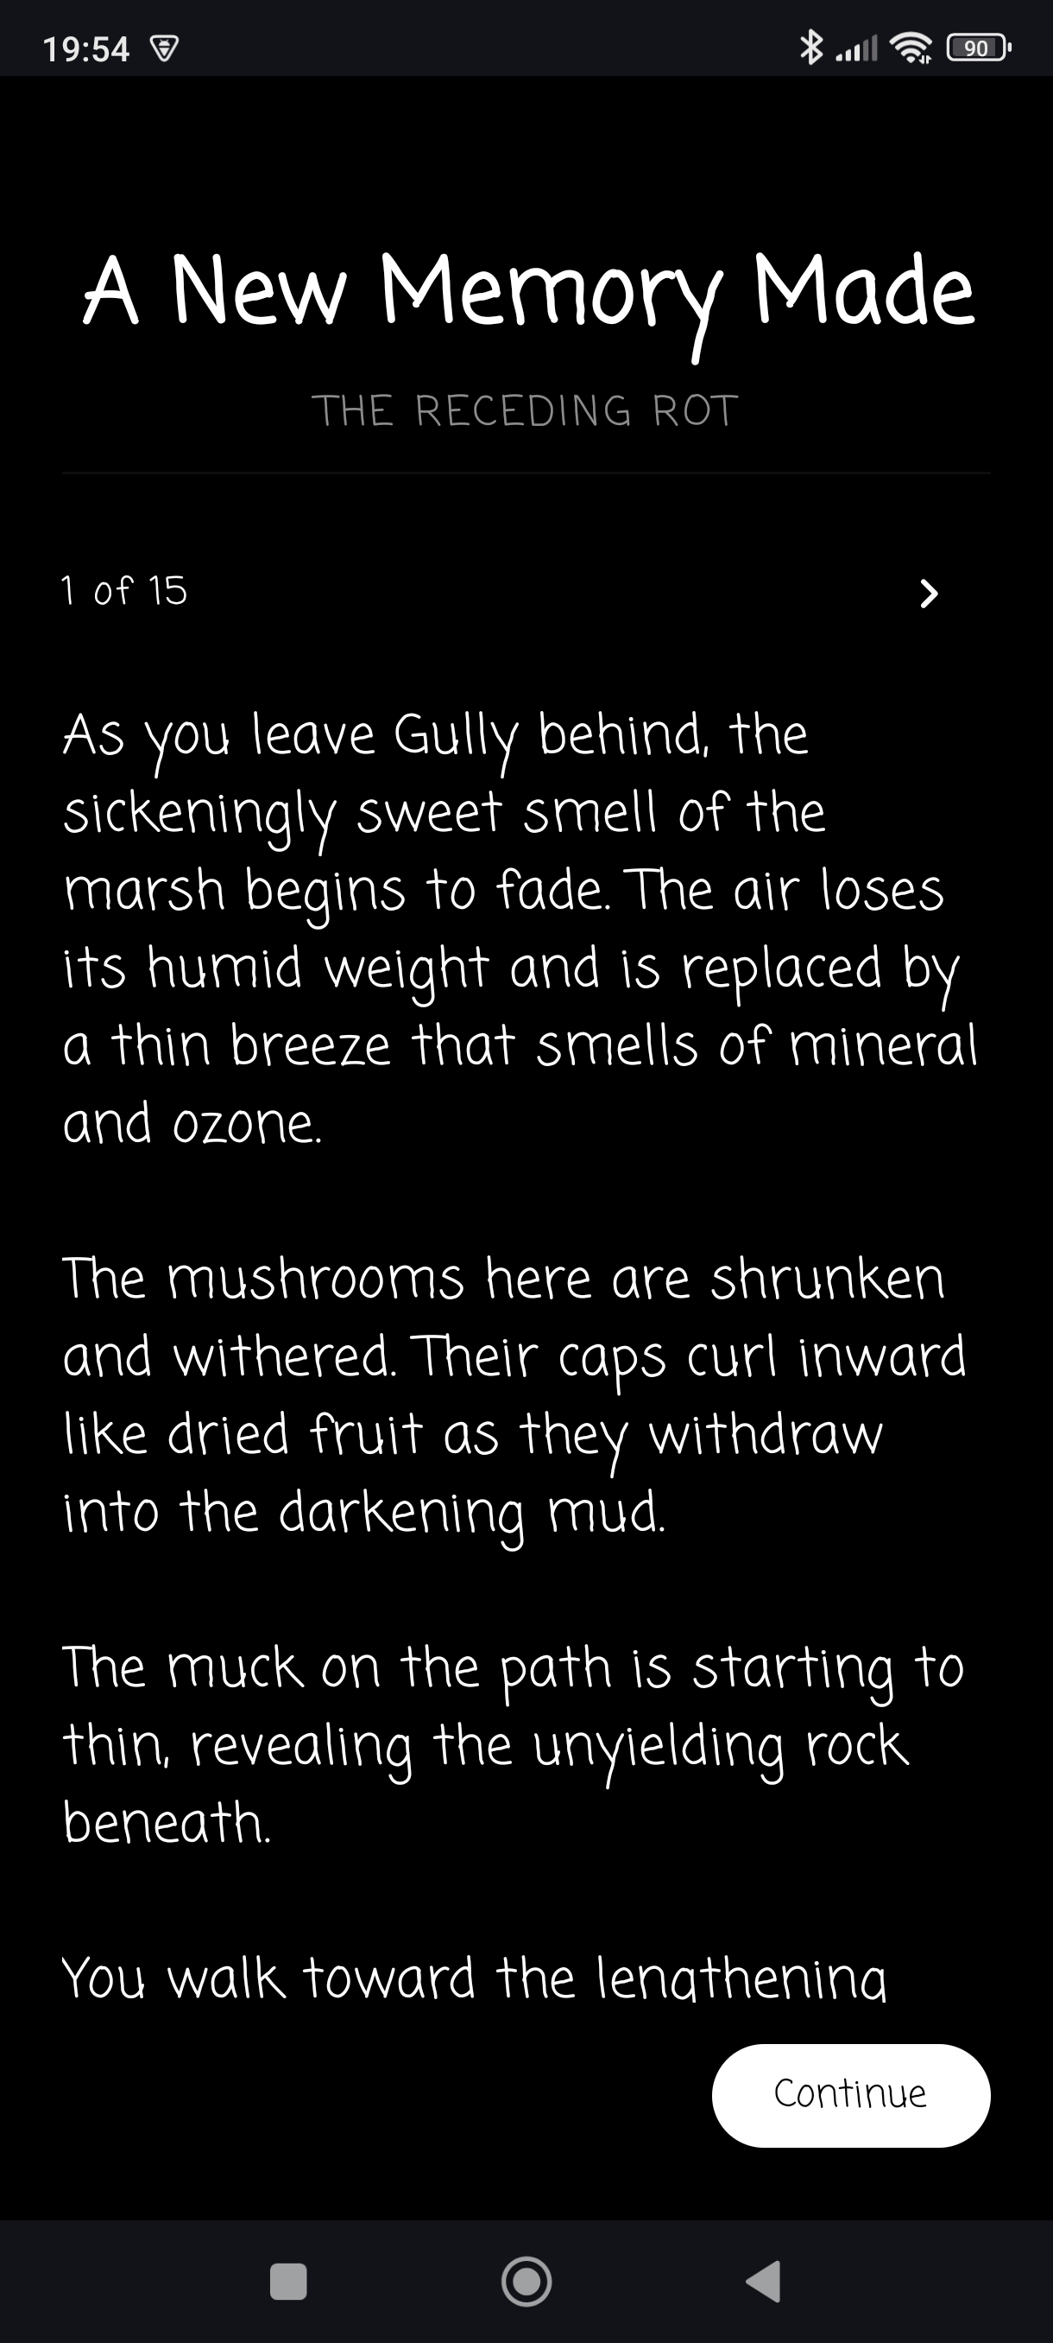

System Architecture
Inkstride uses a single-app, layered architecture organized into five layers:
- UI Layer (Jetpack Compose): Screens, reusable components, and router composition
- ViewModel Layer: Route decisions, sync orchestration triggers, and UI state management
- Service Layer: Progress calculation, milestone unlock logic, data validation, and error handling
- Data Layer: Room entities, DAOs, repositories, and seed data loading
- Integration Layer: Health Connect step reads and WorkManager background sync scheduling
The app does not implement explicit database record locking. Concurrency control for step synchronization is handled in memory via a coroutine Mutex in StepSyncCoordinator. The mutex prevents overlapping sync runs and queues manual retriggers so no user-initiated sync is silently dropped. Automatic and background triggers are skipped when a sync is already running; manual triggers are queued for a single rerun after the current sync completes.

Source Code Structure
Source code structure introduction. The following is a summary of the source code directories and their contents:
Code Directory
Directory | Usage
app/src/main/java/com/inkstride/app | Entry point and top-level app code.
app/src/main/java/com/inkstride/app/ui | Router, ViewModel factory helper, story text formatter, and the viewmodels subdirectory.
app/src/main/java/com/inkstride/app/ui/components | Reusable UI components: bottom navigation bar and startup splash screen.
app/src/main/java/com/inkstride/app/ui/screens | Composable screens: Journey, Storybook, Story Unlock, and Permissions.
app/src/main/java/com/inkstride/app/ui/theme | Material theme, typography, and color definitions.
app/src/main/java/com/inkstride/app/ui/viewmodels | ViewModels for all four screens.
app/src/main/java/com/inkstride/app/data | App-wide data enums: DistanceUnit and BadgeColor.
app/src/main/java/com/inkstride/app/data/database | Room database definition, provider, migrator, seed loader, DAOs, and entity classes.
app/src/main/java/com/inkstride/app/data/repositories | Story and progress repositories.
app/src/main/java/com/inkstride/app/health | Health Connect integration, step sync coordinator, WorkManager scheduler, and background worker.
app/src/main/java/com/inkstride/app/services | Shared services: data validation, distance calculation, milestone unlock logic, and error handling.
app/src/main/assets | Bundled story seed data (story_seed_data.json).
Highlighted rows indicate directories containing source code.

Executables
Inkstride produces one executable in two formats: an APK for direct installation and an app bundle for Play Store submission.

Inkstride (app-release.apk / app-release.aab)
The Inkstride app, installed and run on an Android device. Handles the full user experience: requesting Health Connect permissions, syncing step data, calculating distance, unlocking story milestones, and displaying story content.

Code Architecture
Inkstride uses Model-View-ViewModel (MVVM) architecture with a repository pattern. ViewModels manage screen state and coordinate data operations. Repositories handle database access and expose results to ViewModels. Shared services handle reusable logic like distance calculation, data validation, and milestone checking. The UI layer observes ViewModel state and does not access data sources directly.

Database or Data Store
Inkstride stores all user data locally in a Room SQLite database. The database contains six tables: Settings stores the character name and distance unit preference. ProgressState stores cumulative journey totals in a single fixed row. DailyStats stores per-day step and distance totals keyed by date. Milestone stores route points with distance markers, area names, and badge color data. StorySegment stores narrative text linked to each milestone. UnlockState stores the unlock and read flags for each story segment.

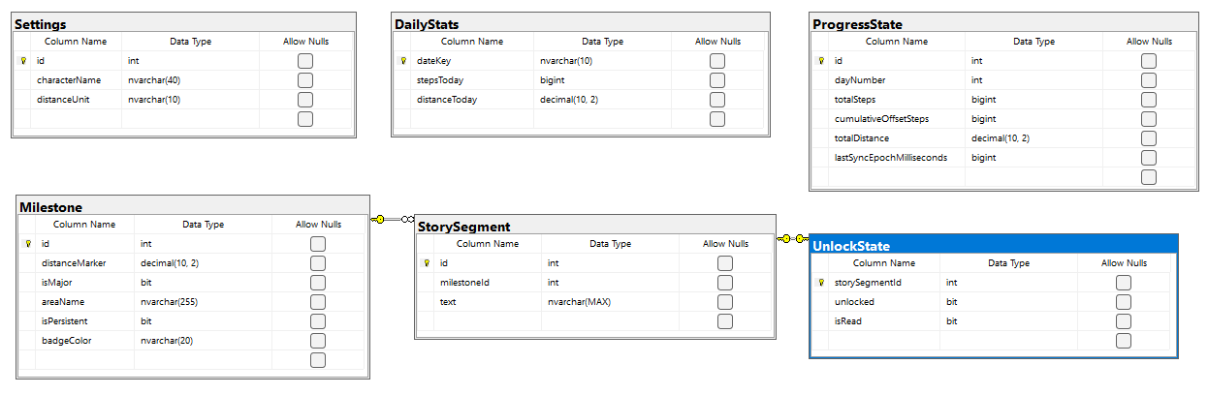

The database is at version 10. Four registered migrations (6 to 7, 7 to 8, 8 to 9, 9 to 10) preserve user data across upgrades. Story content and milestones are seeded from a bundled JSON asset on every startup, so the database stays in sync with the current version of the story. Schema constraints are enforced at the database level through CHECK clauses, guard triggers, and unique indexes.

Views, Stored Procedures and User Defined Functions
Inkstride does not use views, stored procedures, or user-defined functions. All data access is handled through Room DAOs.

External Files & Data
The story_seed_data.json file is a bundled asset that contains all milestone and story content for Act 1. It is parsed at startup and used to seed and update the database. SharedPreferences stores the journey start instant used for day number calculations. This value is written once when permissions are first granted and read on every sync. Health Connect provides step count data. No user data is stored in Health Connect by Inkstride. All data is stored locally on the device. No cloud storage, external APIs, or network communication are used. Standard Android app data security applies.

Programming Language | Kotlin + Android Framework
The project is written in Kotlin targeting Android. Primary components and references include:
- Android Gradle Plugin
- Kotlin Android + Compose Plugin
- Jetpack Compose UI (Material + Material3)
- AndroidX Lifecycle + Activity Compose
- Health Connect client
- Room (runtime ktx, compiler via KSP)
- WorkManager + Junit / AndroidX test libraries

Project Classes
Inkstride organizes its logic into classes that hold state, manage data, or define the structure of stored records. The following classes are used in the project:

ViewModel for App Router | AppRouterViewModel.kt
Manages navigation state and determines which screen to display based on Health Connect permission status and story unlock state.

ViewModel for Journey | JourneyViewModel.kt
Manages Journey screen state, runs foreground sync loops, and handles pull-to-refresh.

ViewModel for Storybook | StorybookViewModel.kt
Loads read and unlocked story segments for the Storybook screen.

ViewModel for Story Unlock | StoryUnlockViewModel.kt
Loads unlocked segment content and tracks which segments have been viewed during the current unlock session.

Screen for Permissions | PermissionsScreen.kt
Displays the Health Connect permission request prompt and Grant Permissions button.

Screen for Journey | JourneyScreen.kt
Displays daily and total distance stats with pull-to-refresh and automatic foreground sync.

Screen for Story Unlock | StoryUnlockScreen.kt
Displays newly unlocked story segments in a horizontal pager with page tracking and a Continue button.

Screen for Storybook | StoryScreen.kt
Displays all read and unlocked story segments in journey order with persistent area labels.

Repository for Story | StoryRepository.kt
Handles story segment reads, unlock state updates, and badge color resolution.

Repository for Progress | ProgressRepository.kt
Persists step totals and calculated distance values from Health Connect syncs.

Database Entity for Settings | Settings.kt
Stores the character name and distance unit preference in a single fixed row.

Database Entity for Progress State | ProgressState.kt
Stores cumulative journey totals including step count, distance, day number, and last sync time in a single fixed row.

Database Entity for Daily Stats | DailyStats.kt
Stores per-day step and distance totals keyed by date string.

Database Entity for Milestone | Milestone.kt
Stores route milestones with distance markers, area names, persistence flags, and badge color data.

Database Entity for Story Segment | StorySegment.kt
Stores narrative text content linked to a milestone by foreign key.

Database Entity for UnlockState | UnlockState.kt
Stores the unlock and read flags for each story segment.

Data Access Object for Settings | SettingsDao.kt
Provides read and upsert access to the Settings table.

Data Access Object for Progress State | ProgressStateDao.kt
Provides read and upsert access to the ProgressState table.

Data Access Object for Daily Stats | DailyStatsDao.kt
Provides distance-based lookups, area name queries, badge color queries, and insert and delete access to the Milestone table.

Data Access Object for Milestone | MilestoneDao.kt
Provides distance-based lookups, area name queries, badge color queries, and insert and delete access to the Milestone table.

Data Access Object for Story Segment | StorySegmentDao.kt
Provides milestone-linked lookups and filtered reads by unlock and read state for the StorySegment table.

Data Access Object for UnlockState | UnlockStateDao.kt
Provides per-segment unlock and read state lookups, unread existence checks, and upsert access to the UnlockState table.

Health Connect Management | HealthConnectManager.kt
Reads step totals from Health Connect and manages the journey start instant used for day number calculations.

Database for Inkstride | InkstrideDatabase.kt
Room database definition at version 9 with all six entity tables registered and DAO access methods exposed.

Service for Milestone Engine | MilestoneEngine.kt
Checks which milestones have been reached by the current distance and unlocks their story segments.

Service for Data Validation | DataValidator.kt
Centralizes data normalization and validation rules used across repositories and services.

Project Modules
Inkstride uses a set of stateless modules for logic that does not require persistent state. These include shared services, background workers, UI components, and utility helpers. The following modules are used in the project:

Database Provider | DatabaseProvider.kt
Provides the shared Room database instance and seeds default data on every startup.

Database Migrator | DatabaseMigrator.kt
Defines the Room schema migrations from version 6 to version 10.

Story Seed Data Source | StorySeedDataSource.kt
Parses the bundled story JSON asset and caches the result to avoid repeated file reads.

Health Connect Steps Sync Scheduler | StepsSyncScheduler.kt
Registers a recurring 15-minute background sync job with WorkManager, using the UPDATE policy so rescheduling replaces the existing job without creating duplicates.

Health Connect Steps Syncer | StepsSyncer.kt
Checks Health Connect permissions and reads step totals when permitted, returning null when permissions are absent so callers can exit early.

Health Connect Background Steps Worker | ReadStepsWorker.kt
Serves as the WorkManager entry point for background syncs, delegating to StepSyncCoordinator and mapping the result to a WorkManager return value.

Service for Progress Calculating | ProgressCalculator.kt
Converts step counts to distance, calculates remaining distance to the next milestone, and rounds values to two decimal places for consistent display.

Service for Distance Unit Label Formatting | DistanceUnitLabelFormatter.kt
Formats distance unit labels with correct singular and plural forms based on the rounded display value.

Service for Error Handling | ErrorHandler.kt
Wraps suspend calls in a try-catch and returns a typed Success or Failure outcome so callers handle results without catching exceptions directly.

Service for Story Text Formatting | StoryTextFormatter.kt
Parses inline italic markup in story text and returns an AnnotatedString with italic spans applied for display in Compose.

UI Component for ViewModel Helpers | ViewModelHelpers.kt
Provides a rememberViewModel helper function that creates and remembers an activity-scoped ViewModel using a factory lambda, reducing boilerplate across screens and the router.

UI Component for Bottom Navigation Bar | BottomNavigationBar.kt
Renders the two-tab navigation bar with a pulsing star badge on the Storybook tab when unread story segments are available.

UI Component for Startup Splash Screen | StartupSplashScreen.kt
Displays the startup screen while the database seeds and the initial route resolves, ensuring the user never sees a blank or partially loaded state.

Program Start and End Flow
When the app launches, MainActivity starts and AppRouter initializes. The startup splash screen displays while the database is seeded and ViewModel caches are warmed from persisted data. Once that is complete, the router checks Health Connect and background permissions and routes to the first screen. If permissions are missing, the user sees the Permissions screen.
If the intro segment is unlocked and unread, the user sees the Intro Story Unlock screen. Otherwise, the app opens to the Journey screen. While the Journey screen is active, it runs a foreground sync every five minutes and responds to pull-to-refresh. Each sync reads the latest step totals from Health Connect, persists progress, and checks for newly reached milestones.
When new story segments unlock, the notification badge appears on the Storybook tab. WorkManager runs a background sync every 15 minutes when the app is not in the foreground. When the app is closed or backgrounded, all data remains persisted in Room and is available immediately on the next launch. Background sync may continue via WorkManager subject to OS battery and permission constraints.

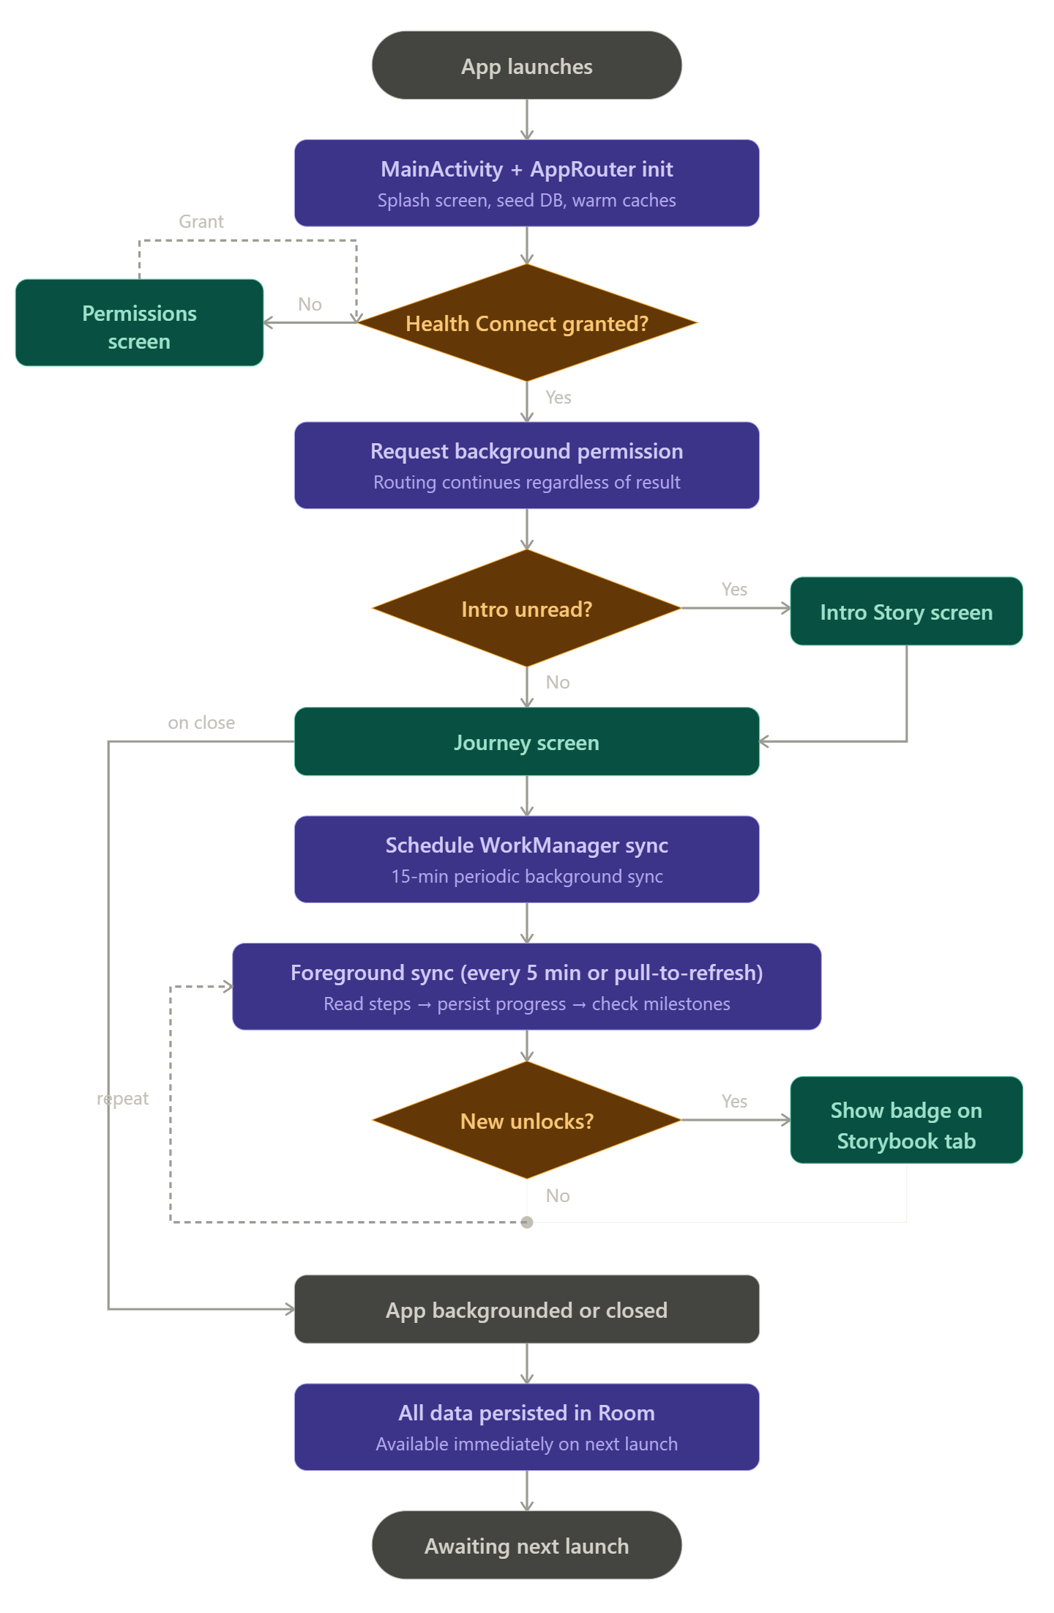

Summary
Inkstride is an Android step-tracking app that reads step data from Health Connect, converts it to journey distance, and unlocks story segments as milestones are reached. All user data is stored locally in a Room database and persists across sessions. The app uses MVVM architecture with a repository pattern, a centralized router for navigation, and a WorkManager background sync for step updates. Act 1 delivers a complete 168-mile narrative across six biomes. The architecture is designed to support future expansion through additional acts and story content without requiring changes to the core data model or sync pipeline.

APPENDIX A (MAINTENANCE, TESTING, AND DEPLOYMENT STRATEGY)

Maintenance
Inkstride is actively maintained as a personal project. Maintenance includes fixing bugs as they are discovered, managing database schema changes as the seed data and story content evolve, and ensuring continued compatibility with Health Connect and Android OS updates as they are released.

Testing Plan
Inkstride is tested at two levels. Unit tests cover isolated logic in the service and data layers, including step-to-distance conversion in ProgressCalculator, normalization and validation rules in DataValidator, and milestone unlock logic in MilestoneEngine. Instrumented tests cover database operations, including migration correctness across all registered schema versions and seed data loading behavior on startup.
Manual testing is performed on a physical Android device for flows that require Health Connect integration, including the permission grant flow, foreground step sync, background sync via WorkManager, and end-to-end story unlock progression. Release builds are tested separately from debug builds to catch packaging-specific behavior before distribution.

Deployment Strategy
Rather than treating deployment as a single upload at the end of development, the plan is to release Inkstride in stages. The first step is to prepare a true release build, which is packaged and signed differently from a development build and can behave differently in ways that only appear after packaging. That build will be released through the Google Play internal testing track before any broader public release. Because Inkstride depends on several components working together correctly—Health Connect permissions, local database storage, background sync, milestone unlocking, and story progression—a limited release provides a more realistic environment to catch problems before they reach a wider audience.

APPENDIX B (BUILD AND RELEASE PROCESS)
This is the recommended formal release workflow for Inkstride:
- Increment the version code and version name in the app-level Gradle build file.
- Run the unit test suite and lint checks. If a device or emulator is available, run the instrumented tests as well.
- Build the desired artifact, either a debug APK for internal testing, or a release APK or app bundle for distribution.
- Configure release signing using a keystore, either through Gradle build settings or stored securely as CI environment secrets.
- Upload the finished APK or app bundle to the chosen distribution channel, such as the Play Console internal testing track.
- After the release is live, verify that the permission flow, step sync behavior, and story unlock progression all work correctly on supported devices.

APPENDIX C (CLIENT INSTALLATION INSTRUCTIONS)
To install Inkstride:

- Use an Android device running Android 8 or higher.
- If prompted, install the Health Connect app from the Google Play Store. Newer Android devices may have Health Connect built in and will not require this step.
- Install Inkstride from the provided download link or distribution source.
- Open the app and tap Grant Permissions on the first screen to allow Inkstride to read your step data from Health Connect.
- If your device asks whether to allow Inkstride to run in the background, allow it. This is required for step counts to update automatically throughout the day.

APPENDIX D (DEVELOPER SETUP INSTRUCTIONS)
To set up Inkstride for development:
- Download and install the current stable version of Android Studio from the Android developer website.
- Open Android Studio and install the Android SDK for API level 33 or higher when prompted.
- Clone the Inkstride repository from GitHub and open it in Android Studio.
- Let Gradle sync the project. Android Studio will handle downloading the required dependencies automatically.
- Connect an Android device running Android 13 or higher or create a virtual device in Android Studio using the AVD Manager.
- Make sure Health Connect is available on the device. On Android 13 and higher it is built in, but you might need to update it through the Play Store if prompted.
- Build and run the app on your device or emulator using the Run button in Android Studio.
- On first launch, go through the permission flow to grant Health Connect access so step syncing works during development.
- To run unit tests, use the Run menu in Android Studio. Instrumented tests require a connected device or running emulator.

