Implementation Specification
for
Highly Conserved Regions in caBIO

Release 4.3

Last Updated: April 14, 2009

Owner: caBIO Team
Email: klemmj@mail.nih.gov

National Cancer Institute Center for BioInformatics
2115 Jefferson Ave. East
Rockville, MD 20852



1 Document Purpose 3
2 Implementation Overview 4
2.1 Team Members 4
2.2 Description 4
2.3 Scope 5
2.4 User Stories 5
2.5 Architecture 5
2.6 Model 6
2.7 Data 7
2.8 Assumptions 9
2.9 Dependencies 9
2.10 Issues 9
2.11 Third Party Tools 9
3 Implementation Contents 10
3.1 Server 10
3.1.1 Algorithms 10
3.1.2 Batch Processes 10
3.1.3 APIs 10
3.1.4 Error Handling 10
3.1.5 Database Changes 10
3.2 Client 10
3.2.1 JSP/HTML 10
3.2.2 Servlet 10
3.2.3 Error Handling 10
3.3 Security Issues 10
3.4 Performance 11
3.5 Internationalization 11
3.6 Installation / Packaging 11
3.7 Migration 11
3.8 Documentation Considerations 11
4 Unit Testing 12
4.1 Test Guidelines 12
4.2 Test Cases 12
5 Data Exemplars 13
DOCUMENT CONTROL 14
DOCUMENT APPROVAL 15

Document Purpose
This document describes the caBIO modeling of highly conserved regions on the human genome, and design and implementation of the import of multiple-alignment data from Ensembl Compara.

Implementation Overview

Team Members

Role | Name
Director of Engineering | Avinash Shanbhag²
Internationalization Lead | N/A
Product Manager | Juli Klemm²
Project Manager | Sharon Gaheen¹
Test Lead | Ye Wu¹
Tech Lead | Jim Sun¹
Documentation Lead
Development Team | Konrad Rokicki¹  Lalitha Viswanath¹
¹ Science Applications International Corporation (SAIC)
² National Cancer Institute Center for Bioinformatics (NCICB)
Table 1: Team Members

Description
DNA alignments across species can reveal the extent of evolutionary conservation in genetic material. The Ensembl Compara project runs many such alignment analyses and provides the results in various accessible formats. The Mayo Clinic has expressed interest in using caBIO to access results from Compara’s Pecan-based alignment analyses in particular.

Ensemble’s Genome Browser allows the user to configure the display of several tracks in the category of “multiple alignments.” In Figure 1, the section of the Human genome which contains the beginning of the BRCA2 gene is displayed with these tracks enabled.

The tracks provide a view of areas where multiple alignment was done, which sections were found to be highly conserved according to GERP analysis, and the individual GERP scores for each nucleotide that was aligned.

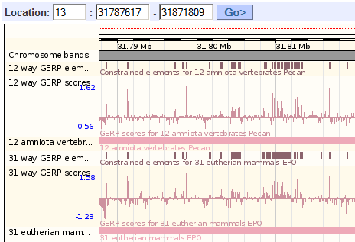
Figure 1: Ensembl Genome Browser

Scope
The scope of this document includes user stories, design and the implementation specification for the domain modeling and data loading necessary to support conserved regions in caBIO.

User Stories

U-020 | GF 18953 | Support for conserved genomic regions
As a caBIO User from Mayo, I want to access Ensembl Compara data, so I can see highly conserved regions as annotations on the human genome.
Acceptance Criteria:
- The user can retrieve coordinates of conserved genomic regions as determined by Pecan multiple sequence alignments across species.

Architecture
The caBIO architecture is not impacted by this data feature.

Model
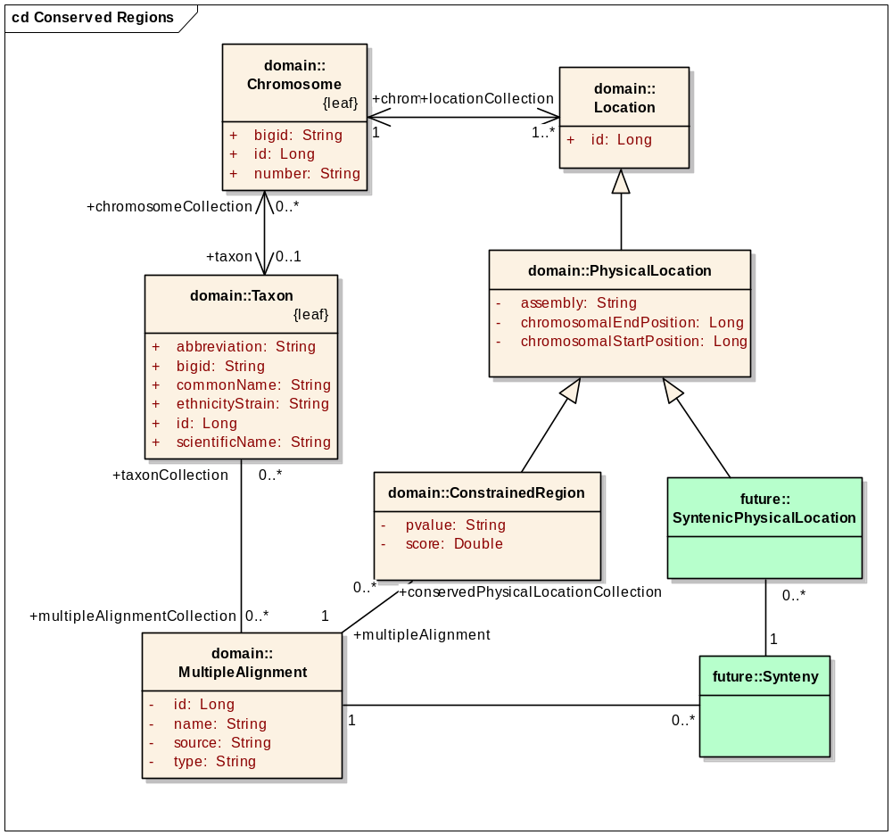
Figure 2: caBIO 4.3 Model Changes to support multiple alignment analysis

The current caBIO model does not support conserved regions directly, but the data can be supported with minimal model changes (Figure 2). A new class called MultipleAlignment will store the different multiple alignment analyses. Each MultipleAlignment is done against a set of species (Taxon), and has a name and type. A new class called ConstrainedRegion will extend PhysicalLocation in order to provide the actual regions on the human genome which are conserved according to the analysis.

The green classes in Figure 2 show potential future expansions of this model. Synteny data could be supported in a similar way as conserved regions, by reusing the MultipleAlignment class and adding a new Location subclass for the syntenic region data.

Data
Compara contains the results of many different types of DNA-DNA alignments. These methods are used to “find links (homologies) between entities.” The following table shows all the analysis sets related to multiple alignment. These analyses appear as tracks in Ensembl’s Genome Browser (compare to Figure 1).

Type | Method | Track Name
Alignment | ORTHEUS | 4 catarrhini primates EPO
Alignment | ORTHEUS | 9 eutherian mammals EPO
Alignment | ORTHEUS | 31 eutherian mammals EPO
Elements | GERP_CONSTRAINED_ELEMENT | Gerp Constrained Elements (31 eutherian mammals)
Scores | GERP_CONSERVATION_SCORE | Gerp Conservation Scores (31 eutherian mammals)
Alignment | PECAN | 12 amniota vertebrates Pecan
Elements | GERP_CONSTRAINED_ELEMENT | Gerp Constrained Elements (12 amniota vertebrates)
Scores | GERP_CONSERVATION_SCORE | Gerp Conservation Scores (12 amniota vertebrates)
Table 2: Multiple alignment tracks available in Ensembl's Genome Browser

The green rows refer to results from GERP analysis of Pecan and EPO (Enredo, Pecan, Ortheus) multiple alignments. The other tracks have different data types, which have been inferred as follows:
- Alignment – contains the complete multiple alignment with references to all of the component sequences
- Scores – GERP scores for individual nucleotides
- Elements – regions of highly conserved DNA as determined by GERP post-analysis

Since the Mayo use case calls for Pecan alignments resulting in highly conserved elements, we are mainly interested in the “Elements” tracks at this time. These two analyses will be represented in the MultipleAlignment object. Each analysis is associated with a set of species. Some of the species used by Ensembl will need to be imported into the Taxon object so that they may be linked to from MultipleAlignment. For example, the Pecan analysis is done across the following 12 species, only 3 of which are present in caBIO:

Scientific Name | Common Name | Assembly | In caBIO?
Rattus norvegicus | Norway rat | RGSC3.4 | Yes
Homo sapiens | human | NCBI36 | Yes
Macaca mulatta | rhesus monkey | MMUL_1 | No
Pan troglodytes | chimpanzee | CHIMP2.1 | No
Canis familiaris | dog | BROADD2 | No
Gallus gallus | chicken | WASHUC2 | No
Ornithorhynchus anatinus | platypus | OANA5 | No
Monodelphis domestica | gray short-tailed opossum | BROADO5 | No
Mus musculus | house mouse | NCBIM37 | Yes
Pongo pygmaeus | Bornean orangutan | PPYG2 | No
Equus caballus | horse | EquCab2 | No
Bos taurus | cattle | Btau_4.0 | No
Table 3: Species involved in the 12-way Pecan multiple alignment analysis

The additional species will be added to the Taxon table. The assembly information will not be loaded in caBIO.

For the Pecan analysis, there are roughly 800,000 constrained element annotations on the human genome. Broken down by chromosome, the counts are as follows:

Chromosome | Count
1 | 72725
2 | 67186
3 | 55482
4 | 41440
5 | 46910
6 | 50726
7 | 51421
8 | 36385
9 | 30683
10 | 40272
11 | 37029
12 | 38944
13 | 21938
14 | 24722
15 | 23981
16 | 24491
17 | 31700
18 | 18001
19 | 18537
20 | 20689
21 | 6101
22 | 10828
X | 29378
MT | 9
Total | 799578
Table 4: Constrained elements per chromosome

All of the chromosomes in Table 4 are present in caBIO’s Chromosome object, and may be linked from the ConstrainedRegion. The other analysis track (EPO analysis: “31 eutherian mammals”) consists of 1464897 constrained elements.

The constrained elements themselves are simply regions on the genome, annotated with GERP scores. For example, the following table presents the first ten constrained elements on the Human genome in the region of the BRCA2 gene, resulting from Pecan analysis.

Coordinate System | Name | Fragment Start | Fragment End | Score
chromosome | 13 | 31788618 | 31788667 | 51.4
chromosome | 13 | 31791212 | 31791409 | 228.4
chromosome | 13 | 31791461 | 31791471 | 20.3
chromosome | 13 | 31797204 | 31797213 | 16.9
chromosome | 13 | 31797272 | 31797285 | 22.2
chromosome | 13 | 31797314 | 31797332 | 39.9
chromosome | 13 | 31798232 | 31798247 | 26.9
chromosome | 13 | 31798269 | 31798273 | 11.8
chromosome | 13 | 31798287 | 31798293 | 16.8
chromosome | 13 | 31798376 | 31798406 | 49.2
Table 5: Conserved elements near the start of the BRCA2 gene

The EPO data is similar but also contains p-values as strings annotations. The model in Figure 2 supports both data sets. These data will be loaded into the ConstrainedRegion object.

Assumptions
TBD

Dependencies
This implementation is dependent on access to public MySQL databases for Ensembl and Ensembl Compara.

Issues
None at this time.

Third Party Tools
The DBD-mysql Perl library will be used to access the Ensembl MySQL database in order to pull the data required for loading into caBIO.

Implementation Contents

Server
N/A

Algorithms
N/A

Batch Processes
The new scripts for data ETL (extraction, transformation and load) of Ensembl data will be added into the caBIO data refresh scripts. The scripts will consist of the following:
- Perl scripts to query Ensembl’s MySQL database and dump data to flat files
- SQL*Loader configurations to load flat files into staging tables
- SQL scripts to transform and load data from staging tables into user tables

The Ensembl databases are segregated by Ensembl version. Each version has its own schema, and all past versions are kept indefinitely. The caBIO loading scripts will be configured to pick the latest version of the Ensembl database at load time. If an upgrade requires script changes in caBIO, the Ensembl version used may be frozen until the changes are made.

APIs
The new data will be available through all of the caBIO APIs.

Error Handling
The standard SDK Error Handling will be used. See the SDK Exception handling documentation for more information.

Database Changes
Two new tables, MULTIPLE_ALIGNMENT and MULTIPLE_ALIGNMENT_TAXON will be added to support the new classes. Data for ConstrainedRegion will be added to LOCATION_CH.

Client
N/A

JSP/HTML
N/A

Servlet
N/A

Error Handling
The standard SDK Error Handling will be used. See the SDK Exception handling documentation for more information.

Security Issues
N/A

Performance
N/A

Internationalization
N/A

Installation / Packaging
The design assumes the standard caBIO installation and packaging.

Migration
N/A

Documentation Considerations
- This design document
- caBIO 4.3 Technical Guide
- SDK 4.1 Developer’s Guide
- Ensembl Documentation
  - http://www.ensembl.org/info/docs/api/compara/compara_schema.html

Unit Testing

Test Guidelines
Unit tests normally do not test data because the data can change. The unit tests will ensure that the new classes are functioning correctly and retrieving data from the database. QA test cases will be necessary for ensuring data consistency.

Test Cases
- Query the MultipleAlignment class and retrieve its attributes, as well as its taxonCollection.
- Retrieve a count of ConstrainedRegion objects associated with one MultipleAlignment
- Query for a ConstrainedRegion and retrieve its chromosome and multiple alignment.

Data Exemplars
See embedded tables in section 2.7 (“Data”).

DOCUMENT CONTROL
Change History
Content changes to this document from the previous to the current level are indicated by revision bars (|) unless a complete rewrite is indicated.

Table 6 – Implementation Specification Document Change Log
Version/Date | Approved By | Change Description and Explanation | D - Draft  A - For Review/ Approval  R - Re-Approval, Plan of Record Change
04/06/2009 | Konrad Rokicki | Initial revision | D
04/09/2009 | Konrad Rokicki | Editing/formatting | A
04/14/2009 | Konrad Rokicki | Changes from design review | A
Note: If this document has been inspected, please indicate the inspection date that each version is based on in the “Change Description and Explanation” area. Entries in this log must be maintained for at least 3 years.

DOCUMENT APPROVAL
Approvers List
The individuals listed in this section constitute the approvers list for the Integration Test Plan document. Formal approval must be received from all approvers prior to the initiation of the next steps in the process.

Title | Name
Project Manager | Name
Development Manager | Name

Reviewers List
The individuals listed in this section constitute the reviewers list for the Master Test Plan document. Formal approval is not required from the reviewers, however, it is desirable to have all reviewers review and comment on the document. Reviewers may choose to concentrate on reviewing only those sections that are in their area of responsibility, rather than the entire document.

Title | Name
Solutions Manager | Name
Project Manager | Name
Test Manager | Name
Test Engineer | Name
Development Manager | Name
Technical Writer | Name
Client Support Analyst | Name
Internationalization Lead | Name
DBA | Name
Developer | Name
Developer | Name

END OF DOCUMENT

Pecan (http://www.ebi.ac.uk/~bjp/pecan/) is a “global multiple sequence alignment program that makes practical the probabilistic consistency methodology for significant numbers of sequences of practically arbitrary length. As input it takes a set of sequences and a phylogenetic tree.”
GERP (http://genome.cshlp.org/content/15/7/901.abstract) is “Genomic Evolutionary Rate Profiling.”

