Implementation Specification
for
Online Mendelian Inheritance in Man

Release 4.3

Last Updated: April 23, 2009

Owner: caBIO Team(Lalitha Viswanathan)
Email: klemmj@mail.nih.gov

National Cancer Institute Center for BioInformatics
2115 Jefferson Ave. East
Rockville, MD 20852



1 Document Purpose 3
2 Implementation Overview 4
2.1 Team Members 4
2.2 Description 4
2.3 Scope 4
2.4 Use Stories 5
2.5 Use Cases 5
2.6 Model 6
2.7 Data 7
2.7.1 MorbidMap 7
2.7.2 GeneMap 8
2.7.3 Notes 8
3 Implementation Contents 10
3.1 Server 10
3.1.1 Algorithms 10
3.1.2 Batch Processes 10
3.1.3 APIs 10
3.1.4 Error Handling 10
3.1.5 Database Changes 10
3.2 Client 10
3.2.1 JSP/HTML 10
3.2.2 Servlet 10
3.2.3 Error Handling 10
3.3 Security Issues 10
3.4 Performance 10
3.5 Internationalization 10
3.6 Installation / Packaging 10
3.7 Migration 10
3.8 Documentation Considerations 10
DOCUMENT CONTROL 11
DOCUMENT APPROVAL 12

Document Purpose
This document describes the caBIO modeling of OMIM, a compendium of human genes and genetic phenotypes and contains information on all known mendelian disorders.

Implementation Overview

Team Members

Role | Name
Director of Engineering | Avinash Shanbhag²
Internationalization Lead | N/A
Product Manager | Juli Klemm²
Project Manager | Sharon Gaheen¹
Test Lead | Ye Wu¹
Tech Lead | Jim Sun¹
Documentation Lead
Development Team | Konrad Rokicki¹  Lalitha Viswanath¹
¹ Science Applications International Corporation (SAIC)
² National Cancer Institute Center for Bioinformatics (NCICB)
Table 1: Team Members

Description
OMIM is a catalog of genes which exhibit Mendelian inheritance traits (autosomal dominant, autosomal recessive, x-linked) that cause diseases. It is a phenotypic companion on the Human Genome Project and provides the cytogenetic location and the molecular basis of these genes, if available.
A Mendelian trait is one in which a mutation in a single gene can cause a disease inherited according to Mendel's laws. Examples include sickle-cell anemia and cystic fibrosis.
This contrasts with multi-factorial disease like cancer which is almost always caused by several loci, influenced by environment factors and in most cases is caused by mutations that are not inherited (somatic carcinogenic mutations).
caBIO, through the introduction of data from Cancer Gene Index project already exposes information of the latter kind. With the introduction of OMIM in caBIO, a user would be able to identify cancers attributable mostly to oncogenes with mendelian mutations play a significant role.

Scope
The scope of this document includes user stories, use cases, design and implementation specification for the domain modeling and data loading.

Use Stories
U-070 | GF 19718 | Support for OMIM
As a caBIO User from Mayo, I want to access OMIM data, so I can identify
- caBIO genes with mendelian traits
- Retrieve Cytogenetic and Chromosomal Location of such genes
- Correlate with oncogenes (from Cancer Gene Index Curation)
- Identify diseases (and their cytogenetic locations) attributed mostly to mendelian mutations / genes exhibiting such traits
Acceptance Criteria:
- The user can retrieve phenotypic data from OMIM using the caBIO API.

Use Cases
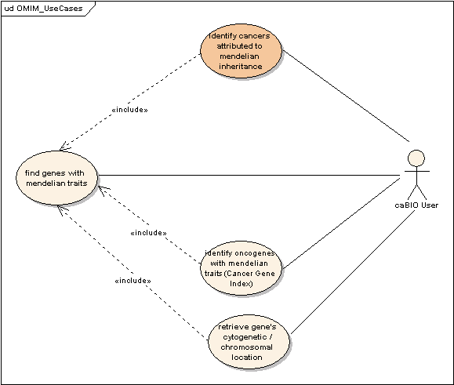

The current caBIO model provides extensive support for these use cases except the one in orange.

Model

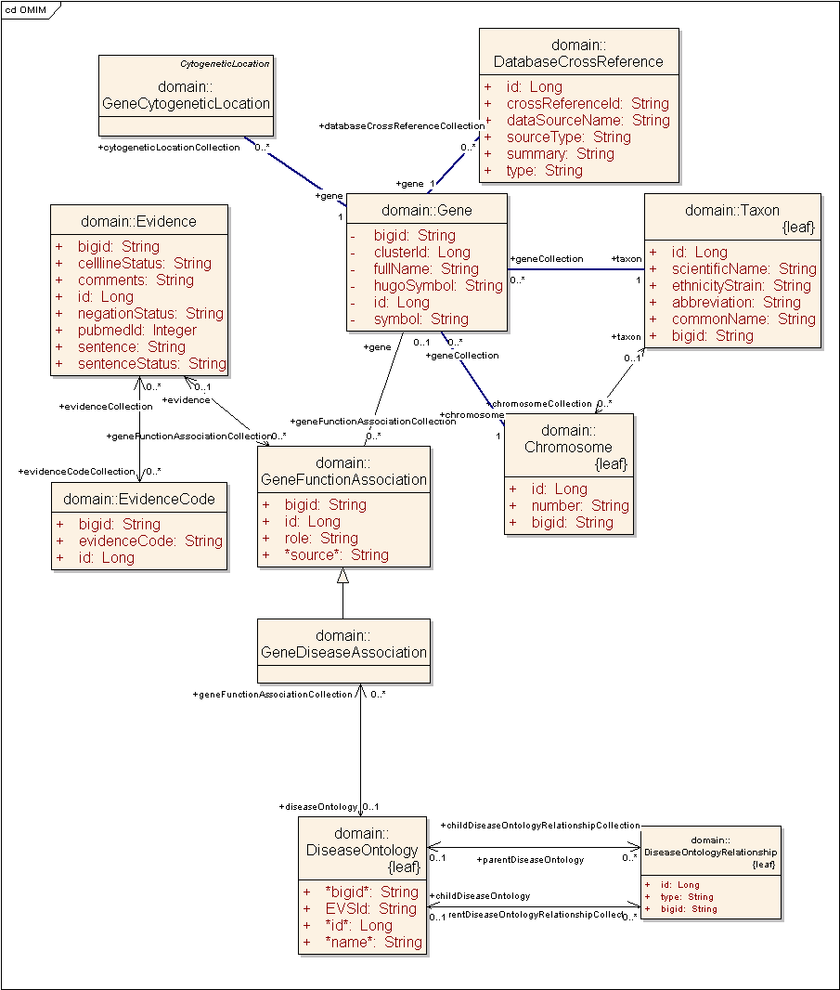
Figure 1: caBIO 4.3 Model Changes to support OMIM

Using the existing model, it is currently possible to fulfill the following
- Identify caBIO genes with mendelian traits
  - DatabaseCrossReference (source-type= ‘OMIM’) -> Gene
- Retrieve Cytogenetic and Chromosomal Location of such genes
  - DatabaseCrossReference (source-type = ‘OMIM’) -> Gene -> GeneCytogeneticLocation
- Identify Oncogenes with mendelian traits
  - DatabaseCrossReference (source-type = ‘OMIM’)-> Gene -> GeneDiseaseAssociation -> DiseaseOntology

But the current model does not allow support for User Story (4) to permit a user to identify diseases attributed exclusively to these genes nor does it allow distinction between different types of mutations.

This use case can be supported with the existing GeneDiseaseAssociation class which models the relationship between Gene and DiseaseOntology, with a few minor changes.

- New disorder information from OMIM will be added to DiseaseOntology.
- A new attribute called source will be added to provide provenance information and distinguish between OMIM and Cancer Gene Index since GeneDiseaseAssociation currently models Gene-Disease relationships from Cancer Gene Index

With the above changes, each new GeneDiseaseAssociation from OMIM will be identified by its
- disease name (from OMIM MorbidMap) in DiseaseOntology
- corresponding gene(s) and chromosome (already supported)
- corresponding organism (always Human by definition, for data from OMIM) (already supported)
- cytogenetic location (already supported)
- omimId (if required? Already supported in DatabaseCrossReference)
- source (OMIM)
- caBIG identifier

Ontology used by OMIM though internally consistent and partially included as a part of NLM Metathesaurus, is not based on the NCI Metathesaurus, unlike existing data in DiseaseOntology and does not model hierarchical relationships unlike those in NCI/NLM Metathesaurus.

- The proposed model allows for EVS Concept Ids to be associated with OMIM DiseaseOntologies as and when the data is made available.
- It also allows for hierarchical relationships in DiseaseOntologies to be modeled using the existing model (ChildDiseaseOntology, DiseaseOntologyRelationship).
- It also allows for extension of this relationship to model different kinds of disorders as well as data from other genotype-phenotype databases such as PhenomDB.

Data
OMIM provides three datasets
- Gene Map: cytogenetic locations of genes in OMIM with all disorders associated with a gene.
- Morbid Map: Name and CytogeneticLocation of each disease causing phenotype.
- E-version of the OMIM textbook

MorbidMap
Data Exemplar: {Breast-ovarian cancer, familial, 1}, 604370 (3) |BRCA1, PSCP, BROVCA1|113705|17q21
Field | Example | Object in caBIO API
1- Disorder / Disease Name | {Breast-ovarian cancer, familial, 1}, 604370 (3) | DiseaseOntology.name
2 - HUGO Gene Symbol | BRCA1, PSCP, BROVCA1 | Gene, GeneAlias
3 - OMIM Id | 113705 | DatabaseCrossReference
4 - Location | 17q21 | GeneCytogeneticLocation

GeneMap
Data Exemplar: 17.339|2|17|09|17q21|BRCA1, PSCP, BROVCA1|C|Breast cancer-1 gene||113705|Fd, REc|||{Breast-ovarian cancer, familial, 1}, 604370 (3)| | |11(Brca1)|
Attribute | Text | Object in caBIO API
1- Numbering system | 17.339
2 , 3, 4 – Month, Day, Year entered into OMIM | 2-17-09
5 - Cytogenetic Location | 17q21 | GeneCytogeneticLocation
6 - Gene Symbol(s) | BRCA1, PSCP, BROVCA1 | GeneAlias, Gene
7 - Gene Status (The certainty with which assignment of loci to chromosomes or the linkage between two loci has been established)  C = confirmed P = provisional  I = inconsistent L = limbo | C
8 - Title | Breast cancer-1 gene; The title field in the omim full text dump does not always correspond to that in the GeneMap. It may differ slightly in some cases.
10 - MIM Number | 113705 | DatabaseCrossReference
11 – Method used for mapping genes | Fd, REc
12 – Comments
14 , 15, 16– Disorder information  The number in parentheses indicates whether the mutation was positioned by mapping the wildtype gene (1), the disease phenotype itself (2), or by both (3). "3", includes mapping of the wildtype gene combined with demonstration of a mutation in that gene. | {Breast-ovarian cancer, familial, 1}, 604370 (3) |||  In this case, fields 15 and 16 are empty since there is only one disorder associated with this gene. | Only disorder name is modeled as indicated in 2.7.1.
17 - Mouse correlate | 11(Brca1)
18 – Reference | || In this case this field is empty.
Fields against which no caBIO Objects are listed, are not modeled.

Since caBIO is Unigene-centric, OMIM data will be available only for those genes that are used to build Unigene and are hence in caBIO.

Notes
- Not all OMIM records cause diseases
- Not all OMIM records have map information
- Information from OMIM GeneMap is integrated into MapView already in caBIO
- OMIM Identifiers follow a numbering scheme that gives provenance information about the type of disorder. This information is not modeled in caBIO.
1----- (100000- )
2----- (200000- ) Autosomal loci or phenotypes (entries created before May 15, 1994)
3----- (300000- ) X-linked loci or phenotypes
4----- (400000- ) Y-linked loci or phenotypes
5----- (500000- ) Mitochondrial loci or phenotypes
6----- (600000- ) Autosomal loci or phenotypes (entries created after May 15, 1994)

Implementation Contents

Server

Algorithms

Batch Processes
The new scripts for data ETL (extraction, transformation and load) of OMIM data will be added into the caBIO data refresh scripts.

APIs

Error Handling

Database Changes

Client

JSP/HTML

Servlet

Error Handling
The standard SDK Error Handling will be used. See the SDK Exception handling documentation for more information.

Security Issues

Performance

Internationalization

Installation / Packaging

Migration

Documentation Considerations
- This design document
- caBIO 4.3 Technical Guide

DOCUMENT CONTROL
Change History
Content changes to this document from the previous to the current level are indicated by revision bars (|) unless a complete rewrite is indicated.

Table 2 – Implementation Specification Document Change Log
Version/Date | Approved By | Change Description and Explanation | D - Draft  A - For Review/ Approval  R - Re-Approval, Plan of Record Change
04/07/2009 | Lalitha Viswanath | Initial revision | D
04/23/2009 | Lalitha Viswanath | Revised to include final model based on discussions | A
Note: If this document has been inspected, please indicate the inspection date that each version is based on in the “Change Description and Explanation” area. Entries in this log must be maintained for at least 3 years.

DOCUMENT APPROVAL
Approvers List
The individuals listed in this section constitute the approvers list for the Integration Test Plan document. Formal approval must be received from all approvers prior to the initiation of the next steps in the process.

Title | Name
Project Manager | Name
Development Manager | Name

Reviewers List
The individuals listed in this section constitute the reviewers list for the Master Test Plan document. Formal approval is not required from the reviewers, however, it is desirable to have all reviewers review and comment on the document. Reviewers may choose to concentrate on reviewing only those sections that are in their area of responsibility, rather than the entire document.

Title | Name
Solutions Manager | Name
Project Manager | Name
Test Manager | Name
Test Engineer | Name
Development Manager | Name
Technical Writer | Name
Client Support Analyst | Name
Internationalization Lead | Name
DBA | Name
Developer | Name
Developer | Name

END OF DOCUMENT

