## 2.2 Battery Thermal Control (BTC)

**2.2.1 Feature Objective:**

The objective of designing the battery thermal control (BTC) system is to improve battery performance and extend battery life in electric and hybrid electric vehicles. In this feature, we will use air cooled approach to control the air flow rate in the battery cooling system such that the battery temperature can be maintained within a certain range of temperatures that are optimal for operating battery systems.

**2.2.2 Functional Description:**

There are four quantities we used for BTC: maximum temperature upper threshold $T_{hh}$, maximum temperature lower threshold $T_{hl}$, minimum temperature upper threshold $T_{lh}$, minimum temperature lower threshold $T_{ll}$.

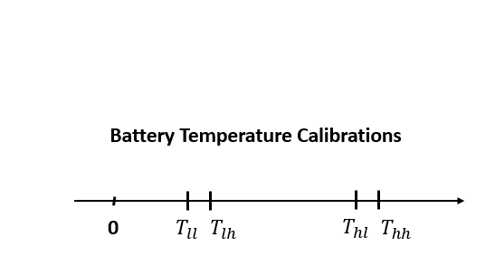

Figure 2.2.1 Battery Temperature Associated Calibrations

The main objective of the BTC is to control the battery temperature between $T_{hh}$ and $T_{lh}$ by manipulating the cooling air flow rate. To achieve the control objective, there are two main quantities need to be calculated: the actual battery temperature and the target battery temperature.

* **Compute the actual battery temperature**: When the minimum battery cell temperature is below a lower battery temperature threshold, we shall use the minimum battery cell temperature to denote the actual battery temperature. Otherwise, we will use the maximum cell temperature. This will ensure that the worst cell temperature case is captured.
* **Compute the target battery temperature**: three are three cases to setup target battery temperature
  + If the battery temperature is above the maximum temperature upper threshold, the desired temperature should be set to maximum temperature lower threshold.
  + if the battery temperature is below the lower temperature lower threshold, the desired temperature should be the lower temperature upper threshold.
  + If the cell delta temperature is above the given threshold, the desired temperature should be set to the average of the cell temperature.
  + When the battery is fully charged (minimum cell SOC is greater than a threshold), if the ambient temperature is below lower threshold, then the BTC target temperature should be set to the maximum temperature lower threshold; If the ambient temperature is above the upper threshold, the BTC target temperature should be set to minimum temperature upper threshold.
* **Cooling air flow control**: the cooling air is in general from vehicle cabin air. The coolant flow should be controlled to non-zero rate if any cell temperature is above the maximum temperature upper threshold or below the minimum temperature lower threshold, or if the cell temperature difference is above the given threshold. In all other cases, the coolant flow rate should be set to zero. When the coolant flow rate is not zero, it is controlled with a PID controller whose input is an error between target and actual battery temperature.
* **Thermal conditioning request status**: The BTC high level function should set thermal conditioning required status to 0 (not required) if coolant flow is set to zero, and should be set to 1 (required) when coolant flow rate is not set to zero. Thermal conditioning required status should be broadcasted through CAN bus to vehicle controller.

**2.2.3 I/O description:**

The BTC feature requires the dynamic I/O shown in the following table

|  |  |  |  |
| --- | --- | --- | --- |
| **Signal(s)** | **I/O** | **Description** | **Units/comments** |
| btc_cell_temp | Input | all cell temperature | deg C |
| btc_cell_soc | Input | all cell soc | unitless |
| btc_charging _status | Input | battery charging status, 0 means charging contactor is open and 1 means charging  contactor is closed | unitless |
| btc_ambient_temp | Input | ambient temperature | deg C |
| btc_discharging_status | Input | battery charging status, 0 means discharging contactor is open and 1 means  discharging contactor is closed | unitless |
| btc_coolant_inletT_fault | Input | coolant inlet temperature fault | unitless |
| btc_coolant_outletT_fault | Input | coolant outlet temperature fault | unitless |
| btc_cellT_high_fault  btc_cellT_Low_fault  btc_coolant_flow_percent | Input  Input  output | cell high temperature fault  cell Low temperature fault  commanded coolant flow percent | unitless  unitless  unitless |
|  |  |  |  |

**2.2.4 Fault Management:**

When any of the following fault triggered by the VIT monitoring module, the battery thermal conditioning status will be set to 0 and coolant flow will be set to half of maximum flow rate. This will ensure that at the temperature fault situation, where will be still cooled air flow through the battery to control the temperature to be not too high.

* Coolant inlet temperature fault
* Coolant outlet temperature fault
* Cell temperature high fault
* Cell temperature low fault