STA321: Week #02 Assignment

Luke Volm

2025-09-07

#1 Variable The variable I’m using is Tree nuts. These are edible seeds of specific trees. These nuts include almonds, cashews, walnuts, pecans, and hazelnuts.

#2 Confidence Interval

url="https://pengdsci.github.io/STA321/ww02/w02-Protein_Supply_Quantity_Data.csv"  
protein = read.csv(url, header = TRUE)  
t.test(protein$Treenuts, conf.level = 0.95)

##   
## One Sample t-test  
##   
## data: protein$Treenuts  
## t = 11.228, df = 169, p-value < 2.2e-16  
## alternative hypothesis: true mean is not equal to 0  
## 95 percent confidence interval:  
## 0.2008097 0.2864856  
## sample estimates:  
## mean of x   
## 0.2436476

#3 Bootstrap Method

original.sample = na.omit(protein$Treenuts)  
   
 bt.sample.mean.vec = NULL  
for(i in 1:1000){  
 ith.bt.sample = sample(x = original.sample,  
 size = length(original.sample),  
 replace = TRUE  
 )  
 bt.sample.mean.vec[i] = mean(ith.bt.sample)  
 }  
quantile(bt.sample.mean.vec, c(0.025, 0.975))

## 2.5% 97.5%   
## 0.2031951 0.2878665

#4 Bootstrap Sampling Distribution of Sample Mean

hist(bt.sample.mean.vec,  
 breaks = 20,  
 xlab = "Sample Means of Treenuts",  
 main = "Sampling Distribution of Treenut Means"  
 )

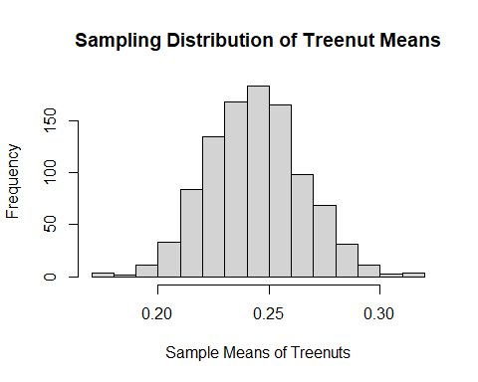

#5 Comparison between Confidence Intervals The t-test 95% confidence interval for the treenut sample means was (.2008, .2865). The 95% confidence interval for the boostrap method was (.2016, .2864). These intervals are very similar to each other.