Table of Contents

CSPM Aggregator - Detailed Design Document (DDD)

Document Control
Version | Date | Author | Role | Contact
1.0 | 8 January 2026 | Liem Vo-Nguyen | Security Architect | liem@vonguyen.io

Table of Contents
Section | Page
Architecture Decision Records | 1
Data Flow Diagrams | 6
Component Design | 7
API Specifications | 9
Data Models | 11
AI Scoring Design | 13
Security Design | 16
Appendix: Technology References | 18

Architecture Decision Records

ADR-001: Language Selection
Status: Accepted Date: 8 January 2026
Context: Need to choose a language for the aggregator service that handles multi-cloud API calls, JSON processing, and LLM integration.
Options:
Option | Pros | Cons
Go | Single binary, fast startup, strong typing, excellent concurrency | Verbose error handling
Python | Rich AI/ML ecosystem, rapid prototyping | Slower startup, dependency management
Rust | Memory safety, performance | Steep learning curve, slower development
Decision: Go
Rationale:
- Single binary deployment simplifies container images
- Fast cold start ideal for CronJob workloads
- Strong typing catches errors at compile time
- Excellent cloud SDK support (AWS, Azure, GCP)
- Go 1.23+ generics improve code reuse

ADR-002: AI Provider Selection
Status: Accepted Date: 8 January 2026
Context: Need an LLM provider for contextual risk scoring and complexity assessment fallback.
Options:
Option | Pros | Cons
Anthropic Claude | Superior reasoning, JSON mode, safety | API-only, no self-host
OpenAI GPT-4 | Wide adoption, function calling | Rate limits, cost
AWS Bedrock | Managed, multiple models | AWS lock-in, complexity
Self-hosted (Llama) | No API costs, privacy | Ops overhead, quality gap
Decision: Anthropic Claude (claude-opus-4-5-20250514)
Rationale:
- Best-in-class reasoning for complex security context
- Native JSON output mode reduces parsing errors
- Consistent, deterministic output at low temperature (0.1)
- Strong safety alignment for security-sensitive prompts

ADR-003: Authentication Strategy
Status: Accepted Date: 8 January 2026
Context: Need to authenticate to three cloud providers without storing credentials.
Decision: Federated Identity (OIDC/MSI/WIF)
Cloud | Method | Token Lifetime
AWS | OIDC Federation via STS | 1 hour
Azure | Managed Identity | Automatic
GCP | Workload Identity Federation | 1 hour
Rationale:
- Zero credential storage eliminates secret rotation burden
- Audit trail via cloud-native identity logs
- Automatic token refresh handled by SDKs
- Aligned with zero-trust architecture

ADR-004: Deployment Model
Status: Accepted Date: 8 January 2026
Context: Need to run the aggregator on a schedule (monthly) with minimal operational overhead.
Options:
Option | Pros | Cons
Kubernetes CronJob | Native scheduling, resource limits | Requires cluster
Azure Functions (Timer) | Serverless, pay-per-use | Cold start, 10-min limit
AWS Lambda + EventBridge | Serverless | 15-min limit, cross-cloud auth complex
VM + cron | Simple | Always-on cost, manual patching
Decision: Kubernetes CronJob on AKS
Rationale:
- Native Workload Identity integration for Azure
- No execution time limits (job can run 1+ hours)
- Resource limits and pod security policies
- Reuse existing AKS infrastructure

ADR-005: State Storage
Status: Accepted Date: 8 January 2026
Context: Need to persist state between runs for delta detection (NEW/EXISTING/CLOSED/REOPENED).
Options:
Option | Cost | Durability | Complexity
Azure Blob Storage | $0.02/GB | 99.999999999% (11 9s) | Low
Azure Table Storage | $0.04/GB | 99.999999999% | Low
PostgreSQL | $25+/mo | High | Medium
Redis | $15+/mo | Medium | Low
Decision: Azure Blob Storage
Rationale:
- Cheapest option for small state files (<1 MB)
- 11 9s durability with GRS replication
- Simple JSON file read/write (no ORM)
- Managed Identity authentication

ADR-006: Complexity Assessment Strategy
Status: Accepted Date: 8 January 2026
Context: Need to classify findings into remediation complexity tiers (Tier1/2/3).
Decision: Rule-based with AI fallback
Strategy:
1. Try rule-based matching (25+ predefined rules)
-> Match found -> Return tier
2. AI fallback for unknown finding types
-> LLM assesses complexity
-> Return tier with lower confidence
3. Conservative default
-> Unknown + AI unavailable -> Tier3
Rationale:
- Rules provide deterministic, fast classification for known patterns
- AI handles novel/edge cases without manual rule updates
- Conservative default ensures no underestimation of effort

ADR-007: Priority Matrix Design
Status: Accepted Date: 8 January 2026
Context: Need to combine risk severity and remediation complexity into actionable priorities.
Decision: 2D Matrix with Escalation Rules
Base Matrix:
 | Tier 1 | Tier 2 | Tier 3
CRITICAL | P1 | P1 | P2
HIGH | P1 | P2 | P3
MEDIUM | P3 | P4 | P4
LOW | P4 | P5 | P5
Escalation Rules (can bump priority up):
- Production environment: +1 priority (max P1)
- PCI/PII data: +1 priority (max P2)
- Internet-facing resource: +1 priority (max P2)
- SLA overdue: +1 priority
Rationale:
- Simple mental model for security teams
- Escalations capture business context
- Maps cleanly to SLA timelines (P1=24h, P2=7d, P3=14d, P4=30d, P5=90d)

ADR-008: Container Security
Status: Accepted Date: 8 January 2026
Context: Need to secure the container workload running in AKS.
Decision: Defense in Depth
Control | Setting
Non-root user | runAsUser: 1000
Read-only filesystem | readOnlyRootFilesystem: true
No privilege escalation | allowPrivilegeEscalation: false
Drop all capabilities | capabilities: { drop: [ALL] }
Resource limits | cpu: 1000m, memory: 1Gi
Rationale:
- Non-root prevents privilege escalation exploits
- Read-only filesystem limits persistence mechanisms
- Dropped capabilities reduce kernel attack surface
- Resource limits prevent DoS from runaway processes

ADR-009: Network Policy
Status: Accepted Date: 8 January 2026
Context: Need to restrict network access for the aggregator pod.
Decision: Egress-only to DNS and HTTPS
egress:
- ports: [53/UDP, 53/TCP] # DNS
- ports: [443/TCP] # HTTPS
to:
- ipBlock:
cidr: 0.0.0.0/0
except:
- 10.0.0.0/8
- 172.16.0.0/12
- 192.168.0.0/16
Rationale:
- DNS required for service discovery
- HTTPS required for cloud APIs and LLM
- Exclude private ranges to prevent lateral movement
- No ingress required (batch job, not server)

Data Flow Diagrams

Scoring Pipeline
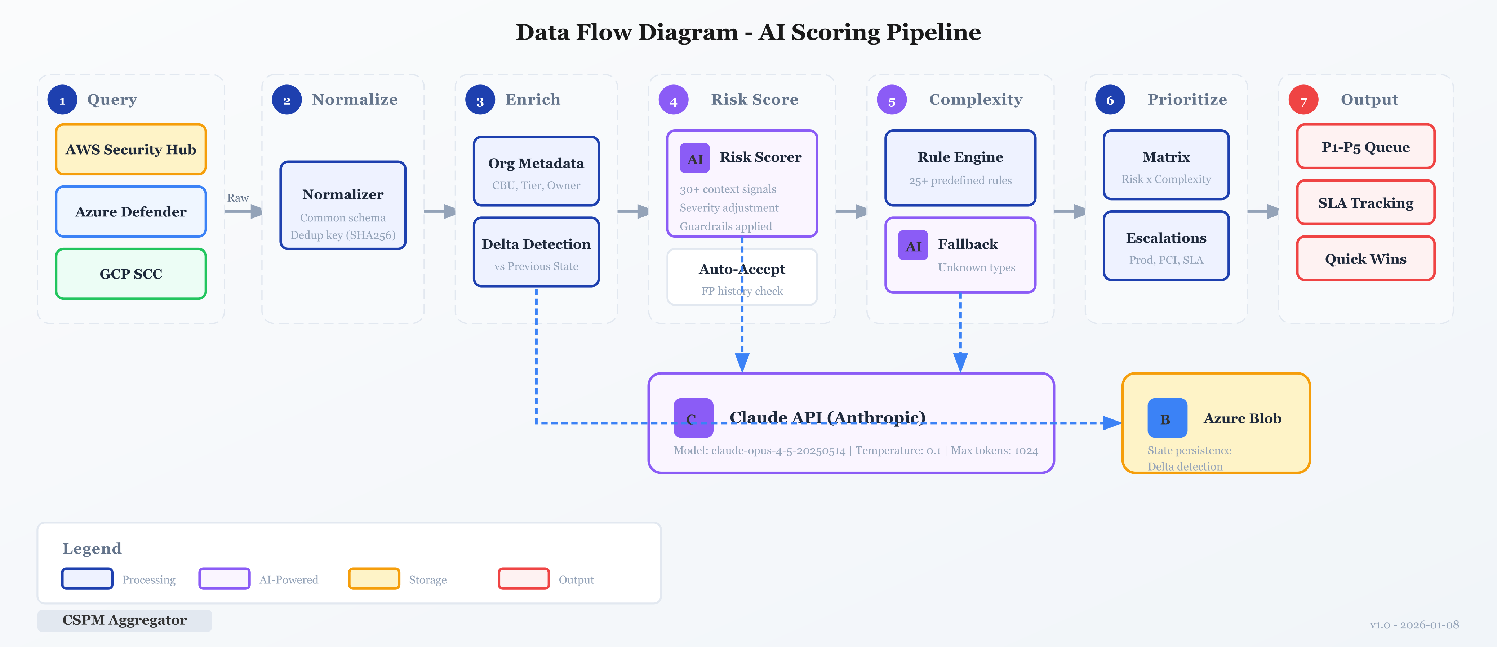
Shows: Cloud providers -> Normalizer -> Delta Detection -> AI Scoring -> Priority Matrix -> Outputs

Priority Matrix Flow
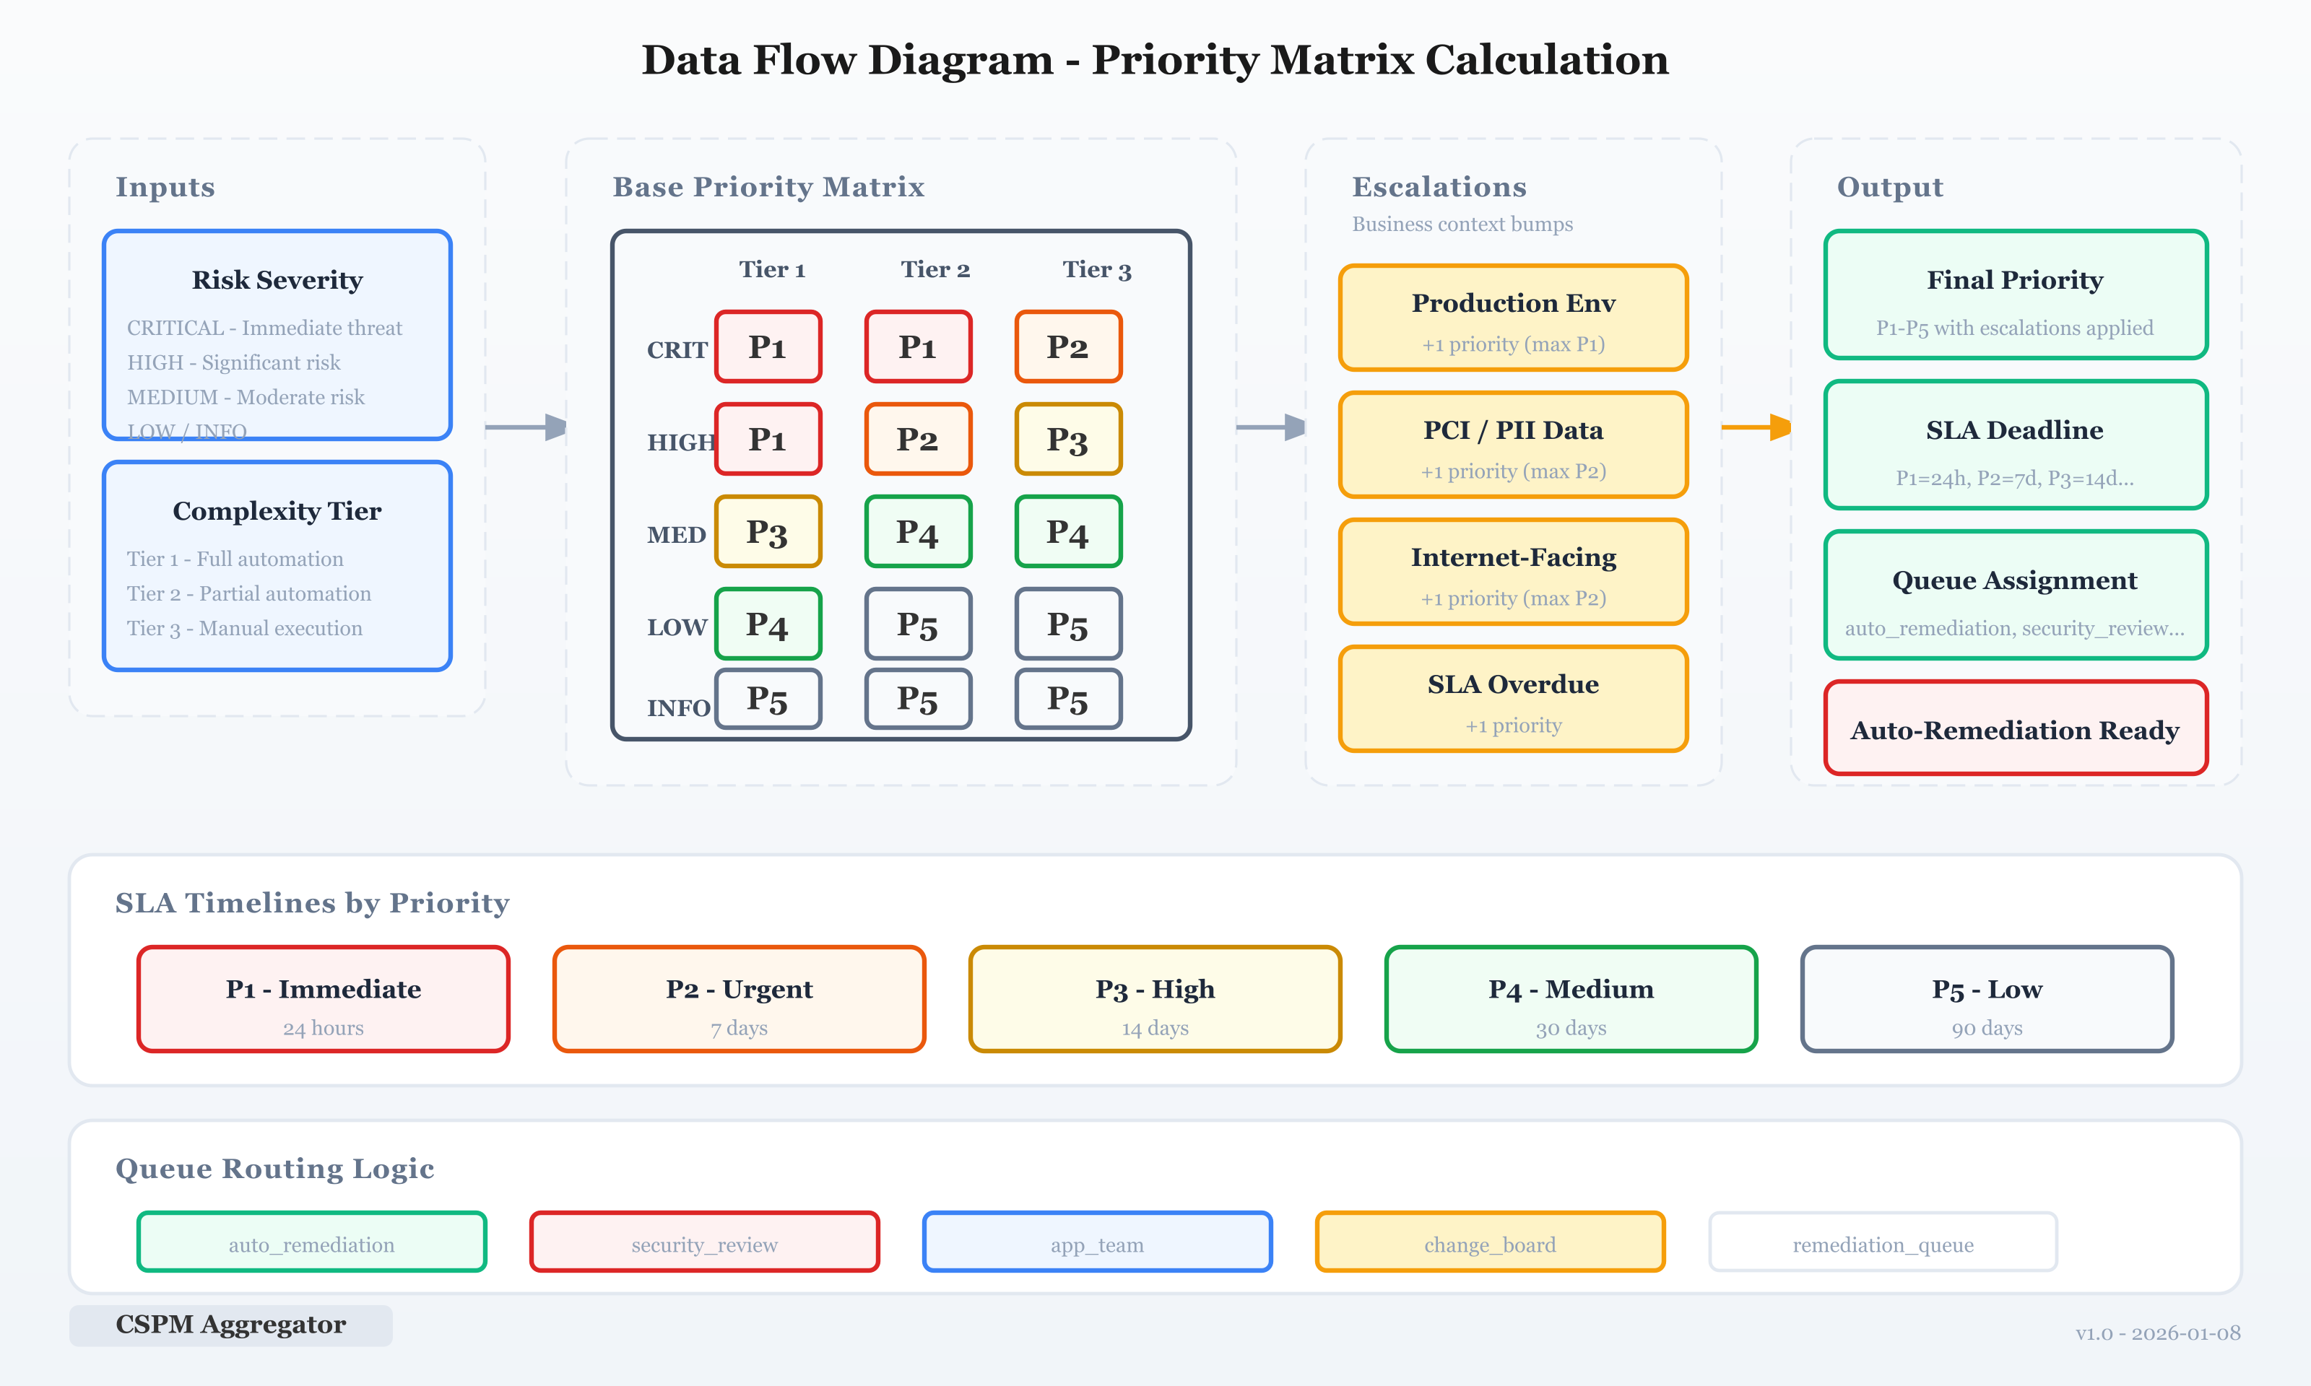
Shows: Risk severity + Complexity tier -> Base priority -> Escalation rules -> Final priority + SLA

Component Design

Package Structure
cspm-aggregator/
├── cmd/aggregator/ # Application entrypoint
│ └── main.go # CLI flags, pipeline orchestration
├── internal/
│ ├── config/ # Configuration management
│ │ └── config.go # YAML + env var loading
│ ├── providers/ # Cloud provider clients
│ │ ├── aws/securityhub.go
│ │ ├── azure/defender.go
│ │ └── gcp/scc.go
│ ├── normalizer/ # Common finding schema
│ │ └── schema.go # Finding struct, delta detection
│ ├── scoring/ # AI scoring layer
│ │ ├── risk_scorer.go # Contextual risk assessment
│ │ ├── complexity.go # Remediation tier classification
│ │ └── priority.go # Priority matrix calculation
│ ├── asana/ # Asana task sync
│ ├── email/ # Email notifications
│ └── reporter/ # Report generation
├── configs/config.yaml # Configuration template
└── k8s/ # Kubernetes manifests

Interface Definitions
Cloud Provider Interface:
type Provider interface {
Name() string
GetFindings(ctx context.Context) ([]normalizer.Finding, error)
}
LLM Provider Interface:
type LLMProvider interface {
Complete(ctx context.Context, req CompletionRequest) (*CompletionResponse, error)
Stream(ctx context.Context, req CompletionRequest) (<-chan StreamChunk, error)
CountTokens(ctx context.Context, text string) (int, error)
ModelName() string
MaxContextLength() int
IsAvailable(ctx context.Context) bool
}
Metadata Provider Interface:
type ResourceMetadataProvider interface {
GetDependencyCount(ctx context.Context, resourceID string) (int, error)
IsStateful(ctx context.Context, resourceID, resourceType string) (bool, error)
IsSharedResource(ctx context.Context, resourceID string) (bool, error)
GetSLATier(ctx context.Context, resourceID string) (string, error)
}

API Specifications

CLI Interface
# Full pipeline execution
./aggregator --config /app/configs/config.yaml
# Dry run (no external writes)
./aggregator --dry-run
# Single cloud provider
./aggregator --cloud aws
# Version info
./aggregator --version

Planned HTTP API (v1.1)
Get Prioritized Findings:
GET /api/v1/findings
?priority=P1,P2
&severity=CRITICAL,HIGH
&tier=Tier1
&automation_candidate=true
&queue=auto_remediation
&sla_status=overdue
&csp=aws,azure
&cbu=HMA,GMA
&limit=100
&cursor=xxx
Response:
{
"findings": [PrioritizedFinding],
"summary": {
"total": 150,
"by_priority": {"P1": 5, "P2": 20, "P3": 45, "P4": 60, "P5": 20},
"auto_remediation_ready": 12,
"quick_win_risk_reduction_pct": 35.5
},
"next_cursor": "yyy"
}
Dashboard Summary:
GET /api/v1/dashboard/summary
Response:
{
"total_findings": 150,
"p1_count": 5,
"p2_count": 20,
"p3_count": 45,
"p4_count": 60,
"p5_count": 20,
"auto_remediation_ready": 12,
"quick_wins": 8,
"quick_win_risk_reduction_pct": 35.5,
"on_track_sla": 120,
"at_risk_sla": 20,
"overdue_sla": 10,
"trend": {
"new_findings": 25,
"closed_findings": 40,
"net_change": -15,
"closure_rate": 0.62
}
}
Quick Wins Report:
GET /api/v1/reports/quick-wins
Response:
{
"quick_wins": [
{
"finding_id": "xxx",
"title": "S3 bucket public access",
"priority": "P1",
"tier": "Tier1",
"automation_candidate": true,
"estimated_effort_hours": 0.5,
"risk_reduction_pct": 5.2
}
],
"total_risk_reduction_pct": 35.5
}

Data Models

Common Finding Schema
type Finding struct {
// Core identification
FindingID string `json:"finding_id"`
FindingIDShort string `json:"finding_id_short"` // SHA256 dedup key
CSP string `json:"csp"` // aws|azure|gcp
AccountID string `json:"account_id"`
ResourceID string `json:"resource_id"`
// Details
Title string `json:"title"`
Description string `json:"description"`
Severity string `json:"severity"` // CRITICAL|HIGH|MEDIUM|LOW
Status string `json:"status"` // ACTIVE|RESOLVED|SUPPRESSED
ControlID string `json:"control_id"`
Standard string `json:"standard"` // CIS|FSBP|MCSB
// Classification (from org metadata)
CBU string `json:"cbu"` // Cost Business Unit
Tier string `json:"tier"` // Tier1-Prod|Tier2-NonProd|Tier3-Dev
EnvType string `json:"env_type"` // DEV|STG|PROD
Owner string `json:"owner"`
// Timestamps
FirstSeen time.Time `json:"first_seen"`
LastSeen time.Time `json:"last_seen"`
RemediationSLA time.Time `json:"remediation_sla"`
// Tracking
AsanaTaskID string `json:"asana_task_id,omitempty"`
DeltaStatus string `json:"delta_status"` // NEW|EXISTING|CLOSED|REOPENED
DaysOpen int `json:"days_open"`
}

Risk Assessment
type RiskAssessment struct {
OriginalSeverity string `json:"original_severity"`
AdjustedSeverity string `json:"adjusted_severity"`
SeverityDirection string `json:"severity_direction"` // upgraded|downgraded|unchanged
RiskScore int `json:"risk_score"` // 1-100
Confidence float64 `json:"confidence"` // 0.0-1.0
Rationale string `json:"rationale"`
MitigatingFactors []string `json:"mitigating_factors"`
AggravatingFactors []string `json:"aggravating_factors"`
RecommendedAction string `json:"recommended_action"` // remediate|accept_risk|investigate|suppress
AutoAcceptEligible bool `json:"auto_accept_eligible"`
AutoAcceptReason string `json:"auto_accept_reason,omitempty"`
}

Complexity Assessment
type ComplexityAssessment struct {
Tier int `json:"tier"` // 1|2|3
ComplexityScore int `json:"complexity_score"` // 1-100
AutomationCandidate bool `json:"automation_candidate"`
AutomationBlockers []string `json:"automation_blockers,omitempty"`
// Coordination requirements
RequiresAppTeam bool `json:"requires_app_team"`
RequiresNetworkTeam bool `json:"requires_network_team"`
RequiresDBTeam bool `json:"requires_db_team"`
RequiresChangeWindow bool `json:"requires_change_window"`
RequiresDowntime bool `json:"requires_downtime"`
// Impact estimates
ServiceImpact string `json:"service_impact"` // none|minimal|moderate|significant
EstimatedDowntimeMin int `json:"estimated_downtime_min"`
EstimatedEffortHours float64 `json:"estimated_effort_hours"`
RecommendedApproach string `json:"recommended_approach"`
Rationale string `json:"rationale"`
}

Prioritized Finding
type PrioritizedFinding struct {
Finding Finding `json:"finding"`
RiskAssessment RiskAssessment `json:"risk_assessment"`
ComplexityAssessment ComplexityAssessment `json:"complexity_assessment"`
// Priority output
Priority string `json:"priority"` // P1|P2|P3|P4|P5
EscalationReasons []string `json:"escalation_reasons,omitempty"`
Queue string `json:"queue"` // auto_remediation|security_review|app_team|change_board|remediation_queue
AutoRemediationReady bool `json:"auto_remediation_ready"`
// SLA tracking
SLADeadline time.Time `json:"sla_deadline"`
SLAStatus string `json:"sla_status"` // on_track|at_risk|overdue
DaysUntilSLA int `json:"days_until_sla"`
}

AI Scoring Design

Risk Scorer Architecture
Context Signals (30+):
Category | Signals
Asset Classification | AssetTier, EnvType, DataClassification, BusinessCriticality
Network Exposure | InternetFacing, VPCType, IngressPorts, EgressRestricted
Compensating Controls | WAFEnabled, EDREnabled, DLPEnabled, EncryptionAtRest, EncryptionInTransit, MFARequired, PrivateEndpoint
Vulnerability Context | CVSSScore, ExploitAvailable, ExploitInWild, PackageInUse, PatchAvailable
Historical Patterns | FalsePositiveHistory, FPRateForType
Business Context | ComplianceScopes, DataResidency, CostCenter, ApplicationOwner, SupportTier
Risk Scoring Flow:
1. Enrich context from metadata providers
2. Load FP history for finding type
3. Check auto-accept scenarios:
- LOW severity in sandbox -> auto-accept
- High FP rate (>30%) + 3+ historical FPs -> auto-accept
4. Build LLM prompt with all context signals
5. Call Claude API (temperature=0.1)
6. Parse JSON response
7. Apply guardrails:
- Never downgrade CRITICAL on Tier1-Prod + internet-facing
- Minimum MEDIUM for PCI/PII data
- Cap confidence at 70% when package usage unknown
- Ensure risk score aligns with severity

Complexity Normalizer Rules
Tier 1 (Full Automation):
Cloud | Finding Types
AWS | S3 public access, logging disabled, IMDSv2, tagging, CloudTrail
Azure | HTTPS only, diagnostic logging
GCP | Public bucket access, audit logging
Tier 2 (Partial Automation):
Cloud | Finding Types
AWS | Security groups, IAM policies, TLS config, patching
Azure | NSG rules, Key Vault access
GCP | Firewall rules, IAM bindings
Tier 3 (Manual Execution):
Cloud | Finding Types
AWS | RDS config, network architecture, critical patches
Azure | SQL configuration
GCP | Cloud SQL, GKE cluster configuration
Environment Bumps:
- Production environment: +1 tier
- Stateful resource (database, queue): +1 tier
- High dependencies (>5): +1 tier
- Shared resource: Minimum Tier2, no automation
- PCI/PII/PHI data: Minimum Tier2, requires change window

Security Design

Authentication Flow
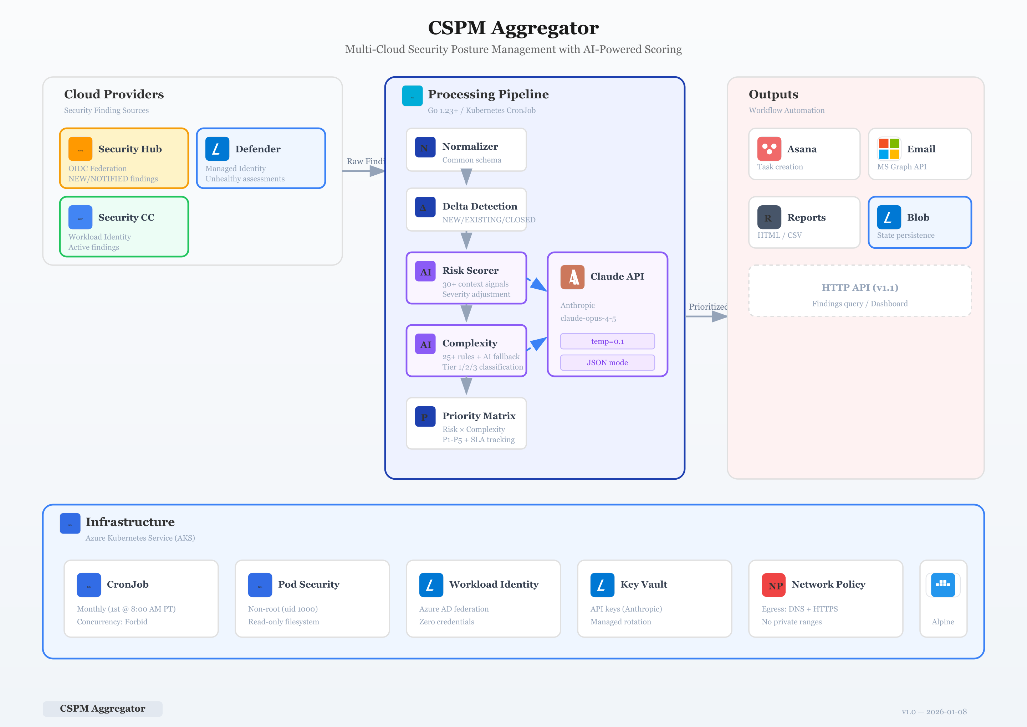
Shows: OIDC/MSI/WIF authentication to cloud providers, Key Vault for secrets

Data Access Control
Data | Read | Write | Delete
Cloud findings | Aggregator | N/A | N/A
State files | Aggregator | Aggregator | Admin
Reports | Aggregator, Users | Aggregator | Admin
Config | Aggregator | Admin | Admin
Secrets | Aggregator | Admin | Admin

Secrets Management
Secret | Storage | Rotation | Access
Anthropic API Key | Key Vault | Annual | Aggregator (MSI)
Asana PAT | Key Vault | Annual | Aggregator (MSI)
Graph Client Secret | Key Vault | Annual | Aggregator (MSI)

Audit Logging
Event | Log Level | Fields
Pipeline start | INFO | timestamp, version, config_hash
Provider query | INFO | provider, finding_count, duration
AI scoring | DEBUG | finding_id, original_severity, adjusted_severity
External write | INFO | destination, record_count
Error | ERROR | operation, error_message, stack_trace

Appendix: Technology References
Technology | Purpose | Documentation
Go 1.23 | Language runtime | Official docs
AWS SDK for Go v2 | AWS API client | AWS docs
Azure SDK for Go | Azure API client | Microsoft docs
GCP Go Client Libraries | GCP API client | Google docs
Anthropic Claude | LLM API | Anthropic docs
Zap Logger | Structured logging | Uber docs
Azure Blob Storage | State persistence | Microsoft docs
Azure Key Vault | Secrets management | Microsoft docs
Kubernetes CronJob | Scheduling | K8s docs
Asana API | Task management | Asana docs
Microsoft Graph | Email API | Microsoft docs

