Table of Contents

CSPM Aggregator - High-Level Design (HLD)

Document Control
Version | Date | Author | Role | Contact
1.0 | 8 January 2026 | Liem Vo-Nguyen | Security Architect | liem@vonguyen.io

Table of Contents
Section | Page
Executive Summary | 1
Architecture Overview | 2
Component Descriptions | 3
Data Flow | 4
Security Architecture | 5
Integration Points | 6
Build vs Buy Analysis | 7
Cost Analysis | 8
Deployment Model | 9
DR/BC Architecture | 10
Technology Stack | 11
Architecture Decision Records | 12

Executive Summary
CSPM Aggregator is a multi-cloud security posture management platform that aggregates findings from AWS Security Hub, Azure Defender for Cloud, and GCP Security Command Center. It applies AI-powered contextual risk scoring and remediation complexity analysis to transform raw security findings into actionable, prioritized work items.
Key Differentiators:
- Contextual AI Scoring: Uses Claude API to analyze 30+ context signals (asset tier, network exposure, compensating controls, vulnerability details) and adjust finding severity beyond raw CSPM output
- Remediation Complexity Tiers: Classifies findings into Tier 1 (full automation), Tier 2 (partial automation), Tier 3 (manual) based on 25+ rules plus AI fallback
- Priority Matrix: Combines risk severity + complexity tier -> P1-P5 prioritization with SLA tracking
- Zero Credential Storage: Uses OIDC (AWS), Managed Identity (Azure), Workload Identity Federation (GCP)
Target Users: Security Operations, Cloud Engineering, Compliance Teams Deployment: Kubernetes CronJob on Azure AKS Data Store: Azure Blob Storage (state persistence) AI: Anthropic Claude API (claude-opus-4-5-20250514)

Architecture Overview

High-Level System Diagram
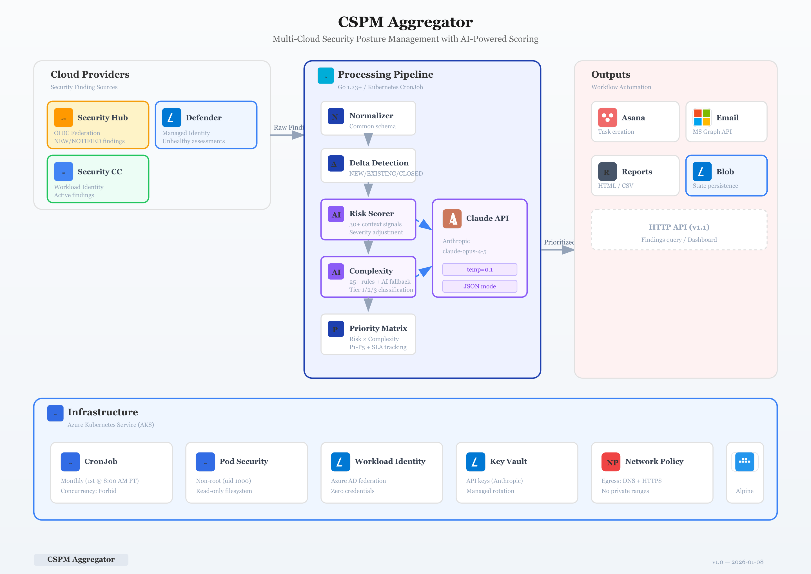

Architecture Principles
Principle | Implementation
Multi-Cloud Parity | Normalized finding schema works across AWS, Azure, GCP
Zero Trust | OIDC/Managed Identity/WIF - no static credentials
Read-Only Access | SecurityAudit/Reader roles only
AI-Augmented | LLM scoring with guardrails and fallbacks
Stateless Processing | State externalized to Azure Blob Storage

Component Descriptions

Cloud Provider Clients
Provider | Service | Authentication | Data Source
AWS | Security Hub | OIDC Federation | Active findings (NEW, NOTIFIED)
Azure | Defender for Cloud | Managed Identity | Unhealthy assessments
GCP | Security Command Center | Workload Identity Federation | Active findings

Core Processing Pipeline
[Cloud Providers] -> [Normalizer] -> [Delta Detection] -> [AI Scoring] -> [Priority Matrix] -> [Output]
| | | | | |
Raw findings Common schema NEW/EXISTING/ Risk + Complexity P1-P5 + Asana/Email/
CLOSED/REOPENED assessment SLA Reports

AI Scoring Layer
Component | Purpose | Lines of Code
Risk Scorer | LLM-based contextual severity adjustment | 589
Complexity Normalizer | Remediation tier classification (25+ rules + AI) | 905
Priority Calculator | Risk + Complexity -> P1-P5 with escalations | 638

Integration Services
Service | Purpose | Authentication
Asana | Task creation and sync | Personal Access Token
Microsoft Graph | Email distribution | OAuth 2.0 Client Credentials
Azure Blob Storage | State persistence | Managed Identity

Data Flow

Finding Ingestion Flow
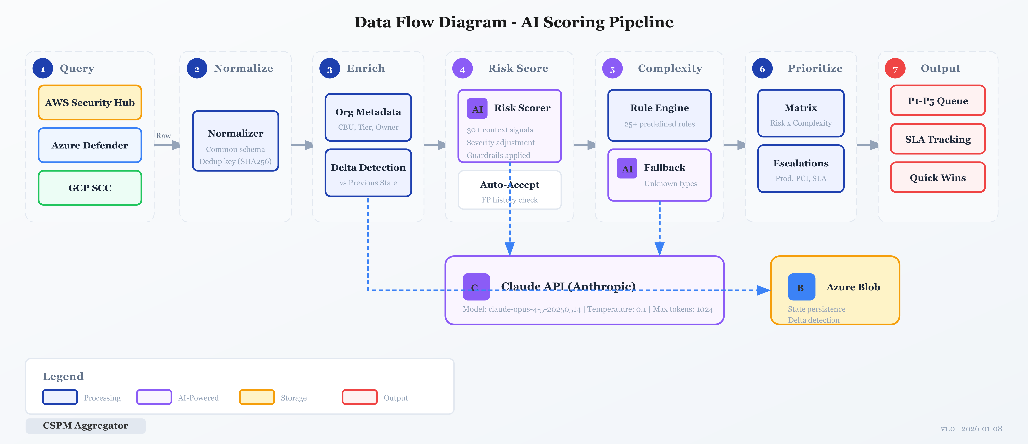

Data Transformation Stages
Stage | Input | Output | Latency
1. Query | Cloud API credentials | Raw findings | 30-60s per provider
2. Normalize | Raw findings | Common schema | <1s
3. Enrich | Common schema | + Org metadata (CBU, Tier, Owner) | <1s
4. Delta | Current + Previous state | + DeltaStatus field | <5s
5. Risk Score | Enriched finding | + AI risk assessment | 2-5s per finding
6. Complexity | Enriched finding | + Complexity tier | 0.5-2s per finding
7. Prioritize | Risk + Complexity | P1-P5 + SLA + Queue | <1s

Priority Matrix
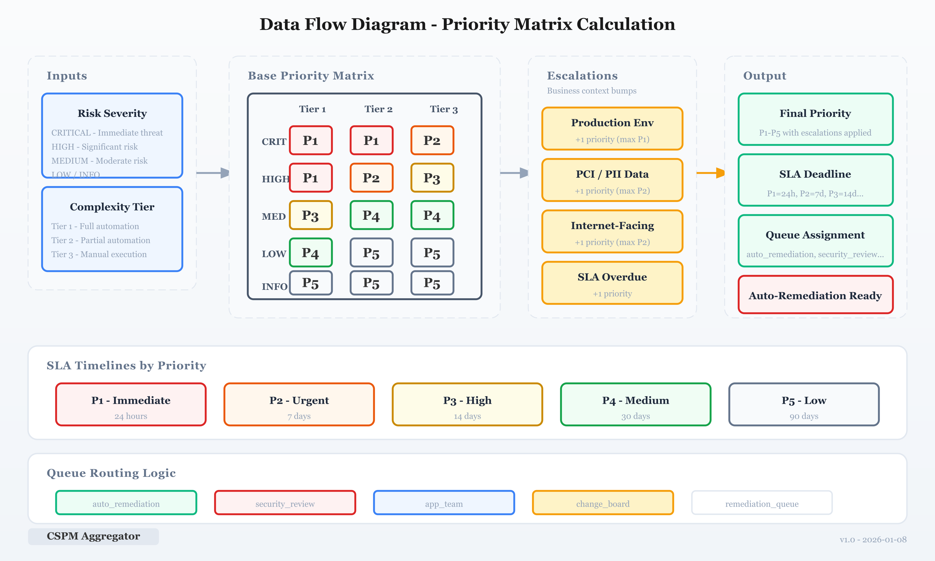
 | Tier 1 (Auto) | Tier 2 (Partial) | Tier 3 (Manual)
CRITICAL | P1 | P1 | P2
HIGH | P1 | P2 | P3
MEDIUM | P3 | P4 | P4
LOW | P4 | P5 | P5
INFO | P5 | P5 | P5

Security Architecture

Authentication Model
Cloud | Method | Credential Storage | Rotation
AWS | OIDC Federation | None (STS) | Automatic
Azure | Managed Identity | None (MSI) | Automatic
GCP | Workload Identity Federation | None (WIF) | Automatic
Anthropic | API Key | Azure Key Vault | Manual (annual)

Data Protection
Data Type | Classification | Protection
Finding metadata | Internal | Encrypted at rest (AES-256)
Resource IDs | Internal | No PII extracted
LLM prompts | Internal | Sanitized (no PII/secrets)
State files | Internal | Blob encryption + RBAC

Container Security
Control | Implementation
Non-root user | UID 1000
Read-only filesystem | readOnlyRootFilesystem: true
No privilege escalation | allowPrivilegeEscalation: false
Dropped capabilities | drop: [ALL]
Resource limits | CPU: 1000m, Memory: 1Gi

Network Security
# NetworkPolicy - Egress only
egress:
- to: [DNS (53), HTTPS (443)]
- except: [10.0.0.0/8, 172.16.0.0/12, 192.168.0.0/16]

Integration Points

Upstream (Data Sources)
Source | Protocol | Rate Limit | Pagination
AWS Security Hub | HTTPS/REST | 10 TPS | Yes (paginator)
Azure Resource Graph | HTTPS/REST | 15 req/5s | Yes (skipToken)
GCP Security Command Center | HTTPS/gRPC | 1000 req/min | Yes (iterator)

Downstream (Outputs)
Destination | Protocol | Purpose
Asana | HTTPS/REST | Task creation and tracking
Microsoft Graph | HTTPS/REST | Email notifications
Azure Blob Storage | HTTPS/REST | State persistence
Local filesystem | File I/O | HTML/CSV reports

AI Integration
Provider | Model | Temperature | Max Tokens | Use Case
Anthropic | claude-opus-4-5-20250514 | 0.1 | 1024 | Risk scoring
Anthropic | claude-opus-4-5-20250514 | 0.1 | 512 | Complexity fallback

Build vs Buy Analysis
Component | Decision | Rationale
Cloud Provider Clients | Build | Custom filtering, normalized output
Finding Normalizer | Build | Cross-cloud schema alignment
Risk Scoring | Build + Buy (LLM) | Contextual analysis requires AI
Complexity Rules | Build | Domain-specific remediation knowledge
Priority Matrix | Build | Custom escalation logic
Asana Integration | Build | Simple REST API
Email (Graph) | Build | Simple REST API
State Storage | Buy (Azure Blob) | Managed, encrypted, cheap
Secrets | Buy (Key Vault) | Managed rotation, audit
Container Orchestration | Buy (AKS) | Managed Kubernetes

Alternative Solutions Considered
Alternative | Pros | Cons | Decision
Wiz/Orca | Comprehensive CSPM | $100K+/year, no AI scoring customization | Pass
Prisma Cloud | Multi-cloud native | Complex licensing, limited priority logic | Pass
Custom LLM (self-hosted) | No API costs | Ops overhead, model quality | Pass
ServiceNow integration | Enterprise ITSM | Requires license, complex setup | Future

Cost Analysis

Infrastructure Costs (Monthly)
Component | Usage | Cost | Notes
AKS Node | 1 node (B2s) | $30 | Shared cluster
Azure Blob Storage | <1 GB | $0.02 | State files only
Key Vault | 10 secrets | $0.03 | Per-operation pricing
Container Registry | 1 image | $5 | Basic tier
Egress | <1 GB | $0.09 | API responses
Subtotal (Infra) |  | ~$35

AI Costs (Monthly)
Operation | Volume | Cost/Unit | Cost
Risk scoring | 500 findings | $0.015/call | $7.50
Complexity fallback | 50 findings | $0.008/call | $0.40
Subtotal (AI) |  |  | ~$8

Total Monthly Cost
Scenario | Findings | Infrastructure | AI | Total
Low | 200 | $35 | $4 | $39
Medium | 500 | $35 | $8 | $43
High | 2,000 | $35 | $32 | $67

Deployment Model

Kubernetes Architecture
AKS Cluster
├── Namespace: cspm-aggregator
│ ├── CronJob (monthly, 1st @ 8:00 AM PT)
│ │ ├── Pod (1 replica)
│ │ │ ├── Container: aggregator
│ │ │ ├── ServiceAccount + Workload Identity
│ │ │ └── Volume mounts (config, reports, tmp)
│ │ └── Secrets (from Key Vault via ESO)
│ ├── ConfigMap (config.yaml)
│ └── NetworkPolicy (egress-only)
└── Shared Infrastructure
├── Azure Key Vault
└── Azure Blob Storage

Deployment Lifecycle
Event | Trigger | Action
Scheduled run | CronJob (1st of month, 08:00 PT) | Full pipeline execution
Manual run | kubectl create job --from=cronjob/cspm-aggregator | Ad-hoc execution
Image update | Git push to main | CI/CD -> Container Registry -> kubectl rollout

Resource Configuration
resources:
requests:
cpu: 100m
memory: 256Mi
limits:
cpu: 1000m
memory: 1Gi

DR/BC Architecture

Recovery Objectives
Metric | Target | Rationale
RTO | 4 hours | Monthly batch job, not real-time
RPO | 30 days | State snapshot per run
MTTR | 1 hour | Redeploy from CI/CD

Failure Scenarios
Scenario | Impact | Recovery
AKS cluster failure | Job doesn't run | Manual trigger after cluster recovery
Cloud provider API outage | Partial data | Retry logic, skip unavailable provider
AI API outage | No scoring | Fallback to rule-based (conservative)
State corruption | Incorrect deltas | Re-run with --reset-state flag

Backup Strategy
Data | Backup Location | Retention | Frequency
State files | Azure Blob (GRS) | 90 days | Per run
Reports | Azure Blob (GRS) | 1 year | Per run
Config | Git repository | Indefinite | Per change
Secrets | Key Vault (soft delete) | 90 days | Manual

Technology Stack
Layer | Technology | Rationale
Language | Go 1.23+ | Performance, single binary, strong typing
AI Provider | Anthropic Claude | Best-in-class reasoning, JSON mode
Cloud SDKs | AWS SDK v2, Azure SDK, GCP SDK | Official, well-maintained
Logging | go.uber.org/zap | Structured JSON logging
Configuration | gopkg.in/yaml.v3 | Human-readable, env var support
Container | Docker (Alpine 3.19) | Minimal attack surface
Orchestration | Kubernetes (AKS) | Managed, Workload Identity native
Secrets | Azure Key Vault | Managed rotation, audit logging
State | Azure Blob Storage | Cheap, durable, encrypted

Architecture Decision Records
ADR | Title | Decision | Rationale
ADR-001 | Language Selection | Go | Performance, single binary deployment
ADR-002 | AI Provider | Anthropic Claude | Superior reasoning, JSON output
ADR-003 | Authentication | OIDC/MSI/WIF | Zero credential storage
ADR-004 | Deployment Model | Kubernetes CronJob | Scheduled batch, resource efficient
ADR-005 | State Storage | Azure Blob | Durable, encrypted, cheap
ADR-006 | Complexity Strategy | Rules + AI fallback | Deterministic where possible
ADR-007 | Priority Matrix | Risk x Complexity | Actionable prioritization
ADR-008 | Container Security | Non-root, read-only | Defense in depth
ADR-009 | Network Policy | Egress-only HTTPS | Minimize attack surface
Full ADR details in docs/adr/ directory.

Future Roadmap
Phase | Feature | Priority
v1.1 | HTTP API for on-demand queries | High
v1.2 | Auto-remediation for Tier1 findings | High
v1.3 | ServiceNow integration | Medium
v2.0 | Real-time streaming (event-driven) | Low
v2.1 | Custom rule engine (user-defined) | Low

