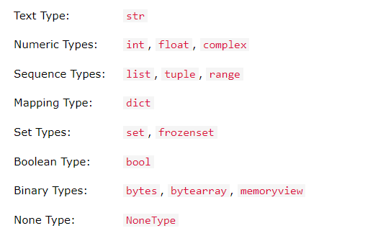



Python



SQL



Linear Algebra

Probability & Statistics

Exploratory data analysis (EDA)



Supervised Learning



Dimensionality Reduction

Unsupervised Learning



Deep Learning



Feature Engineering

Natural Language Processing (NLP)



Product ionization ML/DL models



Reinforcement Learning

String is a group of characters



A = “



I am learning Python”

Conditon1, Condition2

True && True = True

True && False = False

False && True = False

False && False = False

True || True = True

True || False = True

False || True = True

False || False = False