

**SRI LANKA INSTITUTE OF INFORMATION TECHNOLOGY**

[Enterprise Standards and Best Practices for IT Infrastructure](http://courseweb.sliit.lk/course/view.php?id=137)

**4th Year 2nd Semester 2016**

**(Group Assignment)**

**vMotion Migration**

L.V. Rajapaksha – IT 13146498

H.K.V.P. Silva – IT 13127992

N.A.I. Dhanushka – IT 13136666

**vMotion Migration**

vMotion Migration is transferring a running virtual machine (VM) from one host to another with zero downtime, continuous service availability and complete transaction integrity.

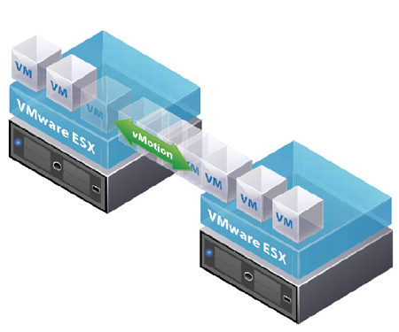

**How vMotion migration works,**

Shared storage

VM

ESXI 01

ESXI 02

Production network

**vMotion Network**

To perform a vMotion there should be a shared storage for both hosts. Shared storage makes migration faster, because there is no need of copying any of the files. What actually need is copying the memory state of the virtual machine from first host to the second host. That performs across the vMotion network.

Hosts should have identical network configuration including identically spelled labels for the VM port groups for networks such as production network.

**Virtual Machines should have following requirements**.

* VM must not have a connection to virtual devices (eg:CD-Rom) with a local image mounted.
* VM must not have a connection to an internal switch.
* VM must not have CPU affinity configured.

**Hosts should have following requirements.**

* Visibility to all storage used by the VM. (Fiber channel, iSCSI, NAS)
* At least a Gigabit Ethernet network.(faster the network more concurrent vMotion migrations allows)
* Access to same physical networks.
* Compatible CPUs. Using VMware CPU identification utility, CPU characteristic can be identified. Comparing the reports for both hosts Incompatibilities can be detected.(following is a screenshot of the report given by the utility)

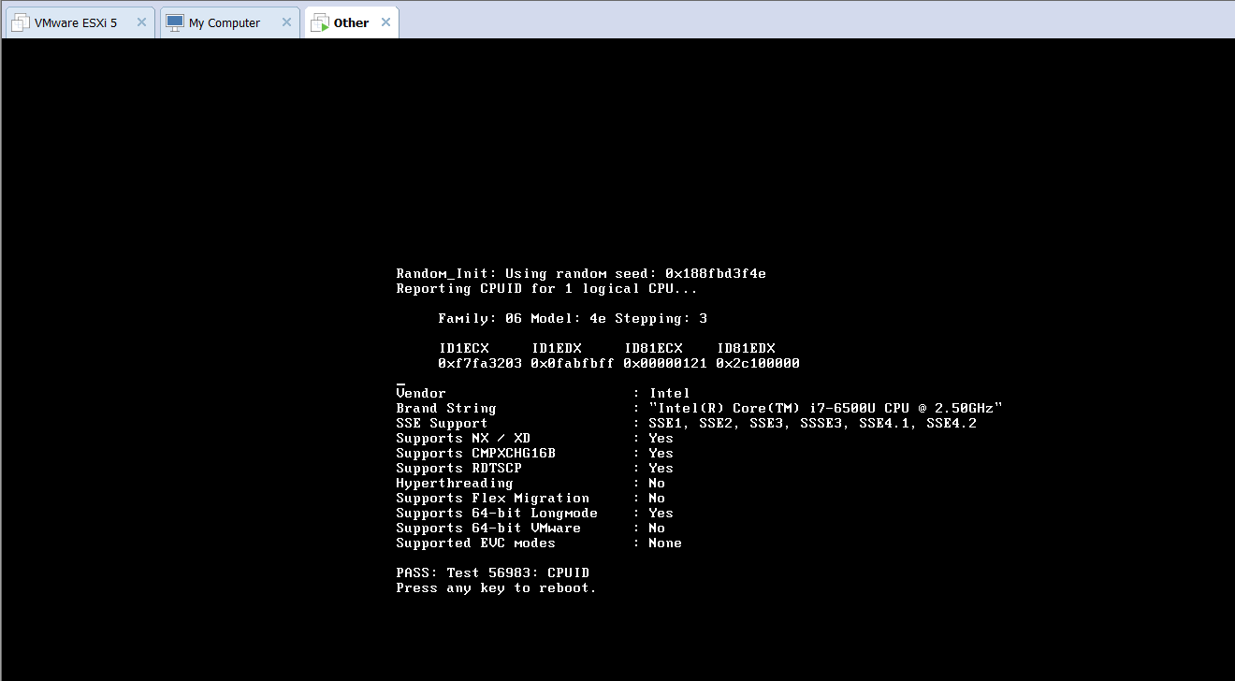

**Minimum hardware requirement to install a ESXI 5.5 server:**

* 4GB RAM (ESXI itself requires 4GB of RAM, to run a VM 8GB is requried)
* 64 bit x86 CPU with at least 2 cores.
* One or more Gigabit Ethernet controllers.
* SCSI disk or a local, non-network, RAID LUN with unpartitioned space for the virtual machines.

Screen shots of Host1 and Host2:

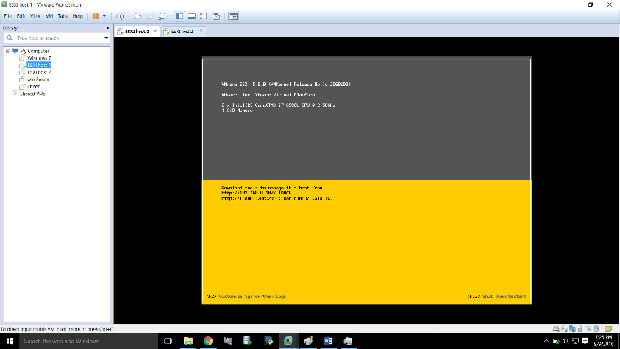

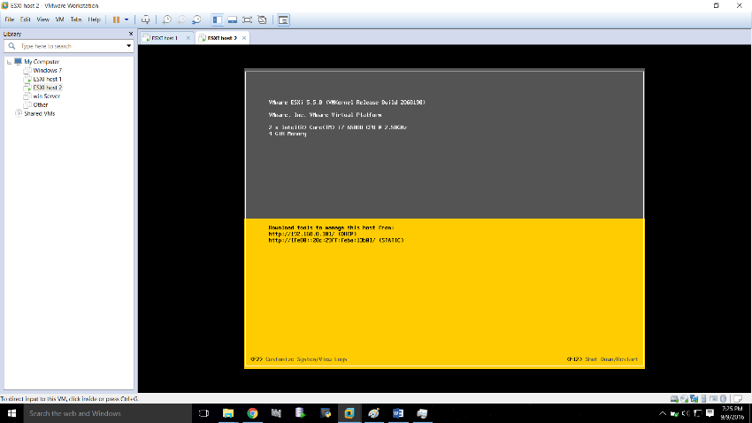

**vMotion migration benefits are,**

* Improve overall hardware utilization.
* Allow continued virtual machine operation while accommodating scheduled hardware downtime.
* Allows vSphere Distributed Resource Scheduler (DRS) to balance VMs across hosts.