# Becoming Familiar with Database Tables

## Objective

To look at a variety of tables used in different environments and become familiar with their structure with regards to:

* Fields
* Datatypes
* Primary Key

## Exercise to do

Look at the following tables and identify Fields and Datatypes

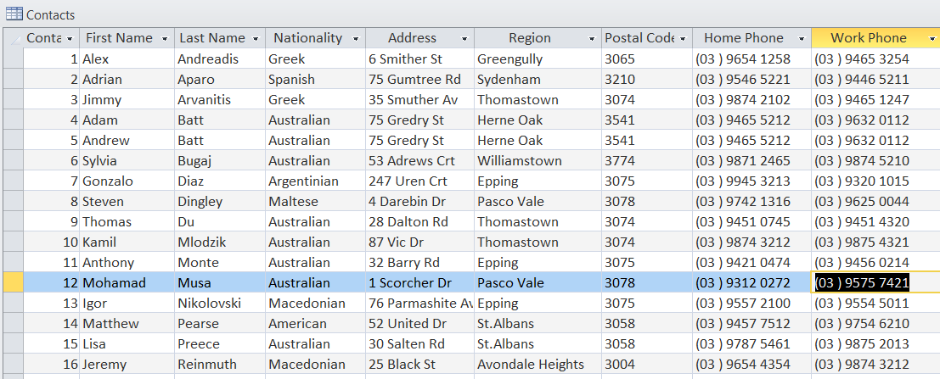

Fields Datatypes (PK or not) eg “Supplier Name” - Text -20 char- not PK

|  |
| --- |
| “Contact ID”- number - 2 char - PK “First Name” – Text – 10 char – not PK |
| “Last Name” – Text – 10 char – not PK Nationality – Text – 20 char – not PK |
| Address – Text – 20 char – not PK Region – Text – 20 char – not PK |
| Postal Code – Text – 4 char – not PK Home Phone – Text – 20 char – not PK |
| Work Phone – Text – 20 char – not PK |

# 

Fields, Datatypes (PK or not) eg “Supplier Name” - Text -20 char- not PK

|  |
| --- |
| “Video Collection” – Text – 10 char – PK “Movie Title” – Text – 30 char – not PK |
| Genre – Text – 20 char – not PK Rating – Text – 5 char – not PK |

Length – Text – 10 char – not PK DateReleased – Text – 10 char – not PK

|  |
| --- |
| Purchase Price – Number – 10 char – not PK Description – Text – 50 char – not PK |

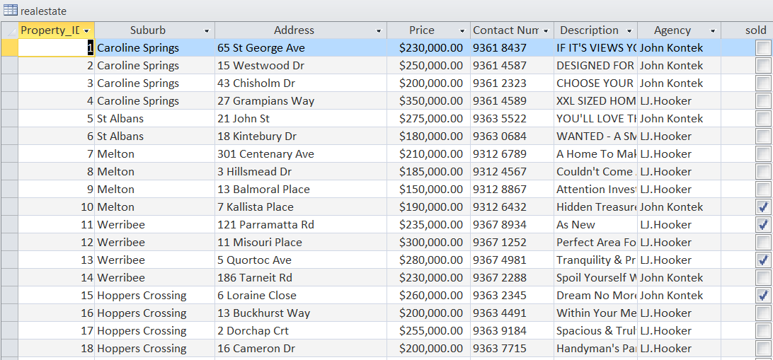

Fields, Datatypes (PK or not) eg “Supplier Name” - Text -20 char- not PK

|  |
| --- |
| Property_ID - Number – 20 char – PK Suburb – Text – 20 char – not PK |
| Address – Text – 25 char – not PK Price – Number – 10 char – not PK |
| Contact Number – number – 10char – not PK Description – Text – 30 char – not PK |
| Agency – Text – 20char – not PK |

|  |
| --- |
|  |

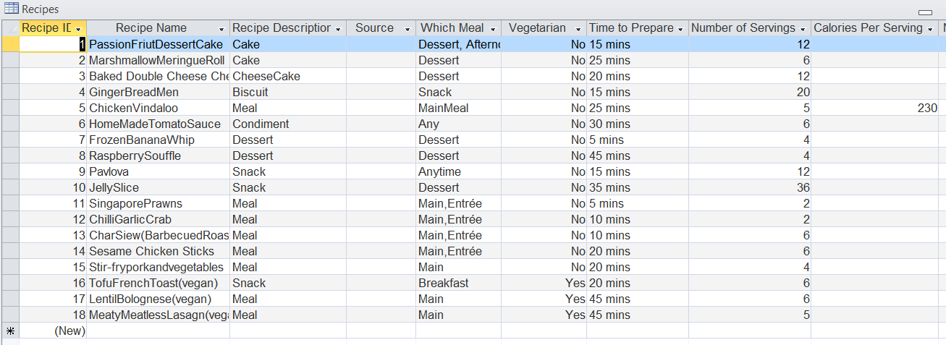

Fields, Datatypes (PK or not) eg “Supplier Name” - Text -20 char- not PK

|  |
| --- |
| Recipe ID – number – 2 char – PK Recipe Name – Text – 30 char – not PK |

Recipe Descripitor – Text – 15 char – not PK Which Meal – Text – 20 char – not PK

|  |
| --- |
| Vegetarian – Text – 3 char – not PK Time to repare – Text – 10 char – not PK |
| Number of Serving – Number – 2 char – not PK |

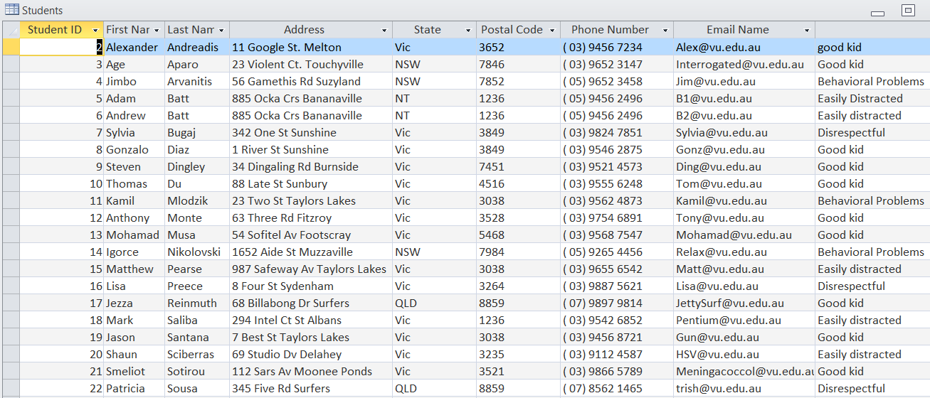

Fields, Datatypes (PK or not) eg “Supplier Name” - Text -20 char- not PK

|  |
| --- |
| Student ID – number - |

|  |
| --- |
|  |