Report OpenStack

Lời nói đầu:

1. Introduction cloud computing
   1. Introduction cloud computing:

Cloud computing is a computing model, where resources such as computing power, storage, network and software are provided as services on the Internet.The cloud mode has 5 essential characteristics , 3 service models and 4 deployment models

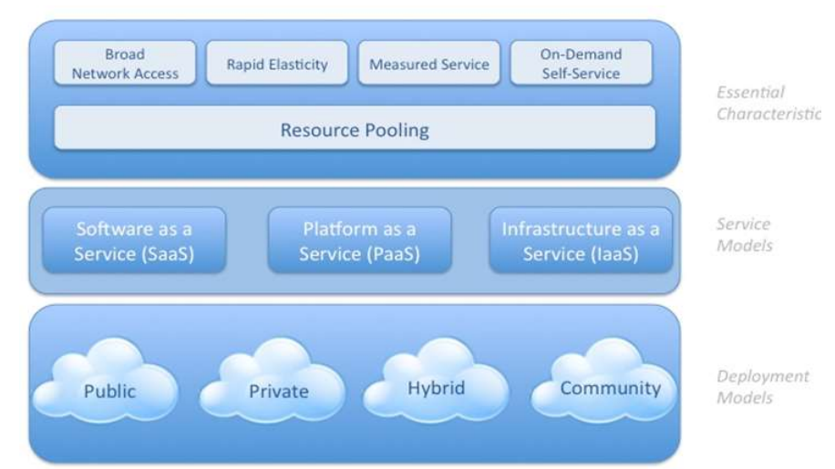

Essential Characteristics:

On-demand self-service: A user can individually provision computing capabilities, such as server time and network storage and this process need automatically without requiring human interaction.

Broad network access : The availability access over the network and through standard mechanisms such as workstations, mobile phones, tablets and laptops.

Resource pooling : All of resource are centralize to service for customer. And the tenant can’t know the information about resource. Resource is network, storage, bandwidth, CPU, RAM…

Rapid elasticity: Capabilities can be elastically provisioned and replaced. This characteristics increase the use of resource more flexible.

Measured service: The cloud need it to manage the service and billing. Beside, cloud automatic control and optimize resource use by leveraging a metering. Resource can be collected , monitored, reported and billing. This ensure the user can pay per use.

Service Models:

Software as a Service(Saas): The capacity provide to the user is to deployed the application running on the cloud infrastructure. The app can accessible from client through web interface , API or program interface. The client only work with app and config app setting, not manage the cloud infrastructure include network, storage, service, operating system.

Platform as a Service (PaaS): The capacity provided to the consumer is to deploy onto the cloud infrastructure consumer-created or acquired applications created using programming onto the cloud languages, libraries, services, and tools supported. The client does not manage or control the underlying cloud infrastructure like Sass but has control over the deployed applications and possibly configuration settings for the application-hosting environment infrastructure consumer-created. Some of PaaS is: Heroku, Google App Engine,

(platform, database,web server, operating system)

Infrastructure as a Service (IaaS): The capacity provided the instance or vitural machine to the consumer. The user can control the image, firewall, storage, balancing traffic, IP address, VLAN and all contain in resource pooling. Some of IaaS is : Amazon EC2, Google Compute Engine, Rackspace Cloud, Windows Azure, Digital Ocean

Deployment Models:

Private cloud

Public cloud

Hybrid cloud

* 1. Introduction OpenStack:

OpenStack is a collection of open source software projects that enterprises/service providers can use to setup and run their cloud

compute and storage infrastructure.

* 1. Run VM

1. Các thành phần của OpenStack
   1. OpenStack Comute:
   2. OpenStackNetwork:
   3. OpenStackStorage:
   4. Horizon:
   5. Telemetry:
2. Topology:

Triển khai mô hình sử dụng nova-network

1. Demo and Test.
2. Future work
3. Conclusion