**Minesweeper User Manual**

**By: Liam Vukasinovic**

**What is Minesweeper?**

Minesweeper is a single player puzzle game. What you are faced with is a 9x9 grid that contains 10 bombs in it. The goal of the game is to clear all cells that do not contain a bomb in it. If you hit a bomb then you instantly lose. You are able to flag cells that you suspect to be bombs. Mines that are not a bomb will contain a value when you click on it. The value indicates how many bombs is touching that cell. Examples of what the game looks like below.

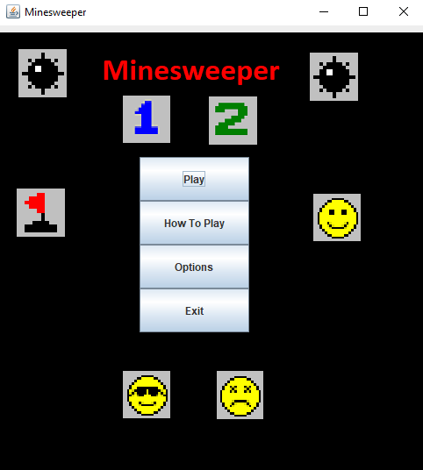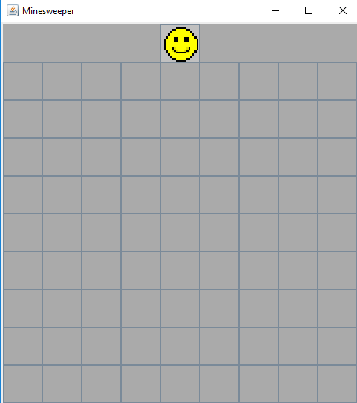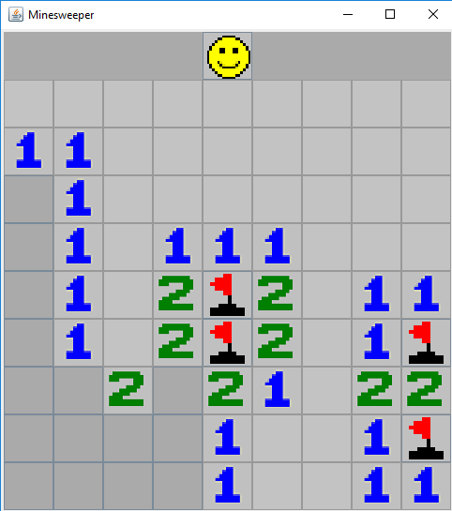

**How to Play?**

Before you learn the instructions, you must run the game from the Main.java file. Running from any other file will not let you play. When you first run the game you will be on the main menu. To navigate the menu you just left click on the button which you would like to go to. Once you click “Play”, you will be in the game. The controls of the game are very simple. You left click to reveal a cell, and right click to flag a cell. If you would like to restart the game at anytime, you can left click the face at the top of the screen. You need to keep revealing cells until there are only the ten bombs left on the screen. You do not need to flag every cell you think is a bomb to win, flagging is only for personal reference. As stated before, cells that are not bombs have a value showing how many bombs are touching that cell. You can use this value to help yourself reveal where the other bombs are. There are ways to recognize this which will be shown later in the manual.

**Winning**

To win the game there must be only the ten cells that have a bomb in them left of the screen. When you win the bombs will show themselves and you the face at the top will become happy. It looks like this.

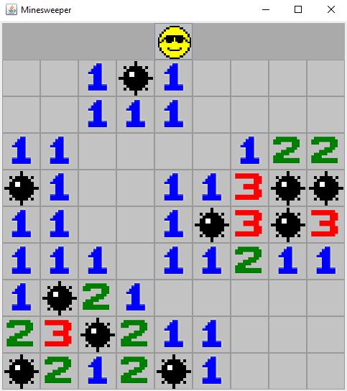

**Losing**

To lose a game you simply just have to reveal a tile that has a bomb under it. If this happens the game will instantly be done as you only have one life. When you lose it will look like this.

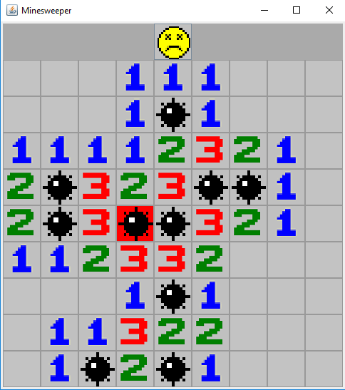

**Strategy**

There are many simple things that you can look at that can quickly help you recognize if a tile has a bomb in it or not. Here are some examples:  
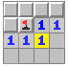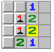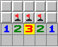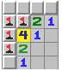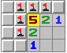  
Overtime patterns like these will become more natural to notice and you will soon be able to complete the game much quicker