Architecture Overview
  - Components, tools, execution approach, control flow, and key decisions
Solution | AI-Assisted URL Shortener
Candidate | Vishnu Vandana Lanka
Technology | Java 21, Spring Boot, Maven, H2, Flyway, JUnit 5, Actuator

Document Contents
- Executive summary and architecture principles
- High-level component architecture
- Component responsibilities and tools
- Execution approach and AI-assisted controls
- Control flows
- Data architecture and schema evolution
- Key architecture decisions
- Security, reliability, and production evolution

Implementation Status at Document Creation
Capability | Status | Evidence / next action
Greenfield core | Completed | Spring Boot application starts; health returns 200; generated link creation returns 201; redirect returns 302 with correct Location header; Maven test phase succeeded.
Brownfield expiration | Planned | Add V2 migration, optional expiresAt, 410 handling, deterministic Clock-based tests, and regression validation.
Ambiguous analytics | Planned | Agree assumptions, add V3 click-events migration, analytics API, privacy controls, and integration tests.

1. Executive Summary
The solution is a modular Spring Boot application that converts URL-shortening requirements into a runnable, reviewable engineering outcome. It supports incremental delivery: a greenfield core establishes creation and redirection, a brownfield increment adds expiration without breaking existing records, and an ambiguous requirement is normalized into a privacy-conscious click-analytics capability.
The architecture intentionally favors a modular monolith over microservices. The assignment timeframe and local demonstration needs make a single deployable application the most defensible option. Clear package boundaries preserve maintainability and provide future extraction points if scale or independent ownership later justifies separate services.
- Engineer-led execution: requirements, acceptance criteria, architecture, reviews, and sign-off remain human-owned.
- AI-assisted acceleration: GitHub Copilot supports decomposition, implementation, debugging, test generation, and review within bounded tasks.
- Controlled schema evolution: Flyway owns all database changes; Hibernate validates rather than mutates the schema.
- Testability: dependency-inverted time handling through java.time.Clock enables deterministic expiration and analytics tests.
- Privacy by design: analytics stores link identifiers and timestamps only; no IP address, cookies, or full user-agent data are required.

2. High-Level Component Architecture
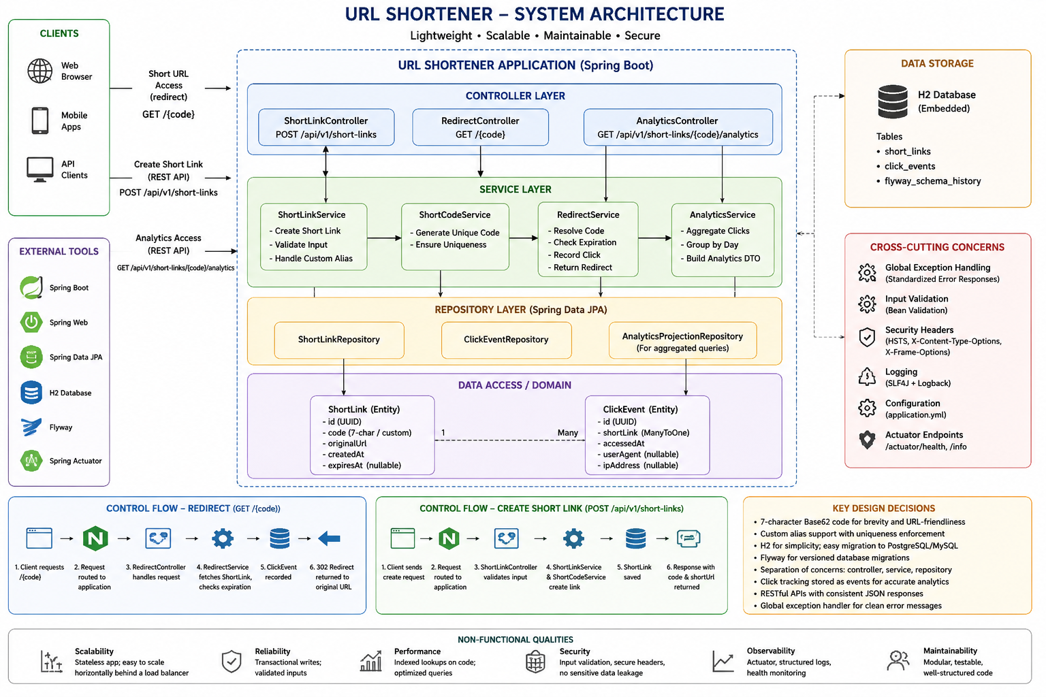

3. Components and Responsibilities
Component | Primary responsibility | Design constraint
ShortLinkController | Accepts create-link requests and returns 201 Created with the resource location. | Performs HTTP concerns only; does not call repositories directly.
RedirectController | Resolves GET /{code} and returns 302 Found with the original URL in the Location header. | Delegates lookup, enabled-state, and expiration decisions to the application layer.
AnalyticsController | Returns total clicks, last access, and UTC daily counts. | Introduced only in the ambiguous analytics increment.
ShortLinkService | Coordinates validation, alias selection, generated-code collision handling, persistence, lookup, and expiration. | Defines transaction boundaries and uses bounded retries.
DestinationUrlValidator | Accepts only absolute HTTP/HTTPS destinations with a host and supported length. | Does not perform outbound network calls or log complete sensitive URLs.
ShortCodeGenerator | Generates seven-character codes using SecureRandom and a Base62-style alphabet. | Stateless and thread-safe; uniqueness is ultimately protected by the database.
AnalyticsService | Records successful redirects and aggregates click data. | No events for unknown or expired links; UTC grouping.
GlobalExceptionHandler | Maps domain and validation failures to consistent safe API errors. | No stack traces, SQL text, or implementation class names in responses.
Repositories | Provide persistence access for short links and click events. | Not exposed directly to web controllers.
Flyway | Creates and evolves database objects in ordered migrations. | Applied migrations are immutable; every schema change uses a new migration.

4. Tools and Technology
Area | Selected tool | Purpose
Language | Java 21 | Modern Java runtime and language features.
Application framework | Spring Boot | Application configuration, dependency injection, web runtime, testing support.
REST | Spring Web | HTTP endpoints, JSON serialization, status and header handling.
Persistence | Spring Data JPA | Repository abstraction and transactional persistence.
Prototype database | H2 file database | Easy local execution with persistence across restarts.
Schema management | Flyway | Versioned and reviewable database migrations.
Validation | Jakarta Validation + domain validation | Request constraints plus URL and business-rule validation.
Testing | JUnit 5, Spring Boot Test, MockMvc | Unit and application-level integration tests.
Operations | Spring Boot Actuator | Health, info, and selected metrics endpoints.
Build | Maven Wrapper | Reproducible build and verification commands.
IDE | Eclipse | Development, Copilot prompts, Maven execution, and EGit workflow.
AI assistance | GitHub Copilot | Bounded planning, code suggestions, debugging, tests, documentation, and review.
Change control | Git / EGit | Branches, commits, traceability, and safe change management.

5. Execution Approach
1. Normalize the requirement: identify intent, ambiguities, assumptions, constraints, and measurable acceptance criteria.
2. Decompose the increment into schema, API, application, persistence, tests, documentation, and validation tasks with dependencies.
3. Use Copilot within one bounded task at a time. Prompts define intent, allowed files, prohibited changes, acceptance criteria, and required tests.
4. Review every proposed change before acceptance. Generated output may be accepted, edited, or rejected with rationale.
5. Run quality gates: compile, unit tests, integration tests, Flyway migration validation, manual curl tests, H2 inspection, and Actuator health.
6. Commit a small coherent change to Git only after the relevant gates pass. High-impact changes require explicit engineer sign-off.

6. Control Flows

6.1 Create Short Link
POST /api/v1/short-links
-> validate JSON and field constraints
-> validate/normalize original URL
-> use approved custom alias OR generate SecureRandom code
-> check availability / bounded collision retry
-> persist short_links record
-> return 201 Created + Location header + response DTO

6.2 Redirect
GET /{code}
-> validate code format
-> load enabled short link
-> unknown: return 404
-> expired: return 410 (brownfield increment)
-> record click event (analytics increment)
-> return 302 Found with Location = original URL

6.3 Analytics Retrieval
GET /api/v1/short-links/{code}/analytics
-> verify short link exists
-> count click events
-> calculate last accessed timestamp
-> group events by UTC date
-> return 200 with totalClicks, lastAccessedAt, clicksByDay

6.4 Error Handling
Condition | HTTP status | Control
Invalid or unsupported URL / malformed request | 400 Bad Request | Jakarta validation and domain validator.
Unknown short code | 404 Not Found | Domain not-found exception mapped by global handler.
Duplicate custom alias | 409 Conflict | Availability check plus database unique constraint.
Expired short link | 410 Gone | Clock-based expiration rule.
Unexpected server error | 500 Internal Server Error | Safe generic response; internal details remain in controlled logs.

7. Data Architecture and Schema Evolution
Migration | Purpose | Main fields / controls
V1__create_short_links.sql | Greenfield core schema. | id, unique code, original_url, created_at, enabled.
V2__add_short_link_expiration.sql | Brownfield optional expiration. | Nullable expires_at; existing null records remain valid.
V3__create_click_events.sql | Ambiguous analytics implementation. | id, short_link_id foreign key, accessed_at, query index.

short_links (1) ------------------- (many) click_events
id PK id PK
code UNIQUE short_link_id FK
original_url accessed_at
created_at
expires_at NULL
enabled

8. Key Architecture Decisions
Decision | Rationale | Trade-off / consequence
Modular monolith | Meets the 2-3 day prototype timeline with simpler deployment and testing. | Independent scaling is deferred; package boundaries preserve future extraction options.
H2 for prototype | Removes external database setup and makes reviewer execution simple. | Production database behavior, concurrency, and SQL compatibility must be revalidated on PostgreSQL or another managed RDBMS.
File-backed runtime; in-memory tests | Runtime data can survive restart while tests remain isolated and repeatable. | Working-directory changes can create a different H2 file path; configuration must be explicit.
Flyway owns schema | Provides versioned, reviewable, brownfield-safe evolution. | Requires disciplined immutable migration practice.
SecureRandom code generation | Avoids predictable short codes. | Random generation cannot prove uniqueness; bounded retry and a unique database constraint are still required.
Clock injection | Enables deterministic expiration and timestamp tests. | Time must be consistently sourced through the injected Clock.
302 redirect | Standard temporary redirect semantics for a configurable short link. | Permanent caching behavior is avoided; a later product decision could change status semantics.
Synchronous analytics in prototype | Simple and immediately consistent. | Adds a write to redirect latency; production scale may require asynchronous event processing.
Minimal analytics data | Meets useful metrics without unnecessary personal tracking. | Geography, device, campaign, and fraud analytics are deferred.

9. Security, Reliability, and Production Evolution
- Input controls: allow only absolute HTTP/HTTPS destinations, validate alias format and length, and enforce database uniqueness.
- Information protection: do not expose stack traces or database details; do not log complete URLs where query parameters may contain secrets.
- Operational controls: expose only health, info, and selected metrics in the prototype; protect all operational endpoints in production.
- Reliability controls: bounded collision retries, database constraints, transactions, regression tests, and explicit error semantics.
- Production evolution: managed PostgreSQL, rate limiting, abuse and malicious-URL controls, authentication for management APIs, distributed cache only when justified, asynchronous analytics, backups, high availability, observability, load testing, and secure secrets management.

