实验一 进程同步算法模拟
一、实验目的
1、设计算法解决哲学家进餐问题
2、自行选择解决算法，实现死锁的预防。
二、实验学时
2007年10月4课时
三、实验环境与平台
Windows 2000, C/C++程序开发集成环境(开发语言可自选)
四、实验内容及要求
（1）自定义PCB的数据结构；
（2）针对哲学家进餐中出现的问题，选择适合的算法，实现避免死锁情况的出现。
五、完成的实验内容
下例是用JAVA语言编写，用JCreator调试结果
实现代码如下：
public class kuai
{ String name;
boolean Enable = true;
public kuai(String name)
{ this.name = name; }
public synchronized void pickup()
{ try { while(Enable==false)
{ this.wait(); }
this.Enable =false;
} catch (Exception e) { }
}
public synchronized void putdown()
{ this.Enable =true;
this.notifyAll();
}
public static void main(String args[]) {
kuai k1 = new kuai("筷子1号");
kuai k2 = new kuai("筷子2号");
kuai k3 = new kuai("筷子3号");
kuai k4 = new kuai("筷子4号");
kuai k5 = new kuai("筷子5号");

People p1 = new People("老大", k1, k2);
People p2 = new People("老二", k3, k2);
People p3 = new People("老三", k3, k4);
People p4 = new People("老四", k5, k4);
People p5 = new People("老幺", k5, k1);

p1.start();
p2.start();
p3.start();
p4.start();
p5.start();
}
}

class People extends Thread
{ String name;
kuai left;
kuai right;
public People(String name, kuai l, kuai r)
{ this.name = name;
left = l;
right = r;
}
public void run()
{ left.pickup();
System.out.println(name + " 眼明手快，以迅雷不及掩耳之势一把抓起 "+left.name);
right.pickup();
System.out.println(name + " 眼明手快，以迅雷不及掩耳之势一把抓起 "+right.name);
System.out.println(name + " 左右开弓，狼吞虎咽起来");
try { Thread.sleep(2000); } catch (InterruptedException e) { e.printStackTrace(); }
System.out.println(name + " 酒足饭饱，打了个饱嗝，心满意足的放下了 "+left.name+" 和 " +right.name);
left.putdown();
right.putdown();

}
}
六、实验结果
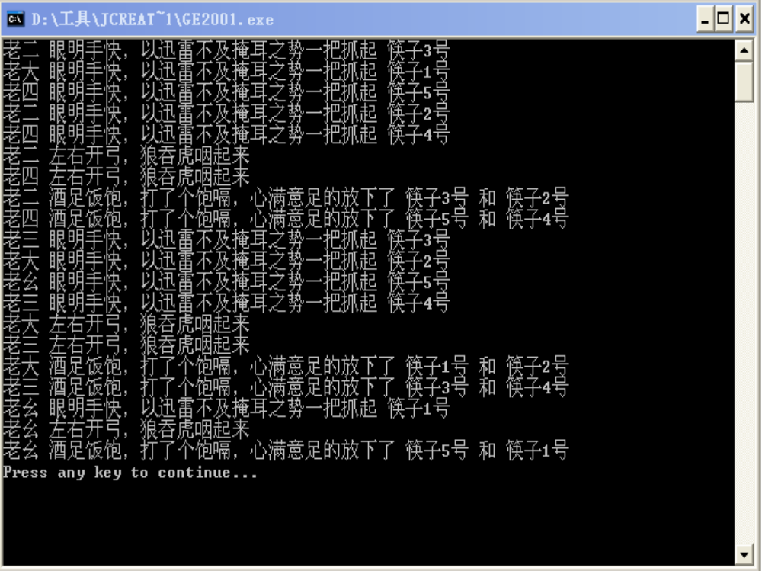
七、结论分析
本例用 Enable 来显示个筷子能不能用，原作在使5个人拿筷子时，是按先拿左边筷子，后拿右边筷子，在多次运行后，出现了死锁，从一到五都眼明手快，以迅雷不及掩耳之势一把抓起左边的筷子，所以改为
People p1 = new People("老大", k1, k2);
People p2 = new People("老二", k3, k2);
People p3 = new People("老三", k3, k4);
People p4 = new People("老四", k5, k4);
People p5 = new People("老幺", k5, k1);
基数号先拿左边的筷子,偶数先拿右边的筷子，调试多遍都成功，解决了死锁问题。

