Firstly, deploy web application into war, and find its position

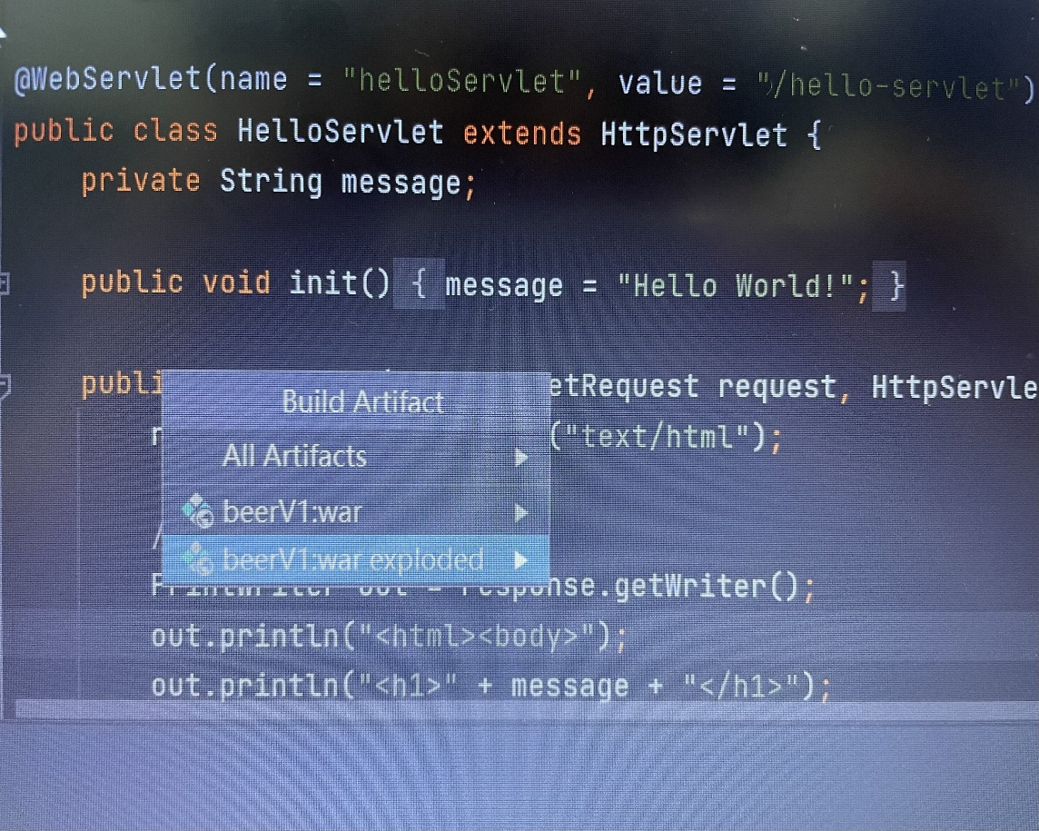

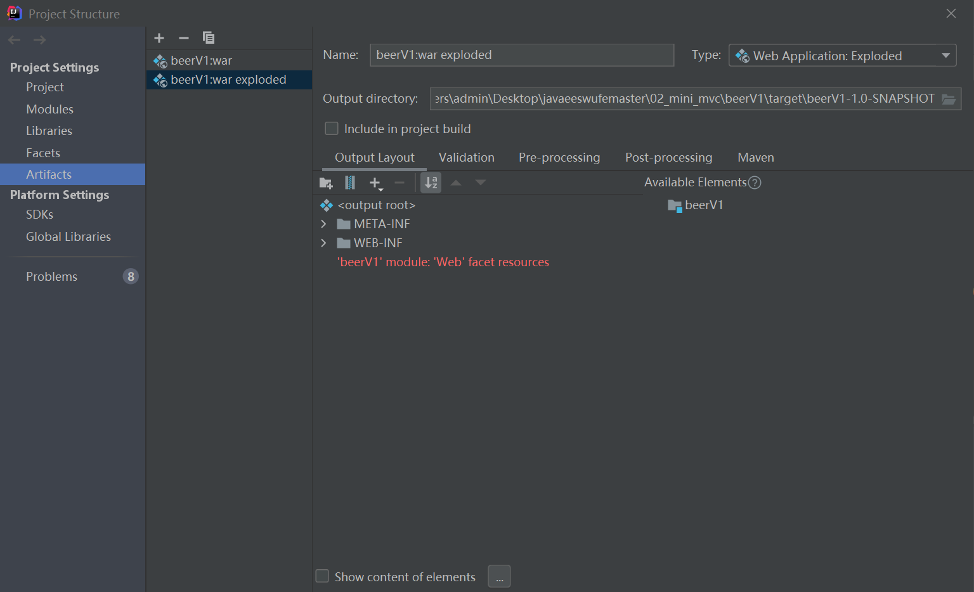

Secondly, star up Tomcat manually.

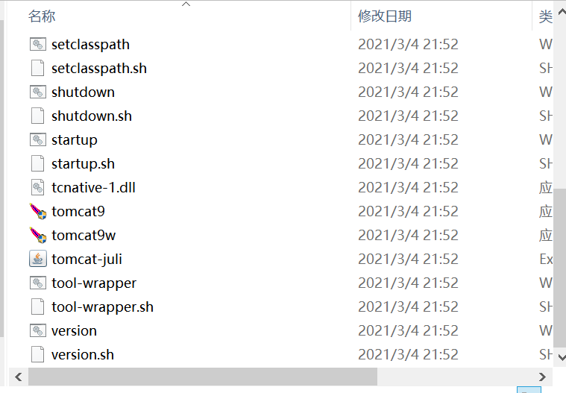

At last, copying and pasting it on <http://localhost:8080/>

Then, it can work.