**Delete the cookies of localhost:**

First, find cookies in the advanced setup and choose the according cookie of localhost.

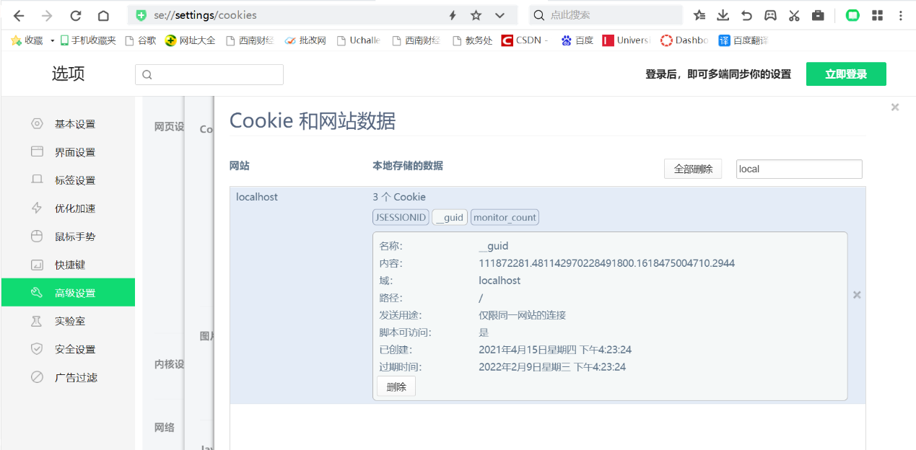

Second, delete these cookies one by one.

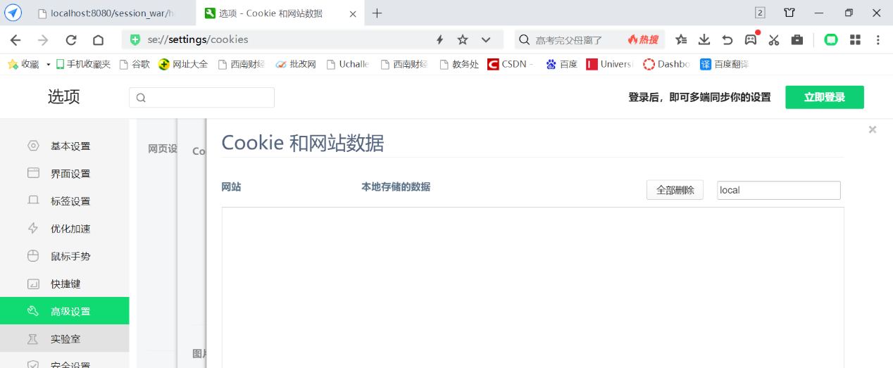

Then, back to the browser, visiting /hello-servlet again. We find that it shows: this is a new session on the page instead of “welcome back.”

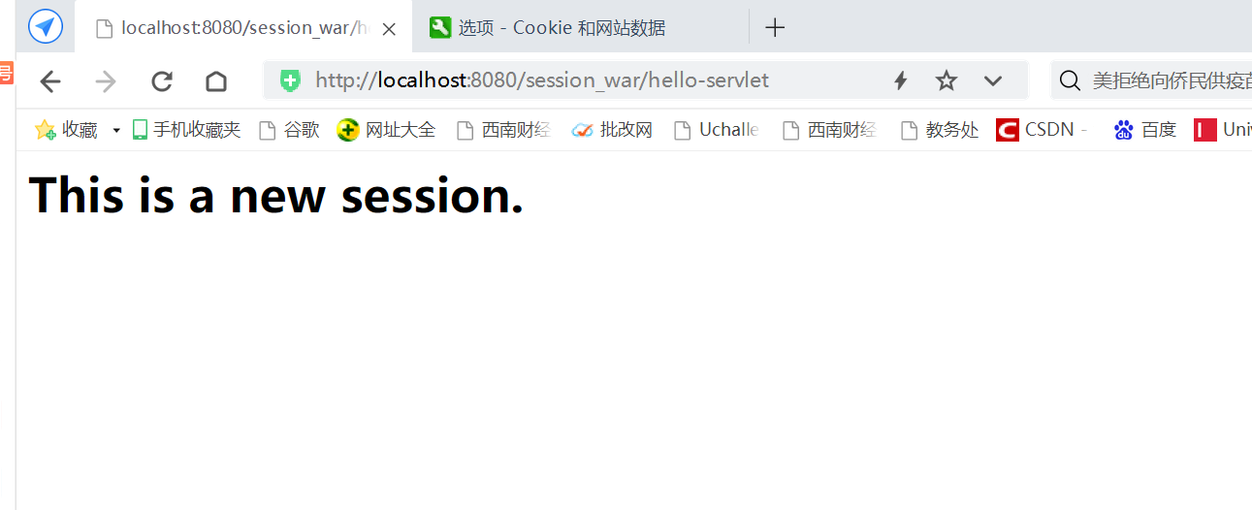

Because the server cannot recognize the identity of the user in the request, session failure.