**Cookie2(disable)**

Find the cookie setting first:

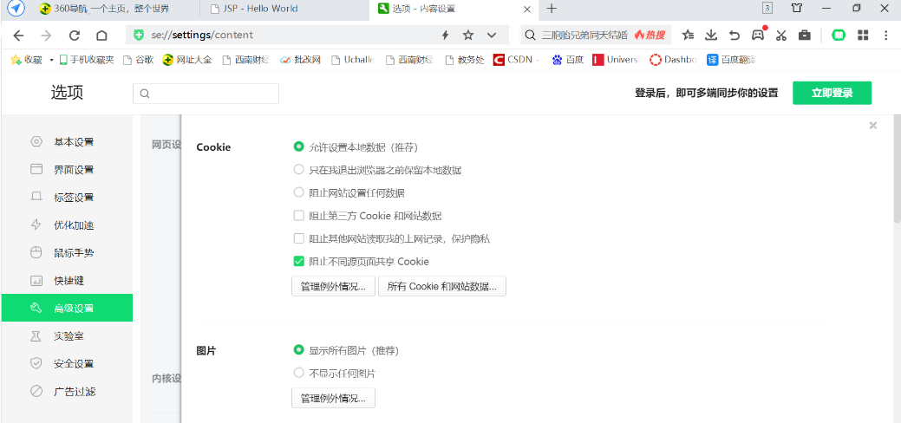

Then disable the cookies for localhost in the browser:

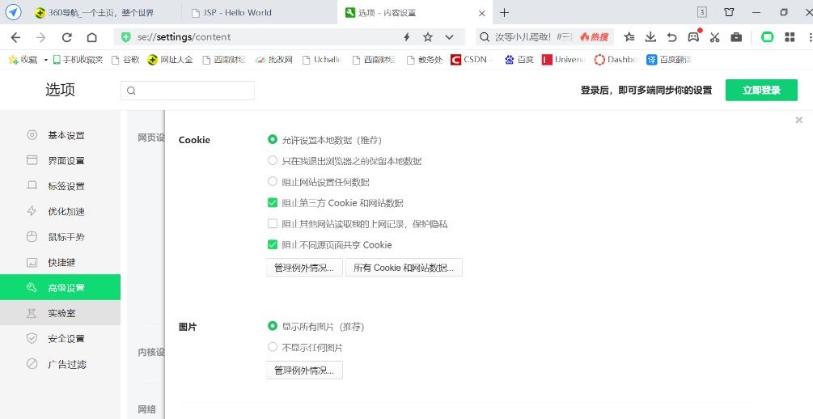

Then, enter the “hello servlet” again, there will also show: This is a new session.

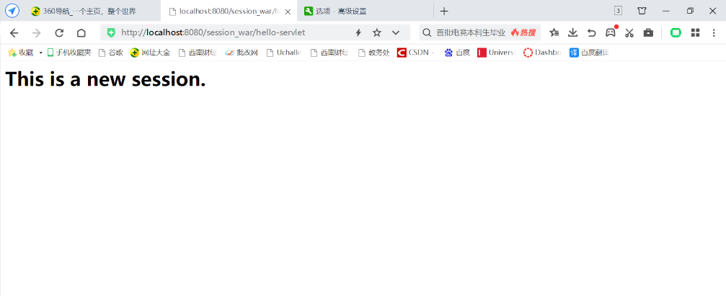

Because by default, the browser will accept all the cookies, so the response.encodeURL does not necessarily fall back to URL rewriting.

If the browser disables cookies, the browser request server cannot carry sessionid, the server can not recognize the identity of the user in the request, session failure.