**Degree Report**

**Results:**

Average Degree: 1.544  
  
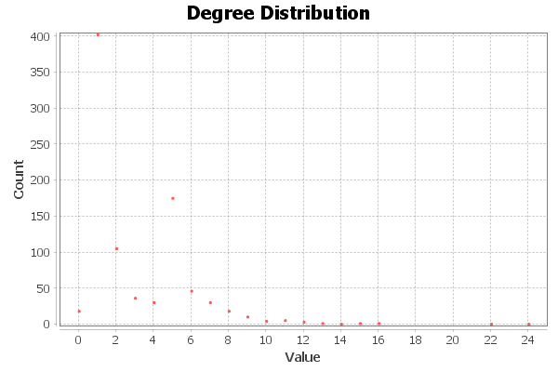  
  
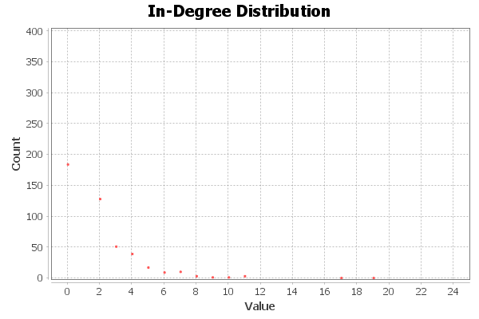  
  
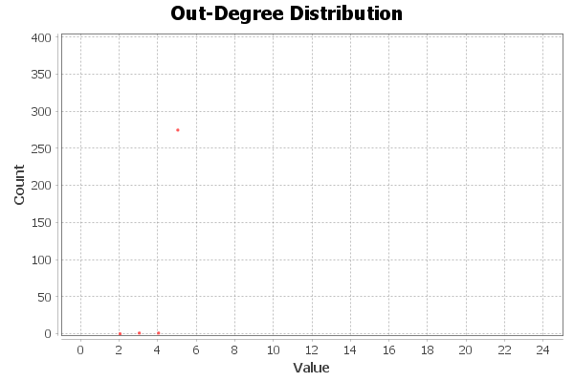

**Graph Distance Report**

**Parameters:**

Network Interpretation: directed

**Results:**

Diameter: 11  
Radius: 0  
Average Path length: 3.878191613961115  
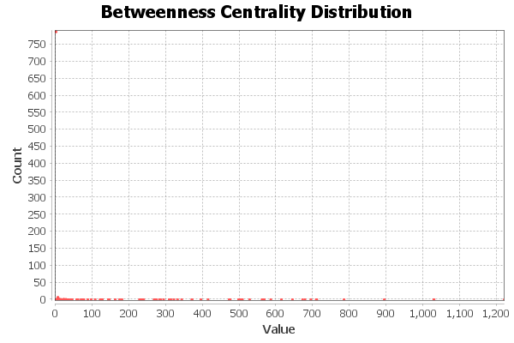  
  
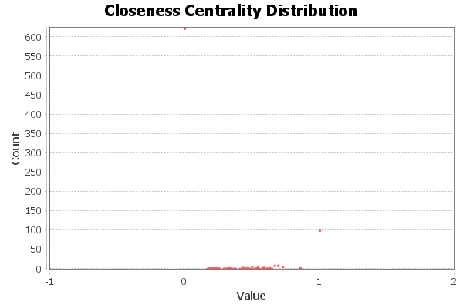  
  
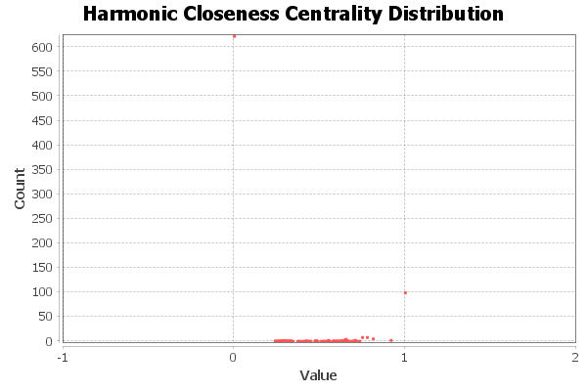  
  
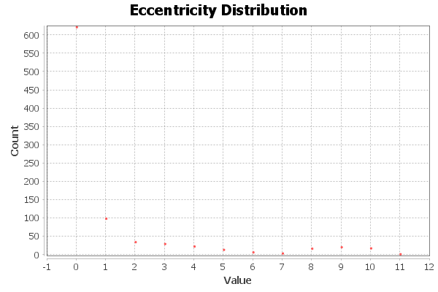

**Algorithm:**

Ulrik Brandes, *A Faster Algorithm for Betweenness Centrality*, in Journal of Mathematical Sociology 25(2):163-177, (2001)

# Graph Distance Report

## Parameters:

Network Interpretation: directed

## Results:

Diameter: 11  
Radius: 0  
Average Path length: 3.878191613961115  
  
  
  
  
  
  


## Algorithm:

Ulrik Brandes, *A Faster Algorithm for Betweenness Centrality*, in Journal of Mathematical Sociology 25(2):163-177, (2001)