## **Restaurant Location Recommender – New York City**

**Introduction/Business Problem：**

**This capstone project is meant to build a restaurant location recommender in New York City. NYC is one of the world’s most prosperous and diverse metropolis. There are a huge number of restaurants in NYC already, recorded at 26,697 in 2017, which is up from 25,305 in 2014 [1]. Therefore, it is indisputable that the competition in the NYC restaurant business is fierce. With the number of restaurants still increasing, it can be anticipated that the competition will become even stronger in the future. Therefore, for a prospective new restaurant owner who dreams of opening a restaurant anywhere in NYC, it is critical for them to understand where to open their restaurant based on his/her desired restaurant type (e.g. fast food stand/fine-dining restaurant, cuisine, etc.), to maximize their probability of survival and profitability in the sea of restaurants in NYC. Therefore, this project is targeted for anyone who is interested in opening a restaurant of any type in NYC.**

**Of course, determination of a restaurant’s location is based on various factors, such as availability of retail space, population of the area, etc., and comprehensive coverage of all these factors is not within scope of this project. This project provides a straightforward location suitability score metric to help the restaurant owner narrow the prospective location down to which of the 306 neighborhoods in NYC should they pay special attention to in hunting for a prospective restaurant location. To maximize the profitability of opening their desired type of restaurant in NYC, this location recommender would be a great start for restaurant owners.**

**Data：**

The first dataset needed for this project will be the json data of NYC, which includes 5 boroughs and 306 neighborhoods. This data is essential for obtaining a complete set of location data, including boroughs, neighborhood longitude, neighborhood latitude, etc. It is also the basis of the location suitability score we are trying to obtain as a final product of the project. This dataset has been used in the ungraded lab of Week 3, so it will be processed similarly in this project.

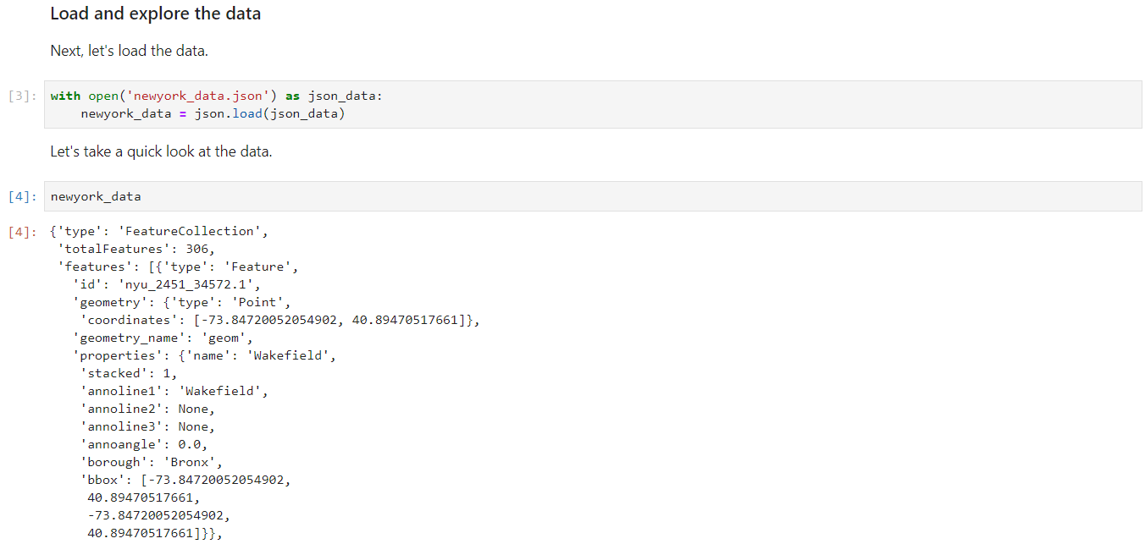

Besides, there is of course the Foursquare location data, in which you can find hundreds of categories of restaurants in NYC with various types of information. Foursquare location data provides venues in which we can access details including ID, name, exact location (latitude, longitude), URL, contact information, ratings, tips and other statistics. These information can be particularly useful for a more refined restaurant locator than what the present project presents. However, some of these information requires premium calls that is limited to 500 each day for free developer accounts, therefore limiting the possibility of the location recommender. An example of Foursquare location data is provided below.

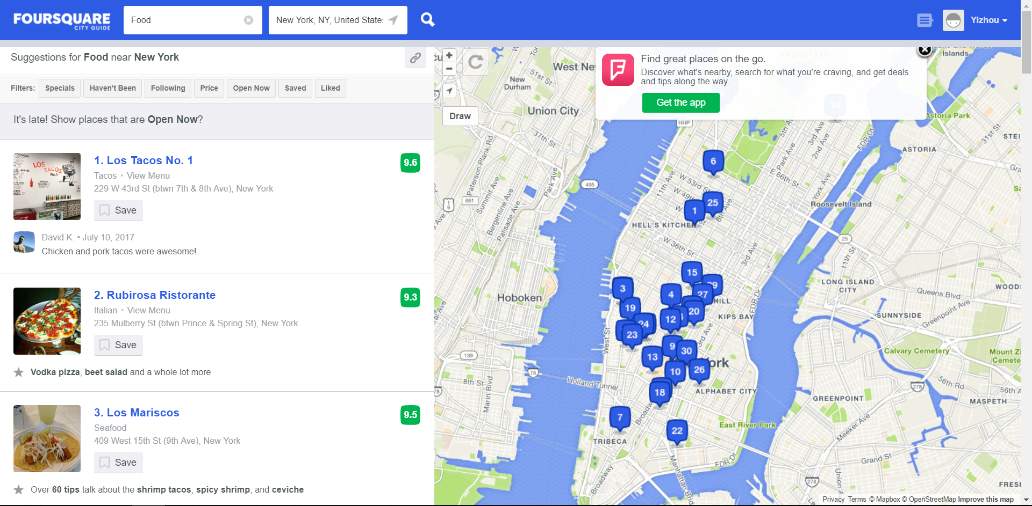

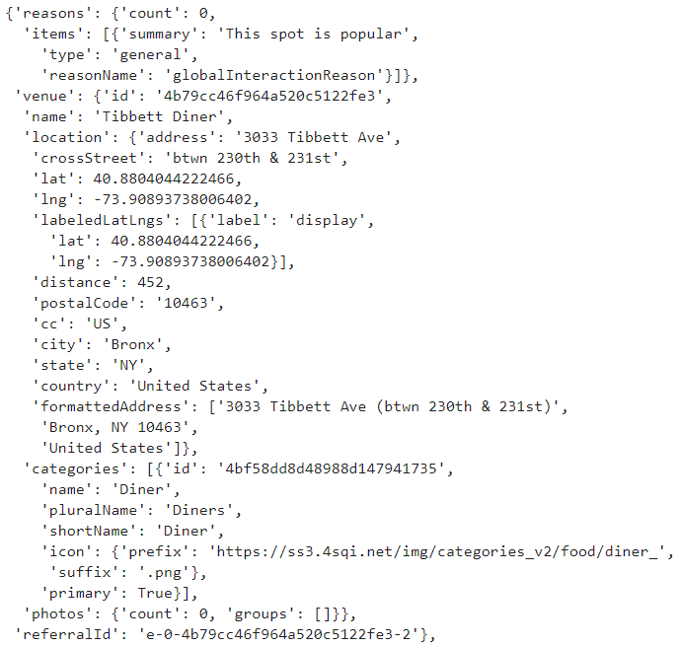

Foursquare location data of restaurants will provide insights into the competitiveness of a certain type of restaurants (cuisine, etc.) in each neighborhood. The relevant data of the restaurants will be obtained through the search API, belonging to regular calls, with up to 99,500 calls per day. The most useful information extracted from the requested data of API calls would include the categories, latitude, longitude of the restaurant. We will count how many restaurants in total and by categories can be found in each neighborhood.

**Methodology：**

**The first step in the analysis is to import all the necessary modules and download the NYC neighborhoods JSON file ‘newyork_data.json’. Imported modules include numpy, pandas, json, requests, matplotlib and scipy, in which we will use distance_matrix to compute the distances between neighborhoods later.**

**Then we create the neighborhoods data frame by extracting the borough name, the neighborhood name and the exact location of the neighborhoods (latitude and longitude) from the JSON file. It is basically the same thing that we did in the ungraded lab in Week 3. The head of the data frame is shown below:**

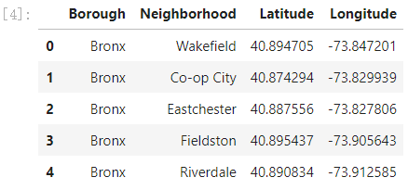

**Once the neighborhood information is obtained, Foursquare location data can be used to access the information of neighborhood restaurants. First, the Foursquare credentials and version are specified, then a search request URL with a query of ‘restaurant’ is established:**

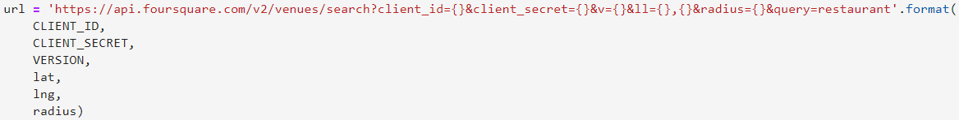

**The URL was sent to request all the restaurants within a 500m radius of the default center point of each neighborhood. Useful information (name, location and category) of the restaurants was extracted, and together with the neighborhood information obtained previously, fills a new data frame named ‘nearby_restaurants’. The head of this data frame is shown below:**

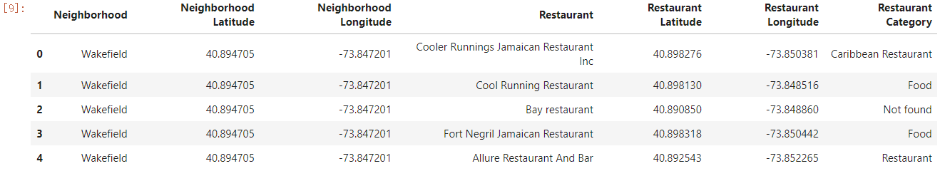

**A function was thereby created to integrate the above process associated with Foursquare location data. The function was named ‘NeighborhoodRestaurants’, to complete the following procedure:**

1. **Create the request URL for all the restaurants in each neighborhood within a radius of 500 meters.**
2. **Make the GET request and acquire the results.**
3. **Extract relevant information for each nearby restaurant.**
4. **Create a data frame containing the relevant information for all the nearby restaurants.**
5. **Drop the duplicates, which can occur due to a restaurant being searched for more than one neighborhood.**

**After establishing the data frame of the useful information, the next step is data cleaning. This is a critical step in the project. In the Foursquare search results, some of the restaurants showed N/A in their categories. Besides, some of the listed search results were not actually restaurants of any types, including venues like Automotive Shop, Design Studio, etc. Therefore, it was necessary to rule out all the irrelevant venues. The idea was to group the ‘nearby_restaurants’ by restaurant categories. The venues with empty category name were categorized as ‘Not Found’. All the category names were manually examined to determine whether they can be considered a restaurant. Those that were not restaurants were ruled out, including all ‘Not Found’ venues. It is also an idea to manually examine the name of the ‘Not Found’ venues to see if they belong to a restaurant. However, some of the venue names could be hard to identify their categories, and in case there are thousands of ‘Not Found’ venues, manual examination can be a very tedious process.**

**Then we had all the venues that can be considered a restaurant. It was discovered that some of the restaurant categories may seem confusing because one category can be part of another category. For example, ‘Hunan Restaurant’, ‘Shanghai Restaurant’ and ‘Szechuan Restaurant’ can all belong to ‘Chinese Restaurant’, because these are all regional cuisines in China. Therefore, it was assumed that restaurants in category ‘Chinese Restaurant’ sells some dishes from all parts of China, or a mixture of different regions, while the regional cuisine restaurants feature specialties only from a region in China. Considering this, the category ‘Chinese Restaurant’ was renamed ‘Generic Chinese Restaurant’. The same thing happened to ‘Middle East Restaurant’, ‘African Restaurant’, ‘Latin American Restaurant’, etc. Also, for those categories that were very generic and vague, like ‘Food’ and ‘Restaurant’, we combined them into a single category named ‘Unknown Type Restaurant’. This was to remind the restaurant owner that Foursquare location data cannot identify the exact type of this restaurant, and the owner may need to visit that restaurant to understand the type if necessary.**

**In addition, many of their categories symbolized the cuisines, such as African, Chinese, Italian, etc., while others showed their styles, especially bars. However, some of the categories could be combined. For example, a ‘Dim Sum Restaurant’ has the same cuisine and is basically the same type of restaurants as a ‘Cantonese Restaurant’, only perhaps featuring Dim Sum as their specialties. Therefore, they were combined into a single category ‘Cantonese Restaurant’. Similar examples included ‘Sushi Restaurant’ and ‘Japanese Restaurant’. Besides, some of the categories were actually synonyms, including ‘Coffee Shop’ and ‘Cafe’, ‘Food Court’ and ‘Fast Food Restaurant’, etc. They were combined similarly to a single type. By counting the unique values in ‘Restaurant Category’, it was discovered that the total number of restaurant types was cut down to 101 types. These types should already cover all the major types of restaurants out there, and should be enough for a restaurant owner to find his/her right choice.**

**After all the cleaning work, we used group by again jointly on neighborhoods and categories to count how many categories of restaurants and how many of each category are available around each neighborhood. The first 10 rows of the grouped data frame are shown as follows:**

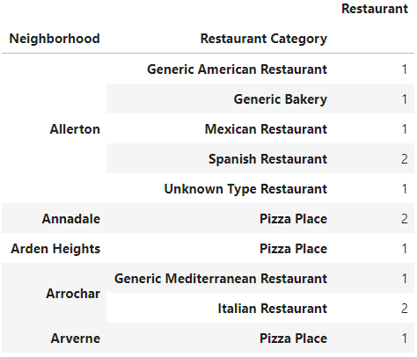

**Although visually it gives a clear indication of the restaurants in each neighborhood, it is not friendly for statistical purposes, which will eventually be used to compute the location suitability score. Therefore, one-hot encoding was used. Then the encoded data frame was grouped by neighborhood and count was applied to all 101 categories, getting a more orderly frame more friendly for statistical analysis. The first 10 rows of the one-hot encoded and grouped data frame ‘newyork_restaurants_grouped’ are given below (only the first few categories in columns are shown):**

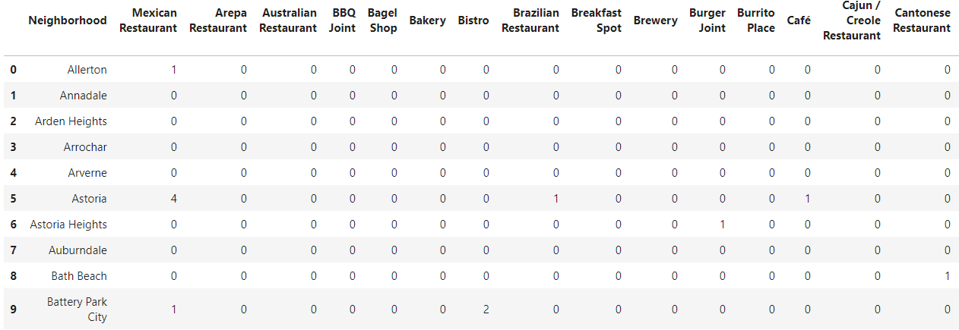

**From the shape of the ‘newyork_restaurants_grouped’ data frame, it was discovered that only 264 out of 306 neighborhoods actually has a venue that can be considered a restaurant.**

**Now we can start** creating a new data frame called ‘recommender’ to hold features needed for final calculation of location suitability score. First, the total number of all restaurants and the specific category of restaurants that the person want to open was included in the analysis. It was assumed that if there are a ton of restaurants already in or near this neighborhood, then it could be slightly more difficult for a new restaurant to stand out, regardless of the type. Of course, the greater impact would come from restaurants of the same cuisine or type, so restaurants from the same categories would be something to avoid when opening new restaurants. Suppose someone wants to open a new Italian restaurant, the head of the initial ‘recommender’ data frame would look like this:

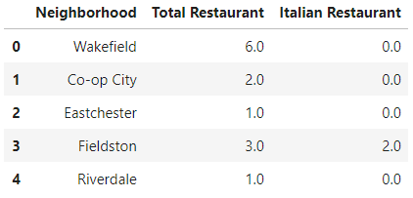

**The next step is to compute the** distances between neighborhoods and correlate the neighborhoods based on their distances. It is generally assumed that the farther neighborhoods are from each other, the less impact the restaurants in one neighborhood would have on those in the other one. Since we have the latitudes and longitudes of each neighborhood, we can use distance_matrix in scipy to compute a 306*306 square distance matrix for all neighborhoods.

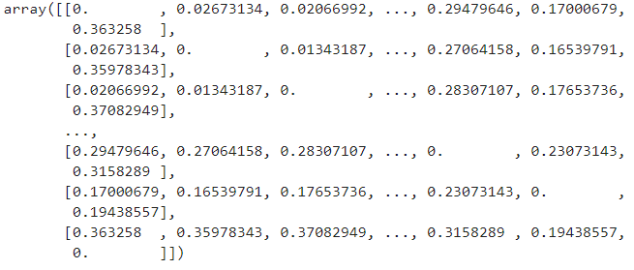

Then we inverse all the distances values as the impact of restaurants in one neighborhood on another neighborhood is negatively correlated. For diagonal elements, which are 0 due to the distance between each neighborhood and themselves, were converted to a large number of 100 to replace infinity in inverse, to indicate their huge impact. The resultant matrix essentially becomes an impact matrix.

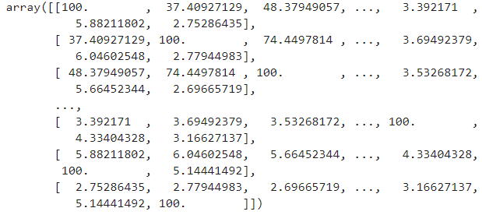

**Since the customer is interested in opening an Italian restaurant, we will need two versions of impact matrix: one for all categories of restaurants, and one specifically for Italian restaurants. Take Italian restaurants for example,** the updated impact matrix Ei for Italian restaurants, containing impact scores of Italian restaurants in the other neighborhoods to one in the current neighborhoods were computed, by multiplying the old impact matrix Eo with the number of Italian restaurants in each neighborhood, recorded as a vector vi, which is the series ‘Italian Restaurant’ in the **‘newyork_restaurants_grouped’ data frame**

**The updated matrix** Ei **was then transformed into a data frame and visualized as follows. As can be seen, each column represents the impact from a specific neighborhood to the current neighborhood in rows.**

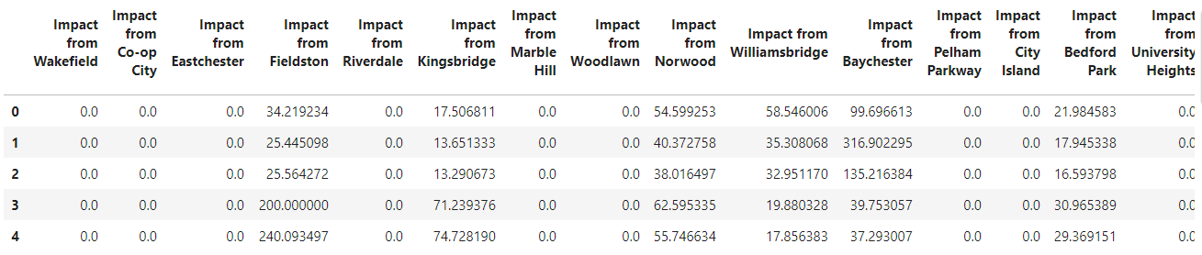

**The impact scores were summed in columns to compute the total impact score of Italian restaurants in NYC to a new Italian restaurant in each neighborhood, and they were added to the ‘recommender’ data frame. The same procedure applied to the total number of restaurants of all categories as well. The head of the updated ‘recommended’ data frame is shown below:**

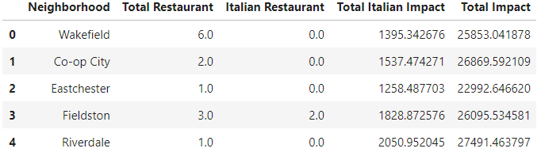

**Now that the impact scores were derived from the total number of restaurants, we may drop the first two columns. Then simple scaling normalization of the two series of impact scores were conducted as they were on different scales. For the final location suitability score, a weighted sum was adopted. By default, 0.25 was used as the weight for Total Impact, while 0.75 was used for Total Italian impact, since restaurants of the same type may not necessarily compete severely when they are close to each other, but Italian restaurants close to each other will almost surely compete hard against each other. The obtained final scores were added to the data frame. The head of the complete ‘recommender’ was shown below**

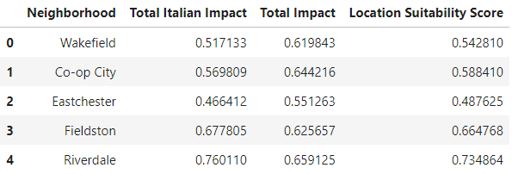

**Finally, the entire process of computing Location Suitability Score was integrated into a function named ‘LocationSuitabilityScore’, for ease of use in reality.**

**Results：**

**To test our restaurant location recommender, let’s assume that another ambitious restaurant owner would like to open a new Vietnamese restaurant in NYC. He would like to make a preliminary choice of which neighborhood the new restaurant would be in. Using what was discussed in the previous section, notably the ‘LocationSuitabilityScore’ function, we can obtain a new ‘recommender’ data frame as follows (only the first 20 rows shown):**

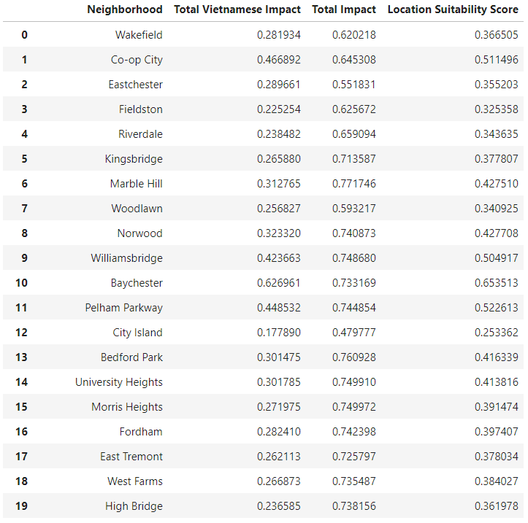

**To visualize the distribution of location suitability scores of all 306 NYC neighborhoods, histogram was implemented to the above results.**

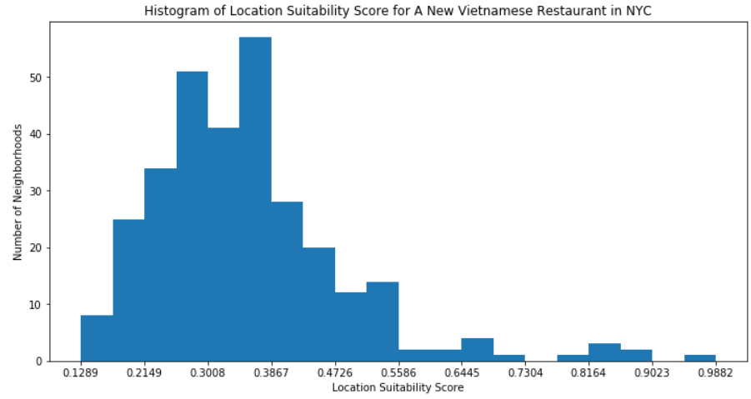

**Evidently, most of the neighborhoods earned scores hanging around 0.2-0.4, while only a very small set of neighborhoods earned high scores of above 0.75 or so. Therefore, the choice of neighborhoods can be narrowed down only to those with very high scores, and the job of restaurant location hunting is therefore made much easier. Alternatively, other restaurant categories can also be tested.**

**Discussion：**

**The restaurant location recommender in this project is just a preliminary recommender, as it only provides a single metric based on the neighborhoods. It cannot yet be detailed to a specific street address or store location. However, if more detailed JSON data covering the available retail spaces within every neighborhood would be available, then it is possible to create a more refined recommender. Some parameters, such as the weight factors associated with the impact scores of all categories of restaurants and the specific category were also chosen empirically. Other assumptions include that every neighborhood is NYC is densely populated enough and are all easily accessible. In other words, opening a new restaurant where peer competition is minimal is always more likely to be profitable. This may not be always true in the real world. However, the biggest contribution of this recommender is that it is a handy, simple yet effective tool for narrowing the choice of a new restaurant location down from the entire NYC containing 306 neighborhoods to a much smaller number of neighborhoods. The restaurant owners only need to look at the available commercial spaces in the periphery of these neighborhoods to choose the final location.**

**On the other hand, this project had meant to take some more factors from Foursquare location data, such as ratings of a restaurant, and the number of people that have visited a restaurant, which is a symbol of popularity of a restaurant. However, since accessing these information requires premium calls limited to only 500 every day, I eventually gave up on this idea. However, it would be very beneficial in reality to take the ratings and popularity of each restaurant into account. Avoiding being too close to a popular or highly rated restaurant of the same style or cuisine is very important to the sustainability of a new restaurant. Also, in terms of data visualization, I had meant to create a choropleth map for viewing the location suitability score. However, for some reasons, the choropleth map always looked as follows (I have no idea why these blue markers were out there), and I couldn’t find a way through this problem. Overall, the outcome could be even better, but it has already been a lot of efforts to go this far.**

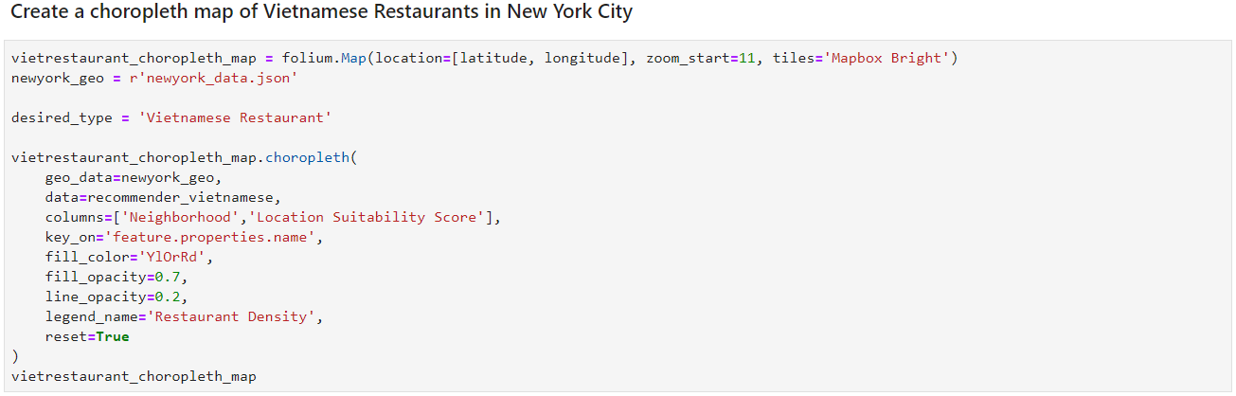

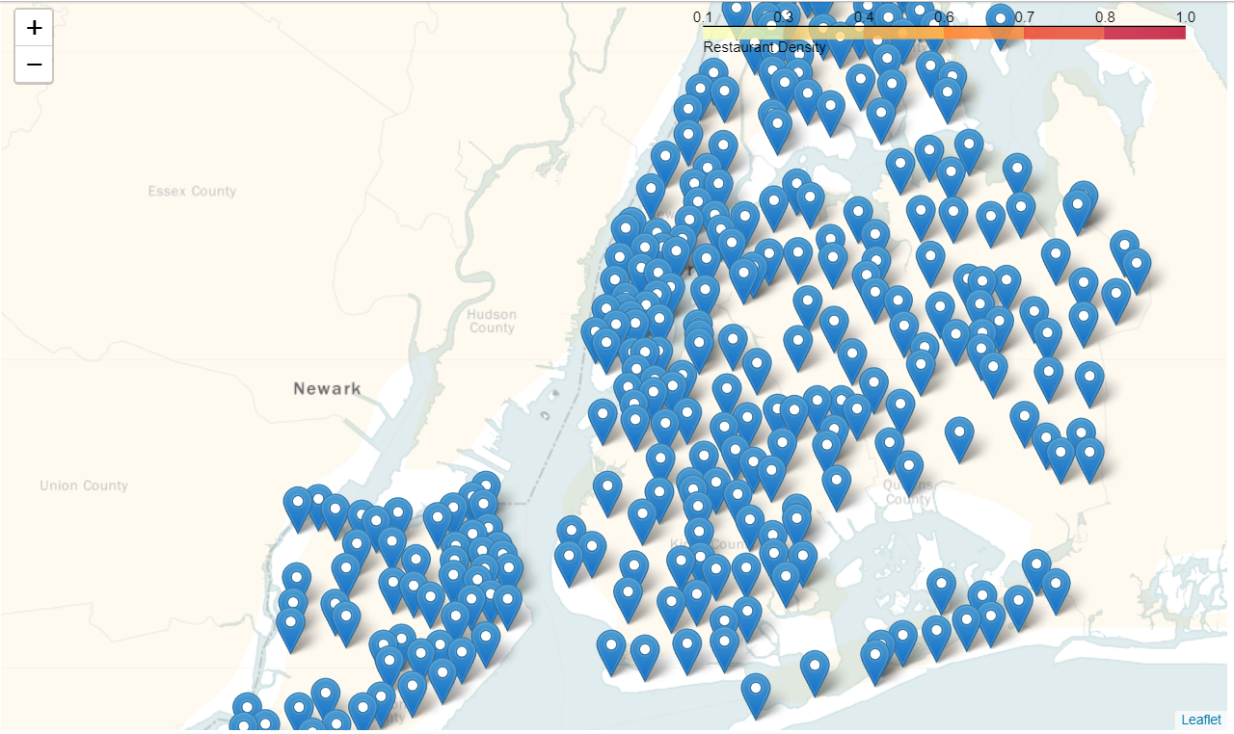

**Conclusion：**

All in all, this report addresses the development of a preliminary restaurant location recommender that aims to help future restaurant owner ambitious to open new restaurants in New York City, the greatest and most influential metropolis in the world, to preliminarily select which neighborhoods their new restaurants should be located in. NYC JSON data and Foursquare location data were used to extract information of over 100 categories of restaurants currently available in NYC. Extensive data cleaning and distance matrix were used to establish the algorithm of suitability of neighborhoods for the desired type of restaurants. The outcome includes a set of location suitability scores straightforward to understand, to help owners narrow their choices down to around a small number of neighborhoods.

**References:**

**[1] Restaurant Statistics, NYC** Department of Health, 2017