Three two-component ResNet blocks, with Dropout, BatchNormalization, and Relu activation

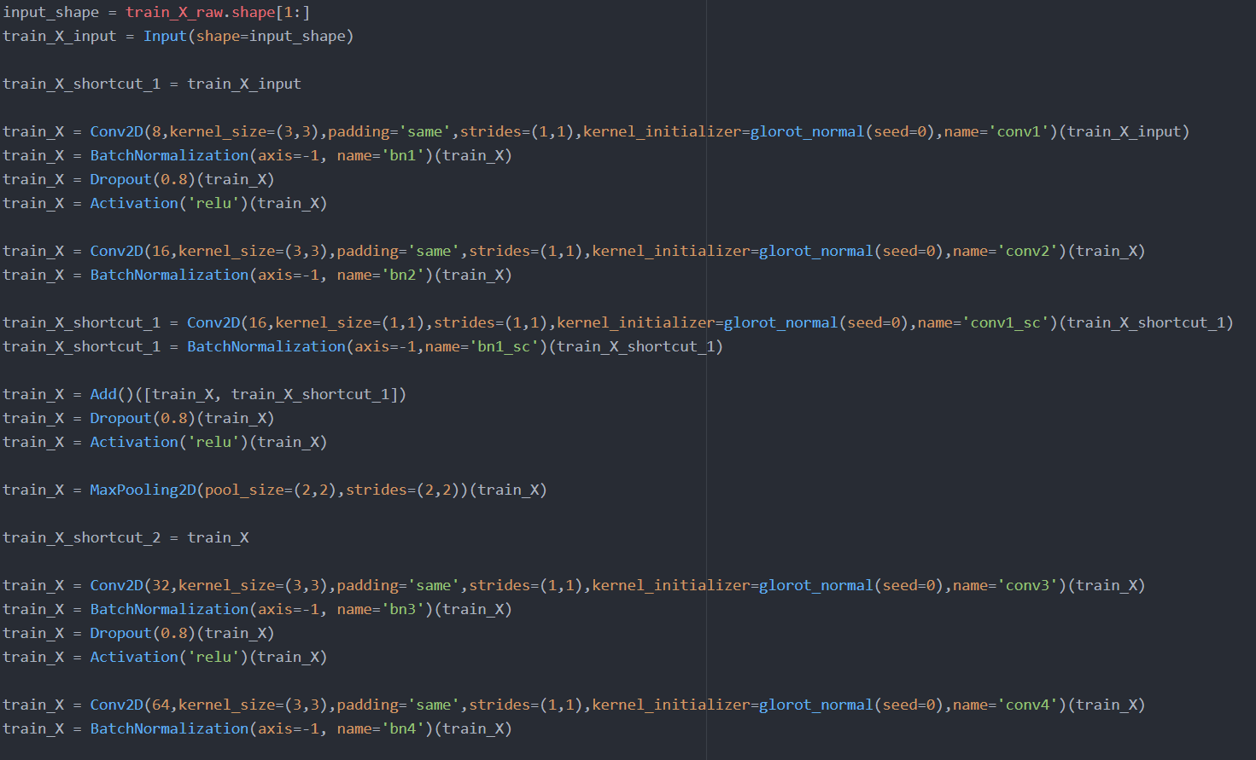

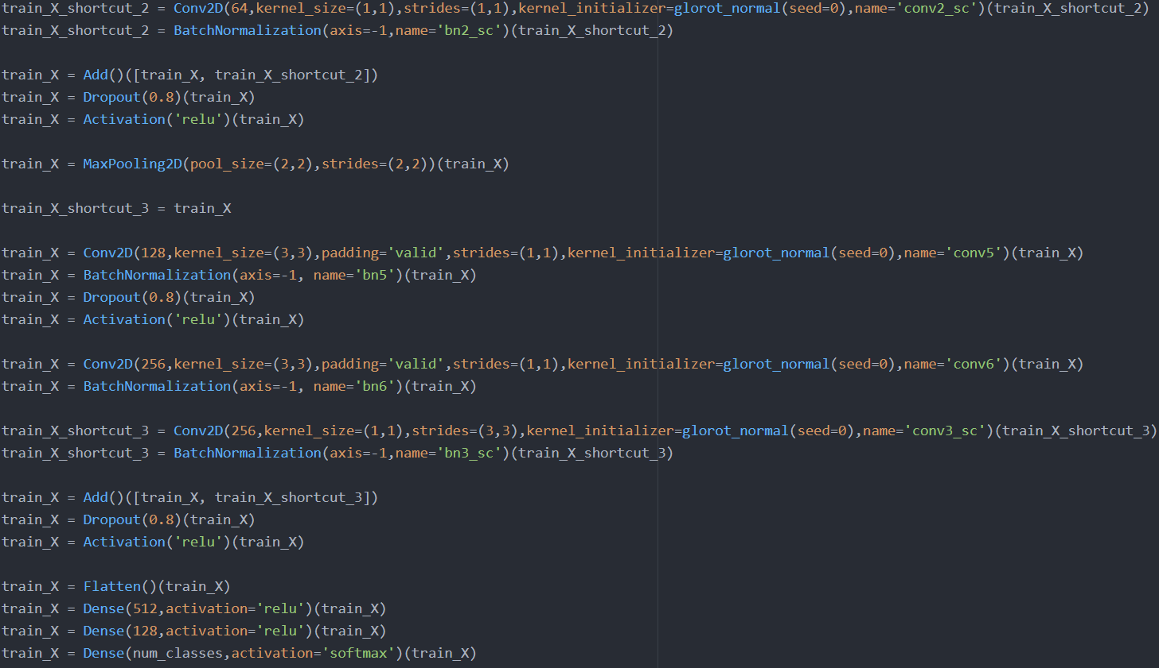

2 epochs:





5 epochs:

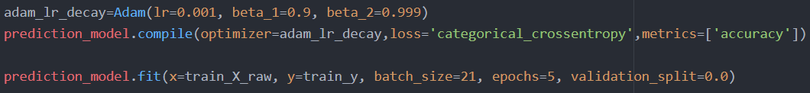

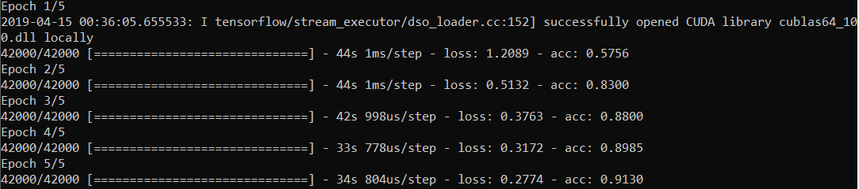

10 epochs:

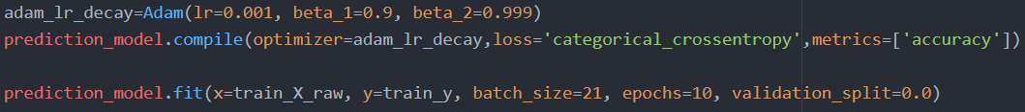

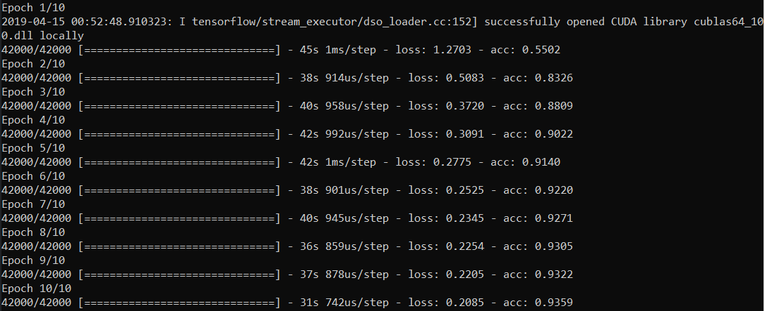

Introducing full decay:

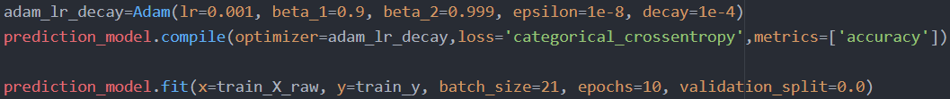

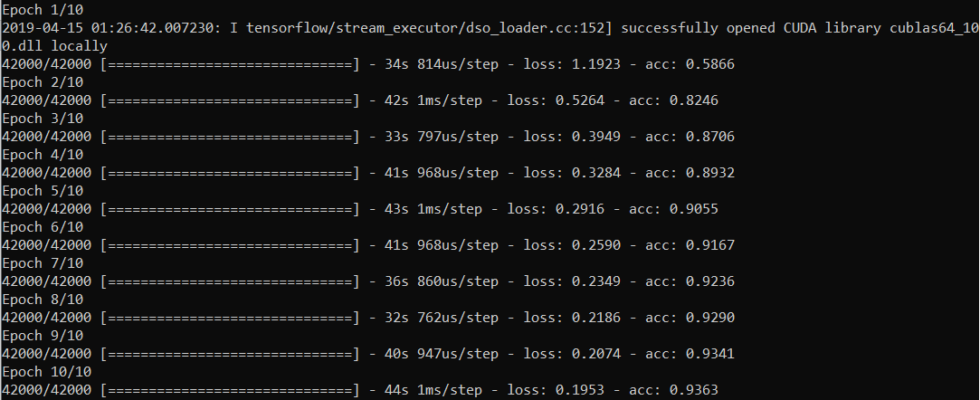

Implementing half learning rate decay:

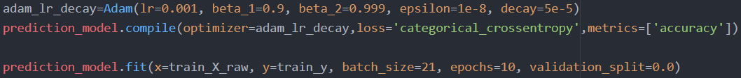

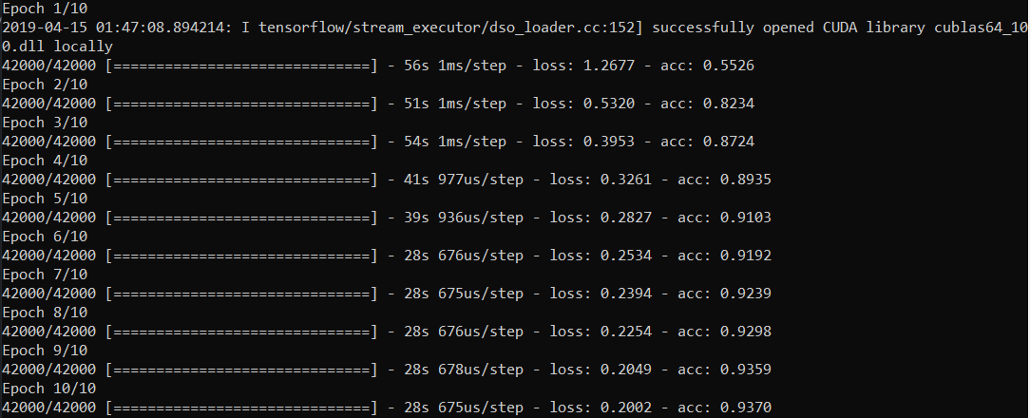

Kaggle Submission Result:



Increasing learning rate:

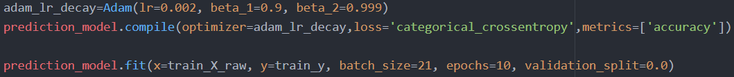

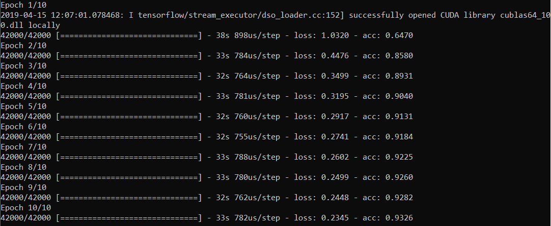

Increasing learning rate and implement half decay:

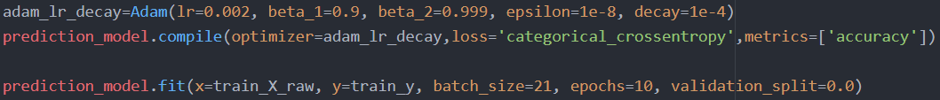

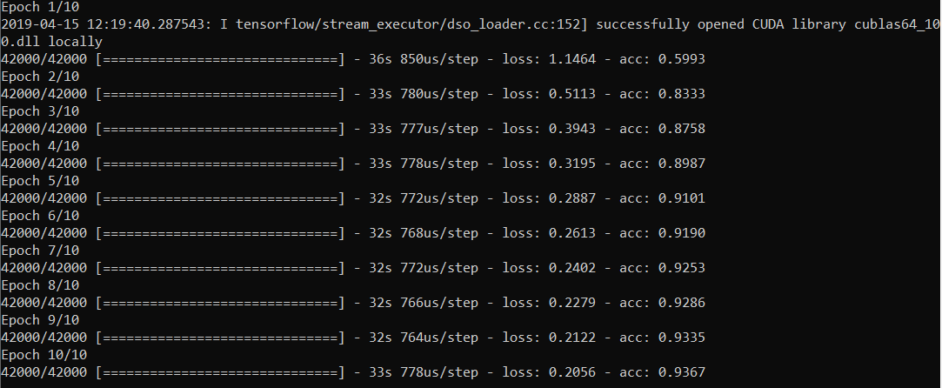

Reducing learning rate:

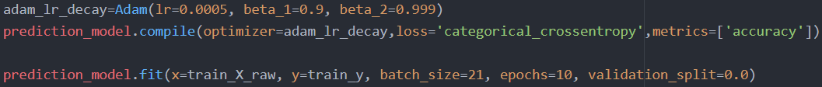

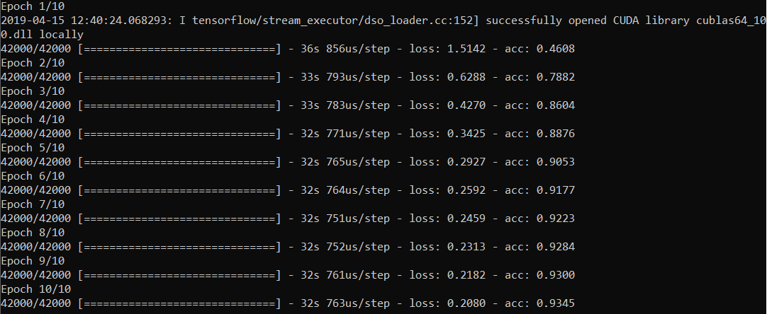

Increasing beta 1:

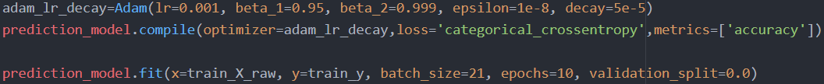

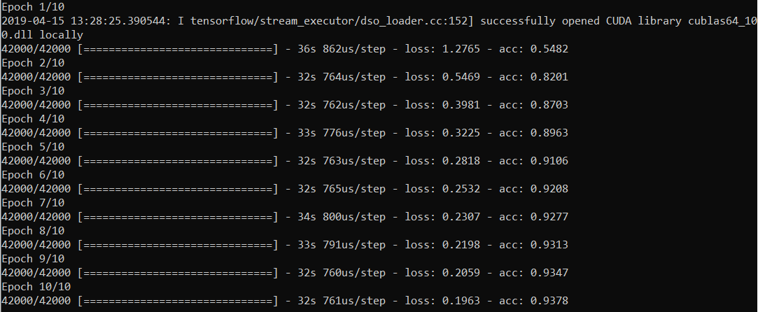

Decreasing beta 1:

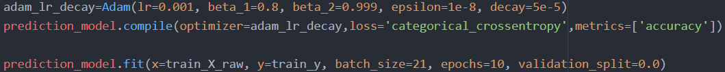

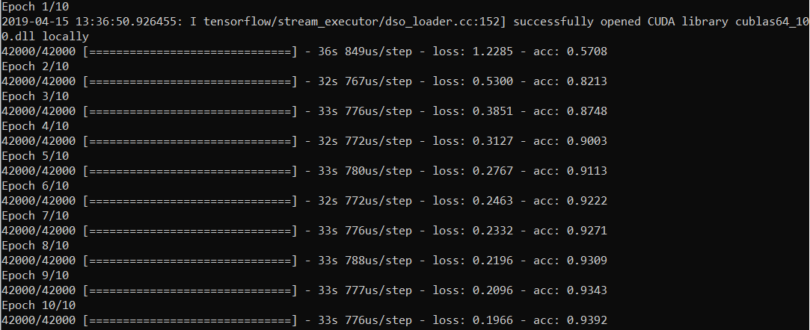

Decreasing beta 1 further (0.75):

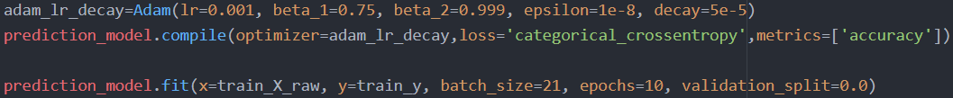

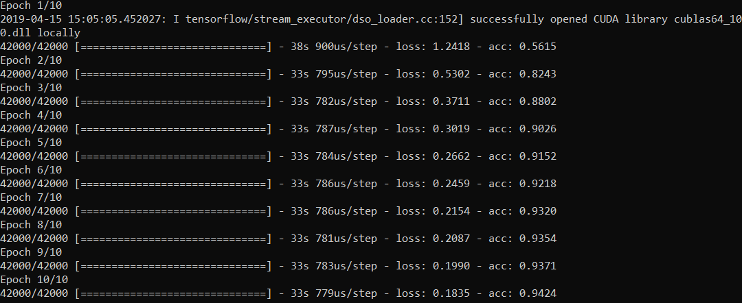

Increasing batch size:

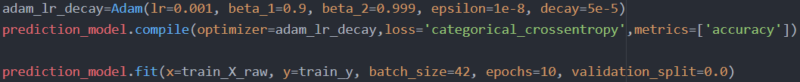

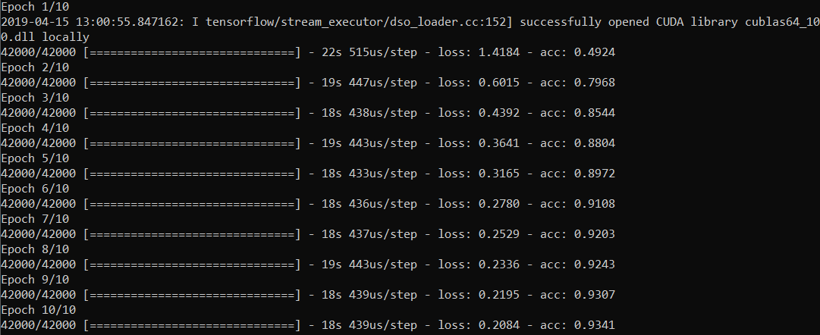

Increasing to 20 epochs with full decay:

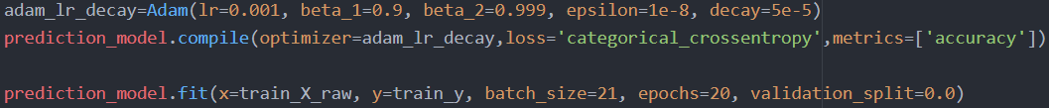

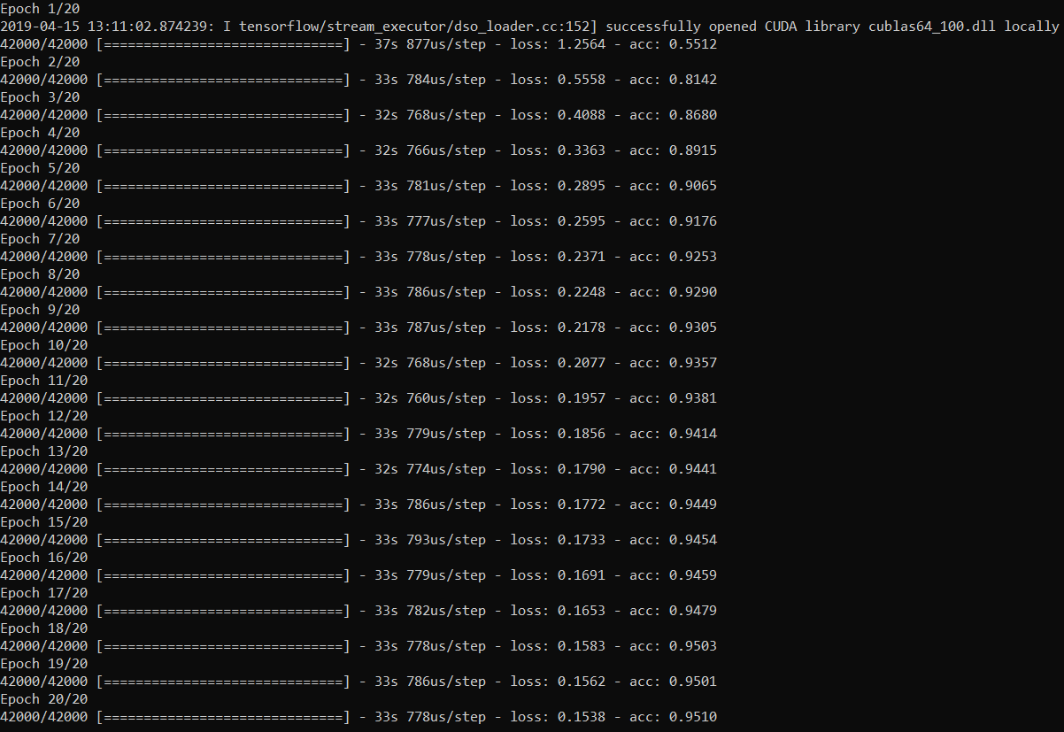

Enhancing dropout to 0.6:

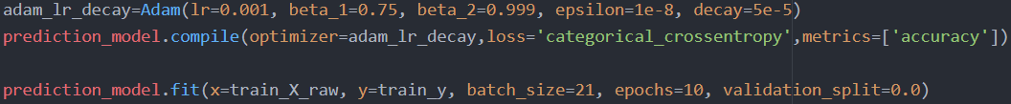

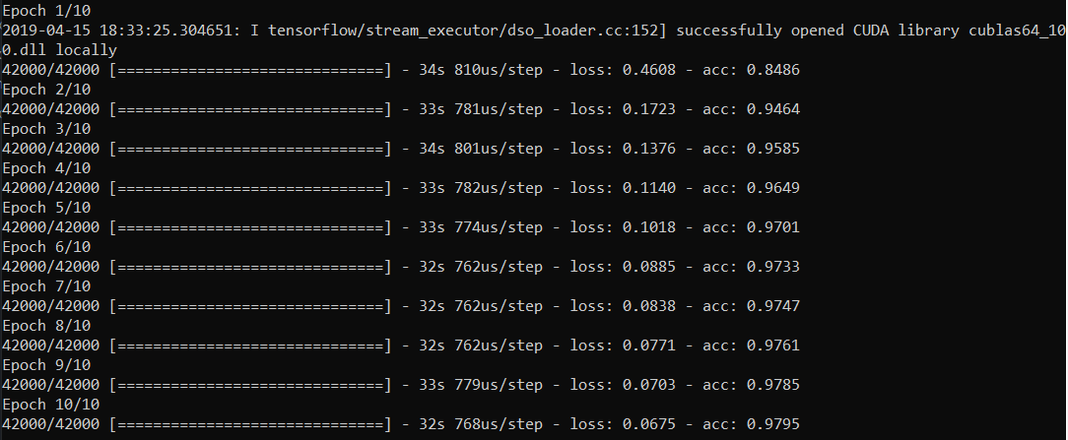

Adaptive dropout (0.5-0.8):



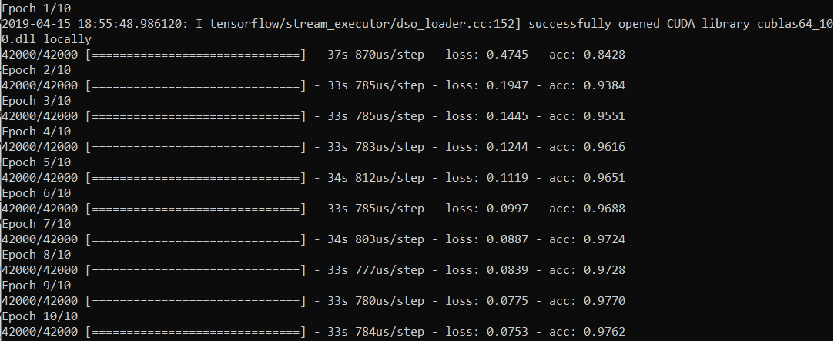

Adaptive dropout (0.5-0.6) and 20 epochs:

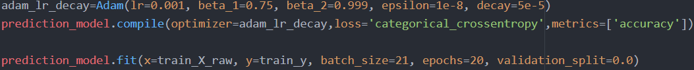

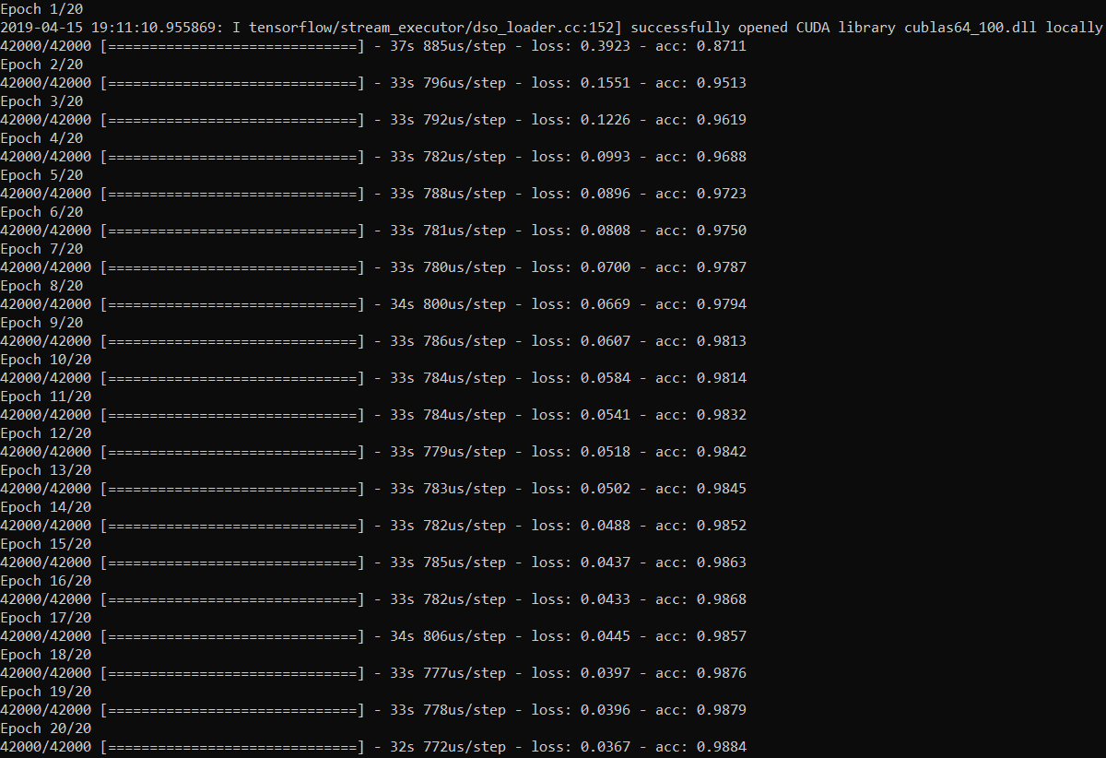

Adaptive dropout (0.5-0.6), 20 epochs and average poolings:



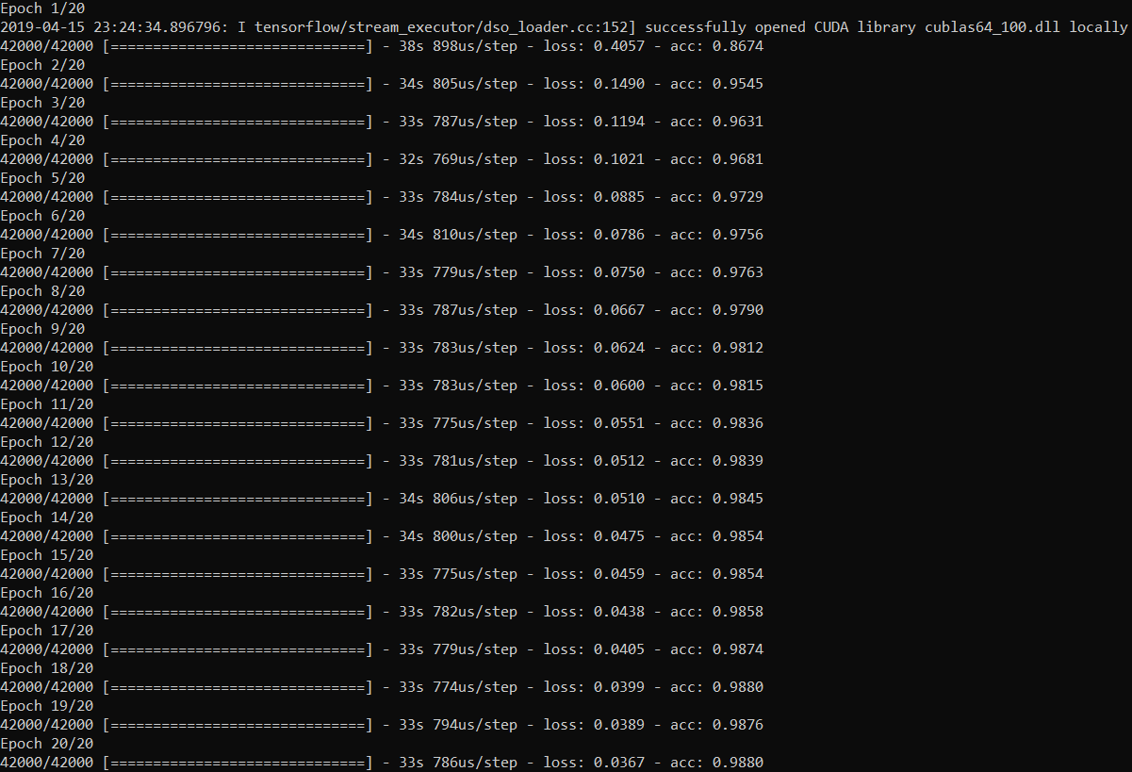



Five two-component ResNet blocks, with Dropout, BatchNormalization, and Relu activation

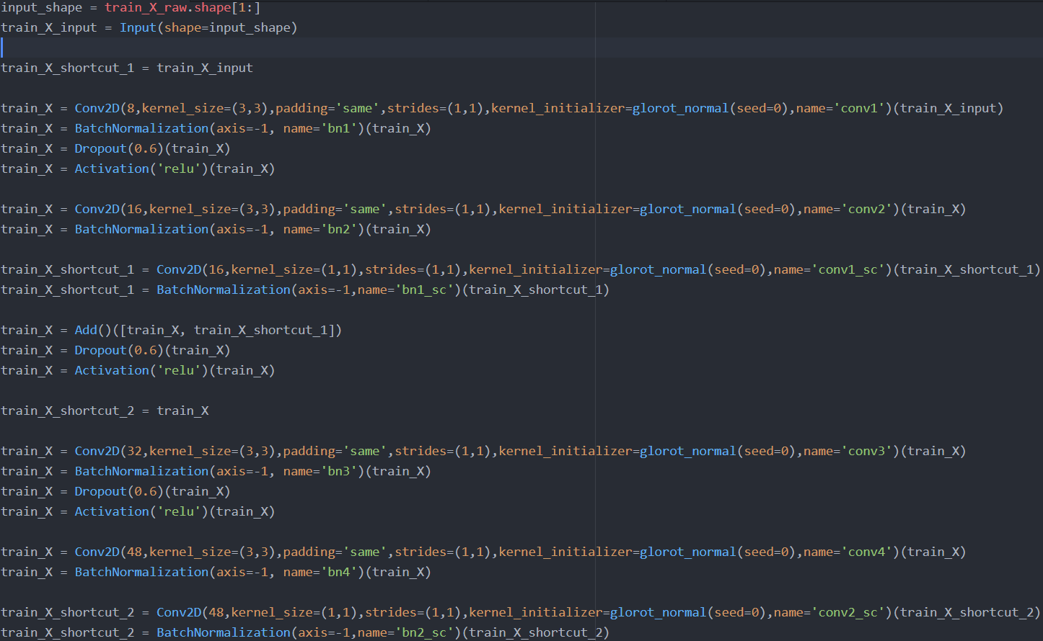

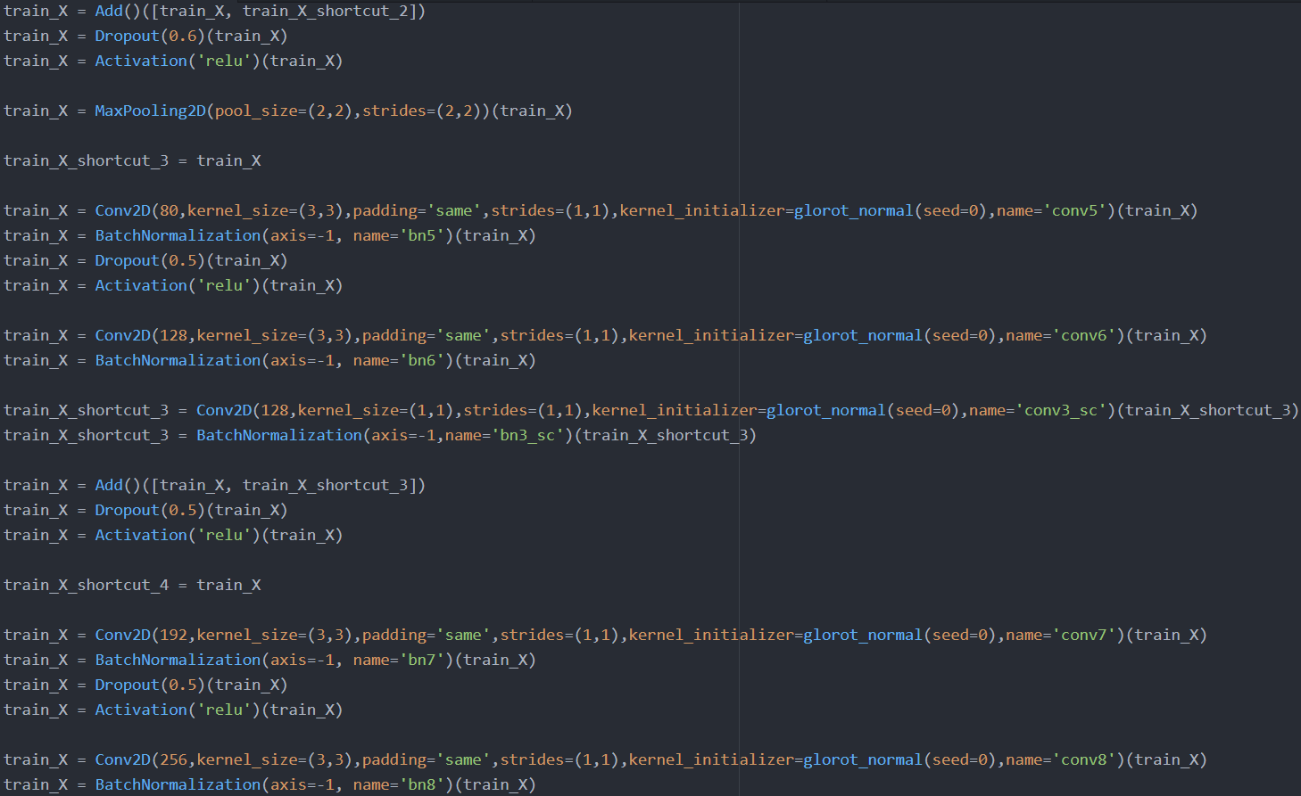

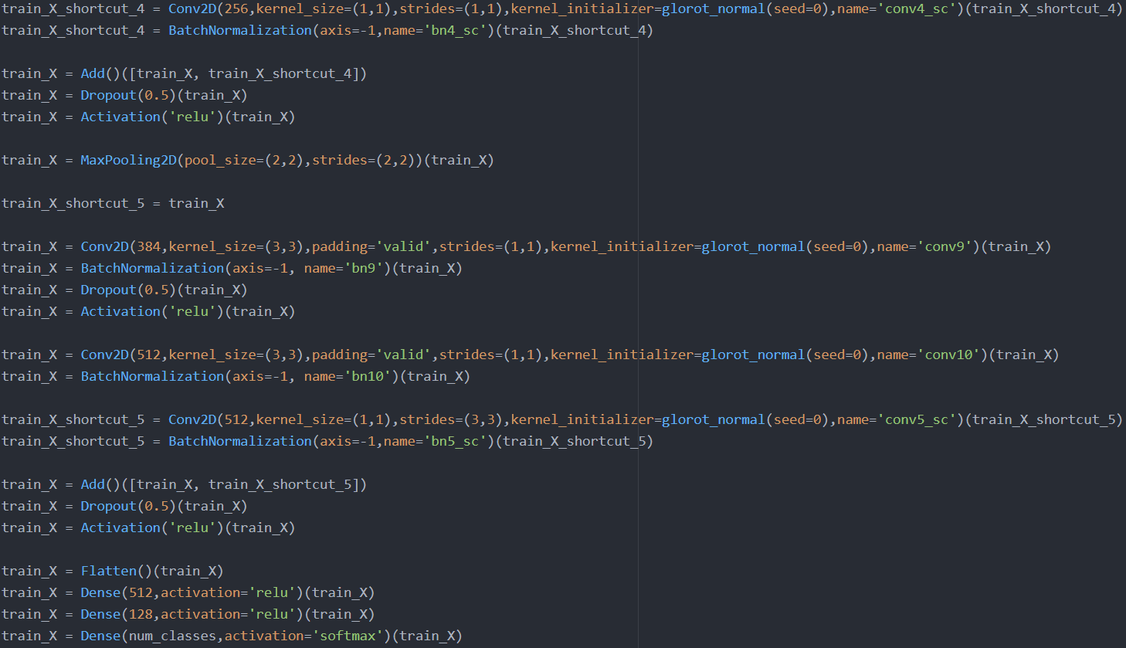

Adaptive dropout (0.5-0.6):

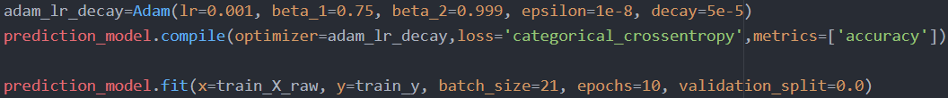

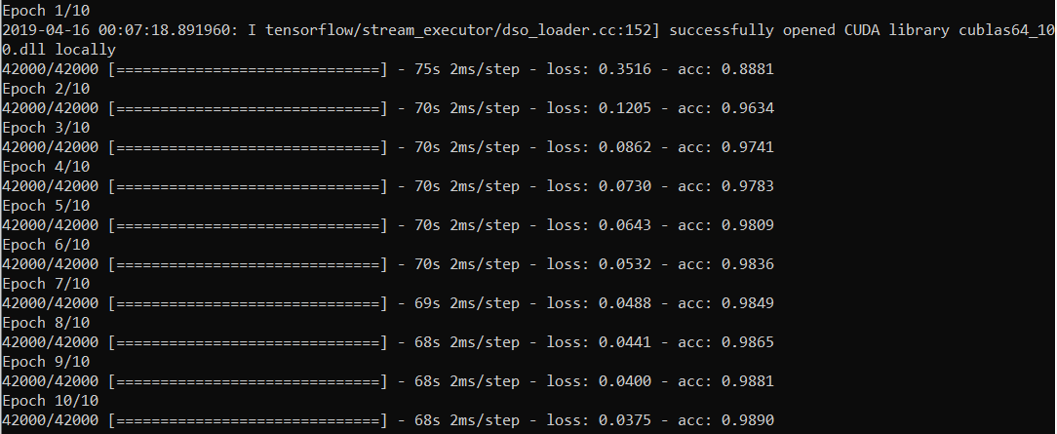

Adaptive dropout (0.5-0.6) and 20 epochs:



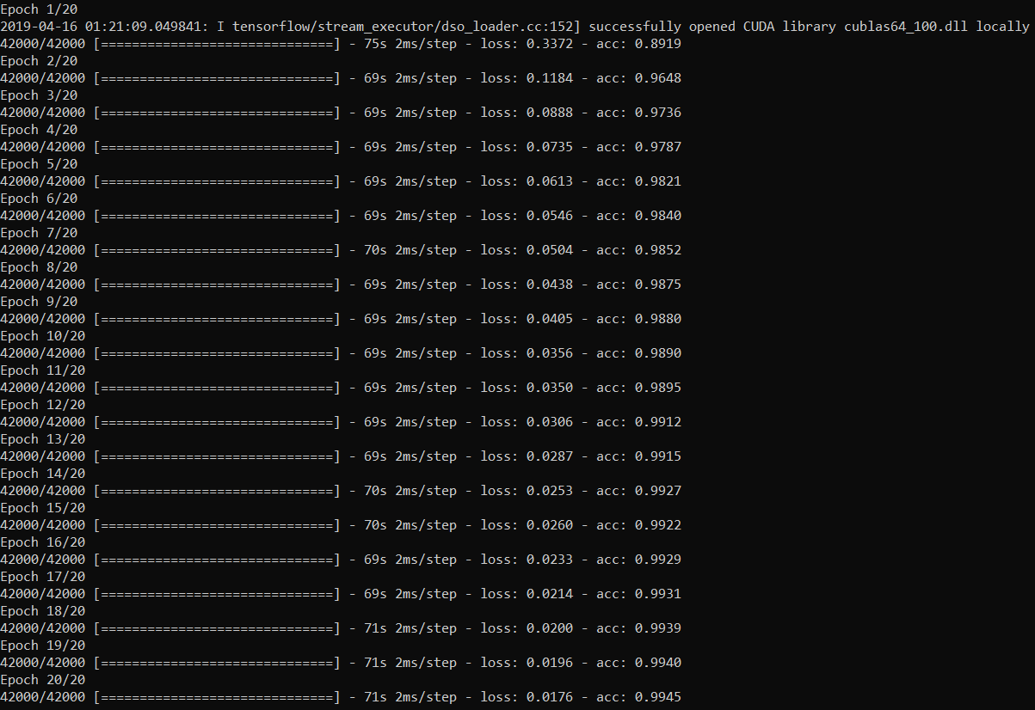

Increasing the hidden unit sizes:



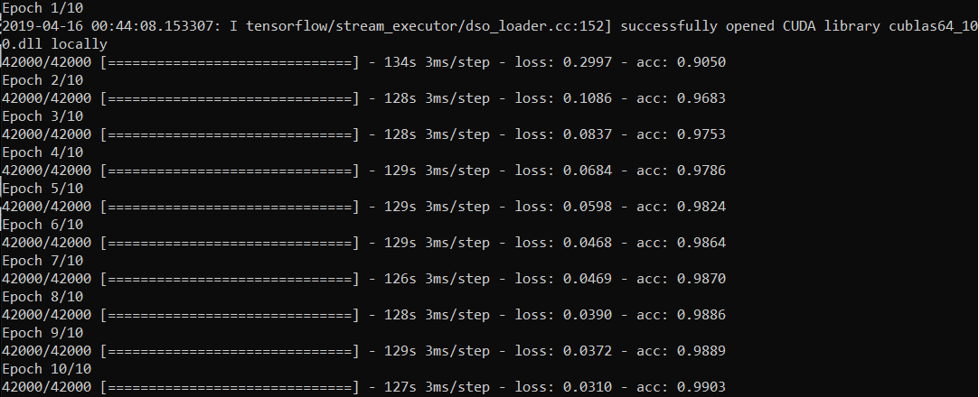

Increasing the hidden unit sizes and 20 epochs:



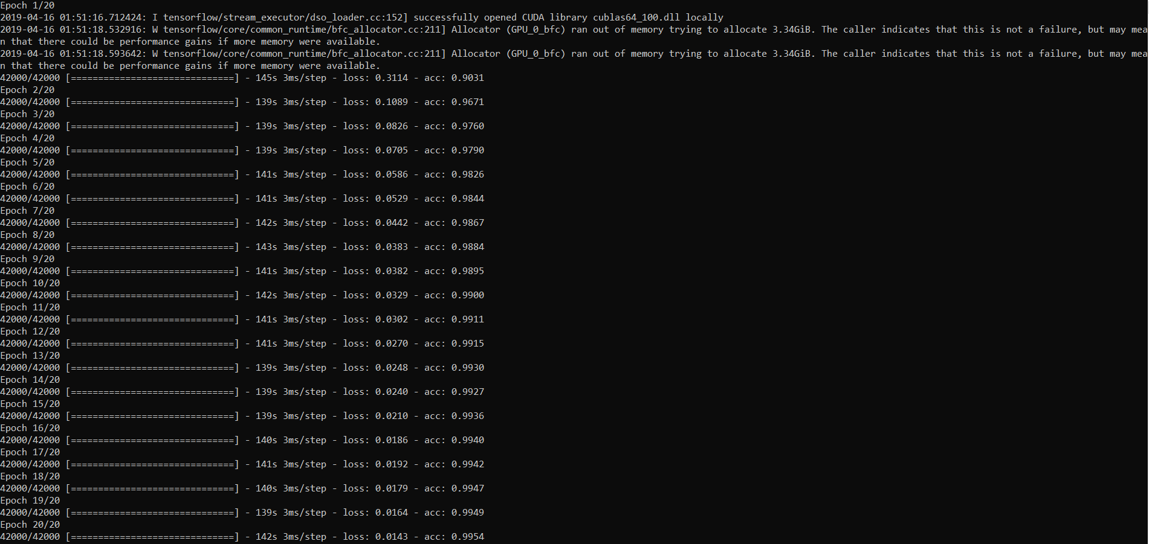



Increasing to 30 epochs:

