实验7
名称：数据库设计（4学时）
姓名： 丁少亭
学号： 2311320105
班级： 网安2301
日期： 2025/5/27
实验内容：
设计一个采购、销售和客户管理应用数据库。
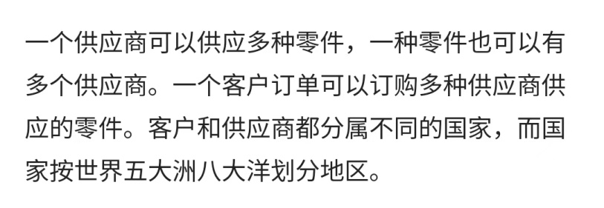
分析得出系统中有如下实体型及其属性：
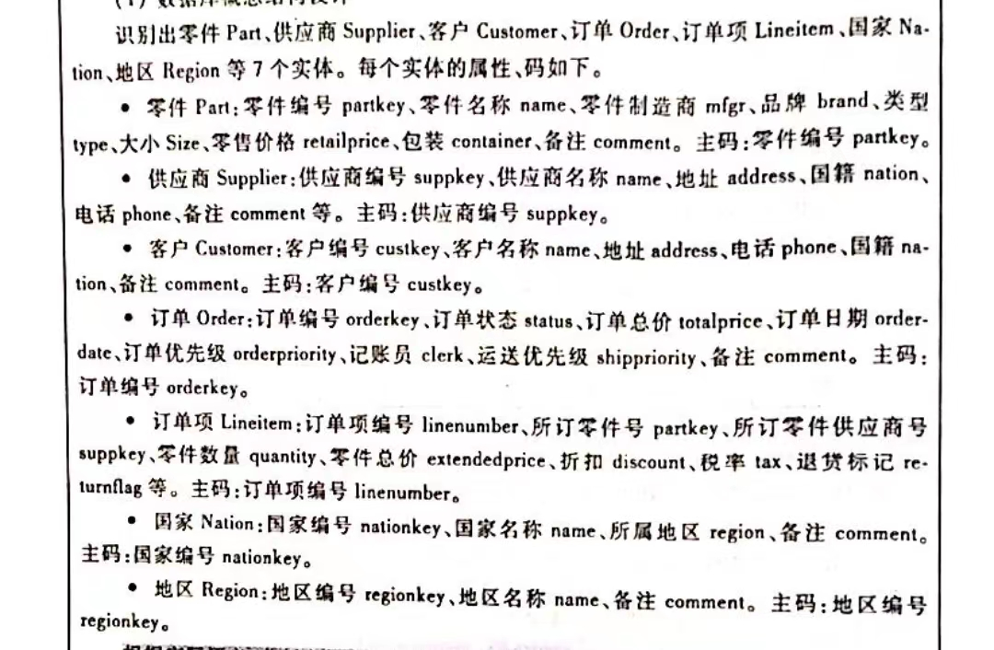
概念结构设计：
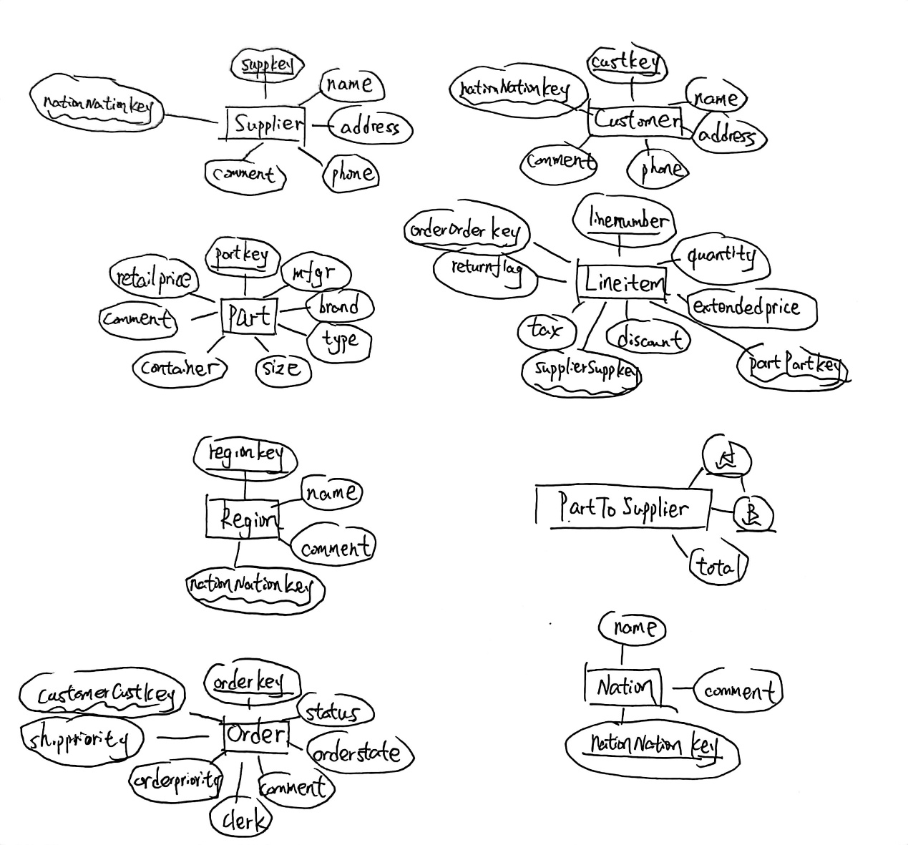
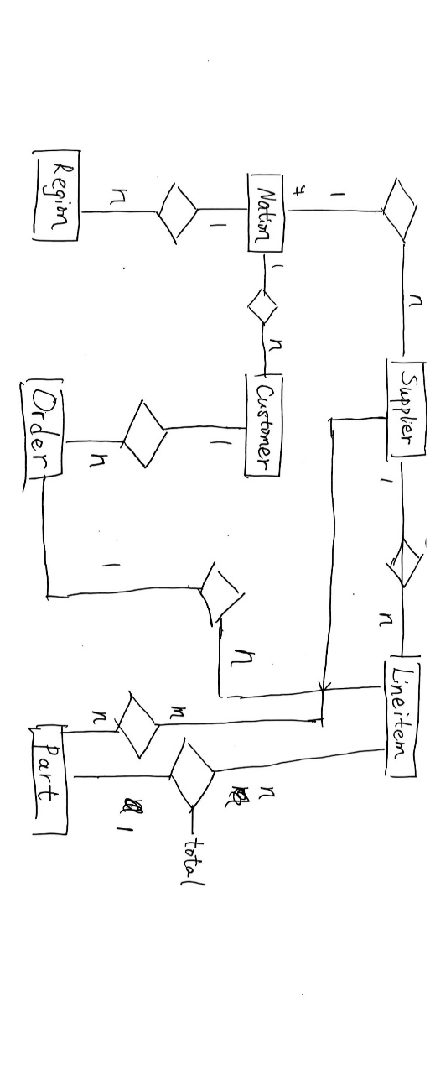
逻辑结构设计：
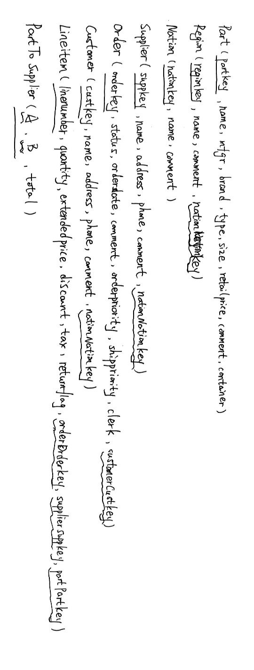
创建表：
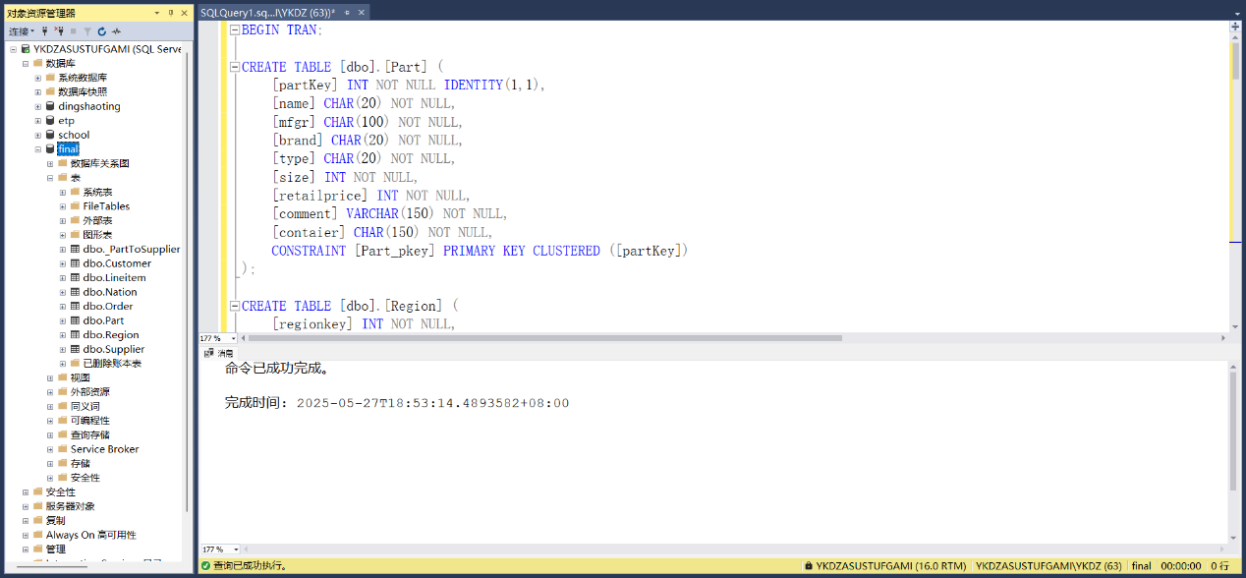
BEGIN TRAN;

CREATE TABLE [dbo].[Part] (
[partKey] INT NOT NULL IDENTITY(1,1),
[name] CHAR(20) NOT NULL,
[mfgr] CHAR(100) NOT NULL,
[brand] CHAR(20) NOT NULL,
[type] CHAR(20) NOT NULL,
[size] INT NOT NULL,
[retailprice] INT NOT NULL,
[comment] VARCHAR(150) NOT NULL,
[contaier] CHAR(150) NOT NULL,
CONSTRAINT [Part_pkey] PRIMARY KEY CLUSTERED ([partKey])
);

CREATE TABLE [dbo].[Region] (
[regionkey] INT NOT NULL,
[name] CHAR(20) NOT NULL,
[comment] VARCHAR(200) NOT NULL,
[nationNationkey] INT,
CONSTRAINT [Region_pkey] PRIMARY KEY CLUSTERED ([regionkey])
);

CREATE TABLE [dbo].[Nation] (
[nationkey] INT NOT NULL,
[name] CHAR(15) NOT NULL,
[comment] VARCHAR(200) NOT NULL,
CONSTRAINT [Nation_pkey] PRIMARY KEY CLUSTERED ([nationkey])
);

CREATE TABLE [dbo].[Supplier] (
[suppkey] INT NOT NULL,
[name] CHAR(20) NOT NULL,
[address] VARCHAR(50) NOT NULL,
[phone] CHAR(20) NOT NULL,
[comment] VARCHAR(200) NOT NULL,
[nationNationkey] INT,
CONSTRAINT [Supplier_pkey] PRIMARY KEY CLUSTERED ([suppkey])
);

CREATE TABLE [dbo].[Order] (
[orderkey] INT NOT NULL,
[status] CHAR(20) NOT NULL,
[orderdate] DATE NOT NULL,
[comment] VARCHAR(200) NOT NULL,
[orderpriority] INT NOT NULL,
[shippriority] INT NOT NULL,
[clerk] CHAR(15) NOT NULL,
[customerCustkey] INT,
CONSTRAINT [Order_pkey] PRIMARY KEY CLUSTERED ([orderkey]),
CONSTRAINT [chk_status] CHECK ([status] IN ('success', 'processing')),
CONSTRAINT [chk_orderpriority] CHECK(orderpriority > 0 AND orderpriority < 3),
CONSTRAINT [chk_shippriority] CHECK(shippriority > 0 AND shippriority < 3)
);

CREATE TABLE [dbo].[Customer] (
[custkey] INT NOT NULL,
[name] CHAR(20) NOT NULL,
[address] VARCHAR(50) NOT NULL,
[phone] CHAR(20) NOT NULL,
[comment] VARCHAR(200) NOT NULL,
[nationNationkey] INT,
CONSTRAINT [Customer_pkey] PRIMARY KEY CLUSTERED ([custkey])
);

CREATE TABLE [dbo].[Lineitem] (
[linenumber] INT NOT NULL,
[quantity] INT NOT NULL,
[extendedprice] INT NOT NULL,
[discount] INT NOT NULL,
[tax] FLOAT(53) NOT NULL,
[returnflag] CHAR(1) NOT NULL,
[orderOrderkey] INT,
[supplierSuppkey] INT,
[partPartKey] INT,
CONSTRAINT [Lineitem_pkey] PRIMARY KEY CLUSTERED ([linenumber]),
CONSTRAINT [chk_returnflag] CHECK ([returnflag] IN ('N', 'Y')),
);

CREATE TABLE [dbo].[_PartToSupplier] (
[A] INT NOT NULL,
[B] INT NOT NULL,
[total] INT NOT NULL,
CONSTRAINT [_PartToSupplier_AB_unique] UNIQUE NONCLUSTERED ([A],[B])
);

CREATE NONCLUSTERED INDEX [_PartToSupplier_B_index] ON [dbo].[_PartToSupplier]([B]);

ALTER TABLE [dbo].[Region] ADD CONSTRAINT [Region_nationNationkey_fkey] FOREIGN KEY ([nationNationkey]) REFERENCES [dbo].[Nation]([nationkey]) ON DELETE SET NULL ON UPDATE CASCADE;

ALTER TABLE [dbo].[Supplier] ADD CONSTRAINT [Supplier_nationNationkey_fkey] FOREIGN KEY ([nationNationkey]) REFERENCES [dbo].[Nation]([nationkey]) ON DELETE SET NULL ON UPDATE CASCADE;

ALTER TABLE [dbo].[Order] ADD CONSTRAINT [Order_customerCustkey_fkey] FOREIGN KEY ([customerCustkey]) REFERENCES [dbo].[Customer]([custkey]) ON DELETE SET NULL ON UPDATE CASCADE;

ALTER TABLE [dbo].[Customer] ADD CONSTRAINT [Customer_nationNationkey_fkey] FOREIGN KEY ([nationNationkey]) REFERENCES [dbo].[Nation]([nationkey]) ON DELETE SET NULL ON UPDATE CASCADE;

ALTER TABLE [dbo].[Lineitem] ADD CONSTRAINT [Lineitem_orderOrderkey_fkey] FOREIGN KEY ([orderOrderkey]) REFERENCES [dbo].[Order]([orderkey]) ON DELETE NO ACTION ON UPDATE NO ACTION;

ALTER TABLE [dbo].[Lineitem] ADD CONSTRAINT [Lineitem_supplierSuppkey_fkey] FOREIGN KEY ([supplierSuppkey]) REFERENCES [dbo].[Supplier]([suppkey]) ON DELETE SET NULL ON UPDATE CASCADE;

ALTER TABLE [dbo].[Lineitem] ADD CONSTRAINT [Lineitem_partPartKey_fkey] FOREIGN KEY ([partPartKey]) REFERENCES [dbo].[Part]([partKey]) ON DELETE SET NULL ON UPDATE CASCADE;

ALTER TABLE [dbo].[_PartToSupplier] ADD CONSTRAINT [_PartToSupplier_A_fkey] FOREIGN KEY ([A]) REFERENCES [dbo].[Part]([partKey]) ON DELETE CASCADE ON UPDATE CASCADE;

ALTER TABLE [dbo].[_PartToSupplier] ADD CONSTRAINT [_PartToSupplier_B_fkey] FOREIGN KEY ([B]) REFERENCES [dbo].[Supplier]([suppkey]) ON DELETE CASCADE ON UPDATE CASCADE;

COMMIT TRAN;

