实验三
名称：高级数据查询
姓名： 肖彭
学号： 2311320409
班级： 网安2304
日期： 2025/5/16
实验内容：
- 启动SQL SERVER服务
- 连接SQL SERVER Management Studio环境
- 完成下面查询
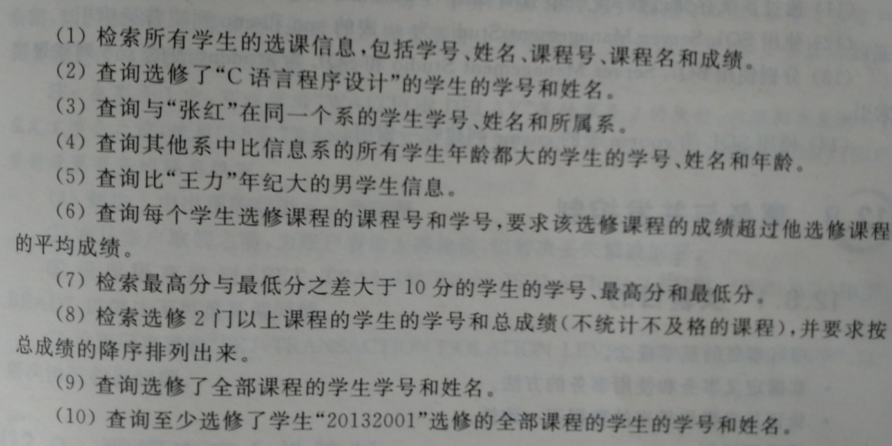
在复杂查询中，同一个题目可以有多种查询方法，例如连接或嵌套。连接查询的写法也不唯一，连接的条件可以现在where子句，也可以写在From子句on关键字的后面。实验时，写出一种解决方法即可。实验指导中的方法仅供参考，不是唯一的方法。
实验步骤和结果：
1.检索所有学生的选课信息
Sql语句：
SELECT s.sno, s.sname, c.cno, c.cname, sc.grade
FROM student s
JOIN sc ON s.sno = sc.sno
JOIN course c ON sc.cno = c.cno;
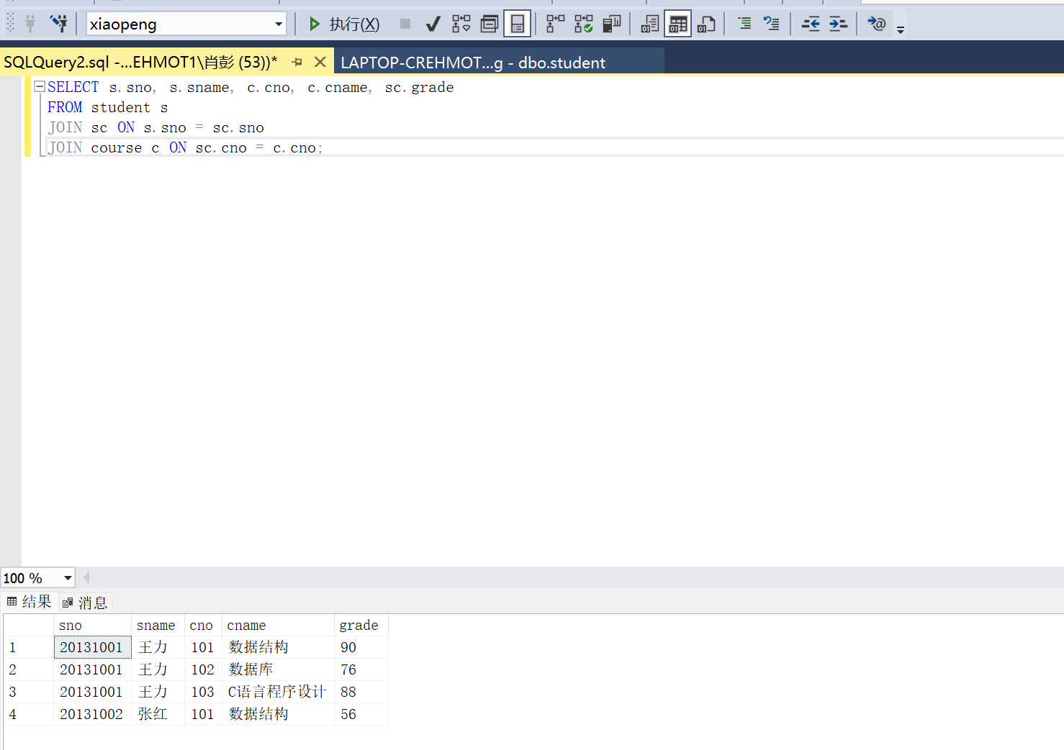
2.查询选修了"C语言程序设计"的学生的学号和姓名
Sql语句
SELECT s.sno, s.sname
FROM student s
JOIN sc ON s.sno = sc.sno
JOIN course c ON sc.cno = c.cno
WHERE c.cname = 'C语言程序设计';
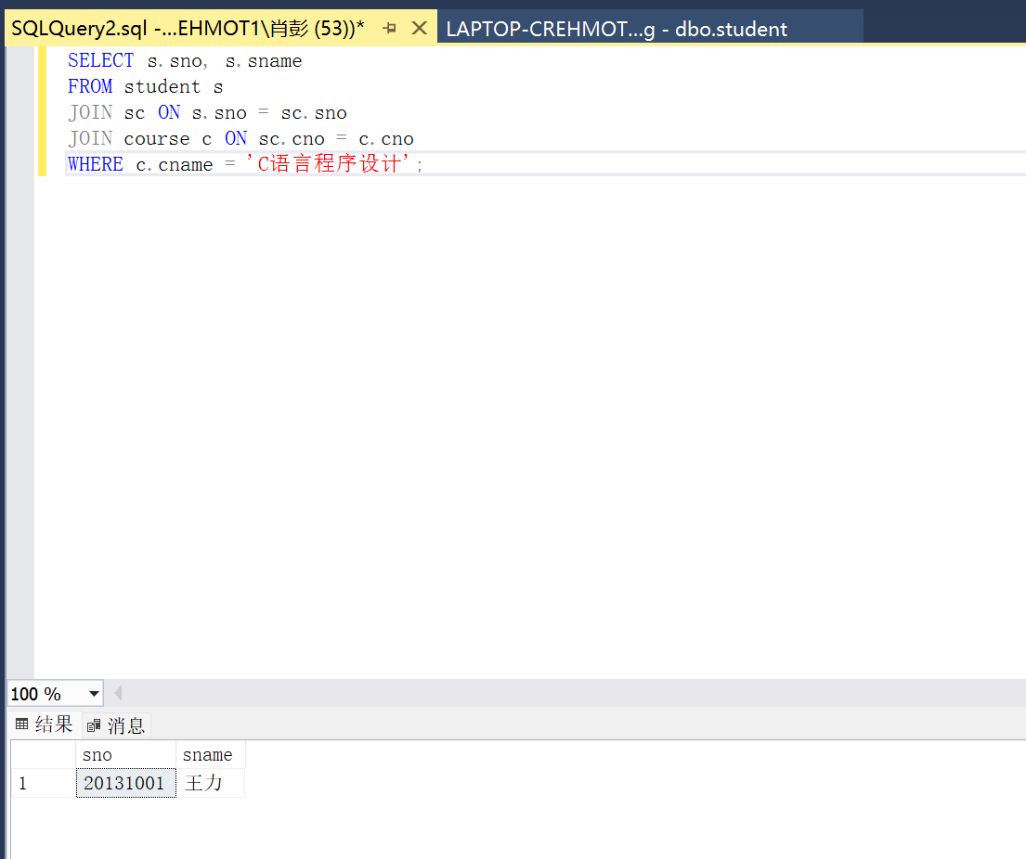
3. 查询与"张红"在同一个系的学生学号、姓名和所属系
Sql语句：
SELECT s2.sno, s2.sname, s2.sdept
FROM student s1
JOIN student s2 ON s1.sdept = s2.sdept
WHERE s1.sname = '张红' AND s2.sname != '张红';
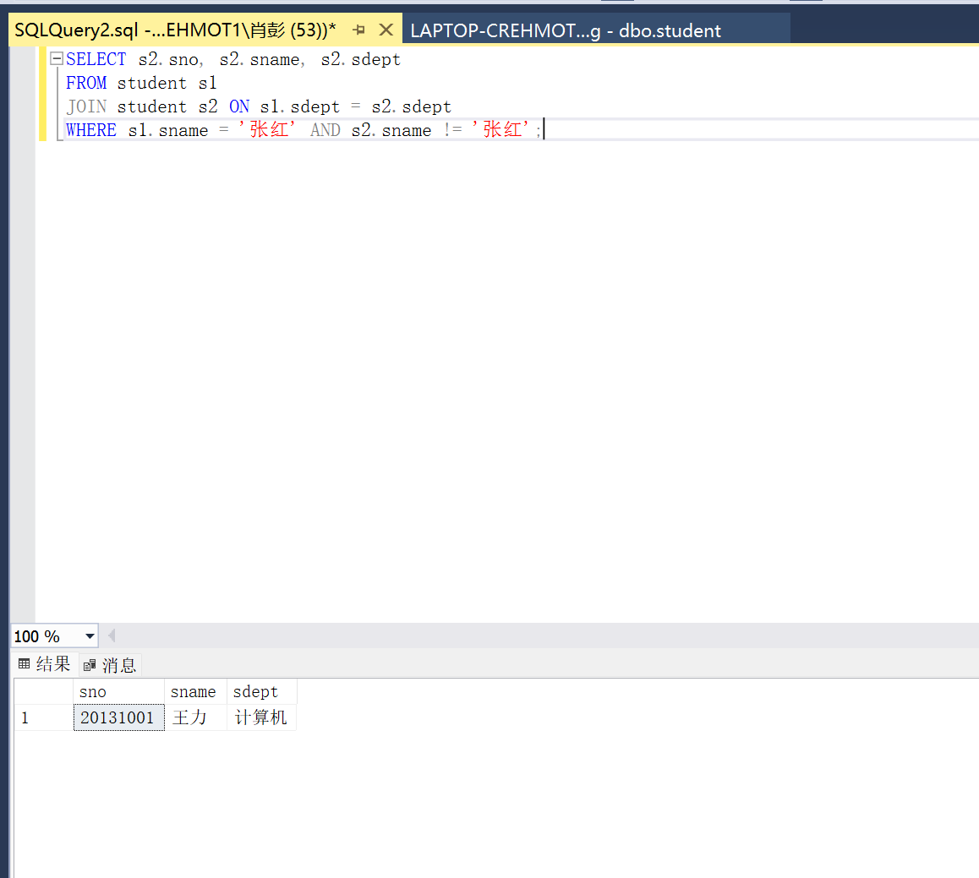
4. 查询其他系中比信息系的所有学生年龄都大的学生的学号、姓名和年龄
SELECT s.sno, s.sname, s.sage
FROM student s
WHERE s.sdept != '信息'
AND s.sage > ALL (
SELECT sage FROM student WHERE sdept = '信息'
);
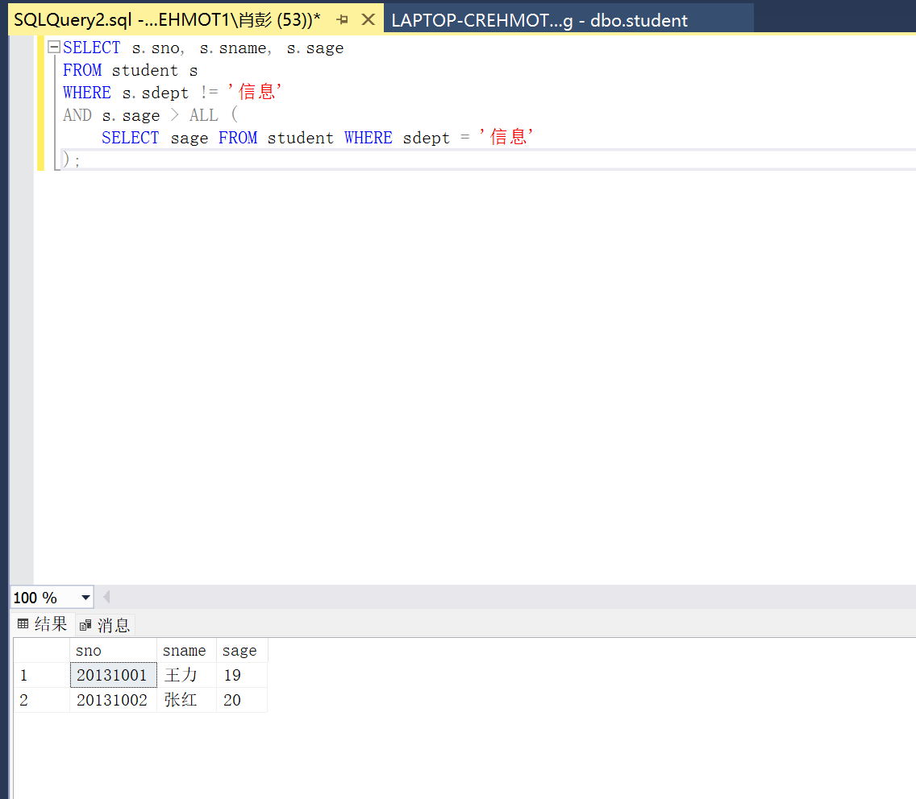
5. 查询比"王力"年纪大的男学生信息
SELECT s2.*
FROM student s1
JOIN student s2 ON s1.sage < s2.sage AND s2.sgender = '男'
WHERE s1.sname = '王力';
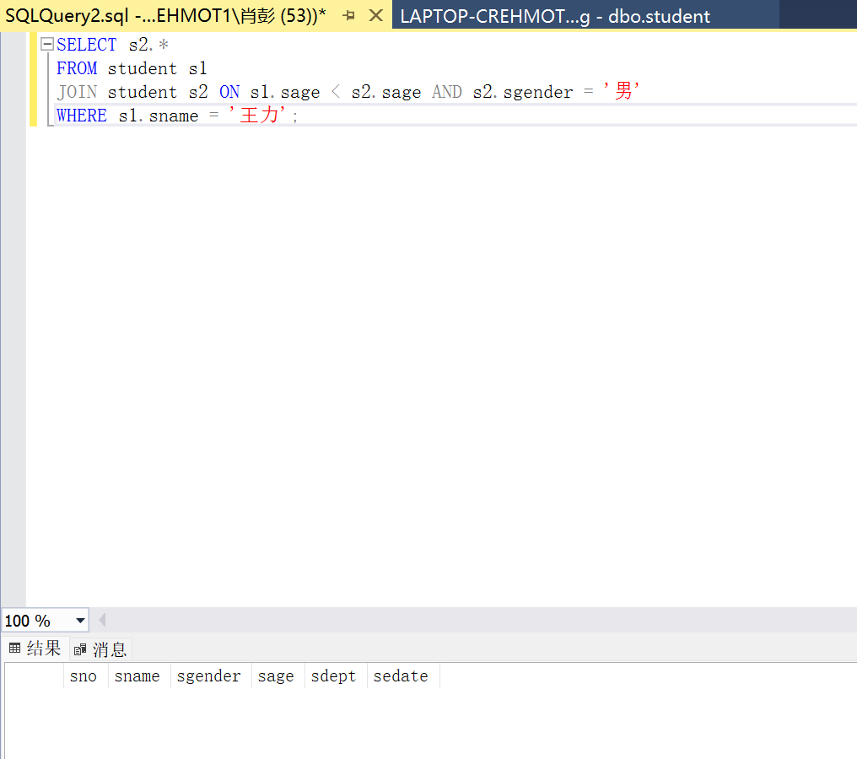
6．查询每个学生选修课程的课程号和学号，要求该选修课程的成绩超过他选修课程的平均成绩
SELECT sc1.sno, sc1.cno
FROM sc sc1
JOIN (
SELECT sno, AVG(grade) as avg_grade
FROM sc
GROUP BY sno
) sc2 ON sc1.sno = sc2.sno AND sc1.grade > sc2.avg_grade;
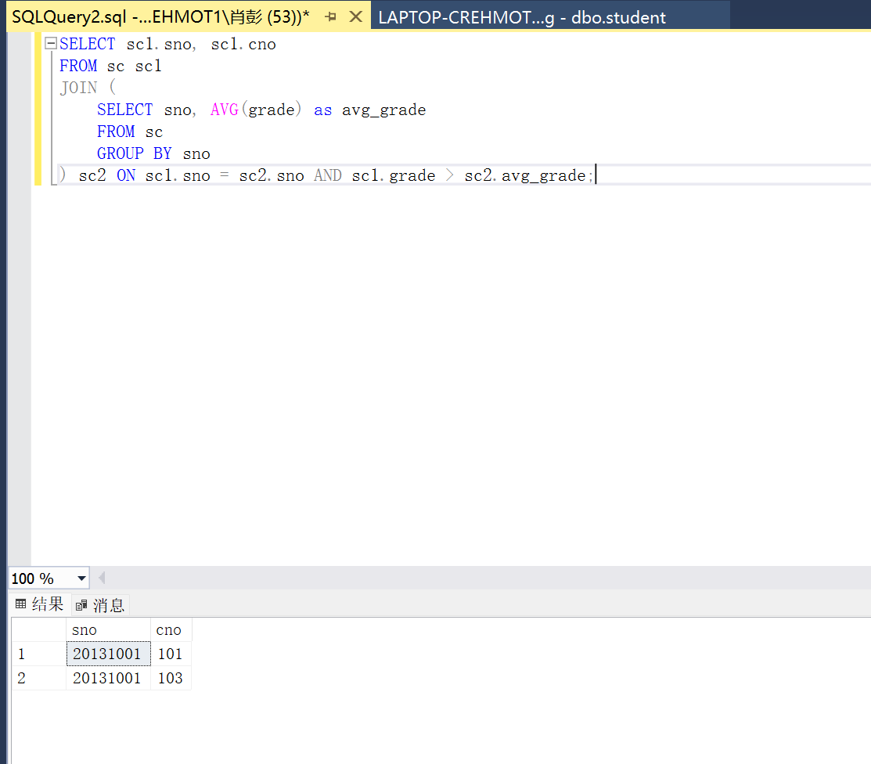
7. 检索最高分与最低分之差大于10分的学生的学号、最高分和最低分
SELECT sno, MAX(grade) as max_grade, MIN(grade) as min_grade
FROM sc
GROUP BY sno
HAVING MAX(grade) - MIN(grade) > 10;
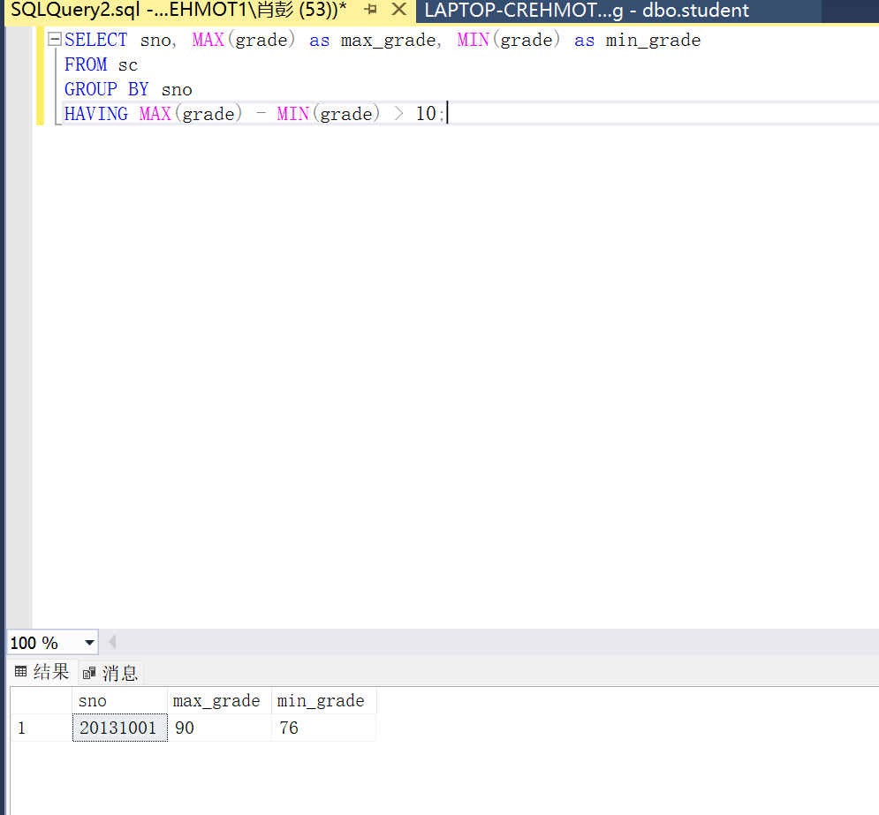
8. 检索选修2门以上课程的学生的学号和总成绩（不统计不及格的课程），并要求按总成绩的降序排列出来
SELECT sno, SUM(grade) as total_grade
FROM sc
WHERE grade >= 60
GROUP BY sno
HAVING COUNT(*) > 2
ORDER BY total_grade DESC;
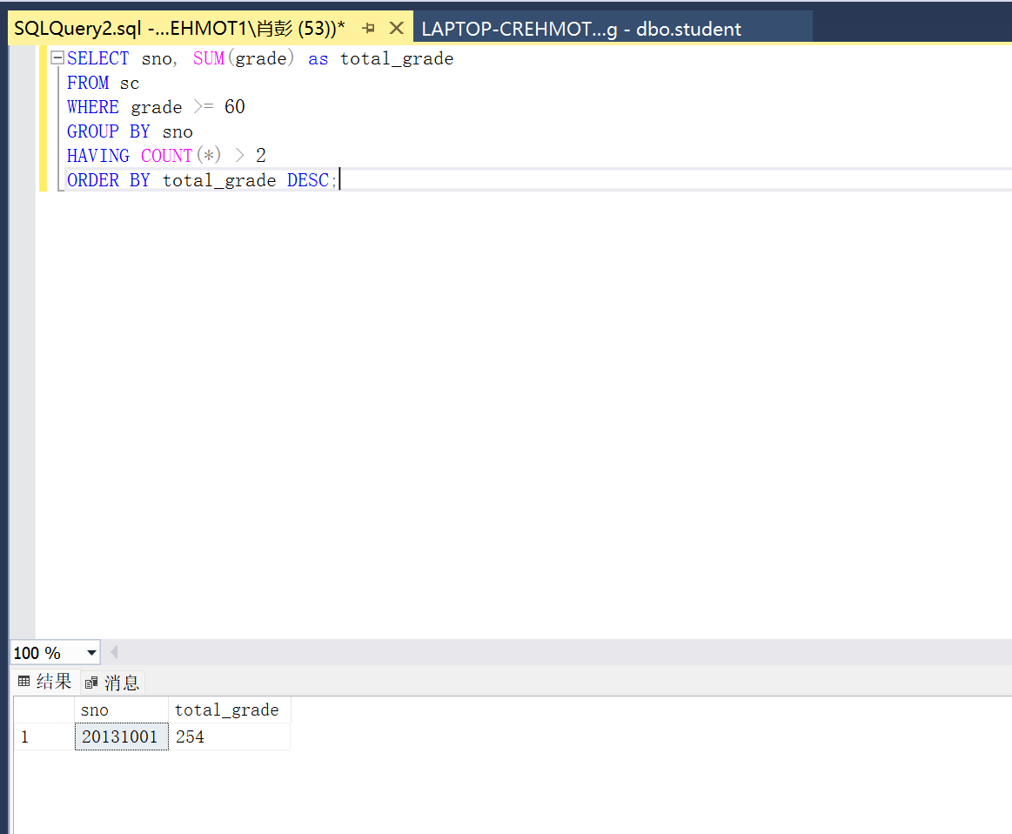
9. 查询选修了全部课程的学生学号和姓名
SELECT s.sno, s.sname
FROM student s
WHERE NOT EXISTS (
SELECT c.cno FROM course c
WHERE NOT EXISTS (
SELECT * FROM sc
WHERE sc.sno = s.sno AND sc.cno = c.cno
)
);
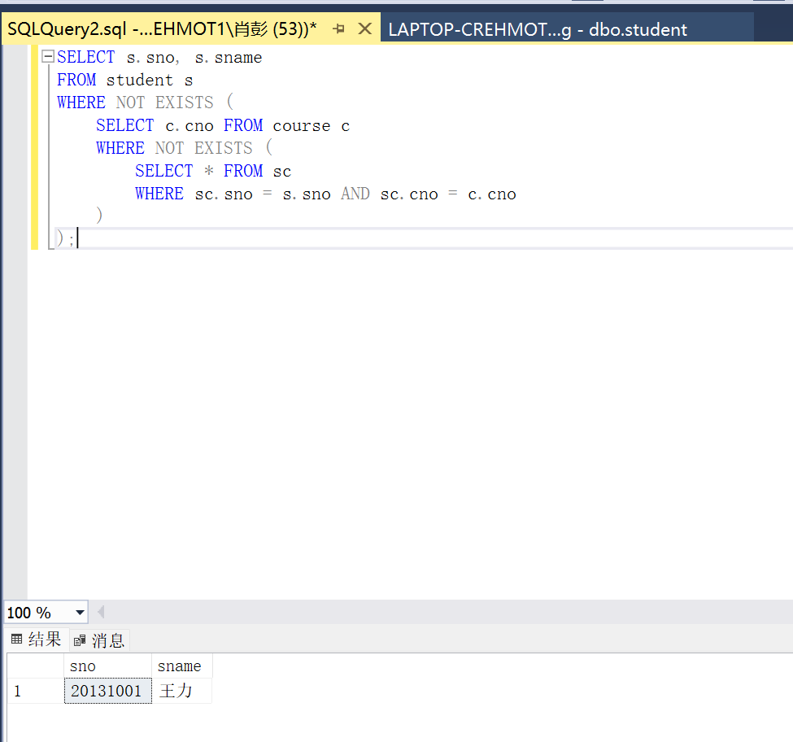
10. 查询至少选修了学生"20132001"选修的全部课程的学生的学号和姓名
SELECT DISTINCT s.sno, s.sname
FROM student s
JOIN sc sc1 ON s.sno = sc1.sno
WHERE NOT EXISTS (
SELECT * FROM sc sc2
WHERE sc2.sno = '20132001'
AND NOT EXISTS (
SELECT * FROM sc sc3
WHERE sc3.sno = s.sno AND sc3.cno = sc2.cno
)
);
