《网络安全协议实习》结课作业实验报告
应用层网络安全协议开发实习
班级：网安2301
学号：2311320105
姓名：丁少亭

题目
在投票应用层协议项目的基础上，使用现代密码学算法，将该应用层协议修改为安全传输的通信过程。

设计
加密方面，在原先实现的基础上添加一会话密钥，用AES的GCM模式做对称加密，实现加密、完整性验证和防重放。会话密钥的交换则通过客户端和服务端预共享的一组公私钥，在RSA加密的连接中完成。

实现
在原先实现的基础上，首先对Framer进行一次抽象，将其视为处理出入流的Channel并抽象出接口：
public interface Channel {
void send(byte[] message) throws IOException;
byte[] receive() throws IOException;
}
之后，修改原先的Framer令其实现此接口：
public class LengthChannel implements Channel {
public static final int MAXMESSAGELENGTH = 65535;
public static final int BYTEMASK = 0xff;
public static final int BYTESHIFT = 8;
private final @NotNull DataInputStream in;
private final @NotNull OutputStream out;
public LengthChannel(@NotNull InputStream in, @NotNull OutputStream out) {
this.in = new DataInputStream(in);
this.out = out;
}
public void send(byte[] message) throws IOException {
// 省略
}
public byte[] receive() throws IOException {
// 省略
}
}
之后进入加密实现。首先，定义一个加解密处理器接口：
public interface CryptoHandler {
byte[] encrypt(final byte[] plaintext) throws GeneralSecurityException;
byte[] decrypt(final byte[] ciphertext) throws GeneralSecurityException;
}
再完成基于ASM+GCM和RSA的两个实现：
public class AESGCMCryptoHandler implements CryptoHandler {
private static final int GCM_IV_LENGTH = 12;
private static final int GCM_TAG_LENGTH = 16;
private final @NotNull SecretKey key;
public AESGCMCryptoHandler(@NotNull final SecretKey key) {
this.key = key;
}
@Override
public byte[] encrypt(final byte[] plaintext) throws GeneralSecurityException {
final byte[] iv = new byte[GCM_IV_LENGTH];
final SecureRandom random = new SecureRandom();
random.nextBytes(iv);
final Cipher cipher = Cipher.getInstance("AES/GCM/NoPadding");
final GCMParameterSpec spec = new GCMParameterSpec(GCM_TAG_LENGTH * 8, iv);
cipher.init(Cipher.ENCRYPT_MODE, key, spec);
final byte[] ciphertext = cipher.doFinal(plaintext);
final ByteBuffer buffer = ByteBuffer.allocate(iv.length + ciphertext.length);
buffer.put(iv);
buffer.put(ciphertext);
return buffer.array();
}
@Override
public byte[] decrypt(final byte[] ciphertextWithIv) throws GeneralSecurityException {
final ByteBuffer buffer = ByteBuffer.wrap(ciphertextWithIv);
final byte[] iv = new byte[GCM_IV_LENGTH];
buffer.get(iv);
final byte[] ciphertext = new byte[buffer.remaining()];
buffer.get(ciphertext);
final Cipher cipher = Cipher.getInstance("AES/GCM/NoPadding");
final GCMParameterSpec spec = new GCMParameterSpec(GCM_TAG_LENGTH * 8, iv);
cipher.init(Cipher.DECRYPT_MODE, key, spec);
return cipher.doFinal(ciphertext);
}
}

public class RSAECBCryptoHandler implements CryptoHandler {
private @Nullable PublicKey publicKey = null;
private @Nullable PrivateKey privateKey = null;
public RSAECBCryptoHandler(@NotNull final PublicKey publicKey) {
this.publicKey = publicKey;
}
public RSAECBCryptoHandler(@NotNull final PrivateKey privateKey) {
this.privateKey = privateKey;
}
@Override
public byte[] encrypt(byte[] plaintext) throws GeneralSecurityException {
final Cipher cipher = Cipher.getInstance("RSA/ECB/PKCS1Padding");
cipher.init(Cipher.ENCRYPT_MODE, publicKey);
return cipher.doFinal(plaintext);
}
@Override
public byte[] decrypt(byte[] ciphertext) throws GeneralSecurityException {
final Cipher cipher = Cipher.getInstance("RSA/ECB/PKCS1Padding");
cipher.init(Cipher.DECRYPT_MODE, privateKey);
return cipher.doFinal(ciphertext);
}
}
接着实现一个基于CryptoHandler接口的SecureChannel（同时也是对LengthChannel的一个包装）：
public class SecureChannel implements Channel {
private final @NotNull LengthChannel channel;
private final @NotNull CryptoHandler cryptoHandler;
public SecureChannel(@NotNull final InputStream in, @NotNull final OutputStream out, @NotNull final CryptoHandler cryptoHandler) throws IOException {
this.channel = new LengthChannel(in, out);
this.cryptoHandler = cryptoHandler;
}
public void send(final byte[] data) throws IOException {
try {
final byte[] encrypted = cryptoHandler.encrypt(data);
System.out.println("加密信道即将发送一条长 " + encrypted.length + " 字节的信息");
channel.send(encrypted);
} catch (GeneralSecurityException e) {
throw new IOException("加密失败: " + e.getMessage());
}
}
public byte[] receive() throws IOException {
final byte[] encrypted = channel.receive();
if (encrypted == null) return null;
System.out.println("加密信道收到一条长 " + encrypted.length + " 字节的信息");
try {
return cryptoHandler.decrypt(encrypted);
} catch (GeneralSecurityException e) {
throw new IOException("解密失败: " + e.getMessage());
}
}
}
之后分别在客户端和服务端主类中使用预加载的公私钥以及交换出的会话密钥创建安全通道，进行密钥交换和后续通信即可。客户端相关实现如下：
// 密钥交换
final SecretKey sessionKey = generateSessionKey();
Channel keyExchangeChannel = new SecureChannel(in, out, rsaHandler);
keyExchangeChannel.send(sessionKey.getEncoded());
// 创建安全通道
final CryptoHandler crypto = new AESGCMCryptoHandler(sessionKey);
final Channel channel = new SecureChannel(in, out, crypto);
服务端则对应如下：
final Channel keyExchangeChannel = new SecureChannel(in, out, rsaHandler);
byte[] keyBytes = keyExchangeChannel.receive();
SecretKey sessionKey = new SecretKeySpec(keyBytes, "AES");
// 创建安全通道
final CryptoHandler crypto = new AESGCMCryptoHandler(sessionKey);
final Channel channel = new SecureChannel(in, out, crypto);

效果
程序正常运行，客户端连接后，首先从密钥交换信道传输256字节的会话密钥，之后用这个密钥加密传输请求和响应：
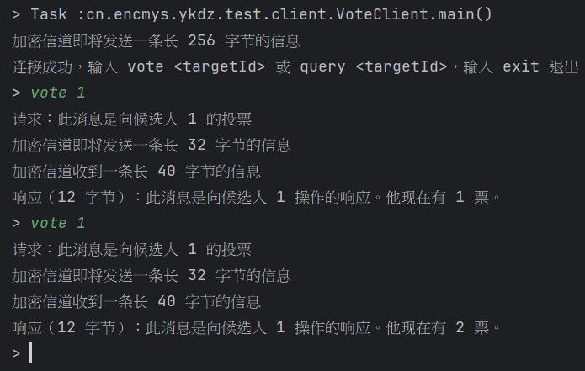
抓包分析中也可以观察到，连接建立时，客户端首先向服务端发送了256字节的数据：
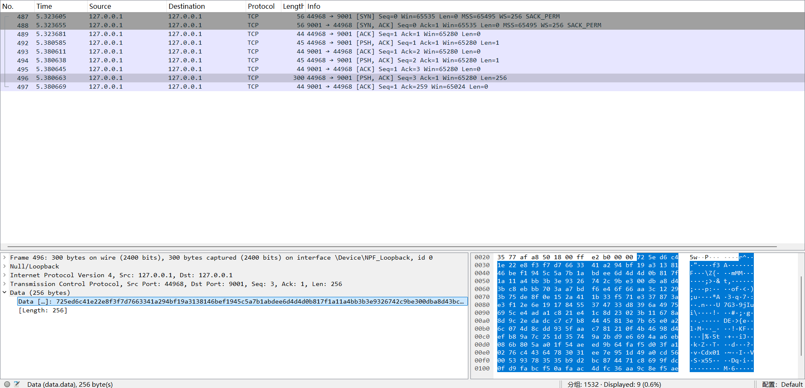
进行一次vote后则能观察到32字节的请求（4字节原始请求体+12字节初始向量IV+16字节完整性标签）：
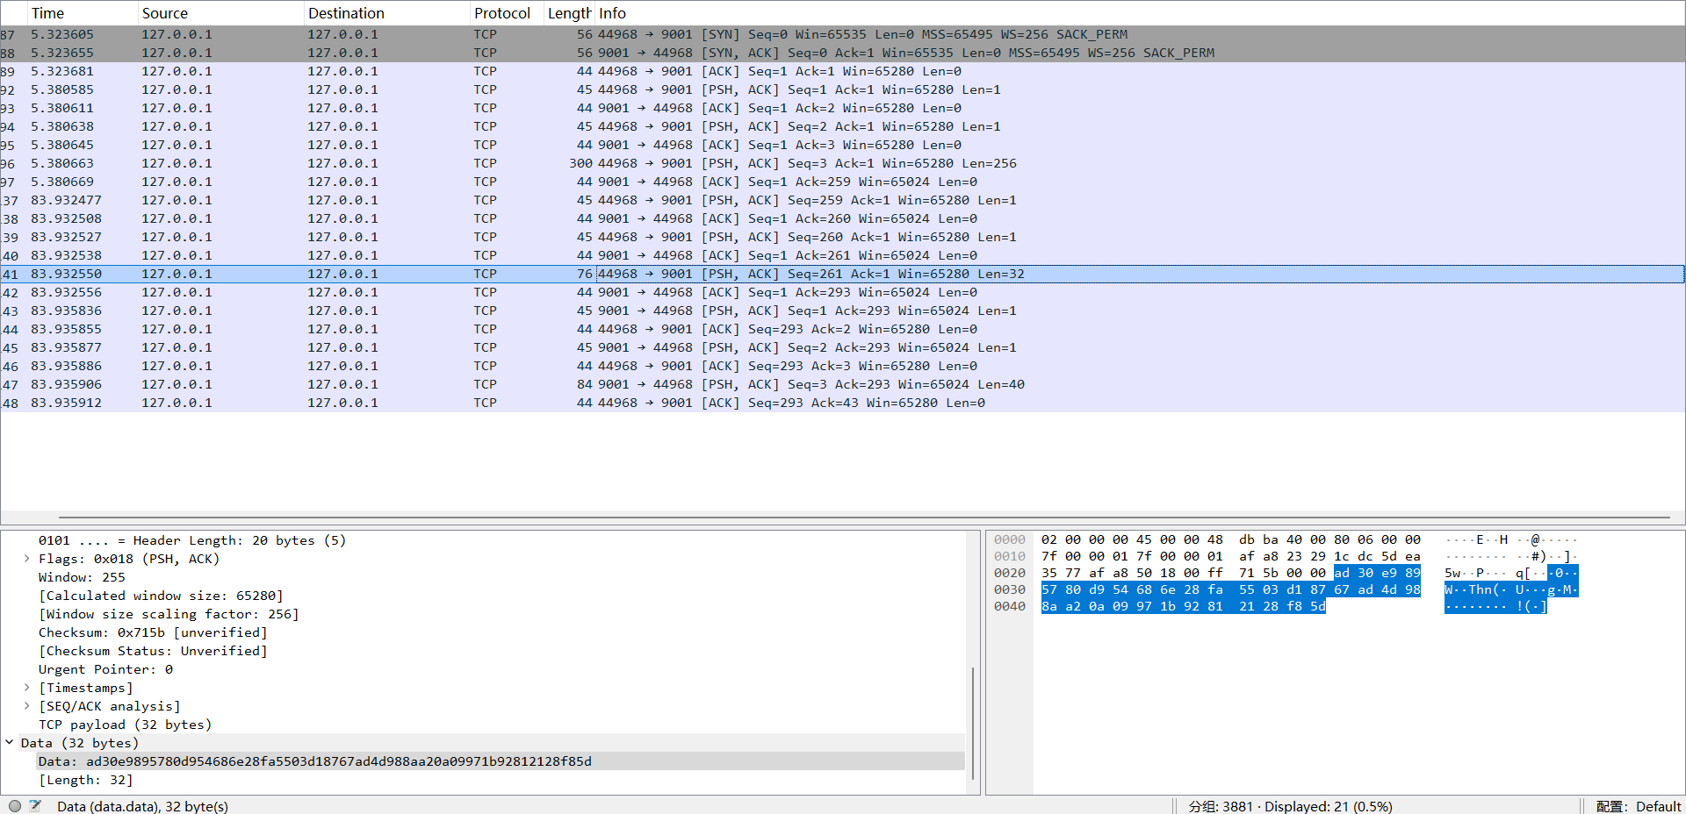
以及40字节（12字节原始响应体+12字节初始向量IV+16字节完整性标签）的响应：
